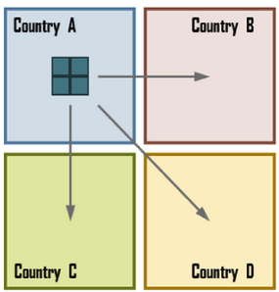
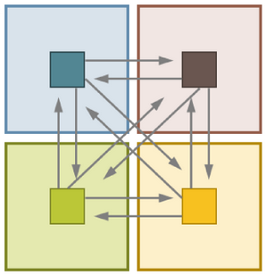
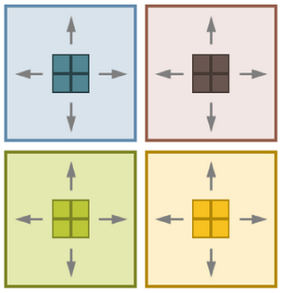
Main Types of Economies: Economies of Transportation: Lower transport costs. For production, it relates to a location that minimizes total transport costs (accessibility to suppliers) and thus lowers production unit costs. Economies of transportation in distribution considers the management of transport chains, often of several modes, to reduce total transportation costs (model and intramodel). Can be derived from economies in distribution and accessibility to customers.Economies of Scale: larger the production unit, lower the unit costs. Larger modes (eg megaships). Larger retail outlets tend to reduce input costs.Economies of Scope: Achieved when a transporter is able to bundle several different loads into fewer loads. Wider range of goods/services. Product diversification and flexible manufacturing systems. Expanding range of goods/services. Agglomeration Economics: Clustering effect. Sharing common infrastructures like roads & utilities. For production, industrial and service linkages are offered as respective suppliers and customers benefit from close proximity and interactions. Outcome is manufacturing cluster. Co-locate. Commercial districts or shopping malls. Economies of Density: Production: increased accessibility to labor (skills) with higher density. Distribution: Lower unit distribution costs with higher densities. Consumption: Increased accessibility to goods/services with higher densities.For consumption, a shopping mall is a good example of x and a large retail is good example of y. x=economies of agglomeration, y=economies of scale. Major Economic Sectors: Primary: mainly natural resources-related.Secondary: manufacturing-related.Tertiary: retail-oreinted/related. Quaternary: service-related. PRIMARY activities: characterized by most basic location factors but have a strong reliance on transportation since (1) locations are rarely close to centers of demand. (2) usually concern heavy/bulky goods. SECONDARY activities: industrial and manufacturing activities. Location is an important cost factor. TERTIARY activities: Activities are retail-oriented. The main focus is to maximize sales revenue with location as an important revenue factor. Local road accessibility. QUATERNARY activities: High level services like banking. High technology sector where innovation is key commercial factor.
The Purpose of Transportation: The goal to transform the geographical attributes of freight, people or information, from an origin to a destination, conferring them an added value in the process. The specific purpose of transportation is to fulfill a demand for mobility. The outcome of a derived demand it takes place because other activities are taking place. Characteristics of Transportation: It cannot exist alone and a movement cannot be stored. An unsold product can remain on a store shelf until bought, but an unsold seat on a flight or unused cargo capacity in the same flight remains unsold and can’t be brought back as additional capacity later. Importance of Transportation: Historical. Played different historical roles in the rise of civilizations. Social. Modes facilitate access to healthcare, welfare, and cultural. Political. Governments play critical role in transportation as sources of transport investments and as regulators of transport operations. Economic. The evolution of transport is linked to economic development. Environmental. Negative impacts: air, water quality, noise level and public health.Transport Competitiveness: Regions compete over factors like resources, labour and governance to provide the most suitable economic advantages. Transportation is a key factor ; gives accessibility to markets, labor and resources. Important component of the competitiveness of transportation concerns investments in infrastructure, modes and terminals & marketing and financing. Investments are to maintain operating conditions or expand geographical extend and/or capacity of transport system. Private sector seeks transport investments that promise economic returns and public sector invests for social and strategic reasons. Distance: A Core Transportation: order in length of time shortest to longest. Euclidean Distance, Transport Distance and Logistical Distance. Euclidean is straight line between two locations. Used to provide approximate distance but rarely accurate. AB. Transport account for existing structure of transport network. Pick up at AMode 1(ex.bus)TranshipmentMode 2(ex.subway)delivery to B. includes pickup, travel by mode 1, transshipment, travel by mode 2 and delivery. Logical Distance (highest measure) encompasses all the tasks needed to move between two locations that can take place. Geographical distance units are less important here.Order processing , packing and scheduling (pickup at A)mode1order(transshipment) sorting warehousing mode2 (delivery at B) inventory management unpacking.
GMS803
Transport and Location: Transportation is linked with the location of economic activities, including retail, manufacturing and services. The goal is find suitable location that would maximize the economic returns for this activity. The majority of location theories have an explicit or implicit role attributed transport. Centralized global production: The entire production occurs within only one nation (region) and is exported after on global market. This is the case for activities that are difficult to relocate like goods linked to the location of resources, hard to reproduce or depending on economies of scale. Cost is moderate or low.

Regional Production: Takes place within each region.
That manufactures a good with the size of production
system related to the size of the regional market. Has
high distribution costs (eg soft drinks).
Regional Specialization: Involves a spatial division of the production based on comparative advantages. Advantages outweigh additional transport costs. Each region specializes in production of a certain good and imports from other regions what it requires.

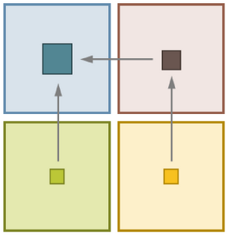
Vertical Transnational Integration: Variant of specialization. Occurs at
locations offering best comparative advantages. Raw materials from
locations most accessible. Low labour costs or high skill levels. Difficult
to coordinate. EXAMPLE IS APPLE IPAD. Location Factors: dependent on the nature of the activity itself. Top of pyramid site (micro;local) includes land, utilities, visibility, transportation (local access), amenities. Second accessibility (neso;regional) include labor, materials, energy, markets, suppliers/customer. Bottom socioeconomic environment (macro;national) include capital, subsidies, regulations, taxation, technology.

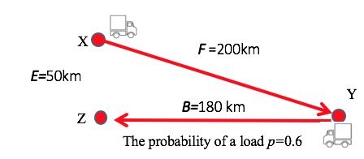
What single rate ( r) or price per km ensures that the carrer will be profitable in the longrun:. (1) Find Revenue. Revenue= (r x km for F) + probability of load in decimal x (r x km for B). Ex. (r x 200) + 0.6( r x 180) = 308r . (2) Find Cost of Moving Loads. Cost= ( c x km for F) + probability of load in decimal x ( c x km for B). Ex. (c x 200) + 0.6 ( c x 180)= 308c = 308. (3) Find Cost of Moving Empty. Traveling empty to city (x) from city (z)= (0.6) (c x 50)=30c=30. . Traveling empty to city (x) from city (z)= (0.4) (c x 200)=80c=80. Cost of Moving Empty : 30c + 80c=110c.=110. (4) Profit.= 308r-418 308r -418>0, then r >$1.36. (418=308+110).

Allocate Common Costs plus allocation of separable cost:. (1) In given each equation, ex $160 + x. Divide dollar amount so $160 by 2, then plugin unit for x for each appropriate shipper and solve. Shipper A: ($160/2)+40= $120. Shipper B: ($160/2)+60= $140.

Transshipment Markets: Connect regional ports to transoceanic and circum equatorial routes, mainly through hub-and-spoke services. Interaction and relay functions between long distance shipping services performed..Air Transport is high value freight and global logistics. Time sensitive, valuable and pershible goods. Just-in-time production. Five kinds:dedicated cargo operators, combination services, passenger operators, air freight integrators, specialized operators. Comparative advantages for modal shift: costs, convenience, speed and reliability. Passenger, involved a transition in modal preferences as income goes up. Freight, shift faster and flexible modes when possible and cost effective.Intermodal Transportation: segmented and un-integrated. Requires management units for freight like pallets. Pallets are common management unit but small and lack protective frame made by intermodal handling labor intensive and prone to damage or theft. Reasons: Economies of scale, frequency, and interchange (optional activity).
Total Cost Must Cover. (1) Take formula given. Ex.$160+x. (2) Plugin unit given and solve. Ex.40-unit shipment.Answer: $160+40=$200. What Price Carrier Charge Shipper. (1) Answer: >___ (put total cost must cover here).New Answer for Q1 with Second Shipper. (1) Take formula given. Ex.$160+x. (2) plugin unit given in Q1 + Unit given now for second shipper. Ex. Q1- 40-unit shipment & Second Shipper- 60-unit shipment. (3) Solve. Ex. $160+(40+60)= $260. Proportional to Weight. Shipper A (original from Q1): = (Units for A / Total weight (units for A + units for second shipper B)) x Total Cost (found in New answer for q1 with second shipper). Shipper B (second shipper): = (Units for B / Total weight (units for A + units for second shipper B)) x Total Cost (found in New answer for q1 with second shipper). Proportional to Separate Costs: Shipper A Cost: = (1) Take formula given. Ex.$160+x. (2) Plugin unit given and solve. Ex.40-unit shipment.Answer: $160+40=$200. Shipper B Cost: = (1) Take formula given. Ex.$160+x. (2) Plugin unit given and solve. Ex.60-unit shipment.Answer: $160+60=$220. Shipper A: = [Shipper A Cost /(Shipper A Cost + Shipper B Cost)] x Total cost (found in New answer for q1 with second shipper). Shipper B: = [Shipper B Cost /(Shipper A Cost + Shipper B Cost)] x Total cost (found in New answer for q1 with second shipper).
If your quantity is based on value which one shows higher traffic? General Cargo. Bremen Rule: developed 1982 by port of Bremen. Based on a survey of the labour cost incurred in the handling of one ton of different cargoes. If one port handles general cargo, in a specific period of time, for example 100000 tons, you need to multiply by 12 to find liquid. One ton of general cargo= 3 tons dry bulk or 12 tons of liquid bulk.
Difference: Multi-modal, Intermodal:The main::multimodal doesn’t t use more than 1 option for transport in same shipment. Intermodal offers cost savings & costly delays. Is efficiency of the transshipment points in terms of cost and time. If they inefficient, multi-modal transportation may be a better alternative.

Pipelines: One major disadvantage of pipelines is the inherent inflexibility of the mode? ANS:Once built(usually at a great expense), expansion is not easily accommodated. Pipelines. Carries one commodity from location to another. Liquids. Main: gas and oil. Gas: low viscosity, oil: high viscosity. .Maritimes operates in own space, like land mode,, by physical attributes, strategic by control and commercial usage. Most effective to move large quantities of cargo over long distances. Routes composed of coasts, seas, lakes, rivers, oceans, channels. Advantages: economies of scale, making it cheaper per unit of all transport modes, which fits well for heavy industrial activities. High terminal costs because port infrastructures are one of the most expensive to build, maintain and improve. Passenger Vessels: (1) Paseenger Ferries, people carried across short bodies of water in a shuttle-type service.(2) Cruise Ships: people taken on vacation trips of different durations, like over several days. Freight Vessels: (1) Bulk Carriers: ships ment to carry certain commodities and are differentiated into liquid and dry bulk. (2) Cargo Ships: carry non-bulk cargoes. Replaced by container ships in 1960s because more rapid and efficiently loaded. (3) Roll on Roll off (RORO): designed to allow cars, trucls amd trains to be loaded directly on board. Two Main Markets: (1) Bulk Cargo: Dry and liquid, that is not packaged such as minderals (oil, coal, iron ore, bauxite) and grains. Requires specialized ships like oil tankers and specialized transshipment and storage facilities. Has single origin, destination and client and is prone to economies of scale. (2) Break-bulk cargo: cargo been packaged in way with use of bags, boxes, drums and particularly containers. Have many origins, desitnation and clients. Before containerization, economies of scale were hard to achieve with break-bulk cargo because loading and unloading process was labor and time consuming.Transoceanic Connectors: You have 3 sub categories: pacific, atlantic and Indian, if you travel from one ocean to another.
Passenger Terminals: Good design of platforms and access points, and with appropriate scheduling of arrivals and departures. 2 important components: design and scheduling of arrivals/departures. Services like information, shelter, food and security needed but layout and activities taking place in passenger terminals are simple and need relatively little equipment The result is that a wide range of services have to be provided for passengers not directly related to the transfer function, including restaurants, bars, stores, hotels, in addition to the activities directly related to operations such as check-in halls, passenger loading ramps and baggage handling facilities. Airports: two measures to look at traffic. (1)number of passengers. (2) number of aircraft movements.You need to be caution with the number of aircraft movements because.. additional info is required. You need to know size of aircraft. In designing passenger terminals is important to have? well-designed platforms and access points. Bulk: (1) Liquid Bulk: include crude oil and refined products that can be handled using pumps to move product along hoses and pipes. Limited handling and significant storage facilities. (2) Dry Bulk: wide range of products like ores, coal and cereals. Measurement of Freight Traffic: standard measures of weight and value are difficult to compare and combine. Liquid handling is much more faster. Bulk means quantity is larger. If your quantity is based on weight, which one shows higher traffic? Liquid Bulk. General Cargo: valuable higher because those are packages, final products that are coming. Shows a higher number compared to liquid bulk.

Major Technological Trends: (1) Alternative Modes: Range of modes that could replace but more likely complement existing modes, particularly for the transportation of passengers. Ex. Maglev.first fundamental innovation technology. (2) Alternative Fuels: concerns existing modes but the sources of fuel or the engine technology, are modified. Ex. Hybrid vehicles. (3) Intelligent Transport Systems: development of set of information and communication technologies. Goal: efficiently use existing infrastructures through information technologies. Ex. Public transit. Freight transportation: more complex because more intelligent,has objects and size. Dealing with smart human being for passenger transportation vs an object. Variety and sizes are way different vs passenger. Road Transport: Capital cost of vehicles small, which means there are low barriers to entry. HIGHLY COMPETITIVE. Penetration Lines: link a port city with its hinterland to access natural resources like minerals, agricultural & wood products. Found in developing countries (Africa, latin America) Which one is safer: trucking. Which one is cheaper: railroad. Rail System Limitations: space consumption at terminal, gradient and turns, network ownership:public vs. private and gauge (integration is hard)

