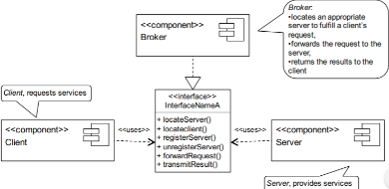  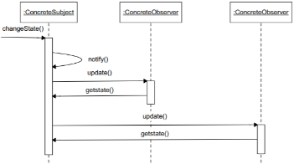  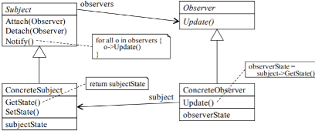  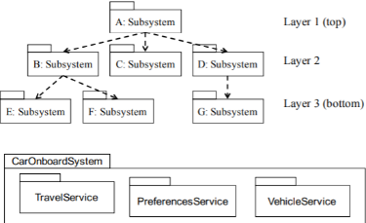  Requirement: [Lethbridge]: a statement about what the proposed system will do that all stakeholders agree must be made true in order for the customer’s problem to be adequately solved. [Dutoit]: a feature that the system must have or a constraint that it must satisfy to be accepted by the customer. Users of req: system customers, managers, system engineers, system test engineers, & system maintenance engineers. Functional: interaction b/w a system & its environment (e.g., UML actors), independent from its implementation what NOT how. NF: restriction on the system that limits our choices for constructing a solution (e.g., memory, platform, real-time constraints). Types: usability, dependability, reliability, robustness, safety, performance, response time, throughput, availability, accuracy, supportability, adaptability, maintainability. Req.Eng: the process of defining the requirements for the system under construction. Dutoit: Requirements engineering has two main activities: (1) Elicitation: results in requirements specification that the customer understands, (2) Analysis: results in analysis model that developer can unambiguously understand. Specifications’ Qualities: Clear/ unambiguous/ understandable:(Need for rigor and formality), realistic: (late changes to requirements are expensive, correspond to real needs: (valid), verifiable: (to ease testing), consistency: (not self-contradictory), completeness: (self-contained, complete sets of req). Why is requirements elicitation hard? Customers / users are not always good at describing what they want or need, & Software Engineers are not always good at understanding someone else’s concerns. In certain application domains, software engineers & customers have completely different backgrounds & use a different terminology.Req. El: Techniques: observation, interviewing, brainstorming, & prototyping. Activities: (1)identify actors,(2) identify scenarios,(3)identify use cases,(4)identify NF requirements, (5)refine use cases,(6)identify relationships among use cases. SS.Scope: (very important decision) System Boundary: define activities and data IN/OUT the system. Scope Q’s: What/who triggers the behaviour expected from the software? Should we implement the requirements or is the requested functionality a responsibility of another system or a human? Use Cases: describes the systems behaviours under conditions as system responds to stakeholder. Primary Actor: has a goal with the soft. System. Secondary Actors: The system will use other actors to help primary actor achieve its goal. Relationship:<<include>>-when a base case will use the include case.(withdraw includes print recp.) <<extend>>-Use case A triggered when B executes only under some condition(if you want to cancel trans, it extends to cancelTrans) generalization: A(base) use case can be specialized by another use case. Template: name; brief description; precondition; primary actor; secondary actors; dependencies to other use cases; basic flow; alternative flows: specific, bounded, global alternative flows; special requirements; technology & data variations; open issues. Advantages: helps define the scope of the system, can be used as part of the development plan, form the basis of definition of test cases, can be used to structure user manuals. Dis-Advantages: use cases themselves must be validated; some aspects of functional requirements are not covered by use case analysis, only those triggered by an actor. OO Analysis: Entity: info tracked by syst.(normal classes) Boundary: Interaction b/w actors and syst, (interface, GUI) Control: control task performed by the syst, links boundary & entity. Types: primitive (weight) Data (date: address, number) Enumeration (Grades: letters). Association: A B know each other (A-----B), aggregate, no dependency (has, member of)(A<>-----B), composite, owns, existence-dependency (A<->-----B), A knows B, B don’t (A---- >B). Multiplicity: B(0..1) A linked to 0 or 1 B; B(1) A linked to exactly 1 B, B(*) A is linked to 0 or n of B, B(1..*) A linked to at least 1 or n B. Generalization: (relation b/w general, specific elms) types inheritance: (1) Interface: Inherits attribute & operations (harmless), declared through abstract class. (2)Implementation: imply code reuse, overrides with new implmnt. (3) Extension: extends to class (produces additional outputs). (4)Restriction: things in a superclass that the subclass cant use. (5)Convenience: inherited operations are meaningless(don’t need). Liskov substitution principle: if a client code uses the methods provided by a superclass, then developers should be able to add new subclasses without having to change the client code. (defines generalization) Dependency: When a link between two objects does not need to survive the execution of an operation. (2nd class is used as a parameter for an operation in 1st class). Association: When a link between two objects has to survive the end of execution of an operation. Design by Contract: includes specifying op-to-op communcations. Preconditions(what must be true) and Postconditions(what must be true after use case) must be satisfied. OCL: (= equal, <> NE) Constraints: conditions that must be true about some aspect of the system. Sequence Diagrams: Show an exchange of messages bw objects in a time sequence. Solid line (sending msg, getData()) Dashed-Line(return message, Date). Message Interactions: Synchronous (filled arrow) return msg can ret values or acknowledge operation completed. Asynchronous (empty arrow) sender doesn’t wait on a reply, Continues without waiting). State Machines: must follow form of execution, reject events if it’s impossible to go to it without going through another event first. ( if e1 occurs before e2, e1 has to execute before e2, else ignore e2) Responsibilities0: design by contract. (preconditions, postconditions, class invariants and contracts) Stair structure diagram is better than fork in general. System Design: Software Arch:A decomposition of the system into manageable subsystems, addressing system-wide design goals. Subsystem Arch: high-level system structure composed of interconnected subsystems. SubSys Prop: highly cohesive classes, loosely coupled subsys. Coupling: measure of how closely two classes or subsystems are connected. Cohesion: measure of how well a class or subsystem is tied together. Kinds of Coupling: Outside: class or subsys refers directly to the public members. Inside: An operation refers directly to other, private members in the same class. Coupling from below: specialized class refers directly to (protected) members in the super class. Sideways coupling: class refers directly to private properties in another class. Measures Cohesion:LCOM- Lack of Cohesion of Methods = non-zero if P (the # of methods without common variables) is greater than Q (the # of methods with common variables). LCOM = |P|-|Q| if |P|>|Q| and 0 otherwise. Bigger LCOM=less cohesive(at 0). Layer: grouping of subsys providing related services. Partitions: result from decomposition into peer subsystems. Pros: maintainability Layered Arch: Closed: layer only use operations immediately adjacent (highly maintainable & flexible), Open: any layer can be accessed (run time efficient) Strict: use operation in layers below. Relaxed: use layers above & below. C–Strict: Simple dependencies, easier changes. Results in many operations that merely transmit calls to the lower level. OS: More efficient (no delegations from layer to layer). Difficult to change layers at lower levels, as it can lead to changes to all layers above. Must look at the number of layers to decide. ORelaxed: Simple subsystems interfaces at the expense of complex dependencies. CR: Potential for the highest level of inter-dependencies, resulting in low maintainability. Model (entity objects) Function (control objects) Interface (boundary objects) MVC: Model: domain knowledge, View: display, Controller: determine sequences of user interactions. Pros: suited for interactive systems, multiple views needed, useful to maintain consistency. Cons: model holds system back (bottleneck). Observer design pattern decouples the view and model objects. (breaks it apart) Observer D.P: When one object changes state, all its dependents (observers) are notified & updated automatically. Cons: hard to maintain data among consistency between related objects. Extensibility: MVC helps since model/view objects don’t need to be modified to accommodate the new view, Response time: Hurts because the view seen by the user is updated only after the model has been updated, Modifiability: Helps, since only the view that needs to be aware of the new attributes needs to be modified. All other views can be left unchanged, Access control: Helps as the model is accessed using a clear interface which can be controlled. Client-Server: Clients interact by requesting services of servers. Shared resources and services that large numbers of distributed clients wish to access. Service providers wish to control access & quality of service. Cons: server & network performance bottleneck & single point of failure.Pros: increase modifiability, reuse. Improve scalability & availability by centralizing the control of these resources and services, while distributing the resources themselves across multiple physical servers. Broke: separates clients from servers using an intermediary component, the broker. Pros: availability purposes. (make it easier to change bindings b/w client and servers) Cons: broker add indirection: latency bw c-s, communication bottleneck, single point of failure. Add up-front complexity, difficult to test, target for security atks Piper-Filter: Many systems need to transform streams of discrete data items. Pros: divided into reusable, loosely coupled components with simple, generic interaction mechanisms. Cons: not good choice for interactive software, leads to computation overhead. Peer-to-Peer: components directly interact as peers, act as both client and server. Pros: ensures high availability & scalability. Cons: managing security, data consistency, availability, backup is complex. Distribution Pattern: system is distributed on several processors over a network. Centralized, Distributed and Decentralized. Cen (Fun,In,Md in server) Dis( FIM in client) System Design Process: identify design goals: consider performance, dependability end user criteria cost, maintenance. Identifying Subsystems: initial decomp: objects involved in use case. Acceptance Testing: Evaluates the system delivered by developers 2- Carried out by the | 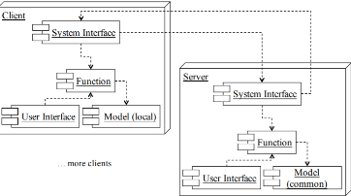  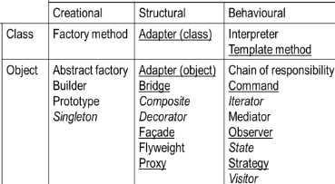  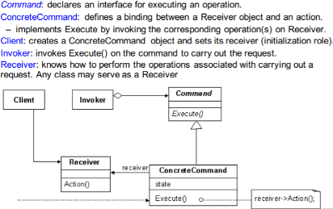  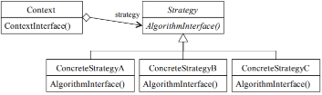  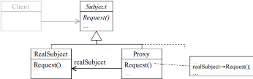  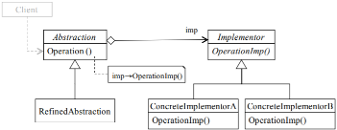  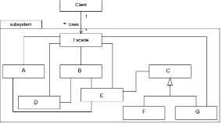  client. May involve executing typical transactions on site on a trial basis, Goal: system meets the req and ready to use. Façade D.P: provides a unified higher-level interface to the subsystem functionality, knows which subsystem classes are responsible for a request. Cons: promotes weak coupling bw subsy clients. Proxy Design: Provide a surrogate or placeholder for another object to control access to it. (control proxy to control main object) Remote: encode & sending request to real subject. Virtual: offline viewing. Protection: check access permissions. Cons: remote: slow at peak load periods. Virtual: perform optimizations creating object on demand. Protection, smart ref allow housekeeping tasks when object is accessed. Adapter: convert interface into another interface clients expect. Classes work together that couldn't otherwise because of incompatible interfaces. AdapterVSFaçade adapter provides an object that acts as an intermediary for method calls between client objects and ONE OTHER object that is not known to the client objects, Façade provides an object that acts as an intermediary for method calls between client objects and MULTIPLE objects (which are parts of a subsystem) not known to the client objects. AdapteVSProxy – Both Adapter and Proxy use an object that is a surrogate for another object, however Proxy object has the same interface as the object for which it is a surrogate, Adapter has a different interface. ProxyVSFaçade –façade pattern uses a single object as a front end to A SET OF interrelated objects. Proxy uses a single object (proxy object) as a front-end to another single object (the real one). Database management systems (DBMS): Contain mechanisms for describing data, managing persistent storage and for providing a backup mechanism. Bridge: Decouple a set of implementations from the objects using them. Strategy: algorithm vary independently from clients that use it, thus selecting the appropriate one based on context, Separate the selection of algorithm from its implementation. Control Flow Mech: control flow = seq of actions in a sysc. Procedure-driven: Operations wait for input whenever need data from actor, Mostly in legacy systems written in procedural languages. Event-driven: main loop waits for an external event, Whenever an event becomes available, dispatched to appropriate object, Simpler structures, inputs centralized in the loop. Threads: system can create an arbitrary number of threads, each responding to a different event. Command DP: necessary to issue requests to objects without knowing anything about the operation being requested or the receiver of the request. Template Method: skeleton of an algorithm in an operation, deferring some steps to subclasses. Write abstract class that contains part of the logic needed to accomplish its purpose.  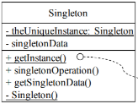  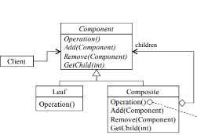  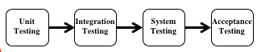  Singleton: Ensure a class only has one instance, and provide a global point of access to it. Pros: applicability, need one instance, extensible by subclassing. Cons: need controlled access, reduce name space. Composite: Compose objects into tree structures to represent part-whole hierarchies. Pros: clients ignore diff bw composition and indie objects. Cons: consists of primitive objcts, can be composed into complex objects. State DP: object to alter its behavior when it’s internal state changes. Decorator DP: Attach additional responsibilities to an object dynamically, provide a flexible alternative to subclassing for extending functionality. Iterator: Provide a way to access the elements of an aggregate object sequentially without exposing its underlying representation Testing: Failure: Any deviation of the observed behavior from the specified behavior. Erroneous state (error): The system is in a state such that further processing by the system can lead to a failure. Fault: The mechanical or algorithmic cause of an error (“bug”). Verification: Find as many latent defects as possible before delivery. Validation: Activity of checking for deviations between the observed behavior of a system and its specification. Faults in the Interface specification: Mismatch bw what client needs & system offers, Mismatch bw requirements and implementation. Algorithmic Faults: Missing initialization - Incorrect branching condition- Missing test for null. Mechanical Faults (very hard to find): Operating temperature outside of equipment specification. Errors: Null reference errors, Concurrency errors, Exceptions. How to deal with Errors: Modular redundancy, declaring the bug as a feature, patching, testing. Unit Testing: Individual component (class or subsystem), Carried out by developers Goal: Confirm that the component or subsystem is correctly coded and carries out the intended functionality. [Static Testing (at compile time) 1. Static Analysis 2. Review 2.1 Walk-through (informal) 2.2 Code inspection (formal)] [Dynamic Testing (at run time) 1. Black-box testing 2.White-box testing] Black-box testing: Testing, either functional or non-functional, without reference to the internal structure of the component or system. Black box test design technique: Procedure to derive and/or select test cases based on an analysis of the specification, either functional or non-functional, of a component or system without reference to its internal structure. Used to find errors in the following categories: Incorrect or missing functions - Interface errors - Errors in data structures or external database access - Behavior or performance errors - Initialization and termination errors. Black-box testing is applicable to the following levels: Integration Testing- System Testing - Acceptance Testing Techniques: Equivalence Partitioning: software test design technique that divides input values into valid and invalid partitions and selects representative values from each partition as test data. Boundary Value Analysis: determines boundaries for input values and selects values that are at the boundaries and just inside/ outside of the boundaries as test data. Cause-Effect Graphing: identifies the cases (input conditions) and effects (output conditions), producing a Cause-Effect Graph, and generates test cases accordingly. Black Box Testing (Selecting a test case) Black Box Testing (Selecting a test case) Input is valid across range of values: Developer selects test cases from 3 equivalence classes: 1- Below the range Within the range Above the range Input is only valid, if it is a member of a discrete set: Developer selects test cases from 2 equivalence classes: Valid discrete values - Invalid discrete values. Advantages: Tests are done from a user’s point of view and will help in exposing discrepancies in the specifications. Tester need not know programming languages or how the software has been implemented. Tests can be conducted by a body independent from the developers, allowing for an objective perspective. Disadvantages: Only a small number of possible inputs can be tested and many program paths will be left untested. Without clear specifications test cases will be difficult to design.- Tests can be redundant if the software designer/developer has already run test cases. White-box testing: Testing based on an analysis of the internal structure of the component or system. Technique: Procedure to derive and/or select test cases based on an analysis of the internal structure of a component or system. Applicable Unit Testing (most often): for testing paths within a unit. Integration Testing: for testing paths between units. System Testing: for testing paths between subsystems. Coverage: Code coverage, Branch coverage, Condition coverage, Path coverage Advantages: Testing can be commenced at an earlier stage. No need to wait for the GUI to be available. Testing is more thorough, with the possibility of covering most paths. Disadvantages: tests very complex, highly skilled resources required, with a thorough knowledge of programming and implementation. Test script maintenance can be a burden if the implementation changes too frequently. J-Unit: A Java framework for writing and running unit tests: Test cases and fixtures Test suites Test runner Written with “test first” and pattern-based development in mind: Tests written before code Allows for regression testing - Facilitates refactoring. Design pattern in J-unit: composite pattern, template method pattern, adapter pattern, command pattern. Integration Testing: Groups of subsystems (collection of subsystems) and eventually the entire system, Carried out by developers Goal: Test the interfaces among the subsystems. The entire system is viewed as a collection of subsystems (sets of classes) determined during the system and object design Goal: Test all interfaces between subsystems and the interaction of subsystems. Determines the order in which the subsystems are selected for testing and integration. Bottom-up Testing Strategy: subsystems in the lowest layer of the call hierarchy are tested individually, then the next subsystems are tested that call the previously tested subsystems, repeated until all subsystems are included, Drivers are needed. Con: Tests the most important subsystem (user interface) last, Drivers needed. Pro: No stubs needed, Useful for integration testing of the following systems: Object-oriented systems, Real-time systems, Systems with strict performance requirements. Top-down Testing Strategy: Test the top layer or the controlling subsystem first Then combine all the subsystems that are called by the tested subsystems and test the resulting collection of subsystems Do this until all subsystems are incorporated into the test, Stubs are needed to do the testing. Pro: Test cases can be defined in terms of the functionality of the system (functional requirements) - No drivers needed, Cons: Writing stubs is difficult: Stubs must allow all possible conditions to be tested.- Large number of stubs may be required, especially if the lowest level of the system contains many methods.- Some interfaces are not tested separately. System Testing: The entire system, Carried out by developers, Goal: Determine if the system meets the requirements(functional and nonfunctional)
Sandwich Testing Strategy: Combines top-down strategy with bottom-up strategy. The system is viewed as having three layers: A target layer in the middle, a layer above the target, A layer below the target. Testing converges at the target layer. Pros/Cons of sandwich Testing: Top and Bottom Layer Tests can be done in parallel. Prob: Does not test the individual subsys & their interfaces thoroughly before integration. Solution: Modified sandwich testing strategy.Modified Sandwich Testing Strategy:Test in parallel:1.Middle layer with drivers and stubs 2. Top layer with stubs 3.Bottom layer with drivers.Test in parallel: 1.Top layer accessing middle layer (top layer replaces drivers) 2.Bottom accessed by middle layer (bottom layer replaces stubs). Continuous Testing: Continuous build: 1.Build from day one 2.Test from day one 3. Integrate from day one 4. System is always runnable. Requires integrated tool support: 1. Continuous build server 2.Automated tests with high coverage 3.Tool supported refactoring 4. Software configuration management 5. Issue tracking. Steps in Integration Testing: 1. Based on the integration strategy, select a component to be tested. Unit test all the classes in the component. 2. Put selected component together; do any preliminary fix-up necessary to make the integration test operational (drivers, stubs) 3. Test functional requirements: Define test cases that exercise all uses cases with the selected component. 4. Test subsystem decomposition: Define test cases that exercise all dependencies. 5. Test non-functional requirements: Execute performance tests. 6. Keep records of the test cases and testing activities. 7. Repeat steps 1 to 7 until the full system is tested. The primary goal of integration testing is to identify failures with the (current) component configuration. Functional Testing Goal: Test functionality of system: 1- Test cases are designed from the requirements analysis document (better: user manual) and centered around requirements and key functions (use cases) 2- The system is treated as black box Unit test cases can be reused, but new test cases have to be developed as well. Performance Testing Goal: Try to violate non-functional requirements. Test how the system behaves when overloaded: 1- Can bottlenecks be identified? (First candidates for redesign in the next iteration) 2- Try unusual orders of execution 3- Call a receive() before send(). Check the system’s response to large volumes of data: 1- If the system is supposed to handle 1000 items, try it with 1001 items. Types of Performance Testing. Stress Testing (Stress limits of system), Volume testing (Test what happens if large amounts of data are handled) Configuration testing (Test the various software and hardware configurations) Compatibility test (Test backward compatibility with existing systems) Timing testing (Evaluate response times and time to perform a function) Security testing (Try to violate security requirements). Environmental test (Test tolerances for heat, humidity, motion) Quality testing: (Test reliability, maintainability & availability) Recovery testing (Test system’s response to presence of errors or loss of data) Human factors testing (Test with end users.). Acceptance Testing: Goal: Demonstrate system is ready for operational use: 1- Choice of tests is made by client 2- Many tests can be taken from integration testing 3- Acceptance test is performed by the client, not by the developer. Alpha test:1- Client uses the software at the developer’s environment. 2- Software used in a controlled setting, with the developer always ready to fix bugs. Beta test:1- Conducted at client’s environment (developer is not present) 2- Software gets a realistic workout in target environment. The 4 Testing Steps: 1. Select what has to be tested: 1-Analysis: Completeness of requirements 2- Design: Cohesion 3- Implementation: Source code 2. Decide how the testing is done: 1- Review or code inspection 2- Proofs (Design by Contract) 3- Black-box, white box, 4- Select integration testing strategy (big bang, bottom up, top down, sandwich). 3. Develop test cases: 1- A test case is a set of test data or situations that will be used to exercise the unit (class, subsystem, system) being tested or about the quality attribute being measured. 4. Create the test oracle: 1- An oracle contains the predicted results for a set of test cases 2- The test oracle has to be written down before the actual testing takes place. Guidance for Test Case Selection: Use analysis knowledge about functional requirements (black-box testing):1- Use cases 2- Expected input data 3- Invalid input data. Use design knowledge about system structure, algorithms, data structures (white-box testing):1- Control structures. Use implementation knowledge about algorithms and data structures: 1- Force a division by zero 2- If the upper bound of an array is 10, then use 11 as index. Testing consists of: Unit testing, Integration testing, System testing, and Acceptance testing. Design patterns can be used for integration testing. Testing has its own lifecycle.  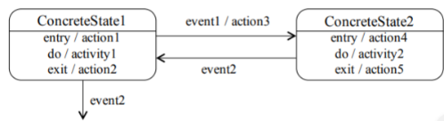  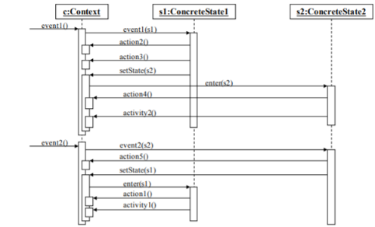  Q1)Describe in a few lines the main risks and benefits associated with the reuse of software, in particular commercial or open-source software: Risks: cost of adapting if component doesn't meet need exactly, provider may go out of business and we may no longer have support. Benefits: cost savings, reliability of “battle-tested” software.Q2) Explain the difference between centralized version control and decentralized version control (DVCS). Name and (briefly) describe a functionality that only exists for DVCS: Centralized VC: only one central, shared repository. Decentralized: every user has a copy of the entire repository. Functionality that only exists for decentralized VC: clone / fork (copy the entire repository).Q3) In the context of verification and validation, name and define two static analysis techniques (no more than one line for each). Two of: 1. Model checking: prove that software cannot reach an incorrect state, based on model (e.g. state machine) 2. Code reviews: a human reviews code or models produced by others in order to verify them. 3. Automated code analysis: a program reads the code looking for patterns of syntactically correct code but potentially problematic (e.g. a subclass has an attribute with the same name as in the super class, or equals is redefined but not hashcode).Q4) In the context of white-box testing, it is important to obtain high coverage of the code. Explain why this cannot be the only goal: One reason is that not all code is of equal importance: there should be high coverage in general, but the critical code (most important/frequent use cases) should be better covered. Another is that code coverage (lines) ignores path coverage, and when the code is complex and has many paths, 100% line coverage may still miss bugs that will occur when using particular paths.Q5) As a first prototype, your company will build a prototype implementation that is centralized (runs on a single computer, instead of over the internet), and only accepts up to 4 players. The system will not manage any user accounts or authentication. If the above classes are mainly relevant to the game engine, what other subsystems are needed to build this game? Clearly specify the responsibility of each subsystem: MVC (use Q6. VC).Q6) Propose a software architectural pattern to organize these subsystems. Illustrate it with a “block diagram” showing the dependencies between subsystems: M(game engine)V(user interface)C(collect user input). Q7) Extend this architecture (i.e. add new subsystems) for a distributed version, where the main game engine runs on a centralized server, and the players are all on remote machines. Your system design does not need to handle the user accounts and authentication. Note that the main design goal in this case would be to minimize the latency between the players and the server, to ensure that they get a real-time experience. Indicate if/how your design makes use of this aspect: Mainly a subsystem is needed on the server to handle the communication with the clients. Q8) In order to limit the traffic to the main game server, your boss wants the user accounts, authentication, and payments to be processed on a separate server in a different city. Describe a subsystem to handle this functionality: This subsystem should interface with Paypal and include a DB for persistent storage. Q9) Indicate the persistent storage needs of this subsystem: indicate what information needs to be stored, and give a detailed solution: The account information needs to be stored, and the funds associated with the account. A single relational table is enough, with username, password (encrypted), balance.Q10)Testing: We want to use the technique of input space partitioning, with respect to the number of books already borrowed. Give a partitioning of the input space and suggest values we should test. Explain your choice of values:The space of possible inputs is the possible numbers of borrowed books. Equivalence classes are (a) negative (should not happen) (b) 0-4 (user can continue) (c) 5: should terminate and (d) 6+ (should not happen). Values to test could be: -2 (robustness) 0, 2, 4 (class b including boundaries), 5, 6 (classes c and d at boundary.Q11)Describe why a stub might be needed to perform these tests. Indicate the purpose of the stub and describe its implementation:We need a stub to be able to test the system without connecting it to the main library system. The stub would simulate the main library system and return the given values as how many books the user has already checked out. Q12) Suppose that the PlanningService class needs to sort trips using one of the following algorithms: bubble sort, heap sort, or quick sort. The selection of an algorithm will depend on the context: Strategy pattern for the selection of any of the sorting algorithms at run time. Q13)You are creating an application that needs functionality for logging.Log requests will come from different sources and need to be written to the file:Command pattern to decouple the invocation of a command (i.e., the requests for logging from different places in the system) from the command execution (i.e., the actual logging done by the receiver of the command). Q14) A design solution for pluggable software components, i.e., a design where components are viewed as clients and servers: Adaptor pattern for converting the interface of the TaxCalculator (target) into the interface of the pluggable component (adaptee) that computes the taxes. Each pluggable component may have a different interface, hence it needs its own adaptor. Driver: Component calls the tested unit. Controls test cases (integration testing). Stub: Component the test unit depends on (partially implemented, returns fake values.) | 

