Chapter 3. Displaying and Summarizing Quantitative Data
The Learning Objective
The objective of this lecture is to provide you with the tools to:
- Display quantitative data with graphs:
  - Histogram
  - Stem-and-leaf plot
  - Dotplot
  - Boxplot
- Summarize quantitative data, with measures of centre and spread:
  - Median and IQR (Interquartile range: Upper Quartile (Q3) – Lower Quartile (Q1))
  - Mean and standard deviation
- Calculate the 5-number summary and make a boxplot
- Dealing with outliers
Distribution of Data
- The pattern of variation of a variable is called “distribution”.
- We need to plot data in order to realize its pattern.
- In any graph of data, look for overall pattern and for striking deviations from that pattern.
- An important kind of deviation is an outlier – an individual value that falls outside the overall pattern.
Visualizing A Quantitative Data with a Histogram
Histogram displays the entire distribution of a quantitative variable. How are they constructed?
- Slice up all possible values into bins.
- Then count the number of cases that fall into each bin.
- Attached bars (bins) with interval scale (equal width).
- The bins, together with these counts give the distribution of the quantitative variable.
- A gap in the histogram indicates that there a bin with no cases in it.
- There are usually between 5 to 30 bins, unless for very large data sets there may be more number of bins.
- Number of bins depend on the sample size.
- Appropriate number of bins:
  - not too little; not too many
  - StatCrunch software, automatically creates bins.
Shape of a Histogram
For the shape of a histogram, we need to detect:
Any peak in the graph:
Does it have a single peak (one hump/mode), or several peaks (humps/modes).
  - Histogram with one peak/mode is called “unimodal”.
  - Histogram with two peaks is called “bimodal”.
  - Histogram with three or more peaks is called “multimodal”.
  - A histogram with no apparent mode in which all the bars are about the same height is a uniform distribution.
Note: Value on the horizontal axis of the histogram is the mode.
Whether it is symmetric:
- Fold the histogram along a vertical line in the middle and see if the edges match closely.
Whether it is skewed to the right or to the left:
- Skewedness occur when an observation (or a few observations) is deviated from the overall pattern of the data.
- See if the thinner ends of a distribution, tails, pull the distribution to their side.
- If one tail stretches out farther than the other, then the histogram is skewed toward the side of the longer tail.
Common Shapes of A Histogram
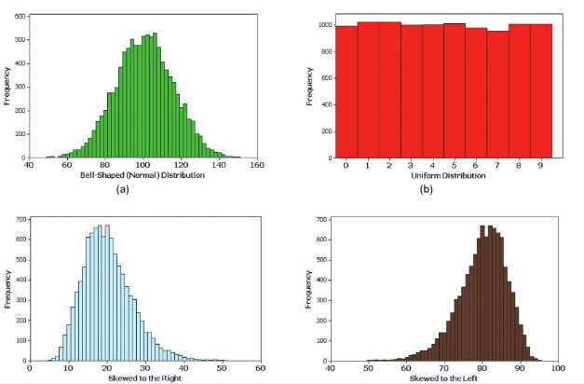

Example of a Bimodal Distribution Depicted by a Histogram

- Bimodal: We see two peaks in a plot
- (this plot, regarding sugar content (in %) cereals suggest accounting for two groups in the data:
low sugar, high sugar)

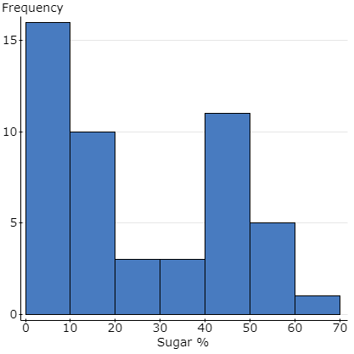
A Guide to Construct Stem-and-leaf Display
- Find the largest and the smallest number.
- Split all numbers into two parts: the stem and the leaf.
- The stem is the left part of the number and the leaf is the right part.
- The stem consists of a column of numbers in sequence starting with the smallest (or largest).
- The number of stems depends on the size of the data (sample size).
- Small data sets should have few stems.
- To figure out the number of stems, take the stem part of the smallest number and subtract from the stem part of the largest number.
  - If the number of stems is less than 5, repeat stems.
- Write the leaf part for every number on the same line as its stem.
- If you do not have any numbers that go into a bin for a stem line of the first and last row of the stem and leaf display, you will delete these lines; but if there are no numbers that go into the bins associated with a stem in other rows (not the first and/or last row(s)) you will leave the stem line(s) empty.
- For the leaf:
  - use only 1 digit and drop the rest of the number.
  - Do not round.
- Do not use commas.
Construct By Hand: Stem-and-leaf Display of Educational Attainment %
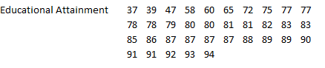
Centre and Central Tendency
Centre:
A typical value in the data.
Central tendency:
- It is a statistical measure (e.g., average, middle) to determine a single score that defines the centre of a distribution.
- The goal of central tendency is to find the single score that is most typical or most representative of the entire group.
- The three measures of central tendency are Mean, Median, and Mode.
Mean of A Quantitative Variable
Think of the mean (average) as:
- Amount of something that individuals receive when the total is divided equally among them in a distribution.
- The mean is a balance point.
- The mean is located between the lowest and the highest data value.
- The total distance below the mean is the same as the total distance above the mean.
Finding Mean or Average:
We sum all of the observations from a particular variable that we are interested in finding its mean, and divide by the total number of cases of the same variable.
Note:
- The mean gets influenced by the extremely large or small observations (unusual, rare observations) in the data.
- The mean is not resistant (“sensitive”) to extreme values in the data.
- Mean of a population is denoted by $μ$.
Population Mean =$μ=\frac{\sum_{i=1}^{N}{y_{i}}}{N}=\frac{sum of all values in the poulation}{Population size}$
The sum $\sum{\left(greek upper case letter sigma\right) }$taken over all i values from 1 to N.
- Mean of a sample is denoted by $\overline{y}\left(y-bar\right)$ (or $\overline{x}$or M).
Sample Mean = $\overline{y}=\frac{\sum_{i=1}^{n}{y_{i}}}{n}=\frac{sum of all data values in the sample}{sample size (number of cases in the sample)}$
The sum $\sum{\left(greek upper case letter sigma\right) }$taken over all i values from 1 to n.

Median of a Quantitative Distribution
- For skewed distributions, we report the median.
- Median is the middle value in the sorted data from smallest to largest.
- To find median, list data values from smallest to largest. The median is the midpoint (middle number) of the list.
- Median is the 50th percentile. It is a point on a measurement scale such that 50% of the data values are below it and 50% of the data values are above it.
Sample Median:
- In odd numbered data: $\frac{n+1}{2}$ position (the middle number in ordered data)
- In even numbered data: average of $\frac{n}{2} and\left(\frac{n}{2}+1\right)$ position (the average of two middle numbers in ordered data).
Note:
- The median is resistant (not sensitive) to values that are extremely large or small. Because the median takes the order of the data values into account and not what the actual values are.
Mode of a Variable
- Mode is a value that occurs most frequently in the frequency distribution.
- It is a the location of peak (or peaks) in the frequency distribution graph.
- Mode is typically used for categorical variables measured on a nominal scale.
- Mode is also used for discrete variables.
- By knowing the mean, median, and the mode of data, we can have a better picture of the data.
The Spread of a Quantitative Distribution
How spread out are data?
- Spread tells us how much data vary around its centre.
- How far from the mean or the median do the observed values tend to be?
Variability describes the distribution.
- It provides a quantitative measure of the differences between scores in a distribution and describes the degree to which the scores are spread out or clustered together.
- It measures how well an individual score (or group of scores) represents the entire distribution.
- It provides how much error to expect if you are using a sample to represent a population.
When we describe a distribution numerically, we always report measure of its spread along with its centre.
- There are several measure of spread: Range, Interquartile range, Variance and Standard deviation.
Range
- Range is a simple measure of spread.
- It is calculated as Maximum value – Minimum value
Measure of Variability: Interquartile Range (IQR)
- IQR is the range of the middle half of the data. 50% of the data fall in this range.
- To find IQR, we divide the data into quartiles.
  - We define the median of the data as the second quartile (Q2, 50th percentile). It has half (50%) of the data below and half (50%) of the data above it.
  - We define the median of the first half as the first quartile (Q1, 25th percentile). It has 1/4 (25%) of the observations below it and 3/4 (75%) of the observations above it.
  - We define the median of the second half as the third quartile (Q3, 75th percentile). It has 3/4 (75%) of the observations below it and 1/4 (25%) of the observations above it.
- IQR is: 75th percentile (Q3 ) – 25TH percentile (Q1)
Note: IQR is NOT (or less) affected by (resistant to, not sensitive to) outliers.
Quartiles in the Data
- The Quartiles together with the median (Q2) split the distribution into four parts.
- Each part contains one-fourth of the observations.
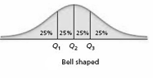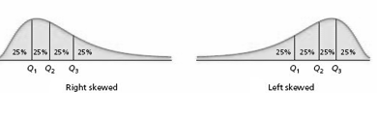
5-number Summary Statistics:
Nice Features for Data Visualization (Boxplot – next slide)
The 5-numbers Summary Statistics provide a simple description of the data. These are:
- Minimum: Smallest value in the data
- Lower quartile (Q1): 25th percentile
- Median (Q2): 50th percentile
- Upper quartile (Q3): 75th percentile
- Maximum: Largest value in the data
Box Plot: Graphing 5-Number Summary of Positions
- Boxplot is designed by John W. Tukey.
- Boxplot utilizes the 5-number summary statistics. For example:
min=37, Q1=77, median=82, Q3=87.5, max=94
- It reflects the shape of the data.
- It summarizes both the centre and the spread.
- The box of the box plot contains, 50% of the data, from Q1 to Q3.
- The median is marked by a line drawn within the box but it is not necessarily in the middle of the box.
- The line extending from the box are called whiskers.
These extend to minimum and the maximum data values,
except for extreme values (potential outliers), which are marked separately with a circle on the plot.
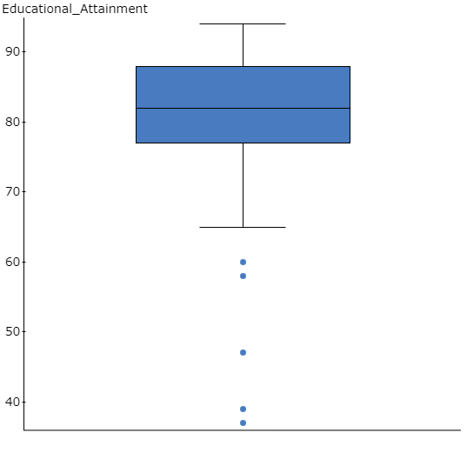
- Aside: IQR= Q3- Q1
- Rule= 1.5 x IQR
Outliers
- Outliers (potential outliers) are observations that are plotted in the lowest or in the highest end points in the data that appear to be deviated from the rest of the data.
- They are also refereed to as extreme values in the data.
- They tell us something interesting or exciting about the data.
- They can be very informative and can affect almost every statistical method.
- We need to investigate outlying points in the data.
- They could be a wrong input in the data; in that case, we can fix it (correct it with the right value).
- If they are correct values, we need to understand their value and explain them.
- We need to employ statistical analysis with and without outliers and describe how they affect our data analysis.
- Note: we do not simply remove outliers from any data set without investigating them.sc
Drawing the Box Plot
. Locate the min and the max on a horizontal line
2. Locate the median, draw a vertical line above the median (away from horizontal line).
3. Locate Q1, and Q3, and draw vertical lines above these values.
4. Draw a rectangle using the vertical lines from Q1, Q2, and Q3.
5. Calculate IQR = Q3 – Q1= 87.5 – 77 = 10.5
6. Calculate 1.5 IQR = 1.5 x 10.5= 15.75
7. Calculate inner fences:
- Lower inner fence = Q1 – 1.5(IQR) = 77 - (1.5(10.5)) = 77 – 15.75 = 61.25
- Upper inner fence = Q3 + 1.5(IQR) = 87.5 + (1.5(10.5)) = 87.5 + 15.75 = 103.25
- Draw lines (whiskers) connecting the box to the most extreme value within fences:
- From Q1 draw a line to a value ≥ 61.25 (greater than or equal to 61.25) in the data (in our example it will be 65).
- From Q3 draw a line to a value ≤ 103.25 (less than or equal to 103.25) in the data (in our example it will be max = 94).
- Plot values outside fences individually. In our example, we plot 37, 39, 47, 58, & 60 individually.
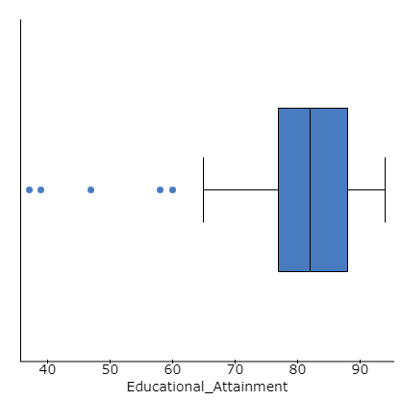
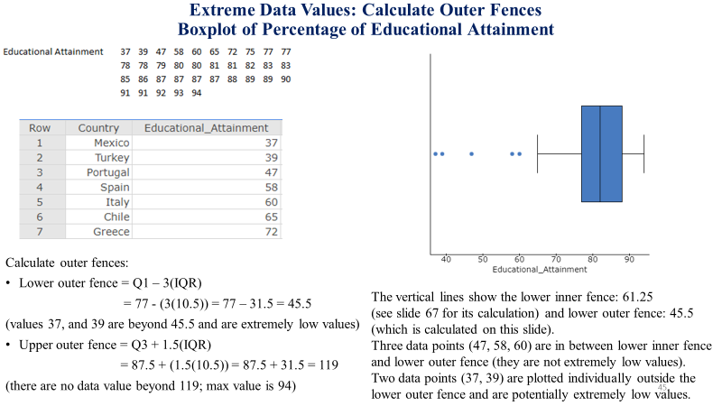
Extreme data vales beyond Fences
- Data values beyond 1.5(IQR) from either Q1 or Q3 are suspect outliers.
- Moreover, data values that are 3(IQR) away from either Q1 or Q3 are “potentially” extreme (low or high) observations, and therefore, need to be further investigated for their impact on statistical analysis; Such data points are considered rare, unusual, and unlikely.
- However, data points that fall in between 1.5(IQR) and 3(IQR) from either Q1 or Q3 are not necessarily outliers. They are only suspect outliers.


