Department of Physics

Course Number | PCS 120
Course Title | Physics
Semester/Year | Fall 2019
Instructor | Eric DeGiuli
TA Name | Mathew Rajic

Lab/Tutorial Report No. | Lab 1

Report Title | Identification of Metals by Density

Section No. | Section 222
Group No. | 193
Experiment Date | Sept 19, 2019
Due Date | Sept 26, 2019

Student Name | Student ID | Signature
(Note: remove the first 4 digits fr
Objective
The purpose of this experiment was to identify an unknown metal by calculating its density using three distinct methods and using the uncertainties of the density in each method to ultimately determine which method resulted in the most accurate determination of the metal. The first two methods were using a meter stick and Vernier calipers to determine the dimensions of the block. The mass of the block was also measured using the triple beam balance. Eventually, these dimensions were used to find the volume of the block and ultimately, to determine the density of the unknown metal using the relationship between mass and volume. Another method used was the water displacement method which was used to find the volume of the block by observing the volume of water displaced in a beaker. Therefore, the three different measurements of the volume of the block along with the measurement of the mass of the block were utilized to determine three different measurements of density(using the formula, density=mass/volume). Finally, the objective was reached and the three densities were compared using error analysis to determine which method was most accurate in determining the identity of the unknown metal.

Background Information:
All measurements, specifically in science, are subject to some uncertainty or error. During experiments, scientists usually record their results using experimental uncertainties to ensure that the correct measurement falls within the range of uncertainty. It is important to understand that the density of a metal is unique to itself, thus it can determine a metal’s identity. Therefore, using the measured density and the range of uncertainty, the identity of the unknown metal can be reasoned. The scientific significance of the experiment is to understand the importance of uncertainties and how they affect the precision of data.
Theory
In this experiment, the objective was to find the density of the unknown metal and to use uncertainties to determine the most accurate method of finding density. This is accomplished by the use of the density equation, p=m/v, where p is the density of the metal, m is its mass and V is its volume. The block’s density is its mass per unit volume and the SI units of density are grams per cubic centimeter. The mass and volume of the unknown metal were measured experimentally. The mass of the block was measured on the balance and the volume was measured in three different ways: meter stick, Vernier calipers and the water displacement method. Thus, after determining the mass and volume, the density of the block was calculated using the density formula. It is also crucial to pay close attention to the uncertainties of the density measurements in each method. This is because when using measuring equipment (rulers, clocks, triple beam balance, etc.) there is an amount of uncertainty of the measured value, regardless of it being well-made equipment. In physics, uncertainty and error are included to inform how accurate a measuring instrument is. For example, a measurement of 7.07± 0.05 mL means that the experimenter is certain the actual value for the quantity being measured is between 7.02 mL and 7.12 mL. 0.05 mL in this case is the uncertainty that the experimenter believes is the best estimate of how far a experiments quantity is from the “true value” instead of stating a precise point value which may be inaccurate. Furthermore, error analysis such as percent error for the three different methods helped to determine which method was the most precise and closest to the theoretical value.

A. Density Formula B. Volume Formula
p=m/V V=lwh
Where: Where:
p is the density of the metal V is the volume of the metal
m is the mass of the metal l is the length of the unknown metal
V is the volume of the metal w is the width of the unknown metal
h is the height of the unknown metal

C. Uncertainty Formula for Volume D. Uncertainty Formula for Density$ΔV÷V=\sqrt{{\left(Δl÷l\right)}^{2}+{\left(Δw÷w\right)}^{2}+{\left(Δh÷h\right)}^{2}}$ $Δp÷p= \sqrt{{\left(Δm÷m\right)}^{2}+{\left(ΔV÷V\right)}^{2}}$
Where: Where:
$ΔV$is the volume uncertainty $Δp$is the density uncertainty
V is the volume of the metal $p$is the density of the metal
$Δl$is the length uncertainty $Δm$is the mass uncertainty
$l$is the length of the block $m$is the mass of the metal
$Δw$is the width uncertainty $ΔV$is the volume uncertainty
$w$is the width of the block $V$is the volume of the metal
$Δh$is the height uncertainty
$h$is the height of the block

E. Percent Error Formula

% Error = $\frac{l Experimental value - Theoretical value l }{Theoretical value }$× 100

Procedure
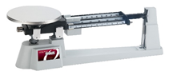
- The mass of the unknown metal was measured using a triple beam balance. The result was recorded with the appropriate uncertainty including an explanation of how the uncertainty was determined.
Triple Beam Balance
- The dimensions (length, width and height) of the unknown metal were measured using a meter stick. The result was recorded with the appropriate uncertainty including an explanation of how the uncertainty was determined.
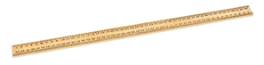

Meter Stick

- The dimensions (length, width and height) of the unknown metal were measured using Vernier Calipers. The result was recorded with the appropriate uncertainty including an explanation of how the uncertainty was determined.
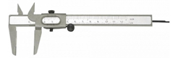

Vernier Caliper

- The volume of the unknown metal was measured using a water displacement method:

- The metal was placed in a beaker (Figure 1) of water and once it was submerged, the height of the water level was marked.
- The block was removed from the beaker of water once done marking the water level.
- A graduated cylinder (Figure 2) was filled to 100 mL.
- Water from the graduated cylinder was slowly poured back into the beaker until the water reached the original level that was marked from step (A).
- The amount of water left in the graduated cylinder is recorded which will help determine the volume of the block
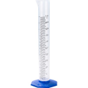
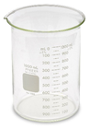

Beaker Graduated Cylinder

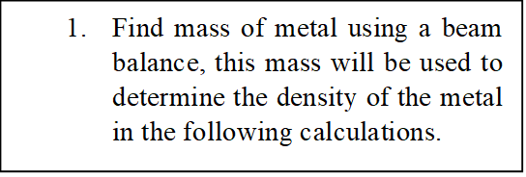
Observation and Results

Triple Beam Balance
Mass of Block | 91.5 ± 0.05 g

Water Displacement
Volume of Water and Block | 300mL ± 1mL
Volume of Water without Block | 270mL ± 1mL
Volume of Block | 30.0mL ± 1mL  Volume of water and block-volume of water without block=Volume of block  Therefore,  300mL- 270mL= 30mL
Graduated Cylinder Volume | 100mL ± 1mL
Water left in Graduated Cylinder after Filling Beaker to 300mL | 72.0mL ± 1mL
Volume of Block | 28.0mL ± 1 mL  Graduated Cylinder Volume- Water left in Graduated Cylinder after Filling Beaker to 300mL=Volume of Block  Therefore,  100mL- 72mL=28mL

Calculating Uncertainty:
To calculate uncertainty, divide the smallest increment on the measuring device by two, unless the uncertainty is already stated on the device. Then you add and subtract this value from the experimental value to find the range of the experimental value that the real value may fall in.

Finding Uncertainty for the Beaker:
The uncertainty of the beaker will be ± 1 mL because it was given on the beaker.

Calculating Density (Water Displacement):

Mass of Block : 91.5 ± 0.05 g
The volume of the block is 28mL or 28cm³
Since 1mL=1cm³
P = m/V
= 91.4 g / 28.0 cm³
= 3.268 g/cm³
= 3. 27 g/cm³
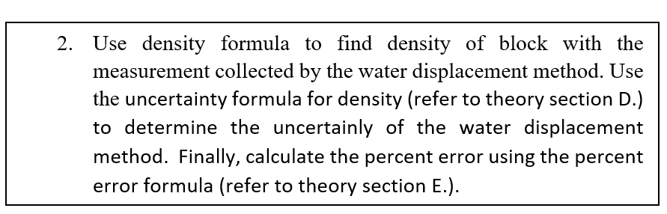
$Δp÷p= \sqrt{{\left(Δm÷m\right)}^{2}+{\left(ΔV÷V\right)}^{2}}$

$=P \sqrt{{\left(0.05÷91.5\right)}^{2}+{\left(1÷28.0\right)}^{2}}$

$=3.27 \sqrt{{\left(0.000000298\right)}^{}+{\left(0.00128\right)}^{}}$

$=3.27 \sqrt{ {0.00128}^{}}$

$=3.27 (0.0358)$

$=0.117 g/cm ³$

$=0.12 g/cm ³$

Therefore, P = $3.27$ g/cm³ ± 0.12 g/cm ³

Therefore, P =$3.15$ g/cm³ - $3.39$ g/cm ³

% Error = $\frac{l Experimental value - Theoretical value l }{Theoretical value }$× 100

= $\frac{l 3.27 - 2.70 l }{2.70 }$× 100

= 21%
Meter Stick
Length | 3.50 cm ± 0.05cm
Width | 3.20 cm ± 0.05 cm
Height | 3.10 cm ± 0.05 cm

Finding Uncertainty for a Meter Stick:
The smallest increment on a meter stick is 0.1cm, therefore the uncertainty will be (0.1cm$÷$2) which is 0.05cm.

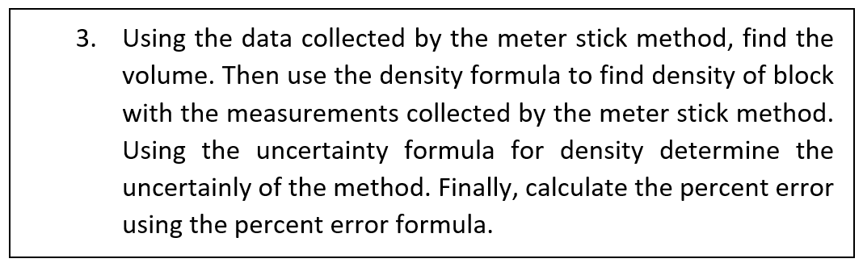
Calculating the Volume using Meter Stick:

Volume = lwh
= (3.50 cm) (3.20 cm) (3.10 cm)
= 34.72 cm³
= 34.7 cm³

$$ΔV÷V=\sqrt{{\left(Δl÷l\right)}^{2}+{\left(Δw÷w\right)}^{2}+{\left(Δh÷h\right)}^{2}}$$

$$=V\sqrt{{\left(0.05÷3.50\right)}^{2}+{\left(0.05÷3.20\right)}^{2}+{\left(0.05÷3.10\right)}^{2}}$$

$=34.7 \sqrt{{\left(0.000204\right)}^{}+{\left(0.000244\right)}^{}+{\left(0.000260\right)}^{}}$

$=34.7 \sqrt{ 0.000708}$

$=34.7 (0.266)$

$=0.923 cm³$

$=0.9 cm³$

Therefore, Volume = 34.7 cm³ ± 0.9 cm³

Calculating Density (Meter Stick):
P = m/V
= 91.4 g / 34.7 cm³
= 2.637 g/cm³
= 2.64 g/cm³

$$Δp÷p= \sqrt{{\left(Δm÷m\right)}^{2}+{\left(ΔV÷V\right)}^{2}}$$

$=P \sqrt{{\left(0.05÷91.5\right)}^{2}+{\left(0.9÷34.7\right)}^{2}}$

$=P \sqrt{{\left(0.000000298\right)}^{}+{\left(0.000673\right)}^{}}$

$=2.64 \sqrt{ {0.000673}^{}}$

$=2.64 (0.02595)$

$=0.069 g/cm ³$

$=0.07 g/cm ³$

Therefore, P = 2.64 g/cm³ ± 0.07 g/cm ³

Therefore, P = 2.71 g/cm³ - 2.57 g/cm ³

% Error = $\frac{l Experimental value - Theoretical value l }{Theoretical value }$× 100

= $\frac{l 2.64 - 2.70 l }{2.70 }$× 100

= 2.2 %

Vernier Caliper
Length | 3.50 cm ± 0.03cm
Width | 3.16 cm ± 0.03 cm
Height | 3.10 cm ± 0.03 cm

Finding Uncertainty for Vernier Caliper:
The smallest increment on a vernier caliper is 0.05cm, so the uncertainty will be (0.05cm$÷$2) which is 0.025cm and this will be rounded to 0.03cm.

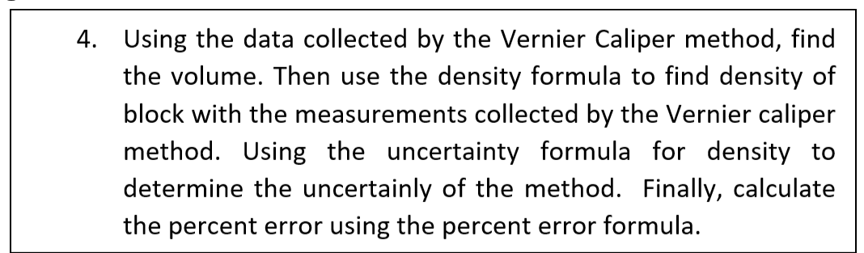
Calculating the Volume using Vernier Caliper:
Volume = lwh
= (3.50 cm) (3.16 cm) (3.10 cm)
= 34.3 cm³

$$ΔV÷V=\sqrt{{\left(Δl÷l\right)}^{2}+{\left(Δw÷w\right)}^{2}+{\left(Δh÷h\right)}^{2}}$$

$$=V\sqrt{{\left(0.03÷3.50\right)}^{2}+{\left(0.03÷3.16\right)}^{2}+{\left(0.03÷3.10\right)}^{2}}$$

$=34.3 \sqrt{{\left(0.00857\right)}^{2}+{\left(0.0049\right)}^{2}+{\left(0.00968\right)}^{2}}$

$=34.3 \sqrt{{\left(0.0000735\right)}^{}+{\left(0.0000901\right)}^{}+{\left(0.0000937\right)}^{}}$

$=34.3 \sqrt{ 0.0002576}$

$=34.3 (0.01604)$

$=0.6 cm$

Therefore, Volume = 34.3 cm³ ± 0.6 cm³

Calculating Density (Vernier Caliper):
P = m/V
= 91.4 g / 34.3 cm³
= 2.67 g/cm³

$$Δp÷p= \sqrt{{\left(Δm÷m\right)}^{2}+{\left(ΔV÷V\right)}^{2}}$$

$=P \sqrt{{\left(0.05÷91.5\right)}^{2}+{\left(0.6÷34.3\right)}^{2}}$

$=P \sqrt{{\left(0.000000289\right)}^{}+{\left(0.000306\right)}^{}}$

$=2.67 \sqrt{{\left(0.000000289\right)}^{}+{\left(0.000306\right)}^{}}$

$=2.67 \sqrt{ {0.000306}^{}}$

$=2.67 (0.0175)$

$=0.0467$

$=0.05 g/cm ³$
Therefore, P = 2.67 g/cm³ ± 0.05 g/cm ³

Therefore, P = 2.72 g/cm³ - 2.62 g/cm ³

% Error = $\frac{l Experimental value - Theoretical value l }{Theoretical value }$× 100

= $\frac{l 2.72 - 2.70 l }{2.70 }$× 100

= 0.7 %

Discussion and Conclusion
Overall, the experiment succeeded in identifying the most accurate determination of the metal. The most accurate method was Vernier Calipers, followed by the meter stick method and lastly the water displacement method. The density measurement collected from the Vernier Caliper method has an error of 0.7%, which is more precise than the meter stick method (2.2% error) and the water displacement method (21% error). Percent error determines the precision of the calculation and portrays how close the experimental value is to the theoretical value. Therefore, a small percent error represents a more precise representation of the measured value. With the accuracy of the Vernier Calipers (p=2.72g/cm³) and by using the known density equation (p = m/V), it can be reasoned that aluminum was the unknown metal (p=2.70g/cm³). The density of aluminum fell in the range of experimental uncertainty and was calculated to be 2.67 g/cm³ ± 0.05 g/cm³; it differed from the real value of 2.70g/cm³ by 0.7%. Therefore, the range of experimental values for the Vernier Caliper method falls between 2.62g/cm³ and 2.72g/cm³. The density of aluminum (2.70g/cm³) fell in the measured experimental uncertainty range for the meter stick method of finding density(2.57g/cm³ to 2.71g/cm³), however the values differed by a percent error of 2.2%. The Vernier Caliper has very close markings which correlates to why it has the most precise dimensions and thus, the most accurate density and lowest percent error.

Furthermore, uncertainty is an estimate range of the experimental value in which the true value may fall. A smaller uncertainty represents that the experimental value is more accurate. The calculated densities make sense for the meter stick and Vernier Caliper method, but for the water displacement method, the results were out of range and not reasonable. The density of the unknown metal determined with the water displacement was in the range of 3.15 g/cm³ - $3.39$ g/cm ³, which has 21% error. The water displacement density value is quite far off from the true value of 2.70 g/cm³, which was provided in the Appendix. This inaccurate value may be the result of the water that was lost when taking out the block (Step 4. B in procedures) that wasn’t accounted for.
When performing the water displacement portion of the experiment, during the first part we started with 300mL in the beaker with water and the block. Afterwards, we had 270mL left in the beaker when the block was removed. Therefore, this indicates that the volume of the block is 30mL. However, the second part of this portion of the experiment required to use a 100mL graduated cylinder of water to fill the beaker back up to 300mL. After doing this, there was only 72mL of water left in the graduated cylinder, although there should’ve been 70mL left since we were pouring back the volume of the block which was 30mL. Therefore, this shows that the volume of the block is now 28mL. Since, it is impossible for the volume of the block to suddenly change, it is evident that some source of error caused this. The problem with this method is that it is an indirect calculation of volume and it relies on calculating the amount of water displaced by the block. This caused an incorrect measurement of the volume because when removing the block from the beaker, water was removed with the block and the volume of that water was not used in the calculation for determining the volume of the block. Furthermore, the measurement for volume could’ve been read incorrectly as a result of the piece of tape indicating the volume of water in the beaker being placed a little too high or low than the real value of the volume. For the second part of this method, when pouring the water from the 100mL graduated cylinder back into the beaker, the water may not have been poured to exactly where the tape was. Therefore, this method of calculating density is inaccurate and not reliable because it is an indirect calculation of the volume, so no calculations were involved.

All three methods of calculating the density had uncertainty as a result of error in measuring the mass. This is because when balancing the block on the triple beam balance, it was difficult to balance it exactly at zero, therefore, due to error in the experimental apparatus, the mass was some decimal points off. During the process of bringing the start value of the balance to 0g, the balance kept fluctuating around zero, however it never actually stopped precisely on zero. Therefore, when we measured the mass, the start value of the balance was a few decimal points below zero which caused this error. Since mass was used to calculate density in every method(p=m/V), it is a source of error that caused uncertainty for every method.

The meter stick density is not as precise in comparison to the Vernier Calipers, this inaccurate value can be due to the experimenters inability to align the ruler with the metal. Other problems can be if the end of the ruler is worn out and doesn’t actually correspond to zero. Another source of uncertainty while using the meter stick method to determine density can be a reading uncertainty. Some measurements of the dimensions of the block were in between the smallest marked increments of the meter stick, in this case, it was reasonable to estimate the final digit resulting in the density not being as precise. As a result, the meter stick had the second highest percentage error.

Even with the accuracy and precision of the readings collected by the Vernier Calipers, none of the uncertainties capture our theoretical value of 2.70 g/cm³ exactly. The density from this method ranges from 2.62 g/cm³ - 2.72 g/cm ³. The range of experimental values for the water displacement method was 3.15g/cm³ - 3.39g/cm³. Therefore, it is possible to assume that the unknown metal may be a composition of metals, such as aluminum and titanium. Since the values are closer to aluminum than titanium, the unknown metal could have a composition of majority aluminum with a little bit of titanium. It is rare to find pure aluminum, so this outcome may be possible. However, in this case, it is unlikely because the densities determined by the Vernier Caliper(0.7% error) and meter stick(2.2% error) method were very close to the real value, but the water displacement density was not (21% error) due to errors in calculating volume and mass.

Although using the Vernier Caliper provided the most precise result very close to the real value of the density of aluminum, there can be disadvantages to using them. Firstly, this measurement instrument can only be used for objects with straight edges. By using this measurement device for an object that does not have straight edges will result in uncertainty. Another disadvantage is that the scale is very small so it can be difficult to determine the exact measurement.

One way to improve the experiment is to reduce error for the water displacement method of finding density by reducing the amount of water removed with the block when measuring the volume. One way of doing this is measuring the volume of water on the block once it is removed, then adding that amount back into the beaker, and this way, the volume of the block will be more accurate. The equipment such as the balance to measure mass can be improved so that it is easier to balance it at 0g which will ensure that that mass is not a little higher or lower than the real value.

In conclusion, Vernier Caliper is the most accurate method to determine the volume of the block with only 0.7% error. The meter stick is also a reliable source to measure the volume of the block with a percent error of 2.2%. However, the water displacement method is an inaccurate method to determine the volume and did not give a precise determination of the unknown metal. Therefore, it is better to do direct measurements such as the meter stick and Vernier Caliper methods rather than indirect measurements such as the water displacement method which usually produces errors. The effect of uncertainties on precision was portrayed through this lab by determining the accurate determination of the metal.

