Lecture 1
- What’s a database?
  - An organized collection of inner-related data
- Terminologies
  - Relation: Basically, a table
  - Relation instance : specific instance of a relation
  - Database schema : overall design of database
  - Database instance : information stored in a database at particular moment
  - Tuple : a row in a table
  - Attribute: a column in a table
- Super key
  - One or more attributes that uniquly identify a tuple in a relation
- Candidate key
  - Minimal set of attributes in a super key that preserves the uniqueness of a tuple
- Primary key
  - A candidate key chosen by the database designer
- Foreign key
  - An attribute in a relation that is a primary key in another relation
- Relational Algebra
  - Set of operations that take one or two relations as input and produce a new relation as output
  - Unary operations operate on a single relation
  - Binary operations operate on two relations
  - No duplicates in relational algebra (definition of sets)
- Select Operation
  - Select tuple that satisfy given predicate
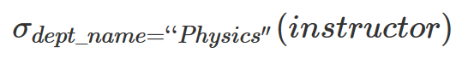
  - Ex. Select tuples from the relation instructor such that they have “Physics” ad their department

  - Example: Find instructors with salary greater than $90,000
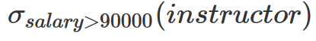

- Connectives
  - And $∧$
  - Or $⋁$
  - Not $¬$
  - Example: Find all instructors in Physics with salary greater than $90,000

- Project Operation
  - Select specific attribute in a relation
  - Example: Find the name and salary of all instructors
  - 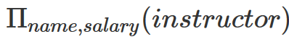
- Multiple Operation
  - Ex. Find the names of instructors in the Physics department
  - 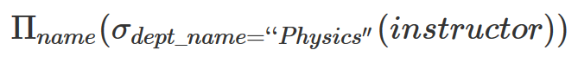
- Join Operation
  - Combine a selection and cartesian product into a single operation
  - Example: Find all instructors and the courses they are teaching
  - Using join operation:
- Set Operation
  - Ex. Find courses taught in the fall of 2017
  - Ex. Find courses taught in the spring of 2018
  - Ex. Find courses that are taught in the fall of 2017, the spring of 2018, or both

