Worksheet 1

Question 1
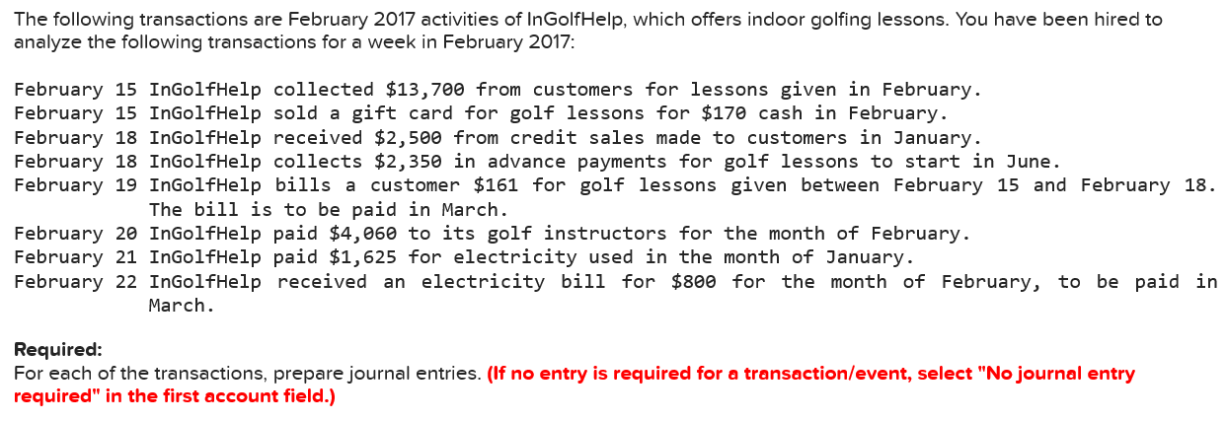
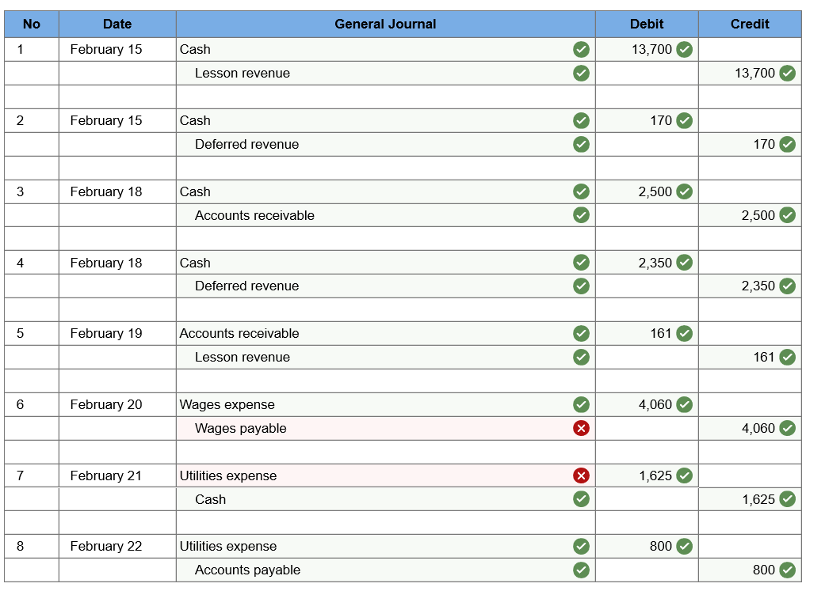

6. Dr. Wages Expense Cr.
Question 2:
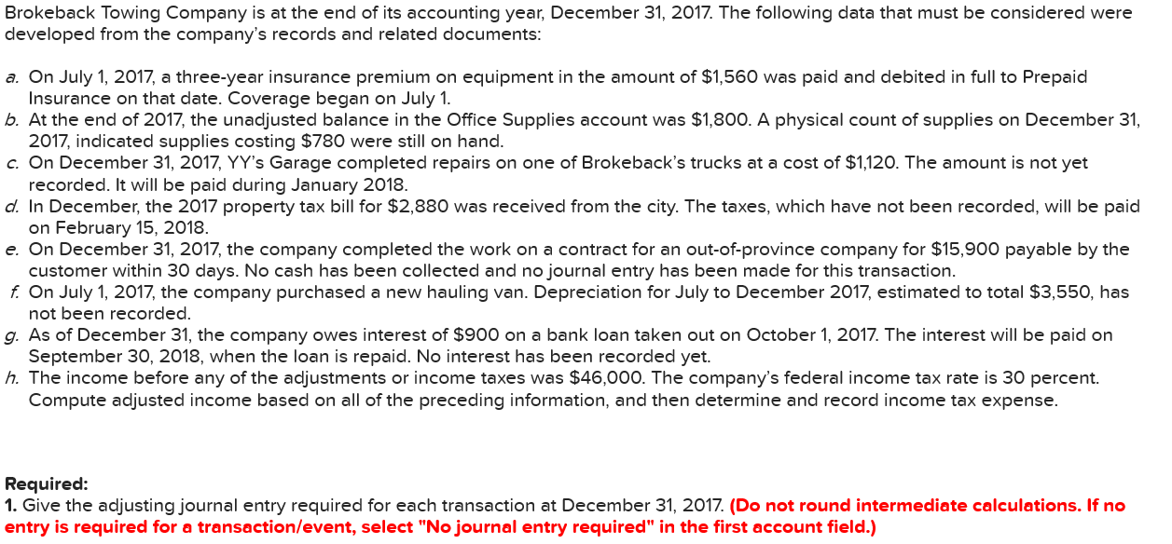
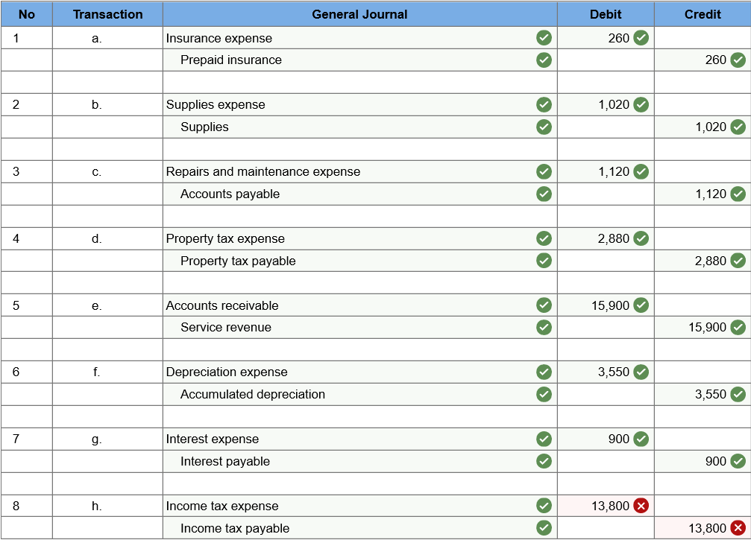
Question 3
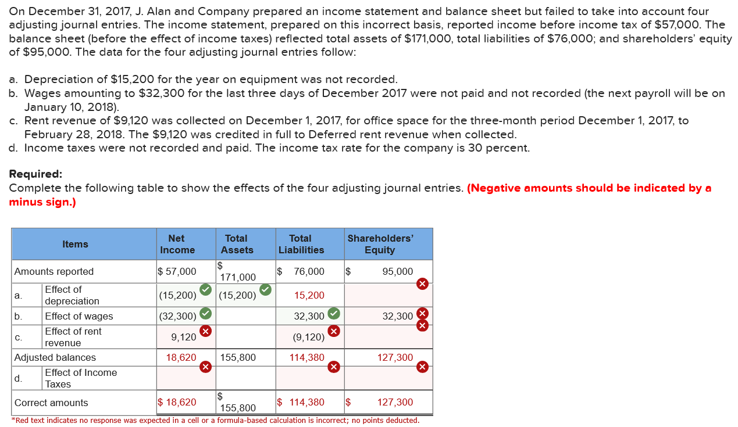

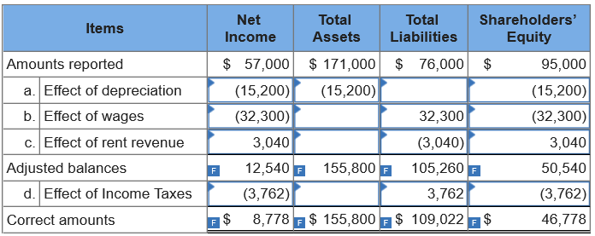

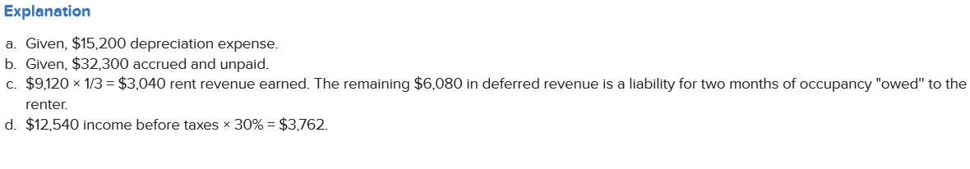

Worksheet 2
Question 1:

Question 2:
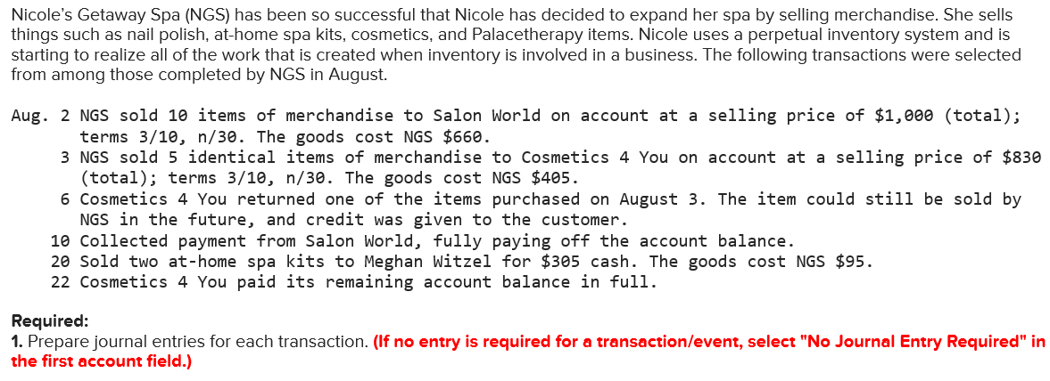
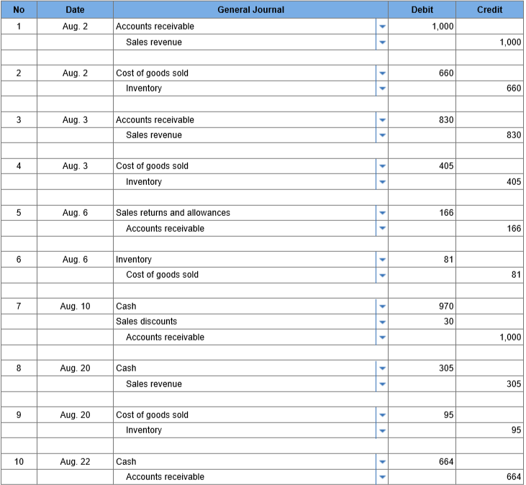
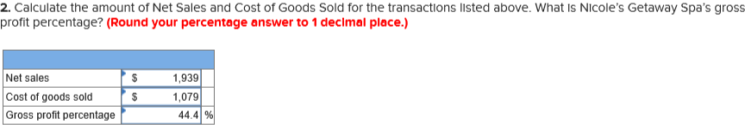

Question 3:
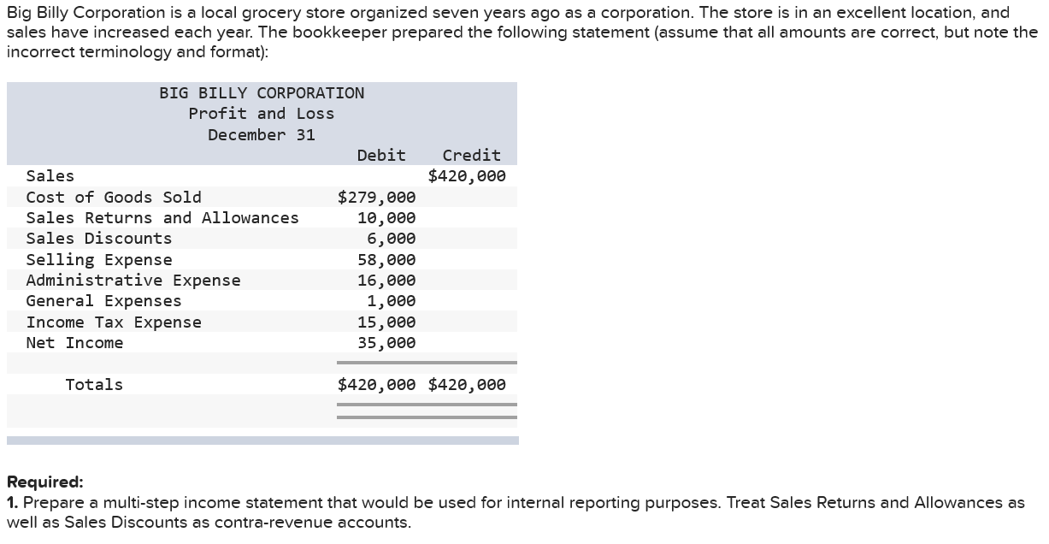
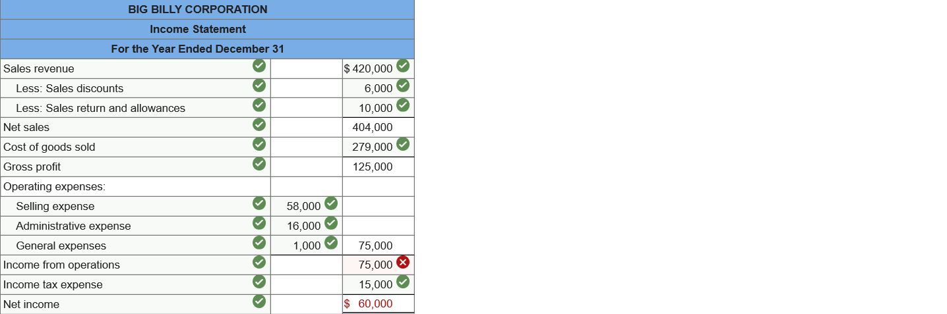

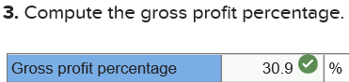
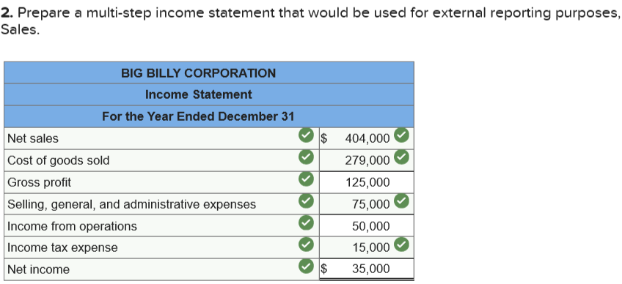
Question 4:
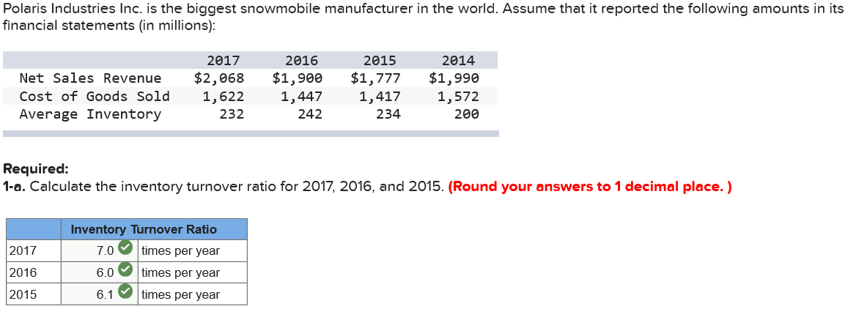

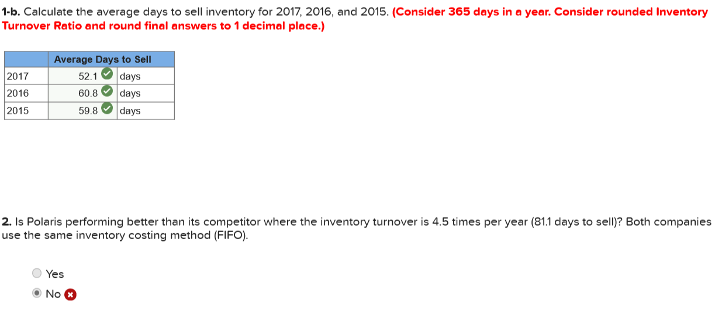
Question 5:
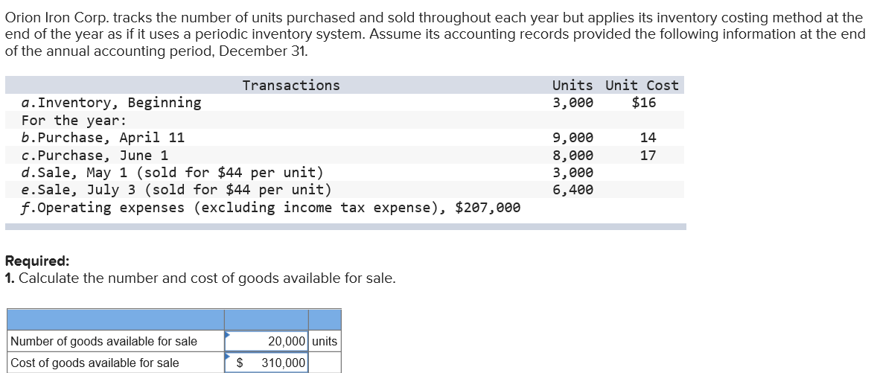
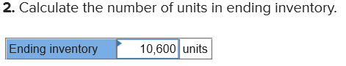
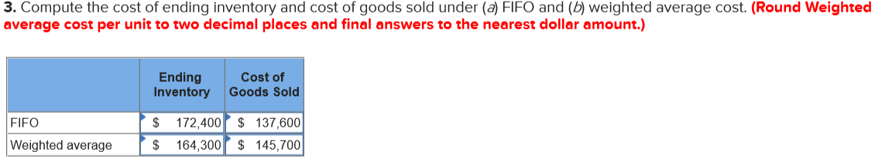
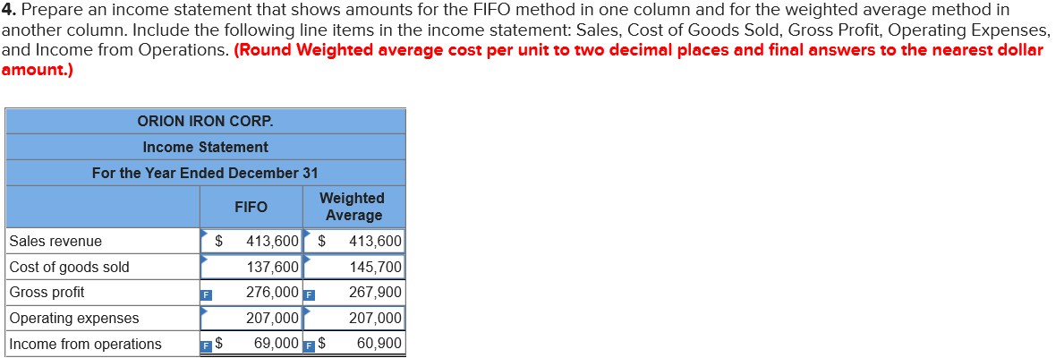
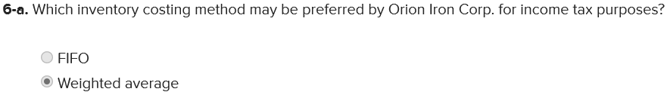
Question 6

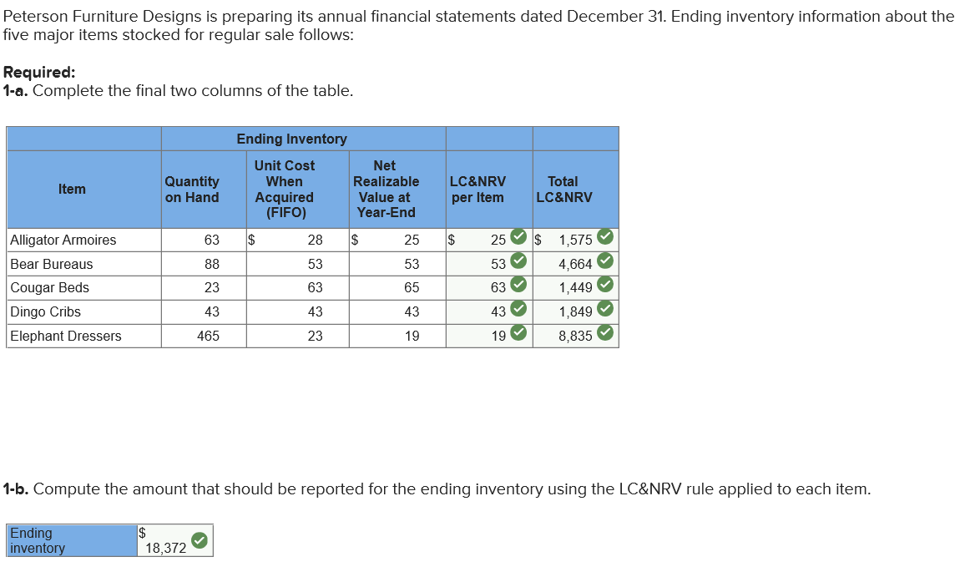

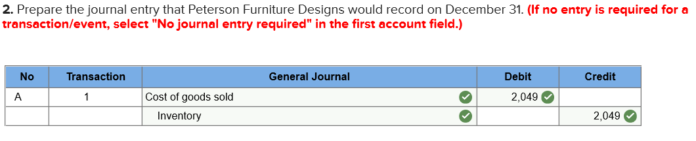

Worksheet 3

Question 1: Chapter 8 - Methods for Estimating Bad Debt
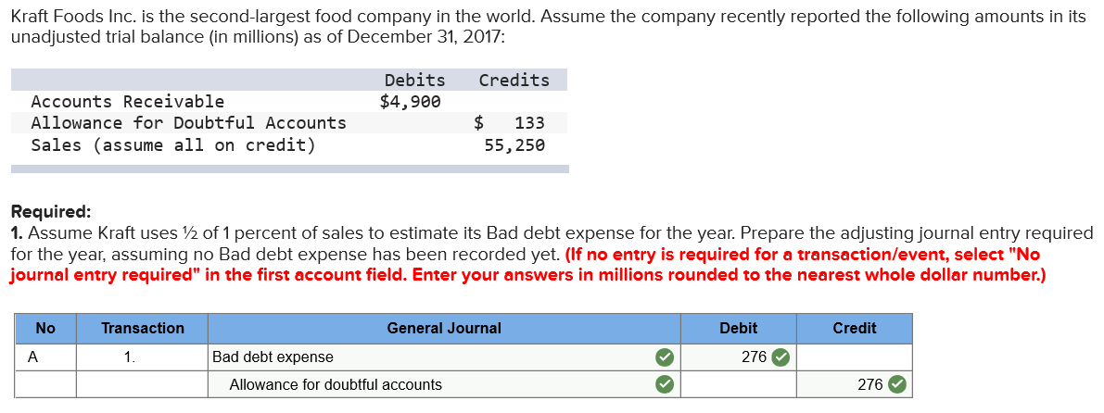

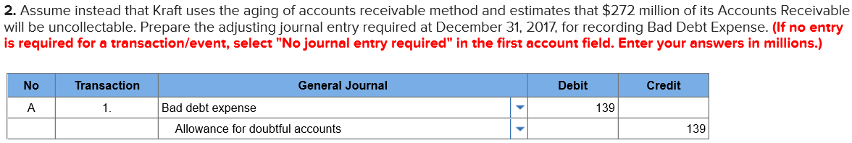
$272 - $133 = $139

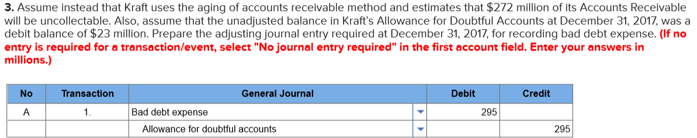
$272 – (-23) = $295

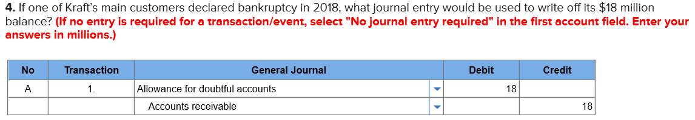

Question 2: Chapter 8 - Notes Receivable and Interest Revenue
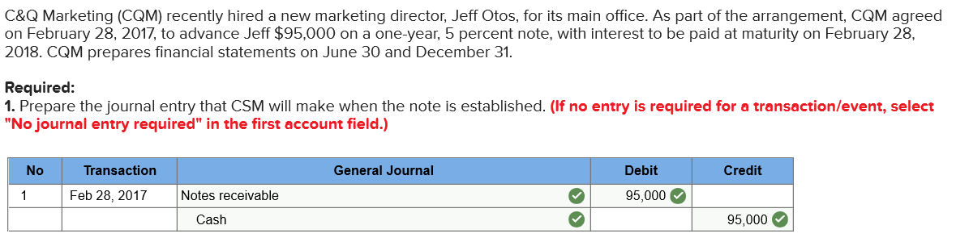

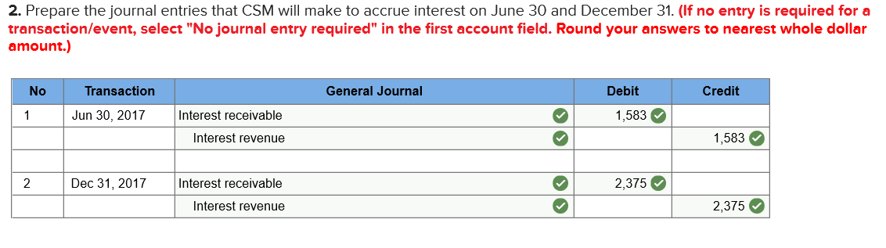
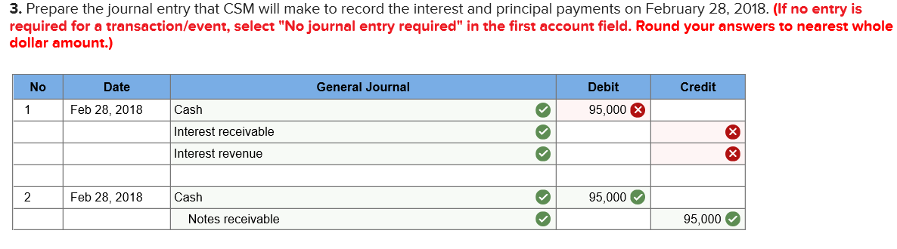
Explanation to 3
- Cash: (95,000 x 5%) = $4,750
- Interest receivable: ($1,583 + $2,375) = $3,958
- Interest revenue: ($95,000 × 5% × 2/12) = $792

Question 3:
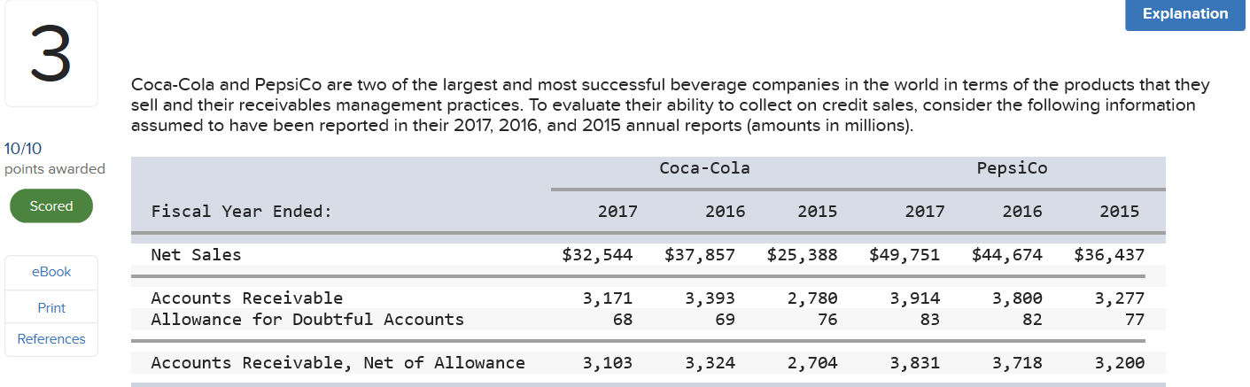

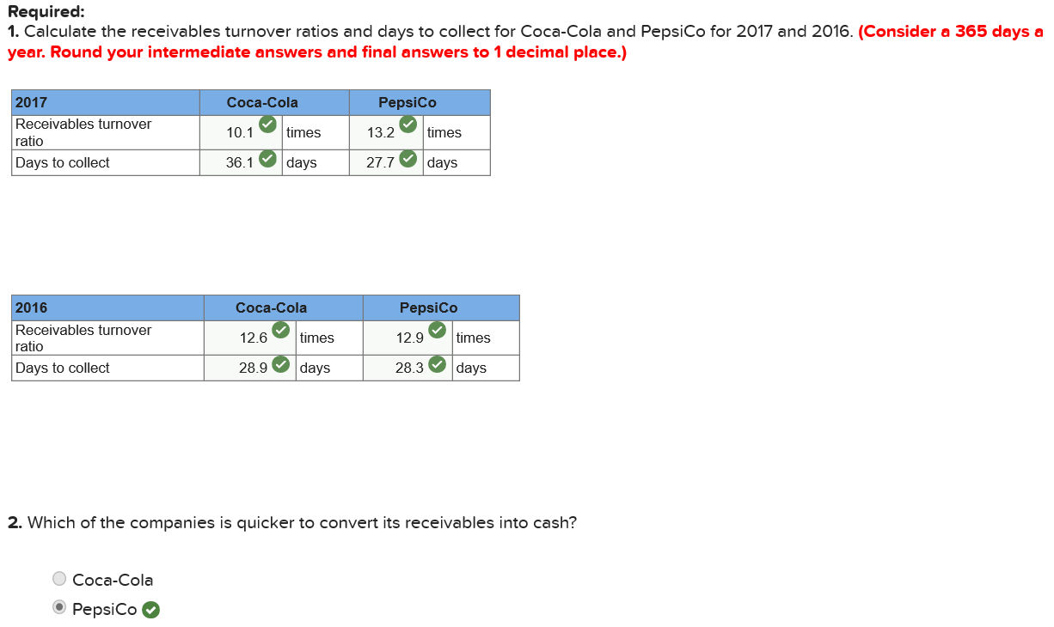

Receivables Turnover Ratio | = | Net sales
Receivables Turnover Ratio | = | Average net receivables
3114.67
Days to collect | = | 365
Days to collect | = | Receivables Turnover

Higher Turnover Ratio = Quickly convert receivables into cash
Question 4
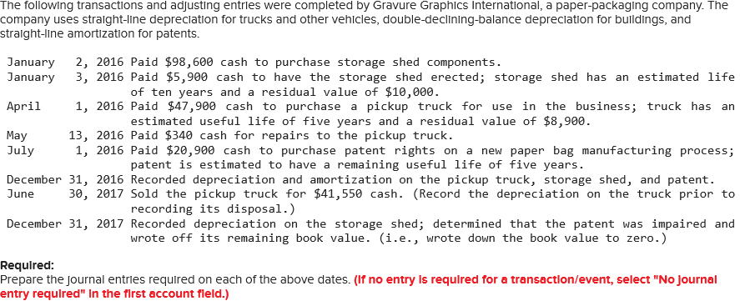
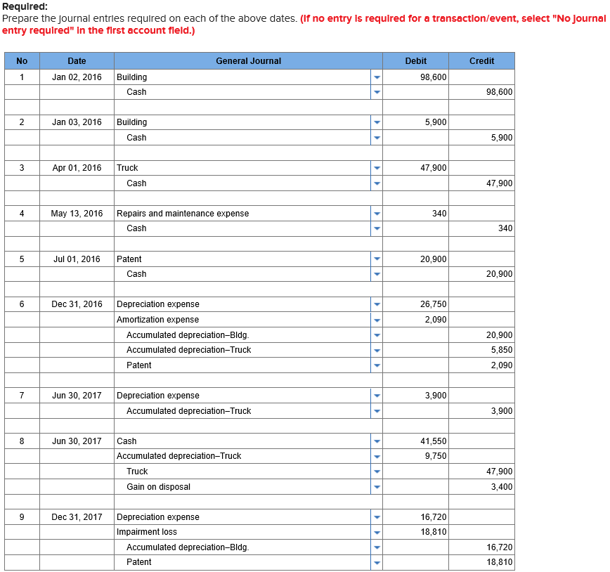
2016:
Building (double-declining-balance): ($98,600 + $5,900 − $0) × 2/10 = $20,900
Truck (straight-line, partial year): ($47,900 − $8,900) × 1/5 × 9/12 = $5,850
Patent (straight-line, partial year): $20,900 × 1/5 × 6/12 = $2,090
2017:
Accumulated depreciation–Truck: ($47,900 − $8,900) × 1/5 × 6/12 = $3,900
Building: ($98,600 + $5,900 − $20,900) × 2/10 = $16,720
Patent book value (prior to write-down): $20,900 − $2,090 = $18,810

Question 5
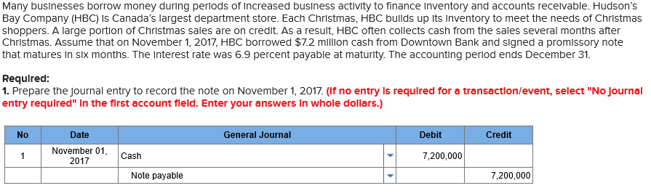
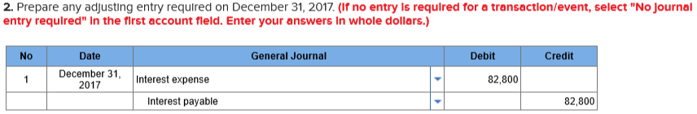
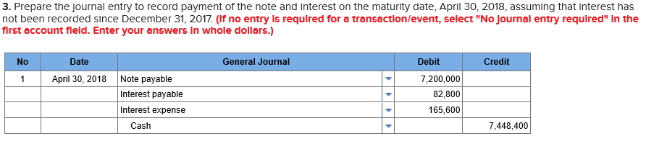
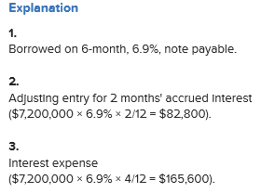

Question 6
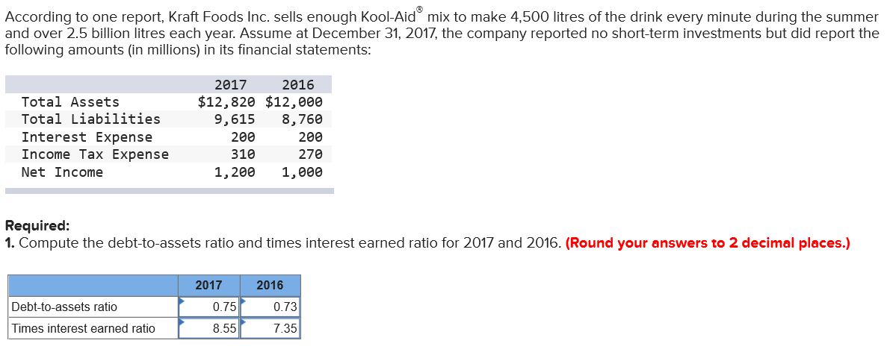
Debit to Assets Ratio: Total Liabilities / Total Assets
Times Interest Earned Ratio: EBIT / Interest Expense
  - EBIT = Net Income + Tax Expense + Interest Expense

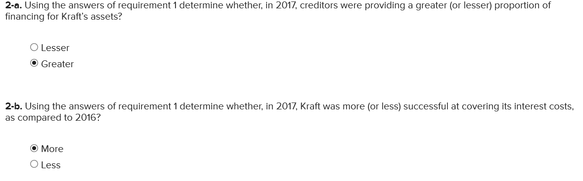

Question 7
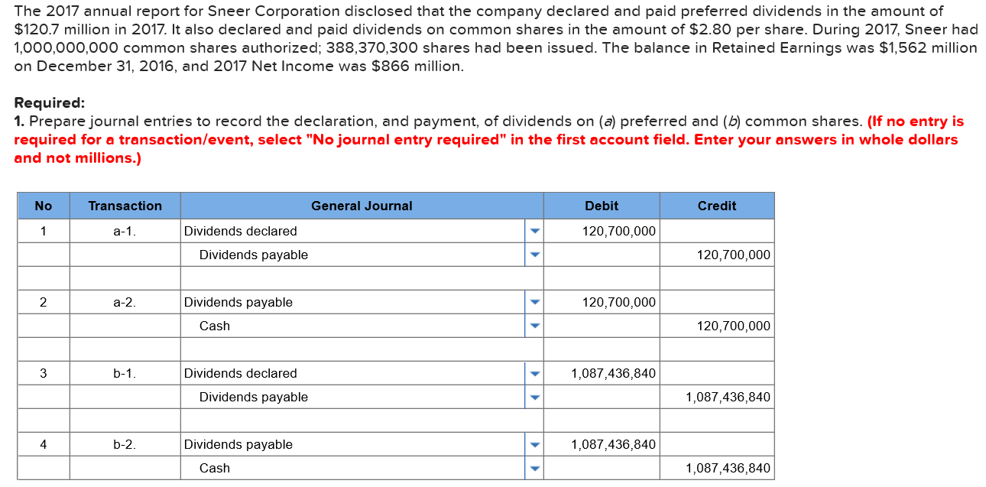
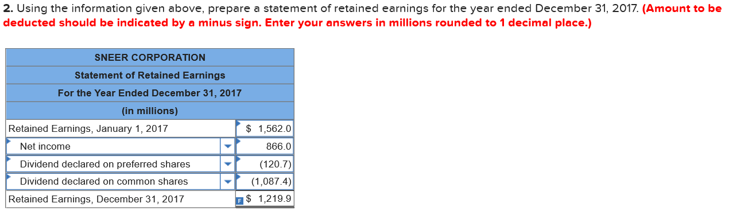

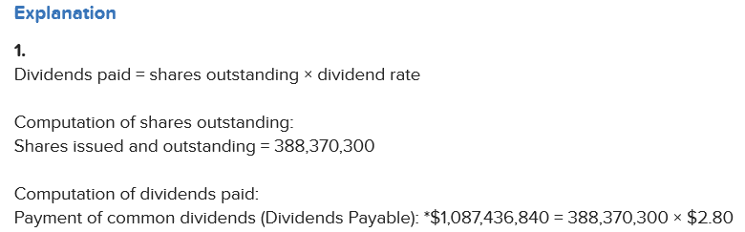

Worksheet 4

Question 1
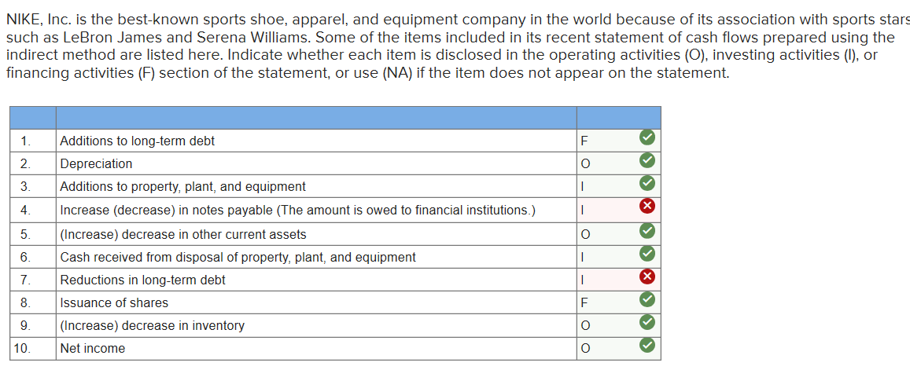
Question 2
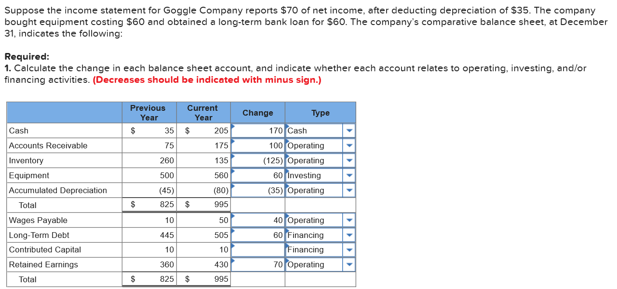
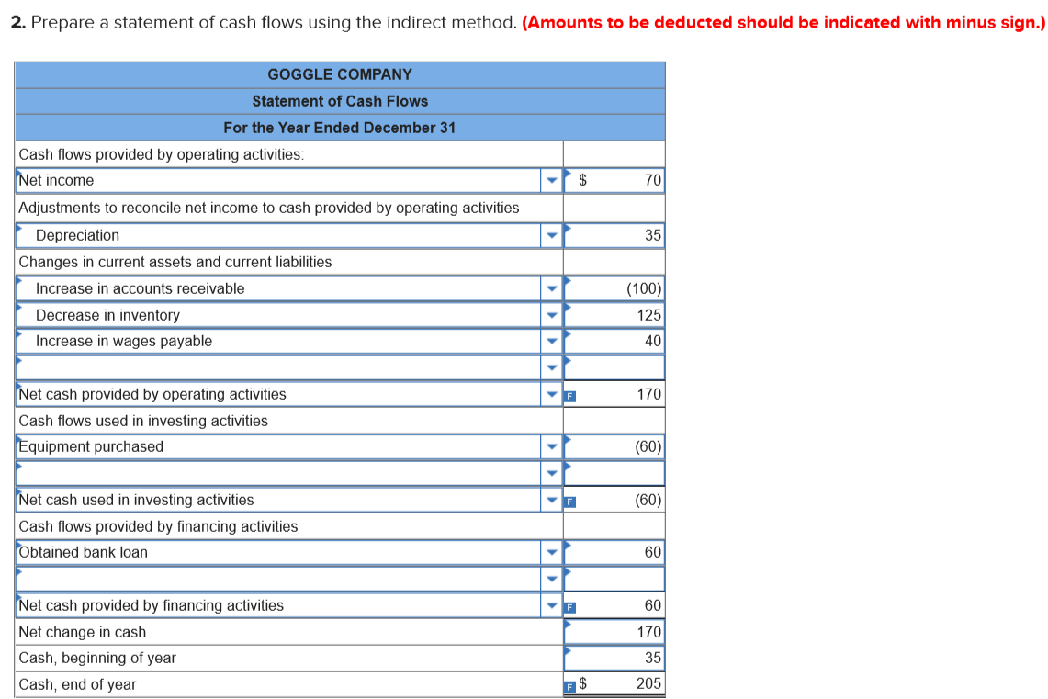

Question 3
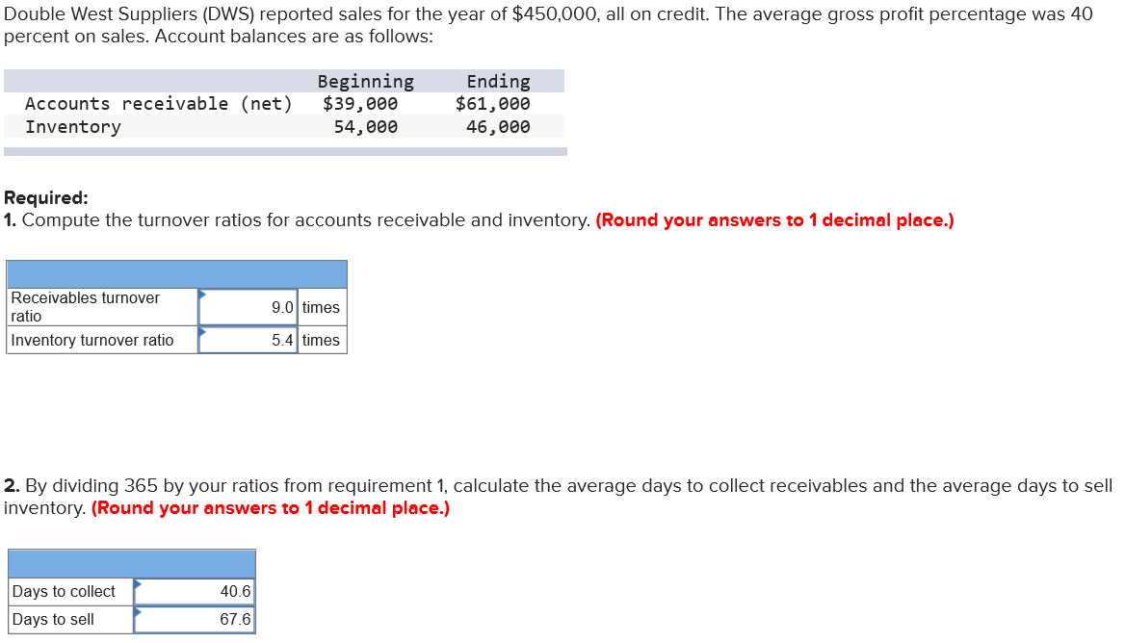
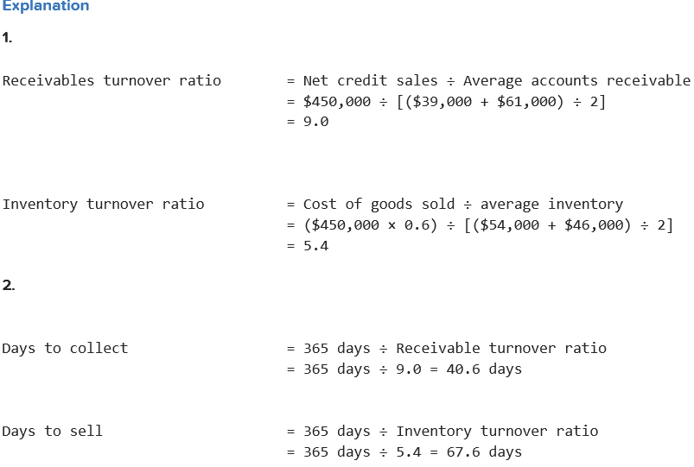

Question 4


