Organizations and Information Systems

What are the fundamental ways of achieving competitive advantage?
- 2 basic ways to develop competitive advantage through systems:
  - Changing the product: By introducing new products or service or enhancing current products or services
  - Business Processes: Organizations use technology to help lock in customers, lock in suppliers, reduce costs, form alliances, and create entry barriers for competitors in the market
- IS can affect competitive advantage by making the primary and support activities in an organization more productive than those of competitors.
  - Increased productivity is realized when business processes within the organization become more effective and more efficient

What are Business function and functional systems?
Porter's value chain model can help explain the scope and purpose of different types of business functions within the organization.

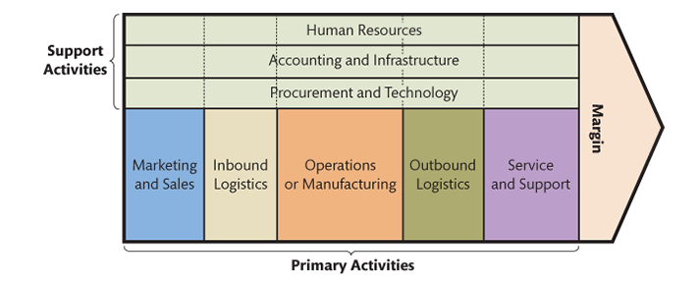
Primary and support activities are also referred to as business functions.
Primary activities: deal with the main or core parts of the good or service that the organization produces or provides. Fundamental activities that create value.
- Marketing and sales
- Inbound logistics
- Operations and manufacturing
- Outbound logistics
- Service and support
Support activities: Secondary to the good or service that is produced. Contribute indirectly to value creation.
- Human resource
- Accounting and infrastructure
- Procurement
- Technology activities
These activities are often supported by Functional Systems. Functional systems facilitate the work of a single department or business function.

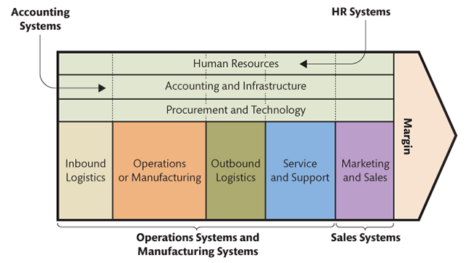

Functional Silos and Cross-functional systems
Functional silos
- Systems designed to work independently of one another
- The separation between systems makes it seem as if various departments in the same company could work separately.
- The reality is that all of these functional systems are interrelated. Business processes are cross-functional, that is, they are processes that cut across functional areas. Purchasing influences inventory, which influences production, which influences customer satisfaction, which influences future sales.
Figure: Separate Functional Systems
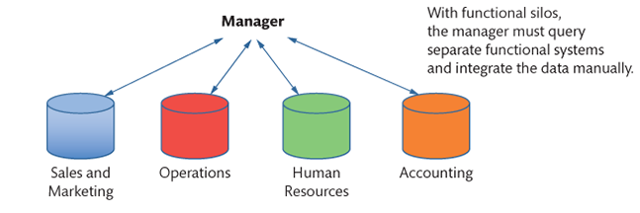
Integrated, Cross-Functional Systems
- The isolation problems of functional systems led to the development of cross-department or cross-functional systems.
- These systems integrate data and business processes across different departments and systems. As cross-functional systems have become more sophisticated, some information systems have begun to cross not only functional boundaries but also organizational boundaries. Systems used by two or more related companies are referred to as interorganizational systems. For example, supply chain management systems and some e-commerce applications.
Figure: Typical Functional Systems
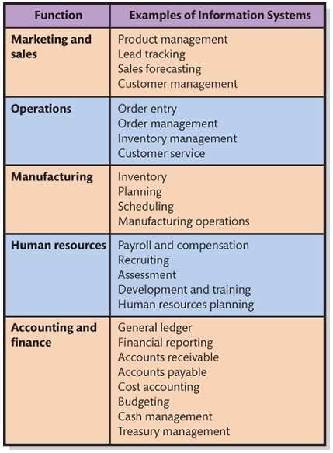
Why are functional systems changing?
- Functional systems provide tremendous benefits, but are limited because they operate in isolation
- Problems:
  - Data re duplicated because each application has its own database. The principal problem of duplicated data is a potential lack of data integrity. Changes to product data made in one system may take days or weeks to reach the other systems.
  - Business processes become disjointed. Produces lack of integrated enterprise information When a customer asks about an order, several systems may need to be queried. For example, some order information is in the order entry system, some in finished goods inventory system, and some in the manufacturing system.
  - Limited information available at any one source
  - Inefficient decisions based on limited knowledge
  - Increased costs to organization
Figure: Major problems of isolate functional systems
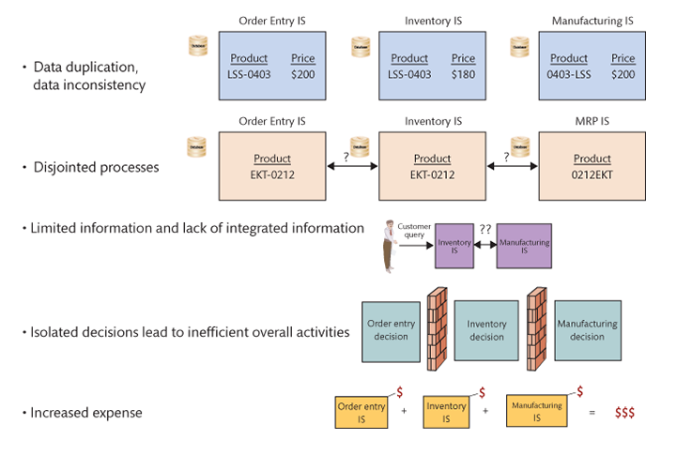
How can business processes be improved?
- Business process are supported by IS
- IT often enables firms to innovate and make significant change
- Besides technology, business process can also be improved by:
  - Adding resources, such as more workers
  - Adding increased specialization
  - Changing/eliminating non-productive activities

Using technology to improve business processes
- Using IT to improve business process requires understanding of where improvement are possible
- Business process design (redesign) idea
  - Organizations should not simply automate or improve existing functional systems
  - "Paving the cowpath" - the process of making efficient what already exists - it makes things easier but change how they are done
  - Business process design was not about paving the cowpath. Instead, it was about making significant changes by integrating functional systems.

- Establish more efficient business processes that integrate the activities of all departments involved in a value chain

Integrating Functional Systems: EAI and ERP
- Enterprise Application Integration (EAI)
  - An approach to combining functional systems, which uses layers of software as a bridge to connect different functional systems together.
  - The data for each functional system stay within the functional system. A customized EAI interface is then created for each functional system. These customized interfaces allow a central EAI server to pull whatever data are necessary from each of the functional systems. The EAI server, thus, acts to centrally integrate the necessary enterprise information from the functional system.
  - 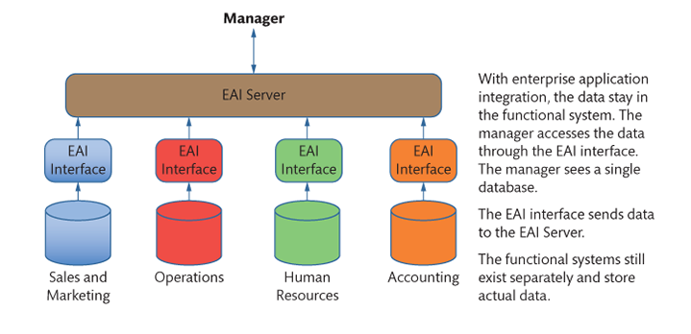
- Enterprise Resource Planning (ERP)
  - A second approach to combing functional systems
  - Main design principle - one central database is combined with a set of standard processes built on top of the database to ensure integration between functional area.
  - The standard processes ensure that the organization integrates data into a single database that can distribute accurate data throughout the organization. The ERP approach uses prebuilt software so that an organization adopting an ERP system must remove its existing functional systems before adopting the ERP system.
  - 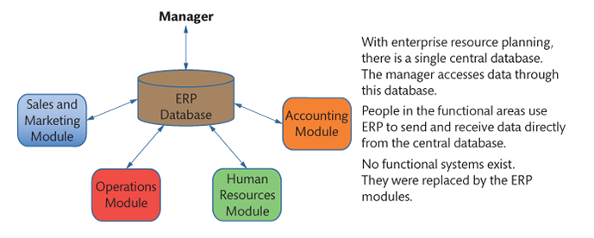

What are the challenges of implementing business process changes?
- Process design projects are expensive and difficult; three reasons for this are:
  - There is a lot of detailed work to be done to determine what to change and make an effective decision
  - Hard to estimate the business value that will emerge from business process changes
  - Many people like change but do not want to change
- May take a long time
- Very expensive and outcomes are uncertain: All these difficulties translate into more hours of labour, which translate into higher costs and increased risk of underperformance.

What is the importance of industry standard processes?
- Many early business process design projects failed because they were tailor-made
- Software vendors designed integrated applications, with built-in industry standard processes
  - Integrate activities across departments
  - Save costs of new process design
  - Examples: Oracle, Salesforce.com, Microsoft, or SAP
- Problems:
  - Industry standard processes may be very different from existing processes in the organization
  - May require the organization to change substantially
Figure: Example of SAP R/3 ordering process
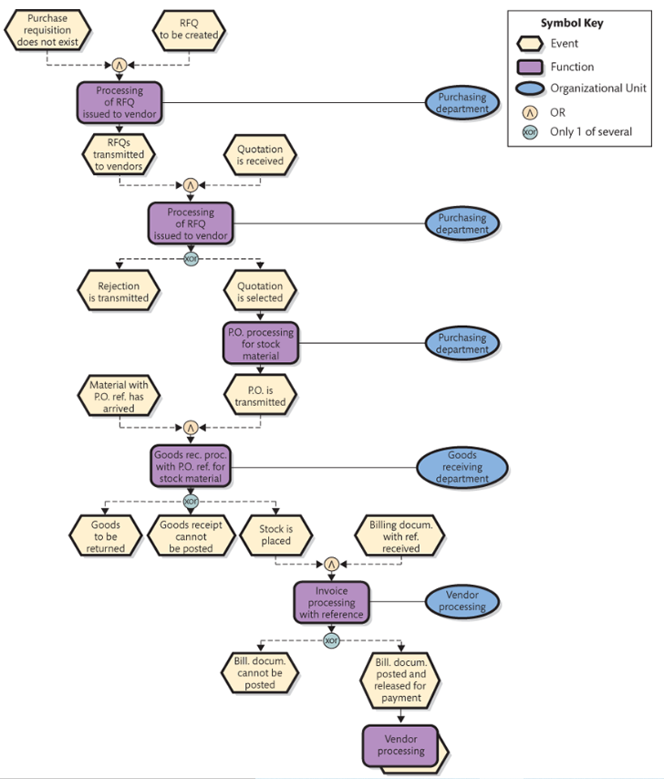

What are ERP systems?
- Enterprise Resource Planning (ERP): The integration of all the organization's principal processes.
  - Support all the primary business processes as well as the HR and accounting support processes
  - Enterprise-wide systems that integrate sales, order, inventory, manufacturing, and customer service activities
  - ERP systems provide software, pre-designed databases, procedures, and job descriptions for organization-wide process integration
  - ERP applications include a comprehensive set of inherent processes for all organizational activities. SAP defines this set as the process blueprint, and documents each process with diagrams that use a set of standardized symbols.

Characteristics of ERP
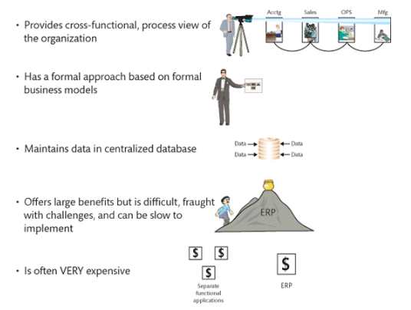
Benefits of ERP
- Efficient business processes
- Inventory reduction
- Lead-time (the time between the initiation and completion of a production process) reduction
- Improved customer service
- Greater, real-time insight into organization
- Higher profitability

What are CRM systems?
- Cross-functional systems are developed to overcome problems in functional silos
- Customer relationship management (CRM) systems:
  - Support the business processes of attracting, selling, managing, delivering, and supporting customers
  - Direct value chain activities that involve the customer
  - Integrates four phases of the customer life cycle:
    - Marketing, customer acquisition, relationship management, and loss/churn
  - All customer data stored in single database

Customer life cycle
- Four phases of the customer life cycle: (1) Marketing, (2) customer acquistiion, (3) relationship management, and (4) loss/churn
- 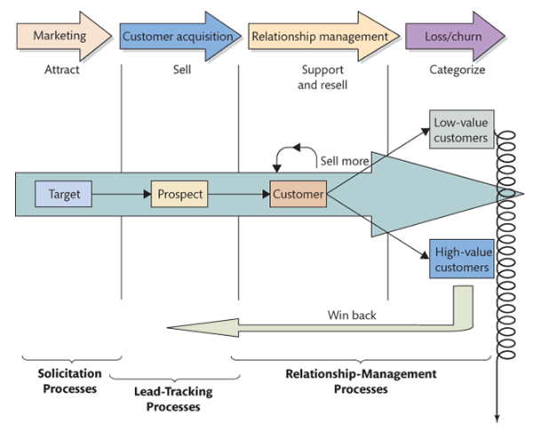
CRM components
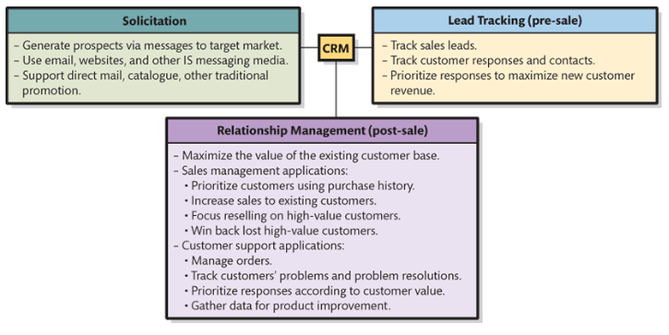
What are SCM systems?
- Supply Chain Management (SCM) systems are interorganizational systems that enable companies to efficiently handle the flow of goods from supplier to customers
- A supply chain is a network of organizations and facilities that transforms raw materials into products delivered to customers

Supply chain relationships
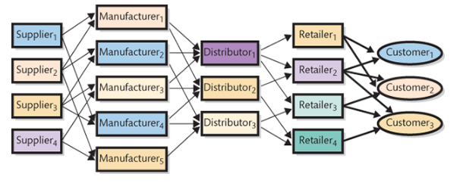
Some exceptions:
- Dell sells to customer, begins manufacturing after order is received, than before
- Distributor and retailer are not present in Dell's supply chain
- Supply chains do not go up/down only
  - More often a supply "network"

Supply chain example
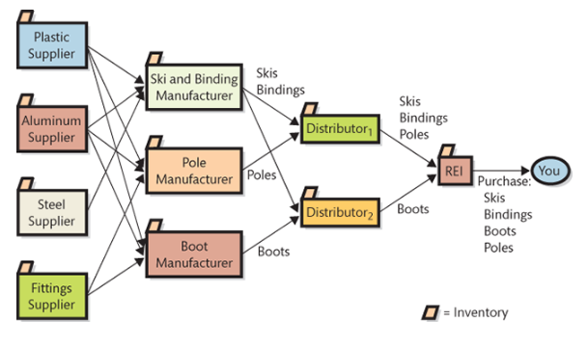
Supplier relationship management
- 3 fundamental IS involved in Supply chain management: (1) supplier relationship management (SRM), (2) inventory, and (3) customer relationship management (CRM)
- 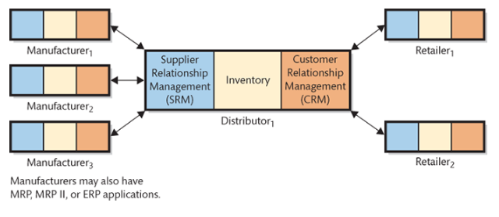
- SRM is a business process for managing all contacts between an organization and its suppliers
- Supplier is any organization that sells something to the organization that has the SRM application
- Supports both the in-bound logistics primary activity and the procurement support activity
- Support basic business processes
  - Source, Purchase, and settle
Summary of SRM processes
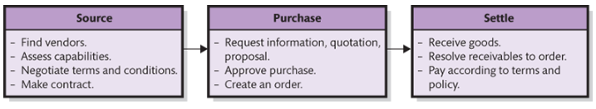

Benefits of IS on Supply chain performance
- Reduce costs of buying and selling
- Increase supply chain speed
- Reduce size and cost of inventories
- Improve delivery scheduling - enable just-in-time inventory

Decision Making and Business Intelligence

What challenges do managers face when making decisions?
- For business managers, decision making or choosing from a range of alternatives is the essence of management
- Decision making process is much more complicated for three reasons:
  - The concept of rationality
  - Result based - Good outcomes may occasionally result from irrational processes, and bad outcomes can result from good processes
  - Humans intend to be rational, but there are limits on our cognitive capabilities: We are simply not capable of thinking through all the various option that are available. Instead of seeking the optimal solution, we satisfice, or choose the most reasonable available solution.

Do managers make rational decisions
- We are not calculators, or economic automatons
- Rather, we settle, sacrifice, choose an alternative "good enough" across a range of criteria

Management Misinformation Systems
- Designers of MIS make erroneous assumptions about managerial decision making, thus systems may not provide good solutions
- Factors that make business decision making challenging
- Three assumptions:
  - Managers will make better decisions if they get the data they need. Ackoff: Too many possibilities exist. The uncertainty and complexity surrounding decisions make them challenging
  - Poor decisions are made because of lack of information. Ackoff: Managers have too much, not too little, information. Information overload
  - Managers know what data they need. Ackoff: They are not sure if their requests are necessary or superfluous, and tend to ask for more than needed, further promoting information overload

Information overload
- Managers face information overload
  - Digital universe is doubling in size every two years
  - Data is growing at the rate of 40 percent a year
  - Occurs inside and outside of organizations
- The challenge for managers in a world overloaded with information is to find the appropriate data and incorporate them into their decision making processes. Information systems can both help and hinder this process.

Problems with operational data (Data Quality)
- Raw data usually unsuitable for sophisticated reporting or data mining
  - Dirty data (Problematic data)
  - Missing values
  - Inconsistent data, esp. In data collected over time
  - Data not integrated
    - From different sources
    - From incompatible source
  - Data can be too fine or too coarse (granularity: the level of detail in data)
    - Too fine means detailed (E.g. Clickstream data: E-commerce data that describe a customer's clicking behaviour. Such data include everything the customer does at the website
    - Too coarse means summarized
    - Better to have granularity that is too fine than too coarse. Too fine data can be made coarser.

What is OLTP and how does it support decision making?
- Online Transaction Processing (OLTP) system collects data electronically and process the transactions online
  - Can be in real time (transactions are entered and processed immediately upon entry) or batched transactions (System waits until it has a batch of transactions before the data are processed and information is updated)
  - Real time systems tend to be more complex can cost more to implement. However provides the most up-to-date information.
- OLTP systems - backbone of all functional, cross-functional, and interorganizational systems in an organization
- Combines large database with efficient input devices, such as grocery store scanners, automated cash registers, and debit and credit card readers, to process transactions quickly and accurately
- OLTP systems support decision making by providing the raw information about transactions and status for an organization.

What are OLAP and the Data resource challenge?
- While data may be collected in OLTP, the data may not be used to improve decision making
- Online Analytic Processing (OLAP) systems focus on making OLTP-collected data useful for decision making
  - OLAP provides the ability to sum, count, average, and perform other simple arithmetic operations on groups of data
  - OLAP report has measures, or facts, and dimensions
  - A measure is the data item of interest. It is the item that is to be processed in the OLAP report
  - Dimension is a characteristic of a measure. E.g. Purchase date, customer type, and location
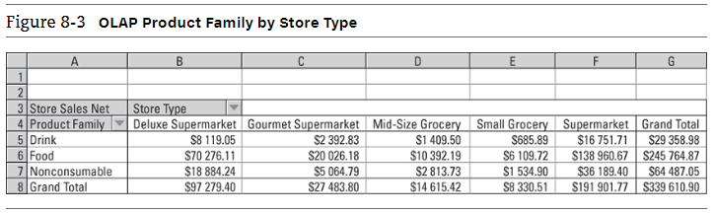
Generated by SQL Server Analysis Services and displayed in EXCEL
What are OLAP
- OLAP reports also referred to as cubes
- User can alter the format of the report. Drill down into the data: to further divide the data into more detail
- Helpful because different managers would use different information
- If large, OLAP can be costly to run, and DBMS are not set up for this
- Although standard, commercial database management system (DBMS) products do have the features and functions required to create OLAP reports, they are not designed for such work. They are designed instead to provide rapid response to transaction-processing applications, such as order entry or manufacturing operations
- To address problem, special purpose products called OLAP servers have been created

Data resource challenge
- Though data is collected, it may not be used to improve decision-making
  - E.g. Grocery chain found to use less than 2% of the scanner data it collects
- Companies must see their data as an asset - a resource from which benefits can be obtained
- If data is an asset, how is it reported? Who manages it? Who extracts the value out of it?
- Treating data as a true resource begins with a focus on business intelligence

What are Business Intelligence (BI) systems and how do they provide competitive advantage?
- BI system provides information for improve decision making
- Five categories of BI systems
  - Group decision support systems (GDSS)
  - Reporting systems
  - Data-mining systems. Market-basket analysis is one of the data mining systems: it computes correlations of items on past orders to determine items that are frequently purchase together
  - Knowledge-management (KM) systems
  - Expert Systems
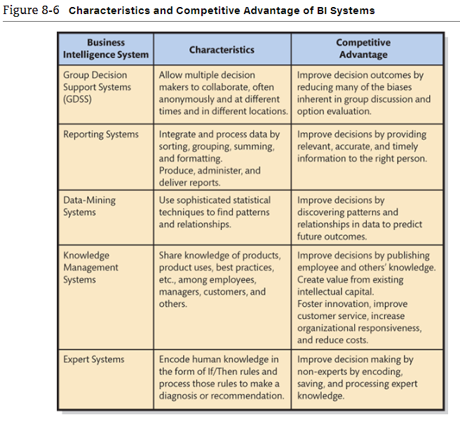
RFM Analysis
- Way of analyzing and ranking customers according to their purchasing patterns
- A simple technique that considers
  - How recently (R) a customer has ordered
  - How frequently (F) a customer orders
  - How much money (M) the customer spends per order

Use of data warehouses to acquire data
- Analyses from operational data are not recommended
- Operational data not set up for analysis, but for fast and reliable
- Operational data gets extracted for BI processing
  - To a database for small companies
  - To a data warehouse for larger companies

Data warehouse
- A facility for managing an organization's BI data
- The purpose of a data warehouse is to extract and clean data from operational systems and other sources and to store and catalogue that data for processing by BI tools.
- Functions:
  - Obtain data
  - Cleanse data
  - Organize and relate data
  - Catalogue data
- Stores metadata, or data about data
- Usually a room with a few computers and storage devices
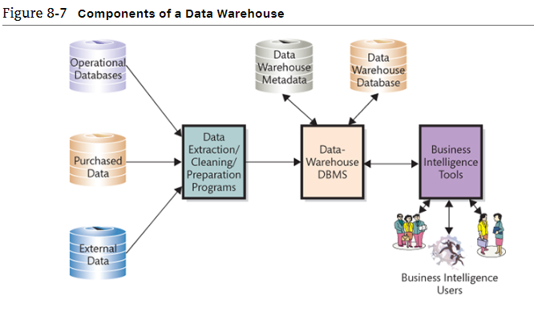
Programs read operational data and extract, clean, and prepare that data for BI processing. The prepared data are stored in a data warehouse database using a data warehouse DBMS, which can be different from the organization’s operational DBMS. For example, an organization might use Oracle for its operational processing, but SQL Server for its data warehouse. Other organizations use SQL Server for operational processing, but DBMSs from statistical package vendors, such as SAS or SPSS, in the data warehouse.

What is a data mart, and how does it differ from a data warehouse
- Data mart is a data collection:
  - Created to address particular needs of a specific function, problem, or opportunity
  - Companies may have more than one data mart
    - One for clickstream data, one for market-based analysis, another for inventory
  - Smaller than data warehouse
  - Addresses a particular component of functional area of the business
  - Users in the data mart obtain data from the data warehouse that pertain to a particular business function. Users may not have data management expertise
    - Knowledgeable analysts for specific function
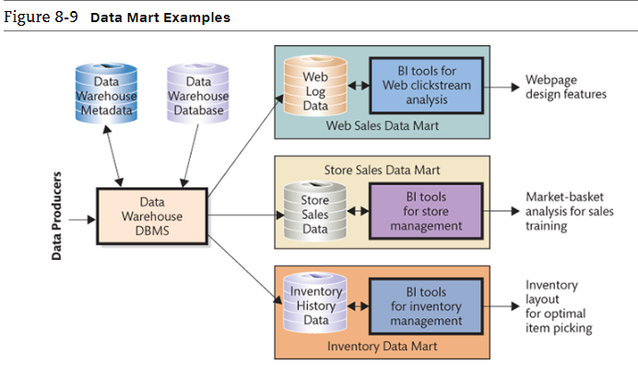
What are the typical data-mining applications?
- Data mining is the application of statistical techniques to find patterns and relationships among data and to classify and predict
- Represents a convergence of disciplines
  - Statistics and mathematics
  - Artificial intelligence
  - Machine-learning fields
- Data mining techniques take advantage of developments in data management
- Unsupervised and supervised techniques
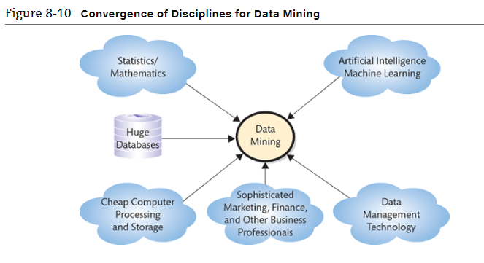
Unsupervised Data mining
- Analysts do not create model or hypothesis before running the analysis
- Apply data-mining technique to the data and observe results
- Hypotheses created after analysis as explanation for results
- Example:
  - Cluster analysis
    - Statistical techniques used to identify groups of entities that have similar characteristics

Supervised Data Mining
- Model developed before the analysis
- Statistical techniques applied to data to estimate parameters of the model
- Examples:
  - Regression analysis
    - Measures the impact of a set of variable on another variable
  - Neural networks
    - Used to predict values and make classifications, such as "good prospect" or "poor prospect" customers
  - Market-basket analysis
    - Used for determining sales patterns

Big Data
- Large amounts of varied data from a variety of sources over a period of time could be used to make better decisions
- Controversial
  - Lack of precision in its definition
  - Adds to excessive data collections
  - Expensive
  - Imprecise (overly vague or general)

Social Networking, E-Commerce and the web

Social media information system
- Social media (SM)
  - The use of IT to support the sharing of content among networks of users
  - Enables people to form communities of practice
    - Groups of people related by common interest
- Social Media Information System (SMIS)
  - IS that supports the sharing of content among networks of users

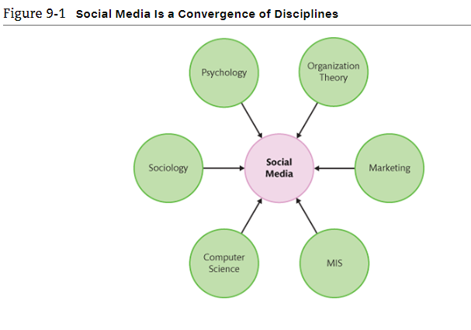
Three SMIS Roles
3 organizational units of SMIS:
- Social Media providers: Companies that provide platforms that enable the creation of social networks
  - Facebook. Google+, LinkedIn, Twitter, Instagram, and Pinterest provide platforms
  - Attracting, targeting demographic groups
- Users
  - Individuals and organizations
  - Companies hire staff to maintain their SM presence, promote their products, build relationships, and manage their images
- Communities
  - Mutual interests that transcend familial, geographic, and organizational boundaries
  - Viral hook: An inducement that causes someone to share an ad, link, file, picture, movie, or other resource with friends and associates over the internet
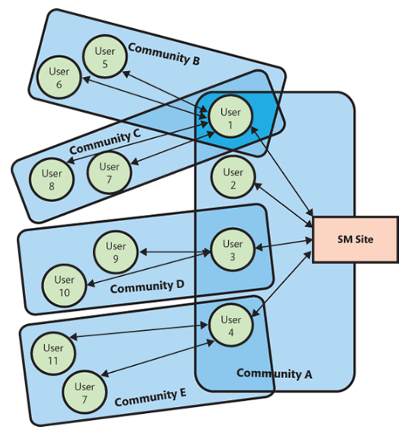
SMIS components
- Same 5 components as all Information Systems:
  - Hardware
    - Desktops, laptops, mobile devices
    - Providers host the SM usually in cloud servers
  - Software
    - Browsers and client application to communicate with users
      - iOS, windows, android
      - Many providers use a noSQL DBMS to process data
      - Many providers invest in analytics
  - Data
    - Content Data (user-generated content)
      - Provided by users
    - Connection Data
      - Data about relationships
      - E.g. Who you like on Facebook, who your friends are
      - Differentiates SMIS from website applications
    - Social Media providers store and retrieve Social Media data on behalf of users
  - Procedures
    - Organizations develop procedures for creating content, managing user responses, removing objectionable content, etc.
  - People
    - Staff must be trained on SMIS user procedures and the
    - Organization's social networking policy
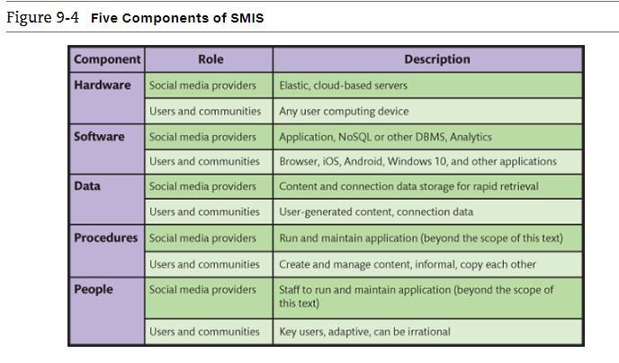
How do SMIS Advance Organizational Strategy
- Strategy determines value chain
  - Value chains determine business processes
  - Processes determine SMIS requirements
- How do value chains determine dynamic processes?
  - Dynamic process flows cannot be designed or diagrammed
- Social media fundamentally changes balance of power among users, their communities, and organizations
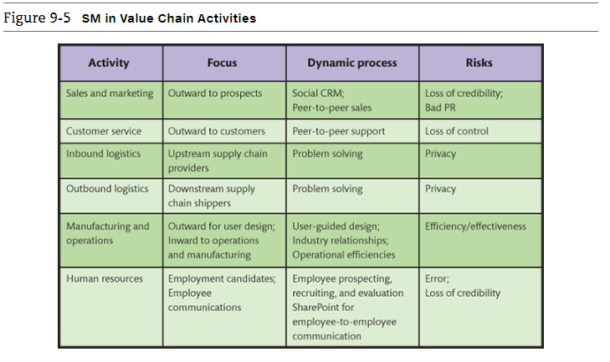
Social media and the sales and marketing activity
- Social CRM (customer relation management): CRM that includes social networking elements and gives the customer much more power and control in the customer/vendor relationship
  - A dynamic, SM-based CRM process
  - Each customer crafts relationship
    - Wikis, blogs, discussion lists, FAQs, sites for user review and commentary, other dynamic content
  - Customers search content, contribute reviews and commentary, ask questions, create user groups, etc.
  - Not centred on customer lifetime value

Social media and customer service
- Relationships emerge from joint activity, customers have as much control as companies
- Product users freely help each other solve problems
- Selling to, or through, developer networks most successful
  - Microsoft's MVP program
- Peer-to-peer support risks loss of control

Social media and inbound and outbound logistics
- Numerous solution ideas and rapid evaluation of them
  - SM used to dispense news, provide updates, and address ever-changing needs and problems
- Better solutions to complex supply chain problems
- Facilitate user created contents and feedback among networks needed for problem solving
- Loss of privacy
  - Problem solving requires open discussion of problem definitions, causes, and solution constraints
  - Problem solving in front of your competitors

Social media and manufacturing and operations
- Improve communication channels within organization and externally with consumers, design products, develop supplier relationships, and improve operational efficiencies
- Crowdsourcing: A process through which users can provide customer support to one another or even participate in product design or product redesign
- Business-to-consumer (B2C): Sm to market products
- Business-to-business (B2B): Use SM to become industry leaders and promote brand awareness. Retailers will view manufacturers who engage in these SM efforts as Industry leaders
- Internal: Use SM to improve communication within the organization

Social media and human resources
- Employee communication using internal personnel sites
  - Ex: MySite and MyProfile in SharePoint
- Finding employee prospects, recruiting candidates, candidate evaluation
- Place for employees to post their expertise in the form of "Ask me about" questions
- Risks:
  - Forming erroneous conclusions about employees
  - Becoming defender of belief or pushing unpopular management message

How SMIS increase social capital
- Capital
  - Investment of resources for future profit
- Types of business capital
  - Physical: investment into resources that produce goods and services (factories, machines, equipment)
  - Human: investment in human knowledge and skills investments
  - Social: investment in social relations with expectation of marketplace returns

Value of social capital
- Determined by the number of relationships in a social network, strength of relationships, and resource controlled by those related
- We benefit in 4 ways:
  - Information
    - About opportunities, alternatives, problems, and other factors important to business professionals
  - Influence
    - Decision makers at one's employer or in other organizations that are critical to your success. E.g. Playing golf with CEO
  - Social credentials
    - Being linked to a network of highly regarded contacts
  - Personal reinforcement
    - Professional identity, image, and position in organization or industry

Gain social capital for professional
- By adding more friends and strengthening relationships with existing friends
- By adding friends and strengthening relationships with people who control resources important to you
- Measure your social networking capital with online service, such as Klout.com

How social networks add value to businesses
- Historically, organizations created social capital via salespeople, customer support, and public relations, and endorsements by high profile people
- Progressive organizations:
  - Presence on Facebook, LinkedIn, Twitter, and other SM sites
  - Encourages customers and interested parties to leave comments
  - Risk - excessively critical feedback

Using Social networking to increase the number of relationships
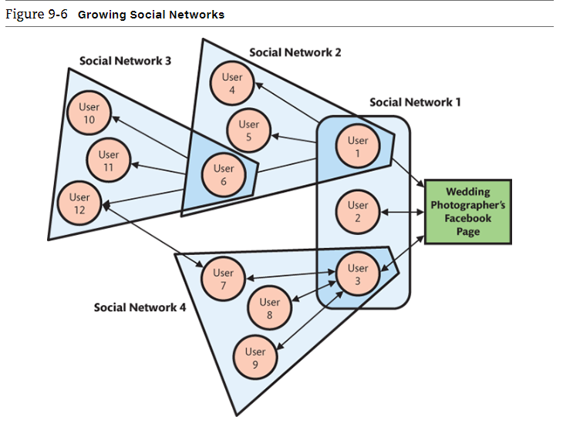
Using social networks to increase the strength of relationships
- Strength of a relationship: is the likelihood that the other entity in the relationship will do something that benefits the organization.
- Positive reviews, post pictures using organization's products or services, tweets about upcoming product releases, and so on
- Strengthen relationships by asking you to do them a favour
- Frequent interactions strengthen relationships

Using social networks to connect to those with more resources
- Social capital = number of relationships x relationship strength x entity resources
- Huge network of people with few resources less valuable than smaller network with substantial resources
- Resources must be relevant
- Most ignore value of entity assets

Earn revenue from social media
- Hyper-social organization
  - Use SM to transform interactions with customers, employees, and partners into mutually satisfying relationships with them and their communities
- How do companies monetize (or make money): a social media company's ability to make money from its application, service or content
- Answer: making users the product (You are the product)
  - "if you are not paying, you are the product."
  - Renting your eyeballs to an advertiser (users are the product being sold to advertisers)

Revenue models for social media
- Advertising
- Pay-per-click
- Use increases value
- Freemium
  - Offers users a basic service for free, then charges a premium for upgrades or advanced features
- Sales
  - Apps and virtual good, affiliate commissions, donations

Does mobility reduce online ad revenue
- Number of mobile devises to reach 10 billion by 2019
- Even though the revenue per device may be lower than PCs, the number of mobile devices may swamp the difference in revenue
- Mobile data traffic eleven-fold increase
- Average click-through rate of smartphones is 4.12%, but just 2.39% on PCs
- Conversion rate
  - Measures how frequently someone clicks on ad makes a purchase, "likes" a site, or takes some other action desired by advertiser
- Paid search, display or banner ads, mobile ads, classifieds, or digital video ads
- Use of ad-blocking software growing by 69% per year

SMIS Security concerns
- Develop and publicize a social media policy: a statement that
  - Delineate employees' rights and responsibilities when generating social media content
  - Index at 100 different policies at social media today website
- Intel's three pillars of SM policies
  - Disclose
  - Protect
  - Use common sense
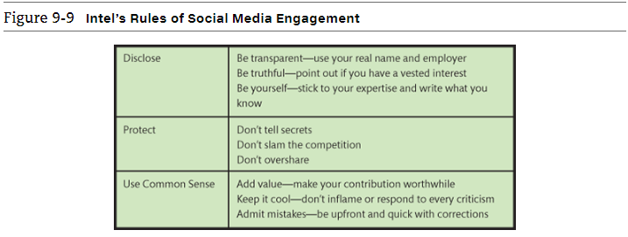

Managing the Risk of inappropriate content
- User-generated content (UGC): content on SM site that is contribute by users
- Below are examples of inappropriate UGC that can negatively affect organizations
- Problems from external sources
  - Junk and crackpot contributions
  - Inappropriate content
  - Unfavourable reviews
  - Mutinous movements

Responding to social networking problems
- Leave it
- Respond to it
- Delete it
- General rule
  - "never wrestle with a pig; you'll get dirty and the pig will enjoy it."

Internal risks from social media
- Threats to information security, increased organizational liability, decreased employee productivity
- Directly affect ability to secure information resources
- Innocuous comments inadvertently leak information used to secure access to organization resources
  - Bad idea to tell everyone its your birthday because your date of birth can be used to steal your identity
- Employees can unintentionally leak information about intellectual property, new marketing campaigns, future products, potential layoffs, budget woes, product flaws, or upcoming mergers
- Employees inadvertently increase corporate liability when they use social media
  - Sexual harassment liability
  - Leak confidential information
- Reduced employee productivity

Where is Social Media taking us
- New mobile devices with innovative mobile-device UX, coupled with dynamic and agile IS based on cloud computing and dynamic virtualization
- Bring your own device (BYOD) policy
- Organization the endoskeleton, supporting the work of people on the exterior
  - Employees craft own relationships with their employers
- Non-routine cognitive skills more important

E-Commerce, and how is it used
- Buying and selling of goods and service over public and private computer networks
- This definition restricts ecommerce to buying and selling transactions
- Checking the weather at yahoo.ca is not ecommerce, but buying a weather service subscription that is paid for and delivered over the internet is

Ecommerce
- Ecommerce has a number of implications
  - Technology perspective
    - Defines the need for additional infrastructure
  - Management and governments perspective
    - Coordination for smooth business operations
    - Security must be enabled
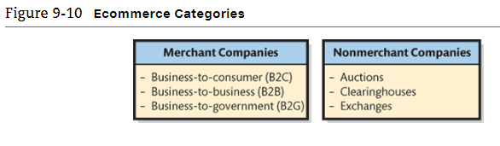
Merchant companies: companies that take title to the goods they sells. They buy goods and resell them
Nonmerchant companies: those that arrange for the purchase and sale of goods without ever owning or taking title to those goods. Merchant companies sell services that they provide; nonmerchant companies sell services provided by others

Ecommerce merchant companies (each use different IS in doing business)
- B2C
  - Sales between a supplier and a retail customer (the consumer)
  - A typical IS provides a web-based application or web storefront which enable customers to enter and manage their orders
- B2B
  - Sales between companies
  - 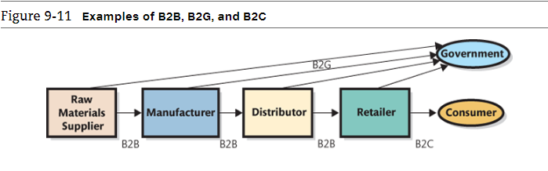
- B2G
  - Sales between companies and governmental organizations

Nonmerchant ecommerce
- E-commerce auctions: match buyers and sellers by using an ecommerce version of a standard auction (e.g ebay)
- Clearinghouses: provide goods and services at a stated price and arrange for the delivery of the goods, but they never take title (e.g. Amazon)
- Electronic exchanges: match buyers and sellers; the business process is similar to that of a stock exchange

Benefits of Ecommerce
- Leads to greater market efficiencies
- Disintermediation: removal of intermediaries between parties
  - Higher revenues for manufacturers
  - Lower price for buyers
  - But, if all intermediaries are cut, will be disruptive to Canadian economy
- Intermediation or re-intermediation
  - Rather than buying directly, consumers prefer to use other websites (e.g. Trivago)
- Improves flow of price information
  - Sites provide price comparisons
- Sellers have access to better information about what customers will pay
- Price elasticity: how much demand rises/falls with changes in price
  - Auction sites helpful for this
  - Experiments with customers

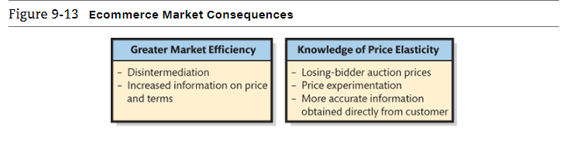
Challenges of Ecommerce
- Channel conflict: if a company sells to a retailer, then adds a channel directly to consumers, will the retailer drop them?
- Price conflict: if manufacturer sells direct to consumer at lower price than retailer, this will disrupt retailer
- Logistics expense: Manufacturers need to factor in costs of entering and processing orders in small quantities
- Customer service expense: manufactures will need to support customers that are not knowledgeable retailers
- Showrooming: merchants lose money if customer tries product out in store, then later purchases it online at a lower cost
- Taxation: problem for shipments crossing borders: collecting the correct taxes
Acquiring Information systems through projects

How can IS be acquired?
- Five basic ways for acquiring software applications:
  - Buy it and use it as it is
  - Buy it and customize it (most common)
  - Rent or lease it
  - Build it yourself
  - Outsource it
- Acquiring new software is NOT the same as acquiring new information systems, because there is a lot more to think about in systems than just software

New software must be integrated into existing systems
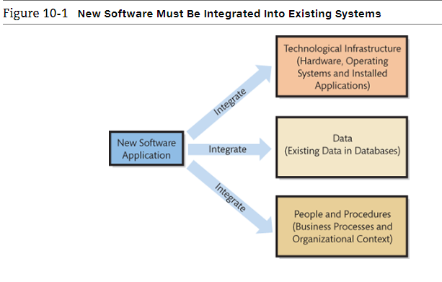
Organizations will always face the cost of integrating the software with its current hardware, data, and procedure. They can exceed the cost of the software itself.

What are IT projects and what does PMBOK mean?
- Project Management Body of Knowledge (PMBOK)
  - Provides project managers, sponsors, and team leaders with a large array of accepted project management techniques and practices
  - A project consists of a temporary endeavour undertaken to create a unique product, service or result
  - Projects often begin with a set of goals or objectives
  - A scope is developed for the project
  - Project usually have a start and an end date
  - Projects often represent change in an organization

IT projects
- Projects of all shapes and size that renew and adapt IT infrastructure
- IT projects have a large information technology components (in terms of budget or personnel)
  - Scope (objective)
  - Start and end date
  - Temporary use of resources
  - Unique
  - Accomplish something new
- Hard to estimate time, budget, and scope

Five critical roles in IT projects
- Team leader (only in large projects)
  - Action initiator, model and shape the team, negotiator, listens for employee discontent, help members to achieve potential, and share workload
- Team members
  - Heart of the project, the engine of its work with special skill in specific discipline
- Steering Committee
  - Approval of charter, secure resources, adjudicate all requests and changes
  - Consists of the sponsor and all key stakeholders

Information Technology Project Management (ITPM)
- ITPM is considered to consists of systematic structured management tools for IT related endeavours
- ITPM is the collection of techniques and methods that project managers use to plan, coordinate, and complete IT projects, including:
  - Planning tools
  - Budgeting methods
  - Graphical scheduling methods
  - Risk management techniques
  - Communication planning
  - High-tech team development

5 process groups in any project
- Initiating
- Planning
- Executing
- Controlling and monitoring
- Closing

What should you know about IT operations and IT projects?
- IT operations: The delivery of service, maintenance, protection, and management of IT infrastructure
- IT projects: the renewal and adaptation of IT infrastructure is normally accomplished through projects
- Operational work and project work tend to attract two different types of IT professionals
- But these two fields rely on each other for success

Information Technology Infrastructure Library (ITIL)
- ITIL is a well-recognized collection of books that provide a framework of best-practice approaches to IT operations
- ITIL offers a large set of management procedures that are designed to help business achieve value from IT operations

What the IT department does
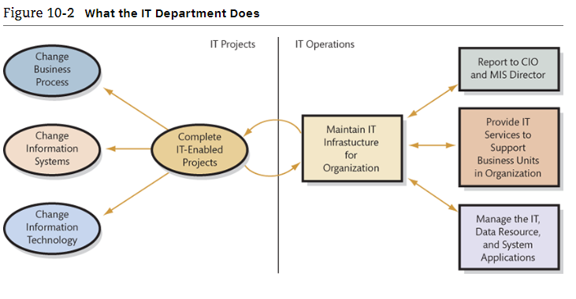

What about the Web?
- Web has become an important avenue for delivering IT services to both internal employees and external customers
  - Internal intranet website may include FAQ, web-based forms for requesting services, and some web-based application that help support tasks
  - Public website provide support for external customers, such as FAQ, customer support information, and company contact information

Why are IT projects so Risky?
- Most IT project definitions are not easy to graphically represent
- Lack of a good model is an important risk to recognize in IT projects
- Good estimates are difficult to develop because the technology is continually changing
- Being able to monitor progress is another challenge for IT projects

Some risks inherent in IT projects
- Lack of experience in the team
- Lack of support from top management
- Lack of participation from system users
- Unclear and uncertain project requirements
- A high level of technical complexity, and changes in the project environments

What is the Systems Development Life Cycle (SDLC)?
- The classic process used to acquire information systems
- To successfully acquire and maintain information systems, there are basic tasks that need to be performed
- These basic tasks are combined into phases of systems development

Systems analysis or systems development
- Classical process with five phases:
  - Systems definition
    - Management's statement defines new system
  - Requirements analysis
    - Identify features and functions
  - Component design
    - Based on approved user requirements
  - Implementation
    - Implement, test, and install new system
  - System maintenance
    - Repair, add new features, maintain
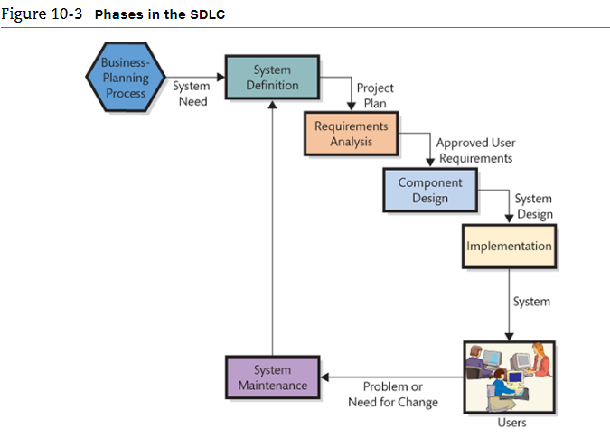
Phase 1: Defining Systems
- Define goals and purpose for new system
  - Must facilitate organization's competitive strategy
  - Supports business processes
  - Improves decision making
- Defining project's scope
  - Simplifies requirements determination and other subsequent development work
- Assess feasibility of project
  - Cost
  - Schedule
  - Technical
  - Organizational

Phase 2: Requirement analysis: project team is formed and requirements are developed
- Management of scope in an IT project
- Determine and document specific features and functions of the new system
- Approve requirements
- Less expensive to change system in this phase

How are IS designed, implemented, and maintained?
- 5 ways to acquire IS:
  - Buy is as is
  - Buy it and customize it
  - Rent or lease it
  - Build it yourself
  - Outsource it
- For options 1-3, organization must match its requirement with the capabilities of the available software application
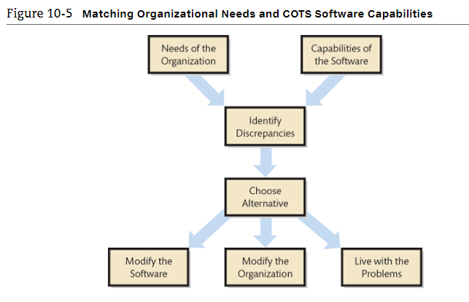
When discrepancies are identified, the organization faces three choices; modify software, modify the organizational procedures and data, or live with the problems. In reality, the final solution is likely a combination of these three options

Phase 3: Component design
- Each of the 5 components of IS must be designed. The team develop and evaluate alternatives against the requirements
  - Accurate requirements critical
- 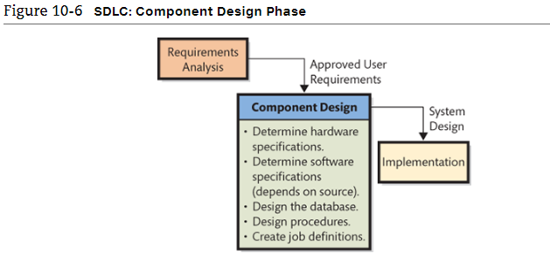
- Hardware design determined by project team
  - Team needs to specify the computers, operating systems, networks, and network connections that will process the data
- Software design depends on source
  - Off-the-shelf
  - Off-the-shelf with alterations
  - Custom-developed programs
- Data model converted to a database design
- Procedures developed for normal processing, backup, and failure recovery operations
- 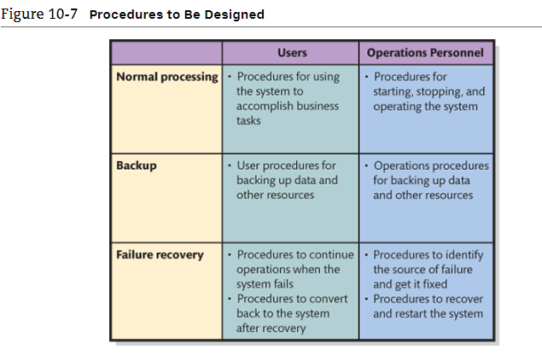
- Job descriptions created for users and operations personnel

Phase 4: implementation
- Systems must be built
  - Components constructed independently
  - Document and review, and test procedures
- System testing
  - Individual components tested
  - System integrated and tested
    - Difficult, time consuming, and complex tasks
    - Developers need to design and develop test plans and record the results of the tests
    - Test plan: groups of sequences of actions that users will take when using the new system
      - Both normal and incorrect actions should be considered
    - Product quality assurance (PQA)
      - Testing specialists
    - Beta testing is the process of allowing future system user to try out the new system on their own
- Users must be converted to new system (system conversion: the process of converting a business activity from the old system to the new)
  - 4 ways to implement a system conversion
    - Pilot
      - Organization implements entire system on single, limited portion of the business
      - If system fails, it only affects limited boundary
      - Reduces exposure
    - Phased
      - New system installed in phases
      - Tested after each phase
      - Continues until installed at entire organization
      - Cannot be used in tightly integrated systems
    - Parallel
      - New system runs in parallel with old system during testing
      - Expensive and time consuming
      - Data must be entered twice
      - Provides easy fall-back position
    - Plunge
      - Direct installation
      - Install new system and discontinue old
      - There is no backup position
  - IS professional recommend any of the first 3 phases. In all but the most extreme cases, companies generally avoid taking the plunge

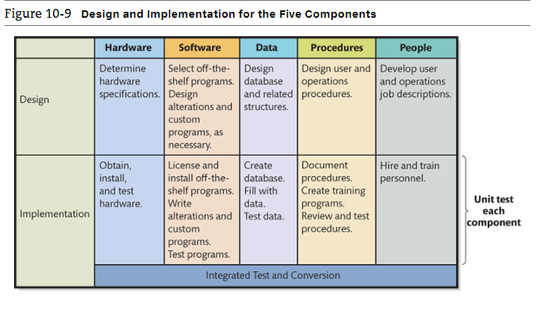
Phase 5: Maintenance
- Fixing the system so that it works correctly or adapting system to changes in requirements
  - Need method to track system failures and enhancements
  - Corrections usually prioritized based on severity
    - Group fixes for high priority failures into a patch (a group pf foxes for high priority failures that can be applied to existing copies of a particular product)
    - Bundle fixes of low priority problems into larger groups called service packs
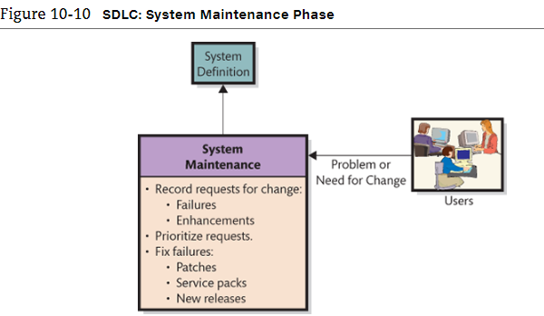
Problems with SDLC
- SDLC waterfall method (a sequence of nonrepetitive phases)
  - Phases are not supposed to be repeated
  - Often teams have need to repeat requirements and/or design phases
- Difficulty in documenting requirements
  - Analysis paralysis: when too much time is spent documenting project requirements
  - or uncertain requirements
- Scheduling and budget difficulties
  - Multiyear projects difficult to properly schedule
  - Estimation on labour often produce insufficient budgets

What is outsourcing and who are application service providers?
- Outsourcing is the process of hiring another organization to perform a service
- The outsourced vendor can be domestic or international
  - Offshoring is when vendor is overseas
  - Nearshoring is when vendor is a neighbouring country
- Application service provider (ASPs) are a special form of outsourcing

Reasons for outsourcing
- An easy way to gain expertise
- Concern cost reductions
- To reduce development risk and implementation risk

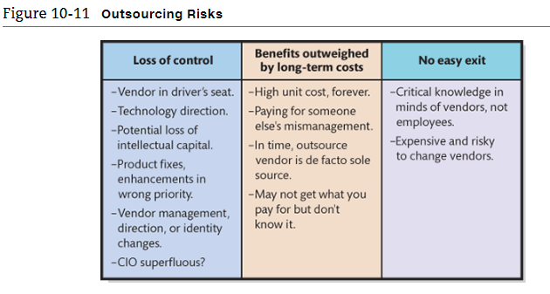

Application service providers
- A particular form of outsourcing
- ASP agreement
  - Organization contracts with a vendor to "rent" applications from the vendor company on a free-for-service basis
- Vendor maintains the system at its own web location and the client organization accesses the application on the vendor's website
- Vendor can then offer standardized software to many companies while maintaining only a single site. This reduces the costs of supporting the application and theoretically reduces the costs associated with outsourcing
- Payments
  - Monthly or yearly
  - Based on number of employees or "user"

Structure, Governance, and Ethics

How is the IT department organized?

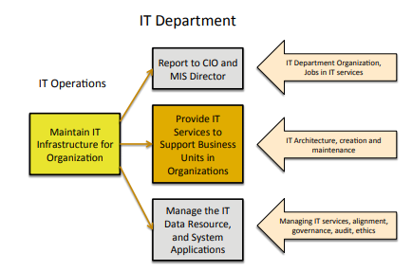
- Organizational structure varies, depending on the organization's size, culture, competitive environment, industry, etc
- All these services - email systems, accounting applications, desktop computers, and mobile devices - used in an organization require some form of technical support
- The department of people who support this is often referred to as "IT services" of "Information Systems services"

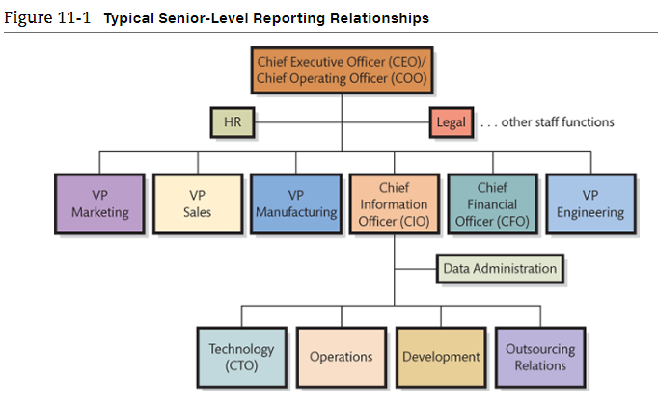
A common title of the principal manager of the IT department is chief information officer (CIO). Other common titles are VP of Information services, director of information services, and less commonly, director of computer services

What about the Web?
- The web has had a significant impact on the organization of IT departments
- Traditionally, IT department was responsible for designing and maintain a website
- This task now belongs to marketing department to keep up with branding and control of content while IT provide technical support for the website
- Creating well-designed company web pages requires knowledge of branding and marketing

What jobs exists in IT services?
- IT industries have a wide range of interesting and well-paying jobs
- Some think that the industry consists only of programmers and computer technician who have great technical skills
- The reality is that most jobs that are in the highest demand in the IT industry require a mix of interpersonal and technical skills
- The industry needs people who can bridge the knowledge gap between computer technicians and business system users
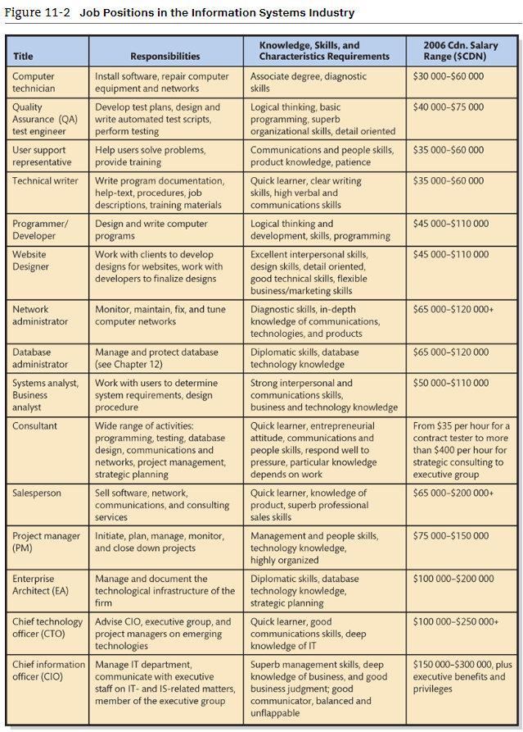

What is IT architecture
- Like a city plan that lays out the street network, water systems, emergency systems, power girds
- IT architecture is the basic framework for all the computers, systems, and information management that support organizational services
- Enterprise architect creates a blueprint of an organization's information systems and the management of these systems
  - In developing the architecture, the enterprise architect usually considers organizational objectives, business processes, databases, information flows, operating systems, applications and software, and supporting technology

What does IT architecture look like
- Few standards since companies are diverse
- Usually a long document with complicated diagrams, management policies, discussion of future changes
- Zachman framework: helps in designing IT architecture
  - It divides systems into two dimension
  - One based on six reasons for communication (what-data, how-function, where-network, who-people, when-time, why-motivation) and the other is based on stakeholder groups (planner, owner, designer, builder, implementer, and worker)
  - 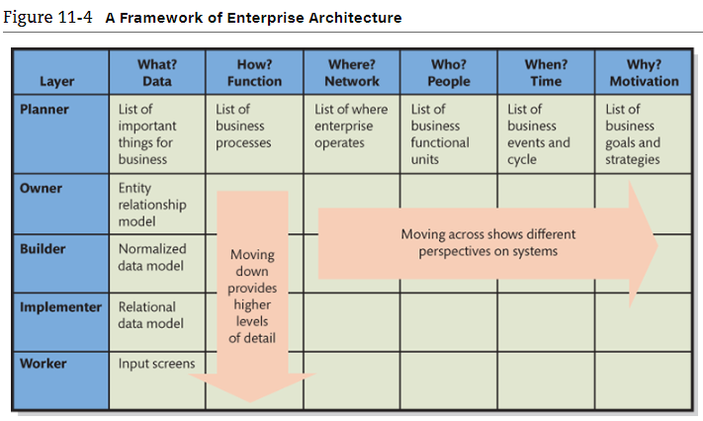
Why an enterprise architecture framework
- The Zachman Framework - originally conceived by John Zachman at IBM in the 1980s
- Became a world standard for expressing the framework for enterprise architecture with tools for every architect needs
- Provided the template, guidance, definition, and content of an enterprise architecture
- Structured view of an enterprise
- Two dimensional classification, based on the intersection of six communication questions with five models of stakeholders

Challenges in enterprise architecture
- Lack of understanding and weak definition of the purpose for enterprise architecture
- Lack of continuous support from senior management
- Lack of business needs/architecture alignment
- Lack of skills and talent
- Inconsistent views among stakeholders

What is alignment, why is it important, and why is it difficult?
- Alignment: process of matching organizational objectives with IT architecture
- Ongoing process: fitting IT architecture to business objectives is a continuous challenge
- Measured as the degree to which t he IT department's missions, objectives, and plans overlapped with the overall business missions, objectives, and plans
- Communication between business and IT executives is the most important indicator of alignment

What is information systems governance?
- Governance: development of consistent, cohesive, management policies and verifiable internal process for IT and related services
- Goal of IS governance is to improve the benefits of an organization's IT investment over time
  - Reporting structures
  - Review processes
  - Improve quality
  - Reduce service costs and delivery time
  - Reduce IT risks
  - better support business processes
- 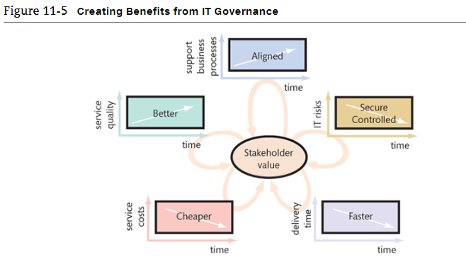
The Sarbanes-Oxley Act and the Budget Measures act
- Sarbanes-Oxley Act (SOX) in USA
  - A federal law enacted on July 30, 2002 in reaction to the major corporate scandals that involved the infamous ENRON
  - Governs the reporting requirements of publicly held companies
- Budget Measures Act (or Bill 198) in Canada
- Require management to create internal controls sufficient to produce reliable financial statements and to protect the organization's assets
  - E.g. Separation of duties and authorities
- Expose both management and the external auditor to financial and criminal liability if subsequent events show that internal controls were defective

What is an Information systems audit, and why should you care about it?
- Examination and verification of a company's information resources that are used to collect, store, process, and retrieve information - including organization's IS policies and procedures
- Many firms offer IS audit services
- Control Objectives for Information and Related Technology (COBIT) is a framework of best practices designed for IT management
  - Provides board members, managers, auditors, and IT users with a set of generally accepted measures, indicators, processes, and best practices to assist them in getting the best from their organizational IT investments
  - Provides a process through which alignment between IT and business objectives is developed

Why should you care about IS governance and IS audit?
- Increased need to report and disclose IS operational information will require employees at all levels of an organization to become more familiar with the issues facing information technology management
- Senior business managers are required to make assertions about the controls on IS that will expose them to both financial and criminal penalties

What is Information Systems ethics?
- IS ethics is about people involved with the system, not hardware or software
- IS ethics is about understanding our won behaviour - the way we think and act in situations where our choices affect others
- Ethical principals
  - United nations declaration of human rights
  - Canada's charter of rights and freedoms
  - Association of computing machinery's code of ethics

What is Green IT and why should I care?
- Green IT, or green computing: using IT resources to better support the triple bottom line for organizations
- The triple bottom line: a concept that expands the notion of traditional financial reports, which are based solely on financial performance, to take into account ecological and social performance
  - Includes measure of traditional profit along with ecological and social performance
- Primary goals to improve energy efficiency, promote recyclability, and reduce the use of materials that are hazardous to the environment
- Green It considers the effects of choices on people and the environment
- ENERGY STAR program - is an international government/industry partnership to produce equipment that meets high-energy efficiency specifications or promotes the use of such equipment
- E-cycling or the recycling of electronic computing devices

Managing information security and privacy

What is identity theft?
- Understanding threats to your own privacy will help make you more sensitive to the importance of security and privacy
- In identity theft, vital information such as a person's name, address, date of birth, social insurance number, and mother's maiden name are acquired to complete impersonation
- With this information, the identity thief can take over a victim's financial accounts; open new bank accounts; transfer bank balances; apply for loans, credit cards, and other services

What is PIPEDA?
- PIPEDA: personal information protection and electronic documents act
- The act is intended to balance an individual's right to the privacy of his or her personal information, which organizations need to collect, use, or share for business purpose
- In other words, gives individuals the right to know why an organization collects, uses, or discloses their personal information
- The privacy commissioner of Canada oversees this act
- PIPEDA governs how data are collected and used
- PIPEDA suggests that organizations should not be able to use the information collected for any purpose other than what the organization agreed to use it for
- PIPEDA suggests that it is the duty of an organization to protect the information they collect
- PIPEDA does not facilitate individuals suing organizations
- The commission reviews case and produces a report stating its conclusions

What types of security threats do organizations face?
Thee sources of security threats are:
- Human errors and mistakes
  - Accidental problems
  - Poorly written programs
  - Poorly designed procedures
  - Physical accidents
- Malicious human activity
  - Intentional destruction of data
  - Destroying system components
  - Hackers
  - Virus and worm writers
  - Criminals
  - Terrorists
- Natural events and disasters
  - Fires, floods, hurricanes, earthquakes, tsunamis, avalanches, tornados, and other acts of nature
  - Initial losses of capability and service
  - Plus losses from recovery actions

5 types of security problems
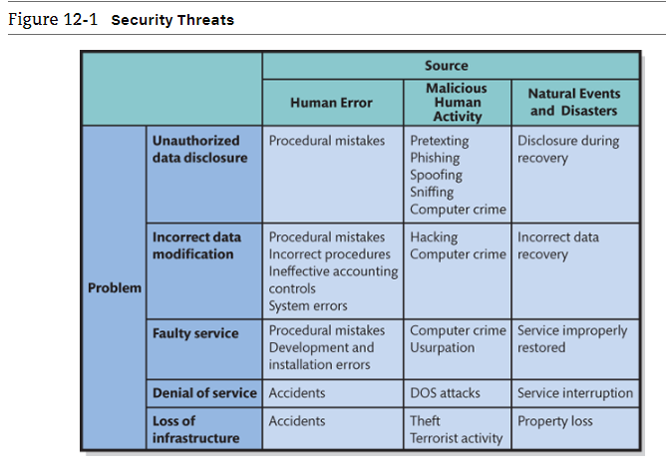
Types of problems
- PIPEDA unauthorized data disclosure: release of data in violation of policy
  - Human error
    - Posting private information in public place
    - Placing restricted information on searchable web sites
    - Inadvertent disclosure
  - Malicious release
    - Pretexting: gathering unauthorized information by pretending to be someone else. Telephone caller who pretends to be from a credit card company
    - Phishing: uses pretexting via email. The phisher pretends to be a legitimate company and sends an email requesting confidential data
    - Spoofing: when someone pretends to be someone else
      - IP spoofing: when an intruder uses another site's IP address as if it were that other site
      - Email spoofing: synonym for phishing
    - Sniffing: Technique for intercepting computer communications. With wired networks, sniffing requires a physical connection to the network. With wireless networks, no such connection is required
      - Drive-by-sniffers: simply access computers with wireless connections through an area and search for unprotected wireless networks. They can monitor and intercept wireless traffic at will.
    - Ransomware: an example of malicious software that encrypts a computer user's data resulting in unreadable files
- Incorrect Data modification
  - Human errors
    - Incorrect entries and information
    - Procedural problems
    - Systems errors
    - Hacking: person gains unauthorized access to a computer system
- Faulty service
  - Incorrect system operation
  - Usurpation
    - Force takeover of a system
- Denial of Service (DOS)
  - Security problem in which users are not able to access an information system
  - Hacker can flood a web server with millions of bogus or fraudulent service requests to hinder the server from processing legitimate requests. Computer worms can infiltrate a network with so much artificial traffic that legitimate traffic cannot get through
- Loss of infrastructure
  - Accidental
  - Theft
  - Terrorism
  - Natural disasters

Elements of security program
- Senior management involvement
  - Must establish a security policy
  - Manage risk
    - Balancing costs and benefits of the security program
- Safeguards
  - Protections against security threats
  - 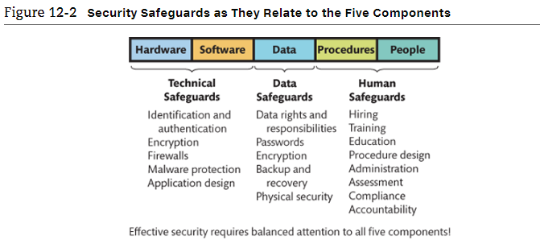
- Incident response
  - Must plan for prior to incidents

How can technical safeguards protect against security threats?
- Identification and authentication
  - User names and passwords (what you know)
    - Identification
    - Authentication
  - Smart cards (what you have)
    - Plastic card similar to a credit card that has a microchip. The microchip, which holds much more data than a magnetic strip, is loaded with identifying data. Normally it requires a PIN
    - Personal identification number (PIN)
  - Biometric authentication (what you are)
    - Fingerprints, facial features, retinal scans, voice
  - Single sign-on for multiple systems
- Encryption and firewalls
- Malware
  - Viruses
  - Worms
  - Trojans
  - Spyware & adware
    - Symptoms: slow performance, pop-up ads, suspicious browsers homepage changes and more
- Malware safeguards
  - Install antivirus and anti-spyware programs
  - Scan hard drive and e-mail frequently
  - Update malware definitions
    - Patterns that exist in malware
  - Open e-mail attachments only from known sources
  - Install software updates promptly
  - Browse only reputable websites

How can data safeguards protect against security threats?
- Data safeguards protect databases and other organizational data
- Data administration
  - Organization-wide function
    - Develops data policies
    - Enforce data standards
- Database administration: management, development, operation, and maintenance of the database so as to achieve the organization's objectives
  - Particular database function
    - Procedures for multi-user processing
    - Change control to structure
    - Protection of database
- 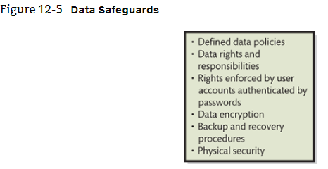
- Encryption keys
  - Key escrow: a control procedure whereby a trusted party is given a copy of a key used to encrypt database data
- Backup copies
  - Store off-premise
  - Check validity
- Physical security
  - Lock and control access to facility
  - Maintain entry log
- Third party contracts
  - Safeguards are written into contracts
  - Right to inspect premises and interview personnel

How can human safeguards protect against security threats?
- Steps taken to protect against security threats by establishing appropriate procedures for users to follow for system use
- Involve people and procedure components of IS
- User access restriction requires authentication and account management
- Design appropriate security procedures
- Security considerations for:
  - Employees
  - Non-employee personnel

Human safeguards for employees
- User accounts considerations
  - Define job tasks and responsibility
  - Separate duties and authorities
  - Grant least possible privileges: users whose job description does not include modifying data should be given accounts with read-only privileges.
  - Document security sensitivity
- Hiring and screening employees
  - When hiring for high-sensitivity positions, however, extensive interviews, references, and background investigations are appropriate. Note, too, that security screening applies not only to new employees but also to employees who are promoted to sensitive positions.
- Dissemination
  - Employees need to be made aware of policies and procedures
  - Employee security training
- Enforcement of policies
  - Enforcement consists of three interdependent factors:
    - Responsibility: clearly define the security responsibilities of each position
    - Accountability: the design of the security program should be such that employees can be held accountable for security violations
    - Compliance: employee activities should be regularly monitored for compliance
- Create policies and procedures for employee termination
  - Protect against malicious actions in unfriendly terminations
  - Remove user accounts and passwords
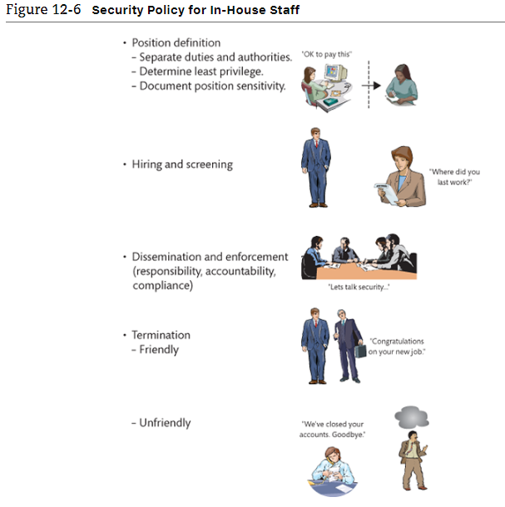
Human safeguards for non-employees
- Temporary personnel and vendors
  - Screen personnel
  - Training and compliance
  - Contract should include specific security provisions
  - Provide accounts and passwords with the least privileges
- Public users
  - Harden web site and facility
  - Hardening: take extraordinary measures to reduce system's vulnerability
- Partners and public that receive benefits from the IS
  - Protect these users from internal company security problems

Account administration
- Account management procedures concerns:
  - Creation of new user accounts
  - Modification of existing account permissions
  - Removal of unneeded accounts
- Password management
  - Acknowledgement forms
  - Change passwords frequently
- Help-desk policies
  - Authentication of users who have lost their password
  - Password should not be e-mailed (just a notification of password change)
- System procedures
  - Normal operation
  - Backup
  - Recovery
    - Procedures of each type should exist for each IS
  - Definition and use of standardized procedures reduces the likelihood of computer crime
  - Each procedure type should be defined for both, system users and operations personnel
    - Different duties and responsibilities
    - Varying needs and goals
  - 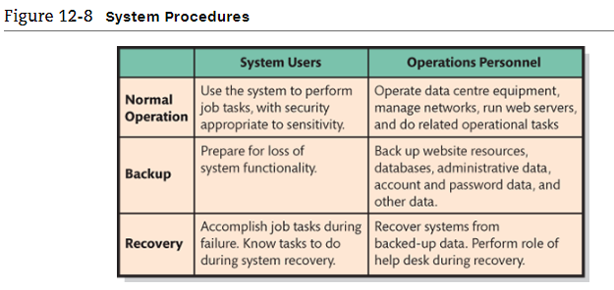
- Security monitoring functions:
  - Activity log analyses
    - Firewall logs
    - DBMS log-in records
    - Web server logs
  - Security testing
    - In-house and external security professionals
  - Investigation of incidents
    - How did the problem occur?
  - Lessons learned
    - Indications of potential vulnerability and corrective actions

What is Disaster Preparedness
- A substantial loss of computing infrastructure caused by acts of nature, crime, or terrorist activity can be disastrous for an organization
- Best safeguard is appropriate physical location of infrastructure
- Backup processing centres in geographically removed site
- Identify mission-critical systems (systems without which the organization cannot carry on and which, if lost for any period, could cause failure) and resources needed to run those systems
- Prepare remote back up facilities for the critical resources at the remote processing centre
  - Hot sites: remote processing centres in an advanced state of readiness that have equipment companies need to continues operations in the event of a loss of their main computing sites
  - Cold sites: remote processing centres that provide office space and limited computer equipment for use by companies that need to continues operations after a loss of their primary computing site
- Train and rehearse cutover of operations
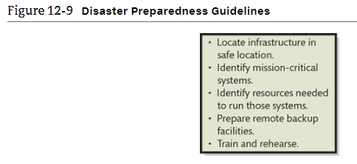
Organizations respond to security incidents
- Organization must have plan
  - Detail reporting and response
- Centralized reporting of incidents
  - Allows for application of specialized expertise
- Speed is of the essence
- Preparation pays off
  - Identify critical employees and contact number
  - Training is vital
- Practise incidence response
- 

