Lecture 1-Notes
September 12, 2019
1:38 PM

Accounting #1-In class notes (lecture)
What are goods?
Physical products consumers buy in exchange for money.
What are services? (Netflix) Nothing physical (enjoyments, spend time there, you don’t come out with a physical product)
Some companies both provide goods and services
Bell and rogers provide phones and service for those phones
3 different sectors of business
Primary: raw materials from natural resources (mining, oil, lumberjack, fishing, farming, agriculture)
Secondary resources: Turns raw materials into products (business, salmon from a lake into food consumers can buy, processing food, turning wood to furniture) *same business might both deal with primary and secondary sectors*
Tertiary sector: Providing services to consumers or to other businesses (phone plan, hair salon, nail salon, restaurants, uber)
Who cares about these businesses?
Stakeholders, consumers or groups with objectives who want to interact or want a benefit from the business. Different individuals who care bout business who have goals which they’d trying to meet. Consumers objective to buy a good product or a cheap product. Stakeholders can be internal or external to a business. *Internal-work for the business* *Customer of business you’re external*
E.G the CEO of coca cola, internal stakeholder who want to keep his/her job and see the company successful (objective) the bank who provides loans for the company is external
-stakeholders make decisions to help them met their objective
Accounting system: info system that collects, (set of info) tracks and communicates business transactions which stakeholders use to make decisions to meet their objectives (for stakeholders)
Business transaction- stuff that happens in a business e.g. you sell a car, your money, that is a business transaction. Paying employees who work for u is a business transaction (tracking and being in the system)
Everything that you record that goes into that accounting system has 2 sides or aspects to it, you give something and you get something. Give BMW and you get money in return.
Stakeholders want financial info about the stuff that happens in a business(transactions), they want good up to date financial info, honest truthful. (wrong info that’s not useful is not ethical) want financial info that have “qualitative characteristics”
6 qualities are: faithful(info that is truthful, relevant(useful for decision making), comparable (can compare to other businesses or the same business over time), verifiable(other people would determine the same $ amounts), timely( Info provided quickly) and understandable (info is clear and concise)
Read the text to review assumptions that accompany the qualitative characteristics- together they ensure financial info useful for decision making
Next week, chapter 2 pick up from here and expand and focus on the categories used to group sort financial info how to analyze business transactions
Tutorial-2019/09/10
RECAP
Define stakeholder, know difference between internal and external, be able to give at least one objective for each stakeholder.
Any employee is internal that works for the business.

From <https://ryersonprod-my.sharepoint.com/personal/abiysha_sundaralinga_ryerson_ca/Documents/Accounting.docx>

9

Lecture 2
September 12, 2019
1:40 PM
Definitions

Assets: past transactions, owned by business, will benefit business in the future. e.g. an ice cream truck
Liability: past transaction, owed by business, will be settled in the future .e.g. Bank loan
Revenue:(what the business earns) minus expenses(costs consumed) =profit E.g. sell ice cream for cash minus cost of ice cream, cones, napkins, employees= profit
-the profit either gets retained in the business and becomes 'retained earnings' (=RE)(accumulated profit) or some/all paid out to owners as dividends 9=payout from the business to the owner (not a salary expense! Think of it as a reward)
-so profit - dividends = retained earnings
-retained earnings is a part of equity
Equity: owners capital ( owners investments in the business) =retained earnings
- Same idea in a diffferent way= equity owners capital + ( revenue- expenses) - dividends
When revenues increase, it increases profit and a reduction in profit is a reduction.

What's the connection between assets- liabilities= equity ( same as; assets= liabilities+ equity) this means that everything that a business owns (left side) is owed either to third parties (liabilities) or to the owners (equity)

Acc100
Class 2 notes
The accounting equation and transaction analysis

Business involved in many thing, simple business such as an ice cream shop
-buying supplies, paying employees
-in complicated businesses everything needs to be recorded
-these activities must e categorized/analyzed/formatted when put in the accounting system to transform into financial info (that can e used for GOOD decision making)
Re call the ACCOUNTING SYSTEM= info system that collects/tracks/communicates info
-end result of accounting system= financial info in the form of financial statements
All info goes into accounting system from point of view of the business (not owner)

GAAP tells you the categories that business activities must be divided into (=elements)
GAAP= generally accepted accounting principles(rules of accounting)

Focus in acc100 is profit oriented businesses

Double entry accounting system- everything is recorded twice and the question must always balance
Analyzing business activity - always ask from the point of view of the business: what did the business get and what did the business give away
textbook

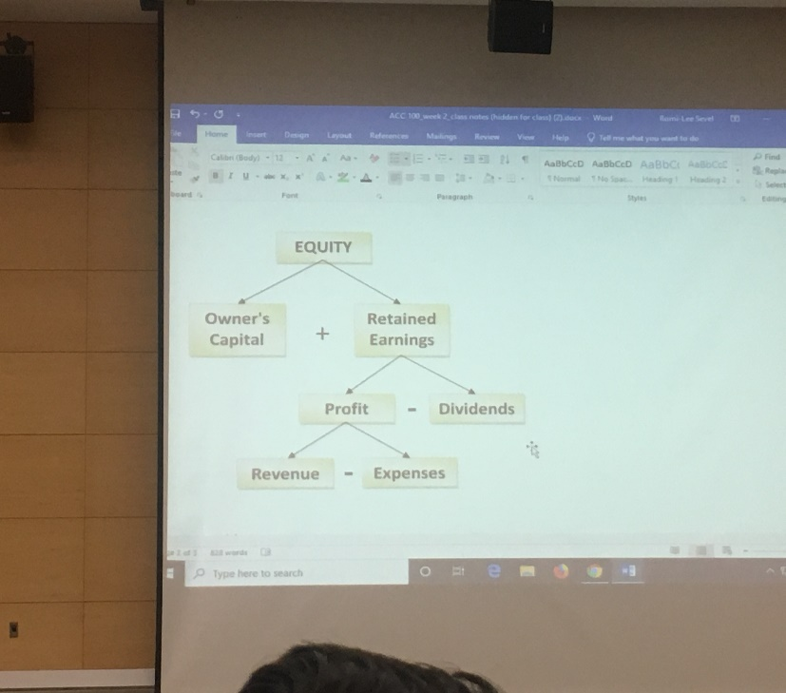

Lecture 3 introduction to accounts
September 23, 2019
10:10 AM
-Past weeks we have talked about the importance of business info being in a specific format that allows stakeholders to quickly evaluate business activities to make decisions
-using the expanded accounting equation is better than the basic accounting equation
-a good accounting system sub-divides elements so more detailed info is available

An account cashed under the element assets tracks cash transaction so you know the total cash at any time
Accounts= subgroups of elements used to accumulate similar activities in 1 place
Ultimately we're using the total in each sub category in the accounts to produce financial statements

There are standard accounts used: accounts receivable, revenue, pre paid advertising- if you the account names on nay businesses financial statements mean the same thing (the amount is set)

Businesses are involved in a lot of stuff- not all of these activities are getting recorded in the accounting records, some of them get record/tracked elsewhere
Example, business receiving a not from lawyer, may not get put into accounting record, but will document it, will not effect assets liabilities equity
An event= business activity of importance to a business (not recorded in accounting system)
IF; an event is measurable ($ value) and realized (exchange has already happened) then it is recorded in accounting system- transaction
-a business signs up for Gmail account to use for business communication
-what did the business get? The use of an email account
-what t=did the business give away? Nothing its free
- If there are no $ value attached (not measurable) this is not a transaction to record in the accounting system
- 3 types of financial statements=
- Income statement = provides the businesses performance over a period of time (includes revenues and expenses)
- -balance sheet=shows the currents financial position (includes assets and liabilities and equity)
- Statement of cash flows= includes all cash transactions

Cash receipt  (increase in cash) | customer | past | Decrease in accounts receivable  A/R
 |  | present | Increase in revenue
 |  | future | Increase in unearned revenue
 | Lender(bank) |  | Increase in loan payable
 | shareholder |  | Increase in owners capital

Cash receipt  (increase in cash) | Supplier | past | Decrease in accounts payable  A/R
 |  | present | Increase in asset/expense
 |  | future | Increase in prepaid expense
 | Lender(bank) |  | Decrease In loan payable
 | shareholder |  | Increase in dividends(decrease in equity)

Be sure to review "when the cash and goods do not coincide" doc on MAIN site

HOW TO ANALYZE TRANSACTIONS
- What kinds of transaction is it? ( is there cash Or no cash)
- No cash, then who is the other party (customer, lender, shareholder, supplier)
- If the other party based on number two is a customer or supplier, when the goods/services have been/will be delivered (previously now or later)

Easy transaction(no cash involved)
Sale on account: increase accounts receivable, increase revenue
Purchase on account: increase asset or expense, increase accounts payable

Lecture 4
October 8, 2019
6:56 PM

Merchandising Operations
The examples you have seen so far have been for Service businesses (e.g. lawn mowing company° or law firm or taxi-cab company...sell a service not a product)
-Now studying merchandising businesses- these are more complicated- WHY???
-INVENTORY- stuff you either make from scratch or buy with the purpose of selling at a profit
Examples: running shoes, BMWs, ice cream
BUT…. how does a business buy something and sell it to make a profit????
-It has to buy for a $ amount and sell it for a HIGHER $ amount e.g. buy a pair of shoes for $20 and sell it for $80 means $60 profit
-The $ amount (e.g. $60) added to the cost of inventory to make a profit is called a MARKUP
-We often also talk about markups as percentage e.g. a 15% markup on shoes means if you buy shoes for $500 then 500 *1.5=$575 so you are selling for $575 and the profit is $75… we actually call this GROSS PROFIT =the difference between the selling price and the cost of the inventory (Why not called profit? More on this later…)
-Gross PROFIT= GROSS MARGIN
-Another way to calculate the marked-up selling price is:
Selling price (SP)= Cost+(cost x markup %)
SP= 500 + ( 500 x 15%)
SP = 500 + 75
SP= $575
To calculate gross profit:
Gross Profit (GP)=Selling Price (SP) - Cost
GP=$575 - $500
GP= $75
-Note - we also have to deduct other expenses to calculate total profit
-We call these other expenses “period costs” - all costs in the normal course of business not specifically related to inventory. Eg. rent, advertising, etc.
-Only then do we know the total PROFIT of the sale!
Inventory cycle
-Businesses buy inventory “on account”, later on, pay cash to suppliers for that inventory, then sell inventory to customers ‘on account’, later on, receive cash from customers and use that to buy more inventory….. And the cycle continues (all of this has to be accounted for…)
-In the above cycle, why are they buying on the account and not spending cash right away???
-As relationships developed, suppliers allow them the ‘pay later’ option
-Called credit terms. E.g. n/30 - ‘n’ means ‘net’ or whole. It means you have 30 days to pay.

