GMS 401 – Final Exam Review

Chapter 1

Operations Management (OM)
- Activities that relate to the creation of g/s through transformation of inputs to outputs
- Production – the creation of goods and services

Efficiency and Effectiveness
- Efficiency – minimizing cost
- Effectiveness – achieving intended goals

3 Functions for Production
- Marketing – generates demand
- Production/Operations – creation of a product
- Finance/Accounting – tracks performance, pays bills, collects money

Supply Chain
- Creates value for a customer
- Supply Chain – global network of orgs and activities that supplies a firm with g/s

Differences B/W G/S
- Services are usually intangible, they are produced and consumed at the same time
- Often unique, high customer interaction, knowledge based
- Dispersed, most are brought to the customer

Decision Process in Operations
- Designing Decisions – include capacity, location, equipment
- Planning/Controlling Decisions – personnel, inventory, scheduling, quality insurance

Chapter 2

Key Customer Purchasing Factors
- Price, Quality, Variety, Timeliness, Customer Service, Convenient Location

Competitive Advantage
- Managers achieve this advantage through differentiation, low cost, and response

Competing on Differentiation
- Differentiation – distinguishing the offerings of an org in a way that the customer perceives adding value
- Experience Differentiation – engage customer with a product through imaginative use of the five senses, so they experience the product

Competing on Cost
- Low Cost Leadership – achieving maximum value as perceived by the customer
- Having the lowest cost in each department possible

Competing on Response
- Response – set of values related to rapid, flexible, and reliable performance
- Match changes in a market where design innovations and volumes fluctuate

Developing Missions and Strategies
- Mission – the purpose or rationale for an organizations structure (destination)
- Strategy – how an organization expects to achieve its mission and goals (director)

Productivity
- The ratio of outputs divided by one or more inputs
- Productivity = units produced/inputs used
- Single Factor Productivity – ratio of one input to the outputs produced
- Multifactor Productivity – ratio of many or all inputs to the outputs produced

Productivity Variables
- 3 critical factors are labour, capital, and management
- 3 key variables to improve labour productivity are:
  - Basic Education
  - Diet of the Labour Force
  - Social Overhead (ex. transportation)
- Knowledge Society – a society in which much of the labour force has migrated from manual work to work based on knowledge

Chapter 3

Maintenance
- Activities involved in keeping a systems equipment in working order
- Maintenance tactics are:
  - Implementing or improving preventative maintenance
  - Increasing repair capabilities or speed

Reliability
- Probability that a machine part or product will function properly for a specified time
- Reliability tactics are:
  - Improving individual components
  - Providing redundancy – use of components in parallel to raise reliability

Series System
- 2 or more events are independent and success is defined as the occurrence of all events
- P_{s} = P₁ x P₂ x P₃…
  - Reliability of the system as a whole is less than each individual component
  - As # of components increase, reliability decreases

Parallel System
- 2 or more events are independent and success is defined as the occurrence of at least one of the events
- P_{s} = 1 – (1 – P₁) x (1 – P₂) x (1 – P₃)…
  - P₂ and P₃ are backups
  - Reliability of a system as a whole is greater than that of each component
  - As # of components increases

Parallel and Series
- Step 1: calculate the reliability of parallel components
- Step 2: calculate reliability of the resulting series system

Chapter 4

Product Development System
- Effective product strategy links decisions with cash flow, market dynamics, product life cycle, understand changes in the market place, and have talents and resources available

Generating New Products
- To develop successful new products companies must be open/understand changes in the environment they are in

Product Development Strategy
- Permanent Product Strategy – several menu items that are permanent and won’t change
  - Ensures there is always something familiar for customers
- Temporary Product Strategy – regularly temporary products
  - Give customers something new to experience and experiment new items that may become permanent
- Local Product Development Strategy – creation of several products to meet customer demand in local markets
  - Ensures local customers have a product to fit to them
- Local Adaption Strategy – takes a product and modifies it for local wants

Product Life Cycle
- Introductory Phase – products are still being “fine tuned”
- Growth Phase – product design has begun to stabilize
- Maturity Phase – competitors are established
- Decline Phase – management may have to terminate the product or update it

Robust Design
- A design that can be produced to requirements even with unfavourable conditions in the production process

Modular Designs
- Designs in which parts/components are subdivided into modules that are easily interchanged or replaced

Computer Aided Design (CAD)
- Use of a computer to develop and document a product
- Design for Manufacture and Assembly – software that allows designers to look at the effect of design on manufacturing the product
- 3-D Object Modelling – extension of CAD that builds small prototypes

Computer Aided Manufacturing (CAM)
- The use of information technology to control machinery

Benefits of CAD/CAM
- Quality is better, shorter design time, cost reductions, database availability, new range of capabilities

Virtual Reality
- A visual form of communication in which images substitute for reality and allow the user to respond interactively

Value Analysis
- Review of successful products that takes place during the production process

Design for Environment
- Remanufacturing used products by replacing worn out or defective components

Design for Disassembly
- Design is so that used products can be easily taken out

Service Design
- Includes direct interaction with the customer
  - Increased opportunity for customization, but reduced productivity
- Cost and quality are still determined at the design stage
  - Delay Customization, Modularization, Reduce Customer Interaction

Quality Function Deployment (QFD)
- Determining what will satisfy the customer
- Translating those customer desires into the target design
- House of Quality – part of the quality function deployment process that helps relate customer wants and how the firm meets them

Chapter 5

Process Strategies
- An organization approach to transforming resources into g/s
- Objective to build a production process that meets cuts requirements and product specs

Process Focus
- Low Volume, High Variety
- Examples: Hospitals, Restaurants, Machine, etc

Product Focus
- High Volume, Low Variety
- Examples: Beer, Baked Goods, Steel

Repetitive Focus
- Repetitive Volume, Changes in Modules for Variety
- Product oriented production process that uses modules (parts/components previously prepared)
- Examples: Autos, Appliances, Motorcycles

Mass Customization
- High Volume, High Variety
- Rapid, low cost production that caters to changing unique customer desires
- Build to Order (BTO) – produce to customer rather than forecast
- Examples: Dell Computers

Machine Technology
- Cutting, drilling, boring, and milling
- Machinery today is 5x more productive, allows more complex and precise items to be made faster
- Computer Numerical Control (CNC) – machinery with its own computer and memory

Automatic Identification System (AISS) and RFID
- AISS – a system for transmitting data into electronic form (ex. bar code)
- Radio Frequency Identification – wireless system, integrated circuits w antennas send radio waves

Process Control
- The use of information technology to monitor and control a physical process
  - Sensors collect data, devices read data, measurements are translated into signals
  - Transmitted to a computer, computer program reads the file
  - Resulting output may be messages on printers/consoles, signals, warnings, lights, horns, or charts

Vision Systems
- Use video cameras and computer technology in inspection roles

Robots
- Flexible machinery, ability to hold, move, or grab items
- Functions through electronic impulses that activate motors and switches

Automated Storage and Retrieval System (ASRS)
- Computer controlled warehouses, automatic place of parts into and from designated spot

Automated Guided Vehicle (AGV)
- Electronically guided and controlled chart used to move materials

Flexible Manufacturing Systems (FMSS)
- System uses an automated work cell controlled by electronic signals from common centralized computer facility

Computer Integrated Manufacturing (CIM)
- Flexible manufacturing systems, inventory control warehousing & shipping are integrated

Comparison of Process Choices
- Crossover Chart – a chart of costs at possible volumes for more than one process
  - Used to determine which choices cost more than others (which is best)

Flow Chart
- Drawing used to analyze the movement of people or material

Time Function Mapping
- Flow chart with time added on the horizontal axis

Value Stream Mapping
- Process helps managers understand how to add value in the flow of materials and info

Process Charts
- Use of symbols to analyze the movement of people or material

Service Blueprinting
- Technique that lends itself to a focus on the customer and providers interaction w them

Opportunities to Improve Service Processes
- Layout – integral part of many service processes, in retailing, dining, and banking
- Human Resources – issue of recruiting and training is important to success in processes

Office Layout
- Grouping of workers, their equipment, and offices

Retail Layout
- Approach that addresses flow, allocates shelf space and responds to customer behaviour

Warehouse Layout
- Attempts to minimize total cost by addressing trade-offs b/w space and material handling
  - Cross-docking, random stocking, customizing

Fixed Position Layout
- System that addresses the layout requirements of stationary projects

Process Oriented Layout
- Deals with low volume, high variety production in which like machines/equipment are grouped together

Work Cell Layout
- Arrangement of machines/equipment that focus on making a single product or group of related products

Product Oriented Layout
- Seek the best personnel and machine utilization in repetitive or continuous production

Chapter 6

Learning Curves
- Premise that people and orgs get better at their tasks as the tasks are repeated

Arithmetic Approach
- Each time production doubles, labour per unit declines by a constant factor
- If the learning rate is 80% and the first unit took 100 hours, the hours required to produce the 2nd, 4th, 8th, and 16th unit are as follows:

Nth Unit Produced | Hours for Nth Unit
1 | 100
2 | 80.0 = (0.8 x 100)
4 | 64.0 = (0.8 x 80)
8 | 51.2 = (0.8 x 64)
16 | 41.0 = (0.8 x 51.2)

Logarithmetic Approach
- Allows us to determine labour for any unit: T_{N} = T₁(N^{b})
- Where:
  - T_{N} = time for the Nth unit
  - T₁ = hours to produce the first unit
  - b = (log of the learning rate)/(log 2) = slope of the learning curve

Coefficient Approach
- T_{N} = T₁C
- Where:
  - T_{N} = number of labour hours required to produce the Nth unit
  - T₁ = number of labour hours required to produce the first unit
  - C = learning curve coefficient found in the table
- Table 6.3:
  - Total Time Coefficient to determine total time needed to produce all units
  - Unit Time Coefficient to determine total time needed to produce a single, specified unit

Chapter 7

Quality
- Ability of a g/s to meet customer needs
- Features/characteristics of a g/s that bears on its liability to satisfy stated/implied needs

Two Ways Quality Improves Profitability
- Sales Gains:
  - Improved Response
  - Flexible Pricing
  - Improved Reputation
- Reduced Costs:
  - Increased Productivity
  - Lower Rework and Scrap Costs
  - Lower Warranty Costs

Quality Management
- Functions involved in determining quality policy and implementing through means such as quality planning and assurance
- Four main components:
  - Quality Planning, Assurance, Control, Improvement

Quality Planning
- Documents that specify standards, practices, resources, specifications, and sequence of activities relevant to a particular g/s

Quality Assurance
- Planned and systematic activities implemented in a quality system so that quality requirements will be fulfilled

Quality Control
- Observation techniques, attributes used to fulfill requirements for quality

Cost of Quality
- The cost of doing things wrong – that is the price of non-conformance
- Prevention Costs – reducing the potential for defective parts/services
- Appraisal Costs – evaluating products/processes/parts/services
- Internal Failure – incurred to cure defects discovered before g/s delivered to customers
- External Costs – incurred to remedy defects discovered by customers
  - Occur after delivery of defective parts/services

ISO 9000
- Set of quality standards developed by the International Organization for Standardization
- Provides guidance to help companies consistently meet customer requirements and quality is consistent

ISO 1400
- Series of environmental management standards established by the ISO

Total Quality Management
- Management of an entire org so that it excels in all aspects of g/s that are important to the customer

Continuous Improvement
- PCDA – Plan, Do, Check, Act
- Kaizen – continuous improvement

Six Sigma
- A program to save time, improve quality, and lower costs
- Set of quality management techniques/tools for process improvement
- Improves quality by identifying and removing the causes and defects, minimizes variability in manufacturing and business process
- 5 Steps: Define, Measure, Analyze, Improve, Control

Employee Empowerment
- Enlarging employee jobs so that added responsibility and authority is move to the lowest level of the org possible

Benefits of Employee Empowerment
- Improved Productivity – reduced costs
- Better Customer Service
- Embracing Change

Benchmarking
- Selecting a demonstrated standard of performance that represents the very best performance for a process or an activity
- Objectives:
  - Where and what improvements are needed
  - How to achieve high performance levels
  - Use this info to improve performance

Just In Time (JIT)
- Designed to produce or deliver goods just as they are needed
- Related to quality in three ways:
  - Cuts cost of quality, improves quality, better quality means less inventory

Taguchi Concepts
- Quality Robust – products consistently built to meet customer needs in spite of adverse conditions in the production process
- Quality Loss Function – identifies all costs connected with poor quality and shows how these costs increase as quality moves from what the customer wants
  - L = D²C

Cause and Effect Diagram
- A fish bone diagram
- Problem on one side, followed by causes of the problem, and then sub cause of each

Scatter Diagram
- Relationship b/w two measurements (ex. # of service calls and # of trips made to the car for parts by the repair person)
- Positive, Negative, and No Correlation

Pareto Charts
- Identify the critical items as opposed to many less important ones

Flow Charts
- Graphically describe a process system, use annotated boxes and interconnected lines

Chapter 8

Role of Inspection
- Inspection – ensuring that an operation is producing at the expected quality level

Source Inspection
- Controlling or monitoring at the point of production or purchase
- Each supplier, process, and employees treats the next step as the customer
- Poka Yoke – “fool proof” a device/technique that ensures production of a good unit

Inspection of Attributes versus Variables
- Attribute Inspection – inspection that classifies items as either good or defective
- Variable Inspection – classes of inspected items as falling on a continuum scale

TQM in Services
- Op managers play a significant role in addressing major aspects of service quality
- Tangible component of many services is important

Service Recovery
- Training and empowering frontline workers to solve a problem immediately

Statistical Process Control (SPC)
- Process used to monitor standards by taking measurements and corrective action
- Natural Variation – variability that affects every production process to some degree
- Assignable Variation – variation in a production process that can be traced to causes

Control Charts for Variables
- X-Chart (sample mean control chart)
- R-Chart (sample range control chart)

Control Charts for Attributes
- P-Chart (used to monitor proportion of defective items generated by a process)
- C-Chart (used to monitor the number of defects per unit product)

Central Limit Theorem
- Regardless of the distribution of the population, the x distribution tends to follow a normal curve as the number of samples increases

Run Test
- Used to examine the points in a control chart to see if non-random variation is present
- When variation is present a flag is raised, means that the process may not be statistically in control

X-Chart (Sample Mean Control Chart)
- A quality control chart for variables that indicates when changes occur in the central tendency of a production process
- The centre line for sample mean control chart is $\overset{̿}{X}$
- To find $\overset{̿}{X}$:
  - Step 1: Calculate the average of each sample
  - Step 2: Calculate the average of each sample average
- Control limits are found using these formulas:
  - UCL = $\overset{̿}{X}$ + Zσ_{X} or UCL = $\overset{̿}{X}$ + A₂$\overline{R}$
  - LCL = $\overset{̿}{X}$ – Zσ_{X} or LCL = $\overset{̿}{X}$ – A₂$\overline{R}$
  - Z = UCL – $\overset{̿}{X}$ /σ_{X} or = $\overset{̿}{X}$ – LCL/σ_{X} (Z usually = 3)
  - σ_{x} = σ/√n
- Estimating the standard deviation of the process σ
  - σ = (√n/3)A₂$\overline{R}$

R-Chart (Sample Range Control Chart)
- A control chart that tracks “range” within a sample; it indicates a gain or loss in uniformity has occurred in dispersion of a production process
- The centre line for sample range control chart is $\overline{R}$
- To find $\overline{R}$:
  - Step 1: Calculate the difference between the largest and smallest observation is each sample
  - Step 2: Calculate the average of that difference between all the samples
- Control Limits are found using these formulas:
  - UCL_{R} = D₄$\overline{R}$
  - LCL_{R} = D₃$\overline{R}$

Sample versus Observation
- Sample – number of things looked at
- Observation – number of things looked at within each sample

p-Charts (Control Charts for Attributes)
- The centre line is the average proportion of defectives in the population:
  - $\overline{p}$ = total # of defectives/total # of observations
- Control limits are found using these formulas:
  - UCL_{p} = $\overline{p}$ + 3 x$\hat{ σ}$_{p}
  - LCL_{p} = $\overline{p}$ – 3 x$\hat{ σ}$_{p}
  - $\hat{ σ}$_{p} = √$\overline{p}$(1 - $\overline{p}$)/n

c-Charts (Control Charts for Attributes)
- The centre line is:
  - $\overline{c}$ = total # of defects/total # of samples
- Control limits are found using these formulas:
  - UCL_{c} = $\overline{c}$ + 3√$\overline{c}$
  - LCL_{c} = $\overline{c}$ – 3√$\overline{c}$

Process Capability
- Design Specification – range of acceptable values established by engineering designs or customer requirements
- Process Variability – actual variability in a process for a product
- Process Capability – ability of process to meet the design specification
- Lower Specification Limit and Upper Specification Limit, process output is either within or outside design specification
- Process Capability Ratio, C_{p} = USL – LSL/6σ
  - Capable process is a ratio of at least 1.00

When Process Capability is Not Centred
- Its capability is calculated by:
  - A₁ = USL – Process Mean/3σ
  - A₂ = Process Mean – LSL/3σ
  - C_{pk} = the lower outcome of A₁ and A₂
- If C_{pk} is less than 1.00, the process is not capable
- To find Z: Z = USL – Mean/σ
- To find σ: σ = USL – Mean/Z

Chapter 9

Supply Chain Management
- Activities that procure materials and services, transform them into goods and final products, deliver them through a distribution system

Supply Chain
- Facilities, functions, and activities associated w flow and transformation of g/s from raw materials to customer

Risk in Supply Chain
- Process Risk – raw materials and component variability and quality
- Control Risk – management metrics and reliable secure communications for financial transactions, product designs, and logistics scheduling
- Environment Risk – customs, duties, tariffs, security screen, disasters, currency, terrorism, and political issues

Make of Buy Decision
- Choice b/w producing a component or service in house or purchasing from an outside source

Outsourcing
- Transferring a firm’s activities that have traditionally been internal to external suppliers

6 Supply Chain Strategies

Many Suppliers
- A supplier responds to the demands and specifications of a “request for quotation” with the order usually going to the low bidder (plays suppliers against each other)

Few Suppliers
- Looking for LT supplier, understand broad objectives of the org and end customer
- Create value by allowing suppliers to have economies of scale (lower transaction and production cost)

Vertical Integration
- Developing the ability to produce g/s previously purchased or actually buying a supplier

Keiretsu
- A Japanese term that describes suppliers who come part of a company coalition

Joint Ventures
- Arrangement in which two or more parties agree to pool their resources for the purpose of accomplishing a specific task

Virtual Companies
- Companies that rely on a variety of supplier relationships to provide services on demand

Mutual Agreement on Goals
- Agreement on contractual terms of buy/sell relationship, appreciate the end customer
- Mutual understanding of mission, strategy, and goals
- Adding economic value and maximize total content of the product

Trust
- Share information, visibility throughout the supply chain, risk and cost savings are shared

Compatible Organizational Cultures
- Positive relationships b/w purchasing/supplying organizations
- Promote formal/informal contracts, help strengthen relationship

Issues in an Integrated Supply Chain
- Local Optimization – inclined to focus on maximizing local profit/minimizing local cost
- Incentives – sales incentives, quantity discounts, quotas, and promotions
- Large Lots – “Bullwhip Effect”: increasing fluctuation in orders that often occur as orders move through the supply chain

Opportunities in Integrated Supply Chain
- Pull Data – accurate sales data initiates transactions, “pull” product through supply chain
- Lot Size Reduction – shipments of less than truckloads, discounts based on total annual volume rather than size of each shipment
- Single-Stage Control of Replenishment – responsibility to monitor and manage inventory
- Vendor Managed Inventory – use of local supplier to maintain inventory
- Collaborative Planning/Forecasting/Replenishment – joint effort to share info/reduce supply chain costs
- Blanket Orders – a LT purchase commitment to a supplier (items delivered against ST releases to ship)
- Standardization – efforts to increase levels of standardization
- Postponement – delaying modifications/customizations to a product as long as possible
- Drop Shipping – shipping directly from supplier to end customer (save time and money)
- Pass-Through Facility – holds merchandise and delivers from shipping hubs
- Channel Assembly – postpones final assembly, the distribution channel can assemble it

Eprocurement
- Use internet to facilitate purchasing
- Speeds purchasing, reduce costs, integrates supply chain (more efficient)

Electronic Ordering
- Electronic Data Interchange (EDI) – standardized data transmittal format b/w orgs
- Advanced Shipping Notice (ASN) – shipping notice delivered from vendor to purchasers

Auctions
- Maintained by sellers, buyers, or intermediaries
- Fertile for disposing of excess raw material and discontinued or excess inventory
- Lower entry to barrier, encourages sellers to join, increase # of buyers

Real Time Inventory Tracking
- Use barcodes and internet to find out exactly where the ordered items are
- Customers will be able to track their items and when they can be picked up

Vendor Selection
- Vendor Evaluation – finding potential vendors and determining likelihood of them becoming good suppliers
- Vendor Development – if firm wants to proceed, how does the firm integrate the supplier into its system
- Negotiations – approaches taken to develop contractual relationships with suppliers

Logistics Management
- Approach that seeks efficiency of operations through integration of all transactions with materials

Distribution Systems
- Trucking, Railroads, Airfreight, Waterways, Pipelines, Multimodal (combines methods)

Warehousing
- Storage of goods in a space (large, small, etc.)
- Can be expensive, but alternatives may be more costly

Inventory Turnover
- = COGS / Average Inventory

Chapter 10

Functions of Inventory
- Decouple or separate various parts of the production process
- Decouple the firm from fluctuations in demand
- Take advantage of quantity discounts
- Hedge against inflation and price changes

Types of Inventory
- Raw Materials – materials that have not been manufactured
- Work-in-Process (WIP) – products/components not yet finished (no longer raw materials)
- MRO – maintain, repair, and operate materials
- Finished-Goods Inventory (FIN) – items ready for sale, but are still and asset

ABC Analysis
- A method for dividing on hand inventory into 3 classes based on annual dollar volume
- Establish inventory policies to focus on critical inventory and not minor ones
  - Class A – 15% of total inventory, 70-80% of $ volume
  - Class B – 30% of total inventory, 15-25% of $ volume
  - Class C - 55% of total inventory, 5% of $ volume

ABC Policies
- Purchasing resources should be much higher for Class A
- A items should have more secure areas for storage, forecasting may deserve more care

Cycle Counting
- Continuing recalculation of inventory records
- Uses inventory classes from ABC, items are counted, records verified, inaccuracies are periodically documented

Control of Service Inventories
- Shrinkage – retail inventory unaccounted for b/w receipt and sale
- Pilferage – amount of small theft

Inventory Models
- Holding Cost – cost to keep or carry inventory in stock
- Ordering Cost – cost of the ordering process
- Setup Cost – cost to prepare a machine or process for production
- Setup Time – time required to prepare a machine or process for production

EOQ Model
- Economic Order Quantity – inventory technique that minimizes the total of ordering and holding costs
- Q* = √2DS/H
- Variable costs are the cost of setting up or placing an order and cost of holding inventory
- Stockouts (Shortages) – can be avoided if inventory is ordered at the right time

- Annual Purchasing Cost = D x P
- Annual Ordering Cost = n x S, where n is = D/Q
- Annual Holding Cost = Q x H/2

- Where:
  - t: cycle length
  - n: number of cycles per year
  - H: holding cost per unit per year
  - S: ordering cost per order
  - D: demand, units per year
  - Q: number of units per order
  - Q*: optimum number of units per order (EOQ)

Economic Production Quantity (EPQ)
- Used to determine the optimal batch or lot size in a batch process
- Batch production is widely used because, in many instances, the capacity to produce a part on a machine exceeds the parts usage or demand rate
- Q_{o} = √2DS/H √p/p – d

- Where:
  - Q = number of units per order
  - H = holding cost per unit
  - p = daily production rate
  - d = daily demand rate, or usage rate
  - t = length of production run in days

The Re-Order Point
- The level of inventory at which an order should be issued

Single Period Model
- Situation in which one order is placed for a product
- The optimal stocking level can be obtained as:
  - SL = C_{s} / C_{s} + C_{e}
  - Where: C_{s} = rev per unit – cost per unit, C_{e} = cost per unit – salvage per unit

Fixed Period System
- System in which inventory orders are made at regular time intervals

Other Systems
- Fixed Quantity System – ordering system with the same order amount each time
- Perpetual – keeps track of each withdrawal or addition to inventory continuously

Chapter 11

Just In Time (JIT)
- Materials arrive where they are needed when they are needed
- When good units don’t arrive just as needed a “problem” has been identified
- Reduces cost associated with excess inventory, cuts variability and waste

JIT Partnership
- Partnership of suppliers and purchasers that removes waste/drives down cost
- Consignment Inventory – supplier maintains title to inventory until its used

Characteristics of JIT
- Mutual understanding and trust b/w buyers and suppliers
- Small lots, deliver with little variability, mutual quality requirements, zero defects
- Seek joint scheduling/shipping, use ASN, frequent small orders

Concerns of Suppliers in JIT Relationships
- Diversification – suppliers may not want to tie themselves to LT contracts
- Scheduling – suppliers have little faith in purchasers ability to produce orders to smooth, coordinated schedule
- Lead Time – engineering/specification changes can play havoc with JIT
- Quality – suppliers budgets, processes, or tech may limit ability to respond to changes
- Lot Sizes – suppliers may see frequent delivery in small lots, transfer holding costs to suppliers

Systems
- JIT – continuous problem solving via focus on reduced inventory
- Toyota Production System (TPS) – continuous improvement, respect for people, standard work practices
- Lean Operation – eliminates waste through focus on customer wants
- Seven Wastes – overproduction, queues, trans, inv, motion, over processing, defects

Removing Variability
- Variability – deviation from optimum process that delivers perfect product on time
- Remove variability caused by internal/external factors
- Less Variability = Less Waste

Sources of Variability
- Poor processes lead to improper quantities or late or non-conforming units
- Unknown customer demands

Throughput
- Time required to move orders through the production process from receipt to delivery

Manufacturing Cycle Time
- Time b/w the arrival or raw materials and the shipping of finished goods

Pull Systems
- Concept that results in material being produced and moved when requested as needed

JIT Inventory
- Minimum inventory necessary to keep a perfect system running
- Exact amount of goods arrive at the needed moment

Reduce Inventory
- Eliminate variability in the production system
- Uncovers the “rocks” that represent the variability and problems currently tolerated
- Chip away at problems and eventually there will be virtually no variability

Setup Costs
- As maximum inventory level drop both inventory and cost of holding go down
- Inventory requires an ordering or set up cost that is applied to the units produced

Scheduling
- Improves ability to meet cost orders, reduce inventory meaning smaller lots, reduce WIP

Kanban System
- Japanese word for “signal”
- System moves parts through production via a “pull” from a signal

When Kanban is Useful
- Producer/user not in visual contact, card can be used
- Technique can be used for different products at the same time
- Combine cards to create larger systems

JIT Quality
- Cuts cost of obtaining good quality
- Improves quality, better quality means fewer buffers are needed

Toyota Production System
- Continuous improvement (Kaizen)
- Respect for people, standard work practice

Chapter 12

Maintenance
- Two types: preventative and breakdown

Preventative
- Plan involves routine inspections, servicing, and keeping facilities in good repair to prevent failure
- Must know when a system requires service or when it is likely to fail

Breakdown
- Remedial maintenance that occurs when equipment fails/must be repaired on emergency or priority basis

Infant Mortality
- Failure rate in the early life of a product or process

Increasing Repair Capabilities
- Well trained personnel
- Adequate resources
- Establish a repair plan and priorities
- Identify the cause of breakdowns
- Authority to do material planning
- Design ways to extend MTBF

Autonomous Maintenance
- Operators partner w maintenance personnel to observe/check/adjust/notify
- Employees can predict failures, prevent breakdowns, and prolong equipment life

Total Productive Maintenance
- Combines TQM with strategic view of maintenance from process/equipment design to preventative maintenance
- Machines that are reliable, easy to operate, easy to maintain
- Emphasize total cost of ownership when purchasing machines
- Develop maintenance departments and depot service
- Training for autonomous maintenance so operators maintain their own machines/partner with maintenance personnel

Enhancing Maintenance
- Simulation – good tool for evaluating impact of various policies
- Expert Systems – assist staff in isolating/repairing various faults in machinery/equipment
- Automated Sensor – warning given when production machinery is about 2 fail/breakdown

Chapter 13

Project Management
- Planning – includes goal setting, defining the project, and team organization
- Scheduling – relates people, money, and supplies to specific activities, relates them to each other
- Controlling – monitors resources, costs, quality, and budgets

Project Organization
- Formed to ensure projects receive the proper management and attention

Project Manager
- Coordinates activities with other departments and reports directly to top management

Ethical Issues
- Offers or gifts from contractors
- Pressure to alter status reports to mask the reality of delays
- False reports for charges of time/expenses
- Pressures to compromise quality to meet bonus or penalty schedules

Work Breakdown Structure
- Hierarchical description of a project into more and more detailed components
- Typically decreases in size from top to bottom, intended to be as follows:
  - Project
  - Major Tasks in Project
  - Subtasks in Major Tasks
  - Activities to be Completed

Project Scheduling
- Involves sequencing and allotting time to all project activities
- Managers decide how long each activity will tale and compute the resources needed

Gantt Charts
- Planning charts used to schedule resources and allocate time
- Low cost means of helping managers make sure that:
  - Activities are planned
  - Order of performance is documented
  - Activity time estimates are recorded
  - Overall project time is developed

PERT and CPM
- Program Evaluation and Review Technique (PERT) – employs three estimates for each activity (UNCERTAIN about duration of activity)
- Critical Path Method (CPM) – uses only one-time factor per activity (CERTAIN about duration of activities)

Two Conventions
- Activity on Arrow (AOA) – arrows designate activities
- Activity on Node (AON) – nodes designate activities

Critical Path
- Critical Path – longest path from start to end; determines the expected project duration
- Critical Activities – activities on the critical path
- Path Slack Time – allowable slippage of a path; Length of Path – Length of Critical Path

Activities Duration
- Deterministic Duration – durations that are fairly certain
- Probabilistic Duration – duration that allow for variation

Deterministic Activity Durations
- ES: earliest time the activity can start
- EF: earliest time the activity can finish
  - EF = ES + t, where t is the expected duration
- LS: latest time the activity can start and not delay the project
- LF: latest time the activity can finish and not delay the project
  - LS = LF – t, where t is the expected duration

Probabilistic Activity Duration
- When the activities duration is variable and is determined using three estimates
  - Optimistic Duration – the length of time under the best conditions (t_{o})
  - Pessimistic Duration – the length of time under the worst conditions (t_{p})
  - Most Likely Duration – the most probable length of time (t_{m})

Probabilistic Activity Durations
- Central Limit Theorem – activity durations are represented by BETA distribution, and a paths distribution is approximately a NORMAL distribution

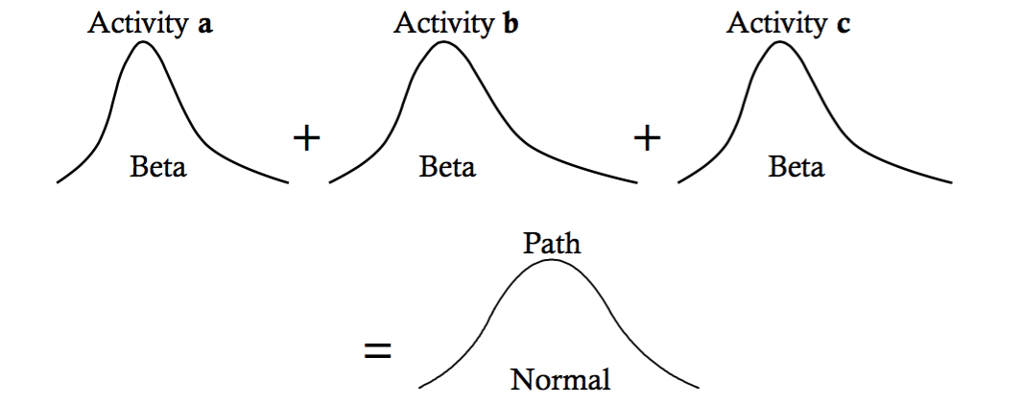

Probabilistic Activity Duration Example

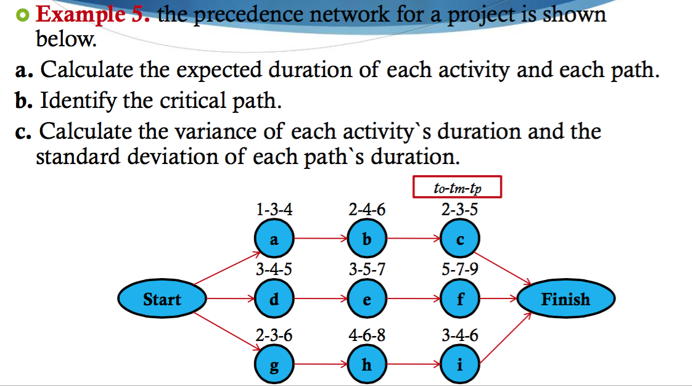
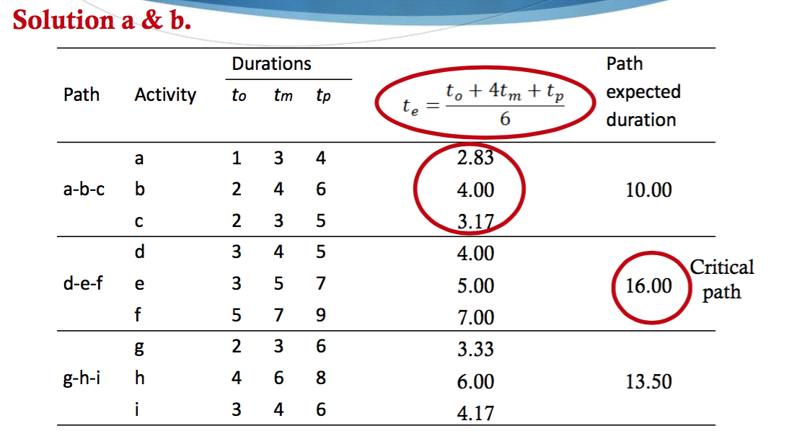

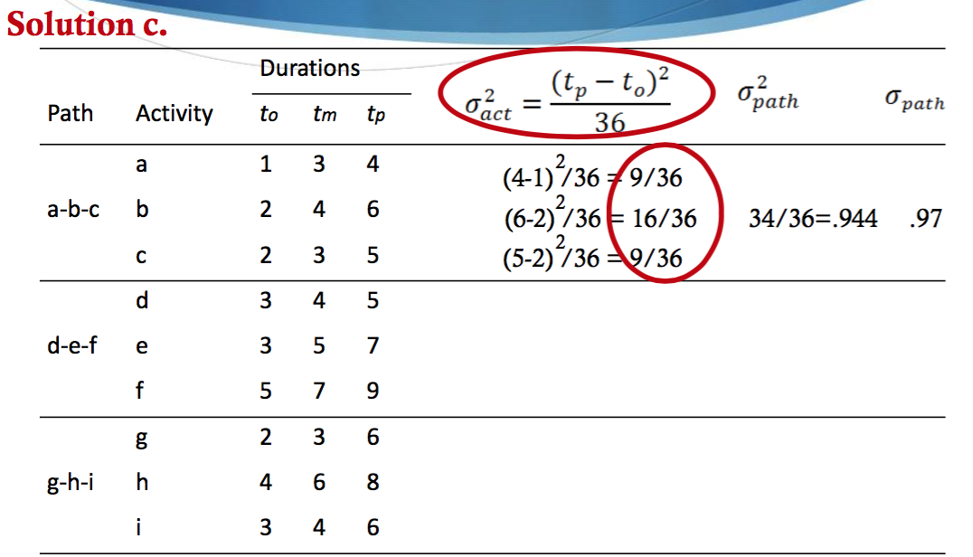

- Operations are those activates within an organization that are directly related to providing a good or service to customers.
- Operations management is transforming inputs into outputs
- The essential functions of OM are marketing, production, accounting
- Basic management functions= Planning, Organizing, Controlling, leading
- Critical decisions that OM ask are- What goods and services should we offer? Where should we put the facility? How do we provide a reasonable work environment?
- Added value – the difference between the cost of inputs and the price of outputs
- The Pareto Principle- 80% of the problems come from 20% of the operation (80-20 rule)
- Productivity= OUTPUTS/INPUTS
- Higher productivity relative to competition leads to competitive advantage
- Capital, Quality, Technology, Management are the four factors that affects productive
- The primary function of competitive is how well the organization meets the needs of the customer
- Strategies for competitive advantage, differentiation, cost leadership, response rate, customer service
- Higher productivity is linked to better wages, more throughput, more consumption. Higher standards of living
- Wage and price increase not accompanied by productivity increases tend to create
- The productivity paradox is the introduction of computers or other such technology having no positive affect
- Poor competitiveness, Excess emphasis on short-term financial performance, failing to take advantage of strengths or opportunities, failing to consider customer wants and needs
- Failure is the situation in which a product, part, or system does not perform as intended
- The weather does not improve reliability
- Reliability is measured in terms of probability statements
- Built in redundancy so important to factory floor efficiency (EFE)
- The rate of failure in Phase II of the bath tub curve decrease rapidly once the truly defective items are weeded out (eliminating inferior products. Services)
- Continuous reliability- The probability that the product or system will function for a given length of time.
- Time and failure rate. Are the X and Y on the bathtub curve.
- Reliability happens by improving components
- If you have the reliability of component, can you calculate the probability that it will fail
- Top organizations usually focus on employee satisfaction
- Product development is the process to generate concepts, designs and plans for service and goods that an organization can provide to its customer.
- Quality, cost and satisfactions, product /service design directly affects the respective development
- Failure has a far-reaching effect on a firm’s operation, reputation, profitability and dissatisfied customers
- Financing is not a source of service and product innovation
- Technical and economic feasibility studies is not a step in developing new products
- Continuous modification of production models includes, adapt to changing market conditions, adapt to changing production technology, allow for manufacturing improvements
- About 5% of all new products ideas service to production, and only about 10% of these are successful
- The product life cycle includes, introduction. Growth, immaturity
- Process flow diagram have steps of Frame tube bending, frame building work cells, frame machining
- The basic strategies for proceeding are Process focus, product focus, and mass customization
- Workers become better at their tasks as the tasks are repeated
- Due to learning, the time it takes to do a task gradually decreases over time until it levels off or otherwise
- Finding wats to make learning faster can results in: Competitive advantage, Increased sales, reduced costs, higher profits
- The learning curve is not useful when production is sporadic
- Industry performance is not an internal (company) use for the application of learning curves
- Establishing costs is a eternal use of the learning curves
- Leaning curves differ from company to company in the same industry
- Projections based on learning curves should be regarded as approximations
- An operations managers objective is to build a total quality system that identifies and satisfies customer needs
- Loss of business, liability issues, productivity issues, and cost related issues are consequences of poor quality in operations management
- Higher employee turnovers rates are not a benefit of product quality
- Key dimensions of quality are the performance, features, reliability, aesthetics
- Strategic cots are not a quality related cost
- Quality management programs today are viewed by many companies as productivity improvements programs
- 85% of quality programs are due to process and material
- Process sampling is not a phase of quality assurance
- With statistical process control, there are two types of variation, random and assignable
- Control limits represent the dividing lines between deviations from the process mean,
- Assign tasks to constituents are not one of the steps when designing a control chart
- The x- bar charts are used with sample mean
- P and C are the two control charts used for attributes
- Pre-screen is not a way to improve process capabilities
- The transformation process turns inputs into outputs
- Financing is not a key to effective SCM
- Lateness and incomplete orders is a negative effect of uncertainty
- Factors that contribute to uncertainty within the scope of SMC, inaccurate demand forecasting, long variable lead times, late deliveries
- The need for supply chain management: Increasing competition, increasing levels of outsourcing, increasing globalization, increasing e commerce
- Bullwhip effect represents demand/ order variability becoming progressively larger the further back in a supply chain the company is
- Risk pooling is holding safety stocks in central location rather than in multiple locations
- The benefit of cross-docking is that it avoids warehouse storage
- The key to effective supply chain management is paying your bills
- Effective supply chain enables members to do all the following expect reduce staff
- The following are the limitations of learning curves: Any changes in personnel, design, or procedure can be expected to alter the learning curve, learning curves do not always apply to indirect labour or material, the culture does not always apply to indirect labour or material, learning curves differ from company to company as well as industry to industry so estimates should be developed to each organization
- The following are criticism of learning curves: Learning percentages may differ from organization to organization, projections based on learning curves should be regarded as approximations, if time estimates are based on the time for the first unit, need considerable care to ensure validly of its time, learning curves do not apply to mass production situations
- DMAC charts are not a tool of TQM
- Fish bone diagram is another name for the cause and effect diagram
- Yes, you should inspect a supplier’s plant while the supplier is producing your goods
- The purpose of the control chart is to distinguish between random and assignable variation

Math questions
- 1. Two components are in a series. Their reliabilities are .9 and .83 respectively. What is the reliability of the system. =.75
- Three components are in a series. Their individual probabilities of working at 9.92, .95,.88. What is the system probability of working? = .77
- Three lamps are in a series. Their individual probabilities of working are as follow. Lamp 1= .97 lamp 2=.95 and lamp 3= .82. Lamp 2 has a backup with a probability of .80. Including the backup, what is the systems probability of working? = .787
- A company that makes shopping carts for supermarkets and other store recently purchased some new equipment that reduces the labour content of the jobs needed to produce the shopping cars. Prior to buyer the new equipment the company used four workers, who produced an average of 80 cart per hour. Labour cost was $10 per hour and machine cost was $40 per hour. With the new equipment, it was possible to transfer one of the workers to another department. Machine cost increased by $10 per hour while output increased by four carts per hour. Calculate the labour productivity after the new equipment. Use carts per worker per hour as the measure of labour productivity. (round THE FINAL ANSWER TO THE NEAREST WHOLE NUMBER. = 28

    - Calculate the multifactor productivity after the equipment. Use carts per dollar cost (labour plus machine) as the measure. (Round the final answers to 2 decimal places.) – 1.05 per dollar cost
- The following are service times for customers at a local restaurant that prides itself on good service. The times are given in minutes from the minute a customer enters the establishment until the customer is waited on, Aggregate the data into groups of four.5,3,4,5,6,8,3,4,6,5,4 AND 10. Find the lower control limit(LCL) for x-bar=1.6813
- A job has an 80% learning curve. If the first unit took 50 hours to complete, the fourth unit should take roughly how many hours? = 32
    - The seventh unit should take roughly how many hours?

