ITM-305 Lecture one notes

Primer on Analysis and Design
- In the 60’s to the 80’s we had old technology, but were the prototypes
- Early emergence of tech
- Command based, not graphical
- Businesses started using tech, and started integrating them into the everyday business world
- In the 90’s the internet was introduced with text and image information
- IT now has to do with the internet of things
  - The concept that everything can be interconnected
  - Self maintaining
- Big data is also another emerging sector
- According the ICT spending chart, hardware spending has stayed the same but services, telecom and new technology is growing rapidly

What is business analysis
- The practice of enabling change in an enerpric=se by defining needs and recommending solutions that deliver value to stakeholders. Business analysis enable rationale for change and to design and describe solutions that can deliver value

What does a business analyst do
- Conduct research, develop and implement information systems development plants, policies and procedures, and provide advice on a wide range of information system issues
- BA is someone who analyzes the existing or ideal organization of systems, including businesses, departments and organizations. BA’s also assess business models and their integration with technology.
- Understand the business process and needs of the business
- Gather business requirements from identifies project stakeholders
- Translate the business requirements into functional requirements
- Create functional specifications for new systems
- Work with the developers
- Create test scenarios and verifying the system
- Acts as a bridge between business and IT
- Can be applied to all different types of technologies and in different industries
- Cannot be automated, business analysis requires human touch
- Digital transformation drives the demand for business

Development Life Cycle (SDLC)
- Computer app - software that executes on a computing device to carry out a specific set of functions
- Information systems - a set of interrelated components that collects, processes, stores and provides an output the information needed to complete a business stask
- What is it
  - IT stand for information tech, refers to anything related to computing tech, such as networking, hardware, software, internet, or the people that work with these technologies
  - Information and communications tech (ICT) covers any product that will store, retrieve, manipulate, transmit or receive information electronically in a digital form
  - Information technology does not include embedded tech that do not generate data for enterprise use

6 Core system development processes related to SDLC (how to integrate IS)
- Identify the problem or need and obtain approval
- Plan and monitor the project
- Discover and understand the details of the problem or need
- Design the system components that solve the problem or satisfy the need
- Build, test, and integrate the system components
- Complete system tests and deploy the solution

Examples of core system development processes
Vacation

SLDC and core processed
Planning - identify the problem plan and monitor
Analysis - Discover and understand details
Design - Design system components
Implementation - Build, test, and integrate
Deployment - complete system test and then deploy the solution

The system Development Life Cycle
- SDLC is the entire process consisting of all the activities to build, launch and maintain information systems
- Most projects falls on a continuum between predictive and adaptive

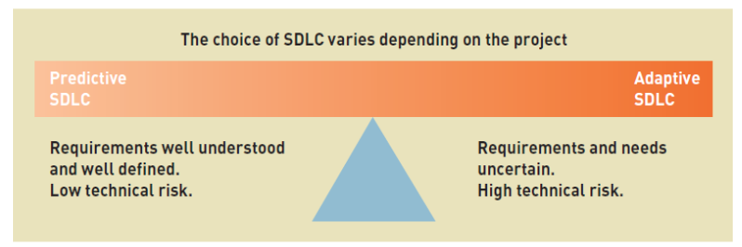

Traditional Predictive SDLC
- Earlier approach based on engineering
- Typically have phases
  - Phases are related groups of development activities, such as planning, analysis, design, implementation and deployment
- Waterfall model
  - SDLC that assumes phases can be completed sequentially with no overlap or iteration
  - Once one phase is completed the project falls over the waterfall to the next phase, no going back
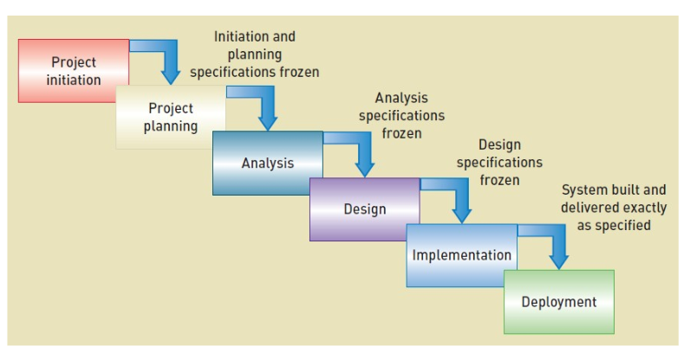

Newer overlapping phases predictive SDLC
- More flexibility, but still assumes predictive planning and sequential phases
- 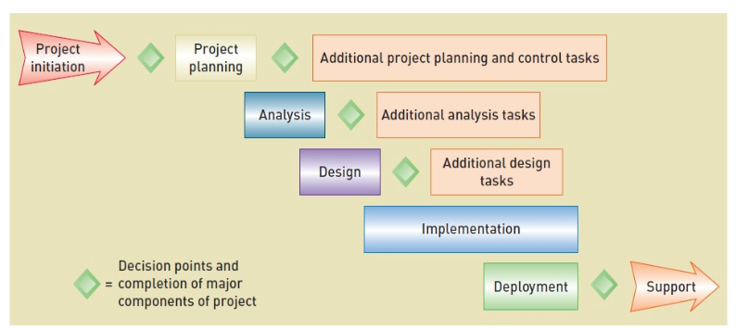
Agile Development philosophies and values
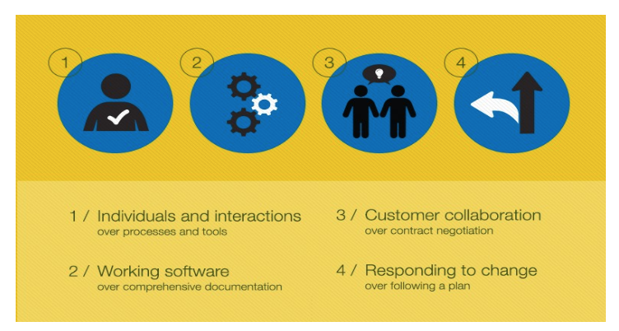

Scrum
- Combination of principles of rugby and agile
  - Intense effort involving the entire team for a defined period of time
- Product backlog
  - Prioritized list of user requirements
- Product owner
  - The client stakeholder who controls backlog
- Scrum master
  - Scrum project manager



