BUSI 1800 EXAM NOTES

LECTURE SLIDES

Chapter 16: Accounting
Learning Objectives
- The role that accounting and financial information lay for a business and for its stakeholders
- The different disciplines within the accounting profession
Types of Accountants
Public | Private
- Auditing  - Tax Consulting and Compliance  - Management Consulting | - Management Accounting  - Government Accounting  - Academia

Private Accountants work for a single firm, government agency, or non-profit organization.
Public Accountants provide his or her services to individuals or businesses on a fee basis.

- Accounting vs Bookkeeping
Bookkeeping | Accounting
- Start of accounting  - Record/journalize | - Analyze  - Recommend

Accounting Terms
Bookkeepers make use of a specialized accounting book called a ledger, which information from accounting journals are recorded into specific accounts.
Trail Balance is a summary of all the accounts in the ledger to check whether the figures are correct and balanced.
- Bookkeeping involves the recording of business transactions and is an important part of financial reporting.
- Accountants classify and summarize financial data provided by bookkeepers and then report the information to management.
- The accounting cycle is a six-step procedure that results in the preparation and analysis of the major financial statements.
Accounting Cycle

- How the Major Financial Statements Differ
Income Statement: Statement of Revenues and Expenses
Revenue – the value of what is received for goods sold, services rendered, and other financial sources
COGS – the accumulated total of all costs used to create a product or service, which has been sold.
Gross Profit (Gross Margin) = COGS – Net Sales
Or
Gross Margin = $\frac{Gross Profit}{Net Sales}$
Operating Expenses – the costs involved in operating a business (e.g., rent, supplies, salaries etc.)
Statement of Cash Flows: Statement of Cash Receipts and Disbursements
Cash Flow Statement reports cash receipts (money coming in) and disbursements (money going out) related to three main activities:
Operations | Cash transactions associated with running the business
Investing | Cash use in or provided by the firms investing activities (normally including capital assets)
Financing | Cash raised from the issuance of new debt or equity capital or cash used to repay loans or company dividends
*Cash flow is simply the difference between cash coming in and cash going out of a business.
Balance Sheet: Statement of Financial Position
3 Types of Assets
Current Assets – can be converted into cash within one year. (E.g. Cash, A/R etc.)
Capital Assets – items that are relatively permanent goods, such as land and buildings, acquired to produce products for a business. (Fixed Assets)
Intangible Assets – long-term assets that have no real physical form but have value (E.g. Patents, trademarks, and copywriters)
Common Liability Accounts on Balance Sheet
- Liabilities – what the business owes to others (debts)
- Current Liabilities – debts due in one year or less
- Long-term Liabilities – debts not due for one year or more
- Accounts Payable – current liabilities involving money owed to others
- Notes Payable – can be short-term or long-term liabilities (e.g., loans from banks) that a business promises to repay by a certain date
- Bonds Payable – long-term liabilities that represent money lent to the firm
- Taxes Payable – includes sales taxes and GST collected and income tax payable
Owners’ Equity Accounts
Owners’ Equity = Assets – Liabilities
*In a corporation, it is called shareholders’ equity and is shown in two separate accounts.
- The Role of Accounting rules and principles in reporting financial information
- International Financial Reporting Standards (IFRS)
- Public Companies are subject to International Financial Reporting Standards (IFRS)
- Private Companies can choose between IFRS or Accounting Standards for Private Enterprises (located in UK)
- Non-Profit Organizations can choose between IFRS or Accounting Standards for Nonprofit Organizations
- Amortization – the systematic write-off the cost of a tangible asset over its estimated useful life
- First in, First Out (FIFO) – an accounting method for calculating cost of inventory; it assumes that the first goods to come in are the first to go out.
- Ratio analysis

Chapter 17: Finance
- The role and responsibility of financial managers
The Key Responsibility: to obtain money and then control the use of that money effectively

- The financial planning process and three key budgets

- Why firms need operating funds and where they find them
- Manage Daily Operations
- Manage Accounts Receivable
- Acquire Inventory
- Capital Expenditures

- Sources of short-term financing – is the day-to-day operation of the firm calls for the careful management
- Firms need to borrow short-term funds for purchasing additional inventory or for meeting bills that come due
- Promissory Note is a written contract with a promise to pay a supplier for a specific sum of money at a definite time
- Can be sold by the supplier to a bank at a discount
- Trade Credit is the practice of buying goods or services now and paying for them later
- Invoices to contain items such as 2/10, net 30.
- Commercial Banks – are highly sensitive to risk and are often reluctant to lend money to small, relatively new, businesses.
- Secured Loan is a loan that is backed by something value, such as property
- The item of value is called collateral
- If the borrower fails to pay the loan, the lender may take possesions of the collateral.
- Unsecured Loan – the loan is not backed by any assets.
- Line of Credit – a given amount of unsecured funds a bank will lend to a business, not guaranteed to a business.
- Some lines of credit may be secured upon some asset and these are called Secure Lines of Credit
- Revolving Credit Agreement – a line of credit that’s guaranteed
- Commercial Finance Companies – non-deposit types of organizations (often called non-banks) make short-term loans to borrowers who offer tangible assets
- Factoring Accounts Receivable – the process of selling A/R for cash
- Commercial Paper – consists of unsecured promissory notes, in amounts of $100,000 and up, that mature (come due) in 365 days
- Sources of long-term financing
Three Major Questions
- What are the organization’s long-term goals and objectives?
- What are the financial requirements needed to achieve these long-term goals and objectives?
- What sources of long-term capital are available?
- How the financial services Industry is regulated
- The Canada Deposit Insurance Corporation (CDIC) is a federal Crown corporation that was created to provide deposit insurance and contribute to the stability of Canada’s financial system.
- The money supply is the amount of money the Bank of Canada makes available for people to buy goods and services.
- The Bank of Canada manages the rate of money growth indirectly through the influence it exercises over short-term interest rates.

- Bank of Canada
The Bank of Canada's primary responsibilities can be grouped into four broad functions:
- Monetary Policy (i.e. managing interest rates)
- Currency (i.e. protecting against counterfeiting)
- Financial System
- Funds Management
- The Canadian Banking Industry
- Royal Bank
- TD Canada Trust
- The Bank of Nova Scotia
- The Canadian Securities Industry
A securities dealer (also known as an investment dealer or brokerage house) is a firm that trades securities for its clients and offers investment services.
Investing in Stocks
- Capital gains are the positive difference between the price at which you bought a stock and what you sell it for.
- A mutual fund is a fund that buys a variety of securities and then sells units of ownership in the fund to the public.
- Diversification involves buying several different investment alternatives to spread the risk of investing.
Investment Strategies
- Bulls believe that stock prices are going to rise; they buy stock in anticipation of the increase.
- Bears expect stock prices to decline and sell their stocks in anticipation of falling prices.

Chapter 14: Marketing
- Marketing Definition - the action or business of promoting and selling products or services, including market research and advertising.
- Marketing Concept
Customer Orientation – finding out what consumers want and provide it for them
Service Orientation – everyone from the president of the firm to the delivery people should be customer-orientated
Profit Orientation – Focus on those goods and services that will earn the most profit and enable the organization to survive and expand
- Applied to for-profit
- And non-profit organizations
- Charities use marketing to raise funds for combating world hunger, for instance, or to obtain other resources.
- The not-for-profit category is one of the most competitive segments in the Canadian marketplace
- Environmental groups use marketing to try to cut carbon emissions
- Churches use marketing to attract new members and to raise funds
- “GREEN MARKETING” – efforts to produce, promote, and reclaim environmentally sensitive products
- The 4Ps of Marketing
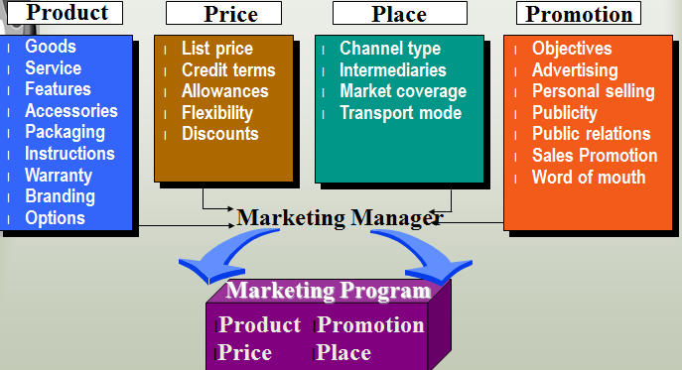
Product is any physical good, service, or idea that satisfies a want or need plus anything that would enhance the product in the eyes of consumers, such as the brand.
Price: the money or other consideration (including other goods and services) exchanged for the ownership or use of a good or service. Depends on several factors including the costs of production, distributing, and promoting the product.
Place: (sometimes referred to as location) where you sell
Promotion: is all the techniques sellers use to motivate customers to buy their products: includes advertising, personal selling, public relations, and various sales promotion efforts, such as coupons and samples.

- The 8P’s of Marketing Services

- Marketing Research Process
- Market Segmentation
Niche marketing is the process of finding small but profitable market segments and designing or finding products for them.
One-to-one (individual) marketing means developing a unique mix of goods and services for each individual customer (travel agencies often develop such packages).
- Relationship Marketing
Relationship Marketing depends greatly on understanding consumers and responding quickly to their wants and needs.
The five steps that are part of this process are:
  - Problem Recognition
  - Information Search
  - Alternative Evaluation
  - Purchase Decision/Or No Purchase
  - Post -Purchase Evaluation (Cognitive Dissonance)
- Business-to-Business vs. Consumer Markets
Consumer market (B2C)  Market Segmentation:  Selecting which groups (market segments) an organization can serve profitably is called target marketing. | Consists of all individuals or households that want goods and services for personal consumption or use and have the resources to buy them.
Business-to-business (B2B) | Market consists of all individuals and organizations that want goods and services to use in producing other goods and services or to sell, rent, or supply goods to others.

Chapter 15: Marketing Mix
- The concept of a total product offer and the functions of packaging.

- Contrast brand, brand name and a trademark.
  - the concepts of brand equity and brand loyalty.
Brand Equity – such as awareness, loyalty, perceived quality, images, emotions – that people associate with a given brand name
Brand Loyalty – the degree to which customers are satisfied, enjoy the brand, and are committed to further purchases
Brand Awareness – How quickly or easily a given brand name comes to mind when a product category is mentioned
Brand Manager – a manager who has direct responsibility for one brand or one product line; called a product manager in some firms
National Brand – a known brand distributed and advertised nationally; (E.g. Kraft Foods)
Private Brand – the goods do not carry the manufactures name; they carry the distributers name (E.g. President Choice for Loblaw)
Generic Name – the name for a product category which is not advertised, is cheaply packaged, and is sold at a discount (E.g. Tissue (Kleenex)).
- Pricing objectives and strategies
Each product requires its own pricing strategy. Some strategies are:
- Achieving a target profit
- Achieving a market share
- Creating an image
- Building traffic

Pricing Determination
Cost-Based Pricing: producers often set the price based on the profit margin desired.
Value Pricing: brand-name goods and services at fair prices
Competition-Based Pricing: a strategy based on what all the other competitors are doing.
Price Leadership: one or more dominant firms set prices – others follow

Pricing Using Breakeven Analysis
Break-Even Analysis is the processes used to determine profitability at various levels of sales
Break-Even Point (BEP) is the point where net income = 0; any profit will come on sales above this point.
$$Break-Even Point=\frac{Total Fixed Costs (FC)}{Price of 1 unit-Variable Cost of 1 Unit}$$
Total Fixed Costs are all expenses that remain the same no matter how many products are made or sold
Variable Costs are costs that change per the level of production
- The concept of marketing channels and the value of marketing intermediaries.
A channel of distribution consists of a set of marketing intermediaries, such as agents, brokers, wholesalers, and retailers, that join to transport and store goods in their path (or channel) from producers to consumers.
Marketing Intermediaries
- Organizations that assist in moving goods and services from producers to business and consumer users.
- Called intermediaries because they’re in the middle of a whole series of organizations that join to help distribute goods from producers to consumers.
- Retailing and non-store retailing.
Retail Distribution Strategy
Intensive Distribution puts products into as many retail outlets as possible, including vending machines.
- Products that need intensive distribution include convenience goods such as candy, cigarettes, gum, and popular magazines.
Selective Distribution - using only a preferred group of the available retailers in an area.
- Such selection helps assure producers of quality sales and service.
Exclusive Distribution is the use of only one retail outlet in each geographic area.
- The retailer has exclusive rights to sell the product and is therefore likely to carry a large inventory, give exceptional service, and pay more attention to this brand.
Non-Store Retailing
Non-Store Retailing categories include electronic retailing, telemarketing, vending machines, kiosks and carts, and direct selling.
Electronic Retailing consists of selling products to ultimate consumers over the Internet.
Telemarketing is the sale of goods and services by telephone.
- Telemarketing is used to supplement or replace in-store selling and to complement online selling.
- Promotion and the promotional mix.
- Promotion: Advertising
- Advertising is paid, non-personal communication through various media by organizations and individuals who are in some way identified in the advertising message.
- Including product advertising, online advertising, and comparison advertising, which is advertising that compares competitive products
- Promotion: Global Advertising
- Involves developing a product and promotional strategy that can be implemented worldwide.
- Much advertising today is moving from globalism (one ad for everyone in the world) to regionalism. WHY?

- Promotion: Personal Selling is the face-to-face presentation and promotion of goods and services.
- It also involves the search for new prospects and follow-up service after the sale.
- Sales Promotion is a promotional tool that stimulates consumer purchasing and dealer interest by means of short-term activities.
- Designed to supplement personal selling, advertising, and public relations efforts by creating enthusiasm for the overall promotional program.
Marketing Tasks
- Identifying opportunities (i.e., guiding new product development)
- Assessing potential markets when a new product is being considered
- Estimating demand for products or services
- Monitoring trends and understanding their implications for existing business and new opportunities
- Building brands and managing brand image
- Setting marketing budgets, and developing strategies for communications and sales promotions
- Managing product lines and pricing
- Working with public relations and sales teams
Marketing Jobs
- Market Researcher
- Marketing Manager
- Media Buyer

Chapter 10: Operations & SCM
Research and Development work directed toward the innovation, introduction, and improvement of products and processes
- Manufactures perform 75 percent of Private-Sector R&D
Through the adoption of newer, more advanced technologies and practices, industries can:
- Increase their production capabilities
- Improve their productivity
- Expand their lines of new goods and services
Canada Today
- Canada is facing some serious challenges to its ability to remain a modern, competitive industrial country.
- Canada has been highly dependent on natural resources.
- Business climate is characterized by constant and restless change and dislocation, as ever-newer technologies and increasing global competition force companies to respond quickly to these challenges
Manufacturing is a cornerstone of our modern economy
- Export more than $318 billion each year, representing 61% of all Canada’s merchandise exports
Canada’s Manufacturing Services Base
- Employs slightly over 7% of Canada’s working population
- Represents more than 10% of Canada’s total GDP
- 1.7 million jobs
Share of Manufacturing Employment in Canada’s Largest Cites: Toronto (13%), Montréal (10.6%), Winnipeg (9.2%)
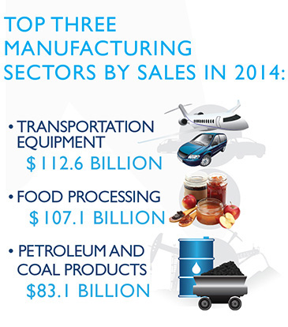

Production is the creation of goods and services using the factors of production:
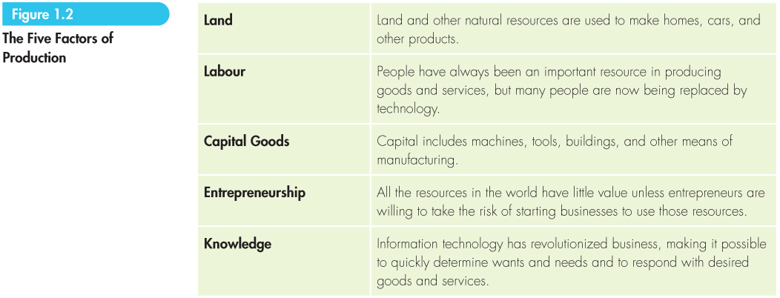
From Production to Operations Management
Production Management has been the term used to describe all the activities that managers do to help their firms create goods.
- To reflect the change in importance from manufacturing to services, the term production often has been replaced by operations to reflect both goods and services production.
Operations management is a specialized area in management that converts or transforms resources (including human resources) into goods and services.
- It includes inventory management, quality control, production scheduling, follow-up services, and more.
Operations Management Functions
- Facility Location is the process of selecting a geographic location for a company’s operations
Most common reasons for a business to relocate:
  - Availability of inexpensive labor or the right kind of skilled labor.
  - Reducing time to market is another decision-making factor.
  - To get closer to their international customers
Outsourcing goods and services has become a popular practice in North America
- Canadian companies are also benefiting from another countries’ outsourcing.
- Canada is one of the top IT outsourcing destinations in the world, especially for the United States.
Canada’s Auto Industry
- The industry supports jobs across Canada in 13 assembly plants, more than 540 parts manufacturers, 3,900 dealerships, and many other related industries.
- This industry has also faced increased competition from international players.
- In recent years, faced with relatively high labor and pension costs, plants have closed, eliminating thousands of jobs.
- Facility Layout - this industry has also faced increased competition from international players.
The goal is to have offices, machines, storage areas, and other items in the best possible position to enable workers to produce goods and provide services for customers.
- Issues that influence site selection include labor costs, availability of resources, access to transportation that can reduce time to market, PROXIMITY to suppliers and customers, low crime rates, quality of life for employees, COST OF LIVING, and the ability to train or retrain the local workforce.
- Many companies are moving from an assembly line layout, in which workers do only a few tasks at a time, to a modular layout, in which teams of workers combine to produce more complex units of the final product.

Three Requirements of Production
- Build and deliver product in response to demand at a scheduled time
- Provide an acceptable level of quality
- Provide everything at the lowest possible cost
In the assembly process, components are put together.
In assembly line layout, workers only do a few tasks at a time and components are put together.
A process layout is one in which similar equipment and functions are group together. The order in which a product visits a function depends on the design of the items thereby allowing flexibility the plant layout can change quickly.
A continuous process is one in which long production runs turn out finished goods over time.
An intermittent process is an operation where the production run is short and machines are changed frequently to produce different products.
Today, most NEW MANUFACTURERS use an intermittent process.
- Some companies move from an assembly line layout to a modular layout in which teams of workers work together to produce more complex units of the final product. Instead of having multiple work stations the functions may be done in one module.
- When working on a major project, such as a bridge or an airplane, companies use a fixed-position layout that allows workers to congregate around the product to be completed.
- Quality Control
Quality is consistently producing what the customer wants while reducing errors before and after delivery to the customer.
Statistical quality control (SQC) is the process that some managers use to continually monitor all phases of the production process and assure quality is being built into the product from the beginning
Statistical process control (SPC) is the process of testing statistical samples of product components at each stage of production and plotting the test results on a graph

- Manufacturing Sector: Operations Management
Materials requirement planning (MRP) is a computer-based operations management system that uses sales forecasts to ensure that needed parts and materials are available at the right time and place in a specific company.
- The newest version of MRP is Enterprise Resource Planning (ERP).
- ERP is a computer application that enables multiple firms to manage all their operations (finance, requirements planning, human resources, and order fulfillment) because of a single, integrated set of corporate data.
- Purchasing is the functional area in a firm that searches for quality material resources, finds the best suppliers, and negotiates the best price for quality goods and services.
- Manufacturers are relying more heavily on one or two suppliers because the firms share so much information that they don’t want to have too many suppliers knowing their business.
- The Internet has transformed the purchasing function in recent years.
- JIT: Just-in-Time Inventory control
JIT systems keep a minimum of inventory on the premises and parts, supplies, and other needs are delivered just in time to go on the assembly line.
- To work effectively, however, the process requires excellent coordination with carefully selected suppliers.
- JIT runs into problems when suppliers are farther away.
- Quality Control Standards
- Six Sigma (δ) Quality
- Statistical Quality Control (SQC)
- Statistical Process Control (SPC)
- Deming Cycle
- Quality Function Deployment (QFD)
- Baldridge Award
- ISO 9000/14000/19011:2002
- The International Organization for Standardization (ISO) is a worldwide federation of national standards bodies from more than 140 countries that set the global measures for the quality of individual products.
- Promotes the development of world standards to facilitate the international exchange of goods and services
- ISO 9000 is the common name given to quality management and assurance standards.
- Importance is that the EU is demanding that companies that want to do business with the EU be certified by ISO Standards
- ISO 14000 is a collection of the best practices for managing an organization’s impact on the environment.

Supply Chain Management
Logistics is the focus on getting the right amount of the right products or services to the right place at the right time at the lowest possible cost.
Supply Chain is the sequence of firms that preform activities required to create and deliver a good or service to consumers or industrial users.
Supply Chain Management is the integration and organization of information and logistics activities across firms in a supply chain for creating and delivering goods and services that provide value to customers
- Firms are trying to improve quality, reduce costs, increase flexibility and speed, and improve customer service while reducing the number of suppliers used
Total quality management (TQM) Involves:
- All levels must be involved and committed
- Doing it right the first time to lower costs (DIRTFT)
- Employees must co-operate to develop a new Corporate Culture – it is an attitude
- Demands commitment to Continuous Improvement (CI)
- Involve suppliers and distributors
Flexible manufacturing involves designing machines to do multiple tasks so that they can produce a variety of products. – Results in Cost Savings
Lean manufacturing is the production of goods using less of everything compared to mass production: less human effort, less manufacturing space, less investment in tools, and less engineering time to develop a new product.
Control Procedures
Pert Charts
- Program evaluation and review technique (PERT)
Gantt Charts
- Bar graph showing production managers what projects are being worked on and what stage they are in at any given time.
Export Climate
- Risk clouds mining and energy exports
- Higher US demand and a much weaker Canadian dollar are increasing Canadian sales in agri-food and aerospace sectors.
- The steady climb of US home building is increasing forestry sector exports despite sluggish paper demand.
CANADA TODAY
- Canada is one of the largest producers of forest products in the world, with plants in nearly all provinces.
- Other significant industries include: Aluminum Mills (in Quebec and British Columbia, automotive-related manufacturing plants (in Ontario and Quebec) and aircraft plants (in Ontario, Quebec, and Manitoba)
Exports amount to more than 30 percent of Canadian GDP
- Net exporter of energy (accounts for 16 percent of total exports)
- Motor vehicles and parts (16 percent)
- Consumer goods (13 percent)
- Metal and non-metallic mineral products (11 percent)
- Forestry products (7.5 percent)
- Basic and industrial chemical, plastics and rubber products (7 percent)
- Industrial machinery (6 percent).
Who Imports Our Products?
- The United States is by far the largest destination for Canadian products (75 percent of total exports)
- Followed by European Union (7.5 percent)
- China (4 percent).
Consumer Price Index (CPI) is a measure of the change in prices paid by urban residents for a market basket of consumer goods and services.
Real GDP is an inflation-adjusted measure that reflects the value of all goods and services produced by an economy in each year, expressed in base-year prices, referred to as “constant-price”, “inflation-corrected” GDP or “constant dollar GDP”.
- Unlike nominal GDP, real GDP can account for changes in price level and provide a more accurate figure of economic growth.
Innovation Funnel
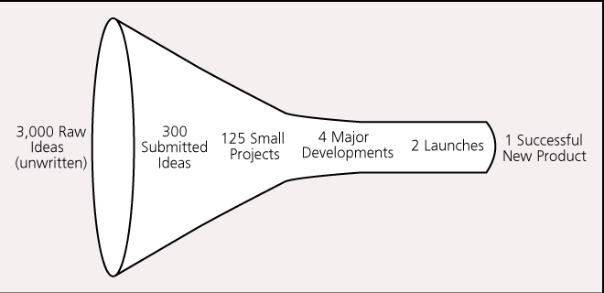

E.g. Life Straw
- Per Wikipedia, this personal water filter filters a maximum of 1000 liters of water, enough for one person for one year. It removes 99.9999% of waterborne bacteria and 99.9% of parasites. Target price $5. Made in Europe by Vestergaard Frandsen.
Supply Chain = Value Chain
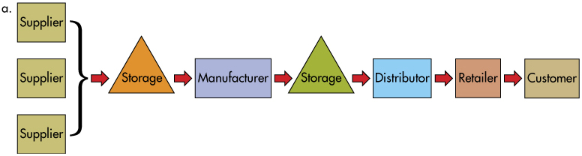
Philosophers of Q
- W. Edwards Deming
- Joseph M. Juran
- Armand Feigenbaum
- Philp B. Crosby
Six Sigma Process
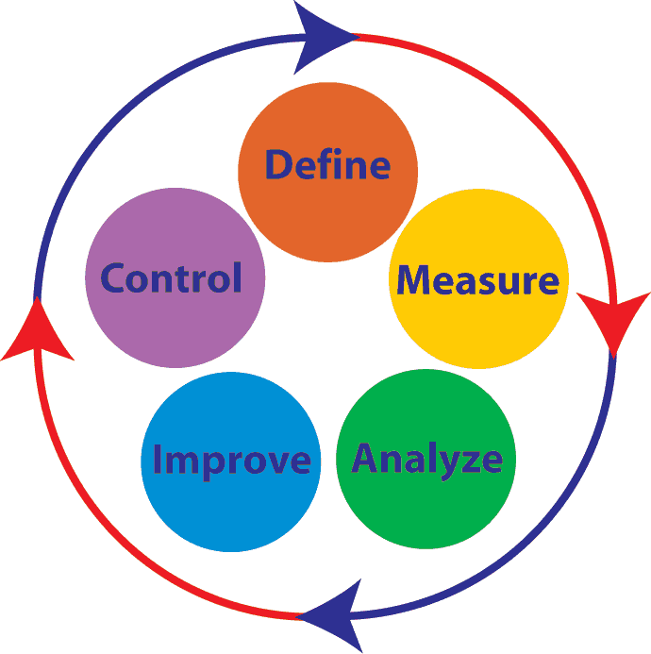

Chapter 7: Entrepreneurship
- Explain why people are willing to become entrepreneurs, and describe the attributes of successful entrepreneurs.
Entrepreneurship is accepting the challenge of starting and running a business.
- The word entrepreneur originates from the French word “entreprendre”, which means “to undertake.”
- People Take the Entrepreneurial Challenge
- Independence
- New Idea, Process, or Product
- Some entrepreneurs are driven by a firm belief, perhaps even an obsession, that they can produce a better product, or a current product at a lower cost, than anybody else
- Many entrepreneurs simply do not enjoy working for someone else
- Challenge - many thrive on overcoming challenges
- Family Pattern - of starting their own businesses
- Immigrants
- Profit
- Attributes of a Successful Entrepreneur
Entrepreneurial Attributes:
Self-directed
- Self-starter, with a lot of confidence in yourself
Determined
- Strong believe in your idea even when no one else does
Attributes:
- Action-Oriented
- Highly Energetic
- Tolerant of Uncertainty
- Able to Learn Quickly - Making errors is inevitable - what is important is what you learn from them.

- Discuss the importance of small business to the Canadian economy.
Micropreneurs & Home-Based Businesses
The smallest of small businesses are called micro-enterprises, most often defined as having fewer than five employees.
- Many home-based businesses are owned by people who are trying to combine career and family.
Importance of Small Business
Small business thus plays a major role in helping to maintain the Canadian identity and Canadian economic independence
- Summarize the major causes of small-business failure.
The following are some of the causes of small-business failure:
- Plunging in without first testing the waters on a small scale
- Underpricing or overpricing goods or services
- Underestimating how much time it will take to build a market
- Starting with too little capital (being careless in its use)
- Borrowing money without planning just how and when to pay it back
- Buying too much credit

- List ways to learn about how small businesses operate.
The functions of business in a small-business setting:
- Planning your business
- Financing your business
- Knowing your customers (marketing)
- Managing your employees (human resource development)
- Keeping records (accounting).
Business Plan is a detailed written statement that describes the nature of the business, the target market, the advantages the business will have in relation to competition, and the resources and qualifications of the owner(s).
- Forces potential owners of small businesses to be quite specific about the goods or services they intend to offer
- Analyze what it takes to start and run a small business.
Getting Money to Fund a Small Business
- Supplier Credit
- Personal Savings
- Personal Credit Cards
- Retained Earnings
- Leasing
- Angel Investment
Angel Investors are private individuals who invest their own money in potentially hot new companies before the go public
- Usually target their support (generally $20,000 to $500,000) to pre-start-up and early-stage companies.
- Outline the advantages and disadvantages that small businesses have in entering global markets.
Advantages | Disadvantages
World Market  Absorb Excess Inventory  Soften U.S Downturns  Extend Product Life | Financial Difficult  How to Get Started?  Lack of Cultural Understanding  Paperwork

Chapter 12: Human Resource Management
- HRM: A Strategic Contributor to Organizational Success
  - 5 Steps in HRM Planning
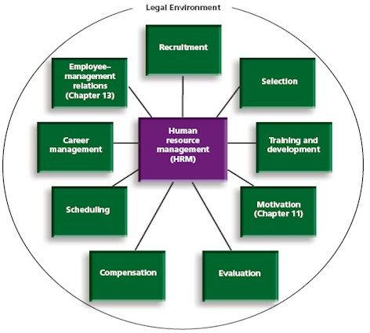
- Methods that companies use to recruit
Recruit & Select | Train/Develop
Application Form  Interview  Test  Investigate  Probation | Orientation  OJT  Apprenticeship  Off-the-Job Training  Online Training  Vestibule Training  Job Simulation

- The 5 Steps in selecting employees
- Prepare HR Inventory – this inventory should include ages, names, education (e.g., languages spoken), capabilities, training, specialized skills
- Prepare Job Analysis – a study of what is done by employees who hold various job titles (necessary to recruit and train employees with the necessary skills to do the job)
- Description
- Specification
- Assess Demand – technology changes rapidly, training programs must be started long before the need is apparent
- Assess Supply – the labor force is constantly shifting: getting older, becoming more technically oriented, etc.
- Establish Strategic Plan – must address recruitment, selection, training and development, evaluation, compensation, scheduling, and career management for the labor force.
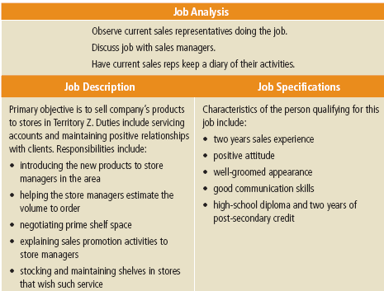
- The 6 Steps in Appraising Employee Performance and Compensation
- Establish Standards
- Communicate Standards
- Evaluate Performance
- Discuss Results
- Take Corrective Action
- Use Results to Make Decisions
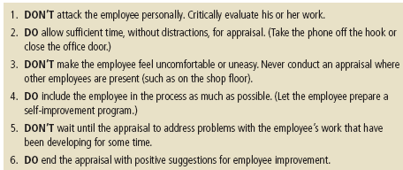
- Promotion, Reassignment, Termination, and Retirement
Promoting and Reassigning Employees
Many companies find that promotion from within the company improves employee morale
- Internal Promotions are also cost-effective in that the promoted employees are already familiar with the corporate culture and procedures
Terminating Employees
- Downsizing and restructuring, increasing customer demands for greater value, the relentless pressure of global competition, and shifts in technology have managers struggling to manage layoffs and firings.
Retiring Employees
Used to downsize companies is to offer early retirement benefits to entice older (and more expensive) workers to retire.
Losing Employees – learning about their reasons for leaving can be invaluable in preventing the loss of other good people in the future.
- Early retirement offers increase the morale of the surviving employees

- Impact of Legislation on HRM
HR and Legal Issues
Provincial | Canada Labor Code (Federal)
Workers’ Compensation  Human Rights  Labor Standards  Trade Unions Act  FOIPOP (Freedom of Information and Protection of Privacy) | Industrial Relations  Occupational Health & Safety  Labor Standards  Canadian Human Rights Act  PIPEDA (The Personal Information Protection and Electronic Documents Act)

FOIPOP (Freedom of Information and Protection of Privacy)
- Provides individuals with the right to access and correct personal information about themselves
- Prevents the unauthorized collection, use, or disclosure of personal information
- Provides routine public information and personal information about the person requesting it
Human Rights Act – requires that every employer ensures equal opportunities and that there is no discrimination regarding race, ethnicity, religion, age, sex, sexual orientation, marital/family status, disability, etc.
Occupational Health and Safety Act – focuses on safe and healthy workplaces and work practices, and safety standards protecting the public
- It sets standards and ensures compliance with requirements
- The most important employee right is the right to refuse unsafe work
- Employer liability can be very high for failing its obligations (criminal charges and fines)
Workers’ Compensation Act
- Insurance Scheme designed to protect employees who are injured at work
- Scheme is comprehensive and prevents employees injured at work from bringing a legal action against the employer.
Privacy Legislation
Federally:
  - PIPEDA (Personal Information Protection and Electronic Documents Act): sets out ground rules for how private sector organizations may collect, use, or disclose personal information during commercial activities.
  - Privacy Act: imposes obligations on federal government departments and agencies by placing limits on the collection, use, and disclosure of personal information.

Chapter 11: Motivating Employees
Motivation is the drive to satisfy a need, ultimately comes from within an individual.
The key to leadership success is: MOTIVATING OTHERS TO DO THEIR BEST
- Hiring and retaining good employees is a major function of management
- Losing an employee is costly
Intrinsic vs. Extrinsic Rewards
- An intrinsic reward is the good feeling you have when you have done a good job.
- An extrinsic reward is something given to you by someone else as recognition for good work and includes pay increases, praise, and promotions.
Extrinsic = Outside

Intrinsic= Inside
Sense of Achievement
Praise
Salary
Increase
Status
Recognition
Promotions
Gifts

- Taylor’s Scientific Management and the Hawthorne Studies

Frederick Taylor
- Increase productivity by studying the most efficient ways of doing things and then teaching workers these methods (i.e. scientific management)
- Three Elements: Time, Methods, and Rules of Work
- Time and Motion – studies break down the tasks needed to do a job and measure the time needed to do each task
E.g., UPS tells drivers how fast to walk (three feet per second), how many packages to pick up and deliver per day (average of 400), and how to hold their keys (teeth up, third finger).

Mayo: The Hawthorne Effect
A study of human motivation and the managerial styles that lead to more productivity

Hawthorne Effect refers to the tendency for people to behave differently when they know they’re being studied
- Mayo hypothesized that human or psychological factors caused increases in worker performance
- Workers thought themselves as a social group and were involved in the planning of the experiments
- The workers enjoyed the special atmosphere and additional pay for the increased productivity.

- Maslow and the Hierarchy of Needs
- Motivation arises from need.
- One is motivated to satisfy unmet needs.
- When one need is satisfied, another higher-level need
emerges to be satisfied.
- A satisfied need is no longer a motivator.
- Lower-level needs can pop up at any time and take attention away from higher-level needs.
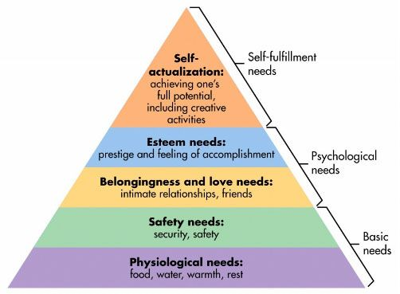
Once managers understand the need level of employees, it is easier to design programs that will trigger self-motivation.

Herzberg’s Hygiene Factors
The most important motivating Factors were the following:
- Sense of achievement
- Earned recognition
- Interest in the work itself
- Opportunity for growth
- Opportunity for advancement
- Importance of responsibility
- Peer and group relationships
- Pay
- Supervisor’s fairness
- Company policies and rules
- Status
- Job security
- Supervisor’s friendliness
- Working conditions
Motivating Factors
Herzberg noted that the factors receiving the most votes were clustered around job content.
Workers like to feel that they contribute to the company (sense of achievement was number one).
They want to earn recognition (number two) and feel that their jobs are important (number six).
They want responsibility (which is why learning is so important) and want recognition for that responsibility
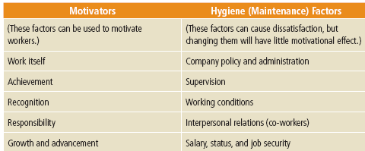
- Job Enrichment is a motivational strategy that emphasizes motivating the worker through the job itself.

Job-Orientated Motivational Techniques
- Job Enrichment/Redesign
  - Skill Variety
  - Task Identity/Significance
  - Autonomy
  - Feedback
- Job Simplification
- Job Enlargement
- Job Rotation
McGregor’s Theories X & Y
Theory X | Theory Y
Dislike Work & will try to avoid it  Avoid Responsibility  Little Ambition  Forced/Controlled/Directed/threatened  Motivated by Fear and Money | Like Work (natural part of life)  Naturally work toward goals  Seek responsibility  Imaginative, Creative, Clever  Motivated by Empowerment

Goal Setting, Expectancy, Reinforcement, and Equity Theories
Goal Setting Theory (MBO – Management by Objectives)
Goal-setting theory is based on the idea that setting ambitious but attainable goals can motivate workers & improve performance.
- This requires that goals are accepted, accompanied by feedback, and facilitated by organizational conditions
- MBO is most effective in relatively stable situations in which long-range plans can be made and implemented with little need for major changes.

Employee-Orientated Motivational Techniques
- Expectancy Theory (Victor Vroom) – the amount of effort employees exert on a specific task depends on their expectations of the outcome (varies from individual to individual)
How to Use Expectancy Theory
- Determine rewards valued by employees
- Evaluate performance level you seek
- Make performance level attainable
- Make reward valuable to employee
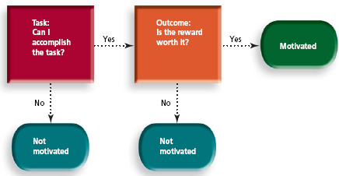
- Equity Theory – “If I do a good job, will it be worth it?
- Employees try to maintain equity between inputs and outputs compared to others in a similar position
- Inequity can lead to lower productivity, reduced quality, increased absenteeism and voluntary resignation
- Believe that the perception of fairness determines motivation to perform

- Reinforcement Theory - Based on the idea that positive and negative reinforces motivate a person to behave in certain ways.
- Motivation is the result of the carrot and stick approach. B.F. Skinner asserted that positive reinforcement is more effective at changing and establishing behavior that is punishment and the that the main thing that people learn from punishment is how to avoid punishment. People try to receive rewards and avoid punishment.
- To stop unwanted behavior a manager may ignore it with the hope that it will stop – this is called extinction.
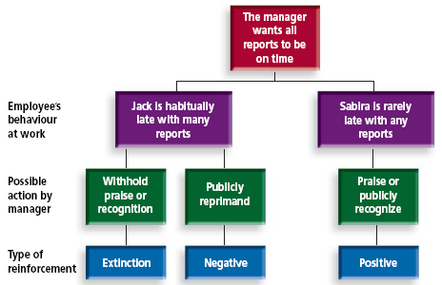

- Open Communication and Team Motivation
Open Communication helps both top managers and team members understand the objectives and work together to achieve them.
- Having teams creates an environment in which learning can happen, because most learning happens at the peer level.

Chapter 3: Global Markets
- Globalization – companies manufacture, finance, and market worldwide
- Canada represents a potential market of 35.7 million customers
- Over 7 billion potential customers globally in 195 countries
Gross Domestic Product (GDP) represents the monetary value of all goods and services produced within a nation’s geographic borders over a specific period. (Canada rep. 2.88% of the world’s economy)
Nations should trade globally because:
- No country is self-sufficient,
- Other countries need products that prosperous countries produce, and
- Natural resources and technological skills are not distributed evenly around the world.
- Exporting/Importing – key terms
Exporting – is the simplest way of going international to sell goods and services
- Success in exporting often leads to licensing with a foreign company to produce the product locally to better serve the local market.
Importing is buying products from another country
The Theory of Competitive Advantage
- The ability of a firm or individual to produce goods and/or services at a lower opportunity cost than other firms or individuals.
A comparative advantage gives a company the ability to sell goods and services at a lower price than its competitors and realize stronger sales margins.
International Trade - large multinational firms, like Intel and Coca-Cola, are big players in international trade
- While Canada has a small population, it produces vast quantities of products, ranking high in terms of nations that export.
- Exports alone account for one in five Canadian jobs and generate 30 cents out of every dollar earned.
- Balance of Trade: the relationship between exports and imports.
- Balance of Payments: the difference between money coming into a country (from exports) and money leaving the country (for imports).
- Current Account: the difference between money coming in and going out of the country from all sources.
- Strategies for reaching markets
Foreign Direct Investment (FDI) – buying permanent property and businesses in foreign nations
- FDI provides benefits to Canadian firms through the transfer of knowledge, technology and skills, and increased trade related to investment, all of which contribute to productivity growth and competitiveness.
Strategies for Reaching Global Markets
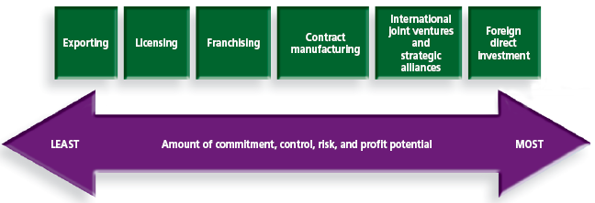
Licensing is a grant a license to (someone or something) to permit the use of something or to allow an activity to take place.

Franchising is an arrangement whereby someone with a good idea for a business sells the rights to use the business name and sell a product or service to others in each territory.
- Franchisors; however, must be careful to adapt their good or service in the countries they serve.
Contract Manufacturing
- Contract manufacturing enables a company to experiment in a new market without incurring heavy start-up costs such as a manufacturing plant.
- The practice falls under the broad category of outsourcing.
Strategic Alliance is a primary type of cooperative strategy in which firms combine some of their resources and capabilities to create a mutual competitive advantage.
- Involves the exchange and sharing of resources and capabilities to co-develop or distribute goods and services.
Cooperative Behavior known to contribute to alliance success:
- Being trustworthy.
- Consistently pursuing ways to combine partners’ resources and capabilities to create value.
- Forces (environments) that affect global trading
Social-Cultural Differences:
- In Turkey, it’s rude to cross your arms while you are facing someone.
- In India, never pat someone’s head as it’s the seat of the soul.
Economic Forces:
- Global financial markets unfortunately do not have a worldwide currency.
- Changes in a nation’s exchange rates can have important implications in global markets.
- Global financial markets operate under a system called floating exchange rates.
Technological Forces:
- Technological constraints in some countries may make it difficult to use the same devices and same machinery everywhere
- Computer and Internet usage in many developing countries is not the same as in North America and Europe.
Political – Legal and Regulatory Forces
In Canada, federal and provincial laws and regulations heavily affect business practices
Canadian businesses must follow Canadian laws and regulations in conducting business globally.
- For example, bribery is not considered legal in Canada

- The advantages and disadvantages of trade protectionism
Colonialism: the “Mother Country” would export finished goods to the colonies. The colonies provided raw materials and a market for finished goods.
Mercantilism: (16th and 17th centuries): exports are good; imports are bad.
Trade Protectionism: the attempt to limit imports or promote exports by putting up barriers of trade
Advantages | Disadvantages
Tariffs will protect a growing country from foreign investors (developing their own competitive advantage)  Temporarily creates jobs for domestic workers | Trade Protectionism in the long term weakens the industry  Without competition, companies within the industry will not innovate and improve  Job outsourcing  Slow economic growth

Protectionism Practices
Protectionism: using government regulations to keep foreign goods out
- Tariffs and quotas to limit imports.
- Revenue tariffs to generate funds for the government.
- Regulatory trade barriers: labeling, health, safety, emission standards can be used as trade embargoes.
Tariffs: tax imposed on imports
Non-Tariff Barriers are not as specific or formal as tariffs, import quotas, or embargoes but can be as detrimental.
Dumping is the selling of products in a foreign country at lower prices than those charged in the producing country.
- The changing landscape of the global market

International Trade Organizations
The World Trade Organization (WTO) has over 100 members
The International Monetary Fund (IMF) and the World Bank lend money to less-developed nations to finance trade
- "The IMF negotiates with a country to provide financial assistance if the country will agree to adopt certain policies to stabilize its economy"

Trade Agreements/Unions
- General Agreement on Tariffs and Trade (GATT); WTO
- Common Markets/European Union
- North American Free Trade Agreement (NAFTA), 1993
- Canada has become a founding member of the Trans-Pacific Partnership (TTP) – still requires ratification in the house of commons
Objectives of NAFTA were to:
- Eliminate trade barriers and facilitate cross-border movement of goods and services
- Promote conditions of fair competition in this free-trade area.
- Increase investment opportunities in the territories of the three nations.
- Provide effective protection and enforcement of intellectual property rights (patents, copyrights, etc.) in each nation’s territory.
- Establish a framework for further regional trade cooperation.
- Improve working conditions in North America.
- Trans-Pacific Partnership: 12-country trading block that will enjoy a significant drop in tariffs

Chapter 6: Forms of Business Ownerships
- Advantages and disadvantages of sole proprietorships.
Advantages | Disadvantage
Ease of starting and ending  Be your own boss  Pride of ownership  Retain profit  No special taxes  Less regulation | Limited financial resources  Management difficulties  Overwhelming time commitment  Few fringe benefits  Limited growth  Limited lifespan  Possibly pay higher taxes  Unlimited liability
Sole Proprietorship: a business that is owned, and usually managed, by one person.
Partnership: a legal form of business with two or more parties.
Corporation: a legal entity with authority to act and have liability separate from its owners.
Major Consideration: Liability includes the responsibility of a business to pay all normal debts and to pay because of a court order or law, for performance under a contract, or payment of damages to a person or property in an accident.

- Advantages and disadvantages of partnerships and he differences between general and limited partners.
Advantages | Disadvantages
More financial resources  Shared management and pooled, complementary skills and knowledge  Longer survival  Shared risk  No special taxes | Unlimited liability  Division of profits  Disagreements among partners  Difficulty of  termination  Possibility of higher taxes
General partnership: all owners share in operating the business and in assuming liability for the business’s debts
Partnership: consists of one or more general partners and one or more limited partners.
Limited partner: an owner who invests money in the business but does not have any management responsibility or liability for losses beyond the investment.
Limited liability: the responsibility of a business’s owners for losses only up to the amount they invest (limited partners and shareholders).
Limited liability partnership (LLP): limits partners’ risk of losing their personal assets to only their own acts and omissions, including those under their supervision.
- Advantages and disadvantages of corporations.
Advantages | Disadvantages
Limited liability  More money for investment  Size: may be larger due to increased resources  Perpetual life  Ease of ownership change  Ease of attracting talented employees  Separation of ownership from management | High initial costs  Extensive paperwork  Double taxation  Two tax returns  Size: may become too inflexible to new ideas  Termination difficult  Stockholder & board conflict
Corporation: a federally or provincially chartered legal entity with authority to act and have liability separate from its owners (stockholders/shareholders).
Public corporation: has the right to issue shares to the public, so its shares may be listed on a stock exchange.
Private corporation: is not allowed to issue stock to the public, so its shares are not listed on stock exchanges; it is limited to 50 or fewer shareholders.

- Types of corporate mergers, and the role of leveraged buyouts and taking a firm private.
Corporate Expansion: Mergers and Acquisitions
Acquisition: one company’s purchase of the property and obligations of another company.
Merger: two firms forming one company.
  - Vertical merger: the joining of two companies involved in different stages of related businesses.
  - Horizontal merger: joining two firms in the same industry.
  - Conglomerate merger: the joining of firms in completely unrelated industries.
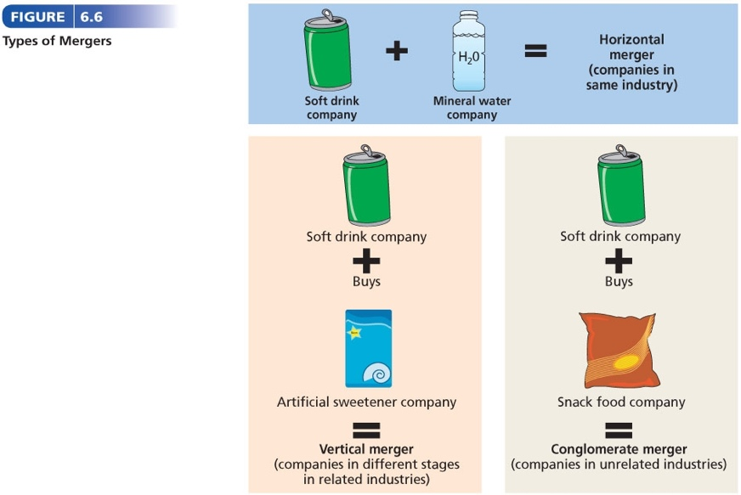
Benefits of Merging
- Allows regional firms to work together and compete more effectively.
- New company will have more leverage when negotiating with other companies.
Leveraged buyout (LBO): an attempt by employees, management, or a group of investors to purchase an organization primarily through borrowing.

- Advantages and disadvantages of franchises, and the challenges of global franchising.
Advantages | Disadvantages
Management and marketing assistance  Personal ownership  Nationally recognized name  Financial advice and assistance  Lower failure rate | Large start-up costs  Shared profit  Management regulation  Coattail effects  Restrictions on selling  Fraudulent franchisors
Franchise Agreement: an arrangement whereby someone with a good idea for a business sells the rights to use the business name and sell its goods and services in each territory.
Franchisor: a company that develops a product concept and sells others the rights to make and sell the products.
Franchisee: a person who buys a franchise and normally pays a fee for the franchise and then pays a percentage of earnings on a yearly basis.
- Role of co-operatives in Canada.
Co-operative: An organization that is owned by the members and customers, who pay an annual membership fee and share in any profits based upon how much they use the co-op, not on how many shares they hold.
Benefits of Co-Operatives
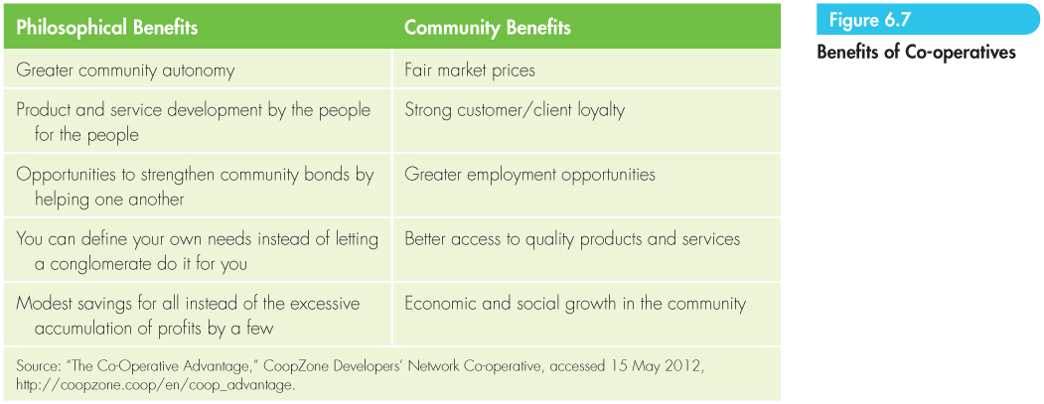

Chapter 9: Adapting Organizations to Today’s Market
- Basic principles of organization management
The Experience Curve Effect exists when unit’s costs decline as cumulative production volume increases because of:
- Accumulating production know-how
- Growing mastery of the technology
The bigger the experience curve effect, the bigger the cost advantage of the firm with the largest cumulative production volume.

Business Growth
Economies of Scope refers to efficiencies the can be realized through sharing resources. Some examples include product bundling and family branding
Two Types of Employees
Line Personnel are employees who are part of the chain of command that is responsible for achieving organizational goals
Staff personnel are employees who advise and assist line personnel in meeting their goals.
Organization Parts
Function – sub-unit composed of people who work together & possess similar skills or use the same kind of knowledge, tools or techniques to perform their jobs
Division/Department – sub-unit that consists of a collection of functions or departments that share responsibility for producing a good or service
Advantages & Disadvantages of Departmentalization
Departmentalization is dividing an organization into separate units. The traditional way to departmentalize organizations is by function.
Functional structure is the grouping of workers into departments based on similar skills, expertise, or resource use.
Advantages | Disadvantages
- Employees can develop skills in depth and can progress within a department as they master those skills.  - The company can achieve economies of scale in that it can centralize similar resources in one area.  - There’s good coordination within the function, and top management can easily direct and control various departments’ activities. | - There may be a lack of communication among the different departments.  - Individual employees may begin to identify with their department and its goals rather than with the goals of the organization.  - The company’s response to external changes may be too narrow.  - People may not be trained to take broad-based senior managerial responsibilities.  - People in the same department tend to think alike.
Alternative Ways to Departmentalize
- By product
- By function
- By customer group
- By geographic location
- By process
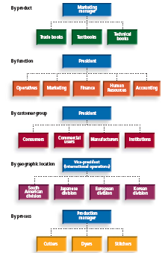

Historical theories – Fayol and Weber
Fayol introduced principles such as unity of command, hierarchy of authority, division of labour, subordination of individual interests to the general interest, authority, clear communication channels, order, and equity.
Weber added principles of bureaucracy such as job descriptions, written rules and decision guidelines, consistent procedures, and staffing and promotions based on qualifications.

- Issues involved in structuring
- Centralization versus decentralization
Centralized authority occurs when decision-making authority is maintained at the top level of management at the company’s headquarters.
Decentralized authority occurs when decision-making authority is delegated to lower-level managers and employees who are more familiar with local conditions than headquarters’ management could be.
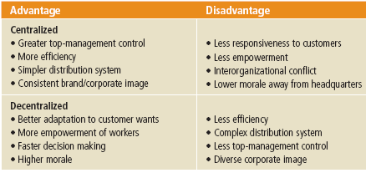
- Span of Control is the number of subordinates under each manager’s direct management

Variables to Consider in Span of Control
- Capabilities of Subordinates and Manager
- Complexity of Job
- Geographically Close
- Functional Similarity
- Need for Coordination
- Planning Demands
- Functional Complexity
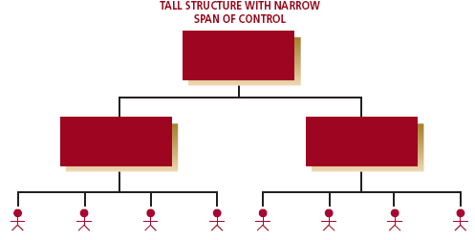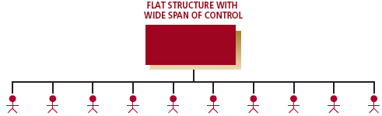
- Tall versus flat organization structures
Flat Hierarchies – managers can be evaluated for their abilities to control organization activities with the smallest # of managers possible
- Experience fewer communication, motivation and cost problems than tall hierarchies
Problems of Tall Hierarchies
- Communication problems increase as org. grows
- Slow decision making
- Distortion - too many levels, intentional or not
- Decreased motivation
- High bureaucratic costs

- Departmentalization involves dividing an organization into different departments, which perform tasks according to the departments' specializations in the organization.
- Customer
- Functional
Location
- Product
- Organizational models

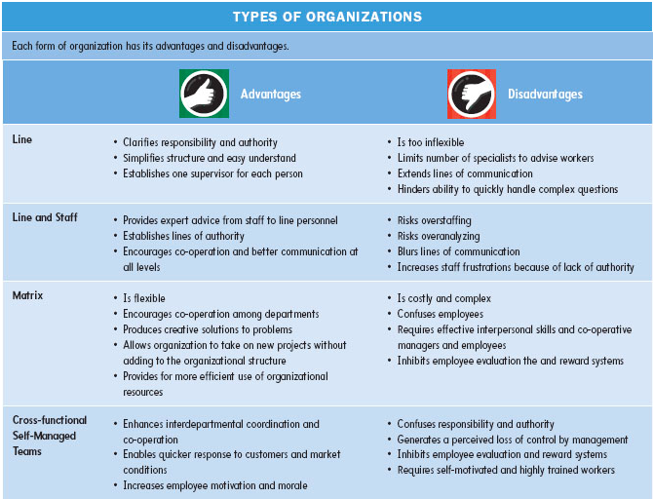
- Identify the benefits of interfirm cooperation and coordination

- How organizational culture can help businesses adapt to change.
Chapter 8: Management & Leadership
- The management function: responding to change

- Four functions of management (PDOC):
- Planning – achieving organizational goals
- Includes anticipating trends and determining the best strategies and tactics to achieve organizational GOPST (Goals, Objectives, Plans, Strategies and Tactics)
- Directing (leading) – different from managing
- Creating a vision for the organization and guiding, training, coaching, and motivating others to work effectively to achieve the organization’s goal and objectives.
- Organizing for success
- A management function that includes designing the structure of the organization and creating conditions and systems in which everyone and everything works together to achieve the organization’s goals and objectives.
- Controlling – the five steps
- Involves establishing clear standards to determine whether an organization is progressing toward its goal and objectives
- Rewarding people for doing a good job
- Taking corrective action if they are not
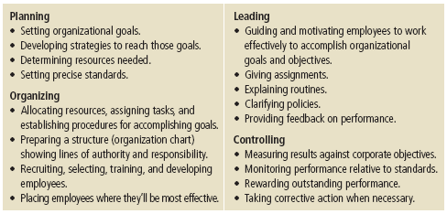
- The different types of planning and the importance of decision making
Planning: SWOT Analysis
Strengths and Weaknesses are things within the control of your organization.
Opportunities and Threats are things outside your control and things you should find information about to act on.
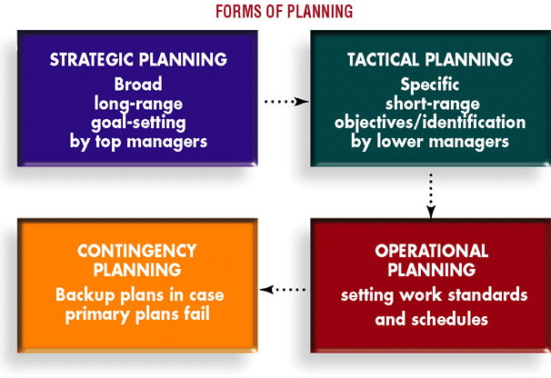
Strategic planning outlines how the company will meet its objectives and goals. It provides the foundation for the policies, procedures, and strategies for obtaining and using resources to achieve those goals
Tactical planning is the process of developing detailed, short-term statements about what is to be done, who is to do it, and how it is to be done.
Operational planning is the process of setting work standards and schedules necessary to implement the company’s objectives.
Operational planning focuses on the specific responsibilities of supervisors, department managers, and individual employees
Contingency planning is the process of preparing alternative courses of action that may be used if the primary plans don’t achieve the organization’s objectives.
- The economic and competitive environments change so rapidly that it’s wise to have alternative plans of action.

- The organizing function of management and the three categories of skills needed by managers.
- Technical Skills
- Human Relations Skills
- Conceptual Skills
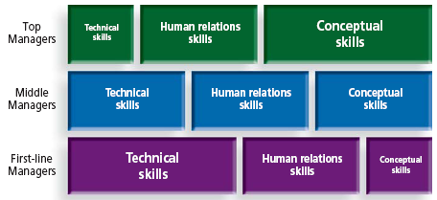

- The differences between leaders and managers, and the various leadership styles.

- The five steps of the control function of management.
Controlling consists of five steps:
- Establishing clear performance standards.
- Monitoring and recording actual performance
- Comparing results against plans and standards.
- Communicating results and deviations to the employees involved.
- Taking corrective action when needed and providing positive feedback.
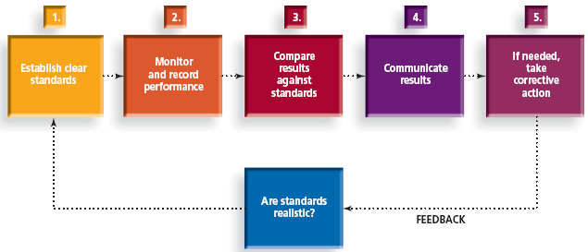

Possible Case: SWOT Analysis
SWOT Analysis:
A rational way of thinking about a problem by looking at the external and internal environment – precursor to development of a business strategy
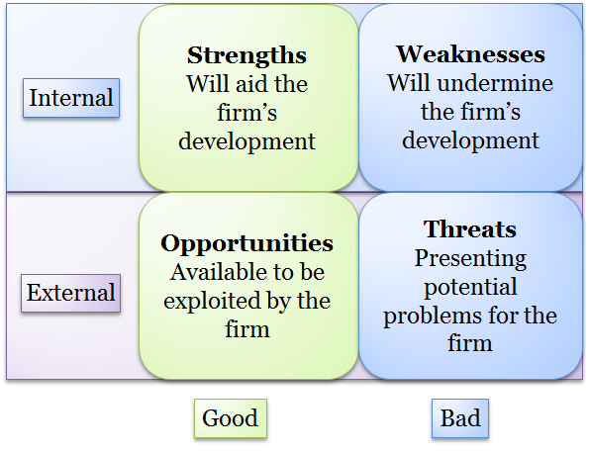

Situation/Environment Analysis
EXTERNAL or MACRO-ENVIRONMENT
    - (Inter)national/macro context
    - Industry context
    - Opportunities and threats
    - Must obtain empirical data for each trend analyzed
INTERNAL OR MICRO-ENVIRONMENT
    - Competencies, capabilities, resource strengths & weaknesses, and competitiveness
Intangible Resources are Highly Valuable
Intangible Resources like a good reputation are often a more powerful and desirable source of core competencies (key things that a firm does well that come from its strengths) as they are less visible, more difficult for rivals to understand, imitate, substitute or purchase
Potential Internal Strengths:
  - An acknowledged market leader
  - Core competencies in key areas
  - Proven and respected management team
  - Well-conceived functional area strategies
  - Cost advantages
  - Better advertising campaigns
Potential Internal Weaknesses:
  - No clear strategic direction
  - Weak market image
  - Subpar profitability
  - Obsolete facilities
  - Lack of managerial depth and talent
  - Too narrow a product line

Internal Audit
Advantages:
  - Opportunity for people to understand how their jobs fit into their department, division, and firm
  - Increase cooperation and communication
  - Increase understanding of company problems and concerns
Key to Success:
Effective coordination/understanding among managers from all functional areas
External Audit/Environmental Scan
- Precedes development of strategy
- Used to identify concrete opportunities (to make $$$ & maximize shareholder wealth) and threats (impede making $$$ & maximizing shareholder wealth).
PESTLED (External Analysis Tool)
Political
Economic
Socio-cultural
Technological
Legal-regulatory
Environmental
Demographic

Political Factors
- Political stability
- Defense expenditures
- Size of government budgets
- Lobbying activities
- Degree of commitment to education
- Commitment to the environment
- Trade restrictions, tariffs
- Increasing regulation & deregulation
- Membership in trade blocs - quotas, tariffs
- Greater interdependency between business and government

Economic Factors
    - Demand shifts for different categories of goods/services
    - Inflation & interest rates & price fluctuations (CPI)
    - Gross domestic product, trade deficits or surpluses
    - Personal & savings rates & consumption patterns
    - Unemployment trends & worker productivity
    - Housing starts
    - Disposable income
    - Availability of credit
    - Value of the dollar - exchange rates
    - Stock market trends

Socio-cultural Factors (Some factors include):
    - Education level
    - Languages
    - Career attitudes
    - Mobility, Disabilities
    - Emphasis on safety, Health awareness

External Technological Factors
Institutions/activities involved in the creation of new knowledge and translating it into new outputs, products, processes and materials. Tends to be common across regions.
- Technology affects most products & services
- Shortens the life cycle of existing products
- Helps create new products
- Influences outsourcing decisions
- Increased speed and efficiency
- Can lower production costs
- Lower barriers to entry (reduce minimum efficient production levels)
*Early adopters of technology tend to achieve higher market shares and returns

Legal/Regulatory Factors
Legal issues that may restrict or enhance functions
- Consumer law
- Patent laws
- Discrimination laws
- Employment law
- Labor training laws
- Health and safety laws
- Foreign ownership laws
- Taxation rates and laws (antitrust laws)
- Environmental laws and regulations

SWOT Matrix
S – STRENGTHS (Internal)
W – WEAKNESSES (Internal)
O – OPPORTUNITIES (External)
T – THREATS (External)

