Individual Assignment Part 1
Part 1:
From my assessment I just came up short of being an entrepreneur, putting me into the class of intrapreneur (Appendix A). However, towards the end of the class I hope to develop further and reach that entrepreneur status. I have learned that my strongest general trait is Motivations, determined from how far my score was from the average (Appendix D). I partially credit this to how I was brought up. My parents always encouraged me to achieve my best, and in my later years I have taken on this mindset. I would consider myself a competitive person, in the case of setting goals for myself. I am always trying to work on objectives set in my personal or academic life, that I consider a challenge. Independence is a trait I enjoy, having the ability to freedom to make my own choices or make decisions decisively. This could be as simple as cooking for myself to moving out from home. I enjoy the idea of power, this past summer when working a parking zone coordinator. I was always moving people around, changing methods on how to handle the ingress and egress of traffic. In general, having the ability to work on my own agenda and have the freedom associated with it, I appreciate. What needs improvement are my attitudes and aptitudes (Appendix A). Firstly, for my attitude I need to become more comfortable with the fact I have the potential to influence my own future (Appendix B). Sometimes I still struggle with self doubt, however I feel this will become less of an issue the further I get into university and especially this course. Linked to that is the lack of my eagerness towards taking on projects that I may encounter failure. I lack the ambition because I do not believe in myself in the first place. Everyone says you learn from failure which I totally agree with. However, it is the embarrassment or potential lose of assets that hold me back. To improve this, I need to except the risks and know it is not the end of the world. Secondly, when it comes my aptitudes my perseverance and creativity need work (Appendix C). I need to keep up my determination when working towards a goal. Having the strength to reproach an issue when I hit a roadblock. For creativity just work on my open-mindedness, I believe this will translate into becoming better at approaching problems from different angles.
Part 2:
As an intrapreneur you are limited in terms of freedom, compared to an entrepreneur. An entrepreneur can choose a project that they enjoy, are good at and pay themselves. Also, they get to choose the personnel that surround them. An intrapreneur can maybe control some of these factors but not to the extent an entrepreneur can. If you are unhappy in your current intrapreneur career take a step back and reassess it. Question yourself, you may be good at your job, but do you love it, are you even getting paid for what you are worth. If you have negative responses consider these two options, find a new employer that treats you better or find a job which you find passionate about. Currently, as a coordinator at Stampede I really enjoy it, I love the people I work with and entertained by the tasks I am assigned. By that theory I should stay put, but the pay could use improvement and the tasks while enjoyable are not challenging. However, it is not my plan to work there forever, I want to work in my field of degree which is Biotech. I want to start on a project that allows me to help others, bring happiness and challenges me. Hypothetically, if I created a successful biotech start up, I would want to be in the industry of cancer therapeutics. I would have a great pay and I would be working on projects in a field that is already complex and is changing everyday. This would translate to new project opportunities always being available for consideration. I would have the aspect of power, being able to choose the people I want to work with and can brand my company with my own vision. The biggest factor would be bringing real happiness to my customers. At the Stampede I made people happy, but with my own Biotech company I could develop medication that could be life saving and change someone’s life forever. If I were to achieve all of this, I would be able to check off all the boxes needed to have a career I am satisfied with.
Part 3:
The biggest lesson I have learned from Chan’s post is that two brains is better than one, but there is a limit. It is true that a larger founding team allows one to obtain a diversified skill set or specialized roles. However, if your team is too big then responsibilities overlap, or person agendas come into play. Having a close group allows us to communicate effectively and being there to back each other up. Hopefully this would develop a strong bond between all of us. Something I did not consider before was that investors may doubt you, not having somebody by your side shows people do not believe in your idea or you are hard to work with. I intend to assemble a team for my start up, I do not believe in working alone on a project like this. My start up idea comes from the landscaping I have done at our home. I have removed and planted trees, grassed in garden beds or make them, move plants around and shovelled mulch and rocks. The reason so much work has been done is because the initial landscaping did not consider the future growth or the surroundings. So, my company would provide a software that scans your layout of the back yard and takes in factors such as soil quality, wind and weather. Then you as the consumer can digitally assemble your garden and simulate the growth, for example 5 years ahead. This allows them to see how things would look, or the program could give warnings like not placing plants by a pine tree as the acidify and roots would prevent its growth. My role in this company would most definitely be the Visionary. What makes me the visionary is that it is my idea but also, I am a people person. Sharing and recruiting this idea, while keeping everyone together are tasks that I would strive at. I feel my passion for the project would inspire my team and translate into sharing and recruiting this idea. Also, I am proficient at making calls, when faced in a tough situation. Biggest hole would be my lack of certain skills. Yes, I would my education in biology to develop the relationships between the plants and the environments. However, when it comes to coding a program or running the financials those are areas of weakness. Additionally, I should not have to be concerned with every single detail. That is why I have people such as the hustlers and hackers to cover those tasks for me.

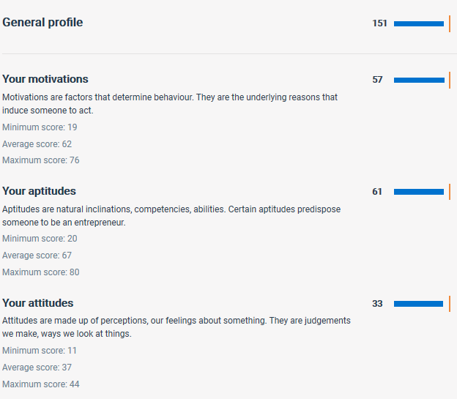
Appendix A

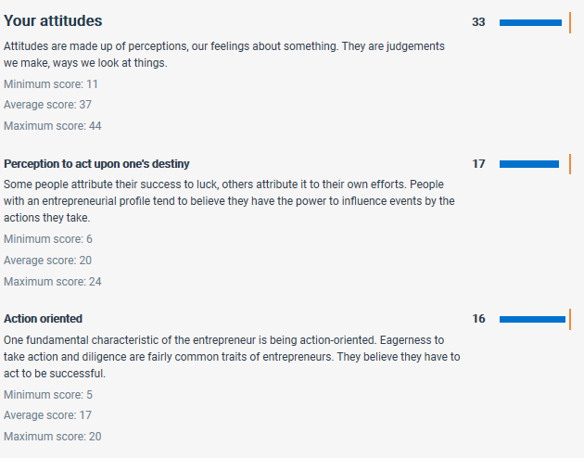
Appendix B
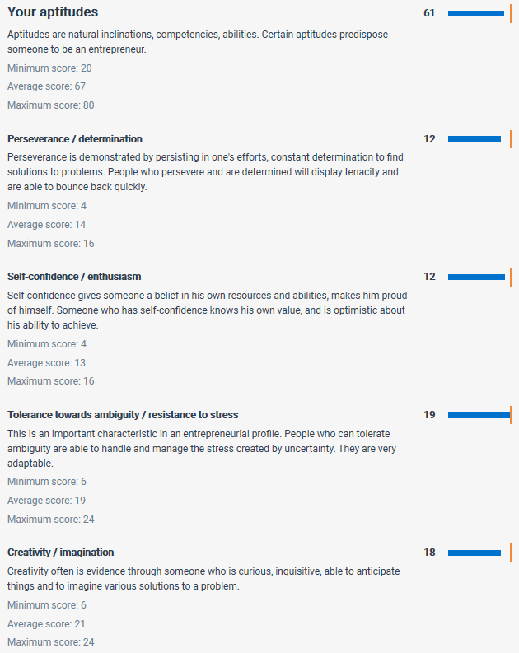
Appendix C
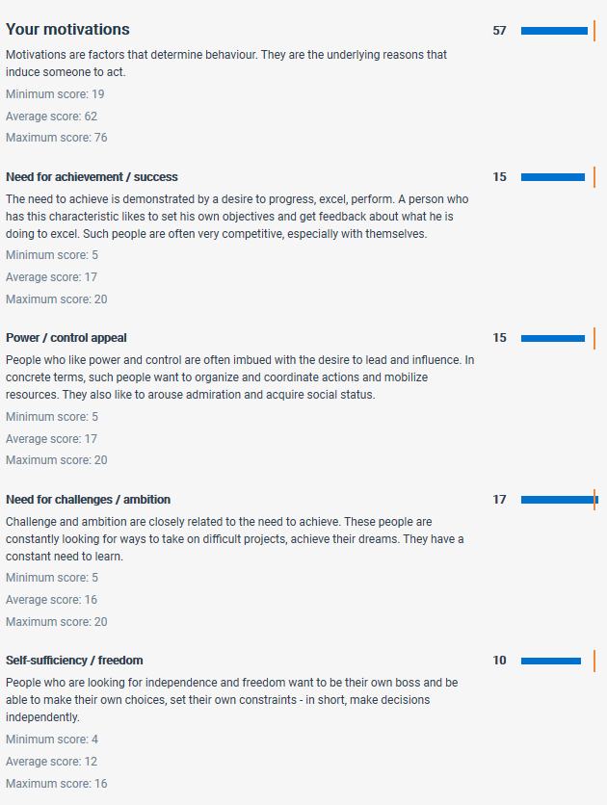
Appendix D

