Law 122 Notes
Chapter 1- Risk Management and Sources of Law
Why Study Law
- Factors affect success and failure in a business
  - ex. Decision making like location, choice, product and marketing
- Business decisions have legal consequences
- Negative: ex. Dumping pollutants into environment
- Positive: ex. Binding contractual party to promise
- Legal consequences affect profit and losses
- Some decisions impose liability, others create opportunities
Risk Management: is the process of identifying, evaluating and responding to the possibility of harmful events – what are you going to do to lessen the risk
Steps:
- Identification- what risks exist in a particular situation
- Evaluation- How serious are those risks
- Response- how will you react
Strategies
- Risk Avoidance- should be avoided altogether
- Risk Reduction- some risks can be reduced to acceptable level
- Risk shifting- shift risk onto another party for ex. Through insurance and exclusion clauses
- Risk Acceptance- simply accept chance of risk if it’s small
The Nature of Law
Law:
- A set of principles and rules that courts will enforce
- A way of thinking (or reasoning) about these principles and rules
Rules and Laws
- All laws are rules but not all rules are laws
Morality and Law
- Moral wrongs are informally sanctioned
- Ex. Damaged friendships or reputation
- Legal wrongs are formally sanctioned
- Ex. Fines or imprisonment
Types of Ethical Reasoning
- Consequence based reasoning- greatest good for the most amount of people (is it good for society or not) ex. Junk mail is annoying to people but allows for mail service to run
- Fairness Based Arguments- balancing of agreement
- Rights and Duties- if there is a right, there is a duty to perform something associated with that right for ex. Everyone in class holds the right to not discriminate against someone’s culture, duty is to not discriminate
- Character and Virtue- What kind of people do you want to be
Ethical Perspective 1.1 – Canoe Ex
Scenario: Person on canoe tipped over and is yelling for help, someone sees, should they rescue the person?
*Use Ethical Reasoning to explain scenario*
- Rights & Duties- person on the canoe has the right to life and government should impose laws that people should help preserve that if they are able to
- Observer has the duty to go rescue the person if it doesn’t inflict harm on themselves
- Alternate argument: person observing has the right to make own decisions
Civil Law: systems trace their history to ancient Rome – only jurisdiction in Canada is Quebec
Jurisdiction: a geographical area that uses same set of laws
Common Law: system that traces their history to England, used in most of Canada. Judge- made laws, dispute-based.
- Criminal laws and constitutional laws are the same across Canada
Public Law: is concerned with governments and the ways in which they deal with their citizens; constitutional, administrative law, criminal law, and tax law
Types of Public Law
- Constitutional law: provides the basic rules of our political and legal systems. It determines who is entitled to create and enforce laws and establishes the fundamental rights and freedoms.
- Administrative law- is concerned with the creation and operation of administrative agencies, boards, commissions and tribunals.
- Criminal law: deals with offences against the state
- White collar crimes: committed by officials (people who wear suits)
- Corporate Crime: committed by a company
- Tax Law: concerned with the rules that are used to collect money for public spending
- Direct tax: cost is expected to fall on taxpayer ex. Income tax
- Indirect tax: expected to be passed on from the taxpayer to someone else like their customers
Private Law: Is concerned with the rules that apply in private matters and the relationships we have with other private individuals
Types of Private Law
- Tort Law: Rules governing wrongs against persons (involuntarily)
- Contract Law: rules governing creation and enforcement of agreements (voluntary) i.e. sale of goods, use of negotiable instruments like cheques, real estate transactions.
- Property Law: concerned with the acquisition, use and disposition of property
- Real property- land and things attached to land
- Personal property- things that can be moved
- Intellectual property- original ideas like patents
Sources of Law
Constitution: document that creates the basic rules for Canadian society including its political and legal systems. Every other law must be compatible with it since it’s the highest source of law, and it’s difficult to amend.
Amending Formula: requires consent of both parliament and two-thirds of all provinces with at least 50% of population
Legislation: laws created by Parliament (Federal) or Legislature (Provincial)
Two levels of government: federal and provincial:
- Federal: governs country as a whole; consists of the House of Commons and The Senate- criminal law, banks, money, copyright
- Provincial and Territorial: politician represent individual provinces- property, civil rights
Division of Powers: states the areas which each level of government can act
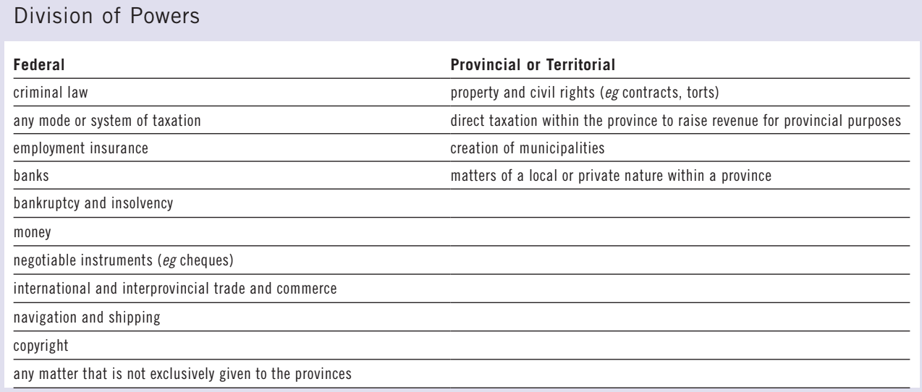
Residual Power: gives the federal government authority over everything that isn’t specifically mentioned
Ultra Vires: when government legislates outside its authority, law is beyond the power of and has no force of effect
Doctrine of federal paramountcy: determines which law applies based on the Constitution’s division of powers
Charter of Rights and Freedoms
- Part of constitution since 1982
- Rights and freedoms commonly affecting business:
- Freedom of religion
- Freedom of expression
- Freedom of mobility
- Right to equality: prohibited grounds of discrimination include race, sex and religion but not poverty
- Section 52: Constitution as supreme law- any law inconsistent ‘of no force or effect”
Limitations on Charter Rights
- Charter applies only to government action- not directly applicable against private businesses
- May apply in favor of private business- some provisions limited to individuals
- Rights subject to “reasonable limitations”- balance individuals rights and community interest
- Subject to “notwithstanding clause”- government can override some rights and freedoms but very rarely used
- Charter doesn’t include
- Property rights: rights to own and enjoy assets
- Economic rights: rights to carry on business activities
Charter Remedies
- Declaration: declare charter has been violated
- Injunction: requires government to address problem in certain way
- Striking down: eliminate a statute that violates the charter or suspend it
- Severance, reading down, reading in: sometimes court may save statute by rewriting part of it
- Damages: compensate plaintiff’s loss, vindicate their rights and deter future wrongdoing
Parliamentary Supremacy: while judges are required to interpret constitutional and statutory documents, they must also obey them
Subordinate Legislation: is the term given to regulations that are created with the authority of Parliament or the legislature
Municipalities: city or town
By-laws: type of subordinate legislation that is created by municipality
Court Hierarchy
- Hierarchy determines appeal route
- All hierarchies end with the Supreme Court of Canada
- Also determines what decisions are binding on courts
Trust: exists anytime that one person owns property for benefit of another

Chapter 2: Litigation and Alternative Dispute Resolution
Who Can Sue and Be Sued
- All adults are free to use the Canadian courts
Class action: allows a single person or a small group of people, to sue on behalf of a larger group of claimants
Requirements for class action:
- Common issues amongst various members of the class
- Representative Plaintiff: must demonstrate workable plan for fairly representing interests of class members
- Notification: plaintiff must notify potential class members
- Preferable Procedure: court must be convinced class is appropriate action
- Certification: represents the court’s decision to allow various claims to be joined together and to proceed as class action. Demonstrates that court believes that there is serious/genuine claim
Legal Representation
- Self-Representation
- Have the right to represent your self

- Lawyers
- Hiring lawyer to represent yourself in court provides you with competent help that may increase likelihood of success
Professional Liability Insurance: allows client to receive compensation from a lawyer’s insurance company if the lawyer acted carelessly
Assurance Fund: provides compensation to people who’ve been hurt by dishonest lawyers
Paralegal: Not a lawyer but provides legal advice and services and are confined to certain types of work
Pleadings
Pleadings: the documents used to identify the issues and clarify the nature of a dispute
- Plaintiff- person who makes the complaint
- Defendant- person about whom the complaint is being made
Limitation Periods: period within which an action must be stated
- Claims must be started within 2 years from the day the plaintiff discovered cause of action
- Special Periods: may have longer period to sue someone depending on circumstance
- Effect of Lapse: while debt still exists, it us unenforceable
- Justifications: limitation periods are necessary because
- After time, memories fade and evidence are lost
- Unfair to allow plaintiff to hold threat of litigation over defendant forever
Statement of Claim: document in which the plaintiff outlines the nature of the complaint. States the facts and the remedy.
- Defendant must reply to this quickly or plaintiff may go to court alone and receive default judgement
Statement of Defense: defendant sets out its version of the facts and indicates how it intends to deny the claim
Counterclaim: claim that defendant makes against plaintiff
Reply: document in which a party responds to a statement of defense
Demand for Particulars: requires the other side to provide additional info
Pre-Trial Activity
Examination for Discovery: process in which the parties ask each other questions to obtain info about their case
- Discoveries encourage settlement: occurs when parties agree to resolve dispute out of court
Pre-trial conference:
- meeting that occurs between the parties and judge
- After parties’ outline positions, the judge may indicate which of them is likely to win if the case went to trial; likely loser may be persuaded to settle
Mediation: process in which a neutral person- called a mediator- helps the parties reach an agreement.
The Trial
- Judge is responsible for finding the law while jury is responsible for finding the facts and applying the law
- Each side present arguments and evidence; plaintiff first then defendant
- Call witnesses:
- Ordinary witnesses- testify about facts that they know first hand
- Expert witnesses- provide info and opinions based on evidence
- Examination in chief: the party who calls witness will ask questions and receive answers
- Opposite side then cross-examines the same witness
Hearsay Evidence: info that a witness heard from another person, rather than info gathered directly from source
Arguments and evidence:
- Plaintiff must prove claim on a balance of probabilities- every important part of claim must be probably true
- End of trial, defendant only held liable if the scales are tipped in the plaintiff’s favor
- Criminal cases standard of proof much higher- Crown has to prove accused’s guilt beyond reasonable doubt
The Remedy
Name of Remedy | Purpose | Example
Compensatory damages | financially repair a loss | accident caused medical expenses and lost income
Punitive damages | punish and discourage very bad behaviour | insurance company fraudulently alleged arson to avoid paying for fire damage
Nominal damages | symbolically recognize wrongful acts even if plaintiff suffered no loss and defendant received no gain | trespasser walked across property without doing damage
Injunction | compels fulfillment of an obligation | property owner prohibited from causing nuisance by hosting loud concerts
Specific performance | compels performance of a positive obligation | property owner contractually agreed to sell a particular piece of land
Rescission | reverses or eliminates a transaction | elderly couple tricked into selling their art collection
Judgement Debtor- defendant who has been found liable and ordered to pay money to plaintiff
Appeals
Appeal Court: decides whether a mistake was made in the court below
Appellant: party who attacks the decision of the lower court
Respondent: party who defends the decision of the lower court
Differences between trials and appeals:
- Most are heard by 3 judges or sometimes more
- Courts don’t listen to witnesses or receive evidence- simply hear and read arguments
- Normally deal with law but not facts- will correct any error of law that occurred in lower court but won’t overturn a finding of fact unless judge made palpable and overriding error
Appeal Decisions:
- Appeal Dismissed: if majority believes decision in court below was correct
- Appeal Allowed: if majority believes that lower court decision was wrong, it could reverse it, vary some part of it or send the case back for re-trial
- Dissent: appellate judge who disagrees with the majority is entitled to write a separate judgement called dissent
Contingency Fee Agreement: requires a client to pay its lawyer only if the lawsuit is successful
The Court System
Supreme Court of Canada
- Highest court in the country; has nine members including Chief Justice and 8 puisne judges
- Hears only appeals from other appellate courts; allowed to choose which ones to hear
Court of Appeal
- Each province and territory have one and members appointed by federal governments
Superior Court
- Federal government appoints judges to court in each province and territory
- Main job is to hear trials but occasionally they hear appeals from lower courts
Federal Court
- Federal government appoints the members of 3 specialized courts that deal only with cases that affect federal government
- Hears trials concerning issues that constitutions assign such as copyright, bills of exchange
Provincial Court
- Provincial governments appoint members of provincial courts; they’re trial courts
- Deal with 4 types of cases
- Small claims- private disputes with small amount of money
- Family matters- i.e. support payments
- Youth matters- young offenders
- Most criminal cases
Small Claims Courts: type of court that deals with disputes involving limited amounts of money
Drawbacks to Small Claims Courts
- Geographical Limits
- Plaintiff must sue either where the relevant event happened or where the defendant lives/carries on business
- Types of Claims
- Case may be brought to court if defendant asked to pay money or return property; however, they’re several restrictions
- Types of Remedies
- Small claims have the power to order defendant to pay money or return property
- Cannot award equitable relief like specific performance or injunctions
- Monetary Limits
- Size of claim determined by amount of money at stake
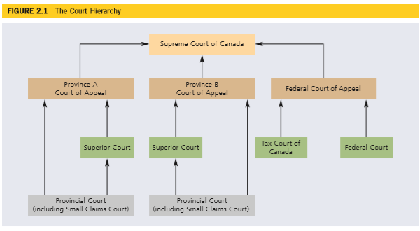
Doctrine of Precedent: requires a court to follow any other court that is above it in a hierarchy
Figure 2.1 Example
- Supreme Court of Canada- top of entire court structure, not required to obey another other court
- Same Hierarchy- Super Court of Province A must obey both Court of Appeal of Province A and S.C.C
- Different Hierarchy- Superior Court in Province A doesn’t have to obey Court of Appeal in Province B
- Federal Courts- Superior Court in Province A is not bound by decision of the Federal Court of Appeal
- Lower Courts- court of appeal can help in trial judgement from either Province A or B if S.C.C. has not yet answered question
- Same Court- S.C.C overrules itself in right circumstances and lower courts do the same
Rule of law: states that disputes should be settled on the basis of laws rather than personal opinions. Allows for consistency since judges have to follow courts above them.
Administrative Tribunals: body, somewhere between a government and a court, that resolves issues and disputes that arise in administrative law
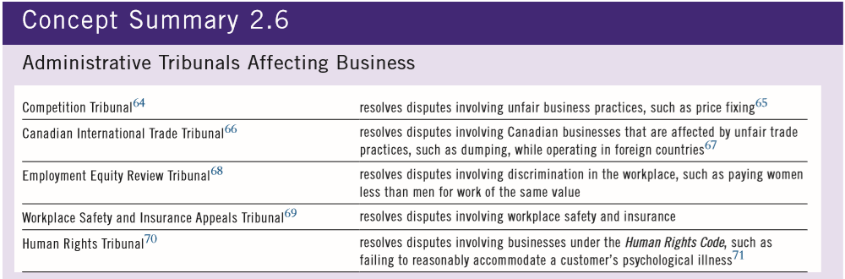
Alternative Dispute Resolution: any process that allows parties to resolve their dispute without going to court
There are 3 major types of ADR:
Negotiation- Discussion aimed at settling a dispute
- Advantages
- Quicker, less complicated, less expensive
- Allows parties to control process and decide outcome themselves
- Helps parties remain on good terms with each other
- Private procedure- avoid bad publicity
- Disadvantages
- Cooperation may not be possible
- One party may drag matter out
- May not have equal bargaining power
- Confidentiality may be undesirable
- No guarantee of success
- Insured party may lose benefit of policy
Mediation- process where a neutral party called a mediator, helps the parties reach an agreement
Arbitration- process in which a neutral third person called an arbitrator, imposes a decision on the parties

Chapter 3- Intro to Torts
Torts- “Do not unto others as you would have them do not unto you”
Torts: Is a failure to fulfill a private obligation imposed by law
- Tortfeasor- someone who commits a tort
- Tort Law: includes almost every sort of private law wrong outside of breach of contract
- Social Purpose: Tort law discourages people from committing private wrongs by requiring them to compensate and restore the wronged party and it provides compensation to the harmed parties
Harm leads to lability- not true because sometimes people are harmed not by others
Types of Torts
- Intentional- people intentionally act in certain ways
- Committing battery by shoving someone or throwing something on another’s lawn
- Ex. Assault, battery, false imprisonment, trespass to land, interference with chattels, conspiracy, intimidation, interference with contracts, unlawful means tort, deceit
- Negligence- is the person accused acting reasonably
- When harm is caused carelessly such as when a medical team accidentally amputates the wrong limb of a patient
- Ex. Occupier’s liability, nuisance, negligence, professional negligence, product liability
- Strict Liability – does something wrong without intention/carelessness
- Liable no matter how much care is taken and no matter what intent
- Applies to very risky activities and inquiries caused by wild or exotic pets or wondering cattle. If your pet tarantula bites someone or your cattle wanders off your property and tramples your neighbor’s yard, you are strictly liable
Facts, Issue, Law, Application
Supposed you are given a set of facts and asked to spot the issue, where do you start
- Ask yourself: is this a tort or a different type or legal wrong
- If it’s a tort, what kind of tort is it (Intentional, negligent, strict liability)
- Now, what tort specifically is involved
Intentional Torts
- A tort occurs when a person intentionally acts in a defined wrong way
- Meaning of intention differs depending on tort:
- Intent to Harm
- Intent to Act
Negligence Torts
- A tort occurs when a person acts carelessly
- But, actions or activity is protected if it is a reasonable in circumstances
- Ex. Negligence, product liability, professional negligence, occupier’s liability, nuisance
Strict Liability Torts for Extraordinarily Dangerous Activity
- A tort occurs when the defendant is responsible for an especially dangerous activity that caused harm
- Transportation of dangerous products
- Keeping of dangerous animals
Risk management: What can you do in situation
- If something happens, you are liable, strict liability
- Insure it if you must do the activity for ex. Having live animals at rainforest café
- Whatever the activity is, don’t do it (no risk involved)
- Find ways to minimize risk
Liability Insurance: contract where insurance company agrees, in exchange for a price, to pay damages on behalf of the person who incurs liability
Duty to defend: requires insurance company to defend at its own expenses, any lawsuit that is brought against insured party
Effects of Liability Insurance:
- Compensation- aims to fully compensate people who are wrongfully injured. If tortfeasor can’t personally afford to pay damages, plaintiff won’t receive full compensation unless defendant is insured
- Deterrence- discourages people from committing torts by holding them liable for losses. People aren’t afraid if they know insurance companies will cover damages if something happened
Intentional Tort: Trespass to Land
- Tort: Trespass to Land
- Test: Improper interference with land
Elements of Test:
- Intentional act
- Causing person or object to interfere with land
- No consent or legal authority
Elements broken down:
- Has to be intentional, but low test (intention to act)
- Land: above, on or below
- Interference: wide definition
- Has to be improper
- Consent= not improper (a defense)
- Legal authority= not improper (a defense)
Remedies for Trespass to Land
- Damages: compensatory, nominal or punitive
- Injunction:
- Preventing ongoing trespass
- Requirement to remove trespassing structure
- Removal of Trespassers
- Arrest of trespassers
- Use of reasonable force in arrest
Case Law Example: Russo v. Ontario Jockey Club
Answering the Case Question- Legal Analysis
- Start with analyzing the facts
- Russo entered a commercial space, was asked to leave and stay off all owned properties. Russo entered once later that month.
- What is the Issue
- Can the Ontario Jockey Club legally keep Russo off their property (Woodbine Race Track and other race tracks owned by the club)? Property is open to public
- What is the Law/ Legal Test- don’t state facts yet, say it in abstract way
- The Law says there is implied consent to be on property that is open to the public, but that consent can be withdrawn with notice, as long as the person is not excluded for reasons that violate the Human Rights Act
- Legal Test to Trespass
- Intentional act
- Causing person or object
- To interfere with land
- No consent
- Apply the law- identify anchor facts, apply law to facts
- Anchor facts:
- The Jockey Club= private-owned property, open to the public
- Russo was told to stay away
- Reasons for excluding her don’t violate human rights code- economic reasons
- Application of law to facts
- Since Club is private property, and since it withdrew consent for Russo to be on the property, Russo no longer has the right to be there. The Club can now exclude here, and if she returns, she is trespassing.
- Answer question/state conclusion/application holding
- Russo is liable for trespass
Trespass to Land Example- Nellie & gas company
- Issue
- Is Mr. Dread likely to succeed in suing Nellie for trespass to land?
- Law/Legal Test
- Intentional act
- Causing person or object
- To interfere with land
- No consent
- Application of law
- Nellie intentionally cut across neighbor’s lawn as shortcut
- Nellie is causing person
- Interfering with his property- his lawn
- No consent- neighbor didn’t give her permission, no legal authority since she isn’t reading meters
- Conclusion
- Mr. Dread likely to succeed as Nellie is liable for trespassing
Legal Issue: Vicarious Liability
Definition: Employer is responsible for a wrongful act done by an employee when it is done in the course of employment
Test: Did the tort occur in the course of employment ex. While employee was doing an employer authorized or closely related act
Effects of Vicarious Liability
Company will be held liable even though they didn’t do anything tortious:
- Victim can sue both employee and employer for their torts
- Employees are directly liable for their own tort
- Employer may also be directly liable if it committed a separate and independent tort- ex. Careless training of a careless employee
- Vicarious Liability is Different
- Employers maybe vicariously liable for employee’s tort even if the employer was not careless
Employer Vicariously Liable for:
- Acts the company authorized an employee to do or;
- A tortious act closely connected to employment relationship
Employer not Vicariously Liable if:
- Employee is not vicariously liable for the independent contractors (non-employees)
- Employee tort occurred completely outside the employment relationship
Independent Contractors
- Control over when, where and how the work is done
- Whose equipment and premises are used
- How is the worker paid (salary or lump sum at the end of a project)?
- Level of integration into employer’s business. Does the worker have other clients?
Effects of Vicarious Liability
- Victim of tort can sue the employee. The employee is personally liable for the tort
- The victim of the tort can sue the employer. The employer is vicariously liable for the employee’s tort
- If the employer pays damages to the victim, the employer may have the right to recover the amount from the employee
Bazley v. Curry Ethical Perspective 3.1
- Issue
- Is the organization vicariously liable?
- Law/ Legal Test
- Employer is liable for torts committed during the course of employment:
- Acts the company authorized an employee to do; or
- A tortious act closely connected to employment relationship
- Application (Holding)
- Nature of employee’s authorized activities (intimate parenting) increased the risk of the wrongdoing-combination of job-created power and job created intimacy
Case Law Example- Speedit Delivery Service
Application of Facts for Trespass
- There was intentional act- Indira intentionally entered property
- Causing person or object- Indira is a person, parcel is an object
- To interfere with land- Indira entered the land, parcel left on land, thus interfering with it
- No consent- was a mistake, she went to wrong address thus no consent
- Indira could be liable for trespassing- had intent to deliver package, went on land, didn’t have consent
Application of facts for Vicarious liability
- Is this an employee- Indira is an employee
- Did the co. authorize employee to do tortious act- delivery company authorize Indira to make the delivery- to enter someone’s property and leave the parcel
- Employer can be vicariously liable for trespass
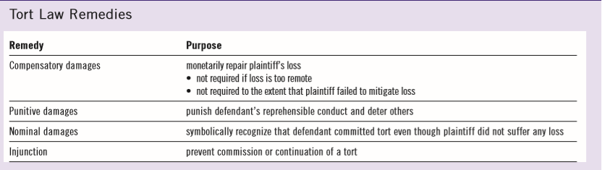

Business Torts (#2)- Chapter 4 and 5
Intentional Torts
- Intent to Act is low- body, liberty, property, chattel (my stuff)
- Reputation, privacy
- Economic and business interests (economic losses, contractual relations)
*intent to harm increases for each one
Assault
Occurs when the defendant intentionally causes the plaintiff to reasonably believe that offensive bodily contact is imminent
Elements of assault
- Belief- reasonable belief that contact will occur even if it doesn’t
- Imminent & offensive contact
Battery- Offensive bodily contact
Elements of Battery
- Contact- physical contact of person or object to defendant (including their clothing or if they’re holding something)
- Social interaction is not offensive contact
Chattels- moveable forms of property, i.e. horses, books and cars
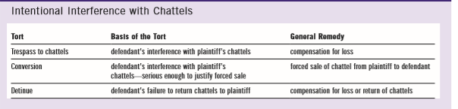
Deceit
Occurs when the defendant makes a false statement that the defendant knows is false/untrue and with which the defendant intends to mislead the plaintiff, and which causes the plaintiff to suffer a loss as a result of having reasonably relied on the false statement
Test to prove Deceit
Plaintiff must prove:
- Defendant made false statement
- Defendant knew statement was false (when they made it) or was reckless in determining truth
- Defendant intended to mislead the plaintiff
- Plaintiff suffered loss as a result of reasonably relying upon statements
Puffs- overexaggerating statements that lack facts
General approach of the law- if you’re buying something, make sure you ask questions instead of assuming things (“buyer beware”)
To avoid tort of deceit- be careful not to create the wrong perception
Case Example: Derry vs. Peek (1889)
- Would plaintiff be successful in suing for tort of deceit- no
- Legal Test/ App of facts
- made false statement- published statement that company had received authorization to use new tech
- knew statement was false- believed they would receive authorization
- intended to mislead plaintiff- didn’t know company would go bankrupt
- plaintiff suffered loss- invested in company and it went bankrupt
- Ratio: Defendant isn’t liable since they honestly believed company would obtain authorization; they were carless but didn’t have knowledge of statement not being true
Dave & RYE 245 Textbook example:
- He made false statement that student would be able to use text
- Dave knew his statement was false because he confirmed it with the prof
- He intended to mislead the plaintiff to make him buy the textbook
- Student suffered loss- waste of money
- Even if Dave didn’t know that the textbook couldn’t be used- can argue that he was reckless in determining the truth
Defamation
Test: defendant makes a false statement that could lead to a reasonable person to have a lower opinion of the plaintiff
Elements of Defamation
Plaintiff must prove:
- Statement reasonably refers to plaintiff
- Irrelevant that defendant didn’t intend reference
- Plaintiff must be a living person (can include corporation)
- Group statement must refer to plaintiff personally
- Statement could hurt plaintiff’s reputation
- Statement was published to third party
- Defenses (mainly “statement was not true”)
Defamation includes any communication (ex. Spoken, written, gestures, documents, and puppet show)
YYZ Bike Example- can be both defamation and deceit since they made false statement & lowered reputation of company

Risk Management
- Business faces special risk if trying to enhance own reputation by disparaging competitors
- Social media presents risks to employees
- Vicarious liability for employer’s defamation, and
- Directly as potential publisher of defamatory material
- Liable where?
Defences to Defamation
Includes
- Justification (i.e. the statement is true)
- Honest and reasonable belief in truth insufficient
- Privilege: encourages free speech
- Absolute privilege
- Qualified privilege
- Fair comment: encourages useful debate on significant issues
Defence: Absolute Privilege
- Complete immunity from liability
- No liability even if statement made in bad faith
- Limited to statements made:
- During parliamentary proceedings
- Between high government officials dealing with government business
- By a judge, lawyer, litigant or witness in legal proceedings
- Between spouses
Defence: Qualified Privilege
- Applies when legal, moral or social obligation to make a statement to someone with a similar duty or interest in receiving it
- Liability if statement made in bad faith or motivated by malicious purpose
- Important application of this defence arises under the label of “public interest responsible journalism”. Journalists may be protected by this defence if they publish a defamatory statement but otherwise acted in accordance with standards or responsible journalism in telling a story that the public has an interest in hearing
‘Public Interest responsible journalism”
Important application of qualified privilege defence arises under the label of “public interest responsible journalism”. Journalists may be protected by this defence if they publish a defamatory statement but otherwise acted in accordance with standards of responsible journalism in telling a story that the public has an interest in hearing
Defence: Fair Comment
- Expression of an opinion on a matter of public importance
- Opinion must be informed
- Opinion must relate to issue of public interest
- Defence applies as long as the opinion in question could honestly be held by some person- even if the defendant is prejudiced or opinionated
Remedies for Defamation
- Usually compensatory damages to repair losses and sometimes for personal distress
- Sometimes punitive damages for outrageous conduct
- Injunction to prevent defamation
- Rarely awarded due to concern for free speech
- Requires clear evidence that defamation is likely
Interference with Contractual Relations
Definition: a disruption of contract between plaintiff and another
Risk Management:
- Danger in luring away competitor’s customers
- Danger in luring away competitor’s workers
Forms of interference with contractual relations
- Direct inducement to breach of contract ex. Convince customer to break agreement, or employee to quit job (Ask: Did D encourage P to commit a breach of K)?
- Indirect inducement to breach of contract ex. Prevent employees from going to work, or steal worker’s tools to prevent performance
Direct Inducement
- Defendant convinces a customer to break the contract the customer has with the plaintiff
- Defendant convinces one of the plaintiff’s employees to breach the employment contract to work for the defendant
- Did the defendant actively encourage the breach?
Indirect Inducement
- Illegally prevent workers from going to work or steal a worker’s tools to prevent performance
- Note: if a company breaches a contract with a customer because the company’s unionized workers on a legal strike, the union is not liable to customer
Defences to Intentional Torts
Full Defences:
- Self-defence, defence of property
- Consent
- Necessity
- Legal Authority
Partial Defences
- Provocation
- Contributory negligence
Self-defence and Third-Party Defence
Definition: right to protect oneself from actual and threatened violence
Elements:
- Defence to torts of assault and battery
- Available only if person at immediate risk
- Limit on defence- cannot use more force than necessary in circumstances
Also allowed to defend third party
- Ex. Parent protecting child
Limits to Defence of Property
- Force used to respond to threat must be proportionate and reasonable
- Self-defence and defence of third party are broadly defined because they protect human life and well-being. There is more room for the use of force, even lethal force
- Defence of property less generous
- If only threat is to land and chattels, may never be reasonable to deliberately cause death or serious injury
Consent
- Plaintiff consented to interference with their body, property or land
- Consent must be voluntary and informed. It can be withdrawn or limited
- There is implied consent in limited cases ex. Implied consent to receive life-saving assistance unless evidence to the contrary (DNR orders)
Defence of Necessity
Definition: defendant’s actions are justified by an emergency
Elements:
- Immediate action must be required to avoid calamity
- Benefits flowing from conduct weighed against harm
- Ex. Doctor giving urgent medical care to unconscious patient
- Ex. Tearing down house to prevent spread of fire
Usually a complete defence but sometimes only a partial defence
Consider the American case
- Emergency caused by storm caused ship to moor to dock
- Damage caused by dock during storm
- Trespass was justified, however compensation required for damages
Legal Authority
- Provides person with lawful right to act in certain way

Partial Defences to Intentional Tort
- Allows court to reduce damage on basis of plaintiff’s own responsibility for injury
- Applies even though defendant committed an intentional tort
- Includes (among others)
- Provocation
- Contributory negligence
Provocation
Definition: words or actions that would cause a reasonable person to lose self-control
- Typically the defendant “snaps” after being taunted or insulted
- Tied to torts of assault and battery
- Defendant liable for attack, but plaintiff’s damages are reduced
Contributory Negligence
Definition: occurs when plaintiff partially responsible for injury defendant tortuously caused.
- Damages reduced to reflect plaintiff’s contribution to harm
- Elements of the defence differs through Canadian jurisdictions
- Some divide responsibility on basis of party’s fault
- Allows defence to apply to any tort, including intentional
- Some divine responsibility on basis on parties’ negligence- courts have found the defence difficult to apply to intentional torts as concept of negligence does not naturally fit intentional torts
- Last clear chance (US)
Nuisance (first negligence-type tort)
Definition: the way the defendant uses its land unreasonably interferes with the plaintiff’s reasonable use and enjoyment of the plaintiff’s own land
The Legal Test: whether the interference caused by the defendant is unreasonable or not
Factors to consider
- Type of nuisance
- Nature of the neighbourhood
- Time and day of the interference
- Intensity and duration
- Social utility of interference
- Defendant’s motivation
“But we were here first”: it doesn’t matter who was there first. What matters is what the neighbourhood is now like. Urban sprawl means that farmers may find that they become nuisances.
Defences:
Statutory Authority: but only if the defendant’s nuisance was an inevitable result of compliance with the statute
Remedies for Nuisance:
- Main remedies for nuisance are compensatory damages and injunctions. The damages will take care of past losses and the injunction will prevent future losses
- Injunctions, as an equitable remedy, do not have to be issued by the Court. Overall social good must be considered
Plain Language Ex. Petra’s apartment in downtown Toronto
- Petra won’t be able to sue for nuisance because it’s the nature of the neighbourhood and she should’ve been aware of that when moving into her new apartment.
Occupier’s Liability
- When the occupier of a premise is held liable for injuries that someone sustains on those premises
- Ontario has adopted legislation to codify occupier’s liability
- Occupier’s Liability Act (Ontario)
- Occupier is any person having possessions of or control over and responsibility for premises or activities for the same premises
- May have multiple “occupiers” for the same premises
- The term “premises” is broadly defined to include land, buildings, other structures, water, planes, trains, automobiles and other vehicles
General Duty and Modified Duty
- Occupier’s Duty of Care
- An occupier of premises owes a duty to take such care as in all the circumstances of the case is reasonable to see that persons entering on the premises, and the property brought on the premises by those persons are reasonably safe while on the premises
- Voluntary Assumption
- The occupier may defend any claim of liability on the basis of risks willingly assumed by persons entering the premises under the circumstances described in S.4, and provided there was no deliberate intent to harm or act with reckless disregard for the presence of the person
Who is deemed to accept the risk of being on premises?
- Trespassers are deemed to have assumed all risks (lowest level of care)
- People on the premises engaged in criminal acts are deemed to have assumed all risks (lowest level of care); and
- Those entering for recreational activity under certain circumstances are deemed to have assumed all risks
Occupier’s Liability
- Occupier of premises must prevent visitors from harm
- Statutory rules:
- Applies to both condition of premises and activities
- Occupier must use reasonable care towards every visitor
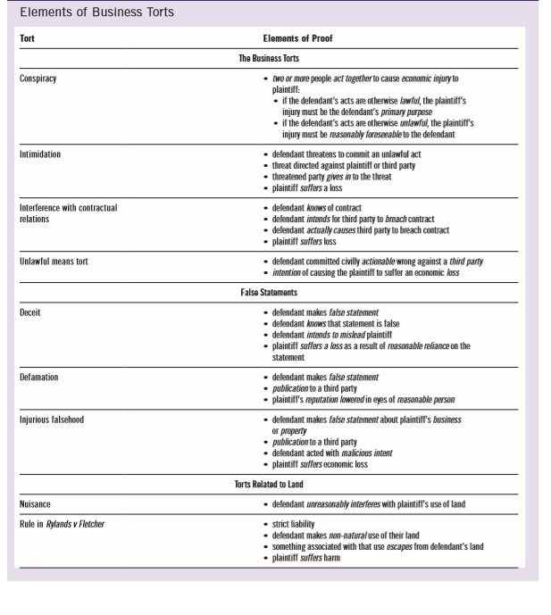
Poor Old MacDonald
- The local home owners should sue Old Mac for nuisance
- The home owners are likely to be successful because the nature of the neighbourhood has changed
- The court is likely to pose an injunction saying that Old Mac should get rid of the smells without necessarily closing his farm

Chapter 6 Negligence
Negligence
- The careless causing of harm- defendant carelessly causes the plaintiff to suffer a loss or injury
- Purpose: To compensate for harmful risky actions conducted carelessly but to allow for careful risk-taking
Elements of Negligence
- Duty of care
- Why should the defendant care (rational analysis)?
- Standard of care
- How should the defendant care (Analyze the act or omission)
- Causation
- Who should care (is there a connection between what the defendant has done, and the injury suffered by the plaintiff)
All three elements must be met to impose liability for the tort of negligence
Duty of Care Elements
- For there to be duty of care, there must be
- Reasonable foreseeability and
- Proximity- not only physical, can be due to your relationship with the person
- But even if there is a duty of care, a court might not enforce it due to
- Public Policy
Reasonable Foreseeability
- Objective test
- Would reasonable person have foreseen risk that harm would occur
- Slip and fall on icy sidewalk in front of store
- In Florida? - not foreseeable
- Not Subjective
- Opinion of either plaintiff or defendant does not matter
- Not perfect-average
Proximity
- Means close and direct
- Physical
- Contractor and tools
- Careless driver hits a bridge
- Social
- Parent and child
- Commercial
- Bar and drunk driver
- Manufacturer and consumer (donoguhe & ginger beer)
Ask, should there be a general duty for the relationship?
Pro Tip: Proximity and Precedent
If courts have already established in a previous case that a category of relationship is subject to a duty of care, then you can simply follow precedent and assume that yes, there will be a duty of care in future cases in the same category. Examples of well-established duties of care:
- Doctor-patient
- Lawyer-client
- Manufacturer of goods- user of goods
Public Policy
- What effect would a duty of care have on society and legal system
- Open the floodgates for litigation
- Stock market loss
- Interfere with political decisions
- Professional regulatory bodies
- Hurt a valuable type of relationship
- Mother and unborn child
Special Case: Duty of Care for Statements
Reasonable Foreseeability
- Communicated on a serious occasion
- Made in response to an inquiry
- Defendant was paid for the statement
- Statement of fact v. statement of opinion
- Disclaimer
Proximity
- Defendant knew that the plaintiff, either as an individual or as a member of a group might rely on the statement and
- The plaintiff relied on the statement for its intended purpose

Standard of Care
- Second element
- How defendant with duty must act
- Reasonable person test
- What would have a reasonable person in the position of the defendant have done
- Objective test
- Subjective conduct of defendant does not matter
- Average, not perfect
- So no hindsight application either
Ethical consideration: Who is this reasonable person
- The reasonable person plays a big role in the negligence law setting the standard for our behaviour. Whether or not a defendant is liable depends in part on whether or not the defendant acted like this reasonable person
- The reasonable person was once called “the reasonable man”. To what extent might this standard have been influenced by a group of power-holders in society? Who were those power-holders?
- Might this standard still represent what is reasonable for a certain group of people? Is it ethical to use this type of standard given the risk?
- Is it ethical to use an objective rather than a subjective standard. What are the ethical arguments in favour of an objective standard or a subjective standard?
The Reasonable Person Weights
- Severity of the harm (magnitude)
- Likelihood of its occurrence (probability)
V.s – cost of avoiding harm
Social Utility
- Permissible for someone with a higher duty of care for ex. Fireman rushing to get to a fire
Sudden Peril
- Emergency
Standard of Care for Professionals
- Professionals must act as a reasonable professional would under similar circumstances
- E.g. the reasonable doctor or the reasonable lawyer
- Standard is higher than a reasonable person in general
- Must act as a reasonable professional
- No allowance for inexperience
- No allowance for exaggerated credentials
- Standard may be higher still for specialist of expert
- Must act as a reasonable expert would act
Limit to Professional Standard
- Remember hindsight can’t be used; focus on info available to defendant at the time
- Medication side-effects
- DNA evidence
- Errors or judgement are different than carelessness
- Choice of medial procedure ex. Using surgical glue instead of staples
- Compliance with approval or statutory standard (careful, judges can reject as too low)
Standard of Care for Products
- Product Liability
- Harm caused by manufactured products
- Strict liability in the US
- Manufacturer liable for any defects
- Negligence in Canada
- Manufacturer liable only for careless defects in design
- Manufacturer usually strictly liable for manufacturing defects
Causation
- Third Element: who caused the harm
- The but-for test
- Would the plaintiff still have suffered harm ‘but for” the defendant
- What happens if you take the defendant out of the picture
- If nothing changes, plaintiff still suffers
- Defendant did NOT cause loss
- If plaintiff does not suffer then
- Defendant is cause of loss
- Defendant must be cause in fact and in law of the plaintiff’s injury
- Factual causation: the “But For” test
- Legal causation: remoteness
Factual Causation: But- For test
- Would the plaintiff still have suffered harm, but for the defendant
- If the defendant had not been careless, would the plaintiff still have suffered the same injury
Applying the But-For-Test
- What happens if we take the defendant out of the picture
- If nothing changes, i.e. the plaintiff still suffers the same injury, then the defendant didn’t cause the loss. It would have happened anyway
- But, if taking the defendant out of the picture changes the outcome, then the defendant is a cause of the plaintiff’s loss. The defendant’s carelessness played role in occurrence of loss.
But-For Example
- Evil law professor mixes rat poison into coffee of two other profs; some poison into one cup, a little more into other
- Both rushed to hospital, treated by same doctor in a CARELESS way—instead of pumping stomach, gives them a pill
- First prof dies
- Second prof dies
- Imagine if both rushed to hospital treated by same doctor in CARING way- doctor pumps stomach
- First prof now lives!
- Second prof still dies
- Did CARELESS doctor cause the death of the first prof
- Do but-for-test- remove defendant from situation- could’ve been saved by caring doctor
- YES
- Did CARELESS doctor cause death of second prof
- Do but-for-test- patient would’ve died even if properly treated
- NO
Proving Factual Causation
- Standard is a balance of probabilities
- More likely than not
- More than 50%
Proving Causation and Shared Liability
- More than one defendant
- Proof and share of blame not the same
- Each defendant- more likely than not threshold
- But can be responsible only for some of harm
- “Joint and several” liability
- Still legal for ALL of harm
- Careless doctor and careless nurse
- If doctor is richer than nurse, can go after them for full compensation; if doctor doesn’t like that, then he can sue nurse for their share
Remoteness
- RULE: no liability if loss was too remote
- TEST: was the type of harm suffered reasonably foreseeable (even if how it happened was not)
- Reasonable foreseeability of harm in specific case
- Unlike proximity which is about general relationships
- Foreseeability of harm that occurred in the end, not the chain of events that led to harm
- Boy burn by gas lamp case (Hughes v. Lord Advocate)
- Focus is on type of harm
Duty of Care- the scope of the people to whom you might be liable
Remoteness- the type of injury which you might be liable
Exceptions to Remoteness
- Thin skull- take defendant as they are
- Thin wallet-
- Intervening act
- A negligent act may occur where the damage is ongoing for ex. Break leg negligently, two weeks later falls down stairs, two weeks later hit by lightning in doctor’s parking life

Defences
- Contributory negligence
- Voluntary assumption of risk (volenti)
- Illegality- see book
Contributory Negligence
Definition
- Occurs when plaintiff partially responsible for injury that defendant tortuously caused: the plaintiff’s own carelessness was a cause or added to the injury he or she suffered
- Damages reduced to reflect plaintiff’s contribution to harm
Test:
- Apply the same tort analysis, focusing on the plaintiff’s actions
- Did the plaintiff breach the standard of care?
- Was the plaintiff’s carelessness a cause of the plaintiff’s loss
Impact on Liability
The plaintiff’s damages will be reduced to reflect the plaintiff’s own contribution to his/her injury
The judge will apportion liability i.e. will decide what percentage of the loss should fall on the plaintiff
Example: Plaintiff doesn’t wear seatbelt in car and is in a serious accident caused by defendant’s carelessness. The plaintiff’s injuries much more serious than they would’ve been if she was wearing seatbelt. Plaintiff sues for $1 million
Judge holds plaintiff contributorily negligent. The judge apportions the liability as follows: plaintiff 45% and defendant 55%
Maximum amount plaintiff can recover is 55% of $1 million.
Voluntary Assumption of Risk
Definition: Plaintiff freely accepted both physical and legal risk of injury (gave up right to sue)
Volenti is a complete defence: if the defendant can prove that the plaintiff freely accepted both the physical and legal risk of harm, then there is no liability
Because of the harsh result, i.e. the plaintiff recovers nothing, that courts have adopted a narrow approach
Establishing Volenti
- The plaintiff must clearly accept the physical risk ( I accept that I might be harmed) and the legal risk (I agree that I wont sue you as a result)
- To be valid, the defendant must have drawn the plaintiff’s attention to the exclusion clause or waiver
*at a minimum
Mitigation
Briefly: the plaintiff has a duty to mitigate, or take reasonable steps to minimize their damages
In other words, a tort isn’t a license to rack up a big bill
Need to take reasonable steps to mitigate
Example: D negligently forgot to file a document for P, Costs $X/day fine
Kauffman v TTC
- TTC owes a duty of care to their passengers
- If there was a rubber hand rail present, Kauffman would’ve still been injured regardless- wasn’t the cause of her injury
- If a security guard was present, the situation couldn’t have been stopped regardless
- Need to show that the injury is connected causally to the law
- Evidence doesn’t support Mrs. Kauffman’s arguments
- Court held that there wasn’t enough proof that the injuries could have been prevented by either a rubber hand rail or the presence of a security guard
- According to the but-for test, TTC was not cause of her injuries
Case Study Question 2: Brokaw vs. Hauser

