CITM500 Module 2
Simple Query Formation in SQL

Introduction
The Structured Query Language (SQL) is the de facto standard interface language for Relational Databases. It is extremely powerful allowing users to focus on specifying their requirements in a logical fashion without having to be concerned with the physical mapping of the data. There is a great deal of conformity between vendors and DBMS implementations on the core “standards” of SQL as defined by ANSI(SQL:1999). While all major Relational DBMS software implementations support SQL there may be differences in “dialects”. The interface chosen for the delivery of this course is Microsoft’s SQL Server DBMS. Where there are potentially significant differences to other major vendors the student will be advised.
SQL can be used to define the relational database environment itself – the Data Definition Language (DDL); to manipulate the data in the database – the Data Manipulation Language (DML); and to control security and integrity of the data - the Data Control Language (DCL).
In addition SQL commands can be executed in an interactive way through an end user interface (such as we will be employing in this course using SQL Server’s Management Studio) or embedded inside a host procedural programming language (such as Java). Most DBMS vendors also support their own SQL based procedural language (such as Microsoft’s Transact-SQL).
Fortunately you will be glad to learn that in this course we will be dealing only with the DML component of SQL and on a small but extremely subset on that feature. In fact most of our focus will be on one command – the SELECT command.
Here is the basic syntax for this command:
SELECT <list of column expressions>
FROM <list of tables and join operations>
WHERE <list of logical expressions for rows>
GROUP BY <list of grouping columns>
HAVING <list of logical expressions for groups>
ORDER BY < list of sorting expressions>
Note: An expression can be any combination of columns, constants, operators, and functions
Note:
To follow the examples and the ‘Your turn” exercises the student is recommended to have SQL Server’s Management Studio opened and the University database attached.

Simple Query Formation in SQL

Basic SQL Query
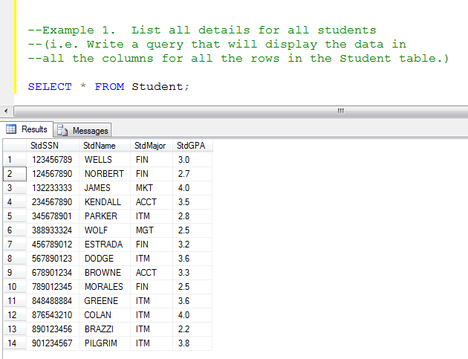
The ‘*” is a wild card. It results in the display of all the columns in the Student table. As there is no row filter clause, all the rows (students) in the table are displayed. Notice the “;” at the end of the command. This part of the standard of SQL and some DBMS’s will give an error message if it is not present. However Microsoft SQL Server is more forgiving and the queries will run without it.
Your Turn:
Write a query that will display the data in all the columns for all the rows in the Faculty table

Solution:

SELECT * FROM Faculty;

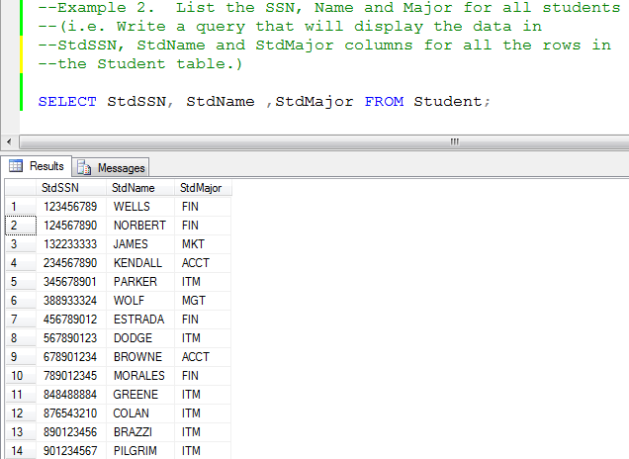

This query will output only the named columns from the Student table. It is a good idea when writing the queries to have the Database Diagram open in another window panel to ensure that the column names are correctly spelt. They will be output in the order in which they are written in the query.
Syntax errors are reported with an error message in red. Unfortunately as with most software the error message is only intelligible if you are already familiar with the language. Also it is just an approximation of what the syntax checker thinks is wrong and may not reflect the specific mistake. The best approach at this stage is always to look for differences between the given examples and your own attempts.
Your Turn:
Write a query that will display the data in the FacSSN, FacName and FacRank columns for all the rows in the Faculty table.

Solution:

SELECT FacSSN, FacName, FacRank FROM Faculty;

Row filtering using the “Where” Clause
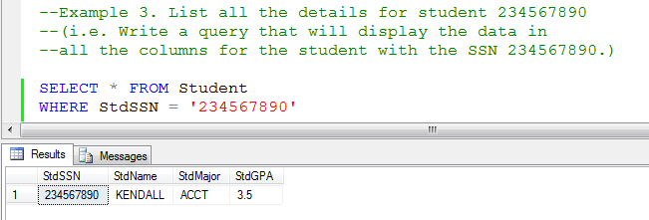
Here only rows that meet the specified condition in the “Where” clause will be displayed. The condition is looking for students where a specific SSN value. The hard coding of a value like this would not usually be used in an SQL statement embedded in a procedural program but would be in a variable whose value would be determined at program execution time but in a dynamic interactive query as above it is acceptable. The hard coded value supplied must match the data type of the column it is being compared to. Now again individual DBMS’s may vary on the strictness by which they enforce this rule but in these examples it will be followed. If you discover that SQL Server will let you ignore this rule in certain situations that is OK but remember that another DBMS may not (just like the semi-colon at the end of a command). Back to the example. As StdSSN is a “char” type field (that is to say can contain alpha-numeric data) its value should be contained in single quotes (Don’t use double quotes. That has a different effect which will be discussed later).
Notice also that we have written this SQL Command over 2 lines. As queries get longer and more complex it is a good idea to start to lay out the command over several lines for readability. This course will not try to impose a strict standard for doing this but rather will by example demonstrate a more casual “best practice” for keeping the code structured for readability and comprehension. Having to scroll over several times to read and/or debug a lengthy query that is written on a single line is difficult and annoying. SQL Server does not worry about the “white space” between parts of a command.
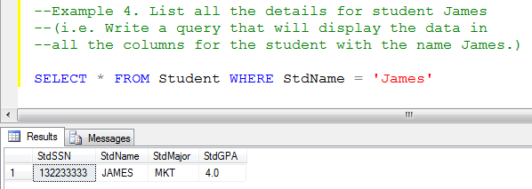
When considering alphabetic values SQL Server is not case sensitive. We could have written ‘james’ as well as ‘JaMeS’. SQL Server would still find a match. This is also true which respect to the command syntax itself as well. ‘Select’ will work as well as ‘SELECT’. It is just for a degree of readability and consistency that we have chosen the particular style as present in the examples.

Your Turn:
Write a query that will display the data in all the columns for the faculty with the name Mills

Solution:

SELECT * FROM Faculty
WHERE FacName = 'Mills'

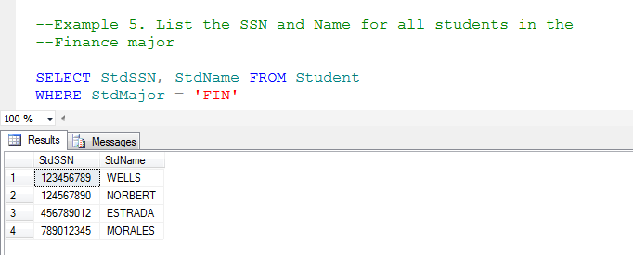
Your Turn:
List the SSN and Name for all faculty in the MS department

Solution:

SELECT FacSSN, FacName FROM Faculty
WHERE FacDept = 'MS'

Debugging
We have already talked about a syntax failure in a query when it an error message in red is returned. The query has executed but how do we know it the logic is correct. Notice a very important feature of Example 5. It was not necessary to output a column by including it in the Select list in order to use it in the Where clause. If we only look at the output how do we know if all the student rows retrieved met the requirement of being in the “FIN” major. Obviously with a simple query like this and with a little experience we could be reasonable sure but in a more complex query it will be less obvious. An initial approach would be to include the StdMajor column in the Select list as a debug statement.
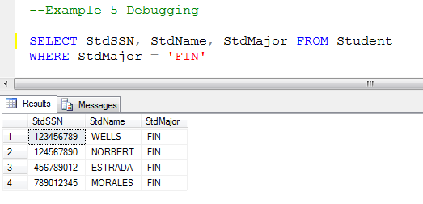
We can now see that all the student rows selected were in the required major. Once we have ascertained that the logic is in fact correct, the StdMajor should be removed from the final query because it was not requested. Although it may seem trivial it is very important that only the columns request be returned. When a query executes within a program, that program will fail to execute correctly if the wrong number of columns and even the wrong order of columns is returned by SQL.
However the debug steps we have taken is not the whole story. While we now know that only correct rows have been returned, we don’t know if we have retrieved ALL the correct rows. To fully ascertain this we need to look at what was NOT returned.
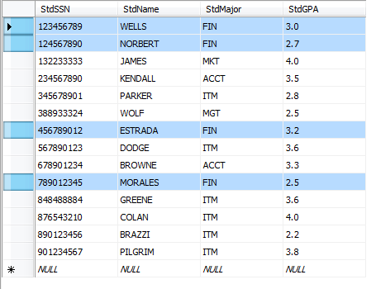
Now we can check that all students in the FIN major were in fact retrieved.

Relational Operators

So far we have only considered a test for equality. Below is a table listing other relational comparisons we can apply.

= | Equal To
< | Less Than
<= | Less Than or Equal To
> | Greater Than
>= | Greater Than or Equal To
<> or != | Not Equal To

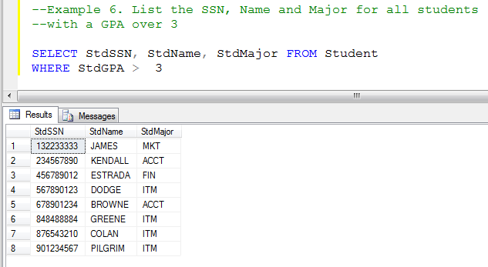
Your Turn:
List the details for all faculty with a salary over $75000.

Solution:

SELECT * FROM Faculty
WHERE FacSalary > 75000

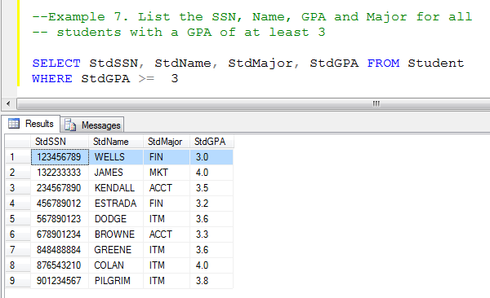
Your Turn:
List the SSN, Name, Salary and Department for all
faculty with a salary of at least $40000
Solution:

SELECT FacSSN, FacName, FacSalary, FacDept FROM Faculty
WHERE FacSalary >= 40000

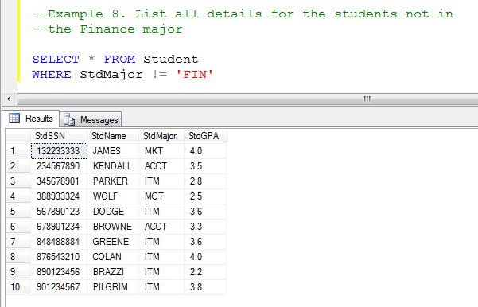
Your Turn:
List all details for the faculty not in the MS Department

Solution:
SELECT * FROM Faculty
WHERE FacDept <> 'MS'

Logical Operators
It is now time to consider some more complex conditions using the Where clause. These are known as Compound conditions because several conditions are combined using AND, OR and NOT logical operators.
Below are a series of tables illustrating the possible combinations of conditions and resultant outcomes for the Logical Operators.
Logical Operators:
“AND” Operator:
Condition 1 Condition 2 Result
TRUE | TRUE | TRUE
TRUE | FALSE | FALSE
FALSE | TRUE | FALSE
FALSE | FALSE | FALSE

“OR” Operator:
Condition 1 Condition 2 Result
TRUE | TRUE | TRUE
TRUE | FALSE | TRUE
FALSE | TRUE | TRUE
FALSE | FALSE | FALSE

“NOT” Operator:
Condition Result
TRUE | FALSE
FALSE | TRUE

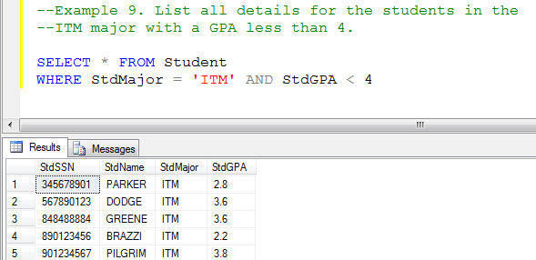

As this is an AND operation both conditions must be True for the combined outcome to be True and for the student row to be selected.
Your Turn:
List all details for the faculty in the
MS department with a salary over $40000
Solution:

SELECT * FROM Faculty
WHERE FacDept = 'MS' AND FacSalary > 40000

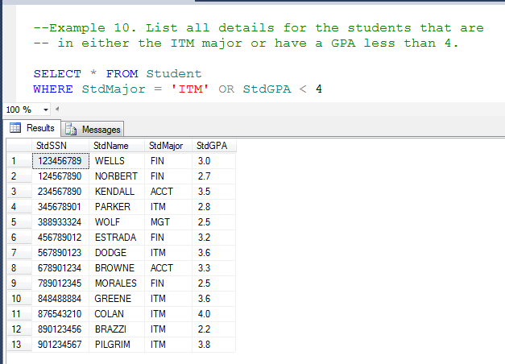
As this is an OR operation only one of the two conditions must be True for the combined outcome to be True and for the student row to be selected.
Your Turn:
List all details for the faculty who are either in the
FIN department or have a salary over $40000

Solution:

SELECT * FROM Faculty
WHERE FacDept = 'FIN' OR FacSalary > 40000

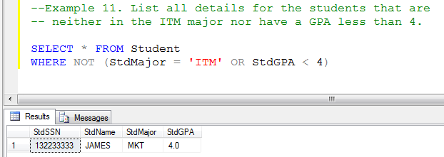

Here we using the NOT operator. It enables us to formualate a condition in the positive and then reverse it. Notice how the OR condition is enclosed in brackets so that the NOT will be applied to the whole expression. Without the brackets only the first condition would be reversed. This is due to the default precedence of operation priority for the operators if the appear in combination in an expression. The default precedence is NOT before AND before OR regardless of the sequence in which they appear in the expression. Brackets override this deafult precedence.

In order to construct a query to satisfy this situation without using the NOT we would have to recast it which is more difficult

--or

SELECT * FROM Student
WHERE StdMajor <> 'ITM' AND StdGPA >= 4

Your Turn:
List all details for the faculty who are neither in the
FIN department nor have a salary over $40000
Solution:

SELECT * FROM Faculty
WHERE NOT (FacDept = 'FIN' OR Facsalary > 40000)

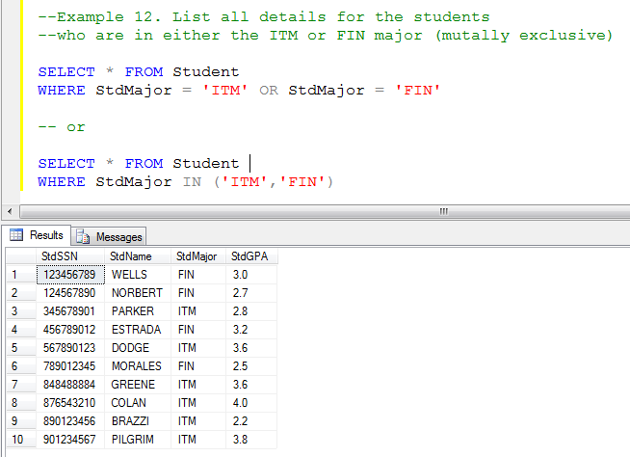
This is another example of an OR condition but here instead of testing 2 different columns, we are testing a single column for 2 different values. This is known as a mutally exclusive OR as only 1 condition can possibly be True. (Any one student can only have a single value for their major. Try running this query with an AND and you will get no output at all). This type of mutually exclusive condition allows us to use a different syntax – the IN condition with a list of acceptable values inside the brackets. As we now progress in our knowledge of SQL we will discover that there will be many different ways to construct a query to secure a desired result. As this course is concerned with the functionality of a query and not its efficiency or performance characteristics, no one solution will be evaluated as “better” than any other. In other words if the query is logically sound and will execute correctly in all circumstances it will be deemed to be correct. However with respect to the 2 solutions below, it is advisable to become familiar with the IN structure as it is simpler to use in other scenarios and becomes especially relevant later in the course when considering NESTED queries.

Your Turn:
List all details for the faculty who are in either the ASST or ASSC rank

Solution:

SELECT * FROM Faculty
WHERE FacRank IN ('ASST','ASSC')

Or

SELECT * FROM Faculty
WHERE FacRank = 'ASST' OR FacRank = 'ASSC'

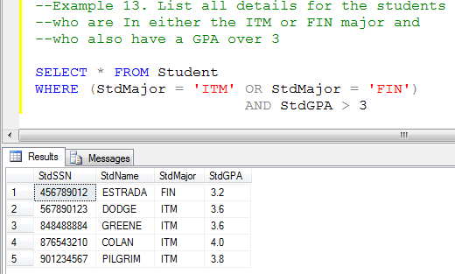

Here we need to combine different logical operators in a compound condition. Firstly it is important to understand the intent of the question. Is the question asking us i) to output all the students in the ITM major and additionally any students in the FIN major whose gpa is over 3 or ii) should the query output students with a gpa over 3 providing they are in either the ITM or FIN major. Here the question would clearly be requesting ii), the latter. Notice that the OR condition is in brackets because we want to the OR to be considered first and without the brackets the AND (based on the default precedence) would be evaluated first. Try running without the brackets and see that the results are not what was intended – we would be meeting the requirements of i) above and not ii).
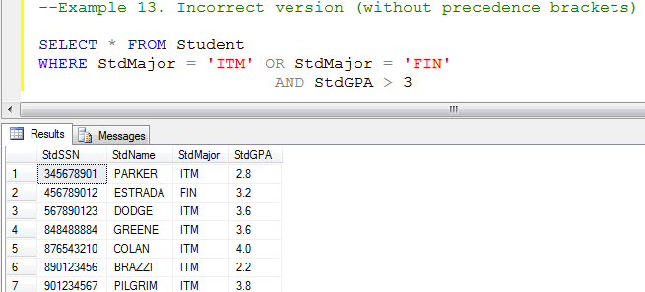
Your Turn:
List all details for the faculty who are in either in the ASST or ASSC rank and who also have a salary over $50000

Solution:

SELECT * FROM Faculty
WHERE (FacRank = 'ASST' OR FacRank = 'ASSC')
AND FacSalary > 50000

Or

SELECT * FROM Faculty
WHERE FacRank IN ('ASST', 'ASSC')
AND FacSalary > 50000

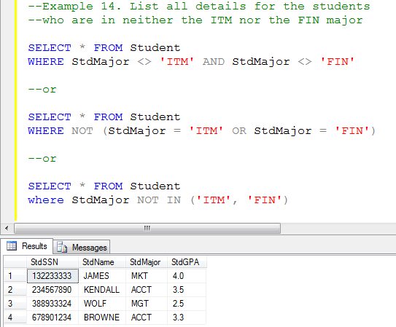
Constructing negative conditions, especially where for compound conditions involving AND and OR operators can be tricky. As the example above illustrates, while all are correct the use of the logical NOT can be a simpler solution. A very common mistake made with the first solution is mistakenly to use an OR instead of AND. Try it and you will retrieve everyone regardless of their major.
Your Turn:
List all details for the faculty who are in neither the ASST nor ASSC rank (Note: Don’t try and reverse the negative and then merely test for the rank of PROF. This would be an unsound approach that could potentially give erroneous results)

Solution:

SELECT * FROM Faculty
WHERE FacRank NOT IN ('ASST', 'ASSC')

Note: We are reaching a stage where there are several possible ways to structure a correct solution. Unless it is a new concept only one solution will be presented. If your solution is different then compare your results with those of the given solution.

Ranges
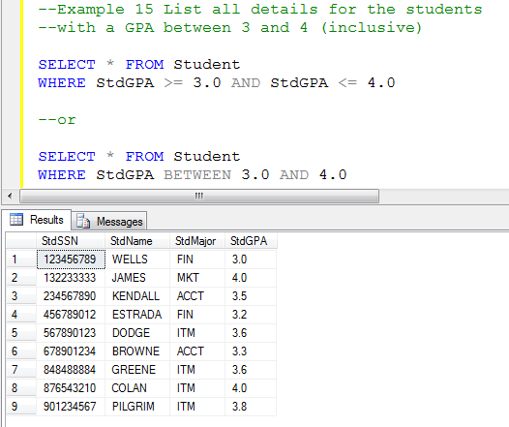
Specifying ranges can be done using a compound condition. If the key word ‘Between” is used this should always in an SQL context be considered as inclusive. There is even an keyword operator “BETWEEN” that can be applied in place of the compound condition. Be aware that users will often express their requirements in a more “relaxed” style.
e.g. “List all students with a GPA of at least 3 but no more than 4” is the same as the example above.
Your Turn:
List all details for the faculty with a salary between $65000 and $120000

Solution:

SELECT * FROM Faculty
WHERE FacSalary BETWEEN 65000 and 120000

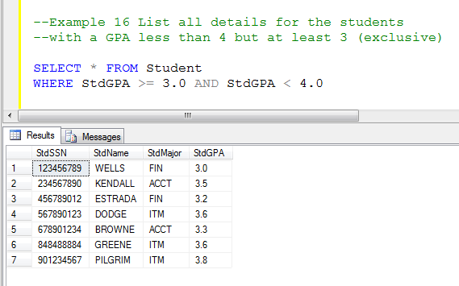
However ranges are not always inclusive. Always construct the condition as stated. Don’t try and restate it to make it inclusive e.g. as Between 3 and 3.9. Depending on whether the unit of measure is an integer or a decimal this approach can be problematic. In this situation a student with a GPA of 3.95 would be erroneously excluded from the results.
Your Turn:
List all details for the faculty with a salary more than $65000 but at least $120000

Solution:

SELECT * FROM Faculty
WHERE FacSalary > 65000 and FacSalary <= 120000

Sequencing the Results
Depending on the DBMS being employed, the rows of output from a single table query, will appear in a default logical sequence. In SQL Server it is based on the value of the primary key. If you look at the output from Example 1 above you will see that the rows are presented an order based on the value of StdSSN which is the primary key for the Student table. If we want the output to be in a different sequence we must use the ORDER BY phrase in the SQL Command.
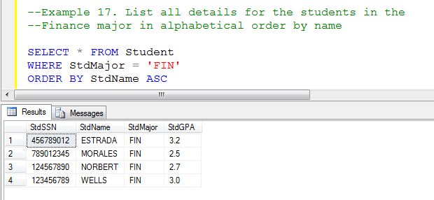
Don’t be thrown by the term “alphabetical”. As alpha-numeric (Char and VarChar data types) as store an internal binary code, that code can be translated internally into a binary numeric value. The code has been assigned in such a way that the equivalent binary value for an “a” is lower than the equivalent binary value for a “b”. It can be a bit more complicated than that in some implementations as Upper and Lower case characters have different values but fortunately SQL Server is not case sensitive. The key word ASC means ascending sequence (i.e. low to high values – alphabetically). It can optionally be omitted as it is assumed as the default.
Your Turn:
List all details for the faculty in the MS department in alphabetical order by name

Solution:

SELECT * FROM Faculty
WHERE FacDept = 'MS'
ORDER BY FacName

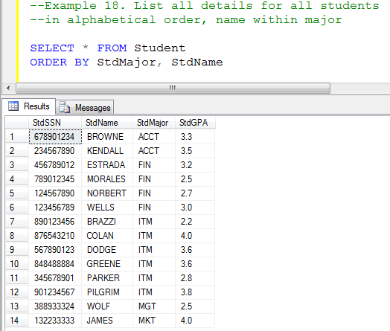

Sometimes the sequencing of the output depends on more than one column.The requirement as expressed in common language rather than in formal computerese may be something like the above. This is the terminology style I will use. So sequencing columnB WITHIN columnA , means columnA is the major determinate of the sequence and columnB will only be used where there are ‘ties’ for columnA values. So in the above the value of StdMajor is the major determinate of sequencing and where there are duplicate values for the StdMajor, the affected rows are then further ordered by the StdName – thus Stdname WITHIN Stdmajor
Your Turn:
List all details for all faculty in the alphabetical order by name within department.

Solution:

SELECT * FROM Faculty
ORDER BY FacDept,FacName

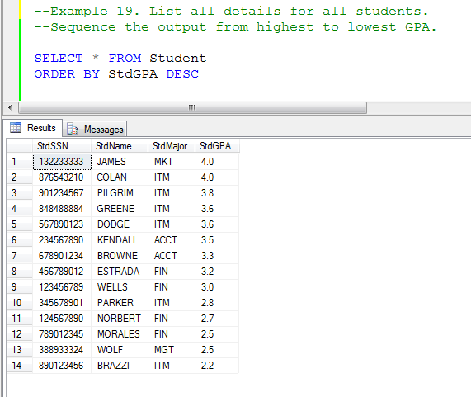
The sequencing column can also be a numeric type field. In such cases we may want to sequence from the highest value to the lowest value. The key word here is DESC. This key word can also be used with an alpha type column but not usually.
Your Turn:
List all details for all faculty. Sequence the output from lowest to highest salary.

Solution:

SELECT * FROM Faculty
ORDER BY FacSalary DESC

