Chapter 5-Interorganizational Relationships

Organizational Ecosystems
- Interorganizational relationships: the relatively enduring resource transactions, flows, and linkages that occur among two or more organizations
- Organizational ecosystems: a system formed by the interaction of a community of organizations and their environment
- Is competition dead
  - Traditional competition which assumes a distinct company competing for survival and supremacy with other stand-alone businesses, no longer exists because each organization both supports and depends on the others for success
  - Organizations now need to coevolve with others in the ecosystem so that everyone gets stronger
  - Companies today may use their strengths to win conflicts and negotiations but ultimately cooperation carries the day
- The changing role of management
  - Managers learn to move beyond traditional responsibilities of corporate strategy and designing hierarchical structures and control systems
  - The company loses opportunities for new and evolving external relationships if a top manager looks down to enforce order and uniformity
  - Managers should think about horizontal processes rather than vertical structures
  - Horizontal structures now include linkages with suppliers and customers who become apart of a team
- Interorganizational framework
  - Relationships among organizations can be characterized by whether the organizations are dissimilar or similar and whether relationships are competitive or cooperative
  - By understanding theses perspectives managers can assess their environment and adopt strategies to suit their needs
  - The first perspective is called resource dependent theory
    - Describes the rational ways organizations deal with each other to reduce dependence on the environment
  - The second perspective is about collaborative networks
    - Organizations allow themselves to become depend on other organizations to increase value and productivity for both
  - The third perspective is population ecology
    - Examines how new organizations fill niches left open by established organizations and how a rich variety of new organizational forms benefits society
  - The final approach is called institutionalism
  - Explains why and how organizations legitimate themselves in the larger environment and design structures by borrowing ideas form each other
  - 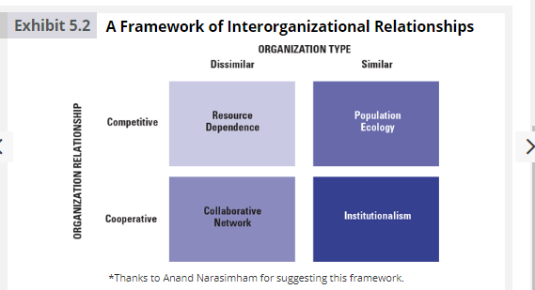

Resource Dependence
- Represents the traditional view of relationships among organizations
- Argues that organizations tr to minimize their dependence on other organizations for the supply of important resources and try to influence the environment to make resources available
- The amount of dependence on a resource is based on two factors
  - First Is the importance of the resource to the org
  - Second is how much discretion or monopoly power those who control a resource have over its allocation and use
- Resource strategies
  - When organizations feel resource or supply constraints, the resource dependence perspective says they maneuver to maintain their autonomy through a variety of strategies
    - One strategy is to adapt to or alter the interdependence relationships
    - Another technique is to use interlocking directorship (e.g board of directors- how some members are on multiple boards of different comapnies)
      - THIS IS ACTUALLY RESOURCE DEPENDENCE THEORY
- Power strategies
  - In resource dependence theory, large, independent companies have power over small suppliers
  - When one company has power over another, it can ask suppliers to absorb more of the costs, ship more efficiently and provide more services than ever before, often without a price increase

Collaborative Networks
- Traditionally the relationship between organizations and their suppliers has been an adversarial one. Today however thanks to uncertain global environment a realignment in corporate relationships is taking place.
- The collaborative-network perspective is an emerging alternative to resource dependent theory. Companies join together to become more competitive and to share scarce resources
- Why collaboration
  - Sharing risks when entering new markets
  - Mounting expensive new programs and reducing costs
  - Enhancing organizational profile in selected industries or technologies
  - Cooperation is a prerequisite for greater innovation, problem solving and performance
- From Adversaries to Partners
  - More companies are changing from a traditional adversarial mind set to a partnership orientation
  - Rather than organizations maintain independence the new model is based on interdependence and trust
  - Maintaining strategic relationships with other firms has become a critical management skill
  - In this new orientation people try to add value to both sides and believe in high commitment
  - 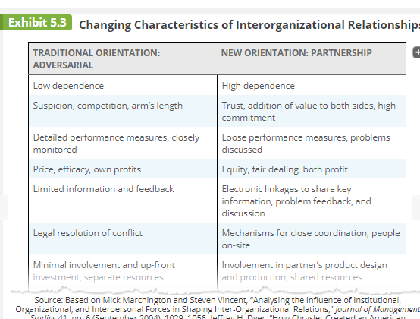

Population Ecology
- The population ecology perspective differs from the other perspectives because it focuses on organization diversity and adaption within a population of organizations
- A population is a set of organizations engaged in similar activities with similar patterns of resources utilisation and outcomes
- New organizations meet the new needs of society more than established organizations that are slow to change
  - The limitations come from heavy investment in plants, equipment and specialized personal, limited info, established viewpoints of decisionmakers
- According to the population-ecology view, when looking at an organizational population as a whole, the changing environment determines which organizations survive or fail. The assumption s that individual organizations suffer from structural inertia and find it difficult to adapt to environmental changes
- Organizational form and Niche
  - The population ecology model is concerned with organizational form. Organizational form is an organizations specific technology, structure, products, goals, and personnel, which can be selected or rejected b the environment
  - Each organization tries to find a niche sufficient to support it. The nice is usually small in the early stages of an org but may increase in size over time if org is successful
- Process of ecological change
  - 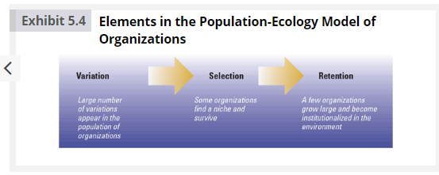
  - The process of change in the population is defined by three principles that occur in stages: variation, selection, and retention
- Strategies for survival
  - Another principle that underlies the population-ecology model is the struggle for existence or competition
  - The struggle is most intense among new organizations and both the birth and survival frequencies of new organizations are related to factors in the larger environment
  - Organizations with a wide niche that offer a broad range of products or services are generalists
  - Organizations that provide a narrow range of goods and services are specialists

Institutionalism
- This perspective describes how organizations survive and succeed through congruence between an organization and the expectations from its environment
- The institutional environment is composed of norms, and values from its stakeholders
- The institutional environment reflects what the greater society views as correct ways of organization and behaving
- Legitimacy is defined as the general perspective that an organizations actions are desirable, proper, and appropriate within the environments system of norms, values, and beliefs
- The institutional view and organizational design
  - The institutional view also sees organizations as having two essential dimensions – technical and institutional
  - The technical dimension is the day to day work, technology and operating requirements. Governed by norms of rationality and efficiency
  - The institutional structure is that part of the organization most visible to the outside public. Governed by expectations from external environment
- Institutional similarity
  - Organizations have a strong need to appear legitimate
  - Institutional similarity is the emergence of a common structure and approach among organizations in the same field
  - Occurs though three core mechanisms
    - Mimetic forces
      - Pressure to copy or model other organizations when in times of uncertainty
    - Coercive forces
      - External pressures exerted on an organization to adopt structures, techniques, or behaviours similar to other organizations
    - Normative forces
      - Pressures to change to achieve standards of professionalism, and to adopt techniques that are considered by the professional community to be up to date and effective
Transaction Cost Theory
- Another way to analyze inter organizational relations and behaviour
- Transaction- a exchange of something of value for other things of value
  - Selling
  - Buying
  - Collaborating
  - Group decision making
- Cost of transaction
  - What does it cost to do a transaction
  - High maintenance relationship
  - Measured by
    - Time spent
    - Money
    - Frustration
    - Acrimony – legal
  - Transaction costs increase due to:
    - Nature of people
      - Cheating
      - Distrusting
      - Forgetting
      - Bounded rationality

In Class Problems:

Exercise 14:
- Pretend you are a manager responsible for providing input on potential strategic alliances
- 3 potential partners
- Alpha
  - Long history dealing with firm
  - Quick to respond to inquiries
  - Goes above and beyond to meet our firms needs
  - Interested in maintain strong relationship
  - However alphas products are sometimes poorly designed and other managers have problems with them

- Beta
  - Partnered with firm for several years
  - Goes beyond contractual obligations to meet needs
  - Technical services require they be up to date
  - Keeps knowledge current by sending employees to tech conferences
  - Has been loyal, blocked info from getting to board of directors that could make management look bad
  - Shared competitive and technical info about competitors while working with them
    - This seems kinda sketch, theyre probably doing same with competitors about our company

- Omega
  - Technical know how, widely regarded as state of the art
  - Fair and honest
  - Quality of work is good
  - Partmerd with firm for number of years
  - Has always fulfilled contractual agreements but will not go beyond (but does for other firms)
  - Unable tod envelope close relationship with omega in past despite omega having close with a number of other firms

Mini case: Apple Pg 204:
- Steve jobs and bill gates teamed up to keep macs and Microsoft office products compatible
- Apple is now the leader in electronics and other companies are feeling pressure to strike deal with them
- Strategy: focus on making the best product, and rewards will follow
- Apple focuses on attracting the best partners rather than the most
- Compatibility factor
  - For the partners who make the cut, apply enforced a brutal perfectionism
- N Unreasonable
  - Working with apply can be exhausting
  - On a need to know basis
  - Its as though your entire reason for being is to serve them

