ECO 101 L3 Notes

p.2

[1]
Yes(my ans)

[2]
No(my ans)

To travel downtown to buy textbook or computer

If MB>MC, travel downtown

If MB<MC, do not travel

What is MB? What is MC?

MB = $30

MC = opportunity cos t (unique to each student) to travel downtown

(Example: if student has TTC pass, so transit is free, then MC= opportunity cost of time to travel downtown and back)

Rational decision making

MB=$30

If MC [opportunity cost] < $30, buy both downtown

If MC>$30, buy both at UofT bookstore

In fact, some would travel downtown to save $30 on the book, but not to save $30 on the computer. This is NOT rational.

p.4

Predictions of economic analysis (rational decision-making) ARE usually accurate

p.5
The Economic Way of Thinking: Insights

- Opportunity Cost
- Thinking at the margin (compare MB with MC)

The Gains (Benefits) of Trade: Insights

- Mutual benefits: individuals/countries

- Key: Comparative Advantage (not Absolute Advantage)

p.7-8

Economy produces two goods: gumdrops and chocolates

To produce more gumdrops, must produce fewer chocolates
To produce more chocolates, must produce fewer gumdrops

FOCUS: Opportunity cost of producing gumdrops or chocolates

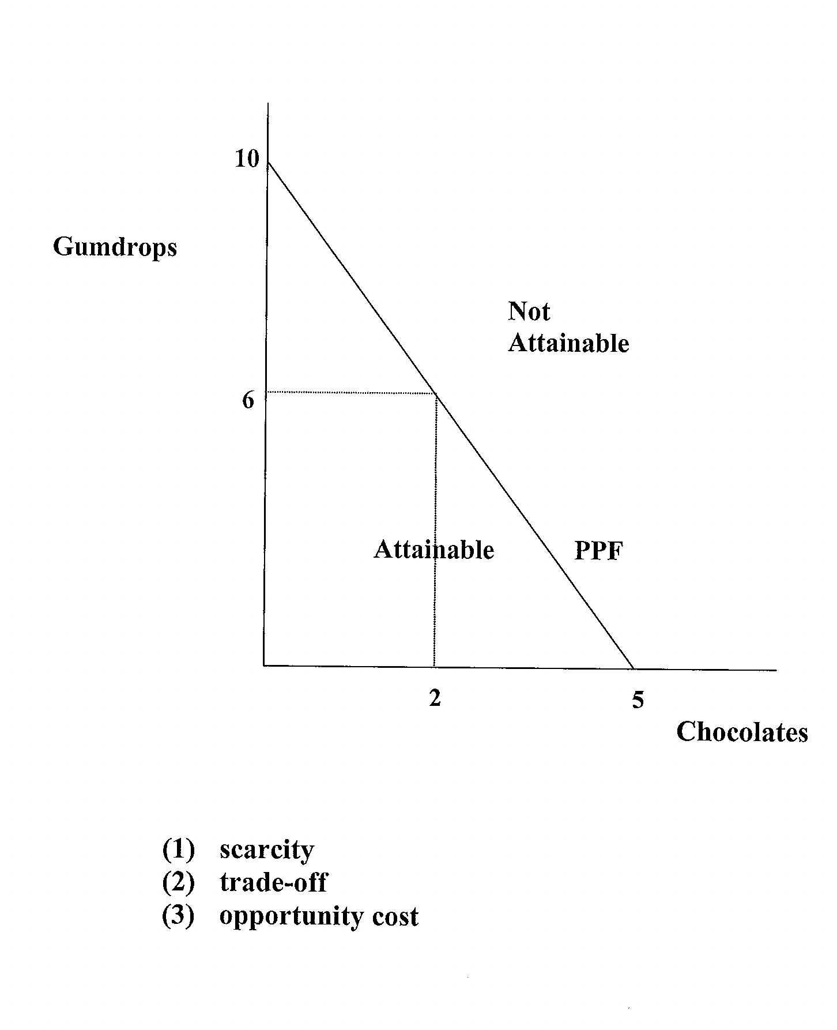PPF

To the right: combinations of gumdrops and chocolates which are unattainable

p.9

Switch from ALL gumdrops to ALL chocolates

Opportunity cost of one Chocolate = 10/5 = 2 gumdrops

Switch from ALL Chocolates to ALL Gumdrops

Opportunity cost of one Gumdrop = 5/10 = 0.5 Chocolate

p.11

Important Insight:

Comparative advantage is the key to the gains from trade, both between countries and between individuals

p.12-15

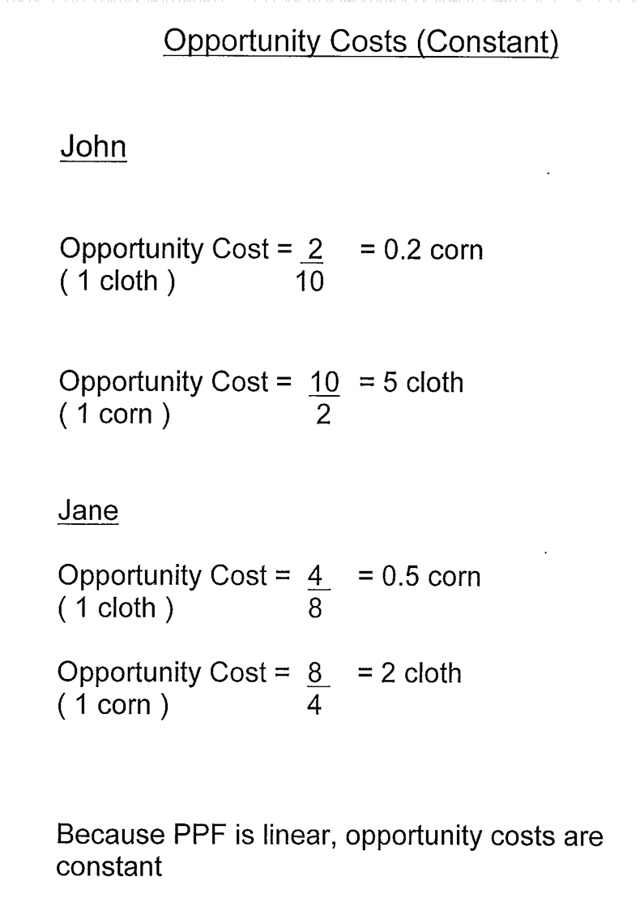
John gives up 0.2 corn for 1 cloth

John gives up 5 cloth for 1 corn

Jane gives up 0.5 corn to 1 cloth

Jane gives up 2 cloth to 1 corn

Identify the OC implied into the PPF separately by John and Jane

p.19
Jane has absolute advantage in the production of BOTH cloth and corn (Jane is more efficient in the production of BOTH cloth and corn)

p.20

BOTH statements are FALSE

[1] John and Jane can both benefit from trade

[2]

