ITM301 Midterm Review

Session 2 – Network Infrastructure
Components of Structured Cabling
- TIA- Telecommunication Industry Association
- EIA- Electronic Industry Alliance
These are known as structured cabling and address commercial building cabling for telecommunications products and services.

From Demarc to a Workstation
- Entrance facility—Incoming network (such as Internet) connects with the school or corporate network
- Demarc (demarcation point)—Device that marks where a telecommunications service provider’s network ends and the organization’s network begins
- MDF (main distribution frame/facility)—Centralized point of interconnection for an organization’s LAN or WAN (also called M C or main cross connect)
- Data room—Enclosed space that hold network equipment (also called data closet, data center, equipment room, or telecommunications room)
- Racks—Holds various network equipment (looks like cabinet)
- Patch panel—Panel of data receptors that can be mounted to a wall or a rack
  - Provides central termination point when many patch cables converge in a single location
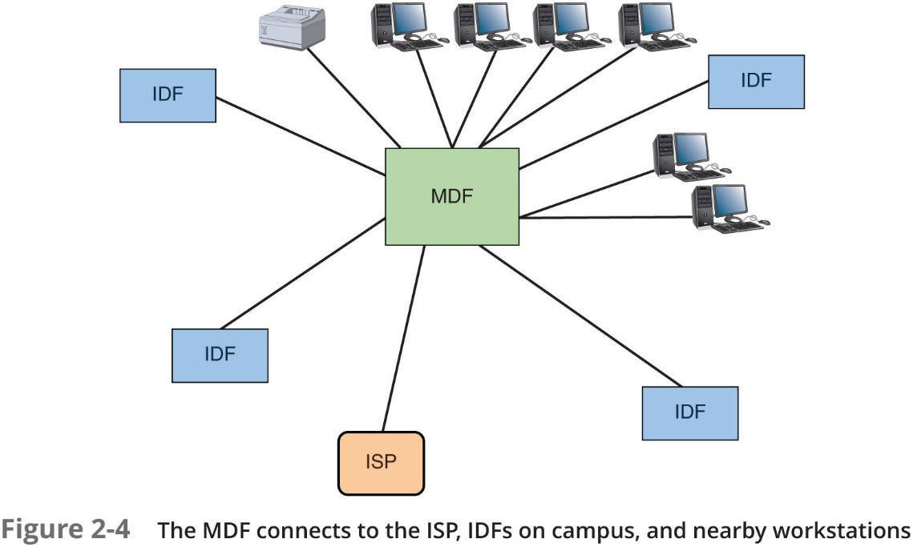

- Voice over Internet Protocol (VoIP)is the use of any network to carry voice signals using transmission control protocols (TCP) and Internet Protocols (IP)
  - VoIP gateway
  - VoIP PBX
  - VoIP endpoints
- IDF (intermediate distribution frame)- Provides an intermediate connection between the MDF (main distribution frame) and end-user equipment on each floor and in each building
- Work area- Includes workspaces, printers, and other network devices
- Wall jacks- TIA/EIA standard calls that each wall jack must contain at least one voice (small cable plug) and one data outlet (bigger cable plug)
Types of Cables:
Patch cable—A relatively short length of cabling with connectors at both ends, used to setup communication between two different types of device. Such as switch to PC communication.
Cross-over cable - A relatively short length of cabling with connectors at both ends, used to setup communication between two same types of device. Such as pc to pc communication
Horizontal cabling—Connects workstations to the closest data room and to switches housed in the room
Backbone cabling—Consists of cables or wireless links that provide interconnection between the entrance facility and MDF and between MDF and IDFs

Network Diagrams
Network Diagrams- Graphical representation of a network’s devices and connections
They could show the layout, the logical topology, Ip address reserves, names of major network devices, and the different types of transmission data

Network mapping- Process of discovering and identifying the devices on a network

Cisco Systems set the standard for diagram symbols used to represent network devices (the symbols used in network diagrams)

Network diagrams show small snapshots of a networks physical or logical topology and are useful for planning where to insert new things (switches) or seeing how a particular router, gateway or firewall interact.

Wiring schematic—A graphical representation of a network’s wired infrastructure
In detailed form, it shows every wire necessary to interconnect network devices
Rack diagram—Drawing that show devices stacked in a rack system

Week 3- Addressing on Networks
Addressing Overview
- Data Link layer MAC address
  - 48 bits, written as 6 hex numbers separated by colons
  - Could also be called physical address
- Network layer IP address
-I P v 4 addresses have 32 bits and are written as four decimal numbers called octets
-I P v 6 addresses have 128 bits and are written as eight blocks of hexadecimal number
- Transport layer port numbers: it is a 16-bit number
- Application layer F Q D Ns, computer names, and host names
-Fully qualified domain name (F Q D N)—A unique character-based name
MAC Addresses
- Traditional MAC addresses contain two parts:
  - The first 24 bits are known as the Organizationally Unique Identifier (OUI) or manufacturer-ID
- The last 24 bits make up the extension identifier or device ID
1st 24 are for manufacturer ID and the last 24 are for device ID

IP Addresses
- Static IP addresses are manually assigned by network
- Dynamic IP addresses are assigned by DHCP (Dynamic Host Configuration protocol)

- Gateway—Device that nodes use for access to the outside world
- Subnet mask—Used to indicate what portion of an I P address is the network portion (network I D) and what part is the host portion (host I D)
- DNS server— Serve responsible for tracking computer names and their I P addresses
Using ipconfig in the command prompt to find TCP/IP settings and the two types of addresses you can get are IPv4 (32) and IPv6 (128)
IPv4 Addresses
- Has 32 bits, that are put into bits of 8 bits each
- 8 bits are called octets
- Each of the four can be any # from 0-255
- Some IP addresses are reserved
Example: 72.56.105.12
- IPv4 are divided into 5 classes, A through E
- A (0), B (10), & C (100) are all IP addresses available on the internet, D & E are not available for general use but for things like research and multicasting
- There are other addresses that are private networks
- •Network Address Translation (N A T)—A technique designed to conserve public I P addresses needed by a network
- •Address translation—Process where a gateway device substitutes the private I P addresses with its own public address
- •When these computers need access to other networks or Internet
- •Port Address Translation (P A T)—Process of assigning a TCP port number to each ongoing session between a local host and Internet host
There are 2 types of NAT, SNAT and DNAT
SNAT is the static version of the translation that assigns the same public IP address every time a request is made to access the internet
DNAT is the dynamic version where there is a public pool that is free to assign any random address when requested to access internet

IPv6 Addresses
Each block of one of these addresses is written in 16 bits, with four characters in each
If a block contains all zeros you can replace the block with double colons (::) but can only be used once
Example: 2001:0000:0B80:0000:0000:00D3:9C5A:00CC turns into…
2001::B80:0000:0000:D3:9C5A:CC

Types of IPv6 addresses are…
Unicast address- Specifies a single node on a network, 1 node to another
Broadcast address- Packets is delivered to all nodes
Multicast address- Packets are delivered to selected nodes
Anycast address- identifies multiple destinations and has packets delivered to the closest destination

Port numbers—Ensure data is transmitted to the correct process among multiple processes running on the computer

Socket- Has the IP address and a port number, separated by a colon

3 types of port numbers…
Well-known ports – 0-1023
Registered ports- 1024-49151
Dynamic/public ports- 49152-65535

FQDN- Fully qualified domain is the complete domain name
ICANN shows what can be associated with .edu, .gov, etc
Top Level Domains include COM- commercial
GOV- government
NET- Network
Name Servers
- Primary DNS server- the authorities name for an organization
- Secondary DNS server- Backup name server
- Caching DNS server- accesses the public DNS data and stores the info
- Forwarding DNS server- Receives queries from clients but doesn’t resolve them
DNS name servers are organized in a hierarchical structure with TLD servers first and then Authoritative servers branching from each TLD
Example. .com would be the TLD server and then google and amazon would branch out from it.

Week 3- Part B
Network Protocols and Routing

TCP uses a three-way handshake to create a connection. The three-step process includes requesting for the connection, responding to the request and then the connection is established. After the 3 steps, the data is sent. (from computer A-B)

UDP (User Datagram Protocol)
No three-way handshake is required for this protocol and it doesn’t guarantee the delivery of data. This protocol would only be useful for things like live audio or video transmissions over the internet. There is no flow control, or error checking.

IP (Internet Protocol)
This is where data should be delivered and where the IP addresses are. It is unreliable and connectionless. Relies on TCP to make sure that messages are put back together in the right order and makes sure each message is received on the other hosts end.

ICMP (Internet Control Message Protocol)
Shows the errors or successes that arise within the delivery of data. Indicates there the network is congested and where it fails to reach the destination. However, it doesn’t not correct the errors that it detects.

ARP (Address Resolution Protocol)
Used to find the MAC address on a local network and relies on broadcasting (which has packets going to all nodes)

Routers
Joins two or more networks together and passes packets from each. They can connect LAN’s to WAN’s. determine the best paths from data to flow and can reroute traffic if the first-choice path is not available.

Router Categories:
Core routers or interior routers have direct data between networks within the same autonomous system (region)
Edge routers or border routers connect the AR (region system) with an outside network.
Exterior routers are routers that are external or outside the AR(region system)

Multilayer Switches
Layer 3 switch works like a router and interprets layer 3 data. This switch is faster and less expensive than a router and the only difference is the way the hardware is built.

Routing Tables is where information about where a host is located and how to reach the. Routers rely on these tables to see which router is next to reach a certain host.

Routing Path Types
Static routing is when a manual routing table is used.
Dynamic is when it automatically shows the best path between 2 networks and shows the info in the routing table.

Routing Metrics
These are properties of routes to see the best path to the destination.
- Hop count
- Theoretical bandwidth and actual throughput
- Delay, or latency, on a potential path
- Load, or the traffic or processing burden
- M T U (maximum transmission unit) or the largest I P packet size in bytes allowable without fragmentation
- Routing cost, or a value assigned to a particular route
- Reliability of a potential path
- Topology of a network

Routing Protocols to see best paths
- Routing protocols—Used by routers to communicate with each other to determine the best path
- Routers rate the reliability and priority of a routing protocol’s data based on these criteria:
  - Administrative distance (A D)—A number indicating the protocol’s reliability
  - Convergence time—Time it takes to recognize a best path in the event of a change or network outage
  - Overhead—The burden placed on the underlying network to support the protocol
Interior Gateway Protocols (IGP)
Core and edge/border routers use this in the A system.
- Distance-vector routing protocols—Calculate path on the basis of the distance to that destination
- Link-state routing protocols—Enables routers to communicate beyond neighboring routers in order to independently map the network and determine the best path
Exterior gateway protocols (EGP)
Used but edge routers and exterior routers to show data outside of the A system

O S P F (Open Shortest Path First)—An I G P and a link-state protocol used on interior or border router
- Introduced as an improvement to R I P
- Characteristics:
  - Supports large networks—Imposes no hop limits (unlike R I P)
  - Uses a more complex algorithm for determining best paths
  - Shared data—Maintains a database of other routers’ links
  - Low overhead, fast convergence—Demands more memory and C P U power for calculations, but keeps network bandwidth to a minimum and provides a very fast convergence time
  - Stability—Uses algorithms that prevent routing loops
I S-I S (Intermediate System to Intermediate System)—An I G P and link-state routing protocol:
- Uses a best-path algorithm similar to O S P F
- Is designed for use on core routers only
- Service providers generally prefer I S-I S because it’s more scalable than O S P F
E I G R P (Enhanced Interior Gateway Routing Protocol)—An advanced distance-vector protocol that combines some of the features of a link-state protocol
- Often referred to as a hybrid protocol
- Fast convergence time and low network overhead
- Easier to configure and less C P U-intensive than O S P F
B G P (Border Gateway Protocol)—The only current E G P and is known as the “protocol of the Internet”
- Can span multiple autonomous systems
- The most complex of the routing protocols

Week 4
Transmission Basics and Networking Media

Bandwith: The amount of data that is transmitted during a period of time.
Throughput- Measure of how much data is actually transmitted
Both expressed as bits

Transmission Flaws
Noise is an undesirable influence that can degrade signal and measured in decibels.
EMI and Cross talk are types of noise.
EMI caused by power lines, motors, copiers, RFI
Cross-talk is the signal on wire, goes onto another wires signal
Attenuation is when the signals strength gets lost as it travels.
You can boost a signal with a repeater that restores the signal strength
Latency is the delay of the noise.

Duplex is when signals are travelling in the same direction
Half duplex is when signals are able to travel in the same direction but only one way at a time.
Simplex is a one-way signal direction.

Multiplexing is when multiple signals travel together over one medium
Sub channels are just smaller channels
Multiplexer combines many channel signals
Demultiplexer, separates signals.
Copper lines have 3 types of multiplexing on them.
Time division multiplexing divides the channels into different times intervals
STDM assigns slots to nodes
Frequency division multiplexing assigns different frequency.

Three types on fiber-optic cable too
Wavelength division multiplexer carries light signals and divides them into different colors
Dense wavelength division multiplexer are usually used on WAN
Coarse wavelength is spaced out widely.

