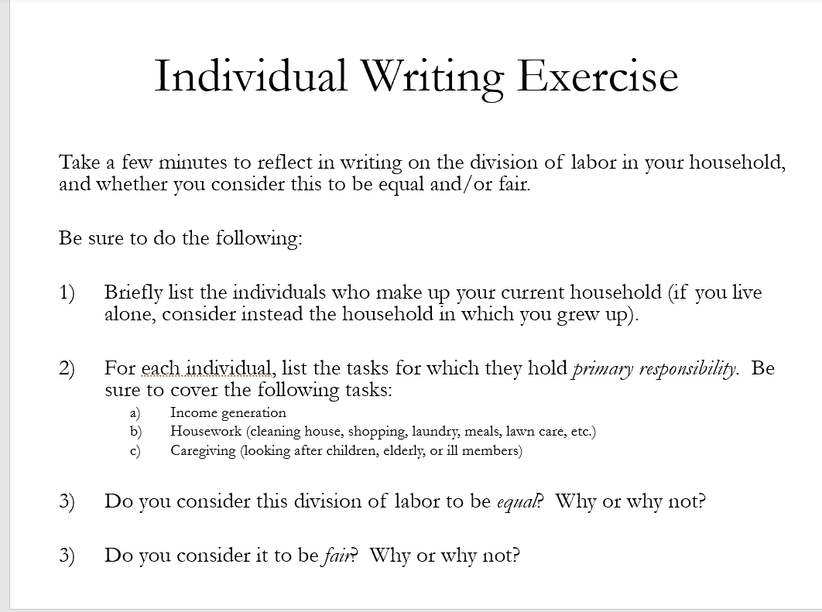
- How did you determine this was equal/unequal?
  - Everyone had different metrics e.g. time it takes, amount of leisure time, etc.
- How did you consider it to be fair?
  - Income disparities?
  - Enjoyment of tasks?
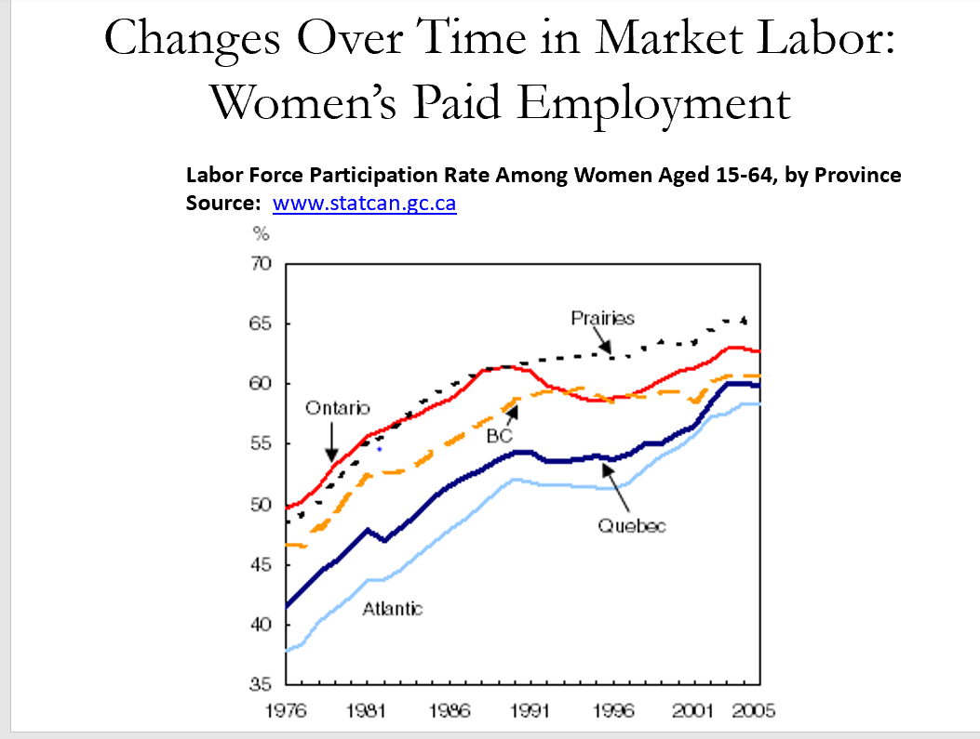
- What led to the increase of female paid employment in workforce?
  - 14 to 62% of women working in formal labourforcce
- In early 1900s, many women contributed to their family’s business/farm – their labor participation may have been underestimated
- Women started working in clerical/service jobs -> “suited for women”
Barriers to Women’s Paid Employment in the First Half of the 20th Century
- Women’s occupational choices were limited to feminized jobs
- “Marriage bars” forbade married women from working in many occupations
- Women’s wages were lower than men’s
- Feminized jobs: secretarial work, support work in a family business
- It was hard for women to break from this barrier and limited their occupational choices
- Marriage Bars => many of these were legal provisions barring women from work, they were told it was to protect them, but it was to keep men’s wages high
- Women didn’t have a great incentive to work as they were paid less than men for the same type of work.

Barriers to Women’s Paid Employment in the First Half of the 20th Century
- Women were discouraged from education and training that would qualify them for many jobs
- Employers saw men as more deserving of jobs
- Especially in the 1950s, the economy was booming and men’s family wages were enough to support a family
- Canadian economy was booming after WWII, thus the male bread-winner was sufficient for families
- Men’s wages were high enough to support a whole family on their own (1950s to early 1960s)
- These conditions gave women incentive to marry – yes, there was a romanticized ideology of marriage, but since women had no avenues for economic survival without marriage, it seemed more attractive.
Facilitators of Women’s Paid Employment in the Second Half of the 20th Century
- Legal barriers were lifted, allowing women to enter the labor force
- The feminist movement helped women gain access to education, lessened employment discrimination, and improved attitudes
- The feminist movement had a role to play in improving attitudes of women’s paid work outside of the home
Facilitators of Women’s Paid Employment in the Second Half of the 20th Century
- Cash was needed for expenses like manufactured goods, heating, and school expenses
- Economic conditions worsened, and men’s wages especially started declining in the 1970s
- By the 1960s, the economy in Canada had monetized. In contrast to the early 1900s these expenses were covered by the male wage.
- Across the world, men’s wages started to decline as the economy takes a turn for the worst in the 1970s. Thus, making it necessary for a dual-income home.
- Despite these changes, Lux and Corman said that marriage was still an important factor for economic security as a women.
- 77 weeks of employment needed to support an average household (only 52 weeks in a household) => 2 incomes are needed to support a household, and it is still very difficult for a women to upkeep a household on a single income in the current economy.
Changes Over Time in Market Labor: Incompatibility with Domestic Labor
- In the early 20th century, market work was often based at home or in a family business or farm, where children were often present.
- Wage work has spatially separated workers from their dependents, and the standard workday assumes another individual is free to care for dependents
- There wasn’t a dilemma of work-life balance, as the work in order to obtain a livelihood was done in the home or in the family business, therefore it was easy to combine both market and domestic labour
- When employers opposes the 9-5pm workday, they assume there is another person at home to take care of the home and dependents. The full workday imposes challenges on the workers to fulfill domestic tasks
- Wage labour force essentially assumes that each wage worker has someone at home
Changes Over Time in Market Labor: Incompatibility with Domestic Labor
- Since the close of the 20th century,
  - wages have declined,
  - work hours have increased,
  - welfare supports have eroded,
  - job insecurity has risen
- Today the majority of couple households are dual-earner households
- The incompatibility of paid work and domestic/care work has become more pronounced
- Since the close…
  - These deteriorating work conditions have thrusted families into dual income earner household and thus the inco
  - More and more people are coming terms/accepting that feminity is becoming separated from domestic/child care and gender egalitarians views are on the up and coming
Social Reproduction
“The activities required to ensure the day-to-day and generational reproduction of the population.” (Luxton and Corman 2011, 212)
This includes paid market work and unpaid domestic work - which includes housework and caregiving.
- Social reproduction: all the tasks done on a day to day basis in order to reproduce one generation to the next.
Social Reproduction and the Second Shift
The second shift is “informal and unpaid [domestic] work performed in the home.” (Hari 2018, 551)
- First Shift – paid and formal work done in the labour market. But hochchilds argues women work a second shift when they return home of domestic chores and work.
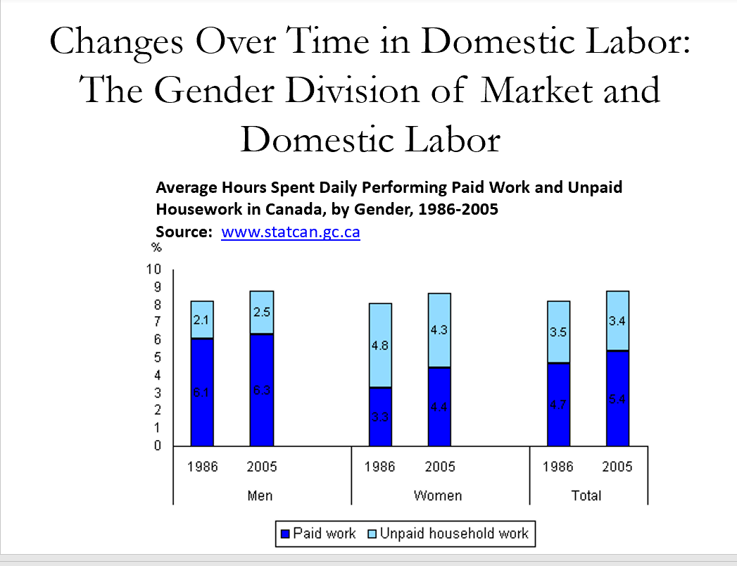
- Overall trends (total) between 1986 and 2005, both time spend in unpaid and paid labor has increased. Canadians used to spend 8.2 hours for both types of work everyday, now they work 8.8 hours of both types of work per day.
- Between 1986 and 2005, Canadians spend more time in paid work than unpaid work (more time at the office, less time at home)
- For unpaid work, women decrease their unpaid work by 0.5hours and approximately absorbed by the increase of men’s unpaid work. However, women are still performing 1.5x as much than men in domestic work and women have increased their market work by women.
- If people are spending more time on combined domestic and paid labor, dual-income earner families tend to skimp on leisure activities, sleep, and social/community/political participation to make up for the time lost .
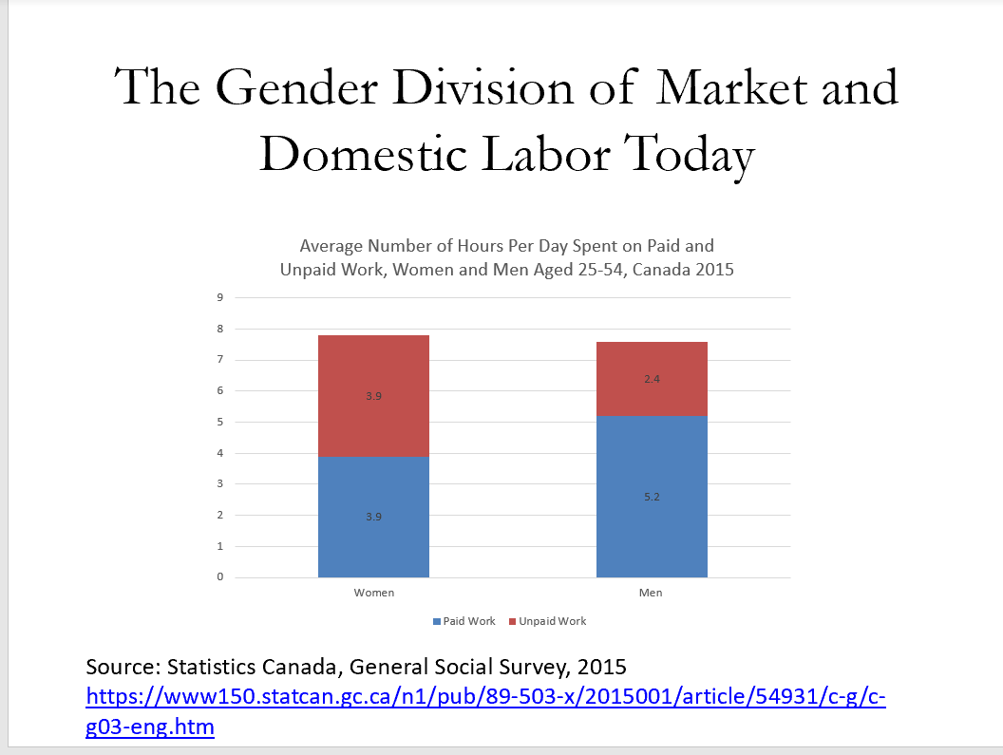
- Women work slightly more than men, 0.2 hour increase of both types of work
- Women are doing equal amounts of paid and unpaid work.
- Men are spending more time in paid work and 2/3 of the time women spend on unpaid work.
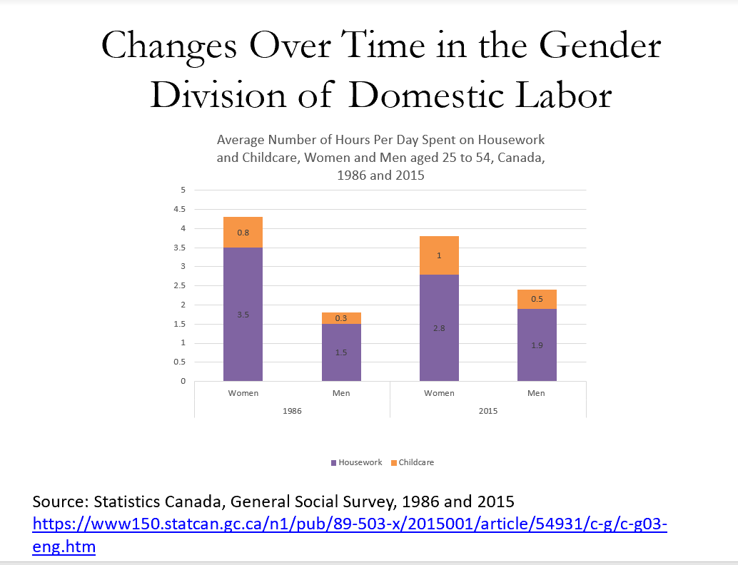
- Much more of a dramatic change than previous trends.
- For both men and women, the amount of time spent on childcare has increased by 0.2 (the same)
- Men increasing their total unpaid work and most of it is accounted for in housework versus childcare.
- Women decrease the amount of time spent in housework but increased amount of time with children.
- Women still provide 3.8 hours of domestic labour compared to 2.4 hours of domestic labour done by men.
- These graphics and statistics did not show the distribution of domestic work (i.e. outdoor work, indoor tasks). Men tend to take the first pick of domestic chores and choose more enjoyable tasks that are not as routine. Men may do some chores, but is more often that women are the ones monitoring, ensuring certain standards and scheduling of tasks.
- Few studies account for the emotional labour that comes with caring for children and elderly which could impact women’s mental health e.g. concern for children’s wellbeing.
Luxton and Corman: Family Strategies for Balancing Market and Domestic Labor
- Increase earnings to buy domestic services
- Limit market labor hours and spend time gained in domestic labor
- Reduce the absolute amount of domestic labor performed
- Increase involvement of men and children in domestic labor
- Increase earnings to buy domestic services
  - This might involve working more hours in order to pay a domestic worker to perform housework/child care – even if they can afford child care service they struggle to maintain/ensure
- Limit market labour hours…
  - Reducing time in the labor market, typically falls on the women and compromise on their long-term earnings by passing up employment opportunities. This makes them vulnerable in the long run – causes women to be disadvantaged e.g. divorce, widower
- Reduce the amount of domestic labour
  - So much you can do
- Increase involvement of men and children
  - Men’s workplaces are much more inflexible than women’s workpalces as they assume there is a female at home
  - Gender ideologies – prevent men from learning domestic work and fear that they will be ridiculed for doing domestic work
- Teaching domestic chores/works, takes time from the women and can cause marital/conflict with spouses if the male takes on more work.
- These family strategies are bound to fail as they don’t resolve the underlying challenges between the balance of work and domestic labour.
- In their view, the government and employers should be responsible to resolve this issue.
State Policies Affecting Family Life
Box 7.2 on page 229 of Luxton and Corman: “State Support for Employees with Family Responsibilities”
- Quality, affordable, and available childcare and eldercare
- Longer and higher paid parental leave
- State legislated provisions for family responsibility leave
- More paid vacations and statutory holidays and mandatory paid sick days
- Quality health care programs that provide care in the hospital and in the home
- National program for extended health, pharmacare, dental, and vision insurance
- A well funded education system that does not rely on parental support for children’s learning or school based fundraising
- Expanded definitions of families and spouses
- Employment equity programs
Neoliberalism and
“Work-Family Balance”
Neoliberal ideologies
- Seek to maximize the competitiveness and profitability of the corporate sector
- Assume that individuals and families are or should be self-sufficient
- Assume that the gender division of labor is equitable and efficient
- Assume that individuals and families do not or should not need government intervention
- Luxton and Corman were vehemently against neoliberal ideologies and work-family balance
- Neoliberal ideologies essentially says that each individual is responsible for themselves and their families with the least amount of government intervention to ensure the private sector can be as profitable as possible
- This shows the inherent tension between social reproduction and employer’s desire for higher profitability.
- There are competing ideologies of capitalist accumulation and social reproduction. The benefits of social reproduction accrue to a society as a whole – this is a public good and everyone benefits from it, thus it is not fair to put the burden of social reproduction on women or on the family.
- According Luxton and Corman the state should intervene
Neoliberalism and
“Work-Family Balance”
- Luxton and Corman argue that there is an inherent tension between social reproduction and capitalist accumulation
- Neoliberalism seeks to reduce government welfare provisions as well as government regulation of enterprises
- Neoliberal policies shift the burden of social reproduction to families (particularly women)
- But the benefits of social reproduction accrue to society as a whole, so is this fair?
Hari: Gender Attitudes vs. Structural Realities for Skilled Immigrants
Attitudes
  - All couples aspired to a 2-career marriage
  - All couples had companionate marriages
  - Some paid lip service to ‘equality’
Reality
  - Couples faced barriers to labor market entry
    - Racial discrimination
    - Credentials not recognized in Canada
  - Couples faced a dearth of available and affordable child care
    - They had previously been able to afford paid domestic workers in India
    - Women responded by scaling back their paid employment and giving priority to men’s careers
- This study gives us some sense of what social reproduction on the ground and real life example of what Luxton and Corman as described previously
- Even their attitude and desires are for equality most women scaled back their employment for their husbands.
Hari: Strategies for Managing Childcare
- Used flexible schedules to work opposite shifts at work and at home
- Used government sponsored childcare facilities
- Deployed grandparents to look after children
- Used unregulated home-based daycares
1 – stress and guilt reported at work and the home
2 – couples faced issues with accessibility
3 – temporary strategies as most grandparents came with visitor visas
4 – temporary solution as they were temporary visitors
Hari: Juggling Housework
- Men’s contributions to housework in Canada exceeded what they used to do in India
- Housework was gender typed, with women taking on routine and indoor tasks, and men taking on occasional and outdoor tasks
- Women took on more housework if they were childless
- All participants faced the same challenges, but women were more likely to express guilt and disappointment
- Mental health burdens of these comprises/challenges fell to the women.
*The last slide was not covered*


