Decline of Manerism ( foreshortening, bizarre spatial settings, complex poses, unnatural forms )

PELLIGRINO TIBALDI. Adoration of the Shepherds. 1549
An example of an overreaction to the Maniera style (Michelangelo perfection)
- Twisted unnatural forms and poses
- Artificial gestures and lack of focus in the image
After 1563 The Roman Catholic Church discourage this type of imagery

PIRANESI. View of St Peter’s. 1750
The new St Peter’s was the most important symbol of the invigorated Roman Catholic Church in Europe

ANNIBALE CARRACCI 1.35-36

Carracci worked in a group workshop, drew & painted from life and models in his studio.

The Butcher Shop. 1580
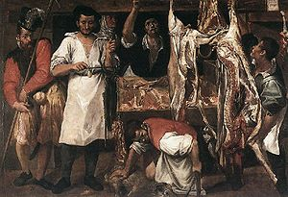
- Genre scene: four men at work
- Rough impasto paint mimics the texture of the bone & fat
- Opposed the perfection of maniera style
- Ex. of early work
- Deliberately mocking maniera style?

Pieta w. Virgin and Saints. 1585
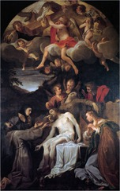
- Arch of figures centralizes the subject of the dead Christ
- Subdued lighting creates a somber mood
- Interest in realism and naturalism shown

Farnese Ceiling 1600
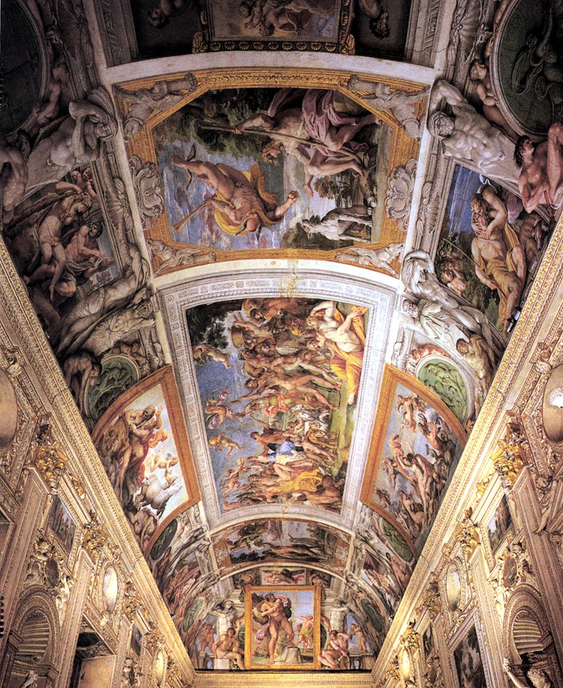
- Collection of framed paintings on the vaulted ceiling– quadri riportati
- Story of profane love and the triumph of love
- Decorated for a duke & duchess of the Farnese family – for a marriage
- Display of eroticism: source-> Ovid’s Metamorphoses
- No single viewpoint
- Triumph of Bacchus and Ariadne is the central image that sets the mood of the ceiling
- The FRIEZE runs along each side above the cornice portraying scenes of Jupiter and Juno: nude figures w. cloths referencing the Sistine Chapel ?
- Michelangelo – like style
- Empathetic portray of human emotion

The Assumption of the Virgin. 1600
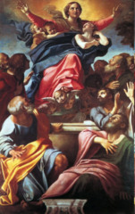
- For the Santa Maria del Popolo
- Demonstrating bright colors – unrealistic
- Shift away from the naturalism
- Religious symbolism: trinity
- Focus on hand gestures

Pieta 1600
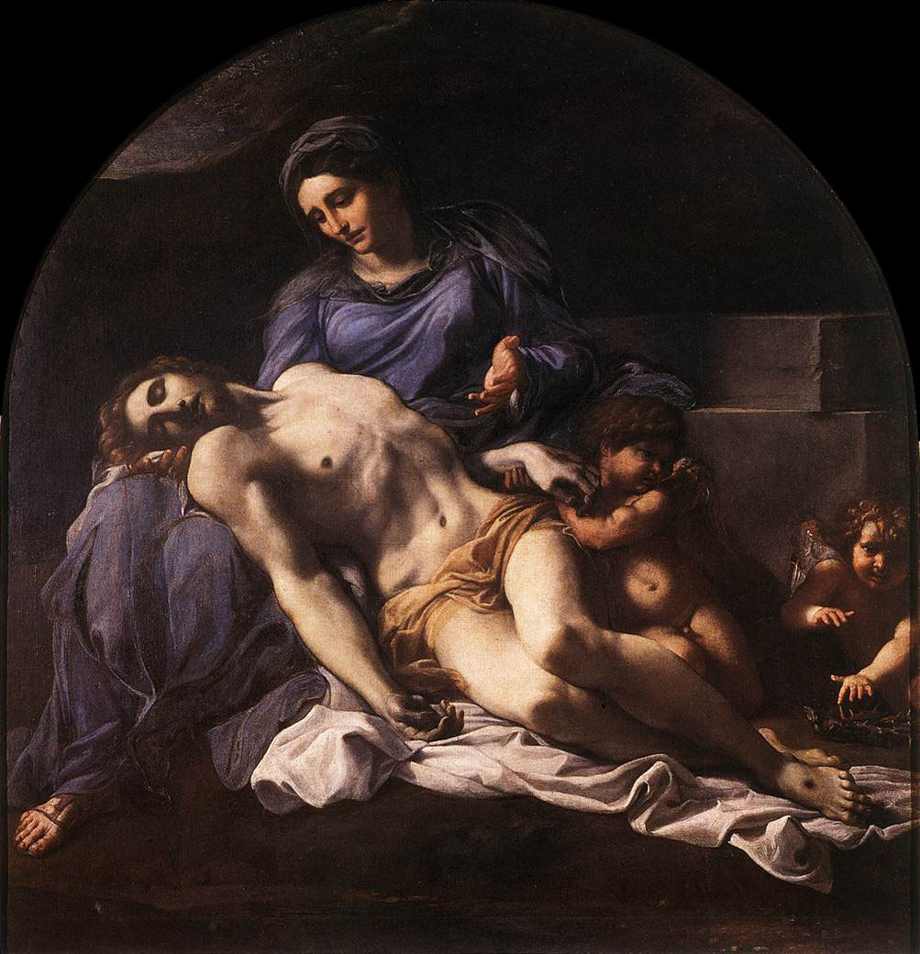
- Dead Christ in the lap of his grieving mother
- Somber and chiaroscuro
- Reference to Michelangelo & bringing to life his sculpture
- Idealized forms and body parts
- Painterly & classic style for northern Italy

CARAVAGGIO

Bacchus. 1595
- Done for a specific type of patron
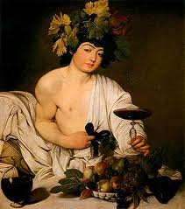
- Bacchus was the god wine – therefore it can be viewed as a religious painting – rep blood? B as Christ ? -> eucharist
- Display of homo- erotic imagery – B offers his body as he undresses
- Moral painting? Will the viewer give into to a world of debauchery and sexual offerings
- Rotting fruit – death -> decay

The Calling of St Matthew 1600
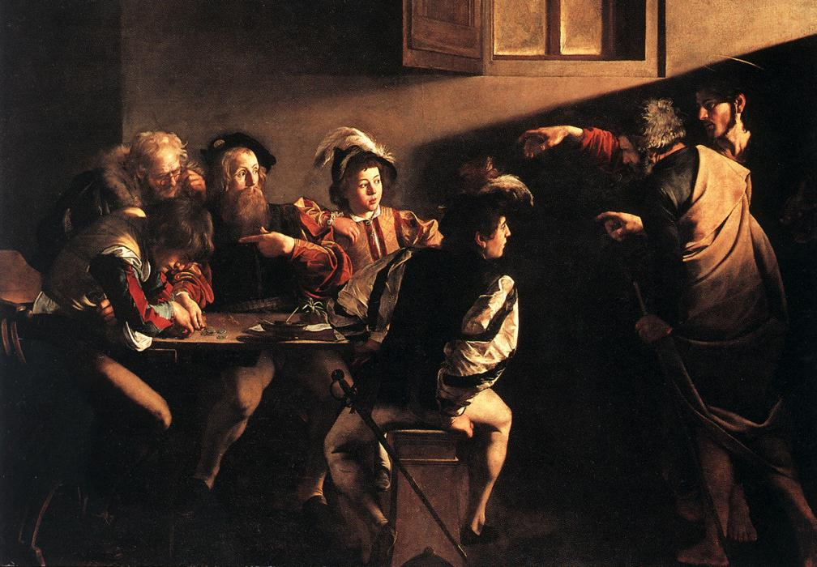
- Caravaggio was never one to do prep drawings & this was his first large scale painting
- dramatic diagonal shadow from the natural light source over Christ’s head
- He is pointing at Matthew & M is in disbelief
- St Peter is shielding Christ from our view
- Ambiguous setting: inside or outside?
- Light is symbolic: “the way of light, the way of truth”
- Window, furniture & dress suggest modern Roman room
- Matthew is about to make a choice btw vice & virtue

St Matthew and the Angel 1600
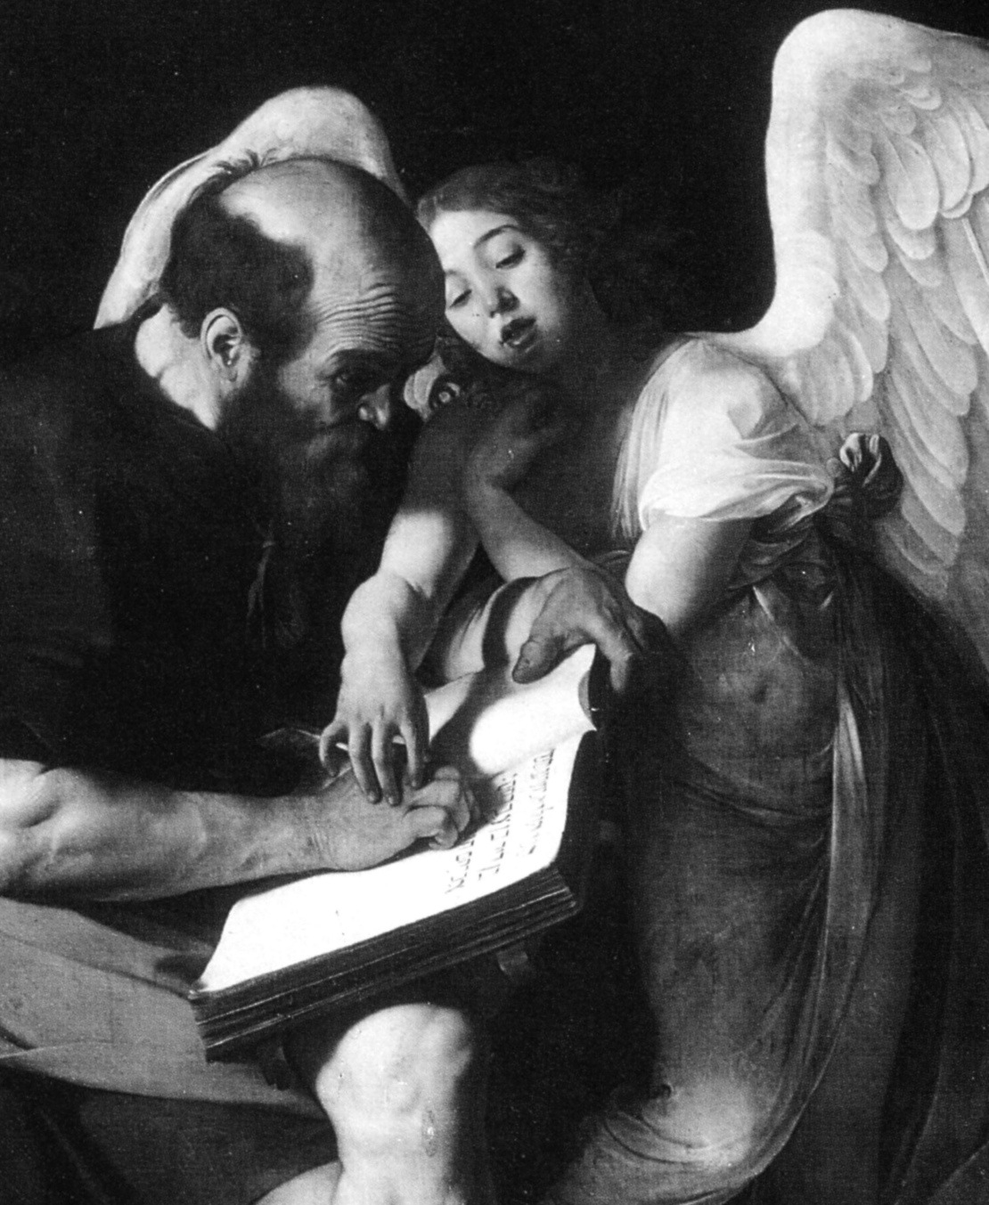
- Matthew is in the process of being guided by god but also has the integrity to write down his own rational analysis and exposition
- Display of transition from ignorance to wisdom
- Looks like Socrates? Self elevation of status?
- Angel is boldly barely covering anything
- Matthew looked helpless – he can barely write
The Inspiration of St Matthew 1602
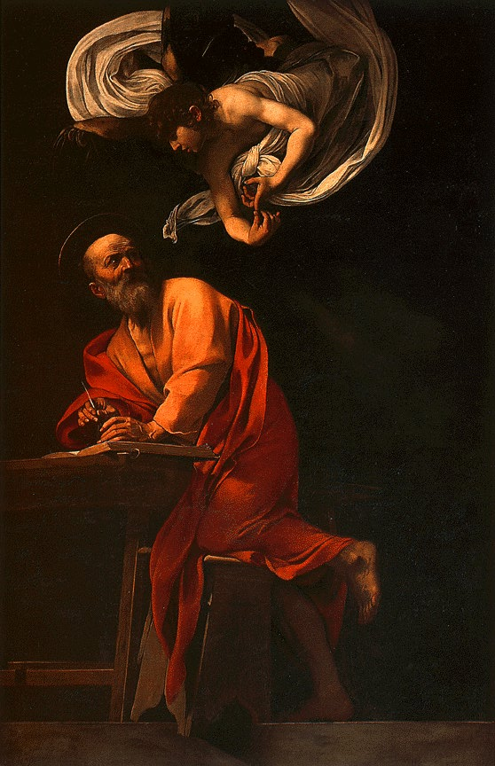
- the second version addresses the initial criticisms
- Matthew is taking dictation & writing on his own
- Feet are away from the picture plane… although Caravaggio added the Stool on the edge of the platform *

* Caravaggio’s Naturalism comes from Venetian tradition although history shows no evidence that the artist travelled to Venice*

Conversion of St. Paul 1600
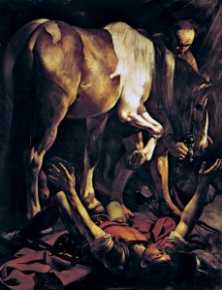
- St Paul lies on his back, with his head close to the viewer
- The horse fills the majority of the canvas
- Drama focuses on inner psychological turmoil of a man at the moment of his conversion to Christianity

Victorious Cupid 1600
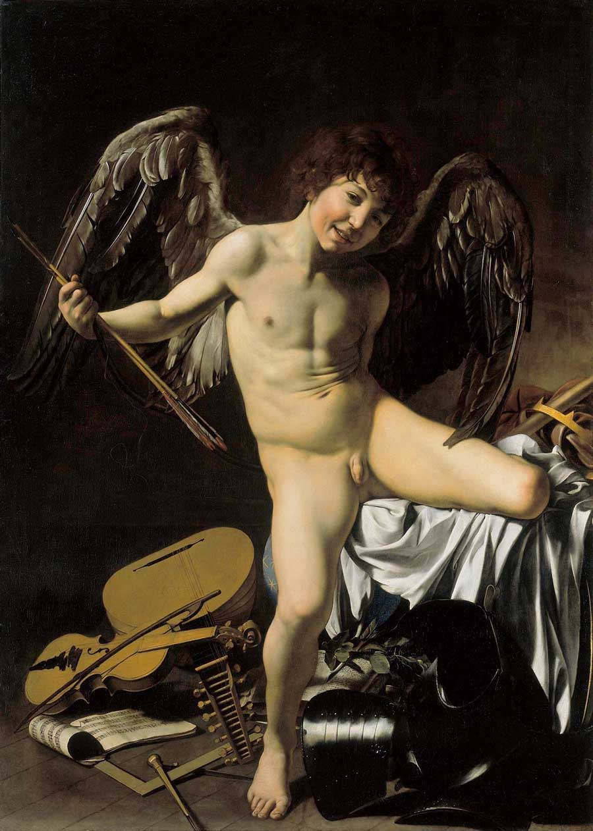
- Mischievous boy on the verge of adolescence
- Genitals seem to be the center of the canvas – all of the directional lines point to the center
- Legs, violin, the bow, crisp white drapery
- Laughter: he is aware that we are unable to look away
- Covered with a curtain for viewers until they had seen every other painting in the collection

Entombment of Christ 1605
- In S Maria, Rome
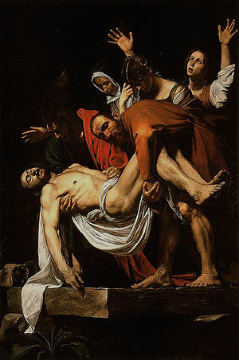
- The painting was intended for the altar of a church – setting is crucial
- Emphasis on the diagonal composition is essential to its placement
- Can be seen as a last farewell as they entomb Christ’s Body – lowering the tomb into darkness
- Display of Counter Reformation and Religious devotion
- Chiaroscuro & dramatization – enhanced shadowing
- Diagonal which starts with the upright hands of Magdalene.
- Restrained emotions – minus Magdalene

Caravaggio’s Followers….

GENTILESCHI
Susanna and the Elders 1610
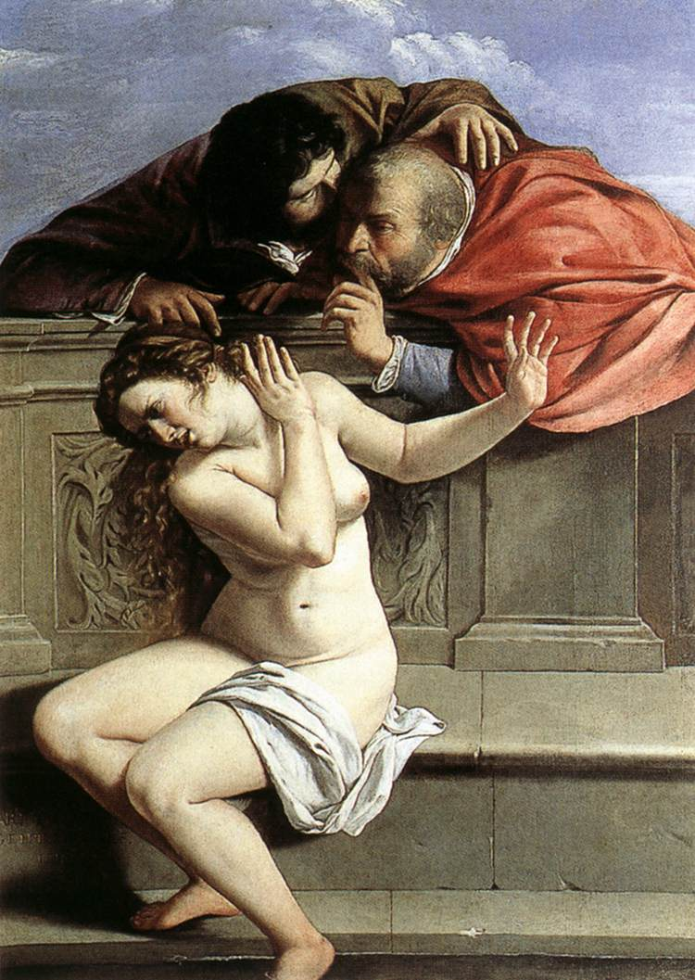
- Full length female nude and two clothed men
- Elegant stone enclosure
- Verticle format
- Women were ineligible to participate in drawing classes so she mastered the female anatomy – immense detail in breats
- Susanna is a symbol of virtue, chastity and marital fidelity
- Woman threatened by rape from two men – if she doesn’t sleep with them she will be accused of adultery – Susanna refused and her innocence was eventually proven
- Male domination is emphasized in the painting – male vs female in 17th
- Caravagio elements: naturalism & figures close to picture plane

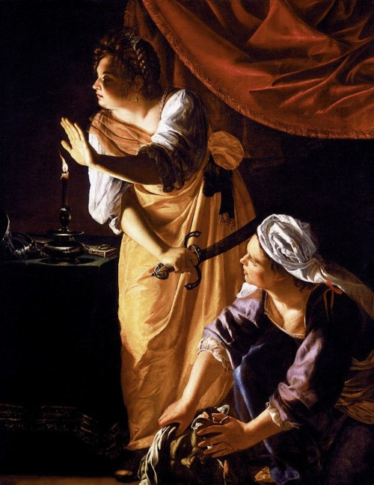
Judith and her Handmaid w. the Head of Holofernes. 1625
- Listening if the guards have been alerted
- Darkness with a light source (candle)
- Judith was a Jewish Heroine who saves her people
- Associated with the personal story of her rape she displayed revengeful and violent emotion (decapitating)

GUIDO RENI
Aurora 1615
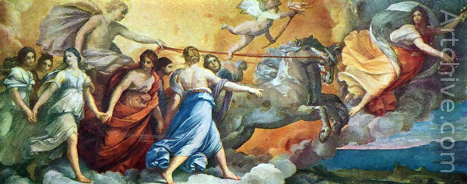
- Quadro riportato
- Drastic change towards Carracci’s classicism from 1605
- Romantic movement of figures- similar to an ancient frieze

GUERCINO .76
Presented to Virgin by Four Saints. 1615
- Dramatic chiaroscuro palette
- Indigo blue, plums, and ruby red
- Light to dark with patches of sfumato
- All key figures have patches of light on their faces
Aurora. 1620
- Same subject as RENI
- Quadro riportato “celing has vanished and replaced with figures”
- Aurora with her chariot and horse
- Strongly contrasted tonal values

BORROMINI

Family name was initially Castelli. Innocent the XI favored Borromini. Worked for Carlo Moderno in Rome while working on St Peters. In 1633 When Bernini was the architect of St Peters, Borromini had to work under him. A set of bell towers collapsed and Borromini lashed out against Bernini

San Carlo Alle Quatro Fontane 1650
- Display of mythical “baroque style - sculpture
- Curves over flat & complexity over simplicity
- Borrominis first independent commission – prove himself greater than Bernini
- Trinitarian order: form of the triangle was essential
- Creates a rippling effect on the façade with columns and arch #fluidity
- Oval plan church
- Hexagone of diminishing size to enhance volume that lead to an image of a dove of the holy ghost & triangle = holy trinity
- Concave and convex forms , complex geometry, corinthian collumns, and decoration everywhere

S Ivo Della Sapienza. Rome. 1640
- Put into a square space of an existing cloister, it was the church of the uni in Rome
- Centrally planned church , complex, the core is a hexagon
- Two levels of arcades complete the façade
- The arches are filled with other arches and windows
- Outer dome roof – like Pantheon
- Based on six-pointed-star representing wisdom ( sapienza )
- plan in the shape of a Bee”? -> a symbol of the Barberini family
- also symbol for…Hardwork, Intelligence, frugality, chastity
- The church was built during the reign of 3 Popes: Urban VIII Barberini, Innocent X Pamphili ( dove ) , and Alexander X Chigi. (mountain )
- There is an endlessly changing rhythm and form.
- Attempt to unify the church through decoration and ornamentation, as well as symbolism related to the family patrons.

Heinrich Wolffin

The double root of style: personal style vs period style

Representational forms to distinguish the development of Renaissance to Baroque style

Renaissance Baroque

Linear Painterly

Plane Recession

Closed Open

*contained in the picture plane/ beyond the space

Multiplicity Unity

Absolute clarity Relative clarity

* subject matter & social context are problematic

ITALIAN SCULPTURE

GIAMBOLOGNA

Most important sculpture after the death of Michelangelo

Displayed immense respect for the male and female nudes

Rape of the Sabine Woman. 1580
- Three dimensionality is essential to his sculptures – allows the viewer to walk around the entire statue

BERNINI

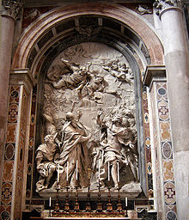
son of a sculpture – golden child, did it all… sculpture, painter, playwrite, architect..

baroque quality

Belori did not appreciate Bernini’s work – not classica

Rape of Proserpine. 1620
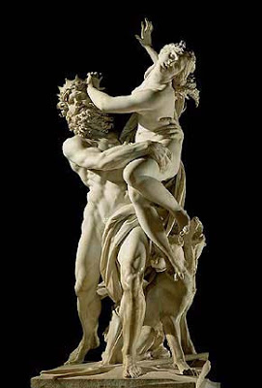
- Pluto who grasps the resisting woman around her waist and hips
- See the emotion in her face – hear the screams
- Plutos hand dig into the flesh of prosepine.
- Erotic & sensual - energy as male has a smirk on his face
- Stabilizing base: three headed dog
- Specific texturing of marble had never been seen before
- Studied only from the front

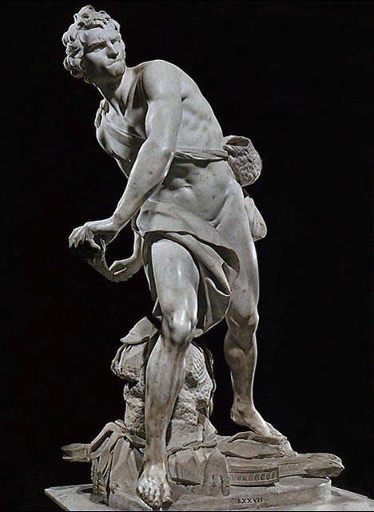
David. 1625
- In the act of lauching the stone in contrasts to his peers static representation
- Feels like the movement is jumping off the canvas
- Sense of momentum in Davids action
- Looks like clay model #technique
- He used carving techniques to create shadow and light

Apollo and Daphne 1625
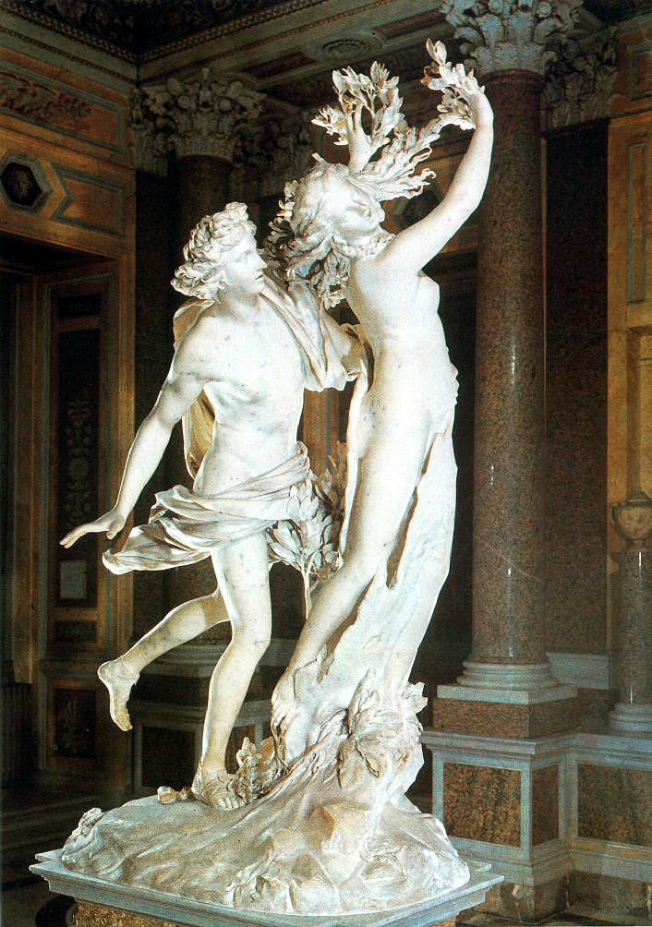
- Antique source of inspiration
- As he touches D her body quickly turns to bark
- Her body is branching out with leaves from her hair and fingers as the same moment she called out to her father to save her
- Setting is also present at the feet with plants and rocks
- Cupid cast a spell that made A love D & D hate A
- Story of unfulfilled desire
- Ideal viewpoint at the right
- Display of movement as figures are running
- Mythological figure for a private patron

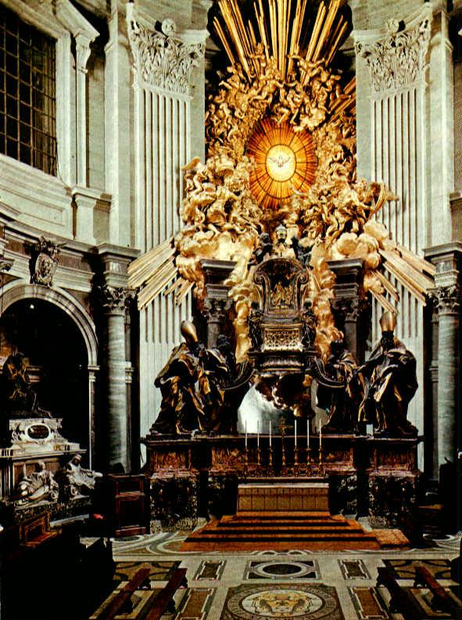
Cardinal Scipione Borghese. 1630
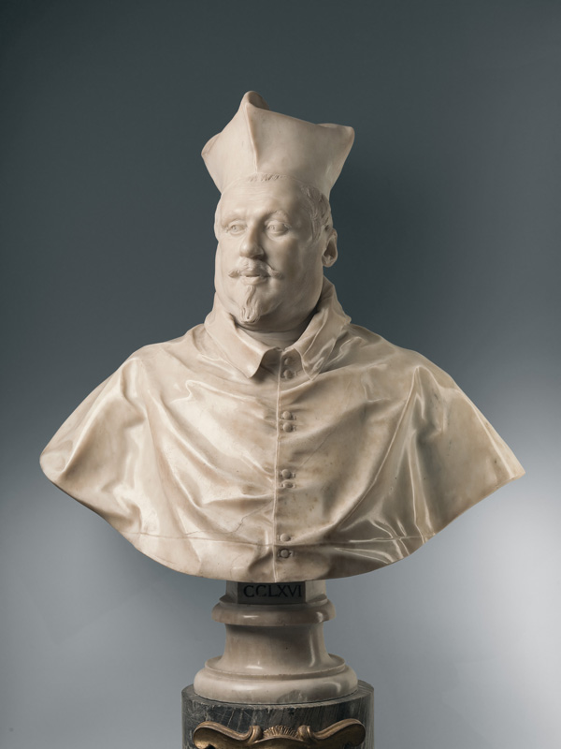
- Created a speaking likeness
- Would have his sitters converse while he drew them from various angles
- Subtle shifts from perfect symmetry
- Elevate social status and political power
- Long friendship between the two

Baldachino, St Peters Rome. 1625
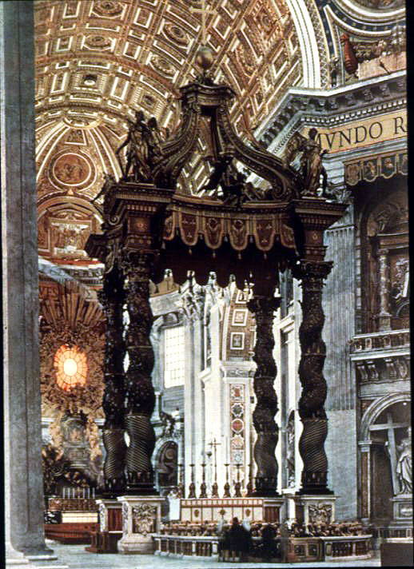
- Intended to draw attention to the high altar that was overpowered by the size of the church … but without hiding it
- High altar canopy with marble using bronze
- Protects the tomb without breaking the flow of the nave
- Decorated with Urban VIIIs personal symbols: trio of bees and the head of cherub
- Protect pope and the body of Christ
- Moderno: lengthens the nave and excutes the façade in relation to Michelangelo’s giant pilasters
- honors memory of st peter
- Asserts dominance of Christianity over other religions

Catherdra Petri 1660
- At st Peters in Rome
- Chair in the apse is a representation of authority
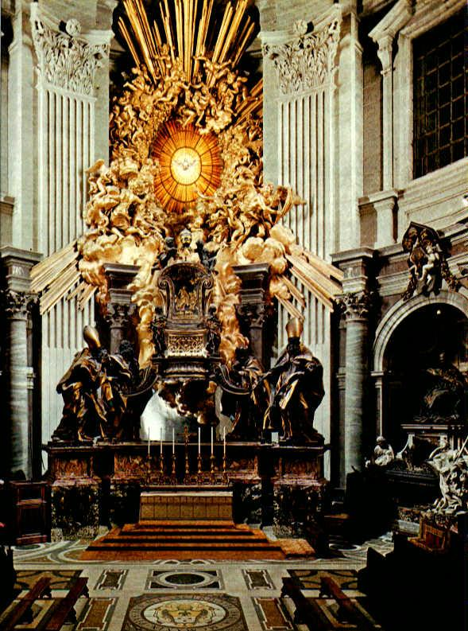
- ( symbolic throne for St Peter the first bishop of the Roman Catholic Church )
- Below the great window of Michelangelo
- Chair looks like its in motion
- Clouds full of angels in bronze gold

Cornaro Chapel. 1650 (ecstacy of St Teresa)
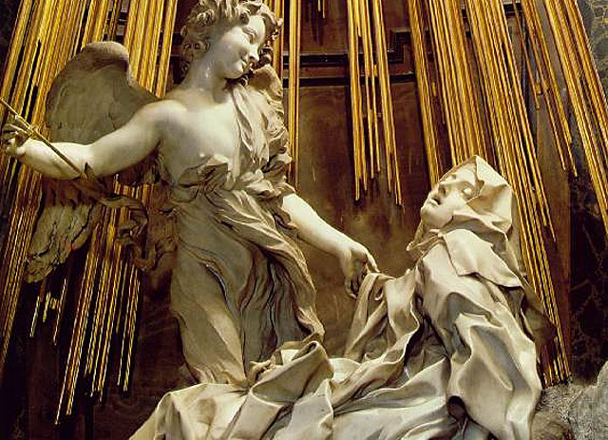
- use of painting and architecture to produce a grand effect
- the “holy temple of heaven” to which Theresa is transported
- physical and spiritual experience
- rays of light

ALGARDI 115

Bellorie regarded him as “the great” sculpture of the time

Classicism associated with his work

Hard to find work when he returned to Rome as Bernini had majority commissions

Donna Olympia Maidalchini. 1650
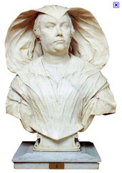
- Innocent X’s sister in law
- Delicate refinement and ability to display character
- Suggest an unpleasant character – which was accurate, she was a tough minded person & unforgiving
- Traditional veil makes her look like a cobra it was a technical feat for the artist
- Carving fabric #skills

Pope Leo I Driving Attila from Rome. 1645
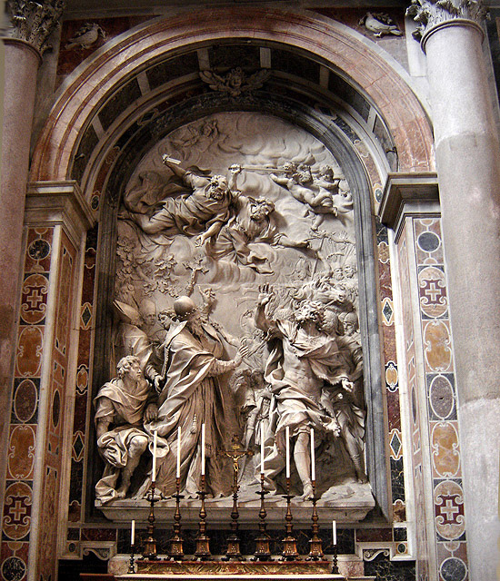
- St Peters Rome. Was his most prestigious commission
- Innocent X wanted to display that Algardi was the greater sculpture
- Attilas figure looks ready to step off the wall as she is turned around by Pope Leo the Great
- Classically balanced composition with a baroque sense of movement
- Created shadows to emphasize key movements and gesture

Bernini was trying to break the boundary btw fictional and real space

Baroque Classicism displayed a lack of movement, no spatial interpretation, restraint

GAULLI

Followed the style of Bernini’s figures with elongated bodys, cascading wavy hair, convoluted drapery forms, etc..

The Glorification of the Holy name of Jesus 1680
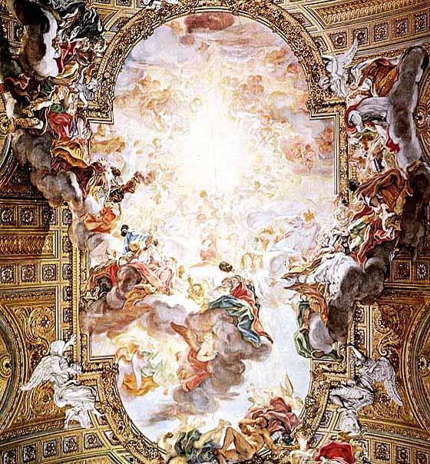
- Il Gesu in Rome
- Nave with the central fresco on a flat barrel vault ceiling
- Expands beyond the fresco to cover parts of the architectural detail – the irregular shape breaks the frame
- Figures are painting in extreme foreshortening
- Blurs the boundaries between world and the spectator #baroque

MONTANES Christ of Clemency 1605
- Relief stone and ivory crucifixion
- Naturalism to express an idealized image
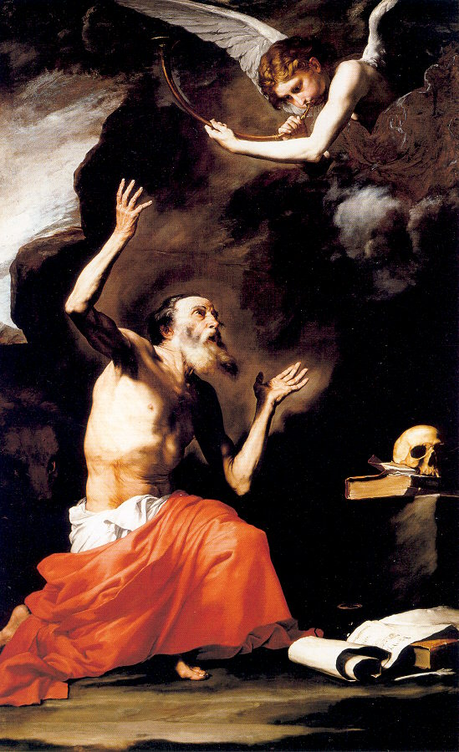
- Not much room for creative as theology dictated the story

RIBERA St Jerome with the Angel of Judgement 1625
- Brilliantly master chiaroscuro
- Lived as hermit in the Syrian desert (shown as wilderness)
- Rocky setting with skull, some religious books and pet lion
- -> Caravaggio

ZURBARAN The Crucifixion 1630
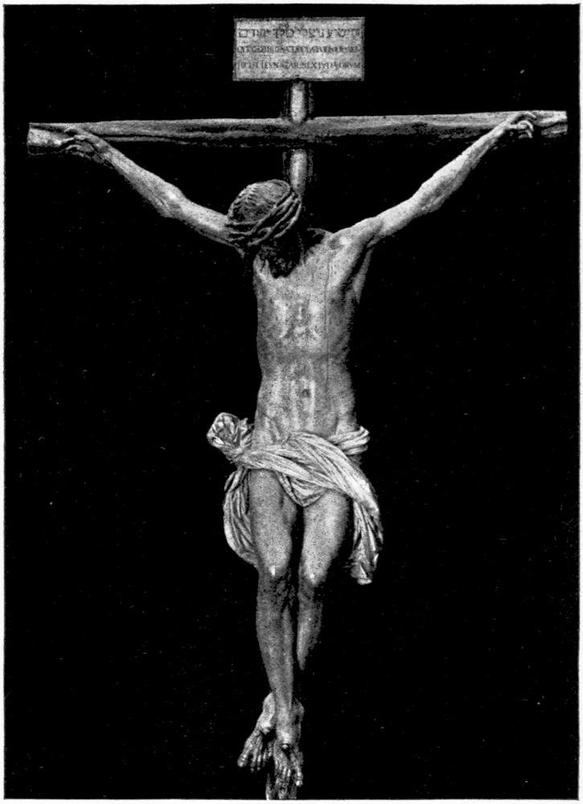
- Counter Reformation was strong in Catholic Space
- Naturalist movement in Spain
- Example of precise handeling and violent chiaroscuro
- Christ of clemency – MONTANES 1603
- Applauded for simplistic image od Christ
- No setting at all – black background

MURILLO Immaculate Conception 1660
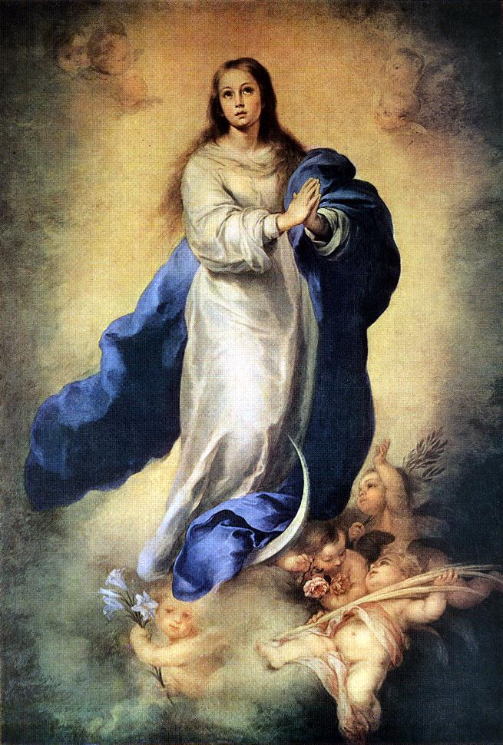
- Young woman dressed in blue and white ` floating over clouds
- Supported by baby angels
- Lily, palm branches, olive branch and a rose: virgin attributes
- ***Caravaggio

