Chapter 4
Non-Wholly Owned Subsidiaries
- When the parent acquires less than 100% of the shares
- The value of shares held by the non-controlling shareholders appears on the balance sheet as “noncontrolling interest” (NCI).
Measuring NCI at Fair Value (Entity Theory)
- Views consolidating entity as 2 groups
  - Controlling shareholders
  - Non controlling shareholders
- The consolidated balance sheet reflects full fair values of subsidiary’s net assets and goodwill as if the parent had acquired 100% instead of the lesser amount actually acquired.
- Assumes linear relationship to calc the value of NCI
- Loses validity as parent moves away from 100% ownership
- If the subsidiary was a public company and its shares were actively traded prior to acquisition, NCI could be calc by= multiplying the number of non-controlling shares by the acquisition date trading price.
- Entity theory results in
  - Assets acquired and liabilities assumed are valued at their total fair value at the date of acquisition.
  - Non-controlling interest is valued on the basis of the market value of the company acquired (Including goodwill)
Measuring NCI at Proportional Share of Identifiable Assets (Parent Company Extension Theory)
- Addresses concern about goodwill valuation under the entity theory
- Reflects both parents and non-controlling interest’s share of identifiable net assets at full fair values
- However only parent’s share of subsidiary’s goodwill is reflected on consolidated balance sheet.
- The Parent Company Extension Theory results in the following:
  - Assets acquired and liabilities assumed are valued at their total fair value at the date of acquisition
  - Non-controlling interest is valued on the basis of the market value of the net identifiable assets acquired (All Net Assets except Goodwill)
Bargain Purchase
- Happens from negative goodwill (purchase price<FV of identifiable net assets)
- IFRS 3 requires that negative goodwill be reduced to zero by first reducing any goodwill on the subsidiary’s books, then recognizing any remaining negative goodwill as a gain
- Check if u calc the FV of identifiable net assets correctly
- 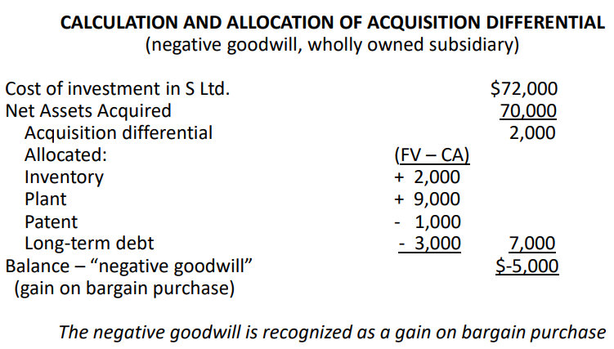
Negative Acquisition Differential
- Results when the parent’s interest in the book values of the subsidiary’s net assets exceed acquisition cost
Subsidiary with Goodwill
- Any goodwill on the balance sheet of subsidiary on acquisition date is not carried forward to the consolidated balance sheet
- Reflecting outdated fair values of entity it acquired
Measurement Period
- Companies have one year to finalize the purchase price allocation on an acquisition made.
Contingent Consideration
- The terms of a business combination may require an additional cash payment, or an additional share issue contingent on specific future events
- IFRS 3 requires the contingent consideration to be recorded at fair value at the acquisition date as part of the acquisition cost
- Contingent consideration can be either liability or equity depending on its nature
Contingent Consideration - Liability
- If contingent consideration is payable in cash or another asset, it should be recorded as a liability
- Recorded at fair value and is included in the purchase price on the date of the acquisition
- Liability needs to be revalued after acquisition date as circumstances change. Record revaluation adjustment in earnings if revaluation arose as a result of events occurring after acquisition (change in estimate).
- The purchase price should not be adjusted, unless if revaluation arose as a result of new information about facts and circumstances that existed as at the date of acquisition. (Error)
Contingent Consideration - Equity
- Recorded as equity if payable in a fix # of shares, if variable meets def of liab
- If equity include in the purchase price

Chapter 5
Methods of Accounting for an Investment in a Subsidiary
- Differentiate between accounting in the internal records and reporting in the external financial statements
- Consolidated net income will be the same regardless of whether the parent used the cost method or the equity method for its internal accounting records
Consolidated Income and Retained Earnings
- The amortization of the acquisition differential is reflected on the consolidated financial statements, not the subsidiary’s financial statements.
- The acquisition differential is amortized or written off on consolidation as if the parent had purchased these net assets directly
Equity Method Recording
- Only the investor’s share of the investee’s income, dividends, and amortization of acquisition differential are recorded in the investor’s records
- The parent’s separate-entity net income should be equal to consolidated net income attributable to shareholders of the parent
- The investment account can be reconciled to the carrying amount of the subsidiary’s shareholders’ equity and the unamortized acquisition differential
- The investment account captures all adjustments since the date of acquisition, whereas equity method income captures adjustments for the current period.
- The parent’s RE under the equity method should be = to consolidated retained earnings.
- Investment in subsidiary and retained earnings are the only two accounts on the separate-entity balance sheet that would be different under the equity method as compared with the cost method.
Testing Goodwill and Other Assets for Impairment
- An asset is impaired if its carrying amount exceeds its recoverable amount
  - The recoverable amount is the higher of
    - fair value - costs of disposal
    - value in use.
- AS 36 established different rules and procedures for impairment testing for each of the following types of assets:
  - Property, plant, equipment, and intangible assets with definite useful lives.
  - Intangible assets with indefinite useful lives or not yet available for use.
  - Cash-generating units and goodwill.
PPE & Intangible Assets with Definite Useful Lives
- The recoverable amount needs to be determined only if there is an indication of impairment.
- Consider the following
  - 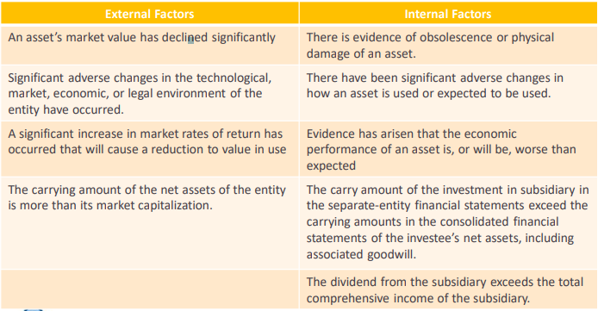
Intangible Assets with Indefinite Useful Lives
- Not subject to amortization is tested for impairment annually.
Cash-Generating Units Definition
- business divides itself into separate cash-generating units, each of which has cash inflows from an asset or a group of assets that are largely independent of the cash inflows from other assets or asset groups
- Goodwill resulting from a business combination should be divided among each cash-generating unit that will benefit from the goodwill
Cash-Generating Units and Goodwill
- Goodwill is allocated to cash-generating units as follows:
  - The total value of the subsidiary is allocated to each cash-generating unit
  - The FV of the subsidiary’s individual net assets is also allocated to each cash-generating unit.
  - For each cash-generating unit, the allocated value is compared with the fair value of the unit’s identifiable net assets.
  - The difference = goodwill of the cash-generating unit
  - Sum of each cash-generating unit’s goodwill = total acquisition goodwill of the subsidiary
- Req significant prof judgment
- Then the recoverable amount of each cash-generating unit is compared to its carrying amount, including goodwill. If recoverable amount > carrying amount then no goodwill impairment
- Recover Amount = Greater of
  - Fair Value of all of the net assets within the CGU – Cost to sell net assets
  - Value in use (Present value of future cash flows)
- When the carrying amount of the cash-generating unit goodwill exceeds the recoverable amount of the goodwill, an impairment loss should be recognized in an amount equal to the excess and should be allocated to the assets of the unit in the following order:
  - First, to reduce the carrying amount of any goodwill and
  - Second, to the other assets of the unit pro rata based on the carrying amount of each asset
Reversing an Impairment Loss
- Cannot reverse impairment losses on Goodwill
- Impairment can be reversed under IFRS on assets other than Goodwill if various conditions are met.
- Impairment losses cannot be reversed under ASPE for any assets
Acquisition Differential Assigned to Liabilities
- Interest rate changes result in differences between fair values and carrying amounts of liabilities assumed in a business combination.
  - This difference is similar to a bond premium or discount that must be amortized over its remaining life
- The effective interest method should be used to account for financial assets and liabilities
- Under IFRS, the acquisition differential related to bonds payable should, theoretically, be amortized using the effective interest method.
Intercompany Receivables and Payables
- All transactions between the parent and its subsidiaries, or between the subsidiaries of a parent, must be eliminated in the consolidation process to reflect this single-entity concept

Chapter 6

Intercompany Revenue & Expenses
- Intercompany transactions are recorded in the books of each of the individual legal entries.
  - These amounts would be included in separate entity financial statements, and reported on separate entity income tax returns
- However, in the consolidated financial statements:
  - All intercompany sales or other intercompany income must be eliminated against the related purchase or intercompany expense.
  - All intercompany balances (including receivables and payables) are eliminated against each other.
  - Income should be recognized only when it is earned in a transaction with an outsider
- The selling company will generally have recorded a profit on the intercompany sales.
  - These profits are “unrealized” because they are only within the combined entity, they are not objectively measurable, and are not with an arm’s-length outsider.
  - Intercompany sales do not reflect the culmination of the earning process.
  - These unrealized profits, must be eliminated net of related income taxes paid.
Intercompany Profits in Assets
- If all or a portion of these assets have not been sold outside the group, we must eliminate the remaining intercompany profits and may need to eliminate the intercompany loss from the consolidated statements.
- There are three types of unrealized intercompany profits (losses) that are eliminated:
  - Profits in inventory
  - Profits in non depreciable assets
  - Profits in depreciable assets
Upstream versus Downstream
- Downstream transactions: when the parent sells to its subsidiary.
  - Non-controlling interest is not affected by intercompany profits made on downstream transactions.
- Upstream transactions: when the subsidiary sells to the parent or another subsidiary of the parent.
  - Non-controlling interest is affected and will share in intercompany profits made on upstream transactions.
Holdback of Inventory Profits
- An adjustment for income taxes relating to the unrealized profits needs to be made (Income tax should be expensed in the same period as profit).
- Since income taxes are calculated at the individual company level rather than the consolidated-entity level, the company that recorded the profit also paid or accrued income taxes on that profit and therefore the income tax expense on its income statement would reflect this
- The difference between the buyer’s tax basis and the cost of transferred assets as reported in the consolidated financial statements meets the definition of a temporary difference and will give rise to deferred income taxes.
Intercompany Profits in Inventory
- First year
  - Cost of goods sold is increased as ending inventory is decreased to its original cost
  - The profit is held back until realized through sale to outsider
  - A deferred tax asset is established
- In subsequent year:
  - Cost of goods sold is decreased as beginning inventory is decreased to original cost
  - The profit is now realized in the financial statements
  - Income tax expense is increased
Losses on Intercompany Transactions
- Selling an asset at a loss raises the question of whether the loss reflects the fair value and an impairment
  - If impairment is present the asset should be written down to its net realizable value
  - If not present loss should be eliminated
Intercompany Land Profit Holdback
- The selling company will normally recognize a gain or loss on the sale, and the buying company will record the assets at the price charged by the seller.
- The gain or loss on these intercompany sales is always unrealized to the group until and unless the asset is subsequently sold to a buyer outside the group.
  - The unrealized intercompany gain must be eliminated
- All adjustments are made with the objective of presenting the statements of the group to report as if the transaction between the companies had never taken place
- Implications of intercompany transactions:
  - The intercompany gain and associated income taxes are eliminated on the income statement in the year of the sale
  - The asset is restated to its original cost on any balance sheet prepared after the intercompany sale
  - This is repeated each period until the asset is sold to an outside party.
  - Retained earnings is adjusted for the effect to the elimination and change in asset value
    - This adjustment is repeated every period until (and unless) the asset is sold outside the corporate group

Chapter 7
Intercompany Profits in Depreciable Assets
- Transactions usually are recorded at the market value of the assets transferred.
- The selling company will record a gain (or loss) on the sale, and the buying company will record the assets at the price it paid, often higher than the original cost of the assets to the combined entity.
  - Unrealized gain until sold to a 3rd party
- Gain or loss is eliminated in the consolidated financial statements
- If the intercompany transaction involves depreciable assets, there are further adjustments to be considered in later periods, including depreciation
- The intercompany sales of depreciable assets at a profit or loss results in depreciation being recorded by the buying company at an amount that is different than what the selling company would have recorded on the historical cost basis if the transaction had not occurred.
  - The buying company has a different (higher or lower) cost basis than the original cost paid by the seller
  - The amount of depreciation recorded in the buyer’s books will be greater (lesser) than the depreciation that would have been recorded based on the historical cost to the consolidated entity.
- The incremental depreciation, which is the portion that is not based on historical cost to the group, must be eliminated.
  - Incremental dep n in later periods may also be thought of as the realization of the intercompany gain or loss through the process of consumption of the value of the asset
- The depreciation expense which remains on the consolidated financial statements after eliminating the incremental depreciation is the amount that would have been recorded by the seller, based on the original cost of the asset to the group, as if the intercompany sale had not occurred.
- Income tax
  - All intercompany unrealized gains or losses affect net earnings “net of tax”
  - Deferred income tax (on the balance sheet) is computed on the outstanding balance of the unrealized gain or loss at the balance sheet date
- Upstream gains and losses
  - Allocate portion of the unrealized upstream gain/loss of depreciation and tax to income statement non-controlling interest
  - To compute balance sheet non-controlling interest, adjust shareholders’ equity of subsidiary for unrealized upstream gain/loss net of depreciation and tax
Chapter 8

Consolidated Cash Flow Statement
- Must include the operating, investing, and financing cash flows of the corporate group, to the extent that these cash flows have taken place with parties outside of the combined group and not within the group
- Consolidated cash flow statement by using comparative year-end consolidated balance sheets and income statements
- Must adjust the following
  - The cash, if any, paid for the acquisition of a subsidiary is presented net of the subsidiary’s cash required at that date. • The acquisition differential is amortized in the consolidated income statement but does not affect cash flows. • Non-controlling interest in the consolidated income statement is an allocation of the entity’s net income and does not affect cash flows. •Dividends paid by subsidiaries to the parent company do not change the combined entity’s cash. •Dividends paid by subsidiaries to non-controlling shareholders are disclosed separately from dividends paid by the parent to its shareholders
- In the period that a subsidiary is acquired:
  - Cash paid to acquire the subsidiary, less cash held by the subsidiary, is netted and disclosed on one line under “investing Activities” on the cash flow statement as: “Acquisition of subsidiary, less cash acquired in acquisition”
  - Details are disclosed in the notes
Subsidiary with Preferred Shares Outstanding
- When there are preferred shares in the capital structure of the subsidiary, total shareholders’ equity of the subsidiary must be allocated among the interests of the various classes of shares on the basis of their respective rights and preferences
  - Preferred shares owned by external shareholders are presented as part of non-controlling interest. • All common and preferred shares owned by the parent are eliminated.
- Preferred shareholders have a non-controlling claim on:
  - Preferred share capital • Preferred dividends (as a claim on current income of the subsidiary) • Preferred dividends in arrears, if the preferred shares have cumulative dividend rights • Redemption premiums, if the preferred shares are redeemable for greater than their cost
- These non-controlling claims of preferred shareholders are “reserved”, or set aside, in NCI by reducing equity available to the common shareholders
Example:
- P bought 80% of S common shares for $500,000 on January 1, Year 1 • S net income for Year 1 = $120,000 and S paid $10,000 of dividends to its common shareholders in Year 1. There were no intercompany transactions during the year. • On January 1, Year 1 the book values of S’s assets and liabilities equalled their fair values, and S’s equity consisted of: • $80,000 Preferred Shares: 10,000, 10% cumulative, stated value $8, redeemable at $9 • $50,000 Common Shares: 50,000 • $400,000 Retained earnings • Preferred share dividends were 2 years in arrears on January 1, Year 1
- 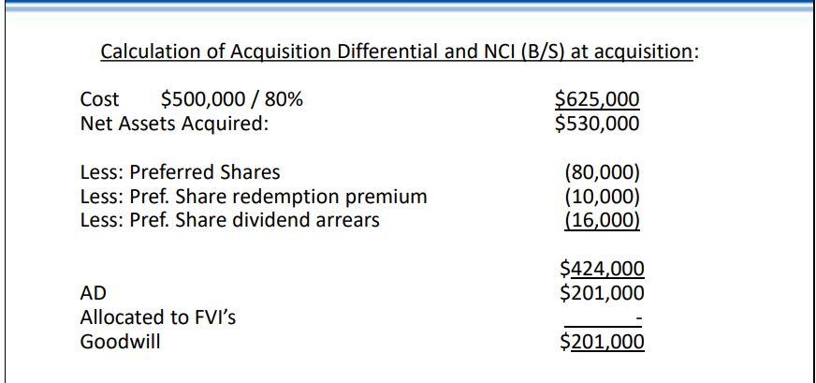
- 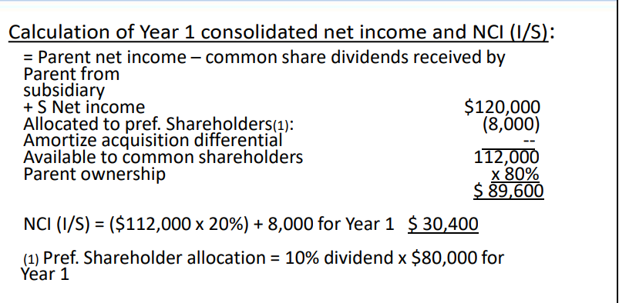
Changes in Parent’s Ownership Interest
- May change because
  - The parent buys additional shares of the subsidiary • The parent sells some of the shares of the subsidiary • The subsidiary issues additional common shares to the public, and the parent does not maintain its previous ownership percentage • The subsidiary repurchases some of its common shares from the non-controlling interest
- Increases in Ownership
  - Investments that do not provide control: account for as FVTPL, FVTOCI, Investment in Associates
  - Once control is reached, the investment account is adjusted to fair value, the fair value increase is:
    - Taken into income if the increase in % ownership went from FVTPL to Control or Investment in Associate to Control
    - Taken into retained earnings if the increase in % ownership went from FVTOCI to Control
Chapter 9
Joint Arrangements
- All subs have = voting rights
- Joint Control – is the contractually agreed sharing of control of an arrangement, which exists only when decisions about the relevant activities require the unanimous consent of the parties sharing control.
- 2 types
  - Joint venture: is an arrangement whereby the parties that have joint control of the arrangement have rights to the net assets of the arrangement.
    - An entity is a party to a joint venture when the separate vehicle has the rights to the assets and responsibility for the liabilities. • In joint ventures, the venturers contribute assets to a separate legal entity, which has title to the assets.
  - Joint operation: each operator contributes the use of assets or resources to the new activity but retains title and control of these assets and resources
    - Example would be a case in which one operator manufactures part of a product, a second operator completes the man
Accounting for Joint Operations
- According to IFRS 11.20, a joint operator must recognize, in relation to its interest in a joint operation
  - Its assets, including its share of any assets held jointly; • Its liabilities, including its share of any liabilities incurred jointly; • Its revenue from the sale of its share of the output arising from the joint operations; • Its share of the revenue from the sale of the output by the joint operations; • Its expenses, including its share of any expenses incurred jointly
Accounting for an Interest in a Joint Venture
- Under IFRS 11 the venturer must use the equity method to report its investment in a joint venture
  - Venturer recognizes its share of the income earned by the joint venture as “Income from Joint Venture” as one line on the income statement and “Investment in Joint Venture” as one line on the balance sheet.
- The following adjustments are required for its share for:
  - • Allocation and amortization of acquisition differentials • Unrealized profits from intercompany transactions • Contributions to the joint venture
- For a joint venture, the venturer’s share of any intercompany asset profits is eliminated
- On the date of formation of a joint venture, instead of contribution cash, a venturer contributes non-monetary assets and receives an interest in the joint venture and that the assets contributed have a fair value that is greater than their carrying amount in the records of the venturer
- IAS 28 requirements:
  - The investment should be recorded at the fair value of the non-monetary assets transferred to the joint venture. • Only the gain represented by interests of the other non related venturers should be recognized on the date of the contribution and only if the transaction has commercial substance as the term is described in IAS 16. • If the transaction does not have commercial substance, then the entire gain is considered to be unrealized unless the venture receives assets in addition to an interest in the joint venture. • The portion of the gain represented by the venturer’s own interest should be unrealized until the asset has been sold to unrelated outsiders by the joint venture. • If a loss results from the recording of the investment, the portion of the loss represented by the interest of the other unrelated venturers is recognized immediately into income. When it is evident that the asset contributed to the joint venture is impaired, the entire loss is immediately recognized.
Deferred Income Taxes and Business Combinations
- A business combination may increase the future likelihood that operating loss carryforwards may be utilized, either as a result of intercompany revenues or reduced costs as a result of the combination.
  - • Previously unrecognized operating loss carry forwards of the subsidiary may be recognized at the time of a business combination as part of the allocation of the acquisition differential, providing that it is probable that the benefits will be realized. • Operating loss carry forwards previously recognized by the subsidiary as deferred tax assets will be allowed to stand • Allocation of the acquisition differential to additional deferred income taxes reduces goodwill.
IFRS 8 – Operating Segments
- An entity shall disclose information to enable users of its financial statements to evaluate the nature and financial effects of the business activities in which it engages and the economic environments in which it operates.
- An operating segment is a component of an entity:
  - (a) that engages in business activities from which it may earn revenues and incur expenses (including revenues and expenses relating to transactions with other components of the same entity), (b) whose operating results are regularly reviewed by the entity's chief operating decision maker to make decisions about resources to be allocated to the segment and assess its performance, and (c) for which discrete financial information is available.
Reportable segments
- Must
  - Meets the definition of an operating segment
  - Exceeds the quantitative thresholds
- An entity shall report separately information about an operating segment that meets any of the following quantitative thresholds
  - Its reported revenue, including both sales to external customers and intersegment sales or transfers, is 10 per cent or more of the combined revenue, internal and external, of all operating segments.
  - The absolute amount of its reported profit or loss is 10 per cent or more of the greater, in absolute amount, of (i) the combined reported profit of all operating segments that did not report a loss and (ii) the combined reported loss of all operating segments that reported a loss. •
  - Its assets are 10 per cent or more of the combined assets of all operating segments.
Disclosure Requirements
- An entity shall disclose information to enable users of its financial statements to evaluate the nature and financial effects of the business activities in which it engages and the economic environments in which it operates.
- Need to disclose general information about each operating segment, specifics about income numbers, and non- current assets.

Chapter 10

Introduction
- When the agreement calls for the transaction to be settled (paid) in foreign currency, this means one of the two things:
  - If the transaction is a purchase, the Canadian company will have to acquire foreign currency in order to discharge the obligations resulting from its imports.
  - If the transaction is a sale, the Canadian company will receive foreign currency as a result of its exports, and will have to sell the foreign currency in order to receive Canadian dollars.
- In a foreign-currency-denominated transaction, accounting issues arise when the value of the Canadian dollar has changed relative to the value of the foreign currency between:
  - The time the transaction occurs and • The date at which the financial statements are reported with the foreign-currency-denominated receivable or payable, and • The date of receipt or payment (“settlement”) of the foreign-currency-denominated receivable or payable
Exchange Rate Quotations
- spot rate is the rate to exchange currency today
- A forward exchange contract is an agreement between a bank and a customer to exchange currencies on a specified future date at a specified rate.
- The forward rate is the rate agreed to today for exchanging currency at a future date
Def
- Functional Currency: The currency of the primary economic environment in which the entity operates.
- Foreign Currency: Any currency other than the functional currency.
- Presentation Currency: The currency in which financial statements are presented.
Monetary and Non Monetary Items
- Monetary Item: Essential feature of a monetary item is a right to receive (or an obligation to deliver) a fixed or determinable number of units of currency.
  - Examples: • Accounts Receivable • Accounts Payable • Cash • Investments
- Non Monetary Item: Non-monetary item is the absence of a right to receive (or an obligation to deliver) a fixed or determinable number of units of currency
  - Assets a company holds for which it is not possible to precisely determine a dollar value.
  - Examples: • Prepaids • Inventory • Goodwill/Intangibles • PPE
Accounting for Foreign Currency Transactions
- Individual transactions must be translated into the functional currency at the historical rate on the date of the transaction
- For revenue and expense transactions, an average rate for the year can be used if there isn’t much fluctuation
- At the end of each reporting period, monetary items must be translated using the closing rate/spot rate
- Non-Monetary Items are not revalued @ the end of the period.
Forward Exchange Contracts
- A forward contract is a financial instrument that must be measured at fair value throughout its life. When the forward rate changes, the fair value of the forward contract changes.
Hedges
- This type of protection is generally referred to as “hedging” which can be defined as a means of offsetting the risk exposure rising from foreign exchange (or interest rate, or price) fluctuations from those who wish to avoid it to those who are willing to assume it.
- The hedged item is the item with the risk exposure that the entity has taken steps to mitigate. A hedging instrument is the item used to offset the risk exposure
- 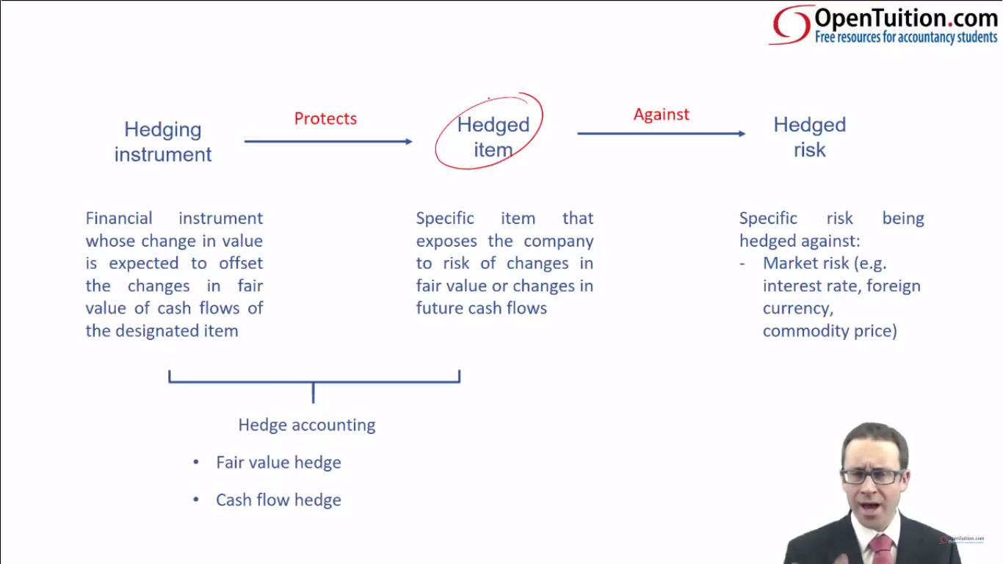
Hedge Accounting
- Hedge accounting is optional. An entity can choose to apply hedge accounting if it wishes and if the conditions for its use are present, but does not necessarily have to use it
- Under hedge accounting, the exchange gains or losses on the hedged item will be recognized in the income statements in the same period as the exchange gains or losses on the hedging item when they would otherwise be recognized in different periods.
- A derivative is a financial instrument or other contract whose value changes in response to the change in some underlying variable, which requires no initial investment, and which will be settled at a future date.
- Hedges can be designated for accounting purposes as fair value hedges or cash flow hedges
  - Fair value hedge:
    - The entity uses a hedging instrument to hedge against the fluctuation in the fair value of the hedged item. • This method will be used when the hedged item will be measured at fair value. • The gain or loss in the fair values of the hedging instrument and hedged items are both recognized in profit or loss in the period of the change in values.
  - Cash flow hedge:
    - The entity uses a hedging instrument (such as derivative) to hedge against the fluctuation in the Canadian-dollar value of future cash flows (such as future sales). • The gain or loss on the hedging instrument is initially reported in OCI and subsequently reclassified to profit when the hedged item affects profit.
Chapter 11

Translation of Foreign Operations
- IAS 21 defines a foreign operation as an entity that is a subsidiary, associate, joint arrangement or branch of a reporting entity, the activities of which are based or conducted in a country or currency other than those of the reporting entity
- There are two methods used under IAS 21 to translate the financial statements of a foreign operation:
  - The functional currency translation method (FCT): used to translate the financial statements of a foreign operation from its recording currency to its functional currency.
  - The presentation currency translation method (PCT): used to translate the financial statements of a foreign operation from its functional currency to a different presentation currency
Functional Currency Determination Primary Indicators
- 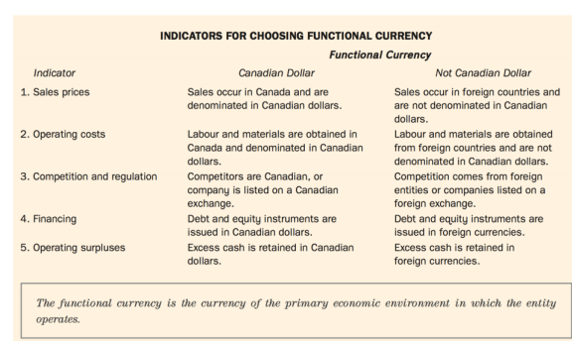
The Functional Currency Translation Method
- FCT method give the same results as if the transactions had occurred in functional currency in the first place.
- Historical exchange rates to translate revenues and expenses.
- Use average rates to approximate historical exchange rates throughout the period.
- Use historical rates to measure expenses based on the historical cost of the related balance sheet items.
- 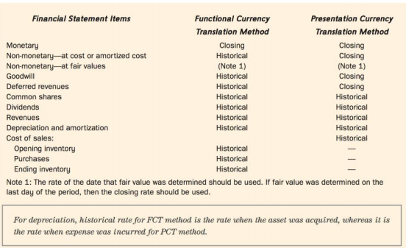
- When the parent acquires the subsidiary, the parent indirectly buys all of the net assets of the subsidiary. For consolidation purposes, we never use an exchange rate older than the rate at the date of acquisition.
- Shareholders’ equity accounts are translated at historical rates
- COGS and depreciation expense are translated using the historical rates of the related balance sheet accounts.
- Assets to be reported at fair value are translated at the closing rate and assets to be reported at cost are translated at the historical rates.
- Exchange gains or losses only occur on items translated at the closing rate.
  - Monetary items
- The exchange gain or loss is reported in net income under the FCT method.

- 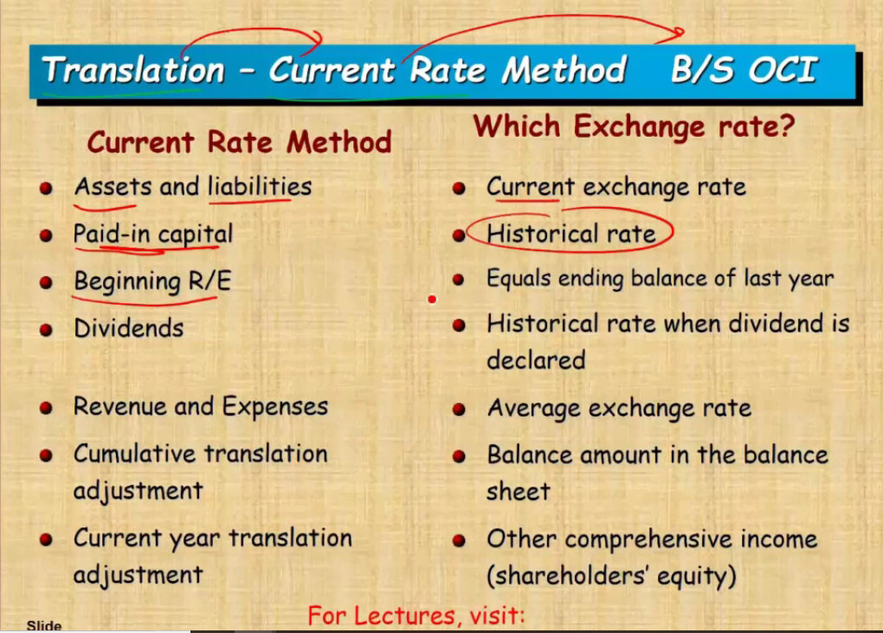
The Presentation Currency Translation Method
- Used for translating a foreign operation from its functional currency to a different presentation currency.
- All assets and liabilities should be translated at the closing rate
- This method is much simpler than the FCT method because it uses the same rate for all assets and liabilities. This maintains the relationship between assets and liabilities when switching from the functional currency to the presentation currency.
- Share capital is translated at historical rates.
- All revenues and expenses are translated using the exchange rate in effect on the dates on which such items are recognized in income during the period.
- Exchange gains and losses occur only on those items translated at the closing rate and only if the rates change during the period.
- Accumulated Other Comprehensive Income
  - When translating from the functional currency to the presentation currency, your assets will not balance with your shareholders equity section (Assets and liabilities translated using the year end spot rate, while income translated using average rate
  - A “plug” is used to allow your balance sheet to balance. This is called the “Accumulated Translation Adjustments”
  - This foreign exchange difference impacts other comprehensive income and NOT the income statement.
Other Considerations
- Lower of cost and net realizable value (LCNRV):
  - Under the FCT method, the LCNRV principle must be applied using historical cost in Canadian dollars and net realizable value in Canadian dollars.
  - Inventory is translated at the closing rate under the PCT method and the LCNRV principle need not be applied.
- Intercompany profits:
  - The historical rate should be used in determining the intercompany profit to be eliminated. This eliminates the profit that was recorded in the first place.
  - When the profit is contained in the assets of the subsidiary and the PCT method is used, the asset has been translated at the closing rate. The historical exchange rate should be used to calculate the amount of the profit. This eliminates the same profit that was recorded in the first place. However, the translated assets will not be reported at historical cost to the consolidated entity. This is one of the anomalies of the PCT method
ASPE Differences
- Functional Currency translation known as the temporal method.
- Presentation currency translation known as current rate method (OCI does not exist under ASPE, therefore OCI differences reported under a separate component of shareholders’ equity)
- Instead of determining functional currency, ASPE distinguishes between self sustaining or integrated operations.
- Self Sustaining Operation = Current Rate Method
- Integrated Operation= Temporal Method.
Current rate method
- 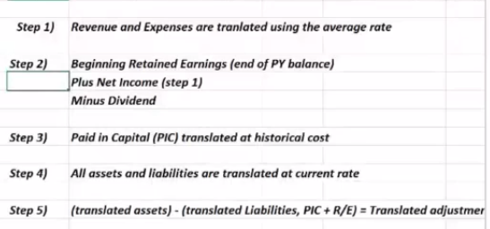
Temporal Method
- 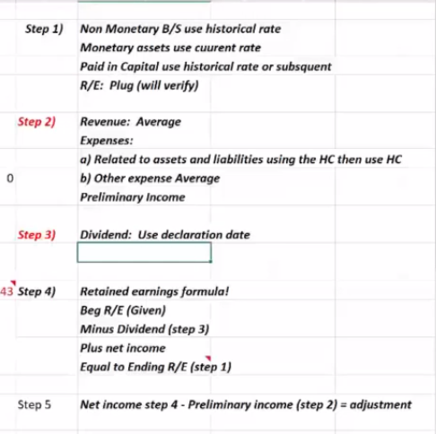

Chapter 12

Not For Profit Accounting Standards
- 2 sectors
  - The public NFP sector – e.g. Hospitals that are controlled by the government.
    - These NFPOs have a choice to follow the CPA Canada Public Sector Accounting (PSA)
  - The private NFP sector – includes NFPOs that are not controlled by the government.
    - They have the choice to follow either IFRS or Part III Accounting Standards for NFPOs of the CPA Canada Handbook
NPO Financial Statements (Section 4400)
- Must present the following financial statements for external reporting purposes:
  - Statement of Operations • Statement of Financial Position • Statement of changes in net assets (Equity Statement) • Statement of cash flows
Inventory
- A NFPO may receive inventory without any cost and may have no intention of ever selling the inventory
- NFPO measures inventories at the lower of cost and current replacement cost (instead of NRV) if distributed at no charge
Revenue (Section 4410)
- An NFPO can have two basic types of revenues:
  - Contributions (in cash or in kind)
  - Other types (investments, the sale of goods and services)
- Types of contributions
  - Restricted Contributions: Donations which are subject to externally imposed stipulations as how the funds are to be used.
  - Unrestricted Contributions: Donation that can be used for any purposes that are consistent with goals and objectives of the organization.
  - Endowment Contribution: The donor has specified that the contribution cannot be spent, but must be maintained permanently. Investment income earned from donation can then be restricted or unrestricted.
Capital Assets (Section 4431)
- Required to capitalize and amortize capital assets
- An exemption from the requirement to capitalize is granted to small NFPOs (two year average revenues < $500,000)
  - Small NFPO has the following choice
    - Expense when acquired • Capitalizing but not amortizing • Capitalizing and amortizing
Collections Held
- Collections are works of art and historical treasures
- A NFPO has the following choices for collections:
  - Expense when acquired •Capitalize but not amortize •Capitalize and amortize
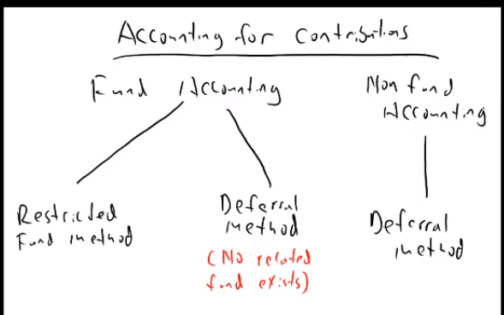
Fund Accounting
- Comprises the collective accounting procedures resulting in a self-balancing set of accounts for each fund established by legal, contractual, or voluntary actions of an organization. Fund accounting involves an accounting segregation, although not necessarily a physical segregation, of resources.
Accounting for Contributions
- 3 options to acc for contributions
  - The deferral method can be used while using fund accounting
  - The deferral method can be used when not using fund accounting
  - The restricted fund method can be used when using fund accounting
Restricted Fund Method
- The restricted fund method requires a NFPO to report a general fund, at least one restricted fund, and, if it has endowments or receives endowment contributions, an endowment fund.
- The restricted funds will be used to record externally restricted revenue as well as any restricted income generated from endowment fund investments.
- The endowment fund, which must be maintained in perpetuity will show only contribution revenue and no expenses.
- The general fund reflects all unrestricted contributions and investment income including any unrestricted income generated from endowment fund investments. Using the deferral method, the general fund also reports restricted contributions and investment income for which no separate restricted fund exists.
- Contributions are reported as revenue when received/receivable if a separate restricted or endowment fund has been established for these contributions.
- Fund balances for the restricted and endowment funds represent the amount of net assets restricted for that fund’s purpose.
- General Fund - captures the agency’s operating activities.
- The deferral method is used for any restricted donations for which no fund exists.The deferral method is used within the General Fund
- 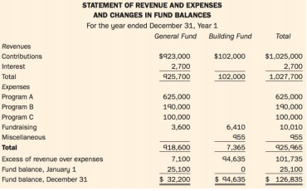
The Deferral Method
- Matches contribution revenues with related expenses.
- Unrestricted contributions are reported as revenue in the period received or receivable, because there are no particular related expenses associated with them.
- Endowment contributions are not shown on the operating statement; rather they are reflected in the statement of changes in net assets because they will never have related expenses.
- Restricted contributions are matched against related expenses.
- Restricted contributions for future expenses are deferred and recognized in revenue in the same periods as related expenses.
- Restricted contributions for expenses of the current period are recognized as revenue in the current period.
- Contributions for a depreciable asset are recognized as revenue as the asset is being amortized.
Donated Capital Assets, Materials, and Services
- NFPO has the option of reporting or not reporting donated material and services
  - Only report if FV can be determined, materials and services would normally be used in the organization’s operations and would have been purchased if they have not been donated.
- Eg A not for profit needs someone to do their accounting records, and they would have paid $1,000 for these services. They can choose to record this transaction on their books or not. If they record it, the following would be the entry:
  - Accounting Services Expense $1,000
Accounting Services Contribution $1,000
Donated Capital Assets (Land – Deferral Method)
- A NFPO is required to record the donation of capital assets at fair value. If fair value cannot be determined, a nominal value will be used.
- If the donated capital is not depreciated (like land), the transaction is recorded as a direct increase to Net Assets
- Eg Land of $50,000 is donated to a not for profit Journal Entry:
Debit – Land - $50,000 Credit – Net Assets - $50,000
Donated Capital Assets (Equipment – Deferral Method)
- A NFPO is required to record the donation of capital assets at fair value. If fair value cannot be determined, a nominal value will be used.
- Under the deferral, revenue is recorded the same was depreciation for the equipment is recorded
- Eg: Equipment worth $50,000 is donated to an NPO that has a 5 year useful life
  - Year 1 Journal Entries:
    - Debit-Equipment- $50,000
    - Debit - Depreciation Expense- $10,000
    - Debit- Deferred Contribution Revenue - $10,000
    - Credit-Deferred Contribution Revenue - $50,000
    - Credit- Accumulated Depreciation - $10,000
    - Credit- Contribution Revenue- $10,000
Donated Capital Assets (Equipment – Restricted Fund Method)
- A NFPO is required to record the donation of capital assets at fair value. If fair value cannot be determined, a nominal value will be used.
- Under the deferral, revenue is recorded the same was depreciation for the equipment is recorded
- Eg: Equipment worth $50,000 is donated to an NPO that has a 5 year useful life
  - Year 1 Journal Entries:
    - Debit-Equipment- $50,000
    - Debit- Deferred Contribution Revenue - $10,000
    - Debit - Depreciation Expense- $10,000
    - Credit-Deferred Contribution Revenue - $50,000
    - Credit- Accumulated Depreciation - $10,000
    - Credit- Contribution Revenue- $10,000

