Carleton University
Experiment Summary
Course #: Biol 2104 Experiment #: 1

Endomitosis in Drosophila virilis
Hussein Assaf
101036733

Lab Period: Thursday PM
Bench 22

Introduction:
The purpose of this experiment was to investigate the phenomenon known as endomitosis in Drosophila virilis. The variation of the typical mitotic cell division that results in a cell having up to 1 000 copies of the genome due to the production of duplicated chromosomes without division, that is the phenomenon known as endomitosis. When endomitosis occurs, the chromosomes become tangled together and form a large structure called a polytene chromosome. Polytene are much larger in size than normal chromosome, ranging about 200 μM as opposed to a normal chromosome which is only 1-2 μM. Secondly, all polytene chromosomes are associated and remain attached at their centromeres, as opposed to separating into discrete structures. Lastly, polytene chromosomes have an alternating light and dark bands. The hypothesis tested in this experiment is that endomitosis also occurs in the salivary glands of third instar Drosophila virilis larvae. (Pulsifer, 2018)
Strategy:
In this experiment, the third instar larvae of D. viliris was dissected to inspect whether or not endomitosis has occurred in its salivary glands, and as a result, the null hypothesis would be accepted or rejected depending on the outcome. A dissecting microscope was used to dissect and isolate the salivary glands, which were then stained with aceto-orcein. The presence of polytene chromosomes were then tested under a microscope. The null hypothesis was then accepted if the polytene chromosomes were present in the salivary glands, and if the polytene chromosomes were not present, then the alternate hypothesis would be accepted instead, which is that endomitosis does not occur in the salivary glands if third instar D. virilis larvae.
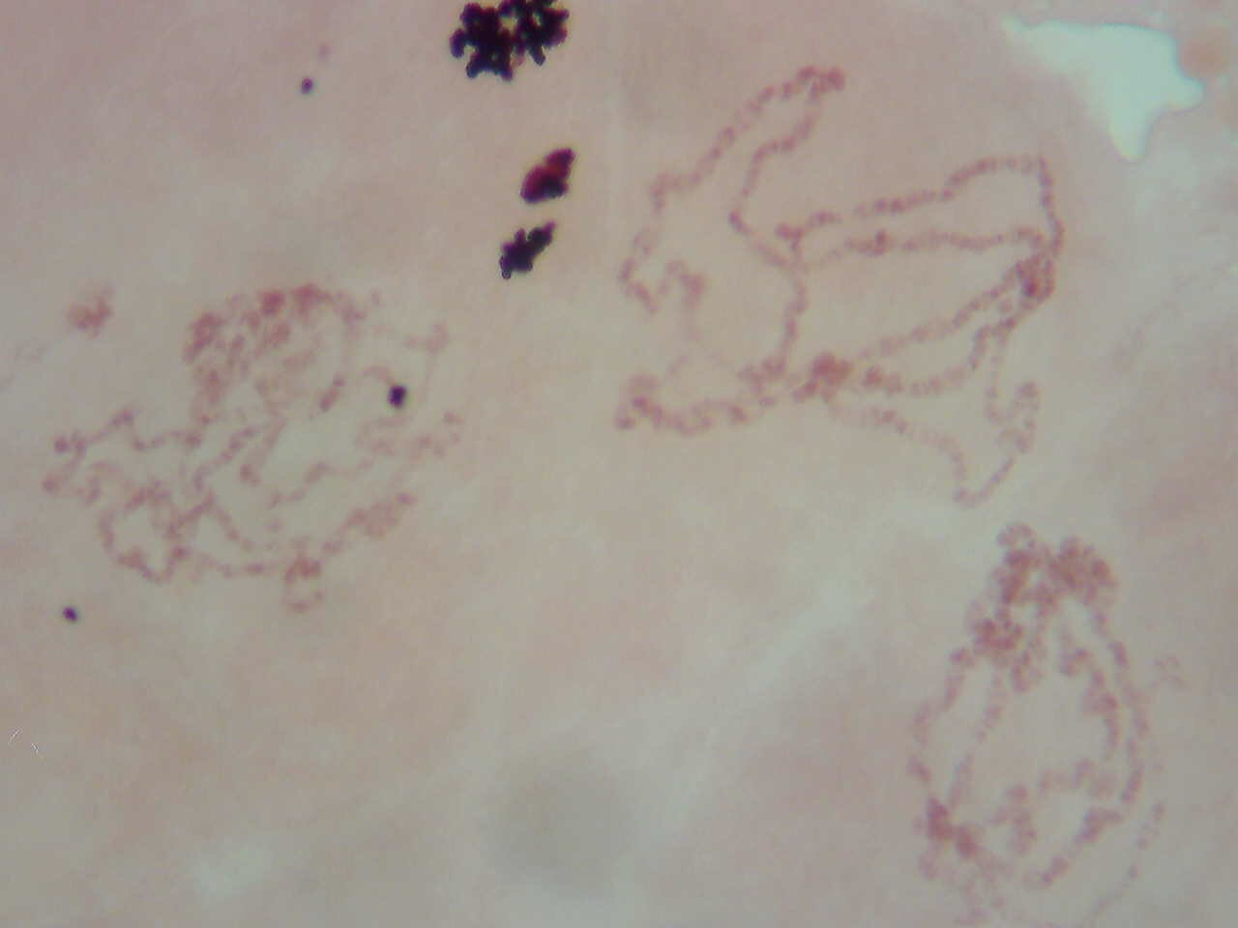
Results
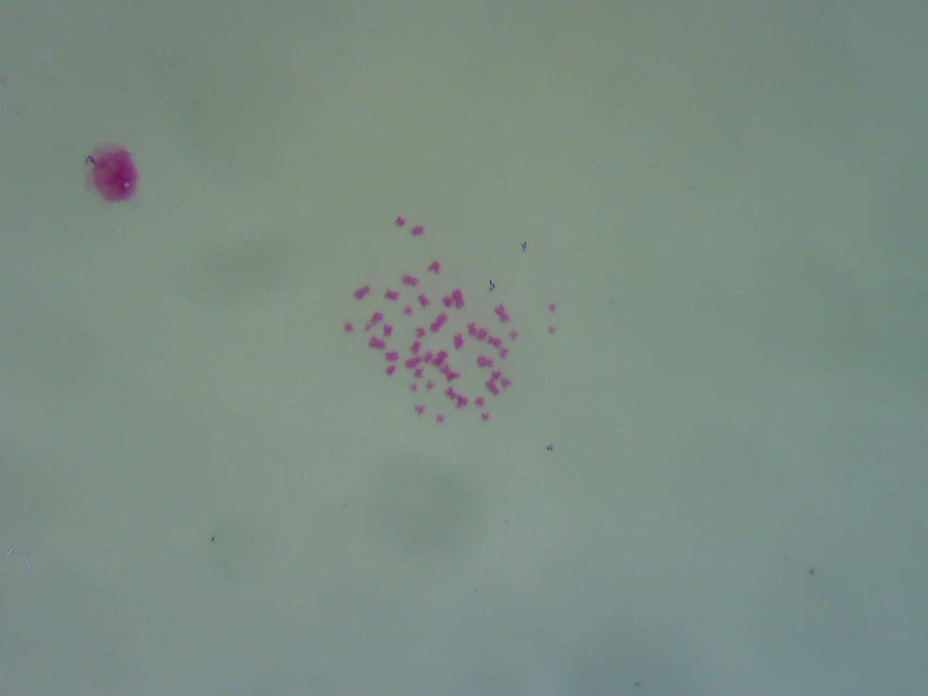
Figure 1: Salivary glands of D. virilis Figure 2: Human chromosome
The figures were taken using MotiCam X cameras, at a 400X total magnification. The polytene chromosomes are clearly visible in the first figure. It appears as if there are multiple arms attached to a single chromocenter, which is unique to polytene chromosomes. Several chromosomes are attached to a single chromocenter instead of separating into discrete structures. Human chromosomes look like small dots, there are numerous chromosomes that are discrete and independent of each other, unlike the polytene chromosomes which are all attached to one another. The figures were taken from my lab partner, Archan Datta.
Discussion
The hypothesis to be tested was that endomitosis also occurs in the salivary glands of third instar D. virilis larvae. Figure 1 is a representation of what polytene chromosomes would look like as opposed to the normal human chromosomes. The polytene chromosomes were really long and are all attached at the same chromocenter, while the human chromosomes which did not undergo endomitosis, have numerous very short chromosomes, each containing their own chromocenter. The human chromosomes have the appearance of small dots, while the D. virilis chromosomes in the salivary glands look like multiple arms are attached to one center, which are unique to cells which have undergone endomitosis, known as polytene chromosomes. In conclusion, since the polytene chromosomes were present in the salivary glands of D. virlis, the null hypothesis is accepted, which states that endomitosis also occurs in the salivary glands of third instar D. virilis larvae.
References
Biol 2104, Introduction to genetics. Laboratory manual, 2018.
Painter, T. S., & Reindorp, E. C. (1939). Endomitosis in the nurse cells of the ovary of drosophila melanogaster. Chromosoma, 1(1), 276-283.
Ashburner, M. (1970). Function and Structure of Polytene Chromosomes During Insect Development. Advances in Insect Physiology, 1-95.

