What does the order of ingredients signify?
- Nutrients that provides calories are listed below calories
- Macronutrients are listed together
- Nutrients between first and second thick lines:
- All nutrients with a Daily Value should be limited
- Fat
- Saturated & Trans fat
- Sugars
- Sodium

What are the changes regarding sugars?
- % Daily Value for Sugar is added
* %DV is a standard nutrient amount, used to indicate how much of nutrient is in a food.
(<5%: is a little; >30%: is a lot)
- Current: Sugar = Sucrose = disaccharide of glucose & fructose (white sugar, table sugar)
- Proposed: Sugars = Any monosaccharide or disaccharide found in food

How do you compare/contrast the nutrient quality of two foods based on the labels?
- Compare the Nutrition Facts table on food labels -> chose products that contain less fat, saturated fat, trans fat, sugar and sodium
- Minimize total calories, sat/trans fat, sodium
- Maximize beneficial nutrients

Absorption of Fat vs Water Soluble Nutrients: know the differences
- Water soluble nutrients
- Absorbed from the small intestine directly enter the blood stream -> Hepatic portal vein -> liver -> tissue and organs
- Fat soluble nutrients
- Absorbed from the small intestine first, then enter the lymphatic system, and from the lymphatic system -> thoracic duct -> blood system -> tissues and organs -> liver
- Fat soluble vitamins
- Can be stored in the liver and adipose tissue
- Are not rapidly depleted from the body
- If intake is extremely high, can have toxic effects
- A, D, E, K
- Water soluble Vitamins
- Not stored in the body
- B vitamins and vitamin C
- Are rapidly depleted so need to be consumer regularly
- When consumed in excess, excreted in the urine

Calcium: Know the order of the foods discussed from the highest to lowest % calcium bioavailability.
- Cheddar cheese (360mg) > Sesame seeds (356mg) > plain yogurt 1% (332mg) > 1% milk (322mg) > Fortified Soy beverage (316mg) > Salmon (180mg) > Kale (96mg) > Almonds (95mg)
- Orange Juice (300mg) > Whole Mile (276mg) > Spinach (122mg) > Soybean (88mg) > kale (47mg) > Carrots (42mg) > Potato (26mg)

Digestive system hormones: know about the 3 hormones gastrin, secretin and CCK
- Gastrin
- Comes from stomach mucosa
- Stimulates secretion of hydrochloric acid (HCL) and pepsinogen by gastric glands in the stomach and increases gastric motility and emptying
- Secretin
- Comes from Duodenal mucosa
- Inhibits gastric secretion and motility
- Increases output of water and bicarbonate from the pancreas
- Increases bile output from the liver
- Cholecystokinin (CCK)
- Stimulates contraction of the gall bladder to expel bile into duodenum
- Stimulates the release of digestive enzymes from the pancreas
- Increases output of enzyme-rich pancreatic juice

Understand catabolism vs anabolism, and how this relates to energy production
- Catabolic pathways
- Breakdown glucose, amino acids and fatty acids into smaller molecules
- Result in the formation of adenosine triphosphate (ATP)
- ATP has high energy bonds, which when broken, provide energy to do work in the cell
- Anabolic pathways
- Use the energy from ATP and glucose, amino acids, fatty acids to synthesize complex biological molecules

Know all about the DRIs, the factors involved in them, and their differences (EER, AMDR, RDA, AI, UL)
- Dietary Reference Intakes (DRIs)
- For planning and assessing diets of healthy individuals
- Values for different life stages / genders
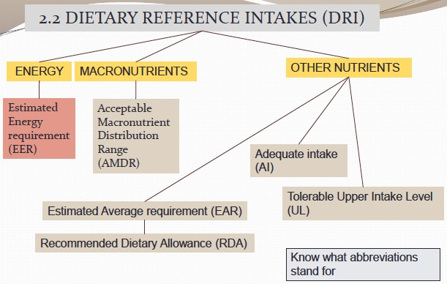
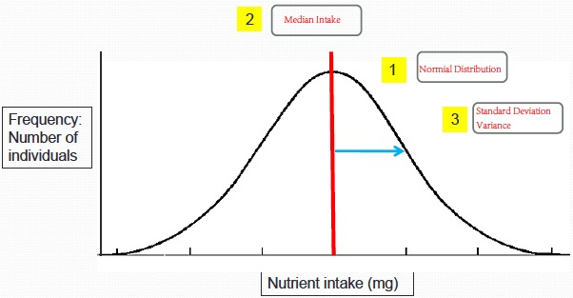
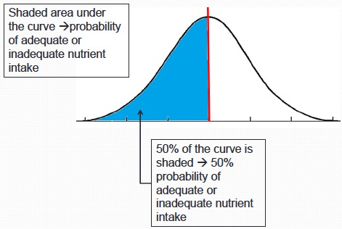
- EER
- Estimated energy requirement
- Men: EER = 662 – (9.53 x age [y]) + PA x (15.91 x weight[kg] + 539 x height [m])
- Women: EER = 354 – (6.91 x age[y]) + PA x (9.36 x weight[kg] + 726 x height[m])
- PA (physical activity term) = 1.00 (sedentary) -> 1.48 (very active)
- AMDR
- Acceptable macronutrient distribution range
- Expressed as percent % of total calories
- Carbohydrates: 45% - 65%
- Fat: 20% – 35%
- Protein: 10% - 35%
- Undesirable fats: as low as possible (saturated fat: <10% kcal/ <7% kcal; trans-fat: <1% kcal)
- AI
- Adequate intake
- Insufficient data to calculate an EAR, more research is needed
- Usually based on an estimate of average nutrient intake by a healthy population
- E.g., AI for calcium intake for young infants 0-6 months of age = 200mg
- Intake > AI, intake ok
- Intake < AI, may or may not be ok
- UL
- Tolerable upper intake level that is unlikely to pose a risk of adverse effects
- The highest amount of nutrient you can take in for each day of the rest of your life, it is not a desirable intake
- Some UL are based only on the amount of nutrient consumed in supplement form
- EAR
- Estimated average requirement
- Nutrient intake that meets the requirement of 50% of individuals in a group (e.g., sex, age)
- Used to estimate the probability that an individual’s usual intake is meeting his/her requirement
- Used to estimate what proportion of a group is meeting their requirements
- RDA
- Recommended dietary allowance, based on estimated average requirements
- Intake that ensures a 98% probability of meeting the requirement
- As a goal for an individual’s usual intake, because it is almost certainly adequate
- RDA = EAR + 2 Standard deviations

Understand the difference between EAR (individual) and EAR cut-point (population). Be prepared to interpret different graphs related to this.
- Individual EAR
- Individual EARs can be established by conducting a depletion-repletion experiment on a population of healthy adults. (E.g., Vitamin X)
- Depletion: fed a vitamin X-free diet to the individual -> levels of vitamin X in blood are tracked -> Eventually levels decline until no vitamin X is detected (e.g., the individual is deficient)
- Repletion: begin refeeding vitamin X -> blood levels of vitamin X begin to rise -> eventually each individual reaches an intake at which there is no corresponding rise in blood levels (blood is saturated with vitamin X) _. That Vitamin X intake is the individual’s vitamin X requirement
- The requirement is not the same for each individual due to genes, gender, etc
- From the vitamin X requirement distribution, the EAR can be determined.
- EAR represents the average daily nutrient intake that meets the requirement of half the healthy individuals in a given group
- If an individual’s nutrient intake is equal to the EAR then there is a 50:50 chance the individual is meeting his/her requirement
- E.g.,
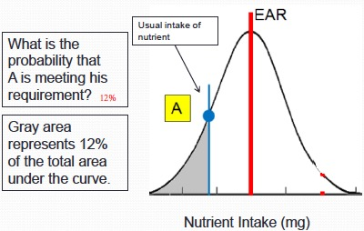
- Population EAR
- Using the EAR cut point method to determine the prevalence of adequate intake within a group
- EAR cut point method -> Intake distribution (results of a survey of nutrient intakes): To estimate what proportion of a group is meeting their requirements
- Proportion of the population whose intake is less than the EAR = Proportion of the population that is NOT meeting its requirement
- 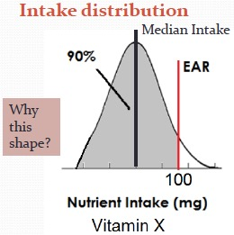
- Question: if two populations have the same median intake, does that mean that the proportion of the population is meeting its requirement is the same? Ans: Not necessarily.
- How well a population is doing with respect to nutrient intake depends on both the median intake and the standard deviation of the intake distribution
- Health Canada: if the proportion of a population whose intake is 10% or less below the EAR, then the population is considered to have an adequate intake.

Know how to calculate % calories for each of the macronutrients.
- Macronutrients:
- Carbohydrates: 4kcal/g
- Lipids (Dietary fat/fat): 9kcal/g
- Protein: 4kcal/g

Know about the enzymes for digesting each of the macronutrients.
- Carbohydrates: (各种Amylase, Dextrinase)
- Salivary amylase -> in mouth -> breaks starch into smaller carbohydrate molecules
- Pancreatic amylase -> breaks starch into shorter glucose chains and maltose
- Maltase: breaks maltose into glucose
- Dextrinase: breaks short chains of glucose into individual glucose molecules
- Lipids: (各种Lipase)
- Pancreatic lipase: breaks triglycerides into monoglycerides, fatty acids and glycerol
- Lipase: breaks monoglycerides into fatty acids and glycerol
- Protein: (Proteases, Rennin, Pepsin, Trypsin, Chymotrypsin, 各种peptidase)
- Rennin: in Stomach -> causes the milk protein casein to curdle
- Pepsin: breaks proteins into polypeptides and amino acids
- Trypsin: In pancreas -> breaks protein and polypeptides into shorter polypeptides
- Chymotrypsin: breaks proteins and polypeptides into shorter polypeptides
- Carboxypeptidase, aminopeptidase, dipeptidase: In small intestine ->breaks polypeptides into amino acids

Know the unique characteristics of breast milk and the infant gut.
- Colostrum contains immune factors to help protect the infant from infection particularly in the GI tract, antibodies pass from the mother’s bloodstream into the milk
- There is lactose in breast milk, behave like prebiotics, promoting the growth of lactobacillus bifidus, reduces the risk of gastrointestinal infections in the infant’s gut
- Breast milk is very high in fat, so that it can support the energy needs of the very rapid growth rate of the newborn
- Infants are able to absorb some proteins intact, antibodies in breast milk are absorbed intact and enhance the infant’s immune system
- Gastric lipase plays a more important role in the digestion of the fat in the infant than the child
- Pancreatic digestive enzymes are present in lower levels in the infant
- No starch in milk -> low amylase in the infant gut
- Instead, lactase is present in large amounts in brush border
- The production of lactase declines with age -> lactose intolerance

Understand the different mechanisms for moving nutrients across membranes.
- Simple diffusion
- Substances move from a region of higher concentration to an area of low concentration -> move down a concentration gradient
- In GI track, as good digesting, some food component can easily pass through the cell membrane and can move from the lumen (high) into the cell (low).
- Does not require energy
- Because cell membrane is made of lipids -> fat soluble components most commonly move into cells by simple diffusion
- Osmosis
- Diffusion of water
- When a membrane separate compounds, water will move across the membrane in the direction from an area of low concentration to the area of high concentration, until the concentration is the same on both sides of the membrane
- Facilitated diffusion
- Process of transporting compounds that cannot diffuse through the cell membrane
- A carrier molecule, like a protein embedded in the cell membrane, can allow compounds to enter the cell
- No energy is required in this process
- Active transport
- Process of transporting compounds from an area of low concentration to an area of high concentration
- Against a concentration gradient -> energy is required

Read your H Pylori reading and understand the main points

Know the main elements of the 7 Countries Study
- One of earliest nutrition research studies, an observational study.
- Looked at the relationship between lifestyle factors and cardiovascular diseases
- Age, Blood pressure, Serum Total Cholesterol (HDL + LDL), Smoking, Physical activity, Resting pulse rate, Overweight & Obesity, Diet: Fat intake (saturated, polyunsaturated), sugar intake, protein intake.
*HDL: high-density lipoprotein cholesterol, “good” cholesterol
LDL: low-density lipoprotein cholesterol, “bad” cholesterol
- Results:
- There is a positive association between serum total cholesterol and cardiovascular disease
- There was a positive association between saturated fat and cardiovascular disease
- There is a positive association between saturated fat and total serum cholesterol
- There is an inverse association between PUFA and serum cholesterol
- Paradox:
- Within a single country CHD mortality increases as serum total cholesterol increases
- As a single cholesterol level mortality differs between countries

Understand pre and pro-biotics.
- Probiotics
- Live bacterial culture
- E.g., Bifidobacterium and Lactobacillus which may be beneficial for health
- Added to foods such as the probiotic yogurt
- Probiotics have to be consumed on a continual basis or they are quickly eliminated in the feces
- Prebiotic
- Indigestible carbohydrates in fruits and vegetables
- Also added to foods in purified form
- E.g., inulin
- Help to support the growth of the beneficial microflora (bacteria culture)

Know the different parts of the digestive tract, where absorption occurs, the role of each part of the digestive tract in digestion/absorption, the role of the ancillary organs and smaller components of the digestive tract

Know about the immune response in the GI tract, mucus, phagocytes, etc.
- The mucus secreted by cells of the digestive tract acts as a barrier to infection from harmful micro-organisms that we ingest along with our food
- Mucus
- Coats the inside of the GI track, protects it from the action of the enzymes, protect cell from autodigestion
- Cells in the mucosa layer are relatively short-lived (2-5 days) -> continually dying off and re-growing -> so intestinal cells need high levels of nutrients
- One of the first parts of the body affected by nutrient deficiency
- If the mucus barrier is unsuccessful, the immune system is able to mount a response against disease-causing organisms. Immune system is vulnerable to nutrient deficiency
- The cells of the immune system important in fighting infection are two types of white bold cells
- Phagocytes
- Phagocytes are the first to respond to infection
- Engulf the harmful organism, breaking it up and presenting antigens
- An antigen is a protein found in a micro-organism that promotes an immune response
- The presentation of antigens stimulates the production of antibodies
- Antibodies will bind to any microorganisms containing that specific antigen
- This makes it easier for phagocytes to detect microorganisms
- Lymphocytes
- Certain types of lymphocytes can also bind to body cells that are infected

Understand the different types of studies, the difference between association and causation, what an RR >1 indicates.
- There are two types of studies:
- Observational studies
    - Determines an association or correlation between diet and health (exposure and outcome)
    - There are 3 types of relationships we can have:
- Direct association: As exposure increases outcome also increases
- No association: No relationship between exposure and outcome
- Inverse association: As exposure increases outcome declines
- Limitations:
- Can only correct for confounders that are identified and measured
- Uncorrected or unknown confounding -> residual confounding
* Confounding factor: related to both the outcome being investigated and a factor that might influence outcome
- Intervention Trial: Randomized Controlled Trial (RCT)
- Determines causation (or establishes a causal link) between diet and health
- Randomization: Assignment to the control group or treatment group is purely by chance, so that confounding factors are equally distributed between control and treatment group. The only difference between control and treatment groups is the treatment or intervention
- Strengths:
- Shows causation, fairly comfortable;
- Evidence from intervention trials considered stronger than observational studies
- Limitations:
- Difficult to sustain especially if you are making substantial changes to the diet
- In this case, it is hard for people to follow, which lowers the outcomes
- Characteristics:
- Placebo: dummy treatment given to control group to eliminate the effect of participant expectations
- Blinding of study: whether the participant is assigned to control or treatment group is unknown to. Both participant and researcher = double blind study; Either the participant or researcher = single blind study.
- Types:
    - Prospective cohort study
    - Case-control study
    - Cross-sectional survey
- Relative Risk (RR):
- RR > 1 increased risk
- RR < 1 decreased risk

Know about what constitutes a nutrition function claim
- A processor can add a nutrient function claim without seeking prior approval from Health Canada
- Foods must contain at least 5% of DV
- Claim must mention food and nutrient. E.g., “Milk is an excellent source of calcium which aids in the formation and maintenance of bones and teeth.”
- Includes “Nutrient” and “Function Claim”

