CIVE 2700
Assignment 2
Fall 2017

Q1 | Q2 | Q3 | Q4 | Q5
/5 | /5 | /5 | /5 | /5

Questions

- On google scholar (http://scholar.google.ca/) search and read a peer-reviewed journal article that relates to this course. Provide a one page summary of your chosen article. In your summary explain how that article relates to this course. Also, describe your opinion of the work presented in the article.
The article I read was Measuring-up in Timber: A Critical Perspective on Mid- and High-Rise Timber Building Design written by Patrick Fleming, Simon Smith, and Micheal Ramage [1]. The article was about the benefits and disadvantages of building with wood rather than concrete and steel. To begin the article briefly speaks about how timber buildings are almost always criticized for safety during fires. The article used the Murray Grove [2] apartment building in London to show how that even a building that is made of wood can offer extreme levels of fire resistance. The article consistently repeats that architects and engineers need to stop thinking about timber as just a replacement for steel and concrete but think of it as its own material. Buildings made from timber can be built in different forms rather than just substituted the steel structure from wood. The article goes through multiple examples of either built structures or proposed buildings that would use structural timber rather than steel. Some of the examples include the LCT 1 by Hermann Kaufmann, FFTT by Micheal Green, Tamedia Office Building by Shigeru Ban Architects, and the Grosvenor Office Building in London. Each example provides a different side to the high-rise timber movement. The LCT 1 is designed to show off the interior wooden structure. This allows others to see the design in work and to showcase that timber can do the same thing that steel can. The Tamedia Office Building was used an example of how timber can be structurally different from steel and concrete. It has oval shaped beams that when fitted through the pillar will not twist. It also goes into the environment that offices usually have. The article says that timber structures will not interrupt this environment and that it could provide more flexibility with how workers are stationed throughout the office. The article finishes off by saying that the more we build with high-rise timber, the better we will get at designing such structures. When we first started building with cast iron, it was using the designs from older wooden structures. The same mimicry is happening with timber and steel right now. So instead of just purely copying the steel design, we need to think outside of the box and design entirely for the timber itself. I think that high-rise timber would be a great addition to the current designs we have. It may not have the same strength as steel, but it can do most of what it can do. The designs would have to be different to account for the strength and material differences. I think that timber looks a lot better than concrete and steel so that may be a reason why I’m so inclined to have timber incorporated within buildings.

- Briefly research an iconic structure of your choosing. Describe how different civil engineering materials were used to suit the building’s green objectives.
The iconic structure I decided to research is the Tamedia Office Building in Zurich, Switzerland. This is a completely timber office building that was designed by Shigeru Ban and finished construction in 2013 [3]. The building is seven stories tall and used Austrian pine for its construction. The building claims to have no steel reinforcements and consists of only timber and glass [4]. AS seen in the next photo, the building has a façade of almost entirely glass in order to bring natural lighting into the building.
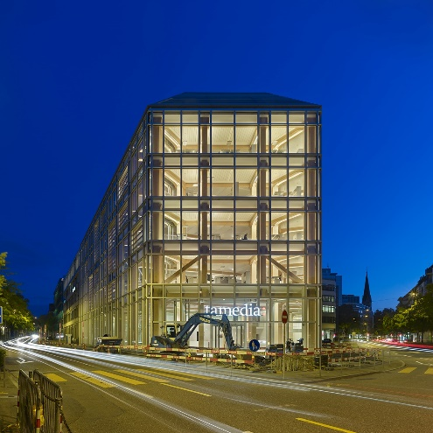
Figure 1: Tamedia office Building [3]
The office building uses a unique design of oval longitudinal beams that run around the perimeter. These beams slots through the columns and beams that run towards the centre of the building. The beams are oval to reduce the twist within said beam. These system is seen in the following picture of the inside of the façade.
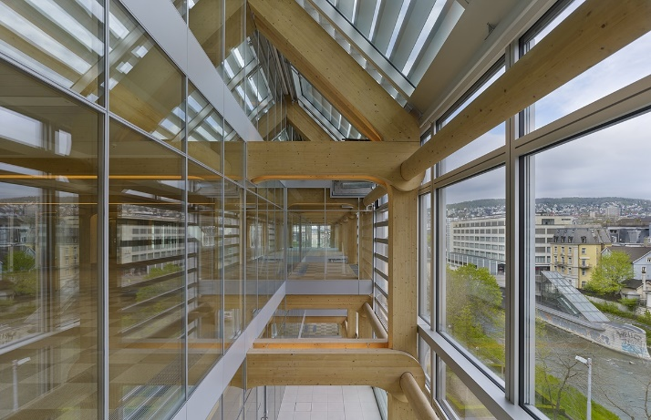
Figure 2: Structure of Tamedia Office Building [3]
This building is iconic because of its lack of concrete and steel within the structure. IT would be very hard to find a structure in Canada without any steel parts to its design throughout its entire structure.

- The image below shows the cross-section of a reinforcing steel bar inside a concrete beam. In 2013, an engineer performed a detailed analysis on this beam section to assess damage by corrosion. Mapping area loss around the steel, she discovered that the effective cross-section of the rebar had reduced by 6.5%. She also identified numerous cracks radiating away from the steel bar.

- Describe how a rebar embedded in concrete can become corroded.
Rebar corrosion starts with the weakening of the concrete surrounding it.
Concrete can crack or be worn away by a multitude of reasons. Once these cracks get to the rebar, that is where the trouble starts. Water can get into the cracks and get to the rebar. The water is what allows the corrosion to happen.
- Assume the reinforcing bar has the markings X 20 followed by two longitudinal lines marked through five spaces on the bar. If this steel rebar lost 6.5% of its effective cross-sectional area due to corrosion, calculate the yield strength capacity that you would estimate remains in this rebar after corrosion.
The yield strength of the rebar will not change. This is because the material is the same as before. The only thing that will change is the amount of load it can withstand before yielding. Since the material has been corroded, the amount of load it can handle before yielding will be lessened. The amount of loading (P) that the rebar can withstand before yield after corrosion is calculated in the following:
$P= σ_{y}×A=\left(500x{10}^{6 }Pa\right)(0.935\left(π\left({0.01)}^{2}\right)\right)=147 kN$

- Beyond the strength capacity of the steel, would you have any other concerns for the strength of the concrete beam?
The size of the cracks is concerning. Just next to the rebar, the width of the crack is rather large. As you go closer to the surface of the beam, the size would most likely become larger. This large crack would be extremely bad in our climate. Due to freeze-thaw cycles, the size of the crack would keep expanding every year thus weakening the concrete and allowing more corrosion.

- The following culvert is classified as a bridge because of its span. The below figures illustrate the Bridge downstream and the interior of the culvert showing severe corrosion.
- Describe 3 reasons how this culvert bridge became corroded (hint – look upstream on the below google map).
One reason for the corrosion of the bridge would be due to the pH of the water passing underneath. The pH could change from a multitude of things but one example would from people in the neighbourhood upstream dumping. Another reason for the pH change would be runoff from pesticides from people’s lawns. Another reason for the corrosion of the culvert could be from the soil around the metal culvert. If not treated properly, the steel culvert would be vulnerable to sulfate attacks from the surrounding dirt. The last reason would be from the snow dump that is just up river from the culvert. On the other side of what looks like to be a rail track, there is an empty snow dump. When the snow melts from that dump in the spring, it drains into the stream. The problem isn’t the snow but the salt that is washed away with the snow. This salt speeds up the rusting reaction between iron and oxygen.

- What civil engineering material might you use in a replacement bridge – be detailed and justify your answer?
I would replace the steel interior of the bridge with aluminium. Although the aluminium would be more expensive than just steel, it would provide a larger protection against the corrosion. Another material that you could use is type 2 or type 5 concrete due to its corrosion resistance [3].

5. You are retained as an engineer to specify the modification factors for roof flooring system made from a CLT three ply decking for a swimming pool as shown below. The height of the ceiling will be over four stories above the swimming pool. You will be required to span timber beams spaced longitudinally 3m apart. The CLT will be hoisted into place through a two point loading mechanism over a short duration. You have also decided to treat the wood with a fire retarding admixture through incision. List all the modification factors which you should consider in this design, then carefully explain why? Assuming the CLT flooring system has an unfactored strength of 12MPa what would be its actual strength after these above factors have been applied?

There are four modifications that must be considered when calculating the strength of the beams. The first factor is the load duration factor, K_{D}. Due to the beams having to with stand the constant load of the roof, the load duration will be considered permanent. This means that the K_{D} value is 0.65. The second factor is the service condition factor, K_{S}. This factor deals with the moisture of the wood and the surrounding area. Due to the building having a pool below the roof the K_{S} is 0.67. The third modification factor is the treatment factor, K_{T}. This factor is dependant apon the wood being treated with chemicals. Since the beams in the question are being treated with a fire retardant, the value for K_{T} is 0.9. The fourth factor to consider is the system factor, K_{H}. This factor changes depending on how many beams are supporting the load. Since the building in question has a beam every 3 meters, the value for K_{H} is 1.4. The following equation is used to calculate the actual strength of the CLT after the factors are applied.

F_{b} = f_{b}(K_{D}*K_{H}*K_{S}*K_{T})
F_{b} = 12MPa*(0.65*1.4*0.67*0.9)
F_{b} = 6.58 MPa

After the modifications factors are applied to the CLT, the strength has decreased from 12 MPa to 6.58 MPa.

.

Work Cited
[1] P. Fleming, S. Smith, and M. Ramage, “Measuring-up in timber: a critical perspective on mid- and high-rise timber building design,” Architectural Research Quarterly, vol. 18, no. 1, pp. 20–30, 2014.
[2] The Murray Grove Stadthaus by Waugh Thistleton Architects.
[3] "Tamedia Office Building - arcspace.com", arcspace.com, 2017. [Online]. Available: https://arcspace.com/feature/tamedia-office-building/. [Accessed: 23- Nov- 2017].
[4] "The New Tamedia Building - Tamedia", Tamedia.ch, 2017. [Online]. Available: https://www.tamedia.ch/en/group/new-building. [Accessed: 23- Nov- 2017].

