REM 100 Notes

1: Introduction to Global Change
- What is Global Change?
- Human induced transformation of the global environment
- Environment- complete range of external conditions, physical and biotic, in which an organism lives, including soil, water, climate and food supply. Includes social, cultural, economic and political considerations.
- It is estimated >50% of Earth’s land surface has been modified by humans.
- Global issues are defined by:
- Global or large scale
- Inter-related to other global issues
- Exposes inter-dependence between countries; cannot be solved by one country
- Persistent (multi-generational)
- Challenges status quo in world order and global institutions
- Requires interdisciplinary knowledge and solutions
- Some global issues:
- Global climate change, food production, energy crisis, air pollution, loss of biodiversity etc.
- Interdisciplinary- combining/involving two or more academic disciplines/fields of study.
- Global issues require:
- Earth science, ecology, economics, political science, social sciences, philosophy
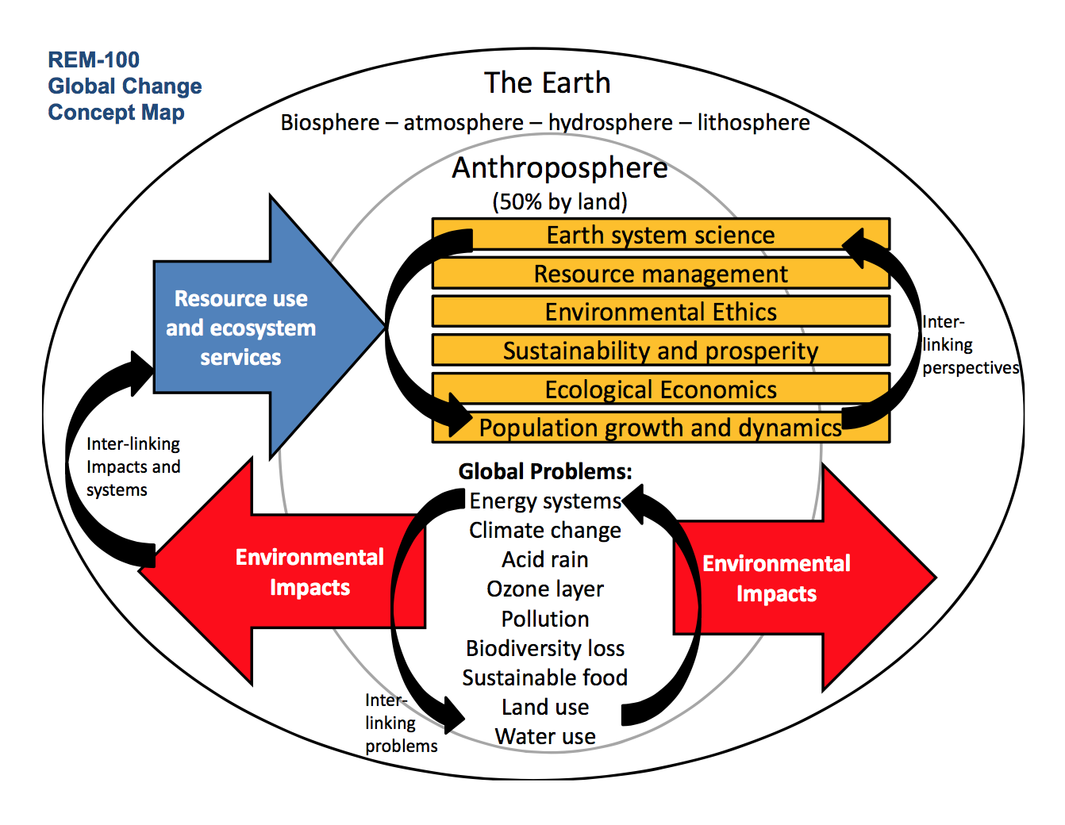
- Global issues are drastically increasing in present day
- Smog produced when sunlight reacts with nitrogen oxides (NOx; car exhaust, coal plants, factory emissions) and at least one volatile organic compound (VOC; solvents, formaldehyde, acetone) in the atmosphere
- Ozone (O3) depletion:
- Ozone found 15-30km above Earth; shield from UVB radiation from the sun
- O3 is destroyed by CFCs:
- CFCl3 + electromagnetic radiation = +Cl
Cl + O3 = ClO + O2
ClO + O3 = Cl + 2O2
- 1987, Montreal Protocol called for drastic reduction of CFCs
- Largest ozone hole observed, 27.5 mil square km
- Land deforestation and habitat loss:
- Forests are valuable for (non-timber) biodiversity, recreation, water/erosion, wood
- Water Pollution:
- Oil spills, eutrophication etc.
- Institutions: Elemental structure required for functioning of a society. Embody a particular set of values, norms and rules a society believes to be essential for continued existence.
- Politics, governance, law
- Economy, work
- Arts, education
- UN World Environment Conferences:
- 1972: Stockholm, Sweden
- 1982 (Commercial Whaling Activity banned this year): Nairobi, Kenya
- 1992: “Earth Summit,” Rio de Janeiro, Brazil (Global Warming/Climate Change Treaty, Biodiversity Treaty, ‘sustainable development’ endorsed
- 2002: “World Summit on Sustainable Development,” Johannesburg, South Africa
2: Global Environment
- System- a collection of interdependent parts enclosed within a defined boundary
- Earth Systems- has interacting spheres
- Earth’s Spheres: (most environmental problems involve at least 3 spheres)
- Lithosphere (land)
  - Earth’s raw materials and mined resources
  - Tectonic processes (mountains, earthquakes, volcanism)
  - Erosion/Sedimentation
  - Soils
- Hydrosphere (water)
  - Three phases naturally on Earth’s surface
  - Component of solid earth (physical/chemical weathering of rocks)
  - Atmospheric ‘heat engine’
  - Essential to life
- Cryosphere (ice)
  - Part of hydrosphere
  - Physical weathering
  - Sea level
  - Planetary albedo
  - Abrupt climate change
- Atmosphere (air)
  - Atmospheric structure/composition
  - Weather/climate
  - Air quality
- Biosphere (life)
  - Air, water, land
  - Created and maintains O2 rich atmosphere
  - Chemical weathering
  - Carbon and nitrogen cycling
- Anthroposphere (humans)
  - Part of biosphere, inhabited and used by humans
  - Approximately 50% of ice-free land surface has been significantly modified by humans (Morais & Steffen, 1999)
- Constanza (1999): Four Visions of the Year 2100
- Star Trek: Fusion energy, solar system expansion (tech optimism, resources unlimited)
- Mad Max: Oil declines, no alternative. Financial market crashes, government weakens. No army, no control. World run by transnational corporations (tech skepticism, resources limited)
- Big Government: Governments sanction companies that fail to pursue public interests. Fusion energy slow to develop. Family planning programs stabilize growth, incomes equalize (tech optimism, resources unlimited)
- Ecotopia: Tax reforms benefit industries; punish polluters and resource depleters. Habitat patterns reduce need for transportation/energy. Shift away from consumerism, reduces waste (tech skepticism, resources limited)
- In earth systems, a change in one sphere often results in change in 1+ other spheres.
- Often fluxes of energy between spheres:
- eg. CO2 released to air (atmosphere) and oceans (hydrosphere)
- Closed system: only energy can be exchanged with other systems (no matter)
- Open system: both energy and matter can be exchanged
- Hydrological Cycles:
- Reservoirs: ocean, groundwater, ice, atmosphere
- Energy Sources: solar, gravity
- Fluxes: evaporation, precipitation, runoff
- Other: carbon cycle, rock cycle
- Carbon Cycle: carbon moves through all four spheres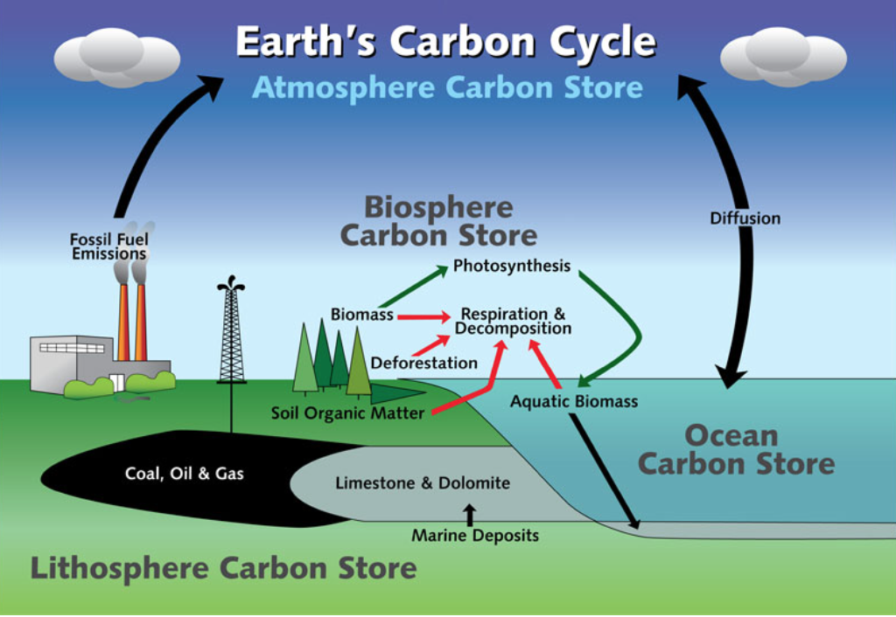
- Perturbations: an impact or disturbance to a system. May or may nt move system out of equilibrium
- Landslide into creek
- Slow changes of Earth’s orbit around sun
- Pollution of pristine environment
- Changes to CO2 concentration in atmosphere
- Development of agriculture
- Earthquake
- Perturbations can be natural or human caused, and small or large scale
- Positive feedback: response to small disturbance= increase in magnitude of perturbation
- Increased CO2 content, Warmer T air in Arctic, less sea ice, more solar radiation absorbed into ocean
- Negative feedback: response to small disturbance= decrease in magnitude of perturbation
- Increased CO2 content, increased primary production (absorb CO2 from environment)
- Long time scales: ice ages, evolution, ocean circulation
- Short time scales: forest fire, seasonal changes in weather
- Across time scales: short industrial used of CFCs has long term ozone layer consequences (stay in atmosphere for a long time)
3a: Environmental Challenges: Resource Management
- An environmentally sustainable society meets the basic resource needs of its people indefinitely without depleting/degrading natural capital that supplies the resources
- Resources – materials/substances such as minerals, forests, water and fertile land that occur in nature and can be used for economic gain
- Material resources: use to individuals/society
- Flows of energy: harnessed for useful purposes
- Attributes of the environment: contribute something of value
- Basic resource needs: food, clean water, clean air, shelter
- What kind of food/shelter/energy is culturally determined
- Resource Categories:
- Origin: biotic/abiotic
- Renewability: non-renewable/renewable
- Exhaustibility: inexhaustible/exhaustible
- Nonrenewable resources- rate of production is much slower than rate it is consumed.
- Fossil fuels, nonmetallic minerals (limestone), metals
- Renewable resources- rate of production is equal or faster than rate it is consumed.
- Forests, land products (crops), soil, water, ecosystems, renewable energy (wind, solar, biofuels, hydroelectric
- Exhaustibility of resources:
- Inexhaustible: will not run out in future (solar radiation, air (not clean), geothermal energy)
- Exhaustible: finite, can deplete (non renewables, most renewables)
- Renewable resources can be depleted- ‘fishing down the food web’ depletes top predators, thus reducing biodiversity and moving onto smaller fish
- Mineral reserve (economic supply)- resources already discovered and measured that are economically viable to extract at current prices and technology
- Mineral resource (physical supply)- all resource, including those undiscovered, as well as resource not profitable to extract with current prices/technology
- Oil reserve estimate changes have been dramatic over the past 8 years
- In the past 15 years: horizontal drilling, hydraulic fracturing (fracking)
- The Resource Cycle:
- Extraction from Earth
- Use for goods production
- Consumption of goods
- Reuse/recycling (materials and/or energy)
- Waste disposal
  - Material waste: extracted from environment, now deemed no further use to individuals and society
  - Energy waste: resulting from human activities that are not worth using (e.g. waste heat from power stations)
- Lifecycle analysis (LCA) is an accounting system to characterize and quantify environmental sustainability metrics. (‘cradle to grave’)
- Defines a products life cycle and input/output
- Resource Management Approaches:
- Exploitation approach:
  - Resource repletion, use all you want
  - Resources are unlimited
  - Nature is to serve humans
  - Eg. fishing in an “empty world” logging strategies, 1920s
- Preservation approach:
  - Resources preserved, set aside, protected
  - John Muir, 1880s, Sierra Club (Establishment of Yosemite and Sequoia National Parks, 1891)
- Utilitarian approach:
  - Careful management of renewable resources for human consumption
  - Maximize human well-being (anthropogenic)
  - Market prices determines resource value
  - Protect resources by harvesting at rate which can be replenished (sustainable yield)
  - Eg. sockeye salmon is high value which pink is little to no value
- Ecological approach:
  - Protect entire ecosystem to sustain renewable resources
  - Knowledge of interrelationships between all species/environment
  - Eg. reintroducing wolves (apex predator) into Yellowstone National Park to benefit other species (plants, trees, rivers)
- Barry Commoner’s Four Laws of Ecology:
- Everything is connected to everything else
- Everything must go somewhere
- Nature knows best
- There is no such thing as free lunch
3b: Environmental Challenges: Environmental Impacts
- The Great Transformation- the transformation of biosphere from natural state by human action.
- Population increase
- Increase in human based land use and resource consumption
- Unprecedented wealth and material consumption
- Values align with ‘growth paradigm’
- The Great Acceleration- even faster growth since 1950
- Anthropocene- Proposed epoch (geological time period) that begins when human activities became a major geological force (~1760)
  - Started with industrial revolution
- Human activity effects all spheres, particularly biosphere
- Environmental Impacts:
- Absorptive capacity: flow or stock
- Spatial scale: local, large regional or global
- Origin: point or non point source
- Occurrence: continual or episodic
- Northern Gateway Pipeline- Kitimat to Bruderheim
- Will increase greenhouse gas emissions
- Possibility of terrestrial oil spill (ruptured pipe)
- We have exceeded the “safe operating space” for rate of biodiversity loss, climate change, and human interference with the nitrogen cycle.
- IPAT Framework:
- Impact= Population x Affluence x Technology
  - Population of an area- increased land use, resource/energy use, pollution
  - Affluence: average consumption per person- aka GDP (gross domestic product) per capita (person). Increased activity/consumption
  - Technology: How resource intensive the production of affluence is (impact/GDP). Eg. how much environmental impact involved in creating, transporting, disposing of goods, services and amenities.
    - Improvements in technology can reduce impact
- Impact= (# of people) x (GDP/person) x (impact/GDP)
- Proposed by Barry Commoner, Paul R. Ehrlich and John Holdren in 1970s
- Describes impact of human activity on environment
- Hunter-Gatherer Society:
- Most/all food obtained from wild plants/animals
- Altered environment to increase well being (eg. used fire; easier to move around and create open space for game)
- Depleted environment around camps
  - May have contributed to late-Pleistocene extinctions
  - Conflicts between societies
- Moved onto new areas once location depleted
- Only supports LOW (and mobile) population density
- Agrarian Society:
- Neolithic revolutions (12k years BP)
- Considerable alteration of environment, domestication of plants and animals
  - Simplification of ecosystem
  - Elimination of predators and competitors
- Increased efficiency, population surpluses
- Supported larger, sedentary populations
- Accumulation of goods/tools, specialization and new forms of labor, development of political institutions, development of urban centers (+affluence)
- 8000 B.C. to 1700 A.D, population increase from 0.005 to 0.6 (billions)
- Industrialized Society:
- Industrial Revolution- 1760 to 1840
- Great Britain, then western Europe and North America
- Steam engines (coal)
  - Breaks connection between natural production rates of biomass fuel and level of industrial activity
- Labor intensive, craft based cottage industries to machine production (factory system)
- Increase in production required steady supply of energy/raw materials (transportation systems)
  - Increased spatial reach of industry
- Wealth from colonies, provide capital/raw materials
- Social, health and environmental problems in cities, led to reforms (sanitation, healthcare etc.)
  - Life expectancy increased
5: Environmental Ethics
- Ethics: the way we should behave
- Environmental Ethics: the part of applied ethics which examines the moral basis of out responsibility towards environment
- Anthropocentrism: environment should be protected because of usefulness to humans, or because we care about its continued existence
- Instrumental value: living beings and things only have value if they are useful to humans
- Ecocentrism: Non-human nature has inherent right to exist, does not depend on humans to give value.
- Intrinsic value: other life forms have value in themselves, even if no use to humans.
- Deep ecology
- Anthropogenic to Ecocentric ecological philosophies:
- Domination, stewardship, conservation, deep ecology
- Domination:
- Nature is solely to serve humans
- Store of resources for human use, sink for human environmental impacts
- Only instrumental value, only valuable if it benefits humans
- Stewardship:
- Anthropogenic, human is superior, but we are the protector of nature
- Nature is complicated, most resources limited or exhaustible
- These limits are important
- Must develop understanding of environment to manage it
- Conservation:
- Contrast of “shallow ecology,” which is against pollution and resource depletion
- Deep ecology, views humans as integral part of Earth, environment and ecosphere rather than apart/separate
- All living things are alike in having value in their own right, independent of usefulness to others
- Richness and diversity of life forms
  - Humans can only reduce richness to satisfy vital needs
- Population reduction necessary, institutions/policies need to change
- Dominant Social Paradigm- most widely held set of beliefs/values/ideals, organizes the way people perceive and interpret functioning of world around them.
- Currently domination, some stewardship. Growth paradigm and consumption.
- Paradigm shift can occur when:
- Scientific understanding progresses
- Doubts raised, or inconsistencies
- Dominant paradigm no longer has support
- New social paradigm takes over
- Changes in institutions
- Events that stimulated environmental movement: 1963 Rachel Carson’s Silent Spring, 1968 Paul and Anne Ehrlich’s The Population Bomb, 1970 Scientific American photos of earth from space, 1970 Meadows et al. published Limits to Growth
6: Sustainability and Prosperity
- Prosperity- state of flourishing, thriving, good fortune, happiness and health
- Human concerns: peace, freedom, development, environment
- Poverty: not having enough money to meet basic needs (food, clothing, shelter)
- Extreme Poverty: absolute poverty, average $1.25 per day of less.
- Gross National Product (GNP): value of output, produced by domestically owned factors of production, irrespective of where production occurs
- Gross Domestic Product (GDP): value of output, produced by factors of production located in domestic economy and equal to sum of all factor incomes arising in domestic economy
*GDP= private consumption + gross investment + government spending + (exports-imports)
- Why is rising GDP a good thing?
  - Reduces poverty, increases literacy, reduces unemployment, slows population growth (lower fertility rate), reduce environmental degradation
- Does GDP growth cause all of any of these?
- Doesn’t account for: resource depletion, environmental degradation, equity/distribution, social problems (crime), non-market services (childcare)
- Environmental Kuznets Curve (EKC):
- Empirical observation that at higher levels of per capita income (x), environmental quality improves
*environmental degradation (y)
- Inverted U shape, for environmental degradation (turning point at top)
  - Emission and impacts increase as a country industrializes
  - Turning point because at higher incomes, consumers and businesses can afford more efficient technology, citizens have pro-environmental values once needs are met, citizens vote for governors who are pro-environment, government puts in laws and institutions better for environment
- The Brundtland Commission, 1987:
- Wrote “Our Common Future” about how environmental problems are global in nature
- Concern: deterioration of human environment and natural resources and consequences for economic/social development
- Linked development and environment for the first time
- Problems of entire world:
  - Developing countries, meet the needs
  - Developed countries, without compromising the ability to meet needs of the future
- Most commonly cited definition of sustainable development
- Components of sustainable development: social, economic, environmental
- Definitions/applications of sustainability vary
- Natural Capital:
- Capital: goods/assets used to produce goods and services
- Physical Capital (Kp), Intellectual Capital (Ki), Human Capital (Kh), = human based capital (Khb)
- Natural Capital (Kn)
- Production function:
  - Q= F(L,K)
  - = F (capital labor)
  - Economic output, GDP, is a function of capital and labor
  - TOTAL CAPITAL: K = Kp + Ki + Kh + Kn
- Weak Sustainability: natural/human based capital are perfect substitutes, relates to anthropogenic perspective
- Strong sustainability: natural/human capital are complements (both required), relates to ecocentric perspective
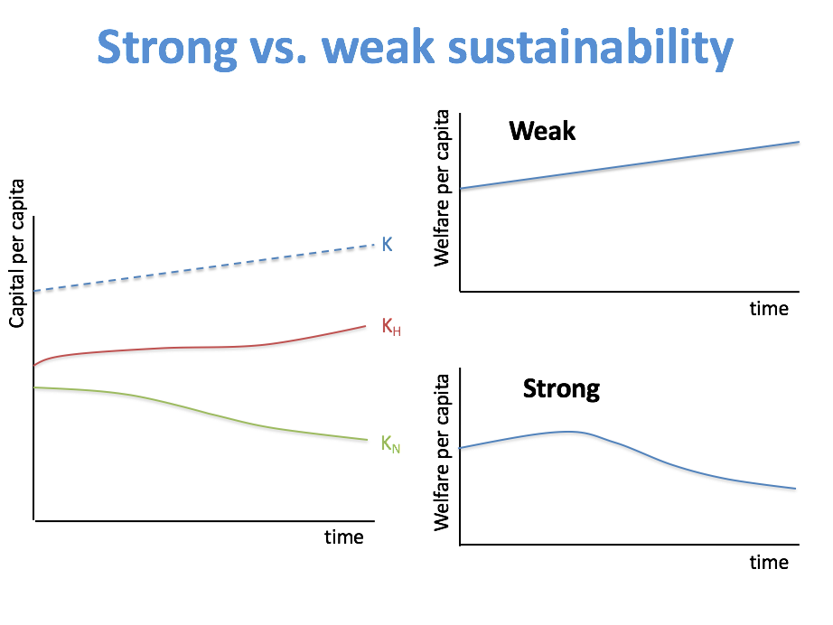
- Definitions of Sustainability:
- Brundtland Commission
  - “meet the needs of the present without compromising the ability of those in future generations to meet their own needs”
- UNESCO
  - “each generation should leave water, air, and soil resources as pure and unpolluted as when it came on the earth”
- Solow
  - “Each generation should be presented with the capability of being at least as well off as previous generations.”
- Alternatives to Growth Paradigm:
- Daly (2004), steady-state principles; sustainable society should be managed as:
  - Renewable resources: harvest at maximum sustainable yield
  - Nonrenewable resources: okay to harvest, but only if profits are invested into equal renewable replacement
  - Emissions do not exceed assimilative capacity of the environment
  - *Limit scale of human activity (e.g. pollution, energy, population)
- Human Development Index (HDI), Green-adjusted GDP, Genuine Progress Indicator (GPI), Genuine Savings, Gross National Happiness (Bhutan), Happy Planet Index, National Well-being index
- Genuine Progress Indicator (GPI) considers:
  - Income distribution
  - Volunteer work
  - Family breakdown
  - Crime
  - Resource Depletion
  - Pollution
  - Loss of farmland/wetland
- Gross National Happiness Index:
  - 2015, 91.2% of Bhutanese were narrowly, extensively or deeply happy. 43.4% were extensively or deeply happy
  - Aim for all Bhutanese to be extensively or deeply happy
7: Ecological Economics
- Conventional economics- understanding the processes that govern production, distribution and consumption of goods/services (in open market)
- Microeconomics: individual/business decisions
- Macroeconomics: country and government decisions
- Key Assumptions of neoclassical (conventional) economics:
- Concerned with supply/demand/equilibrium
- Tries to describe reality, rather than what ought to be done
- Equates well being with GDP and consumption
- Wants to maximize efficiency
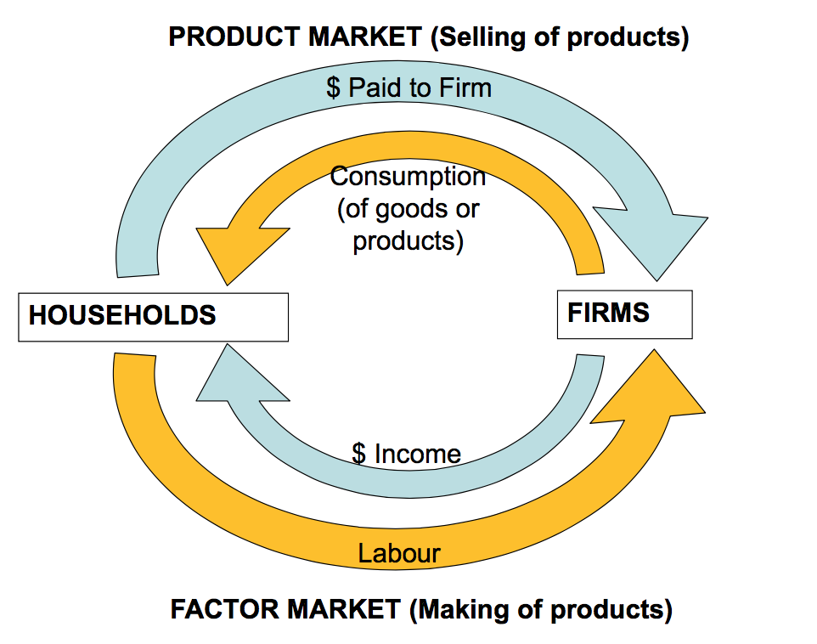
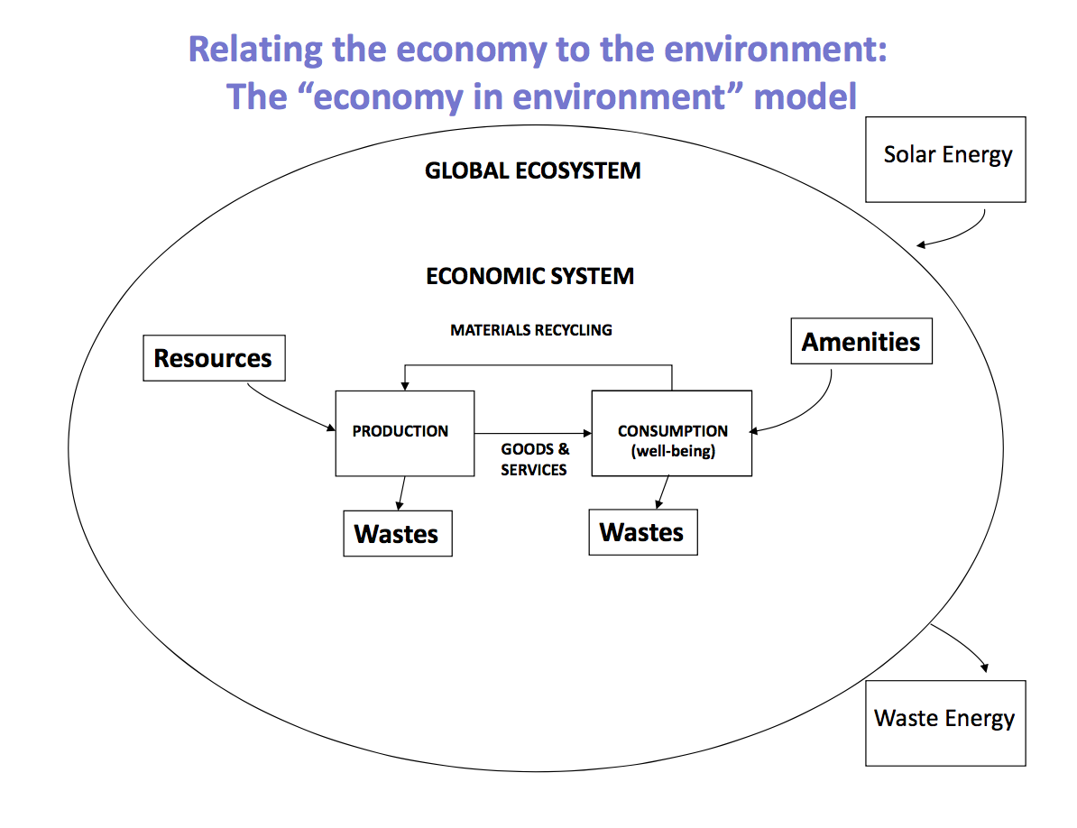
- Economy in Environment model:
- Production and consumption
  - Production- processes by which inputs are transformed into goods/services for consumption or investment in durable, human, intellectual or social capital
  - Consumption- use of goods and services to satisfy needs/wants (things that make us happy)
- Inputs to production are resources (energy/materials)
- Production and consumption processes always result in some waste (energy and materials)
- Some material waste can be recycled
- We are on planet earth, which is finite (sources/sinks)
- Amenities- benefits directly provided by the environment
- Neoclassical Economics- only views resources, wastes and amenities
- Ecological economics- views interactions between economy and environment
- Environmental economics: emission of waste during production (Neoclassical)
- Natural resource economics: Natural resources as inputs to production- depletion and optimal use of renewable resources (Neoclassical)
- Characteristics of ecological economics:
  - Strong sustainability: human capital can’t substitute for natural capital (normative)
  - Limits to growth: laws of thermodynamics limit growth we can have; development is a better idea than growth
  - Human behavior: we can derive happiness from a variety of sources
  - Equity: distribution of impacts in present (intragenerational) and future generations (intergenerational)
  - Interdisciplinary: complex problems involve insights from multiple disciplines
- Free Market: efficient allocation of resources when:
  - Good information on consumption benefits and costs (perfect info)
  - Large number of buyers/sellers (perfect competition)
  - Each transaction only affects buyer/seller (no externalities)
- Market Failures:
  - Externality
  - Common property resource
  - Public good
- Externality:
  - Transaction between a buyer/seller effects a third party
  - 3rd party’s preferences aren’t expressed in transaction (or market)
  - Free market outcome is inefficient (loss of welfare)
  - Positive or negative externality
    - Negative externality: producing or consuming activity imposes cost on third party, and people consume more than is optimal
      - Pollution arising during production
      - Congestion during driving
      - Fishing depletes fishery stocks for other companies
    - Positive externality: producing or consuming activity creates a benefit to a third party, people consume less than is optimal
      - Clean air
      - Bee-keeper and pollination
      - Research and development and spillover of ideas
      - Immunization/public disease resistance
      - Good home maintenance/high neighboring property values
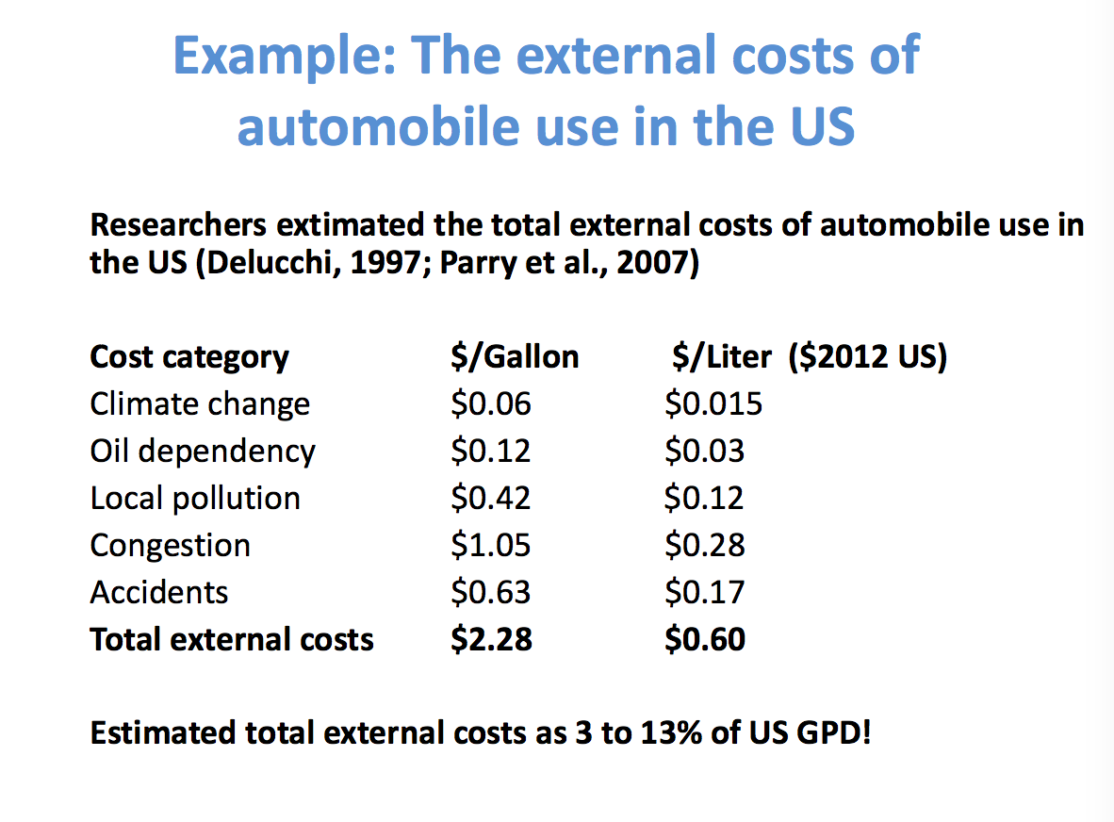
  - How to internalize the externality:
    - Put a price on it
      - Pigouvian tax: tax that reflects externality
      - Make private cost=social cost
    - Assign property rights
      - Coase theorem; assign and enforce property rights
      - Doesn’t matter which party has these rights (right to pollute or right not to pollute?)
- Classes of goods:
  - Excludable: possible to exclude other individuals from consuming the good
  - Rival: use of good by one person detracts from use of the good by another person (depletable)
- Common property resource:
  - Not possible to exclude some people from using the resource (non excludable)
  - Use of resource by one party reduces ability of other parties to enjoy it (depletable)
  - Produces negative externality (overconsumed)
  - Common rangeland, international fisheries, groundwater, early oil reservoirs
  - Tragedy of the commons: each rational individual tries to maximize their own utility, but leads to depletion of resource (efficiency loss)
    - Contrasts with Adam Smith’s “invisible hand” idea; if each person pursues their own self interest, overall wellbeing improves
      - In this case, if each person pursues self interest, resources will deplete
  - Public policy for tragedy of the commons:
    - Assign property rights
      - Tradable quotas for fisheries, hunting on private land; efficient if transferable, enforceable, exclusive; what can you privatize? what about equity?
    - Pigouvian tax
      - Reflect externality cost
    - Establish coercive laws
      - Seasonal fishing bans, technology limits, catch limits
    - Self government (institutions, social capital)
      - Irrigation management, fisheries
      - Defined boundaries, collective rule design; monitoring and sanctioning possible
- Private goods:
  - Owner has exclusive rights, can only be used by owner
- Public goods:
  - Not possible to exclude some people
  - Use of resource doesn’t detract from others use
  - Positive externality, good underprovided (no gov help)
  - Lighthouse, national defense, clean air, stable climate
  - Lots of individuals, total value bigger than individual value
- Why we value the environment:
  - Help make tradeoffs (cost benefits analysis, MATA)
    - Projects, new regulations/policies
  - Assessment of environmental damage
  - Green accounting (green GDP)
  - Policy analysis
- Total economic value (TEV):
  - Direct use values
    - Recreation, harvesting
  - Indirect use values
    - Ecosystem services; soil retention, climate stabilization, water management, life support
  - Non-use values
    - Existence value
- Millennium Ecosystem Assessment (MEA)
  - Benefits people obtain from ecosystems
- Costanza et al. (1997)
  - Ecosystem goods (such as food) and services (such as waste assimilation) represent benefits human populations derive, indirectly or directly, from ecosystem functions
- US EPA (2006)
  - Outputs of ecological functions/processes that directly/indirectly contribute to social welfare or have potential to do so in future; some outputs may be bought/sold, but most aren’t marketed
- Ecosystem service categories (MEA, 2004)
  - Supporting Services: necessary for production of other ecosystem services
    - Nutrient cycling
    - Soil Formation
    - Primary Production
  - Provisioning Services: products obtained from ecosystems
    - Food (crops, livestock)
    - Fiber (timber, cotton)
    - Freshwater
    - Biochemicals, natural medicine, pharmaceuticals
  - Regulating Services: benefits obtained from regulation of ecosystem processes
    - Air quality regulation
    - Water regulation
    - Water purification/treatment
    - Disease regulation
    - Pollination
    - Natural hazard regulation
  - Cultural Services: nonmaterial benefits people obtain through spiritual enrichment, cognitive development, reflection, recreation and aesthetic experiences
    - Aesthetic values
    - Spiritual/religious values
    - Recreation/ecotourism
- David Suzuki Foundation, 2015: Valuation of Howe Sound ecosystem services
  - Howe sound is worth $800M-$4.7B per year
  - Discovered by valuation methods such as:
    - Food provisioning
    - Fresh water
    - Disturbance regulation
    - Nutrient cycling
- Revealed and stated preferences
  - Revealed: observed in market (real)
    - Strengths: real world, dependable
    - Weaknesses: restricted, problematic
  - Stated: elicited from consumer (hypothetical)
    - Strengths: flexible, novel contexts
    - Weaknesses: unrealistic, bias
- Market price method- value for environmental services that are traded in the market
  - Estimates changes in social welfare (CS or PS) from environmental impact
  - Economists use market prices because they reflect true (not hypothetical) values
- Contingent valuation- asks people what they would be willing to pay (or accept in compensation) for changes in quality of environmental amenity
  - “What is the most you would be willing to pay to ensure that the old‐growth forest in the Stein Valley was preserved in a park?”
  - “Suppose the only way of preserving the old‐growth forest in the Stein Valley is if British Columbia residents agree to pay additional taxes to establish a park in this region. What is the maximum you would be willing to pay, in additional taxes per year, to make sure that this park is created?
  - “Government is considering establishing a park to protect old‐growth forests in British Columbia’s Stein Valley. Creation of the park will increase your taxes by $10/year. Would you be in favor of this measure?”
    - Dichotomous choice is more natural
    - Adds realism (respondents are more familiar with taxation than with valuation)
    - Reduces strategic overstatement
- Stated preference limitations: Bias
  - Hypothetical Bias
    - Difficult to envision
    - Budget constraint
    - WTP estimates too large
  - Social desirability bias
    - Appear ‘good’
  - Interviewer bias
    - Influence from interviewer
  - Anchoring
    - Influenced by starting point
  - Framing bias
    - Influenced by context
8: Population, Carrying Capacity & Ecological Footprint
- Global population reached 7 billion in 2011
- Global population growth links to the three stages of human adaptation
- Growth follows a J curve (exponential growth); the population bomb started in last 500 years
  - growth rate= birth rate-death rate
- Rate of growth peaked in early 1960s
- What causes population growth?
  - Globally: birth rate-death rate
  - Locally/Regionally: birth rate-death rate; net migration (immigration-emigration)
- Crude birth rate- number of births per 1000 people per year
- Crude death rate- number of deaths per 1000 people per year
- The annual growth rate- result of a surplus or deficit of births over deaths and balance of migrants entering and leaving a country
- Populations grow faster in developing countries
- UN predicts 2050 population, ~10 billion
- Demographic Transition Model:
  - Stage 1: High stationary
    - Pre-industrial societies
    - Death and birth rates high and roughly in balance
    - Relative constant and young population
    - Cost of children is low, once older, contribute significantly to household
    - Fluctuations in food supply translate directly to population fluctuations
    - No current countries
  - Stage 2: Early expanding- decline in death rate
    - Improvements in food supply
    - Improvements in public health (water supply, sewage, food handling, personal hygiene)
    - Primary reduction of death rate is in child mortality
    - Age structure increasingly youthful
    - Europe in 19th century
    - Can be beginning of population explosion
    - Sub-Saharan Africa, Guatemala, Afghanistan, Yemen
  - Stage 3: Late expanding – decline in birth rate
    - Changing role of women; increased education, employment, more independent
    - Western urban environments; living space scarce, more expensive
    - Less inventive to have more children (child labor laws, compulsory education, old age pensions)
    - More family planning (contraception)
    - Botswana, Colombia, India, Mexico, Kenya, South Africa
  - Stage 3: Low stationary
    - Birth and death rates low
    - Large population, little growth
    - Developed
      - Strong economy, highly educated citizens, advanced healthcare, urban population, expanded employment for women
    - Argentina, Canada, USA, Singapore, China, most of Europe, South Korea
  - Stage 5: Declining?
    - Possible fifth stage of model
    - Further economic development: urbanization, economic opportunity, gender equality, easy access to contraceptives, high cost of living
    - Aging population
    - Birth rate below death rate
    - Loss of population
    - Some compensated by immigration
    - Croatia, Estonia, Germany, Greece, Japan, Portugal, Ukraine
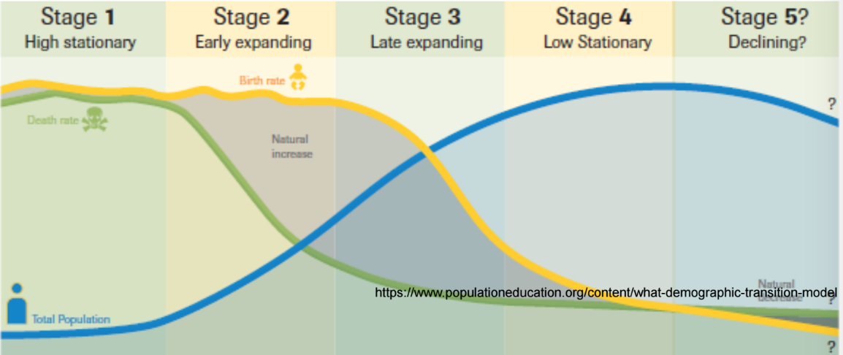
- Carrying capacity (k) of a biological species in an environment: max population size of the species the environment can sustain indefinitely, given food, habitat, water and other necessities available
- Overpopulation and overshoot occurs if population exceeds carrying capacity
  - Resource depletion
  - Toxification of system
  - Might reduce carrying capacity
- Carrying capacity for humans: not static, determined by:
  - Ecological conditions: state of Earth system
  - Human demands: expected standard of living
  - Technology: how we meet standard of living
    - Diet; meat or veggie?
    - Transportation modes? Air travel?
    - Health system?
    - Distribution of well-being/equality?
    - How much clean air, clean water, wilderness
- Techno-pessimist:
  - There are limits to growth
  - Too much population growth, overshoot risk
  - Avoid problems before they happen
  - Focus on reducing population (IPAT)
  - Robert Malthus, Paul Ehrlich et al., Don Meadows et al.
- Techno-optimist
  - Continuous growth is solution
  - Will always be able to innovate way around problems (increase K)
  - Improve technology to reduce environmental impacts (IPAT)
  - Julian Simon
- Three Key Arguments of techno-pessimism
  - Robert Malthus (1766-1834)
    - Essay on the Principle of Population (1798)
    - Population will grow faster than food
  - Paul Ehrlich (B 1932)
    - The Population Bomb (1968)
    - “in the 1970s, hundreds of millions of people will starve to death in spite of any crash programs embarked upon now. At this late date, nothing can prevent a substantial increase in world death rate…”
  - Meadows et al. (Club of Rome think tank)
    - Limits to Growth (1972)
    - Simulation model of population, food, pollution and resources
    - Food and resources would run out and population would crash
- Techno-optimist argument
  - Julian Simon (1932-1998)
    - American economist
    - The Ultimate Resource (1982)
    - Applies economic concepts of technological change
      - Resources become scarce, price of resource increases, incentives kick in (ration usage, recycle materials, discover new sources, develop substitutes)
    - Humans are the ultimate resource due to capacity to invent and adapt
    - Pollution can be decoupled from growth via human innovation
- Challenges of carrying capacity:
  - Prediction about future of a complex system is inherently difficulty
  - Limited understanding of resource system components and interactions
  - Calculations require massive assumptions about future influence of technology/societal choices
  - Predictions associated with large uncertainty, makes it difficult to use for planning
- How much of the biological capacity of the planet is demanded by a given human activity or population?
- Ecological Footprint:
  - Measures how much land and water area a population requires to produce resources it consumes and to absorb CO2 emissions, based on current technology (human demand on natural capital)
- Biocapacity: represents planet’s current biologically productive areas, provide resources and can absorb much of waste we generate, especially carbon emissions
- Calculations:
  - List all biological materials consumed and CO2 emissions (tons per year)
  - Divide by yield of specific land/sea area from which they were harvested/necessary to absorb
  - Convert to global hectares using yield and equivalence factors
  - Ecological Footprint is sum of global hectares needed to support resource consumption and absorb CO2 emissions
- Global overshoot when humanities demand on nature exceeds biosphere’s supply/regenerative capacity
  - Living off geological savings
  - Buildup of waste
  - Depletion of Earth’s life supporting natural capital
- How many planet Earth’s do we need to sustain a given type of living?
- Pros and cons of ecological footprint:
  - Pros:
    - Reduces environmental impacts and resource requirements into single metric
    - Easy to communicate
    - Easy to compare
    - Useful accounting system to track impacts
  - Cons:
    - Reductionist by nature: does it make sense to convert all impacts into land area?
    - Requires accurate assessment of ecosystem functions (uncertain and complex)
    - Simplifies complexity of different types of land (desert vs ocean vs rainforest)
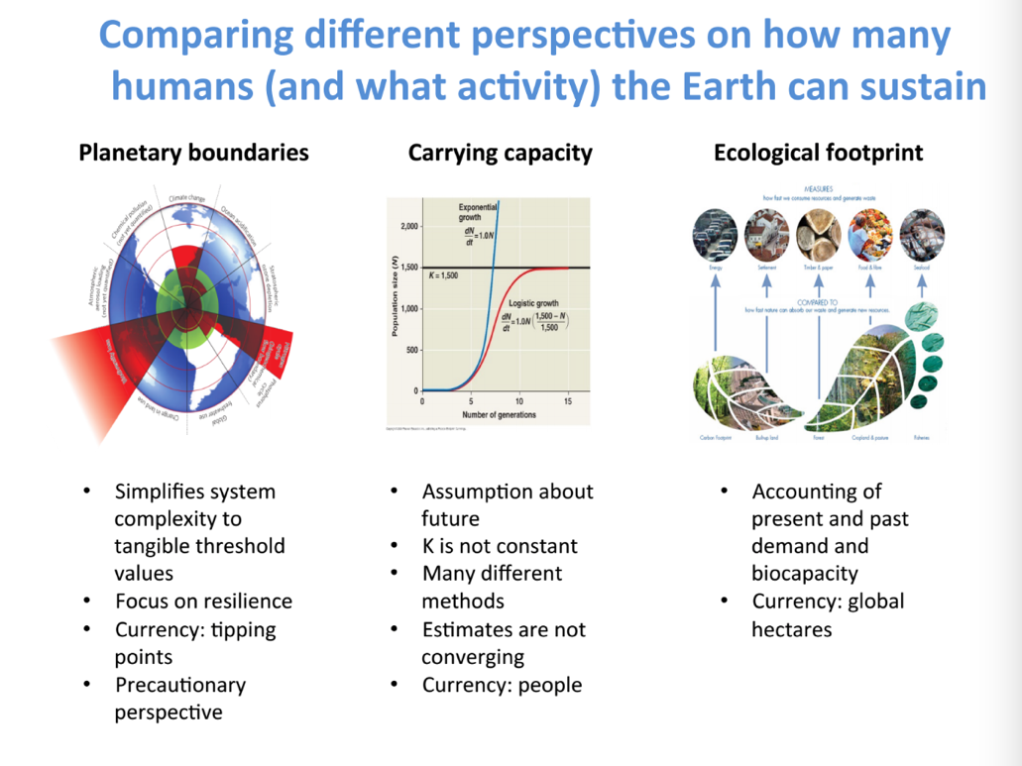
9a: Climate Change
- Levin et al., 2012: Climate change is a ‘super wicked problem’ because:
  - Time is running out
  - Those who cause the problem also seek to provide a solution
  - Central authority needed to address it is weak or non-existent
  - Policy responses are short sighted (discount the future in irrational way)
- Intergovernmental Panel on Climate Change (IPCC)
  - Established in 1988 through UN resolution 43/53
  - Open to all members of UN and World Meteorological Organization (WMO)
  - 195 countries are members
  - IPCC panel, secretariat and working groups
  - Reviews and assesses recent scientific, technical and socio economic information produced worldwide relevant to understanding of climate change
  - Rigorous and balanced scientific info to decision makers (policy relevant, neutral, never policy prescriptive
- Climate vs Weather
  - Weather:
    - Current state of atmosphere: rain, temp, wind, sky cover
    - Single events
    - What happens today
  - Climate
    - Averaged weather over months, seasons, years
    - What you might expect to happen today
- Defining Climate Change
  - Climate change: significant and lasting change in statistical distribution (average and or variability) of weather patterns over long periods of time
  - Anthropogenic climate change: climate change resulting from human activity (greenhouse gas emissions, land-use change)
- Changes in global surface temperatures
  - Each of the past 3 decades has been warmer at Earth’s surface than any other decade since 1950
  - In northern hemisphere, 1983-2012 was likely the warmest 30-year period of past 1400 years
  - 10 warmest years (exception of 1998) have occurred since 2000
  - Year 2014 ranks as Earth’s warmest since 1880
  - Warming not equally distributed
    - Warming in Arctic, Sahara and Amazon much greater than 0.8*C
- Ways to change the climate: Radiative forcing (W/m2)
  - Changing amount of incoming solar radiation
  - Changing concentration of aerosols and GHGs
  - Changes in surface properties (surface albedo)
- What changes the climate?
  - Natural causes
    - Sun: solar variability, changing earth orbit
    - Volcanic eruptions (aerosols in atmosphere)
  - Human causes
    - Long lived greenhouse gases (COS, methane, nitrous oxide, halocarbons)
    - Ozone (stratospheric/tropospheric)
    - Water vapor
    - Aerosols (pollution, volcanoes)
    - Surface albedo (land use change)
    - Linear contrails (airplane emissions)
  - Can compare relative impact of these factors using radiative forcing (W/m2)
- “Nature” causes for climate change
  - Main impact for ice ages- Earth’s movement around sun changes in amount of sun’s radiation hitting earth
  - Smaller, short term: volcanic eruptions, solar variability (sunspots)
- It is extremely likely (>95% certain) that human influence has been dominant cause of observed warming since mid-20th century
- Last 1000 years, CO2 temperature, concentrations, and emissions have increased
  - Carbon comes from fossil fuels, cement, land use change (deforestation), sinks (land, atmosphere, oceans)
  - CO2 emissions vary by region (strong in developing countries, China and India)
- Define climate change and explain how modern day climate change is impacting each of the ‘five earth system spheres’ discussed in REM 100 (possible exam question)
- Observed impacts:
  - Human/managed systems: food production, livelihoods, health/economics
  - Biological systems: terrestrial ecosystems, wildfire, marine ecosystems
  - Physical systems: glaciers/snow/ice/permafrost, rivers/lakes/floods/drought, coastal erosion/sea levels
- Projected impacts of climate change:
  - Food: falling crop yields, possible rising yields in high latitude, falling yields in developed regions
  - Water: glaciers disappear, decrease in water availability, sea level rise threatens coastal cities
  - Ecosystems: coral reef damage, rising number of species face extinction
  - Extreme weather: rising intensity of storms/forest fires/droughts/flooding/heat waves
  - Risk of irreversible changes: increasing risk of abrupt, large scale climatic shifts
- Climate change impacts to know:
  - Extreme weather (more heat, drought, precipitation, storms)
  - Loss of glaciers, ice sheets, sea ice)
  - Less freshwater (drought, less ice pack)
  - More wildfire
  - Rising sea levels (coastal damage)
  - Biodiversity loss, prevalence of pests
  - Ocean acidification
  - Potential for unknown extreme events (+ feedback)
- Extreme weather since 1950:
  - Fewer cold days/nights
  - More warm days/nights
  - More heat waves
  - More heavy rain (North America/Europe)
- 1900-2002, drier (global index of drought)
- Arctic sea ice: observed decreased occurred ~30 years before predicted
- Sea level rise:
  - 20cm since 1900, 0.2-1 m projected
  - Island nations displaced
  - Low lying countries more affected by storm surges
- Biodiversity loss: 20% loss of species in vulnerable ecosystems (Arctic/boreal forest)
- Prevalence of pests:
  - Winter cold spells used to kill of bark beetles
  - Temp now too warm to kill off
  - 16 mil hectares affected in BC
- Ocean acidification: CO2 in stored in ocean and harms ocean ecosystems
- Wide societal impacts
  - Water resource
  - Human health
  - Communities
    - Erosion threatens coastal communities
  - Agriculture
    - Economic and culturally significant fishing
  - Resource/service industries
  - Global security
  - Species extinction
- Climate change costs for Canada can escalate from $5 billion per year in 2020 to $21-$43 billion in the 2050s
- Adaptation: reducing vulnerability to climate change
  - Mechanisms, infrastructure and defenses to prepare ourselves for impending changes
- Mitigation: reducing intensity of global warming
  - Reduce greenhouse gas emissions
  - Increase ‘sinks’ for greenhouse gases
- Adaptation:
  - Newtok, Alaska builds a boardwalk to keep from sinking through melted permafrost
  - Wrapping Swiss glaciers to preserve tourism
  - Pacific island villages to move to higher ground
  - Develop resilient agricultural systems
- International Agreements:
  - UN Framework Convention on Climate Change
    - International environmental treaty: negotiated at UN Conference on Environment and Development (Earth Summit) in Rio
    - Objective to stabilize GHG concentrations in atmosphere at level that would prevent dangerous anthropogenic interference with climate system
  - UNFCCC- Conference of the Parties
    - Annual COP to assess progress in dealing with climate change and potentially set binding limits on emissions
    - UNFCCC Kyoto Protocol
      - International treaty, commits state parties to reduce GHG emissions
      - Dec 11, 1997; COP 3 Kyoto, Japan
      - National GHG emissions reduction, obligations and implementation mechanisms
      - 37 countries and EU agreed to reduce GHG emissions by 2008-2012 on average by 5.2% relative to base year
      - 191 states signed and ratified
      - US signed, never ratified; Canada withdrew in 2011
- Why is climate change so difficult to solve?
  - Climate change results from market failures:
    - GHG emissions are negative externalities
    - Atmosphere is a common pool resource
    - Climate mitigation is public good
9b: Energy and climate policy
- Two main sources of energy:
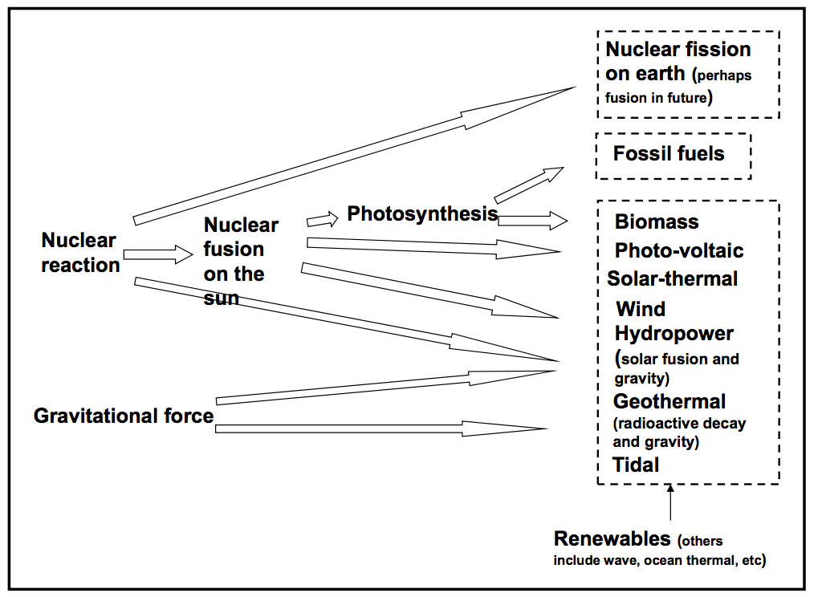

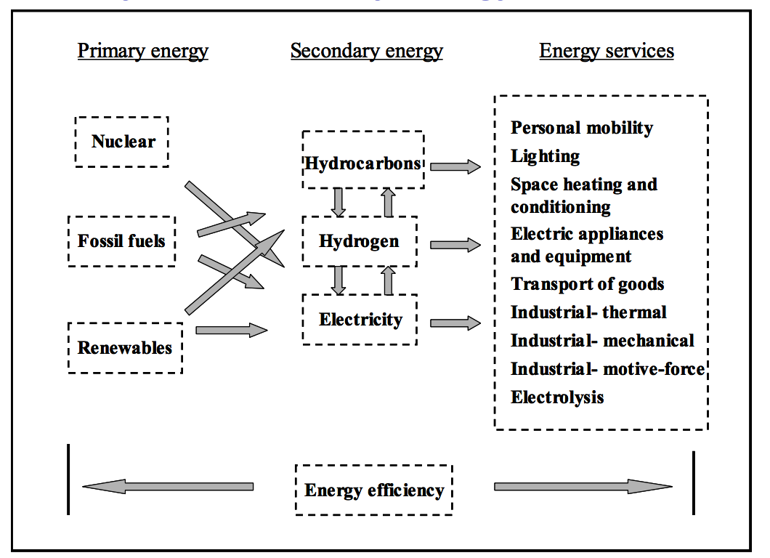
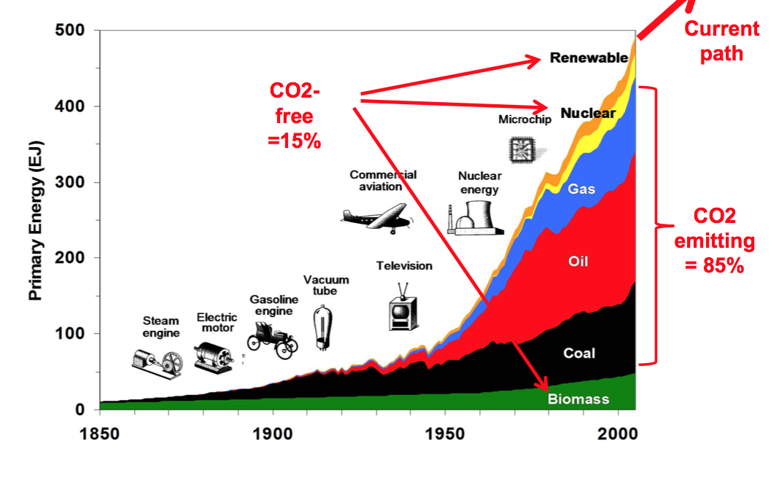

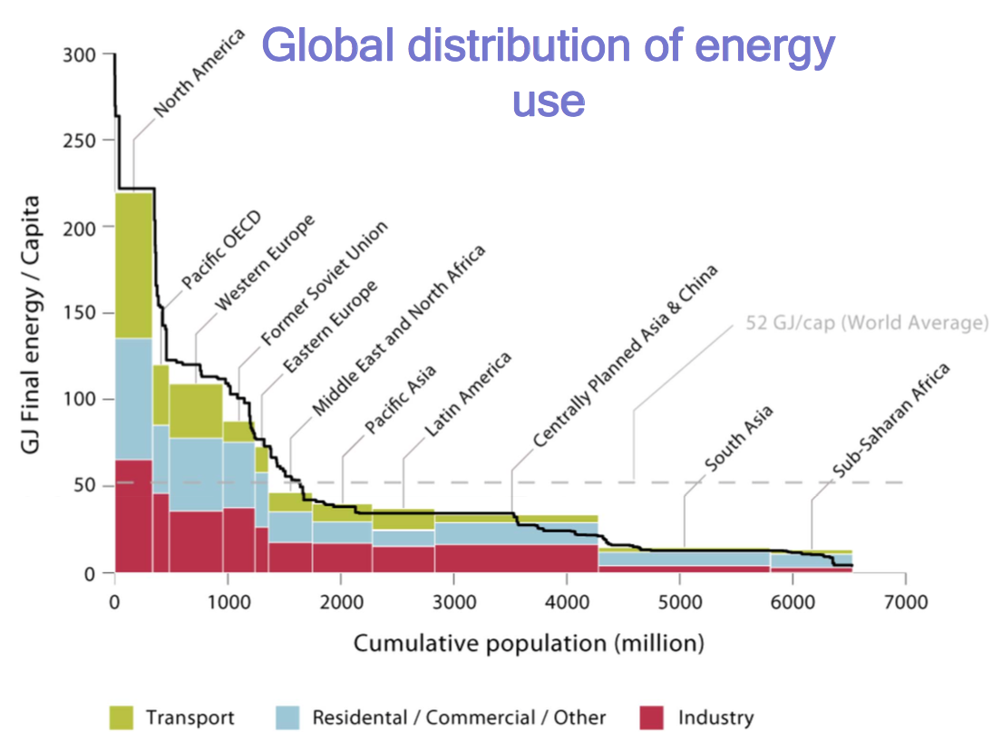
- Energy end-use sectors:
  - Transport- personal/freight and by mode; includes off road
  - Residential- domestic buildings and appliances
  - Commercial-institutional- buildings used for offices, institutions, retail, etc
  - Industrial- includes energy-intensive industries (steel, cement, etc) all other manufacturing, material feedstocks (oil/gas for petrochemicals, biomass for paper, etc)
  - Agricultural- split into residences/industry
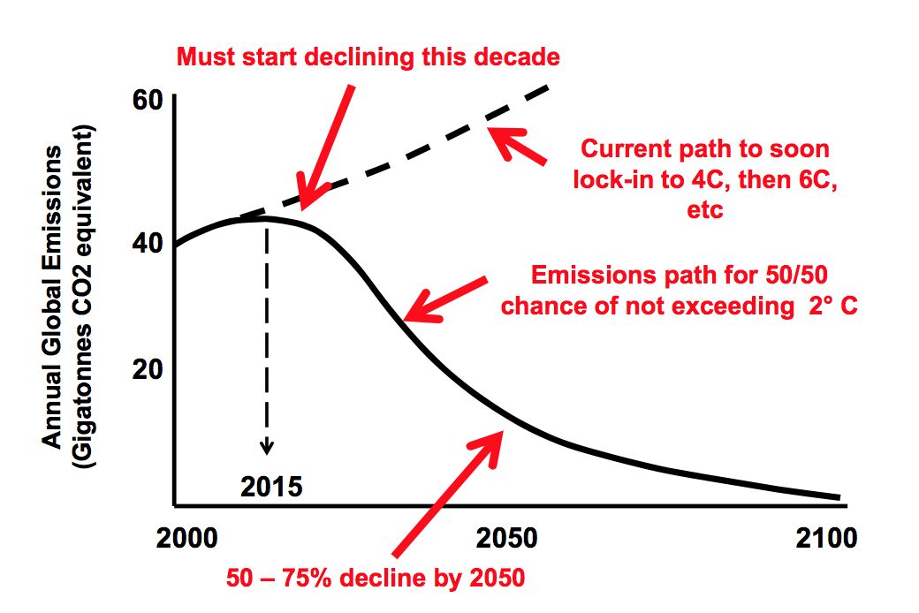
- Fossil Fuels: organic compounds formed over millions of years as carbon and other elements from dead animals/plants was accumulated, compacted and transformed by sedimentary and geological processes
  - Coal- carbonaceous sedimentary rock, formed by compaction of partially decomposed plant material
  - Oil- liquid hydrocarbon formed from dead animals/plants by sedimentary and geological processes (unconventional, includes tar sands, heavy oil, shale oil)
  - Natural Gas- gaseous hydrocarbon, formed from dead animals/plant by sedimentary/geological processes (unconventional, includes deep pressurized gas and shale gas)
- Fossil fuels are non renewable resources
  - Mineral reserve (economic supply)
    - Resources that have been discovered and measured that are economically viable to extract
  - Mineral resource (physical supply)
    - All resource, includes undiscovered and those not profitable to extract
- Are we running out of fossil fuels? Not in time to stop climate change
- Natural gas (largely methane, CH4)
  - In 2010, 23% of USA needs, 31% of Canada’s needs (increasing number)
  - Global reserves will last 60-200 years
- We can only burn so much more fossil fuel to stay in carbon budget (2*C limit)
- Low carbon/renewable energy options:
  - Nonrenewable, low carbon
    - Nuclear
      - Nuclear energy: surrounding water heated by reactor and piped to electric turbine
      - Emergency cooling system: safety device, provides cold water to reactor core
      - France is major nuclear power
    - Carbon-capture and storage
  - Renewable
    - Solar- solar radiation drives biotic and abiotic processes
      - Only a few countries getting more than 1% generated electricity from PV (Italy, Greece, Germany)
    - Wind- uneven solar heating of land/sea
      - Used heavily in few countries (Denmark, Ireland, Portugal, Spain)
    - Ocean thermal- difference between cold depths and solar heating of surface
    - Biomass- carbs of plants and animal waste, solids converted to liquid and gaseous forms of hydrocarbons
    - Hydropower- water flowing downhill, solar energy and gravity
      - Used in Paraguay, Norway, Brazil, Columbia
    - Geothermal- high temp pockets near surface of Earth’s crust
    - Ocean tidal- ocean currents caused by gravitational force of Earth and moon
  - Benefits and drawbacks of each?
  - Fossil fuels, but remove the carbon; carbon capture and storage (CCS); 800 gigawatt sized plants with carbon captured and permanently sequestered
- Policy might target specific actions or technologies, may be technology neutral
  - Transportation GHGs: (GHG/MJ) x (MJ/km) x (km/person) x (# of people)
    - GHG/MJ= reduce carbon intensity of fuel (fuel switching)
    - MJ/km= improve fuel efficiency of vehicle (efficiency)
    - Km/person= demand less motorized mobility (behavior)
  - What actions are lower cost? (financial/intangible)
  - What actions are targeted by carbon tax; electric vehicle rebate; fuel economy standard?
- Policy evaluation criteria: EEFSA
  - Effectiveness: achieves environmental goal (avoids side effects)
  - Efficiency: equimarginal principle, coast effectiveness, potential-pareto efficiency
  - Fairness: equitable distribution of costs/benefits
  - Simplicity: administrative feasibility
  - Acceptable: political support
- Options for Climate Policy:
  - Voluntarism: provide info, ask people to reduce emissions; not very effective
  - Subsidies: give money to industries or consumers for making/buying low carbon technologies (LED bulbs, electric vehicles); effective but inefficient
  - Carbon tax: charge price per tonne of CO2e emitted (like Pigouvian tax); effective and efficient but low acceptability
  - Cap-and-trade: limit amount of emissions, assign permits, allow emitters to trade permits; effective and efficient, complex to administer
  - Regulation/standards: require that manufacturers make more efficient, low emission technology (zero emissions vehicle mandate); effective and acceptable, sometimes inefficient
- Among BC’s climate policies, carbon tax most likely to be opposed by citizens
9: Introduction to Institutions in Resource and Environmental Management
- Institutions: sets of expectations or norms that pattern human behavior; structures social order (authority)
  - Constitutions, laws and rules; govern politics, government, finance and society more broadly
  - Written rules and agreements; govern contractual relations and corporate governance
    - Canada’s Constitution Act, 1982
      - Federal/Provincial governments are granted different legislative jurisdiction over natural resources and environment
      - 1972: International agreement that ‘environmental problems of broad international significance fall within competence of UN system’
  - Unwritten codes of conduct, norms of behavior and beliefs
    - Culturally appropriate behavior
    - Informal rules among a group of resource users
- Organization vs Institution
  - Organization: organized entity/body of people with particular purpose
    - Business, transnational corporation, political party, US congress, non governmental organization, family etc
    - US Congress
      - 2 houses: senate and house of representatives
      - Personnel (congress people, senators, speaker of the house, office staff, lawyers)
      - Buildings/offices
      - Financial resources
  - Institution: accepted rules, norms and strategies adopted by individuals operating within/across organizational settings (Ostrom, 2008)
    - Federalism
    - Legislative process
    - Checks and balances
- Key elements of institutions:
  - Institutions can be formal and/or informal
    - Can be imposed or evolve from society itself
  - Institutions structure policies and influence behavior (set rules of game)
    - Constitutional order (democratic system, parliamentary system, federal system), federal government (granted authority to enact environmental laws), national environmental laws and policies
    - Canadian governments make public policy, but Canadian Constitution determines exactly which actors are entitled to make policies and decisions
  - Institutions are not static, they often change
  - Institutions are often contested and challenged
- Key US Institutions:
  - Clean Air Act, 1977 Amendment
    - Allowed Administrator of Environment Protection Agency (EPA) to regulate any substance, which in his judgment may reasonably be anticipated to affect the stratosphere, especially ozone, if such effect may reasonably be anticipated to endanger public health or welfare
  - Toxic Substances Control Act, 1978
    - EPA used act to ban use of CFCs as aerosol propellants in nonessential applications
    - Aerosol production dropped nearly 95%
  - Clean Air Act, 1990 Amendment
    - Required EPA to develop and implement regulations for managing ozone depleting substances
      - Phase out
      - Import and export restrictions
      - Destruction/transformation of existing ODS (refrigerators, air conditioners)
      - Labeling and certifications
- The Montreal Protocol
  - Key international institution, designed to reduce worldwide production/use of CFCs and ozone depleting compounds
  - Signed in 1987 by 24 countries (now 197)
  - Ozone layer slowly recovering
  - Model for international agreements on global environmental problems
11: More air problems: Ozone depletion and acid rain
- Stratospheric ozone protects earth from UV radiation
- Tropospheric ozone is an air pollutant
- Short lived greenhouse gas, causes warming in stratosphere, cooling in troposphere
- Aerosol
  - Climate science, any particles suspended in air (water, dust, air pollutants, smoke)
  - Aerosol spray- consumer product spray from a can
- Types of air pollution
  - Criteria air contaminants (CACs)
    - Lead, carbon monoxide, sulfur oxide, nitrogen oxides, ozone, particulate matter, volatile organic compounds (ground level ozone/smog formation)
  - Ozone depleting pollutant
    - CFCs, freons, halon
  - Greenhouse gases
    - CO2, methane, N2O, halocarbons
- Many CACs stabilized/declining in developed countries (eg USA, most CACs declining in Canada)
  - Alberta, highest use
- Distribution of O3
  - Highest concentrations in stratosphere, ~10-40km
  - Ozone acts as UV filter, absorbs 95% of UV-B
  - Protects from UV damage to skin, cell walls, immune systems
- 1974, Sherwood Rowland and Mario Molina
  - Discovered CFCs deplete ozone layer
  - CFCS are unreactive, insoluble in troposphere
  - Reach stratosphere in 11-20 years
  - Break up due to UV
  - Release reactive Cl- atoms
  - Long lived effects, over 75-100 years= 100,000 molecules of ozone destroyed by each Cl- atom
- Ozone depleting substances: coolants (refrigeration, air conditioning), foaming agents, fire extinguishers, solvents, pesticides, aerosol propellants
  - CFCs
  - Hydrochlorofluorocarbons (HCFCs)
  - Halons, Methyl bromide, Carbon tetrachloride, methyl chloroform
- Some gases are ozone depleting substances (ODS) and GHGs
  - CFCs, HCFCs, N2O
- UV radiation effects:
  - Sunburn, thinning of epidermis, skin cancer, eye disorders, immunosuppression
    - 1% loss in O3= 7000 more skin cancer cases
- Restoring the ozone layer (decades)
  - Phase out ozone depleting substances, Montreal Protocol
  - Stratospheric concentration of ODS decline
  - Ozone gradually increases
  - Surface UV radiation returns to normal
- Timeline of Montreal Protocol
  - 1974: Discovery—Rowland and Moline (1974) link CFCs to O3 depletion
  - 1975: more attention and research by others (e.g. National Academy of Sciences)
  - US Domestic Action 1977: US Environmental Protection Agency (EPA) amends the Clean Air Act to apply to CFCs
  - 1978: EPA uses Toxic Substances Control Act to ban use of CFCs as aerosol propellants (cut US aerosol production by 95%)
  - 1983: US starts to support international controls Meanwhile...Europe and the UK reject ozone depletion as a serious problem (only implement some “voluntary” measures)
  - Moving to the international stage 1985: Discovery of Antarctic ozone hole, theories of potential for sudden collapse in ozone concentration 1985: UNEP: Vienna convention for the protection of the ozone layers (no policy)
  - 1986: NASA and the World Meteorological Association conclude that CFCs are a real problem
  - 1987: US Senate votes in favor of further action to protect the ozone layer 1987: Montreal Protocol: 24 countries agree to phase out CFCS
- Further Amendments
  - Compounds:
    - Group I: fully halogenated (CFC 11, 12, 113)
    - Group II: halons (bromine, eg firefighting)
  - Developed countries
    - 1989- group 1 production and consumption frozen at 1986 levels
    - 1994- 80% of 1986 levels
    - 1999- 50% of 1986 levels
    - 1993- group 2 production and consumption frozen at 1986 levels
  - Developing countries
    - 10-year delay
    - Funds send from developed countries to help with phase out
    - Ban imports of ozone depleting products, discourage export of ODS technology
    - 191 countries as of 2006
  - Later amendments:
    - 1990, London: complete phase out of CFCs and halons by 2000
    - 1992, Copenhagen: phase out date moved up to 1996
- Similarities between ozone depletion and climate change:
  - Public recognition based on recent scientific work
  - Caused by emission of human made technologies from diverse nations
  - Both emissions stay in atmosphere
  - Can’t be eliminated by a nation on its own
  - International equity (developed vs developing) in impacts and compliance
  - Intergenerational equity
  - US a crucial actor
- Why did the Montreal Protocol work, and not Kyoto?
  - The US opposed Kyoto (reducing greenhouse gases not financially beneficial)
  - Phasing out ozone-depleting chemicals was cost effective, so they supported the Montreal Protocol
  - Self interest
- Acid Rain
  - Deposition of acid from atmosphere
  - Formed when gases dissolve in water droplets of clouds, fog, rain, snow
  - Sulfur Dioxide (SO2)
    - Natural sources (volcanoes)
    - Fossil fuel burning, coal/oil
    - Metal smelting (copper/nickel)
  - Oxides of Nitrogen (NOx)
    - Natural sources (lightning)
    - Formed from nitrogen in air during combustion in vehicles, industrial furnaces and power stations
  - Process is transboundary, large regions
  - Non-point source, difficult to prove sources
  - SO2 molecule remains in atmosphere ~40 hours, sulfate particle stays for ~3 weeks, rains out as sulfuric acid
- Acid rain impacts
  - Ecosystem
    - Aquatic organisms killed at pH <4.5
    - Acid mobilizes metals, enter food chain
    - Aluminum in soil affects growth and kills plants, especially conifers
  - Drinking water
    - Dissolves copper pipes
    - Increases nitrite/nitrate levels
  - Respiratory diseases
    - Bronchitis, asthma
  - ~$1B per year in damages in Canada
- In US, more acidic in west coast than east coast
- SO2 emissions (2005-2010): less in EU and North America, more in Asia
- Acid deposition in China rapidly increasing
- Reducing Acid Rain:
  - 1950s: solution to pollution is dilution
    - Regulations requiring high smoke stacks on power stations and smelters
    - Enabled emissions to travel far from point of production
    - Caused acid rain in downwind countries
  - Reduce pollution locally, but make it into a global/regional problem
  - Switching to low sulfur coal and natural gas and installing flue-gas desulphurization in power stations
  - Emissions differ in Canada and US
    - SO2: Canada mainly industrial sources, US electric utilities
    - NOx: Both mainly transportation, US also electric utilities and fuel combustion; Canada industrial sources, some electric utilities
- Acid Rain Timeline
  - 1950s: Abnormal acidity detected in precipitation and lakes in Nova Scotia
  - 1960s: losses of fish population in Sudbury, Ontario
  - 1978: US and Canada establish research initiative (LRTAP)
  - 1979: team identified acid rain as “the problem of greatest common concern at the present time.”
  - 1980: US-Canada “Memorandum of intent” for transboundary air pollution
  - 1985: Canadian Acid Rain Control program, to cut SO2 emissions by 50% from 1980 levels
  - 1990: US amends the Clean Air Act to require a large reduction in SO2 from power plants (with Tradable permit program)
  - 1991: Canada-US bilateral agreement
- Canada-US Acid Rain Agreement (1991)
  - US and Canada agreement, several years behind EU
  - Huge resistance from US coal burning power utilities
  - Huge source nickel smelting in Sudbury, Ontario, 40% of SO2 emissions in ON
  - Scientific uncertainty argument to delay action
  - Both countries achieved targeted reductions
- US Acid Rain Program
  - Market based SO2 allowance trading, economically efficient
  - Each ton of SO2 reduced below emissions limit, power plant owners received emissions allowance
  - Allowances saved for future use, other power plants, or sold on emissions trading market
  - Economic efficiency: power plant was free to choose cheapest mode of compliance
    - Purchasing/transferring emissions allowances from other units
    - Existing and new stack gas scrubbing and clean coal technologies
    - Low sulfur coal
    - Natural gas or co-firing coal and natural gas
    - Trimming/reducing annual hours of plant utilization
    - Retiring old units
    - New boilers
    - Increasing demand-side management and conservation
    - Bulk power purchases from other utilities/non-utility generators from units using coal/other fuels
  - Substantially reduced emissions
    - SO2 emissions dropped 40%
    - Acid rain dropped 65% since 1976
  - Viewed as an environmental success
  - Skeptics argue change would have occurred anyways (low sulfur coal more economical), normal regulatory mechanisms (not just cap and trade), Europe more effective (SO2 levels dropped 70%)
  - In Canada, although SOx levels are declining, NOx is still relatively high
12: Food and the green revolution
- History of food production:
  - Hunter Gatherers
  - Agrarian Society
    - Small scale, sustenance agriculture
    - Vastly organic
  - Industrial Revolution
    - More people in cities, less farming
    - Get food from rural to urban areas
- The Green Revolution
  - Pushed by Dr. Norman Borlaug
  - Father of the Green Revolution, won a Nobel Prize
  - May have saved >1 billion people from starvation
  - Starting in 1950s, incorporation of innovation, technology and research into agriculture
  - Green revolution components:
    - New seeds (esp. rice, wheat corn)
      - Developed with cross pollinating or genetic modification
      - Highly responsive to fertilizer
    - Use of various inputs
      - Fertilizer
      - Irrigation
      - Pesticides
  - First revolution developed countries, second revolution developing countries
  - Results:
    - Large increase in staple crop harvests (monoculture)
      - Less diversity
      - Specialization in high yield grains/particular animal products
    - Increase in productivity
      - Doubling of yield per acre
      - Global grain harvests triple from 1950-1990
    - Decrease in food prices
    - Less food poverty
      - Increased consumption of food
  - Food poverty still a problem; malnutrition a bigger problem than actual starvation
  - Many developing nations have high rates of hunger
- Environmental impacts of modern agriculture (food production)
  - Pollution (air/water)
    - Fertilizers (nitrogen/phosphorus)
      - Excess nitrogen leads to eutrophication (toxic algae blooms)
      - +400 dead zones globally
      - Can cause air pollution
    - Pesticides
      - WHO approximates 20,000 deaths and 1 million illnesses
    - Air quality
      - Agriculture major source of ammonia/methane emissions
      - Major contributors to Particulate Matter (PM) and ground level ozone formation
  - Water use (irrigation)
    - Intensive agriculture requires intensive irrigation
    - Demand for water increased since 1960s
  - Climate change
    - Intensive agriculture uses lots of energy
    - Agriculture accounts for 14% of global GHG emissions
      - Manure, biomass, etc
  - Biodiversity loss
    - Cropland replaced natural landscapes on large scales
    - Monocultures creates ideal condition for disease/pest spread
  - Soil erosion, degradation, desertification
    - Agriculture/livestock grazing, topsoil erosion
    - Negatively impacts future food production
    - Major source of greenhouse gas
  - Food waste
    - More food waste in developed countries (25-50% in North America)
    - Differs between developing and developed countries
    - Why waste?
      - Aesthetics, supply/demand, timing issues
    - Some trade-off (waste reduced with more energy usage
- Agriculture closely related to all of Rockstrom et al.’s (2009) nine planetary systems, minus ozone depletion
- Can we feed the forecasted population (~10 billion by 2050)?
- Paths to take
  - Organic/alternative farming methods
    - Organic: produce grown without use of pesticides, synthetic fertilizers, sewage sludge, GMOs or ionizing radiation
    - Animals for meat, eggs, dairy don’t take antibiotics or growth hormone
    - Badgely et al., 2006: organic practices reduce need for synthetic fertilizer and pesticides and sustain soil nutrients:
      - Cover crops (soil protection), manures (natural fertilizer), compost, crop rotation, intercropping, biological pest-management, agro-forestry
    - Debate over productivity of organics
    - Badgely et al. found organic is just as productive as conventional (perhaps even more productive)
  - Biotechnology
    - Transfer of desirable genes from one organism to another (especially corn, cotton, soybeans)
    - Controversial, faster than natural evolution
      - Increased nutrition, drought tolerance possible, chemical tolerant plants, big companies, unknown consequences (ripple effect), social effect (who gets seeds, who eats the food)
    - What do GMOs do?
      - Current: tolerance to herbicide, resistance to insect pests
      - Short term (5-10 yr): natural bio-fortification, resistance to fungus/virus, resistance to sucking insect pests, improved processing and storage
      - Medium term (10-20 yr): drought tolerance, salinity tolerance, increased nitrogen use efficiency, high temp tolerance
      - Long term (20+ yr): nitrogen fixation, denitrification inhibitor production, conversion to perennial habit, increased photosynthetic efficiency
    - 25% of US global agriculture land grows GM crops
    - Almost all soy, cotton, corn
      - Corn: 1997, 3% GM; 2014, 89% GM
    - Major GM countries: USA, Canada, Brazil, Argentina, India, China, Australia
  - Changing diets (changes demand)
    - Vegetarian diet?
      - Some countries eat more meat (USA, Canada, Australia)
      - Meat production associated with environmental impacts
        - Carbon intensity, land needed, water use
      - Eat less meat argument:
        - Nutrient differences; is a kg of meat the same as veggies or grain. Calories?
        - Variation in efficiency of meat production (land use, water use, GHG production)
        - Grassland used for livestock… alternate use of land?
        - Meat produced efficiently and better integrated into agriculture system (manure use, food waste as feed)
        - Current meat production system is wasteful (as is entire agriculture system)
13a: Biodiversity & Ecosystems
- Biological diversity: variety of biotic entities (life) in all forms on Earth. Genes, species, populations, communities, ecosystems and landscapes
  - 1.8m species scientifically named and described; 270,000 plant, 45,000 vertebrates, 950,000 insects
  - ~10,000 new species identified annually
- Measuring biodiversity
  - Usually at species level
    - Species- group of living organisms consisting of similar individuals capable of exchanging genes or interbreeding
    - Species richness- number of different species present in a community
    - Species evenness- relative number of each species in a community (population sizes)
    - Species dominance- most abundant species in a community
  - Ecological niche: role and position a species occupies in the environment for which it lives
    - Includes how it meets needs for survival, obtains food, acquires shelter, reproduces, avoids predators/environmental threats
    - Species niche includes all interactions with biotic/abiotic factors of its environment
    - How would availability of different niches in an ecosystem affect species richness?
  - Factors affecting species richness:
    - Abundance of potential ecological niches
      - More niches, more species
      - More primary productivity, more species
    - Geographic isolation
      - Highly isolated, less immigration
    - Environmental stress
      - Extreme environmental conditions, fewer species able to tolerate harsh climate, pollution, invaders
    - Community/ecosystem stability
      - Higher stability, more time for immigration, evolution (adaptations to ecosystem dynamics)
  - Why is biodiversity important?
    - Goods and services
      - Food: 300,000 plants are edible, 20 species are ~90% of human food; wheat rice and maize are >50% of human food
      - Medicine: 20 most common prescription drugs derived from natural products
      - Industrial use: paper, lumber, rubber, cork, dyes, oils
      - Ecotourism
      - Biological control
      - Pollination
      - Water filtration, erosion control
    - Genetic diversity
    - Aesthetic, ethical, spiritual value
    - Intrinsic value
    - Options for future
      - 1.8m species described, estimated 8.7m species existing on earth
      - What future uses can these species have?
  - Species at risk:
    - Extinction- elimination of a species from Earth
      - Background extinction: continual low rate of extinction of species
      - Mass extinction: relatively sudden extinction of a large number of species (major climate change, asteroid impact)
      - Current rate of extinction 100-1000 times natural background rate
    - Classification: under SARA (Species at Risk Act, 2002)
      - Extinct: no longer living on earth (global)
      - Extirpated species: no longer present in wild in a certain geographic area (local extinction)
      - Endangered species: facing imminent extinction or extirpation
      - Threatened species: high probability of becoming endangered
      - Species of special concern: not yet in serious danger, but may be sensitive to human activities/natural events
    - Species at Risk Act (SARA)
      - Committee on the Status of Endangered Wildlife in Canada (COSEWIC)
        - Body of experts responsible for assessing/identifying to Minister of Environment designations for species at risk
      - Provincial legislation
        - BC Wildlife Act
        - Hunting and Fishing Heritage Act
        - Red Listed (extirpated, endangered, threatened) and Blue Listed (special concern) species
          - ~830 species on each list for BC, but only 4 listed under BC Wildlife Act
      - All species at risk:
        - Illegal to possess, collect, buy, sell, trade any part
        - Illegal to damage/destroy habitat
      - Extirpated, endangered, threatened species:
        - Illegal to harm, kill, harass, capture
      - Eastern mole- special concern, Eastern Prickly Pear Cactus-endangered
      - Priorities in species at risk considerations:
        - Endemic species- native to/confined to a particular region and are not found anywhere else in world; loss of endemic spp. May be loss of ancestral organisms from which other species could evolve
        - Biodiversity hotspots- relatively small terrestrial regions that contain an exceptional number of endemic species, and are at high risk due to human activities/influences
- Human Causes
  - Habitat destruction- damaging/destroying habitat to the extent that a species can no longer survive
  - Habitat fragmentation- breakup of large contiguous habitat area into smaller, isolated ‘islands’
  - Habitat degradation- decline in habitat quality (pollution, invasive species, removal of keystone species, alteration of natural processes)
  - Changes in land use over time
- More human causes
  - Pollution
    - Acid rain- deforestation, acidification or freshwater lakes
    - Anthropogenic climate change causes changes in habitat suitability (eg ocean temp)
    - Industrial/agricultural chemicals (pesticides, fertilizers)
    - Thermal pollution (heated industrial wastewater)
    - Acid mine drainage
    - Organic pollutants from sewage
  - Overexploitation
    - Unregulated hunting
    - Poaching (illegal commercial hunting-parts
    - Commercial harvest (pet trade, exotic plant trade)
    - Ghost fishing/by catch
  - Invasive species
    - Foreign species, introduced by humans, spread rapidly in a new area, causing environmental/economic harm
      - 10-25% of plant species in Canada/US are invasive
      - Invasive spp. managed by CFIA
- Japanese Knotweed:
  - Consequences of invasion:
    - Dominate stream banks, increase erosion, degrades wildlife/fish habitats
    - Can grow over 3m/year
    - Able to grow through cement, foundations and walls
    - Root systems resprout even after years of control
    - Roots break off and float downstream to form new infestations
    - Control:
      - Inject stems with herbicide
      - Bagged and buried deep in landfill
      - Managed consistently through growing season
- Conservation:
  - Sensible management of natural resources, such that they are available for future generations needs
  - Sustainable use (absent of environmental damage/severe degradation)
  - Management without depletion of natural diversity and with acknowledgement of ecosystem dynamics
- Preservation:
  - Protecting undisturbed areas, maintaining them in a pristine state
  - Excludes human use
  - Preserve ecosystems (biotic/abiotic entities) and natural processes
- CITES (Convention on International Trade in Endangered Species of Wild Flora and Fauna, 1975)
  - ~180 countries (2013) participate
  - Bans hunting, capturing, selling of endangered/threatened species and regulates trade of organisms “potentially threatened”
  - Penalties too lenient (trade not dissuaded), monitoring inadequate
- Areas of study concerning biodiversity conservation:
  - Landscape ecology:
    - Study of relationship between spatial patterns and ecological processes at landscape level
    - Determines how structure affects abundance, behavior and function of an ecosystem(s)
  - Conservation ecology:
    - Study of human impact on other organisms and ways to protect biodiversity
    - Two techniques:
      - In situ- establishments of parks/reserves to preserve biodiversity in the wild, habitat protection. Included restoration of ecosystems
      - Ex situ- conserve biodiversity in human controlled settings, captive breeding, zoos, gardens, seed/gene banks
  - Restoration ecology:
    - The study of historical condition of a human-damaged/disturbed ecosystem, for the goal of returning it as close as possible to its former state
      - Restoration techniques in streams/rivers, wetlands, road (landscape measures)
      - Introduction/removal of species (animals, fish, plants)
      - Mimic natural dynamic processes
13b: Land resource use and grizzly bears
- Canada contributes 6% of the worlds total land area
  - BC- 9.5% of total land/water area in Canada (Nunavut 21% of this)
- Crown land- owned by federal/provincial governments
  - Parks, historic sites, marine conservation areas (provide ecosystem services/scientific benchmarks)
- Certain areas of land protected under Constitution Act of 1982 as Aboriginal peoples’ land
  - Federal government has not adhered to these rights or title, ongoing treaty negotiations with First Nations to resolve land claims/resource use issues
- Forests
  - 45% of Canada’s landbase (10% global forest resources) and 45% of Canada’s timber harvest in BC
  - 94% of forest landbase is Crown land (mostly provincial)
  - Canada has 12 forest regions, delineated by dominant tree/shrub species, moisture and soil type
- Air is cooler and moister in a forest because of transpiration
  - Transpiration- biological cooling process, plants and tree roots absorb water from soil, transport through ‘hydraulic architecture’ and release water molecules through leaves and stems via stoma on underside of leaves
- Forest are carbon sinks
  - Photosynthesis removes large amounts of CO2 from air (through stomata), fixes it into carbon compounds and releases O2, which is required for cellular respiration by nearly all organisms
  - Plants fix CO2 gas in the Calvin cycle to manufacture energy
- How do forests maintain water quality?
  - Tree roots stabilize soils and slopes, prevent erosion, debris slides and sedimentation into water sources
  - Plants, trees and shrubs absorb, hold and slowly release water, yielding regulating of surface and river flows (controls floods and droughts)
  - Soils leach infiltrated water (removes impurities), reaching groundwater system (aquifers)
  - Deforestation can contribute to regional and global climate change
    - Less trees, less rainfall, increased drought and temperatures
    - CO2, captured by trees, remains in atmosphere, enables air to retain heat
- Prime farmland: soil type, growing conditions and available water to produce food, forage, fibre, and oilseed crops
- Land degradation: natural or human induced processes that decrease the future ability of land to support crops or livestock
- Rangelands: used for grazing livestock; not intensively managed
  - Important not to exceed rangeland carrying capacity; number of animals the land can sustain without suffering deterioration
- Desertification: degradation of once fertile rangeland/tropical dry forest into non-productive desert
- New paradigm of food production: Conservation Agriculture
  - Traditional (conventional) agriculture- heavy tilling of soil, use of fertilizers and planting monocultures
    - Soil erosion, water evaporation and harming soil organisms (recycle nutrients) and nutrient leaching
  - Conservational agriculture (CA)- involves producing a greater amount of food from the current land base while reducing environmental impacts and increasing natural capital and flow of ecosystem services
    - Defined by FAO (UN) as 3 interrelated practices
    - All 3 must be done together in order for CA to increase food production over long-term (10 yr), decrease environmental degradation and enhance ecosystem services and natural capital
    - 18,313,000 hectares (2013) land in Canada for CA; 2006, 20% of farmland
    - 3 practices:
      - Minimum mechanical soil disturbance
      - Permanent organic soil cover
      - Diversification of crop species grown in sequences and/or associations
- Minerals- non renewable resources that are not replenished on human time scale
- Canada produces 60+ different minerals/metals
  - 3rd largest producer of aluminum and diamonds (20% of diamond production)
- Mining and mineral production issues:
  - Water use/pollution
  - Metal leaching (soils/water)
  - Salt accumulation
  - Air pollution (during smelting process in blast furnace)
  - Contaminants from abandoned sites
- Environmental Repercussions of Mining
  - Open-pit mining (gold) uses large quantities of water; aquifers are pumped dry to prevent water table entering the pit
  - Acid mine drainage- precipitation seeps through sulfide minerals in mine waste and produces sulphuric acid, which dissolves heavy metals in spoil banks (strip/open pit mines); pollutes soils, waterways, groundwater
  - Tailings/tail ponds- mines ore impurities (toxic) discarded after processing that contain cyanide, mercury, sulphuric acid
  - Burning of fossil fuels- required to mine and refine minerals- depletes finite reserves and contributes to CO2 and other air pollutants
- Repercussions of Mineral Extraction
  - Air, water, soil pollution
  - Depletion of aquifers and destruction of wetlands and lakes
  - Noise pollution (trucks, blasting, drilling)
    - Greater effect in populated areas, impacts on wildlife; unavoidable, degradation of habitat forces animals to leave; disrupts reproduction, nesting, foraging, predator-prey, interactions, migration movements
  - Light pollution- degrades habitat quality
- National Parks (NPs)
  - Managed by Parks Canada (1911), world’s first NP service
  - Total area 2% of Canada’s total landmass
  - Oldest NP is Banff (1885), a Canada Rocky Mountain Parks World Heritage Site
  - Protected through Canada National Parks Act, prohibits mining, forestry, agriculture and hunting
- Why were parks established?
  - Monumentalism: preserving parks as tribute to scenic grandeur of nature
    - First nations expropriation
  - 1970s/80s shift on recreation
  - 2000s; shift towards science and ecotourism
    - Canadian NPs attempt to meet preservation objectives- maintained undisturbed ecosystems in pristine state, exclusion of human activities, focus is ecological integrity
    - Provincial Parks focus on conservation-management of natural resources
  - Majority of parks have boundaries encompassing areas <100ha
- Canada’s highest peak- Mount Logan (5959m) in Kluane National Park and Reserve, Yukon
- World’s largest national park- North East Greenland NP, 972,000km²
- Forest Management:
  - Sustainable forestry- use and management of forest ecosystems in an environmentally balanced way, considers long-term objectives for all forest resources
    - Economic, social, environmental considerations taken into account in forest operation
  - Ecosystem based management (EBM)- adaptive approach to managing human activities that seeks to ensure coexistence of healthy, fully functioning ecosystems/human communities
    - Maintain spatial/temporal characteristics of ecosystems such that component species/ecological processes can be sustained and human wellbeing supported and improved
- Sustainable forest management:
  - Wildlife corridors- protected, intact forest area, connects isolated unlogged forested patches
    - Reduces fragmentation
    - Allows animals to migrate (interbreed), escape from predators/humans/natural disturbances, preservation of large mammal home ranges, seed dispersal
  - Forest Certification Standards
    - ISO, SFI, FSC
    - FSC, most stringent; requires 20% old growth stands remain, selective cutting retaining <5% new growth, ethical treatment of First Nations communities, implementation of species at risk strategies
  - Wildlife corridor in Eastern Canada- area closed to the public
- Forest Harvesting
  - USA, Canada, Russia, Brazil, China harvest most trees, produce >50% world timber
  - Canada is world’s largest timber exporter, mostly to the US
  - Other harvested products:
    - Food- fungi, berries, syrup, ferns, ornamental plants
    - Medicinal plants- >170 documented in Canada and US
    - Animal products- beaver pelt, deer fur, bear gall bladder, bird feathers
- Harvesting Methods:
  - Clearcut
    - Reduces tree biodiversity and transpiration, animal movement, increases soil erosion, blowdown, fires, runoff
  - Seed tree
    - Removal of all but a few mature, healthy trees to naturally seed
  - Shelterwood
    - Removal of trees at different time intervals (similar age, eg. oldest 50%)
  - Selection
    - Remove valuable trees (high grading), easy access timber, still expensive (single tree selection)
  - Corridor
    - Harvest “strips” of timer, with leave patches in between- increases connectivity, seeding, habitat
- Site Preparation/Silviculture
  - Silviculture- growing of care and cultivation of trees
  - Site (cutblock) preparation, after harvest
    - Trenching, scarifying, mounding (mechanical needs), burns (incl. soil nutrients), removal or competitive spp. (herbicide application, mechanical)
  - Planting
    - Seedling from original site stock/economic spp., bareroot or plug, space-off naturals
  - Before free-to-grow (12-15yrs coastal)
    - Spacing/thinning, prescribed burns, pruning
    - Logging road access deactivated after, left for fire suppression?
- Commercial Harvesting Impacts
  - Forest stand dynamics (ecosystem processes)
    - Stand regeneration (planting vs fire, natural seed), loss of decadent wood (CWD), soil turnover, nutrient accumulation and compaction, tree and plant species mixes
  - Water sources
    - Erosion, debris slides, sedimentation to rivers/lakes, increased flows from surface runoff (flooding)
  - Wildlife
    - Some species benefit from newly harvested forest patches (owls- food source, moose/deer- eat seedlings, wolves and large predators- prey abundance), bird habitat
    - Woodland caribou, bear, amphibians, passerine songbird spp. suffer from removal of mature stands fragmentation of contiguous forest
- Grizzly Bears
  - Forestry conflict with grizzly bears- resource management issue
  - Characteristics:
    - Large habitat requirements
      - Roadless, vast (allow for large home ranges), mix of forest and open meadow
      - Forests provide cover and a place to sleep, but openings provide ants, ungulates, herbs, grasses and roots
      - Naturally occurring meadows are rare (fire suppression)
    - Low reproductive rates
    - Long gestation periods
    - Late age of sexual maturation
  - Traits leave grizzlies vulnerable to decreases in population size and especially sensitive to human-caused mortality
  - Grizzlies are a keystone species for forests
    - Play a role in altering environment, maintaining conditions for ecosystems
  - Grizzly bears transport nutrients from salmon into forest (natural nitrogen fertilization)
  - Transport seeds of berries/plants
  - Excavate roots, tubers and dig for ground squirrels; till soil and increase soil fertility in habitat
- Grizzly effects of forestry
  - Fragmented habitat (-)
    - Destroys connectivity between high quality habitat areas
    - Highways/busy roads effective at bear decreasing movement
    - High car-collision mortality
  - Increased human access to habitat (-)
    - Roads lead to resource extraction, increased travel to area and recreational use
    - Human presence alters ecology, behavior, circadian rhythms
    - Increased bear mortality from human conflict
  - Attractant to roads (-)
    - Spring/early summer, grizzlies attracted to herbs in ditches beside roads
    - Non native clover planted along ditches for erosion control
    - Bears use valley bottoms for easy travel, but also where roads are built
  - Increase in forest openings (+)
    - Clearcuts substitute forest fires by creating forest openings and meadows
    - Grizzlies have adapted to use clearcuts
    - Incerased human-caused mortality may offset this benefit
- Preventing grizzly bear conflicts with forestry:
  - Sustainable forestry practices (use wildlife corridors to prevent fragmentation and practice ecosystem-based management)
  - Avoid planting non native species as erosion control; plant native, less palatable plants
  - Identify high quality grizzly bear habitat before allowing forestry operations; avoid areas with premium habitat
  - With increasing human access to remote forest stands, ensure habitat needs for grizzly bear populations are met
14: Worlds of Water
- In 100 years, a water molecule spends 98 years in ocean, 20 months in ice, 2 weeks in lakes/rivers and a week in the atmosphere
- Canadians have 400-500 liters of water per day for personal/household use
- Worlds poor have as little as 20 L
- As of 2008, 1.1 billion people do not have access to safe drinking water
  - Drought, overuse, pollution of existing resources
- 2.7 billion people lack basic sanitation needs
  - If per capita consumption increases at current rate, we will use over 90% of all available freshwater with 20 years
- 1/4 of Canadians don’t care where their water comes from, as long as it tastes good
- What is happening to freshwater resources?
  - Water tables are declining
    - 69% globally used for irrigation
    - Many countries (North Africa, Middle East, South Asia) extracting water at several times annual supply
  - Many rivers don’t reach sea
  - Regional imbalances, inter-basin transfers
  - Freshwater in peril (28%)
  - Deltas/wetlands disappearing
  - Issues with pollution of existing water sources
  - Climate projections suggest drier areas getting drier
- Water use in Alberta
  - Rapid population increase 1996-2001, 15-40%
  - Agricultural expansion
  - 70% wetlands drained/destroyed
  - Projected 20-61% destruction of peatlands
  - Deep well injection
- Groundwater: unsustainable use
  - Shortfalls often made up by tapping fossil water
  - Free to anyone who can afford to sink a borehole
  - Used copiously for irrigation in areas otherwise not suitable for crop production
  - Extraction subsidized by low cost energy for pumping, credits for installing wells
  - Water level drops if rate of extraction exceeds rate of recharge
    - Problem in USA, China, Australia, Middle East, India
- Ogallala Aquifer
  - 20 million years old
  - Irrigates 20% of all US cropland
  - Total drawdown >8 times recharge rate
    - Recharge negligible (0-150mm per year)
  - Falling at 2m per year
  - Many wells expected to dry up or be uneconomic to pup by 2050
- International conflicts over water (transboundary issues)
  - 2+ countries share 261 important rivers
    - 60% freshwater, 40% people
  - Between 1950-2000- 1831 water related disputes
    - 2/3 settled by cooperation
    - 1/4 unresolved antagonistic disputes
  - 37 occasions involved hostilities (sabotage/military action)
  - 805-1984 A.D. more than 3600 water treaties
    - Often survive severe stress
    - Indus Water Treaty survived 2 wars between India and Pakistan
  - Disputes expected to increase
  - Colorado River (US-Mexico), Ganges-Brahmaputra (India-Bangladesh), Aral Sea (Central Asia)
- Water use in West USA
  - Huge dam projects
  - Politics of Colorado river
  - Draining of Owens Lake for LA water supply
- Aral Sea
  - Once worlds 4th largest lake
  - Fed by 2 rivers
  - Rivers diverted by former USSR to grow cotton and rice
  - Input fell from 60km3 per year to 0
  - Average depth fell from 16m to 2m
  - Since collapse of USSR, problems of Aral Sea have become international problem affecting former Soviet Republics in Central Asia
  - 3 scenarios
    - Steady growth
    - Stable 2000-level demand
    - Optimistic scenario
  - Consequences:
    - Local climate change
    - Increased salinity of sea
    - Species extinction
    - Wetland loss
- Mitigation=Energy, Adaptation=Water
- Diminished Arctic sea ice- observed decreases occurred ~30 years before predicted
- Remember complexity of IPAT- Environmental Impact= Population x Affluence x Technology
- What can’t science do?
  - Better monitoring
  - Forecasting
  - Data management
- What can science do?
  - Engineering
  - Agriculture; revolutionize irrigation
  - Find more water
  - Biotech, nanotech, membranes
  - Toilets and sewage developments
- Supply Management: locating, developing and exploiting new sources of water
  - Dams are limited
  - Import water via canal/pipeline (Nile River, Egypt)
  - Medusa bag technology (Turkey)
  - Wastewater treatment and reuse
  - Desalination (reverse osmosis)
- Large dams often have unintended environmental and social consequences
- Desalination:
  - Distillation
    - Saltwater, steam, water
  - Reverse osmosis
    - Water forced through semi-permeable membrane
  - Problems:
    - Expensive, energy intensive, produces toxic waste (salt brine)
- Long distance transport
  - Transport of water from one region to another, via pipelines
  - California Water Project (CWP)
    - 21 dams, 22 pumping plants, 1140 km canals, tunnels, pipelines
- Austin TX- people for pay for water use less
- Demand side management problems:
  - The idea that the management and distribution of and access to a scarce/vital resource like water can be left to the market- and that the market can assign a reliable price reflecting the real value of water- is both absurd and irresponsible (Dr. Vandana Shiva)
  - Volatility of global market
  - Inefficiency and subsidies in irrigation (wealthy farmers)
  - Domestic water pricing in urban slums (urban poor)
  - Ethical: water is essential for life and is a human right- not a market commodity like gold or soap
- Policy
  - Agenda setting
  - Policy formulation
  - Decision making
  - Implementation
  - Evaluation
- Total irrigated area highest in Alberta, then BC
- Metro Vancouver, supply for over 2.8 million people from 3 surface water sources
  - Each year Metro Vancouver adds 35,000 people that will use an additional 6,264,037,500 liters of water per year, 2500 Olympic swimming pools
  - Metro Vancouver’s summer can be dry and hot, requiring additional water for irrigation and recreation
  - Climate change will bring more extreme weather evens (more rain, shorter period), more summer drought, earlier spring snow melting
- Water Governance
  - Water public good controlled by each province
    - Grant licenses
    - Not privately held
    - Limited trading (mostly Alberta)
  - Each province has its own strategy for water governance
- Changing water policy
  - Changing policy making environment in BC
  - Increased attention on water
    - 2008 WaterSmart Plan
    - Early 2010- Policy discussion paper
    - 2010-2013 blogs/papers/proposal
    - April 2014- Water Sustainability Act passed
      - Provides flexibility for regions to develop community water use plan
      - Set aside water for agriculture
      - Reduction of water rights in terms of water scarcity
      - Amend terms and conditions of licenses identified in the regulation
- Provincial institutions with water resource
  - Natural resource departments
    - Environment, health, natural resources, watershed authority/drinking water, water services/corporations, other crown corporations and departments
- Water Conservation:
  - Capture more water
  - Build storage tanks
  - Home rain barrels
  - Build new reservoirs/dams
  - Use groundwater
  - Use less water
  - Water efficiency improvements
  - Reduce outdoor irrigation
  - Increase price of water
- Vested interest in water:
  - Municipalities (water, wastewater, environment)
  - Health districts (inspectors, water/wastewater safety)
  - First Nations (water, wastewater, environment)
  - Environmental agencies (watershed groups, conservation authorities)
  - Other agencies/industry groups (agricultural groups)
  - Non government organizations (Greenpeace, Sierra Club etc.)
  - Private landowners (private water/wastewater supplies)
  - All citizens
- Decision Making
  - Science identifies trigger points related to damages to systems
  - Physical/biological criteria to identify appropriate policy approaches
  - Look to last data as conditions of future projections
  - Eg. 2008 BC Smart Water Goals- Meeting future water demand in BC by increasing water efficiency by 33%
  - Centralized
    - Ministry experts create policies, devise guidelines, set standards
    - Licenses for beneficial uses of water is granted by province
    - Regional/local authorities are given responsibility to deliver water and protect resources
  - Routinely lacks input from local stakeholders
- Okanagan
  - “Canadian Desert”
  - Expected to need 20-40% more water by 2040

