Lecture 5: Market Opportunities

Overview
- Takeaway from last week
- Learning Objectives
- Lecture 5
- New Venture Project
- Teams
- Your questions and Takeaways

Learning Objectives- WIFM
- Entrepreneurial
  - Target markets and customers
  - Value propositions
- Theoretical
  - Seven domains of the New Business Road Test

Recap
- Customer pain points are unmet NEEDS (or sometimes wants)
- Ideas without customer pain points are not opportunities (yet)
- We collect ideas at all times… and select then as opportunities later
- Start with domains you are familiar with as a guide
- Apply questions and reversing techniques to stimulate ideas
  - Change and shifts in the environment create/expose new opportunities
  - Ask what problem are we solving?
  - Think of the “job to be done”
  - “Why they will buy from you”
- Try reversing associations to generate new ideas

Features and Benefits
- What is a feature? What is a benefit?
  - We sell the benefits of a product or service not the product or service itself
  - If a feature does not give a benefit to the end user then the feature is useless
  - Be careful not to create ideas around useless features
  - Q: why do producers tend to build products loaded with features you don’t care about


Benefits Depend on your target customer (and user)
- Who is the:
  - Customer (children)
  - User/consumer (parents)
  - What is the difference

Customer vs Consumer
- The customer buying your product/service is often not the end user or consumer
- So what does this mean to entrepreneurs?
- You need to satisfy the needs of both groups to create a sellable product
- The benefits (not features) must be clearly apparent to both
- End users and customers influence eachother

The New Business Road Test, Mullins 2013
- Chapter 2 “Will the Fish bite?”
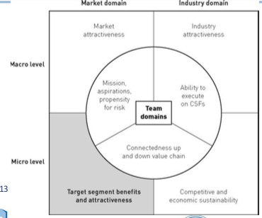
  - Investors notes: The clear lesson here is that entrepreneurs must be painstakingly clear about who makes up the target market that they seek to serve, and they must show tangible evidence that the customers in that market will buy. Why will they buy? To obtain benefits other solutions don’t offer – faster, better, cheaper and so on. Without benefits – without pain relief or delight – there will be no customers. Without customers, there will be no business.

The Seven Domains (Chapter 2)
- Is there a target market segment where we might enter the market in which we offer customers clear and compelling benefits or – better yet – resolve customer’s pain at a price they are willing to pay?

The Seven Domains (Chapter 3)
- Market attractiveness: Box 3.1
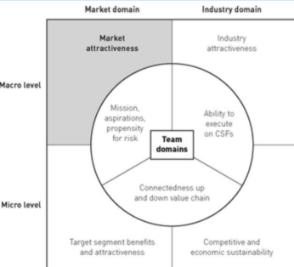
- Is your market large enough?
- What are the predictions for your markets short-term growth rate?
- What are the predictions for your market’s long-term growth rate?

The New Business Road Test, Mullins 2013
- Chapter 3: “Is this a good market”
  - Investors notes: A large and growing market is not the entire story, by any means, but an opportunity lacking such a market is unlikely to be funded by professional investors. Why? Large and growing markets offer two things that investors like. First and foremost, large and growing markets offer the opportunity to build a large company, one worth much more tomorrow than today. That’s good for returns. Equally important, large markets offer the chance for multiple players to be successful, each serving a different segment, perhaps in a different way. That’s good for reducing risk, because it offers multiple pathways to success.
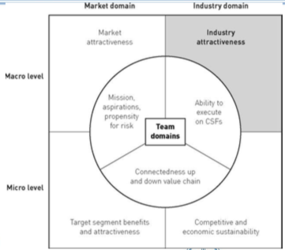
The Seven Domains (Chapter 4)
- Industry attractiveness:
- It’s generally worth thinking both broadly and narrowly. The key point, though, is that your industry, as well as other substitute industries, consists of other sellers – not customers, not products – of goods or services that meet the kinds of customer needs that you hope to satisfy.

The New Business Road Test, Mullins 2013
- Chapter 4 “Is this a good industry”
  - Investors notes: The reality is that [venture capitalists] invest in good industries – that is, industries that are more competitively forgiving than the market as a whole... Silicon Valley investor Bob Zider
  - What Zider’s statement means, in five forces terms, is little threat of entry, weak supplier and buyer power, little threat of substitutes and little competitive rivalry.
Since these are crucial issues to investors, entrepreneurs who intend to seek capital at some point would do well to have invested some time and effort to understand them fully for the industry they propose to enter

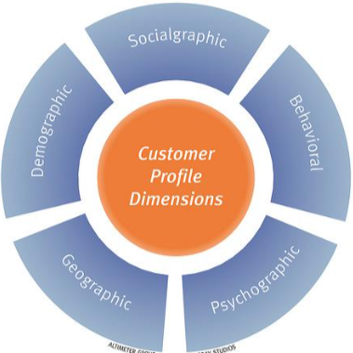
Customer Profiling
- What segment potential customers to identify common needs/wants, buying preferences
- Three ways to define market segments:
- Who the customers are (demographics)
- Where the customers are (geographies)
- How customers behave (psychographics)

Market Segmentation
- A segment is a group of buyers who…
  - Share the same problem
  - Share the same buying criteria
  - Would view each other as a credible reference in a buying decision
- Common segmentation types can be demographic, psychographic
  - Ex. Males 18-25; those who eat at restaurants weekly
Customer Profiling

DEMOGRAPHICS | PSYCHOGRAPHICS
- Key personal characteristics of a group of people  - These include:  - Age  - Sex  - Family status  - Age of children  - Education  - Residence | - Process of a segmenting the population by lifestyles, values and behaviours  - These may include:  - Where they eat and shop  - Sporting activities  - Entertainment activities  - How socially and physically active they are  - Whether they travel for business or fun

Why do entrepreneurs care about the difference?
- Demographic info is relatively easy to attain, males segmenting and targeting the needs to specific groups easier
  - Ex. You want to start a nightclub → find age, marital status of residents. This info is available through Stats Can, reports, etc.
- Psychographic data is based on preference, values, beliefs, attitudes and is much harder t]o gather using surveys, focus groups etc. However, to helps uncover the WHY, rather then the WHAT
- Complications:
  - People may say one thing and do another
  - People generally try to satisfy the questioner
  - Buying behaviours often vary with the situation

Doing research to detect shifts and customer pain
- Primary
  - Direct observation (fresh eyes)
  - Concluding interviews, collecting your own data
  - Demogrpahic or psychographic
- Secondary
  - Using other’s research
- Many osurces
  - Google trends
  - Stats can
  - Survey monkey
  - Linkedin

Customer Research is a key first step
- Start with a customer pain point + idea
- Profile you most typical customer segment
  - Use case: a customer story demonstrating the attractiveness of your idea
- Test your idea/value proposition on members of that profile
- If no go- modify your idea or customer profile; repeat

Recap
- We can often get ideas from consumers and markets based on their needs/wants
- Customer profiling helps pinoint needs into target groups
  - Demographic- based on facts, data (ex. Age)
  - Psychographic- based on choices (ex. lifestyle)
- Customer driven ideas tend to produce incremental changes to what we know
  - The status quo
- But sometimes oppurtunities originate from new catagories customers aren’t aware of

Introducing the Value Proposition
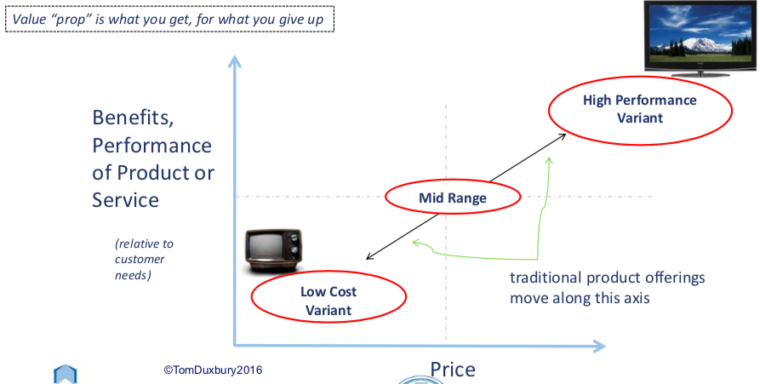

Blue Ocean Strategy
- How to redefine industry boundaries and create new market space
- The Paradox
  - The basis of most industry competition is price
  - 86% of competitive innovations produced 39% of profits
  - In contrast, the remaining 14% on uncontested market space produced 61% of the industry profits
    - Research by Kim and Mauborgne, 2004
    - First publish by Kim and mauborgne in HBR, 2004

What do all these have in common?
- Cola
- BMW
- Android

The usual strategy for new products
- To win, you must
  - Pick a promising market
  - Differentiate either with
    - Lower cost (price strategy) OR
    - More value at higher cost point (feature strategy)
  - Then compete furiously to wrest market share
  - This is called a red ocean
    - Think: Android, store brand soda, BMW

What do all these have in common?
- Ebay
- Wii
- Facebook
- Grand Caravan

Blue Oceans Value Proposition
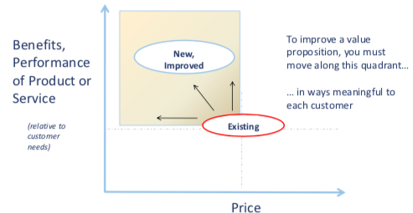
Blue Ocean
- Blue Ocean Strategy is about doing business where there is no competitor
  - Ex. Pursue differentiation AND low cost
  - Create new market space by redefining boundaries- “unknown market”
- Value Innovation: the alignment of innovation with utility, price and cost positions

The blue ocean strategy for new products
- To win, you must
  - Ignore exsisting markets, think of creating new ones
  - Differentiate both with
    - Low cost
    - More unique values
  - Then you own 100% market share
  - This is called blue ocean
  - Defining features: uncontested market space, pursuit of differentiation and low cost. The industry is usually unattractive (initially)
    - Think: Facebook, Dell, AMC multi-theaters, Quicklube

Summary of Differences
Red Ocean Strategy | Blue Ocean Strategy
- Compete in excising market space  - Beat the competition  - Exploit existing demand  - Make the value/cost trade-off  - Strategic activities based on choice of differentiation or low cost | - Create uncontested market space  - Make competition irrelevant  - Create and capture new demand  - Break the value/cost trade off  - Strategic activities based on differentiation and low cost

Recap
- Use reverse associations to generate creative new ideas
- All true opportunities are driven by needs/wants – customer pain
  - We segment markets to address their specific pain points
Put ideas/solutions in search of a problem on the backburner
- Blue Oceans – differentiate on both price and benefits in new markets with no competition
- Improving value propositions- must deliver more for some price or less

