Lecture 4: Idea Generation and Market Driven Opportunities

Overview
- Takeaway from last week
- Learning objectives
- Lecture 4
- Teams
- Entrepreneurial Learning Project
- Your questions and takeaways

Learning Objectives-WIFM
- Entrepreneurial
  - Customer pain- want, needs and opportunities
- Theoretical
  - Seven domains of New Business Road Test

Customer Pain Points
- Describe unmet wants or needs of current customers within existing markets
- Are what we experience everyday
- Are what entrepreneurs most often act upon when others don’t
- Are essential- the first and strongest rationale of any opportunity
  - First question to an entrepreneur: What is your customer pain point

Wants vs. Needs affect opportunity Attractiveness
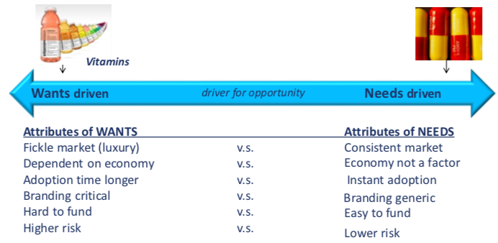

Customer “Wants” vs. “Needs” affect the attractiveness of the Opportunity *Use for 50 to 5 Ideas
- Idea + Need = Opportunity
- Idea + Want = Possible Opportunity (ex. Luxury items)
- Idea + (No clear Need/Want) = Idea
- The New Business Road Test, Mullins 2013
  - Chapter 2 “Will the Fish Bite”
  - Investors notes: The clear lesson here is that entrepreneurs must be painstakingly clear about who makes up the target market that they seek to serve, and they must show tangible evidence that the customers in that market will buy. Why will they buy? To obtain benefits other solutions don’t offer – faster, better, cheaper and so on. Without benefits – without pain relief or delight – there will be no customers. Without customers, there will be no business.

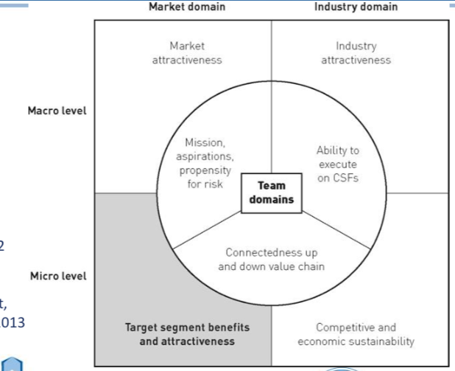
The Seven Domains
- Is there a target market segment where we might enter the market in which we offer customers clear and compelling benefits, or – better yet – resolve customers’ pain, at a price they are willing to pay?
- Based on real start-ups
- Target segment: all about being focused and attractive
  - When you start going over everything you will go for the target market first!
  - If you don’t have a target market, you will run out of cash very quickly

Two Basic Approaches to New Venture Opportunities
- Market Sourced (consumers)
  - Sometimes consumers lead with demand
    - Ex. Consumers want MPs Players, not CDs. Entrepreneurs creates new product to follow trend in demand
  - Consumer: needs, wants, needs/wants

- Industry Sourced (Producers)
  - Sometimes industries change, and new businesses are created without or ahead of consumer demand
    - Ex. Regulations change to encourage competition. Entrepreneur starts new business
  - Changes: Pestel, Industry Rivalry
  - New industries

Where to Start?
- Most fruitful ideas are markets and industries (ex. Domains) you are connected with
- Can also draw from personal experiences, networks, values and areas of domain expertise
  - Values: What you were born to do
  - Passions: How do you spend you free time?
  - Experiences: Upbringing, travel, social, etc.
  - Domain expertise: Work terms, education in finance, marketing, science, etc. What are you paid to do?
  - Daily life: Coming to school, work friends, etc.
- The better you know yourself, the easier this is
- Anytime there is a change, opportunities are created
- Change may happen gradually, suddenly or as part of natural life cycle
- People react to change differently
  - Denial (some)
  - Avoidance (some)
  - Acceptance (most)
  - Opportunistically (us!)

PESTEL: Identifying Sources of Environmental Change (expects version of this in both reports!!)
- Political issues
- Current economics
- Social trends
  - In Canada it is easy, Marijuana is being legalized
  - Not accepted by all age groups
- Current and near future state of technology
  - AI will be a big problem for us in the future
- Environmental concerns
  - Climate change
  - You can find government subsidies to reduce carbon admissions
- Legal and regulatory issues
- Example:
  - Which industry trends are causing the disappearance of this?
  - Has customer paint point away?
  - What opportunities are being created by this change?

Recap
- Ideas require customer pain point to become an opportunity
- Entrepreneurs:
  - Gather ideas
  - Act on opportunities
- Market opportunities are driven by customer needs/wants
  - The best starting place is an unmet need in a domain you are familiar, passionate and motivated about
  - Needs vary in necessity from survival upwards (Maslow’s)
- You can also create opportunities from unrecognized wants, but it is more difficult for entrepreneurs
- Opportunities based on customer needs vs. wants to have very different characteristics for entrepreneurs
  - Ex. Risk, adoption time
- New opportunities are often created by environmental changes
  - Change is all around us, we just have to be sensitive to it
  - Changes in markets (consumers) and industries (producers) are both important drivers of opportunities
  - Major examples: social trends, demographics, technology
  - PESTL

Entrepreneurial Awareness Has Two Sides
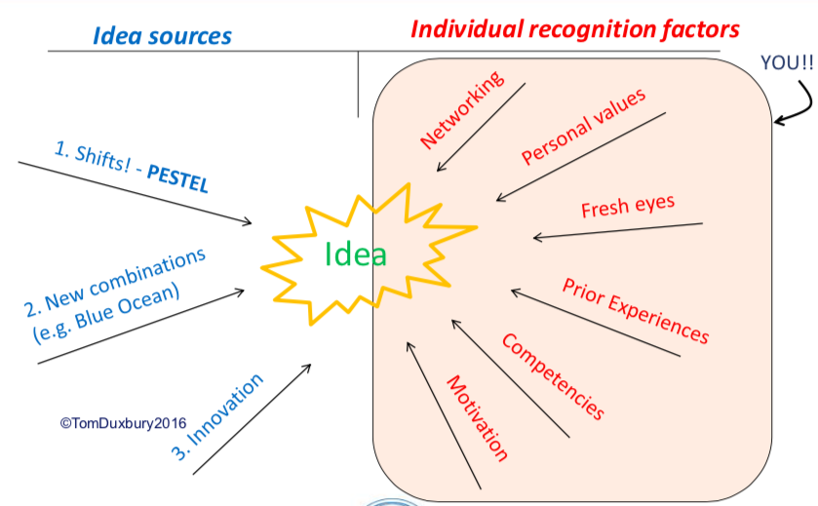

Fresh Eyes
- Power of Observation
- Video link
- Questions
  - What needs, wants or pain points do current customers have?
  - What opportunities for improvement are there?
  - What combinations from other industries might be made? (Think electric cars, bikes)
  - What trends or influenced are creating change in the industry (PESTL, Think compact florescent bulbs, mobile internet)
  - If you changed one aspect, can new customer categories arise?
    - Ex. The way it’s used, packaged, distributed, who it’s targeted at, associations. Think Amazon, Lululemon
  - Is something working in other parts of the world that can be posted here (Think mopeds, scotch, Starbucks

Fresh Eyes Thinking
- Why does it have to be this way?
- What problem are we really trying to solve?
- How might we do this differently?
- Why can’t we do this?

Jobs to be Done Thinking
- Think of the job you are actually hiring something to do
- You could add many features to this tool and try to compete
- But why are you actually hiring the drill
- You are not going to the store to buy this

Seek out the Why not the What
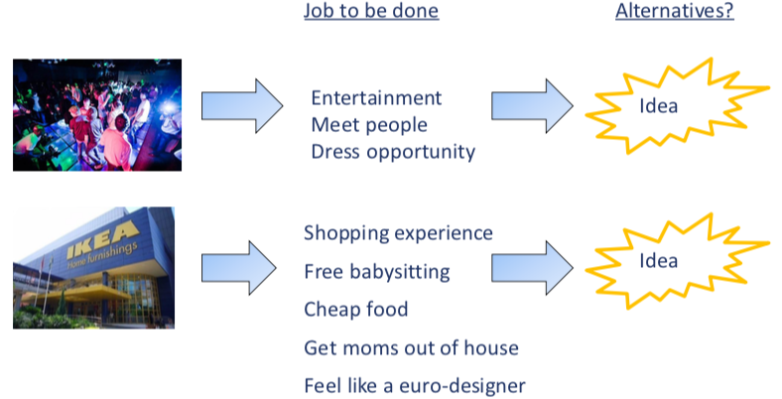

Reserve Associations
- One of the most effective methods for generating new ideas
- Take a traditional product or service and flip around its perceived association to create a new opportunity
  - Example:
  - Luxury (item) Make you think Expensive, exclusion, guilty (associations)
- Reserve the association and you create potential new categories
  - Example:
  - Affordable luxury, luxury for everyone, guilt-free luxury

Reserving Associations is a major source of ideation
- Exercise clothing odors
- Reverse this and you have…
- Exercise clothing Lululemon

The Value of Yes And
- When working with others, this statement accepts what was already offered, then moves it forward
- It builds trust, avoids dead ends, critiquing, critical judgment and…
  - It is absolutely essential to team creativity, brainstorming, improvisation- leading to breakthrough ideas

Recap
- Customer pain points are unmet NEEDS (or sometimes Wants)
- Ideas without customer pain points are not opportunities (yet)
- We collect ideas at all times .. and select them as opportunities later
- Start with domains you are familiar with as a guide
- Apply questions and reversing techniques to stimulate ideas • Change and shifts in the environment create/expose new opportunities
  - Think of the “job to be done” rather than a superficial solution
  - Ask what problem are we solving?
  - Try reversing associations to generate new ideas

Take away: look at everything with fresh eyes
Get peoples opinions and perspectives
Defining target market is crucial

