Chapter 1
Risk Management and Sources of Law

1.Why study law?
Business choices (made in every business all the time) have legal consequences like suing.
Enforceable – (имеющий) законную силу
Liability – ответственность
Litigation – судебное разбирательство
Tort – ущерб
Legal cause- cause of action- why to judge.
2.Risk management (managing risks – goal)
Risk management is the process of identifying, evaluating, and responding to the possibility of harmful events.
The process:
- IDENTIFICATION of the risk of being sued for defamation (клевета)
What risks exist in a particular situation?
- EVALUATION of being legally accepted
How serious are those risks?
- RESPONSE formulation
How will you react?
Strategies used for managing risk:
- RISK AVOIDANCE – eliminating risk altogether
- RISK REDUCTION – reducing/decreasing risk to an acceptable level through precautions
- RISK SHIFTING – shifting/transferring risk to another parties. Important strategies: insurance [risk is reduced or shifted by contracting for an insurer’s promises to pay if a loss occurs] and exclusion clauses (оговорка об исключении/ изъятии) [risk is reduced or eliminated by contracting for a right to limit or exclude liability]; incorporation [risk is reduced by conducting business through a company]
- RISK ACCEPTANCE – tolerating risk as a cost of doing business

Precautions – меры предосторожности
Independent contractor – независимый подрядчик – a person who performs services on behalf of a company, but who is not a regular employee for that company.
Vicariously liable – нести остаточную ответственность

INSURANCE policy is a type of contract. One party, insured, promises to pay a price, premium. The other party, insurer, promises to pay a certain amount of money if the insured suffers a certain type of loss.
Types of insurance (2):
- Liability insurance – a benefit if the purchaser is held liable of doing something wrong.
- Property insurance – provides a benefit if the purchaser’s property insurance is damaged/ lost/ destroyed.
EXCLUSION CLAUSES is a contractual term that changes the usual rules of liability. Such a clause may attempt to exclude all risk of liability, or it may exclude liability for certain types of acts /losses, or it may limit the amount of compensation that is available.
INCORPORATION is a set up of businesses that are given limited liabilities (does not protect from all risks).
In-house counsel – internal permanent legal department.
3.The Nature of Law
A law is a rule that can be enforced by the courts. Ethical perspective + distinction between legal obligations and moral obligations
4.A Map of the Law
Civil laws trace their history to ancient Rome. Jurisdiction is a geographic area that uses the same set of laws. Civil laws deal with suing for money.
Common laws trace their history to England.
Map:
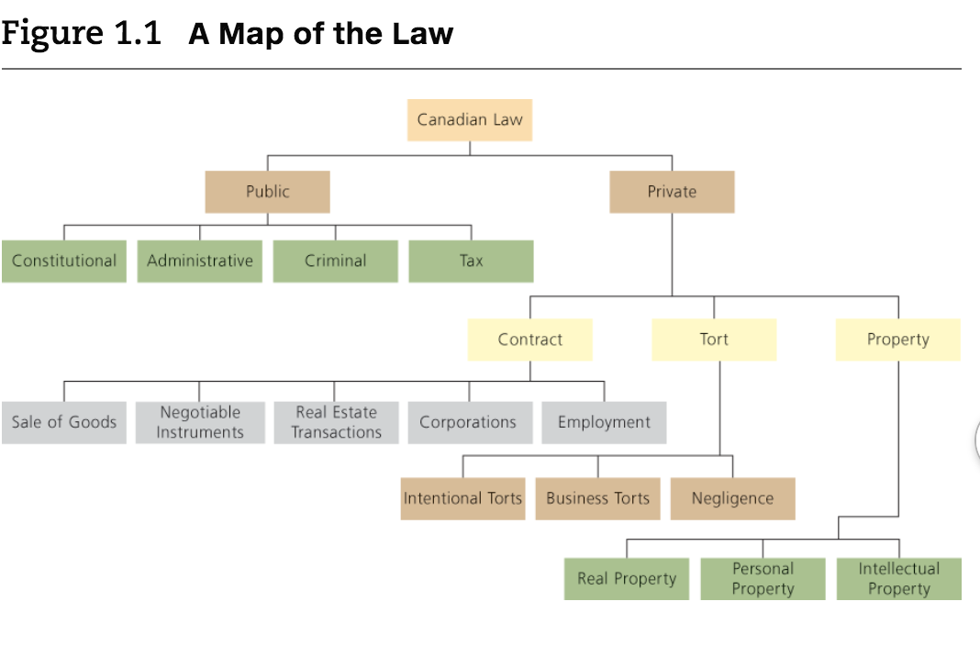
5.Public Law
Public law is concerned with governments and the ways in which they deal with their citizens. Includes constitutional, administrative, criminal and tax law.
Constitutional law provides basic rules of our political and legal systems: determines who is entitled to create and enforce laws; establishes the fundamental rights and freedoms.
Administrative law is concerned with the creation and operation of administrative agencies, boards, commissions, and tribunals; is delegated or assigned by the government to a variety of agencies, commissions etc. responsibilities. Can be Federal, Provincial/Territorial, Municipal.
Criminal law deals with offence against the state – people who break rules that are designed to protect society as a whole.
Tort – done something against a person vs. Crime -done something against the whole society.
Crimes:
- WHITE-COLLAR CRIMES committed by men in suits
- CORPORATE CRIME committed by a company, a fraud.
Tax law is concerns with the rules that are used to collect money for public spending.
6.Private Law
Private law is concerned with rules that apply in private matters. Both parties in a private dispute are usually private persons (individuals/organizations/public body). Private law is divided into 3 main parts: the law of tors, contracts, property.
A tort is a private wrong, an offence against a particular person. Categories of torts are intentional torts, business and negligence torts.
Negligence – небрежность.
The law of contract is concerned with the creation and enforcement of agreements. Used for the sale of goods, as a negotiable instrument, for real estate transactions, the operation of corporations and the employment relationship.
The law of property is concerned with the acquisition, use, and disposition of property. Divided into three main parts: real property (land and what is attached to it), personal property (things that can be moved one place to another), and intellectual property.
Laws that deal with forms of property:
The law of succession (наследствие) deals with the distribution of a person’s property after death.
The law of trust deals with a situation in which one person holds property on behalf of another.
7. Overlap of areas of laws
Two possibilities:
- ALTERNATIVE ANALYSIS when a single event can trigger more than one set of rules (event is both a tort and a crime, tort of negligence and breach of contract).
- MULTIDISCIPLINARY CONTEXTS when a situation involves various types of laws.
8. Sources of Law
Three sources:
- THE CONSTITUTION is the most important source of law. It creates the basic rules for Canadian society (+ political and legal system). Every other law in the country must be compatible with the Constitution. The Constitution is very difficult to change, only through a special amending formula that requires the consent of Parliament + the legislatures of at least two-thirds of the provinces (50% of the country’s population).
- LEGISLATION – законодательство
- THE COURTS
9. Division of Powers
Canada is a federal country because it has two levels of government:
- FEDERAL by the Parliament of Canada in Ottawa. It is composed of two parts: The House of Commons (elected members of Parliament (MPs)) and The Senate (appointed). The leader of the biggest MPs’ party is the prime minister.
- PROVINCIAL AND TERRITORIAL by the elected politicians on provincial and territorial levels. The elected body, legislature (законодательный орган) is called Legislative Assembly.
Sections 91 and 92 of the Constitution establish a division of powers by identifying the areas in which each level of government can act.
The federal government has the residual power (остаточные полномочия) – the power over everything that is not otherwise mentioned.
When government tries to create a law outside of its own area it acts ultra vires – “beyond the power”. These laws have no fore or effect.
The cost of a direct tax is expected to fall on the taxpayer, but the cost of an indirect tax is expected to be passed on from the taxpayer to someone else, such as the taxpayer’s customers.
The doctrine of federal paramountcy determines which law applies based on the Constitution’s division of powers. The federal law wins.
Intra vires – within the scope of powers.
The Canadian Charter of Rights and Freedoms protects basic rights and freedoms. Important sections: fundamental freedoms, mobility, equality rights. The charter has no property or economic rights.
10. Charter Remedies
Remedies - средств правовой защиты.
- DECLARATION – declaring the Charter has been violated.
- INJUCTION – a court impose an injunction (запрет) that requires the government to address the problem in a certain way.
- STRIKING DOWN - a court may strike down or eliminate a statute that violates the Charter.
- SEVERANCE, READING DOWN/IN - a court may save a statute by re-writing part of it. Read in - broader interpretation, down – shorter.
- DAMAGES - intended to compensate the plaintiff’s (истец) loss, vindicate the plaintiff’s rights, and deter or discourage future wrongdoing.
Parliamentary supremacy means that while judges are required to interpret constitutional and statutory documents, they must also obey them.
Legislation is the law that is created by Parliament or a legislate (statutes, acts).
11. Legislative process.
- Bill passes the first reading.
- Re-appears for second reading.
- Third reading.
- Royal assent – approved from the Queen.
Members of Canadian society may influence the legislative process during at least three stages: lobby (encourage) MP to introduce a bill; express concerns about a bill for second reading; express opinion in the committee.
11. Subordinate Legislation and Municipalities
Subordinate legislation – regulations when statutes often set up a basic structure but allow someone else (such as a government minister, a commission, or a tribunal) to create specific rules without the need to go through the entire legislative process.
Municipality is a town or city.
A by-law is a type of subordinate legislation that is created by a municipality.
12. The Courts
Third source of law. Judges interpret and apply the words that appear in the Constitution and in legislation.
13. Common Law
- SYSTEM
- SOURCES
- COURTS
Equity- general sense, fairness. Nature of equity & one set of courts (Canadian court is now a court of law and a court of equity).
A trust exists anytime that one person owns property for the benefit of another. The most common type is an express trust, which is created when one person, called the settlor, transfers property to another person, called the trustee, to hold on behalf of the beneficiary.

Chapter 2
Litigation and Alternative Dispute Resolution
Litigation - судебное разбирательство.
1.Who can Sue/ Be Sued?
All adults are free to use the Canadian courts, whether or not they are Canadian citizens can.
Children must be represented by a parent or litigation guardian.
A class action allows a single person, or a small group of people, to sue on behalf of a larger group of claimants about/with:
- COMMON ISSUES
- REPRESENTATIVE PLAINTIFF (представителями истца)
- NOTIFICATION
- PREFERABLE PROCEDURE
- CERTIFICATION - the court’s decision to allow the various claims to be joined together and to proceed as a class action
2.Representation
Legal representation by:
- Yourself – self-representation.
- Lawyers that hold professional liability insurance that allows you to receive compensation from the lawyer’s insurance company. Law societies also create assurance funds, which provide compensation to people who have been hurt by dishonest lawyers.
- Paralegals not a lawyer but provides legal advice and services.
3.Pleadings (заявлений)
Pleadings are the documents used to identify the issues and clarify the nature of a dispute. Some are prepared by the plaintiff, while others come from the defendant.17 The plaintiff is the person who is making the complaint. The defendant is the person about whom the complaint is being made.
A limitation period is a period of time within which an action must be started.
Special periods are outside of the general limitation provisions, periods vary considerably.
Effect of lapse is the consequences of missing a limitation period deadline may also vary.
Justifications – оправдание.
A statement of claim is a document in which the plaintiff outlines the nature of the complaint.
A statement of defense is a document in which the defendant sets out their version of the facts and indicates how they intend to deny the claim
A counterclaim is a claim that the defendant makes against the plaintiff.
A reply is a document in which a party responds to a statement of defence.
A demand for particulars requires the other side to provide additional information.
4.Pre-Trial Activity
Examination for discovery is a process in which the parties ask each other questions to obtain information about their case.
A settlement occurs when the parties agree to resolve their dispute out of court.
A pre-trial conference is a meeting that occurs between the parties and a judge.
Mediation is a process in which a neutral person—called a mediator—helps the parties reach an agreement.
5.The Trial
Each side will present arguments and evidence. Evidence consists of the information that is provided in support of the arguments.
To get that evidence in front of the court, each side will call witnesses. Ordinary witnesses testify about facts that they know first-hand (for instance, a pedestrian may describe a car accident that they saw happen). Expert witnesses provide information and opinions based on the evidence.
Examination-in-chief is a process when the party who calls a particular witness will ask questions and receive answers.
Hearsay evidence is information that a witness heard from another person, rather than directly from the source.
On the basis of their arguments and evidence, the plaintiff has to prove the claim on a balance of probabilities. That means that every important part of the claim must be probably true.
6.The Remedy
Various punishments may be available if a person is convicted of a crime. The court may, for instance, impose a fine or a prison sentence. Canadian courts also frequently use conditional sentences, which allow criminals to serve time in their own houses, rather than in prisons.
7. Enforcement (обеспечения соблюдения)
A judgment debtor is a defendant who has been found liable and ordered to pay money to the plaintiff.
8. Appeals
An appeal court (or appellate court) decides whether a mistake was made in the court below. The party who attacks the decision of the lower court is called the appellant, and the party who defends that decision is called the respondent. An appeal must be started promptly, normally within 30 days after the trial court gave its decision.
Most appeals are heard by three judges (and sometimes more). Appellate courts do not listen to witnesses or receive evidence. Appellate courts normally deal with law, but not facts.
Appeal court’s decisions:
- DISMISSED - affirms the lower court’s decision.
- ALLOWED - believes that the lower court decision was wrong.
- DISSENT - a separate judgment of a disagreeing judge.
9. Costs
Costs are the expenses that a party incurred during litigation.
A contingency fee agreement requires a client to pay its lawyer only if the lawsuit is successful.
10. The Court System
The Supreme Court of Canada is the highest court in the country. It has nine members: The Chief Justice and eight others (called puisne judges). The Supreme Court of Canada is not a trial court. If you want to take your case to the Supreme Court, you must successfully apply for leave, or permission, to appeal.
Every province and territory has a court of appeal.
The Tax Court of Canada allows a person to dispute the government’s demand for the payment of a tax.
The Federal Court hears trials concerning issues that the Constitution assigns to the federal government.
The provincial governments appoint the members of the provincial courts. These are trial courts.
A small claims court is a type of court that deals with disputes involving limited amounts of money. Drawbacks: geographic limits, types of claims, types of remedies and monetary limits (only small claims).
Courts are arranged in a hierarchy according to their importance
The doctrine of precedent requires a court to follow any other court that is above it in the same hierarchy.
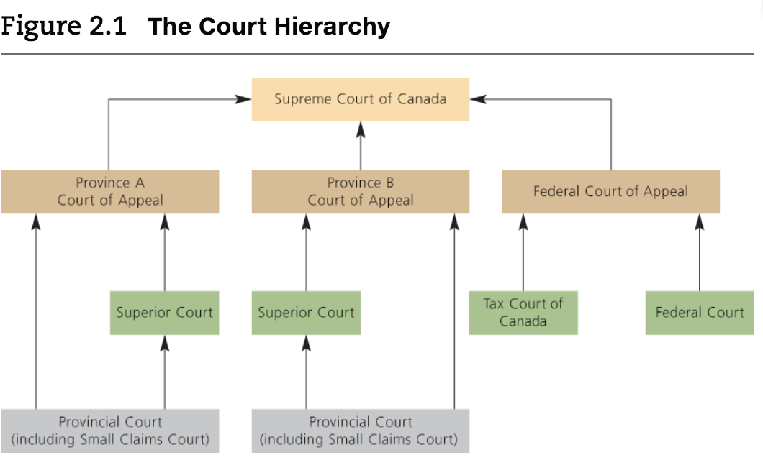
The rule of law states that disputes should be settled on the basis of laws, rather than personal opinions.
An administrative tribunal is a body, somewhere between a government and a court, that resolves issues and disputes that arise in administrative law.
Alternative dispute resolution (ADR) is any process that allows the parties to resolve their dispute without going to court: negotiation, mediation, arbitration.
A negotiation is a discussion aimed at settling a dispute
Mediation is a process in which a neutral party—called a mediator—helps the parties reach an agreement.
Arbitration is a process in which a neutral third person—called an arbitrator—imposes a decision on the parties.

Chapter 3
Intro to Torts

1.Intro
Tort – a failure to fulfill a private obligation (owned to a person) that was imposed by law.
Tortfeasor – a person who has committed a tort.
Tort of battery – насилие
When it comes to torts, the plaintiff sues the defendant.
The remedy is usually a compensation of a damage.
Blood flued – кровная месть
Both torts and contracts involve primary and secondary obligations. Primary – how people should act (before breaching an obligation). Secondary – describe a remedy, what to do after the primary obligation has been breached.
Obligations in torts are imposed by law.
No “privity” when it comes to torts: anyone can sue anyone.
Tort is something that should not happen so the compensation is backwards-looking (as if the tort did not occur).
Contracts – forward-looking
Mental culpability – психическая ответственность/ вина
A tort requires that the defendant acted with a guilty mind.
Intentional torts: when people intentionally act in a certain way.
Negligence torts: when a person acts carelessly.
Strict liability: when a person does something wrong without intending to do so and without acting carelessly.

2.General principles of Tort Law
Liability insurance – a contract in which an insurance company agrees, in exchange for a price, to pay damages on behalf of a person who incurs liability.
The duty to defend requires the insurance company to defend, at its own expense, any lawsuit that is brought against the insured party.
Compensatory function of law aims to fully compensate people who are wrongfully injured.
The deterrence (сдерживание) function discourages people from committing torts by threatening to hold them liable for the losses that they cause.

Vicarious liability – occurs when one person is held liable for a tort that was committed by another person; a plaintiff is more likely to get compensated. Does not relief the employee from the responsibility. Usually both employer and employee are sued.
Employers are not responsible for independent contractors- workers, who are not closely connected to the employer’s business as are employees.
An employee usually: 1. Controls what/where/when is done. 2. Uses the employer’s property. 3.Gets paid regularly. 4.Is integrated into the employer’s business.

3.Remedies
Compensatory damages: usually the largest remedy is preferred.
The defendant is only responsible for the damages the tort has caused.
A loss is remote if it would be unfair to hold the defendant responsible for it. Remoteness does not apply to intentional torts.
Mitigation occurs when the plaintiff takes steps to minimize the loses that result from the defendant’s torts. Only reasonable steps should be taken. It is not required to mitigate for the plaintiff. Damages are denied only to the extent (of loss) that the plaintiff unreasonably failed to mitigate.
The plaintiff can recover the cost associated with mitigation.
Punitive damages are intended to punish the defendant and discourage (deter) other potential wrongdoers.
Nominal damages: the defendant committed a tort even though the plaintiff did not suffer any loss.
Injunction is a court order that requires the defendant to do something or refrain from doing something.
Alternative compensation is a system that allows a person who has suffered an injury to receive compensation without bringing an action in tort. Provide less compensation than a regular tort’s.

MIDTERM:
Follow the IRAC method:
Issue: Make it clear what the issue is in the case. (ex. the issue is whether kanye is trespassing on taylor's land)
Rule: Name the corresponding rule and its elements required that constitute a trespass to land, for example.
Apply: Apply the rule to the issue by using all the evidence provided in the question (be sure to include EVERY detail concerning that specific rule and the case given) Explain clearly by drawing from the case.
Conclusion: Make it clear at the end if kanye indeed trespassed or did not trespass onto taylor's land.
Chapter 4
Intentional Torts
Intentional torts - involve intentional conduct.
Assault and Battery
Assault - occurs when the defendant intentionally causes the plaintiff to reasonably believe that offensive bodily contact is imminent.
- Belief - the tort is based on A REASONABLE BELIEF that physical contact can occur.
- Reasonable belief.
- Imminent contact - immediate.
- Offencive.

Battery - offensive bodily contact.
- Contact - even with clothing or something that the plaintiff is holding.
- Social interaction - must be unusual/ offensive.

Invasion of Privacy
Privacy is indirectly protected by several torts:

- Trespass to Land: sneaking into someone’s land.
- Breach of Confidence: publishing/ sharing one’s photos (embarrassing) without consent.
- Intentional Infliction of Mental Distress - like creating fake news - requires the defendant to act in an outrageous or unjustified manner, either intending to cause an emotional distress callously disregarding that possibility, and caused the plaintiff to suffer a serious emotional injury.
- Abuse of private information:
- Misappropriation of personality:unauthorized usage of one’s image.
- Negligence: ignoring instructions.

According to the Criminal Code of Canada, the crime of “voyeurism” is committed by secretly observing or recording a person in “circumstances that give rise to a reasonable expectation of privacy”, if that person is engaged in sexual activity or is partially or fully nude”. The crime is also committed by anyone who shares, copies, publishes or distributes the prohibited video.

False imprisonment: occurs when a person is confined within a fixed area without justification:
- Confinement: not necessarily an actual prison. Being completely locked n a car/building etc. without any other way to get out.
- Psychology: physical force is not necessary.
- Risk reduction by calling the police instead of arresting on your own.
- Malicious Prosecution: when the defendant improperly causes the plaintiff to be prosecuted.
Imprisonment is false only if it’s done without authority - police or security guards in some cases (only if a crime is actually being committed by the suspect).

Trespass to Land: occurs when the defendant improperly interferes with the plaintiff’s land.
Chattels: moveable forms of property such as horses, cars, books etc. Three torts to protect them:
- Trespass to chattels - defendant interferences with plaintiff’s chattels (damages, destroys, takes or uses)-> compensation for loss
- Conversion - defendant interferences with plaintiff’s chattels and is serious enough to justify forced sale-> forced sale of chattel from plaintiff
- Detinue (незаконный захват чужого имущества) - defendant’s failure to return chattels to plaintiff-> compensation for loss or return of chattel
The right of recaption allows a person to simply take property back.

Complete defences
A complete defence protect a defendant from all liability:
- Consent - exists if a person voluntarily agrees to experience an interference with their body, land or goods. = express (on paper) or implied (by the circumstances). Consent is effective only if it is free and informed. Consent can be revocable.
- Legal authority - provides a person with a lawful right to act in a certain way.
- Self-defence - tied to battery and assault - consists of the right to protect oneself from violence and the threat of violence. Defence of a third party - reasonable - a parent defences the kid. Defence of property - less important than human’s life- excessive force against the plaintiff would be punished.
- Necessity - if the defendant’s actions were justified by an emergency, when an immediate action is required in order to avoid some calamity.
Partial defence
Partial defence allows a court to reduce damages on the basis of the plaintiff’s own responsibility for a loss or an injury:
- Provocation are words or actions that would cause a reasonable person to lose self-control.
- Contributory negligence - the plaintiff is partially responsible for the injury that the defendant tortiously cause.

https://www.studocu.com/en-ca/document/ryerson-university/business-law/past-exams/practice-exam-2014-answers/204582/view
!!! final

