LECTURE 1: STAYING ALIVE

Quick Reminders & Important Information:
- Michael Runtz’s office: 4620 CTTC (same building as Treats, Medical Services); often in 4680 (with the animals).
- See our cuLearn website for all the course information (i.e. office hours), important information, useful links, announcements, sample questions for exams, on-line tests, exam dates, etc.
- Textbook: Natural History.
- TA’s this term: Jacqueline Chapman, Karl Loeffler-Henry
- If you want to email him, make sure you include the course number: “BIO 1902T”. Also, make sure you greet him with a “Professor” or “Professor Runtz”, to make it formal.

Course Objectives:
- To gain insights into the challenges of all living things face, and the remarkable diversity of solutions used to face them.
- To develop an appreciation and respect all living things.
- To learn how to see more of Nature….

- Mammals… talk more about it when you get the chance
- Birds are animals… not mammals
- Reptiles and Amphibians.
- Insects

Lecture 1: Staying Alive:
PART 1
- One of the most basic of all survival strategies for living creatures in the wild is to avoid being detected. If something cannot be seen, the odds ae better that it will be not be eaten. For that reason, many animals have mastered the art of being undetected and invisible, accomplished by using color patterns, body form and behavior.

- Camouflage (form of concealment) has been the focus of much research because it shows great importance for our species, especially for photographers, hunters, and most of all our military. Camouflage can be directly related with background matching, whereby an animal’s appearance closely resembles its surroundings. 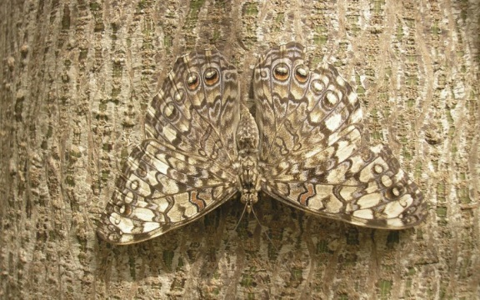 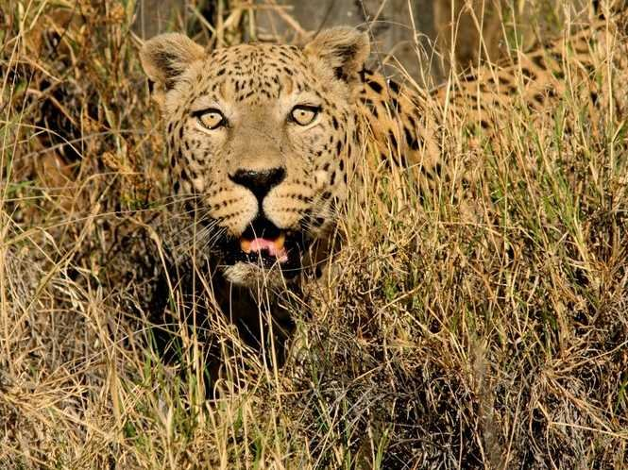

- Every habitat has general patterns that are created by the interaction of sunlight and vegetation. Cattail marshes, for example, are a vast expanse of contrasting dark and light vertical lines due to the upright stems and leaves of the dominant plants – Common Cattails, Narrow Leaf Cattails, and their hybrids – so vertical markings should allow an animal to hide better.

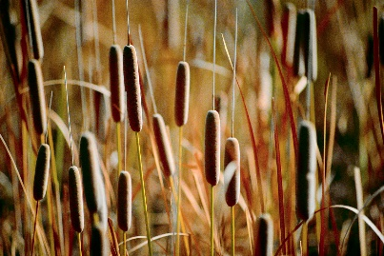

In result of this, some marsh birds including female Redwinged Blackbirds and American Bitterns that hide in Cattail Marshes, bear stripped plumage. When alarmed, bitterns work their breast striped plumage to their best advantage by pointing their bills straight up into the air, a posture that allows not only their brown breast streaks but also their entire body profile – spear-like bill included - to mirror the lines of the background.

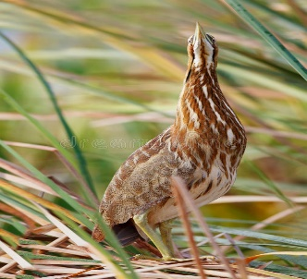

- If an animal is to be camouflaged in woodlands full of shade-casting trees (where the light reaches the forest floor in dappled fragments), its coloration should consists not of stripes, but of high contrast patches of flecks. Having said this, Wood Thrushes and their forest-dwelling relatives have pale breasts with dark spots: fawns (baby deer) have pale coats covered with white spots.
- As much as camouflage and background matching can be effective for living creatures to be undetected, it will fail if not coupled with motionless behavior.

- Gray Tree Frogs are among the very few terrestrial animals that are capable of changing their color to better match their background. They hide on tree trunks during the day, enhance their dark mimicry by folding their front legs under their chest in order for their body to become one with the tree. They also tend to go one step further to make their camouflage perfect: if green lichens cloak a tree’s bark, then these frogs change their color from usual gray to green.

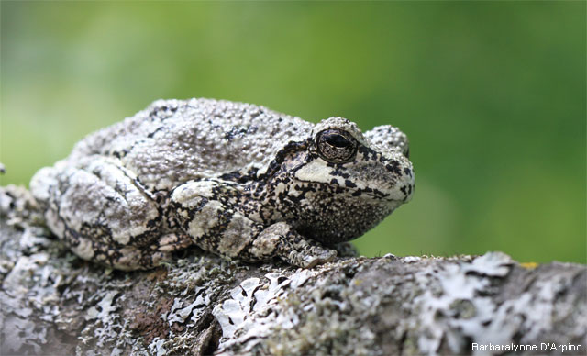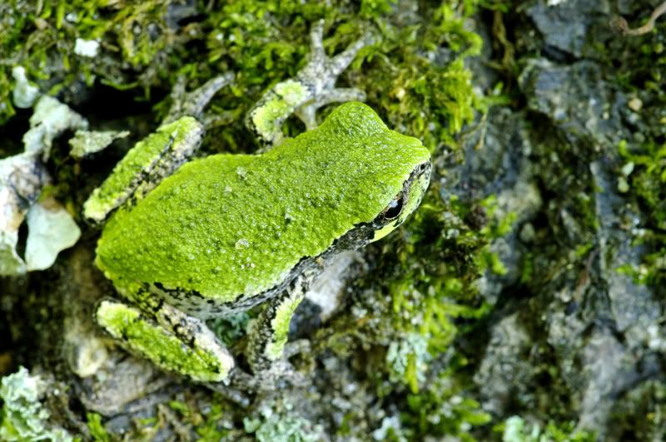

- Coincident Disruptive Coloration or Coincident Disruptive Patterns are patterns of disruptive coloration in animals that go beyond the usual camouflage function of breaking up the continuity of an animal's shape, to join up parts of the body that are separate. For example, the chinstrap of a Canada Goose is a disruptive pattern that works best when the bird’s head is lowered. That combination make it harder to detect. View pictures in textbook Natural History (Page 6) for a better and deeper understanding.

- Some animals take camouflage to another level by having their bodies match their background, not only in color, but also in form. Walking sticks, and Inchworms Caterpillars are excellent demonstrators for this behavior.



