Lecture 3: Team Performance and Idea Generation

Overview
- Takeaway from last week
- Learning objectives- WIFM
- Lecture 3
- Research Resources
- Teams
- Questions

Learning Objectives- WIFM
- Entrepreneurial
  - Research resources
  - Wants, needs and opportunities
  - Idea framework
  - Will clients buy
- Theoretical
  - Seven domains of New Business Road test

Performance Equation- Recall
Team performance =
- Core competencies +
- Motivation +
- Resources +
- Ability to work together

Brainstorming
- How to brainstorm
- An activity designed to bring out a large number of alternatives
- Breaks down barriers to creativity
  - Inhibition (fear of sounding silly)
  - “Tunnel” vision (too narrow focus)
  - Premature idea selection
- Process:
  - Set boundaries of objectives
  - Generates as many ideas as possible without filtering them
  - Build on eachother’s ideas
  - Take notes
  - No criticism- no such thing as a bad idea!

Wants, Needs, Ideas and Opportunities
- What is an idea?
- What is an opportunity

Definitions
- Idea: any conception existing in the mind as a result of mental understanding, awareness or activity. A thought, conception or notion
- Want: to desire greatly; wish for
- Need: Something that is required
- Opportunity: A favourable or advantageous circumstance

Are all needs the same?

Maslow’s Hierarchy of Needs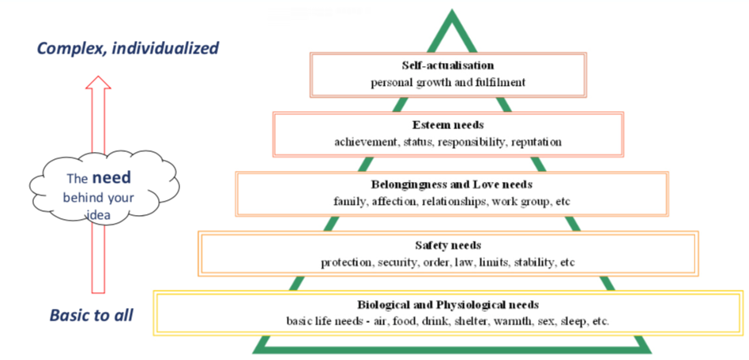

Don’t confuse need with want
- Thoughts
  - If needs can be finite, wants are..?
  - Do ideas based on needs differ from wants?
  - Can consumers mistake wants for needs?

Opportunity- Ch. 1 The New Business Road Test, Mullins 2013
“Why will or won’t this work”
A Customer driven feasibility study
- Are the market and the industry attractive?
- Does the opportunity offer compelling customer benefits, an economically sustainable business model as well as a sustainable competitive advantage over other solutions to the customer’s needs?
- Can the team deliver the results they seek and promise to others?

The Seven Domains
- Figure 1.1 The New Business Road Test
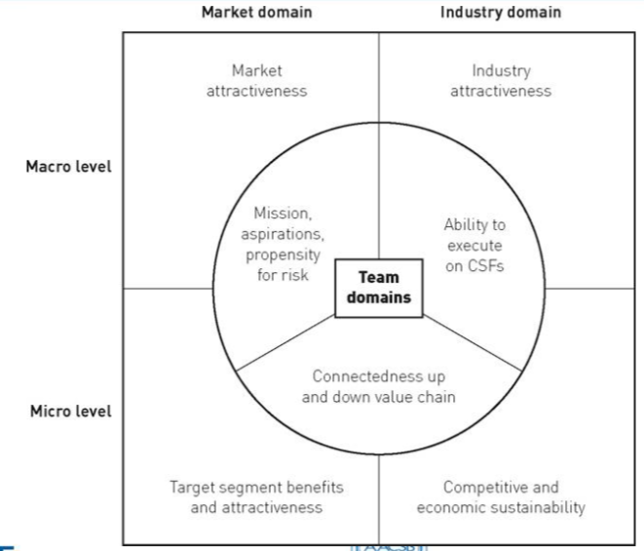

Group Exercise you can do on your own
- Brainstorm your first idea based on a need or want using these prompts to help:
  - What needs, wants, pain points do current customers have?
  - What opportunities for improvement are there?
  - What trends or influences are creating change in the industry?
  - What combination from other industries might be made?
  - If you changed one thing, can new customer categories arise?
  - Is something working elsewhere that can be moved here?
  - Can changing the way something is delivered add new value?

Takeaways
- Learning objectives- WIFM
  - Wants, needs and opportunities
  - Idea framework

Entrepreneur Learning Project DUE November 16!!!!
- 7 domains!!!!
- Chart in lecture size
- Industry: us
- Market: group of buyers
Pg small to big

