EXAM REVIEW

WEEK 8 - CHP. 5
MOTIVATION & AFFECT

MOTIVATION
Marketers segment consumers into groups based on their particular needs
- need; diff. between actual state and idealized state
- the difference leads to goals which leads to motivation
needsgoalsmotivation

biogenic needs: essential for maintaining the fundamental life processes (ex. Sleep, food & water)
psychogenic needs; different from region to region, religion to religion; learned need
needs vs. wants

maslow’s hierarchy of needs

some needs that are important to marketers
- status/ power
- belong/ affiliation; part of a group
- uniqueness
- sexual & partnership needs
- acquire; collecting, general sense of consumerism, need to purchase
- achievement
*marketers play off these simultaneous needs
*small differences that make people stand out ie. Color of the same sweater
- these needs determine brand choice used as a basis of segmentation

REGULATORY FOCUS
needs relate to motivation in 2 ways:
- Prevention focus – avoidance motivation
Negative state (motivated to remove) or possibility of one (motivated to avoid) (eg. Hunger, cold, looking cheap)
- Promotion focus – approach motivation
Positive state (motivated to maintain) or the possibility of one (motivated to achieve) (eg. Socializing, being admired)

**marketers play on the fact that humans like to feel good about themselves
**immediate and observant leads people to behave a certain way over something distant

disconnect payment from reward ** credit cards reduces the pain of paying
feels like you are handing over a piece of plastic card you feel the struggle more if you pay with cash- reduce avoidance

integrated losses doesn’t hurt us as much the individual loss

choosing between two choices;
samplers help you decide between two options you need to pick – choice under conflict
run specials on certain products

new core values
products made in a sustainable way, global health, environment
- conscientious consumerism: consumer’s focus on personal health merging with a growing interest in global health
- consumers who:
  - worry about environment
  - want products to be produced in sustainable way
  - spend money to advance what they see as their personal development and potential

environmental goal conflict:
- superior sustainability& average functional performance
- average sustainability & superior functional performance
  - feelings of distress until a minimum threshold of functional performance achieved
**who’s willing to pay more for these products; we like green products but they have to meet a minimum standard so we are willing to make a tradeoff for function over sustainability
**values interact with performance and cost we make tradeoffs

AFFECT

EMOTIONS – VALENCE
- negative and positive
- the middle is not positive or negative; nostalgia and melancholy

PARADOX
mood maintenance theory (isen & patick 1983)
**generally we want to stay in a good mood, so if we aren’t then we take actions to make ourselves happy
**happy people take small risks because they’re happy they want to keep being happy so higher risk aversion
→ higher aversion more likely to avoid risk
affect infusion model (forgas 1995)
**combination of affect and emotions, we use emotions as a data point/ source of information
**experience happy then they take bigger risks

induce people to feel jovial and sad and they both took bigger risks

affective states have a common valence can often lead to different and even counteracting outcomes
- fear and anger
- fear risk averse
- anger risk taking

retail therapy
- bad mood shopping makes you feel better
- reduces lingering sadness at the time and after
- feeling sad is cause you feel like you are lacking control; but shopping allows you to retake control and outcomes and thus improving mood
- when you’re in a bad mood you want to find a sales person also in a bad mood
- shopping when you’re sad can not only improve your mood, but also reduce lingering sadness, as the choices we make when shopping allow us to feel personal control over our situation

**selling insurance, you want to make people afraid; induce fear and leads to I want to avoid risk and leads to buying insurance
**selling you a trip; make you feel good about the destination
**different emotions are suited for different end goals

anticipated emotions
- will you feel good about this purchase
- how will I feel about it; more likely to make or not make the choice
- pleasure based products and services
- pictures help us envision
- videos
- unboxing videos; allows us to feel the emotions now and anticipate it; so you imagine yourself wanting this excitement

heart and mind in conflict
- chocolate cake study; shiv & fedorikhin, 1999
- deal with what the mind wants (salad) but heart wants (chocolate cake)
- when people have the cognitive resources and mental energy; if it is full then we are more likely to follow cognition (salad)
- if we are burdened by other things then we use our heart leading to (chocolate cake)
- supermarkets leave chocolate near the counter for when you forgot to get the eggs earlier to reassure yourself; feel better

-impulse buys
-mental resources
-decoupling of payment from purchase
-online shopping; doesn’t even give you association with your credit card leads to more impulse buys

affect importance
- memory
- more likely to remember something if there is a strong positive or negative emotion makes it easier to remember
- positive affect to the purchase or restaurant and therefore recommending it
- emotions effect our perceptions of the world
- bad mood but even if your tried to buy something you transfer the feeling on the items so no purchase
- emotions tied to sports teams; creates bond and loyalty to the brand; affective tie

-friendly greeter; affects mood
-type of music playing in the store
-visualize; so in ikea they set it up in a visual context; positive affect, anticipation
-costco free samples; trying food makes you elevate concern, needs perspective; helps you make the decision for you, induce hunger, they want you to wander around and see more products by putting the food stands to fulfill your basic need and stay longer

dress code, location of store, what’s in the store front
fast paced music, colours, sale
-enough sales staff, enough space for you to see the products, play with space to increase tranquility or status, you feel relaxed no rush

WEEK 9 – CHP. 6
THE SELF

Personality: consistently influences the way a person responds to his/her environment
Stability of Personality?
- Underlying characteristics + situational factors = behaviour

Different View of Personality
Freudian:
- Personality: conflict between gratification & responsibility

Karen Horney
- Moving toward others (compliant)
- Moving away from others (detached)
- Against others (aggressive)

Cardinal Traits: traits that define their life – someone who spends their life seeking fame or fortune
Central Traits: building blocks of personality and are closely tied to your view of self – when describing someone, you use words that refer to these central traits (between 5 & 10)
Secondary Traits: aren’t quite so obvious, general or consistent such as preferences, attitudes & situational traits (ex. “he gets angry when you try to tickle him”)

Big 5 Personality Traits
- Neuroticism: tendency to easily experience unpleasant emotions such as anxiety, anger or depression
- Extroversion: energy, unreserved, & the tendency to seek stimulation and the company of others
- Agreeableness: tendency to be compassionate & cooperative rather than suspicious & antagonistic towards others
- Conscientiousness: tendency to show self-discipline, act dutifully & aim for achievement
- Openness to Experience: appreciation of art, emotion, adventure & unusual ideas; imaginative and curious

Cognitive Theories of Personality
- How consumers process and react to info
- NC: need for recognition – a person’s craving for enjoyment of thinking
- Visualizers vs. Verbalizers: person’s preference for info presented visually or verbally

THE SELF
What is the relationship between consumption and the self?
- Why is the self-concept important to marketers?
- Brands and the self
- Advertising and the self
- The extended self
- Ex. Gender roles & body image
We all have many roles
- Sister, friend, athlete, daughter, student, etc…
- Played out in public, but also private
- More transparent than personal qualities and self-evaluations

What is THE SELF?
- Thoughts, beliefs, memories, generalizations and feelings that we have of ourselves
- This total body of info is also known as our self-concept
- We have the tendency to behave a certain way across similar situations – personality traits & qualities

Identities:
- We have at least as many identities as we have roles
- Different self based on situation (activated by cue)
- Some selves just more accessible than otherds

Selves:
- Within each identity, we have multiple selves

Ought self: symbolic self-completion
Actual Self: self-image congruence
Ideal Self: symbolic self-completion

MYTH: true inner self with well-defined, stable traits
- Much (all?) self-knowledge is acquired socially
- The self changes over time
- Different self-schema are cued by different situations

Self-Evaluations
- Tend to focus on competence, perseverance morality…
- Sum of all self-evaluations is self-esteem
- We are generally motivated to maintain and protect our self-esteem
- Both trait & state self-esteem are important

Looking Glass Self
- Actual appraisals: how people view you
- Self-appraisals: how you view yourself
- Reflected appraisals: how you think others view you
  - Individuals see themselves as others see them
    - Imagine appearance to others
    - Imagine their judgement
    - Develop a response to the perceived judgement

Self-Presentation: acting in a manner that suits one’s role in a given situation. Attempts to regulate behaviour to influence others’ impressions
Self-monitoring: extent to which consumers use situational cues to guide social behaviour (individual difference)
Public vs. Private Self: (contextual/situational variable)

Advertising and the Self
- Ads are designed to appeal to a particular identity
  - Consumers like ads more when the ad appeals to one of their salient identities
  - Advertisements often operate as ‘primes’ for a particular identity, which makes the identity salient and the ad more liked
- Fantasy advertising: suggests what selves are possible (ex. Appeals to “possible selves”)

The Self & Consumption
- Self-image congruence: products (brands, ads, etc) will be chosen when their attributes match some aspect of the self
- Symbolic Self-Completion Theory: acquiring and displaying products that allow one to bridge self-discrepancies.
  - Inverse relationship between knowledge with a particular role and reliance on symbolic products
- Product Attachment: extent to which the product is used to maintain or achieve a consumer’s self-concept

Symbolic Consumption
- Consumption helps us construct the self and communicates socially shared meanings about identity
- This occurs for both public and private consumption
- Self-image & brand image congruence are often important in consumption choices
- Products that are very important to us becomes part of us – extended self

Gender Roles & The Body
We see marketers drawing on self-theories in several ways:
- Highlighting differences between ideal, actual, & ought selves
- Creating gender identity congruent ads to increase appeal
- Using media to change the way gendered products are perceived, thereby changing the meanings associated with a particular gender identity

Ideals of Beauty Over Time
Specific “looks”/ideals of female beauty:
- Early 1800s: delicate/looking ill appearance
- 1890s: voluptuous, lusty
- 1990s: waif look
- modern: high heels, body waxing, eyelifts, liposuction

Male:
- agentic roles: be assertive and have certain skills
- breadwinner, rebel, man of action hero
Female:
- communal roles; foster harmonious relationship; traditional family over career
- new managerial class of women has forced marketers to re-examine strategies

Video:
Games were marketed to families

Changing Gender Rules for Products
- gender-bending products: selling a sex-typed item to the opposite sex
  - “target will stop separating girls toys from boys toys in stores
- exposure to ads with an attractive female model lowered women’s satisfaction with own physical attractiveness (Richins 1991)
- men who were exposed to female nudes in playboy rated themselves as being less in love with their wives (kenrick, gutierres and Goldberg 1989)

article:
Loved Objects
- used to describe activities, places & possessions
  - 2nd most common phrase to describe possessions (behind happiness)
- Play a central role in who we are as people
  - Favourite stuffed animal can be soothing
  - Beloved sports cars can compensate for lack of power
  - Chocolate can be used as rewards
  - Comfort foodss

WEEK 10 – CHP. 10 & 11
SOCIAL INFLUENCE & SITUATIONS

Conformity: change in beliefs or actions as a reaction to real or imagined group pressure
Factors of Conformity:
- Cultural pressures
- Fear of deviance
- Commitment to group
- Group unanimity, size, expertise
- Susceptibility to interpersonal influence

- Consumers make purchases based on heavily influence by others whose opinions & product choices exert various kinds of power over the individual
- We may be motivated to buy or use products in order to be consistent w/ what other people do
- Things that other consumers tell us (good or bad) are more influential than ads

Reference Groups: influences are stronger for purchases that are
- Luxuries rather than necessities
- Socially conspicuous (visible to others)

3 types of influence:
- Informational – provide w/ info
- Utilitarian – satisfying the expectations of others
- Value-expressive – enhancing image

Comparative vs. Normative Influence
Normative Influence: sets & enforces fundamental standards of conduct
- Often through smaller & informal groups (parents), ore involved in day to day

Comparative Influence: affects decisions about specific brands or activities
- Often through larger & more formal groups

Associative Groups: can be both actual & aspirational groups
Dissociative groups: do not want to be perceived as belonging

Why do we dissociate?
- Privately dis-identify personal self from a dissociative group
- Protect public self-image that is presented to others
- Concern of being misidentified as a member of a dissociative group
- Protecting the well-being of one’s social group & all its members

Group Effects Behavior
- Deindividuation: individual identities become submerged within a group (ex. Binge drinking @ college parties)
- Social loafing/free-riding: people do not devote as much to a task when their contribution is part of a larger group
- Risky shift: group member show a greater willingness to consider riskier alternatives following group discussion than if member decide alone

Word of Mouth & Consumer Reviews
WOM: the exchange of info & opinions about consumption experiences between consumers
- Product enthusiasm: when consumers are so delighted w/ a product experience they want to relieve the emotion & relive the experience by sharing it
- Self presentation: convey images in our life – WOM demonstrates our knowledge or expertise & constructing an image through our consumption
- Helping others: idea of driving motivation is altruism – we want others to make better decisions
- Helping the firm: consumers feel sympathy or attachment towards a firm & want to help it succeed

Opinion Leadership
Opinion Leader: frequently able to influence others’ attitudes & behaviros
- Technically competent expert power
- Processed info in an unbiased way info power
- Socially active, often well interconnected & higher social standing legitimate power
- Similar to consumers referent power

WOM Flow Patterns
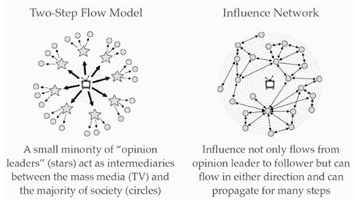
Seeding: providing products to known influencers in exchange for reviews
Sponsoring: providing payment to known influencers in exchange for positive reviews
Astroturfing: posting fake reviews w/o disclosing that they are sponsored &/or not true

WEEK 11 – CHP. 8 & 9
CULTURE, ETHNICITY & CULTURE CREATION

Understanding Consumers and the New Media
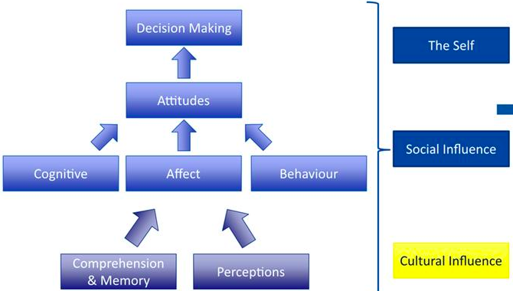

Consumption-Oriented Groups
- Brand Communities: Group of people who meet regularly (in person/virtually), who are connected over a shared passion for a particular brand
  - Pools
  - Webs
  - hubs
- Subcultures of Consumption: distinctive subgroup of society that self-selects on the basis of a shared commitment to a particular product class, brand, or consumption activity

Ethnicity & Acculturation
- Ethnic/racial subcultures: self-perpetuating group of consumers who share common cultural or genetic ties that are recognized by both its members & others as a distinct category
  - Sometimes assumed to possess certain traits (erroneously) which can be positive or negative
  - Dimensions include: language, religious beliefs, upbringing/background, & traditions
Effects on Consumption – Operating in a global market
- People find advertising spokesperson from their own subculture more trustworthy
- Ethnic subculture affects level/type of media exposure, food/apparel preferences, political behaviour, leisure activities, willingness to try new products

Acculturation: adapting to a new cultural environment
- Culture of origin
- Culture of immigration/host culture

Culture
- Since we are always embedded in culture = culture plays a great role in shaping our consumption patterns
- We use myths to make sense out of our world and to achieve certain desired identities. Companies use myths to position their products.
- Many consumption situations are very important & represent deeply ingrained rituals.
- Ordinary consumption is not always ordinary – some consumption is sacred
- Culture: refers to the values, ethics, rituals, traditions, material objects & services produced or esteemed by the members of a society
  - Culture shapes the lens through which we view products (& the world)
  - Ex. Rise of organic & whole foods industries
Culture & Behaviour
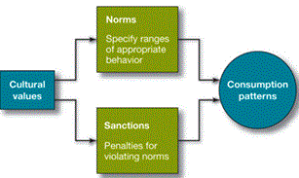
- Norms: rules dictating what is right or wrong
- Enacted norms: explicitly decided on (ex. Green light = go) – not culturally based
- Crescive norms: embedded in a culture
  - Customs: norms handed down from the past that control basic behaviour
  - Mores: custom with a strong moral overtone
  - Conventions: norms regarding the conduct of everyday life

Myths: story containing symbolic elements that expresses the shared ideals of a culture
- Involve binary positions (good vs. evil; nature vs. technology)
- Serves as a moral guide/social code to be followed social order (sociological function)
- Provides clear guidelines for personal conduct reduce anxiety (psychological function)

Monomyth: a myth common to many cultures (ex. Hero myth)
- Everyday person rises to the task, becomes a hero, fights evil staying true to principles
  - Call to Adventure: character leaves his ordinary, exceedingly common life to enter an unusual & often supernatural world
  - Road of Trials: encounters a # of tribulations, & often one exceedingly difficult challenge (often trained or advised by an older, wiser mentor)
  - The Goal or Book: reward the hero receives as a result of his trials, usually accompanied by a new knowledge of self
  - Return to the Ordinary World: hero must consciously decide to return to his world, knowing what he now knows
  - The application of the Boon: hero applies his new skills, powers & understandings to somehow make his world a better place
- Brand myths goal is to help build brand image & create a perception of authenticity

Rituals: Set of symbolic behaviours that occur in a fixed sequence & that tend to be repeated periodically
- Religious rituals (baptism)
- Rites of Passage (marriage)
- Cultural Events (valentine’s day)
- Family (mealtime)
- Personal (grooming)
- Many rituals involve transforming the self or an object from one state to another
  - Transformation from natural states to the social world (makeup)
  - Washing away the sins of the profane world (having a bath)
- Decommodifying a market place object to make it special (ex. Put cranberry sauce on a nice dish during thanksgiving)

- Gift-giving ritual: consumers procure the perfect object, meticulously remove price tag, carefully wrap it, then deliver it to recipient
Stages of gift-giving ritual
- Gestation: the motives for & emotion surrounding gift giving; the meaning, value & amount of time spent searching for gift
- Presentation: actual giving of gift; how it’s presented; ceremony & timing; recipient’s reaction
- Reformulation: changes (or maintenance) of the relationship based on the gift

The Sacred & Profane
- Sacred consumption: objects, events & places that are set apart from normal activities & are treated with some degree of respect or awe
  - sacred objects & events have some similar features
    - family heirlooms, gifts
    - mark certain identities, personal history or our relation to others
    - sacred objects & events provide us with orientation & meaning
- Profane consumption: objects, events & places that are ordinary / do not share the “specialness” of sacred ones

(DE)Sacralization (The process)
- Sacralization: when ordinary objects, events & people take on sacred meaning
- Desacralization: when a sacred item or symbol is removed from its special or is duplicated in mass quantities

Culture Creation Theories
McCracken’s Movement
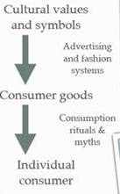
- Meaning Moves: from cultural values & symbols over consumer goods into individual consumers
- Fashion: process of social diffusion by which a new style is adopted by some group(s) of consumers
- Changes: in distribution, production & communication technologies have empowered consumers to contribute to the generation of culture to a greater extent & to act as a partner of companies in the co-creation of value

- McCracken’s model assumes a one way movement of meaning
- Does not account for:
  - Corporate appropriation of meanings (co-optation)
  - Consumers creating culture
  - C to C influence
  - Consumers changing corporate images & meanings (ex. Ad busters; doppelganger brands)

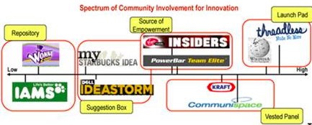
Co-creation of Culture/Meaning
- Co-creation involves the joint creation of value by the company and the customer
- The customer is allowed to co-construct the service/message/experience

WEEK 12
POST CONSUMPTION REACTIONS

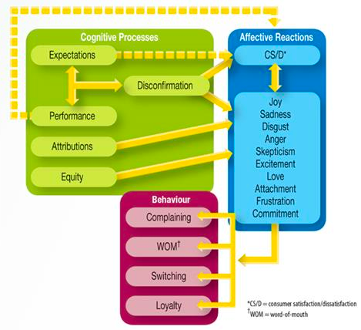
Satisfaction: mild, positive emotional state resulting from a favourable appraisal of a consumption outcome (above = surprise & delight)
Dissatisfaction: mild, negative affective reaction resulting from an unfavourable appraisal of a consumption outcome (below = disgust & anger)

Attribution Theory:
focuses on explaining why a certain event has occurred
- Locus of responsibility:
- Control:
- Stability: is this a one-time event? Or will this happen all the time or again?
Fundamental attribution error
- Known as the correspondence bias, we tend to attribute a behaviour to internal, rather than external factors
  - Ex. Almost always will put it to the disposition rather than external factors
Persuasion knowledge model
- Built over time, but even children recognize persuasion attempts
- PK allows us to
  - Recognize persuasion attempts
  - Understand agent’s intentions
  - Respond accordingly

Expectancy/Disconfirmation Theory
- Predictive: Come in with all these expectations – how well does the service reach our expectations?
- Normative: what will I normally expect?
- Ideal: what would be the best thing that could happen?
- Equitable: what would be fair?
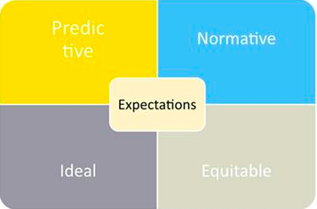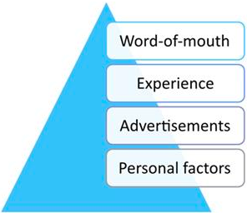

Equity Theory
- Proposes that consumers cognitively compare their own level of inputs & outcomes to those of another party in an exchange
- IF:
  - If higher = happier
  - If lower = less happy
  - Problem with formula = expectations of what we get out of it is much higher

Fairness
Moral judgement about an event
- Procedural fairness: perceptions about the process; did it follow an agreed upon set of rules & procedures
- Distributive Fairness: perceptions of the tangible outcome (think equity theory)
- Interactional fairness: perceptions of how you were treated during the process, including resolution of problems

Consumer Complaining
- Direct: in-person, online, etc. complaining
- Indirect: NWOM (interpersonal), online reviews, focused websites (ex. Consumersrevenge.com, walmartsucks.org)

Retaliation
- Cost/loss
- Vandalism
- Trashing
- Stealing
- Negative word of mouth
- Personal attack
Responding to Consumer Complaints
- Thank the guest for providing the info
- Ask questions to clarify the issue
- Apologize sincerely
- Show empathy for the customer’s situation
- Explain the corrective action that will take place
- Act quickly
- Follow up with the customer after the corrective action

Sainsbury’s: use of humour can diffuse anger
Jet Blue: empathize with your customer
Waterstones: monitor your accounts

