Environmental Chemistry Lecture 1
- Environmental Chemistry
(def): Chemistry of Pollution
- Study of the chemical process associated with disturbances of the natural chemical environment by humans
- Very much Applied Science (solving problems)
- Not Green Chemistry ↵relationship: provides solution to problems
(def): designing procedures and processes in an environmental compatible way
- Reduce/eliminate the generation of toxic chemicals
- Reduce energy use
- Use substance feed stocks ex: fossil fuel→ plant-based
→ Geochemistry, Biogeochemistry: study of chemical process w/o disturbance of humans,
an Understanding Science

- How to Study Environmental Chemistry:
- Issues-Based Approach: Start with a problem *Approach of this course
- Antarctic Ozone Depletion 5 Issues in this Course
- Poor Urban Air Quality
⇒Photo Chemical Reaction: Energy from Sun
- Acid Precipitation
- Processes, Mechanism, Principles: Similarities
ex: Transport Phenomenon: chemicals that move from one phase to another
- Photo Chemical Reaction: urban air quality, toxic organic chemical→ atmosphere
- Global Climate Change: how carbon dioxide is taken up in the ocean, atmosphere/gas→ aquatic

- Antarctic Ozone Depletion: (South Pole) Double Success Story: environmental & political
- Column Ozone: total amount of O₃ in column CO₂
- Blue: low concentration, Green: uniform, Orange: high concentration
- Ozone:
Trace gas: gases in atmosphere other than N₂ ^{78%}, O₂ ^{21%}, Ar ^{1%} (CO₂ ^{0.04%}, H₂O ^{variable})
Sunscreen and radiation Filter, filtering UV lights
0.01mm=1 Db, typical atmosphere 300Db=3mm
- Transit Phenomenon:
- Spring (September/October): low O₃, ozone hole, blue
1979-1980s: blue more distinct
Early 1990s: same
- Summer(December): O₃, green
⇒ Human Disturbance: modified the chemical composition,
CFCs (Chlorofluorocarbons) synthetic chemicals
        - Montreal Protocol: early 1980s
Globally binding treaty, eliminated use of O₃ depleted substance
Unlivable planet by 2020s

- Learning about Stratospheric Ozone Depletion
  - Basic Concept: Structure Atmosphere, Solar Radiation
  - Understand Natural Ozone Chemistry in the Atmosphere
  - Understand the Human Disturbance of that Chemistry
  - Chemicals causing SOD

2) Solar Radiance vs. Wavelength → Solar Radiation Spectrum
High Energy [UV Visible Infrared] $E=c \frac{h}{λ}$
400nm 700nm

Oxygen Absorption vs. Wavelength → O₂ Absorption Spectrum

⇒ Radiation has to be fairly short wave in order to be absorbable by O₂

1) Temperature/Ozone Concentration vs. Height → Structure Atmosphere
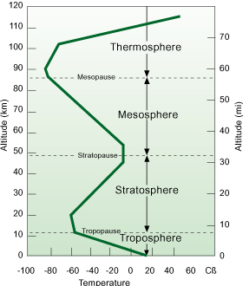

Mesosphere

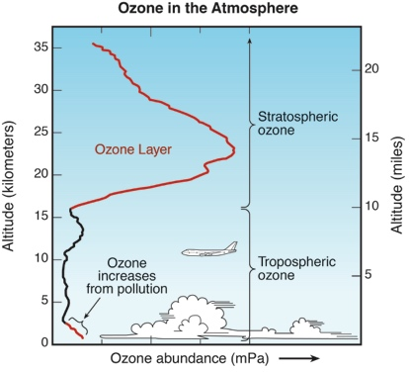
Stratopause 50
→ Warmth: O₂ abs. sunlight
⇒ generates heat

Stratosphere: Stable min. vertical movement
Layers: strata
Tropopause. 10
Troposphere: Warm air at bottom: unstable
Air constantly moving in vert. Mmmmmmm m Turbulent: weather
→ Warmth: Earth surface abs. sunlight

3) Biological Consequences of UV Exposure
- Skin Cancer → Malignant melanoma (1% affected/ 25% mortality)
→ Non-melanoma skin cancer (25% affected)
- Cataract: disease of the eye
- Reduction of Immunity
- UV light Interference with Photosynthesis: plants

