MATLAB EXAM:
20 Mcq 20 Marks
3 by hand 15 marks
3 coding questions 15 marks

Multiple choice will be based on concepts such as root finding
- Search method, finding X_{root} by guessing between an interval
Notes
Root Finding: Graphical and Bracketing Method
Bracketing Search
Incremental Search
- Start with an initial range that contains a root
- Subdivide this range into smaller sub ranges
- X_{n} = X_{n-1} + ∆
- If the f(X_{n-1})^2 < 0, then there is a root
Bracketing Method
- Guess two values that hold this expression true
  - f(𝑋𝑙𝑜𝑤)*f(𝑋ℎ𝑖𝑔ℎ)<0
- Find root x (average of X_{low} and X_{high})
- Find f(X_{root})
- If f(𝑋𝑙𝑜𝑤)*f(𝑋𝑟𝑜𝑜𝑡) < 0, set X_{high} = X_{root} else X_{low}= X_{root}
- Keep going until a relative error is small enough to be accepted
False Position
- Guess two values (𝑋𝑙𝑜𝑤, 𝑋ℎ𝑖𝑔ℎ) that give f(𝑋𝑙𝑜𝑤)*f(𝑋ℎ𝑖𝑔ℎ)
- Find 𝑿𝒓𝒐𝒐𝒕 = 𝑿𝒉𝒊𝒈𝒉 − f(𝑿𝒉𝒊𝒈𝒉)(𝑿𝒍𝒐𝒘−𝑿𝒉𝒊𝒈𝒉)/[ f(𝑿𝒍𝒐𝒘) − f(𝑿𝒉𝒊𝒈𝒉)]
- Find f(Xroot)
- If f(𝑋𝑙𝑜𝑤)*f(𝑋𝑟𝑜𝑜𝑡) < 0, set X_{high} = X_{root} else X_{low}= X_{root}
- Faster but can lead to to root tending to one side
Root Finding: Open Methods
Bracketing method vs open method
- Open methods only need a single starting value or two starting values that do not necessarily bracket a root
- This method may diverge at first but converges much faster than bracketing method
- This method (Babylonian) doesn’t always work because some iterative solutions will not work
Newton-Raphson Method
- Most widely used method
- Quadratic coverage
- X_{i+1} = 𝑥_{i} – [𝑓(𝑥𝑖) /𝑓′(𝑥𝑖)]
  - But requires the derivative of the function
  - Can diverge
Secant Method
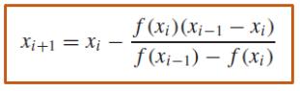
Modified Secant Method
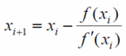
Picture of al root finding methods

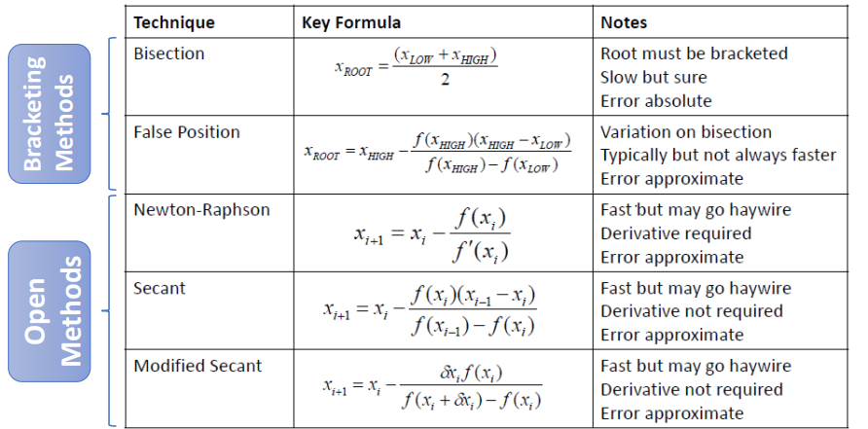
Matrix Stuff
Left Division for solving matrix
- Lets say A is the matrix and b is the values of the equations
- X= A\b
  - X will now contain the values of each variable

Cramers rule
- Find the determinant
- Find the Determinant of matrix by putting the b column matrix in the column of the variable you want to find
- Divide step 2 by step 1 and that is your answer
Naïve Gauss Elimination
- Create Upper triangle matrix (Forward Elimination)
- Then back substitute by staring at last row
Loops through all pivots then loops through all rows after pivot
np= size of the matrix, useful for accessing elements

C (k,i:np) = C(k,i:np)-(C(k,i)/C(i,i))*C(i,i:np);
//row = row – (element below pivot/pivot)*pivot row
x(i) = (C(i, np) - C(i, i + 1: n) * x (i + 1: n))/C(i, i);
//must start at bottom row then you can loop through other ones
With partial Pivoting
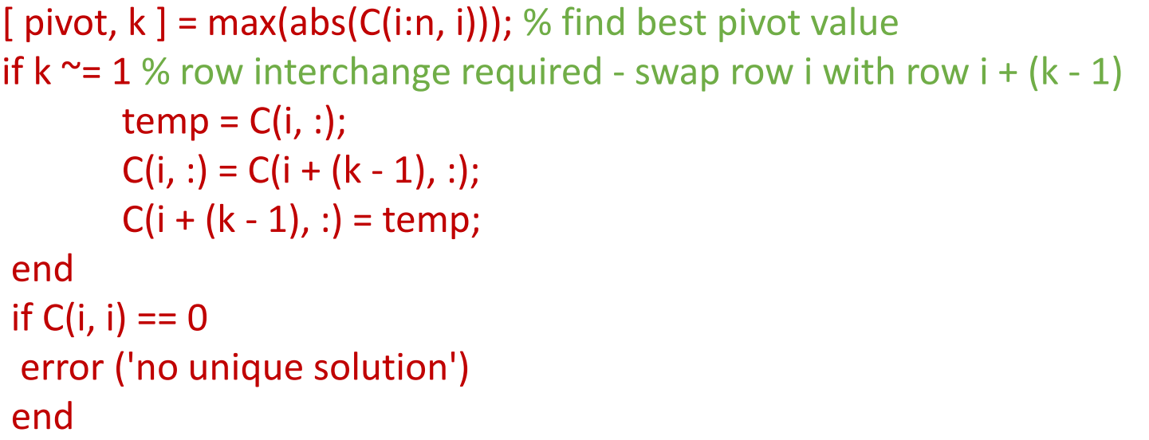
Lu Factorization
Use lu and some bullshit happens

Regression
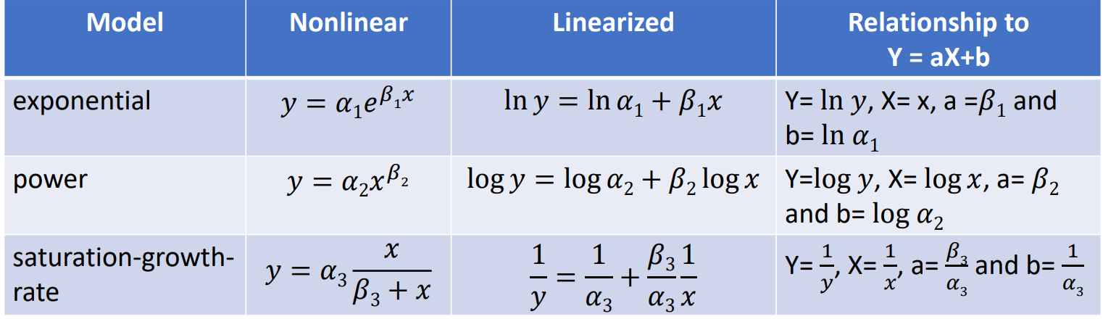
Know how to implement each one by coding
Polyfit
P = polyfit (x,y,n)
x and y are the values from a graph or table
n is the order of the polynomial that is wished to be found
p is the coefficients of the polynomial
Regression
- Object is to find the curve (of some chosen form) that best represents a collection of data points
- Points are assumed to involve errors
- The curve doesn’t need to pass through any of the data points
Interpolation
- Object is to find a curve that can be used to fill in the gaps between the data points
- Points are assumed to be absolutely correct
- The curve must pass through all of the data points
When using polyfit..
- If n is equal to the number of data points -1, polyfit gives the interpolating polynomial
- When n is less than the number of data points-1, polyfit gives the best fit polynomial, regression
Polyfit can generate errors if the numbers are too big so there is a solution
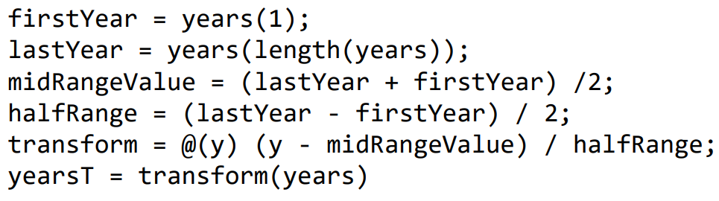
Lagrange formula for interpolation
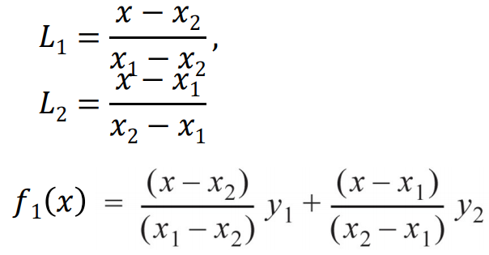
First order

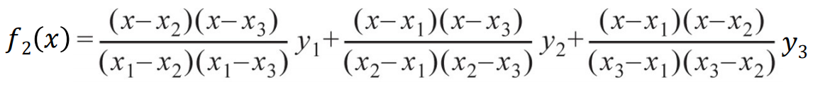
Second order
Newton’s Formula
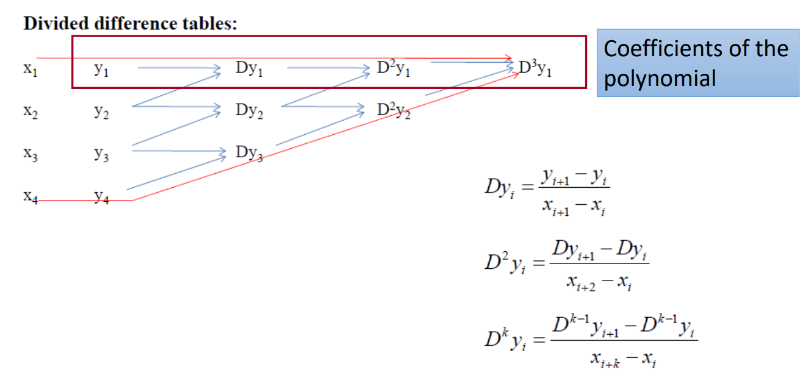
Splines
- Splines estimate oscillations by using small subsets of points for each interval rather than every point. This is especially useful when there are jumps in the data
Linear Splines
- Basically creating a piece wise functions which is linear
- Create intervals between data points

function [yout] = linearSpline( x, y, xin ) %Add comments to explain the function yout = zeros(size(xin)); for k = 1 : length(xin) xval = xin(k); % for convenience lo = 1; hi = length(x); if xval < x(lo) || xval > x(hi); error ('x value out of range'); end; while hi ~= lo + 1 %locate the correct interval m = round((lo + hi) / 2); if x(m) <= xval lo = m; else hi = m; end end yout(k) = y(lo) + (xval - x(lo))*((y(hi)-y(lo))/(x(hi) - x(lo))); end
end
There are quadratic splines but are very computationally intensive and cubic splines are better and faster
Integration
Use quad() or integral() for built in matlab functions
Newton-Cotes Formulas
Trapezodial rule (Width * average height)
$$I=\left(b-a\right)*\frac{f\left(a\right)+f(b)}{2}$$
Error of that equation
$$E_{a}=-\frac{1}{12}f^{''}\left(w\right){\left(b-a\right)}^{3}$$
Where w is somewhere between a and b
Newton-Cotes Composite Rule
$$I=\left(b-a\right)*\frac{f\left(x_{o}\right)+2\sum_{i=1}^{n-1}{f\left(x_{i}\right)+f(x_{n})}}{2n}$$
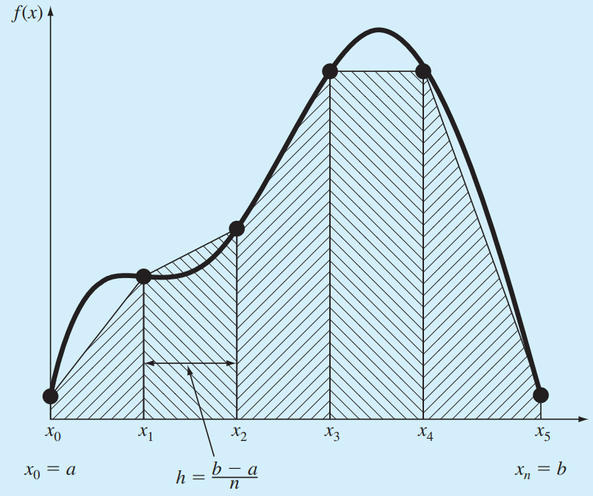

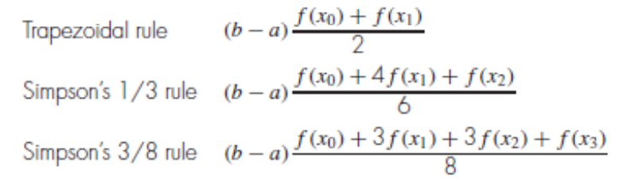
1/3 for 2 intervals, 3/8 for 3 intervals
Richardson Extrapolation
Use two estimates of an integral to compute a third, more accurate approximation, equation on the write is used h₂ = h₁/2
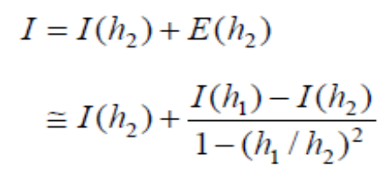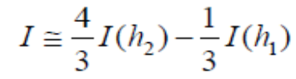

Gaussian Quadrature
Describes a class of techniques for evaluating the area under a straight line by joining any two points on a curve rather than simply choosing the endpoints
The key is to choose the line that balances the positive and negative errors
$$I=f\left(-\frac{1}{\sqrt{3}}\right)+f(\frac{1}{\sqrt{3}})$$
Equation would be used if the limits where from -1 to 1
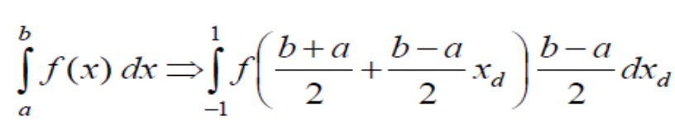
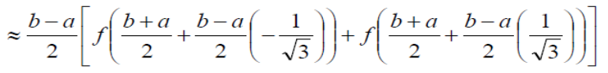
Differential Equations
Euler’s Method
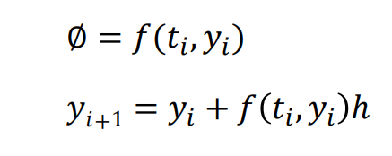
Keep going until a certain error is reached

Heun’s Method
Determine derivatives at the beginning and predicted ending of the interval and average them
Use average of slopes to obtain an improved estimate of the slop for the entire interval
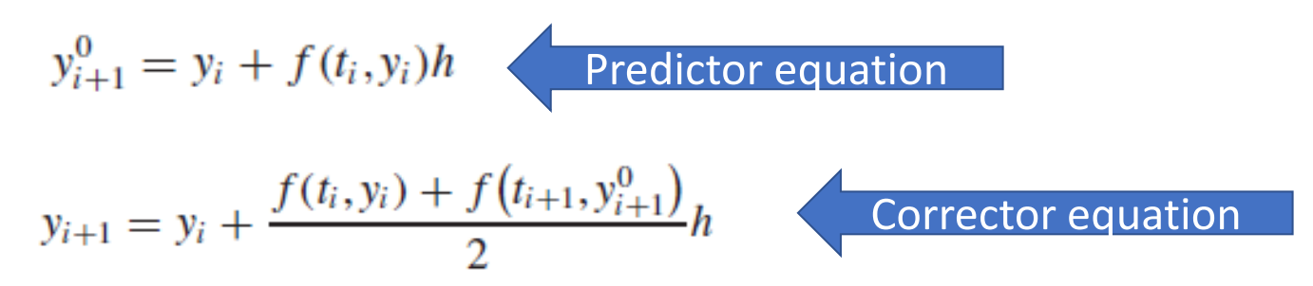
With iteration
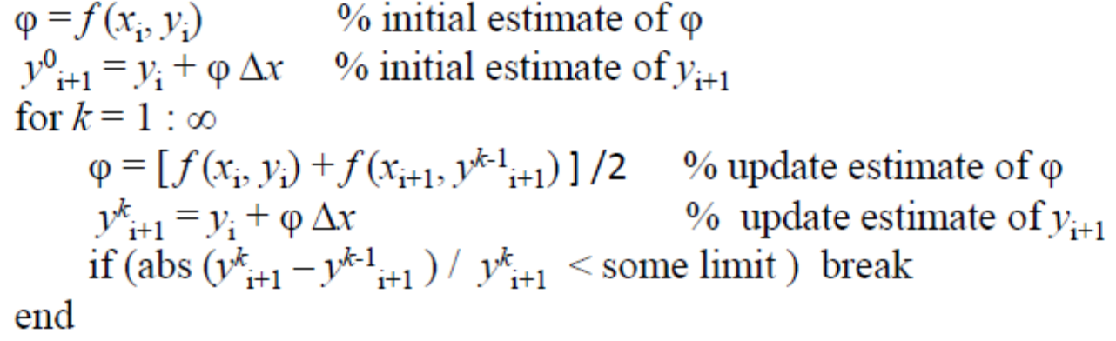
Midpoint Method
Another improvement to Euler’s method is similar to Heun’s method, but predicts the slope at the midpoint of an interval rather than at the end
$$y_{i+1}=y_{i}+f\left(t_{i+\frac{1}{2} },y_{i+\frac{1}{2}}\right)h$$
Runge-Kutta Methods

