MKT 100 Week 5
Chapter 4 Buyer Behaviour & Midterm Information

Chapter 4: Buyer Behaviour

Consumer Buying Decision (CBD) Process
- Need recognition
- Information search
- Evaluation of alternatives
- Purchase decision
- Post-purchase behaviour

CBD Process - Habitual Shopping
- Need recognition
- Purchase decision
- Post-purchase behaviour

Why does CDB change with Habitual Purchases?
- What has worked in the past is likely to work again in the future
- Habits allow us to save time making decisions and be thinking of other things while doing them
- Routine can often be executed more efficiently than new behaviours
- Provides sense of discipline, order, and control into our lives.

CBD Process - Recreational Shopping
- Need recognition
- Information Search
- Evaluation of alternatives
- Purchase decision
- Post-purchase behaviour

CBD Process - Complex Shopping
- Need recognition
- Information Search
- Evaluation of alternatives
- Purchase decision
- Post-purchase behaviour

Study of Buyer Behaviour
- Who consumes? What? Why? Where and how?
- What can we do once we have this knowledge?
- Develop basic strategies to facilitate purchase process

1) Need Recognition
- Functional: Performance oriented
- Psychological

2) Information Search
- Interal
- External
- Factors impacting search
  - Cost V. Benefits
    - Perceived costs and benefits must be weighed
  - Locus of control
    - Internal = More search activities
    - External = Why bother
  - Actual or perceived risk
    - Performance: Will product perform the way it should?
    - Financial: Cost of initial purchase + Cost of use / maintenance
    - Social: Will others value my purchase positively?
    - Physiological: Will I be hurt if my product doesn’t work
    - Psychological: Is this purchase consistent with my self-identity
  - Type of product or service
    - Speciality good or service
    - Shopping goods or services
    - Convenience goods or services

3) Alternative Evaluation
- How do consumers begin to evaluate different alternatives, and what important attributes and criteria do they use?
- Consumer Decision Rules
  - Compensatory
    - Trades off one characteristic for another
  - Non-compensatory
    - On basis of a subset of characteristics, regardless of other attributes
  - Decision Heuristics
    - Shortcuts that narrow down choices (Price, brand, product, presentation)

4) Purchase and Consumption
- Seek out and purchase products that they believe provide them the best value
- After purchase they consume it → “put it to the test”
- Consumption leads to

5) Post-Purchase Outcomes
- Post-Purchase outcome
  - Consumer Satisfaction (Positive)
  - Post-Purchase Dissonance (Negative)
    - Firms attempt to reduce dissonance by reinforcing the decision
  - Consumer Loyalty (Positive)

Undesirable Consumer Behaviour
- Negative word-of-mouth and rumors can be very damaging
- The internet is a very effective way to spread negativity
- Marketers must respond quickly

Factors Influencing the Consumer Decision Process
- Psychological Factors
  - Motives: Hierarchy of needs
    - Physiological → Safety → Love → Esteem → Self-actualization
  - Attitude: Cognitive, affective, behavioural components
  - Perception: Selective exposure, attention, comprehension and retention
  - Learning: Change in thought from experience
  - Lifestyle: Way consumer spends time and money to live
- Situational Factors
  - Purchase Situation: Change in purchase behaviour based on why or who you may be shopping for
  - Shopping situation: Change in purchase behaviour based on something in-store; sales, promos, atmosphere, etc…
  - Temporal State: Change in purchase behaviour based on current state of mind
- Social Factors
  - Family: Decision makers V. Influencers
  - Reference Groups: Person used for comparison of beliefs, feelings and behaviour. Offer info, reward behaviour, enhance self-image
    - Comparison
    - Evaluation
  - Culture: Shared meanings, beliefs, morals, values and customs of a group of people. Most pervasive.
    - Culture can be school, country, religion, etc…
    - Marketers must understand differences among countries

Chapter 5: Business to Business Marketing (CONDENSED VERSION)

Business Buying Process
- Need or Problem Recognition
- Product Specification
- RFP or Supplier Search Process
- Proposal analysis and Supplier Selection
- Order Specification
- Performance assessment

Characteristics of Business Markets
- Market characteristics
  - Demand for business product is derived
  - Fewer customers, more geographically concentrated, and orders are larger
  - Demand is more inelastic, fluctuates more, and more frequently
- Product characteristics
  - Products technical in nature, purchased based on specifications
  - Mainly raw and semi-finished goods
  - Heavy emphasis on delivery time, technical assistance, after sale service, financing
- Buying process characteristics
  - More complex
  - Qualified, professional buyers: More formalized buying process
  - Multiple participants in purchasing decisions
  - Close long-term relationships
- Marketing mix characteristics
  - Place: Direct selling and physical distribution often essential
  - Promotion: More technical, promotions emphasize personal selling
  - Price: Often negotiated, inelastic, affected by trade/quality discounts

Factors impacting the Buying Process
- The Buying Center
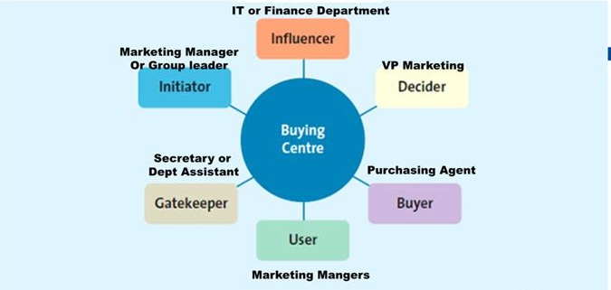
- Organizational Culture
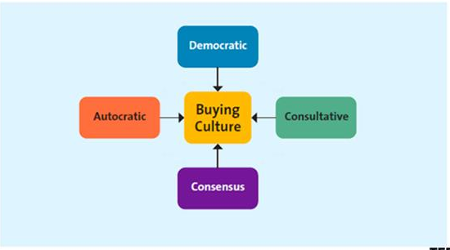
- Buying Situations
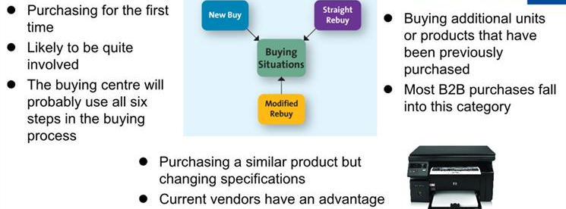

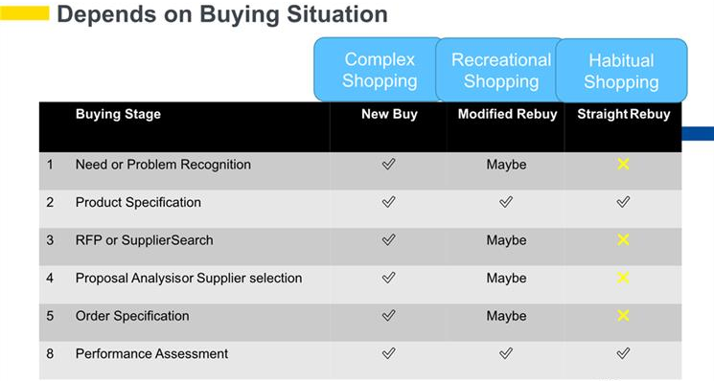

Midterm Information

Formulas for metrics

Contribution margin = Price per unit - (Variable Cost per unit)

Contribution margin = Sales - total variable cost

Contribution margin percentage = Contribution margin / Price

Midterm (as of Winter 2018):
75 minutes
Chapters 1-5, 7, 18, Metrics 1-4, Class discussions and worksheets.
Multiple Choice
50% theory (30 questions) and 50% metrics (15 questions)
Formula Sheet provided

