NUR80A Week 7:
Scrutinizing data collection methods (overview of data collection and data sources (qualitative), self-report methods, observational methods)
Reading:
- Loiselle et al. (2011) Chapter 13, pp. 230-235, 242-246, 249-250, 252-253
- Sanford et al. (2011)

Learning objectives:
1. Discuss the three main categories of data collection methods
- Self-reports: participants’ responses to questions posed by the researcher, like an interview
  - Most common data collection approach in quantitate studies; also with qualitative through interviews with study participants
- Observation
- Biophysiologic measures: to asses important clinical variables
  - Rarely collected in a naturalistic inquiry
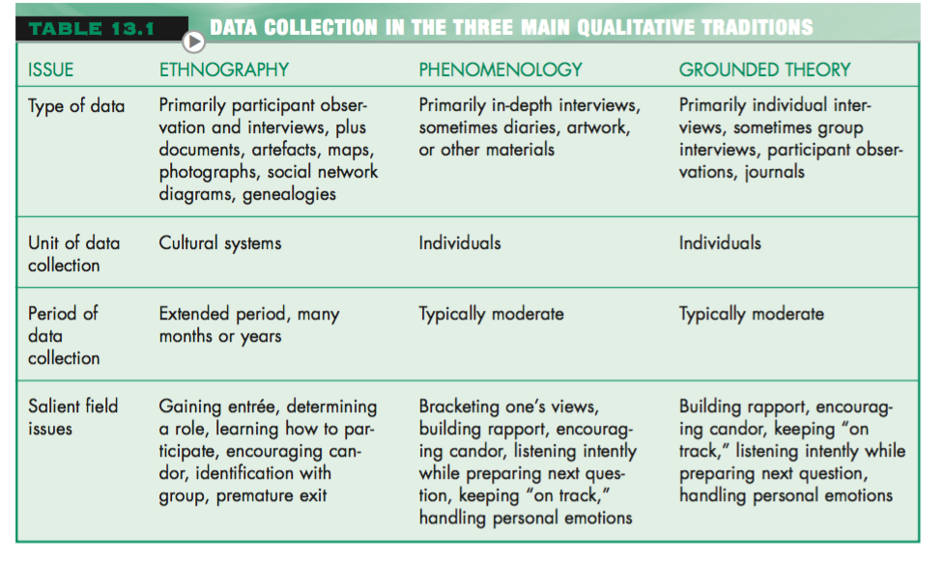
- Ethnographers triangulate data from various sources (interviews and observation mostly); also examine products of culture under study (documents, photos, artefacts)
- Phenomenologists and grounded theorists rely on in-depth interviews with individual participants
- Grounded theorists also rely on observation
Key dimensions of data collection methods
- Structure: research collected in structured manner; same information from all participants in comparable way. Sometimes it is better to be flexible and allow participants to reveal information naturally.
- Quantifiably: data analyzed statistically must be fathered in a way that it can be quantified. Data analyzed quantitatively can be collected in a narrative form. Structured data collection tens to produce data that is easily quantified.
- Obtrusiveness: how aware of their status study participants are. If aware, their responses and behavior might change than their normal. Ethical problems emerge if data collected unobtrusively.
- Objectivity: quantitative researchers try to be as objective as possible. Qualitative researchers consider their subjective judgement a valuable tool.
2. Examine the purpose, advantages and disadvantages of the self-report and observation methods

Self-Report Methods
- Researchers start with general questions and allow participants to tell their stories naturalistically
- Unstructured/semi-structured interviews are conversation in nature; unstructured used when researchers lack precise understanding of what they don’t know
- Completely unstructured interviews (ethnographic and phenomenological studies) are used when researchers have no preconceived view of the content of data to be fathered; aim is to get response without imposing their own views. Begin by asking grand tour question like “What happened when you first learned that you had AIDS?”; subsequent questions are more guided by first response
- Semistructured/focused interviews rely on list of topics/broad questions that must be addressed in interviews. Interviews use a topic guide to cover all that they want to. Interviewer’s role is to encourage participants to talk freely about topics on guide and probe for more detail. They are used more frequently than totally unstructured.
- Focus group interviews (used in qualitative research and can play a important role in feminist, critical theory, participatory research) have groups of 5-10 people. Interviewer guides discussion according to topic guide. Another researcher sits in as silent observer to note nonverbal cues.
- Life histories where researchers ask to describe (usually chronologic sequence) their experiences. Used to obtain total life health history.
- Think aloud method (qualitative method) to collect data about cognitive processes like decision making.
- Diaries may be unstructured. Usually asked to write regarding specific aspect.
- Critical incidents technique a method of gathering info about people’s behaviors by examining incidents relevant to the behavior that is being studied.
- Used to develop a construction of a phenomenon that is consistent with the participants
- If taping, researcher must seek permission from interviewee first
- Self-reports gather what observations can’t like behavior from the past/future
- Validity and accuracy come into question; very time-consuming and demanding. Not used to capture the measurable aspects of phenomenon.
- ***Unstructured (qualitative) interviews are greatest utility when a new area of research is being explored***
Observational Methods
- Used to gather info on characteristics and conditions of individuals, verbal communication, nonverbal communication, activities and environmental conditions
- Flexibility with:
  - Focus of observation: can be broad events/specific behaviours
  - Concealment: awareness of being observed. Reactivity: problem of behavioural distortions r/t known presence of observer
  - Duration of observation: short but can also take months/years (ethnographic)
  - Method of recording observations: can be made through human senses then recorded, but also be done via tech recording (video, audio)
- Participant observation: observer participates in the group/institution under study to record relevant information to gain deeper insight. Some unstructured observations involve watching and recording without observers’ participation in activities, but ethnographic and grounded research do involve some participation. Two extremes: complete immersion and complete separation (onlooker status). Researchers’ role may evolve over course of study.
3. Apply critique skills to data collection methods in a qualitative research study

