Chapter 1: Introduction to Global Management

1. What are the challenges of working in the new economy?

Intellectual Capital

● The shared knowledge of a workforce that can be used to create value.

● People are the ultimate foundations of organizational performance.

Globalization

● The worldwide interdependence of resource flows, product markets, and business competition that characterize the new economy.
● National boundaries of world business have largely disappeared.

Technology

● Continuing transformation of the modern workplace through the internet, WWW, computers, and information Technology.
● Increasing demand for knowledge workers with the skills to fully utilize technology.

Diversity

● Workforce diversity reflects differences with respect to gender, age, race, ethnicity, religion, sexual orientation, etc.
● A diverse and multicultural workforce both challenges and offers opportunities to employers.
- Prejudice – display of negative attitude towards members of diverse population
- Discrimination – actively denies minority members the full benefits of organizational members
- Glass ceiling – invisible barrier limiting career advancement of women and minorities.

Ethics

● Code of moral principles.

● Society requires businesses to operate according to high moral standards.

● Emphasis today on restoring strength of corporate governance.
- Ethical expectation for a modern business : Integrity and ethical leadership at all levels, sustainable development , consumer protection, human rights

Competitive advantage – which country can sell a product better or in a more efficient way has a competitive advantage
Environment uncertainty – When a company or management has a very little information about their external environment or are not sure of their external environment

Other Temrs :
General environment- composed of economic legal political , technological and socio cultural and natural environmental conditions
Sustainable business – both meets the need of customers and protects the well being of our natural environment
Sustainable innovation – creates new products and production methods hat have reduced environmental impact
Specific environment – includes people and group with whom the organization interacts
Stakeholders- persons, groups and institutions directly affected by an organization
Value creation – creation of value satisfying needs of stakeholders
Strategic positioning – occurs when an organization does a different things or the same things in different ways from major competitors
Organizational effectiveness- is sustainable high perfomrane in usng resources to accomplish a mission.

2. What are organizaitions like in the workplace

Organization

● A collection of people working together to achieve a common purpose.

● Organizations provide useful goods and services that return value to society and satisfy customer needs.

Organizations are Open Systems

● Composed of interrelated parts that function together to achieve a common purpose

● Interact with their environments.

● Transfer resource inputs into product outputs (goods and services).

● Environmental feedback tells organization how well it is meeting the needs of customers and society.

Organizational Performance

● Productivity → an overall measure of the quantity and quality of work performance with resource utilization taken into account.
● Performance effectiveness → an output measure of task or goal accomplishment.

● Performance efficiency → an input measure of the resource costs associated with goal accomplishment.
● Effectiveness and efficiency in terms of goal achievement and resource utilization.

3. Who are managers and what do they do?

Importance of Human Resources and Managers

● “Toxic workplaces” treat employees as costs.

● High performing organizations treat people as valuable strategic assets.

● Managers must ensure that people are treated as strategic assets.

Managers

● A person in an organization who supports and is responsible for the work of others.

● The people who managers help are the ones whose tasks represent the real work of the organization.

Levels of Management

● Top managers → responsible for performance of an organization as a whole or for one of its larger parts.
● Middle managers → in charge of large departments or divisions.

● Project managers → coordinate complex projects with task deadlines.

● Team leaders / Supervisors → in charge of a small work group of non-managerial workers.

Responsibilities of Team Leaders

● Plan meetings and work schedules.

● Clarify goals and tasks, and gather ideas for improvement.

● Appraise performance and counsel team members.

● Recommend pay raises and new assignments.

● Recruit, develop, and train team members.

● Encourage high performance and teamwork.

● Inform team members about organizational goals and expectation

● Inform higher levels of work unit needs and accomplishments.

● Coordinate with others teams and support the rest of the organization.

Types of Managers

● Line managers → responsible for activities that directly affect organization’s outputs.

● Staff managers → technical expertise to advise and support the efforts of line workers.

● Functional managers → responsible for a single area of activity.

● General managers → responsible for more complex units that include many functional areas.
● Administrators → work in public and non-profit organizations.

Managerial Performance and Accountability

● Accountability is the requirement of one person to answer to a higher authority for relevant performance results.
● Effective managers fulfill performance accountability by helping others to achieve high performance outcomes and experience satisfaction in their work.

Quality of Work Life

● An indicator of the overall quality of human experience in the workplace.

● QWL indicators:

→ fair pay

→ safe working conditions

→ opportunities to learn and use new skills

→ room to grow and progress in a career

→ protection of individual rights

→ pride in work itself and in the organization

High Performing Managers

● Build working relationships with others.

● Help others develop their skills and performance competencies.

● Foster teamwork.

● Create a work environment that is performance-driven and provides satisfaction for workers

4. What is the management process?

Management Process (4 functions of management )

● Management is the process of planning, organizing, leading and controlling the use of resources to accomplish performance goals.
● All managers are responsible for the four functions.

● The functions are carried on continually.

4 Functions of Management

● Planning → the process of setting objectives and determining what actions should be taken to accomplish them.
● Organizing → the process of assigning tasks, allocating resources, and arranging the coordinated activities of individuals and groups to implement.
● Leading → the process of arousing people’s enthusiasm to work had and direct their efforts to fulfill plans and accomplish objectives.
● Controlling → the process of measuring work performance, comparing results to objectives, and taking corrective action as needed.

Managerial Activities and Roles ( Mintzberg 10 managerial Roles)

● Interpersonal Roles → involve interactions with persons inside and outside the work unit. (Monitor , disseminator , spokesperson )

● Informational Roles → involve giving, receiving, and analyzing information. (figurehead, leader , liaison)

- Decisional Roles → involve using information to make decisions in order to solve problems or address opportunities. ( Negotiator , Disturbance handler, Resource allocator , entrepreneur )

Managerial Agendas and Networks

● Agenda setting→ development of action priorities for one’s job.

→ include goals and plans that span long and short time frames

● Networking → process of building and maintaining positive relationships with people whose help may be needed to implement one’s work agendas.
- Social Capital – capacity to get things done with support of others

Katz’s Essential Managerial Skills

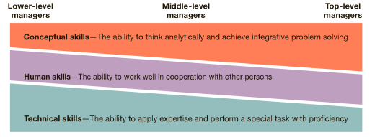

Managerial Competency

● A skill based capability that contributes to high performance in a management job.

● Managerial competencies are implicit in:

→ planning, organizing, leading, and controlling

→ informational, interpersonal, and decisional roles.

→ agenda setting and networking.

5. How do you learn the essential managerial skills and competencies?

Competencies for Managerial Success
- Communication
- Teamwork
- Self-management
- Leadership
- Critical thinking
- Professionalism

Chapter 09 – innovation and organizational change

Innovation in organizations
- Tom Peters – individuals and organizations alike must change and adapt and innovate as the environment changes around them as their primary source of competitive advantage.

- Strategic Leadership – ability to anticipate , envision , maintain flexibility, think strategically and work with others to initiate change that will create a viable future for the organizations.

Creativity and innovation

- Creativity – Generation of new idea or unique approach that solves a problem or crafts an opportunity
- Innovation – the process of taking a new idea and putting it into practice

Types of innovations
- Business innovations
- Product innovations – resultsin new or improved ood and services
- Process innovations – results in better ways of doings things
- Business model innovations – Results in ways for firms to make money
- Sustainable innovations – Creates new products and processes that have lower environmental impact
- Green innovation – Process of turning ideas into innovations that reduce the carbon footprint of an organization or its products ( carbon footprint refers to amount of greenhouse gasses from human activity ) . Similar to sustainable innovation
- Social Business innovation – finds ways to use business models to address important social problems such as poverty.
  - Social entrepreneurship - individuals with innovative solutions to society’s most pressing social problems
The innovation process - imagining , designing, experimenting , assessing & scaling.
- Commercializing innovation – Turns new ideas into actual products, services or processes that can increase profits through greater sales or reduced costs.
- Distruptive innovation – helps create new market and value network , eventually distrupts an existing market and value network .Originally term of art coined by Clayton Christensen.

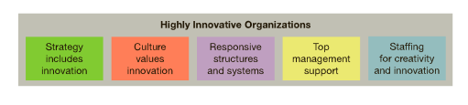
Organizational change : Change leaders
- Change leader/Change Agent – tries to change the behavior of another person/social system.
- Top-down change- The change initiatives comes from senior management
- Bottom-up change- the change initiatives come form all levels in the organization
Incremental and Transformational Change
- Reactive change – Responds to events as or after they occur
- Performance gap – Discrepancy between a desired and an actual state of affairs
- Planned change – Aligns the organization with anticipated future challenges.
Incremental change – Bends and adjusts existing ways to improve performance
Transformational change – results in a major and comprehensive reditrection of the organization
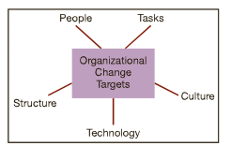

Kurt Lewin’s Three Phases of planned organizational change

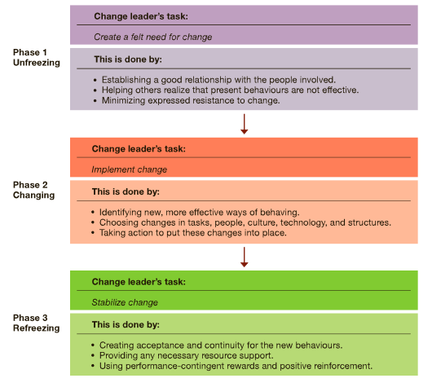

Change strategies

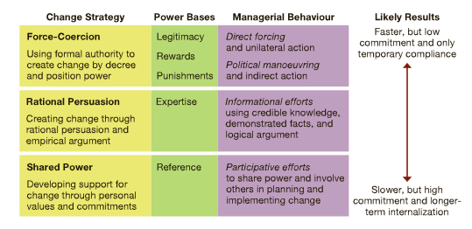
Improvisational Change – Makes continual adjustments as changes are implemented

Organizational development
- Shared power effort to improve an organizations ability to solve problems and improve performance
- Organizational change that involves the application of behavioral science in a systematic and long range effort to improve organizational effectiveness
- Practical OD : Define , Measure Analyze, Improve , Control

Action Research
- Collaborative process of collecting data, using it for action planning and evaluation
- Process : Data Gathering, Data analysis and feedback , action planning, action implementation , evolution and follow up
Organizational Development Process :
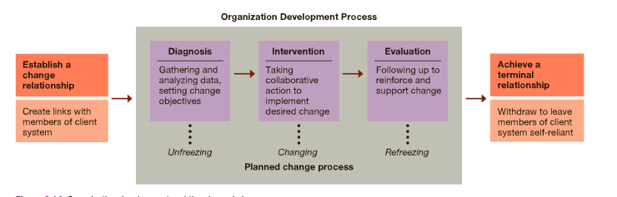

OD intervention – Structured activity that helps create change for organization development
- Individual Intervention – Sensitivity training, Management training role negotiation, job redesign, career planning
- Team Intervention – Team Building, Process consultation, Intergroup team building
- Organization-wide interventions – Survey feedback, Confrontation meeting, structural redesign, management by objectives

Chapter 3: Global Dimensions of Management

Management and Globalization

- Global Economy – resources , markets and competition are worldwide in scope
- Globalization – process of growing interdependence among the components in the global economy
- World 3.0 – Where nations cooperate in the global economy while respecting one another national characters and interests. They balance economic gains with local needs and priorities. National identities say strong even when the opportunities of global economy are sought.
Global Management - Management in businesses and organizations with interests in ore than one country
International management – manging business operations in more than one country
Global Manager -new breed of manager , increasingly sought after. Someone who informed about international developments, transnational inoutlook , competent in working with people from different cultures and always aware of regional developments in changing world.
Why go global ? – profits, customers, suppliers, capital , labor
Global business – conducts commercial transactions across national boundaries
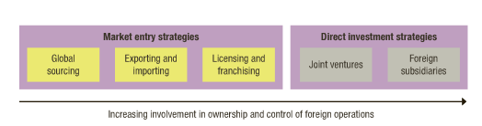
Market Entry Strategy
● Global sources – Global sourcing is the practice of sourcing from the global market for goods and services across geopolitical boundaries
- Exporting – The process of selling goods/services to another country
- Importing – The process of busing goods/services from another country
- Licensing Agreement – being given permission to sell your product or service in another country
- Franchising – It is a practice of using another’s firms business model, granting a franchise for the sale of goods or services e.g mcdonalds, subway

Foreign Direct investment
- Direct investment is a production or business in a country by an individual or company of another country either by : Buying a company in a target country or by expanding operations of an existing business in that country
- Insourcing - having people within the company do jobs that would normally be done by contractors

Direct investment strategies

- Joint ventures – Co-ownership arrangement where the foreign and local partners agree to get resources , share rights and operate the new business together.
- Global strategic alliances – Foreign and domestic firms share resource and knowledge .
  - Foreign Subsidiaries - Local operation completely owned by a foreign firm
  - Greenfield investment – Builds an entirely new operation in a foreign country

Legal and Political Systems
- Political risk – Major planning concern. The potential loss in value of an investment in or managerial control over foreign asset because of instability and political changes in the host country

- political-risk analysis- planning technique. Used to forecast the probability of distruptive events that can threaten the security of a foreign investment.

Trade Agreements and trade barriers

- World trade organization (WTO) – Global organization whose member nations agree to negotiate and resolve disputes about tariffs and trade restrictions. Give eachother most favorable treatment for imports and exports.

Regional Economic alliances

- NAFTA – creates a trade zone with minimal barriers , which frees the flow of goods and services , workers and investments among the three countries ( Mexico , USA , Canada)
- European union – Agrees to support mutual economic growth by removing barriers that previously limited cross-border trade and business development,

Global Businesses

- Global Corporations – Business firms with extensive international operations in many foreign countries

Types of Businesses

- Transnational corporations – They try to operate as a “borderless firms” with worldwide presences and without being identified with one national home

Pros and Cons

● Multinational Corporation (MNC) → a business with extensive international operations in more than one foreign country.
● Mutual benefits for host country and MNC:

○ Shared growth opportunities

○ Shared income opportunities

○ Shared learning opportunities

○ Shared development opportunities

● Host countries complaints about MNC:

○ Excessive profits

○ Domination of local economy

○ Interference with local government

○ Hiring the best local talent

○ Limited technology transfer

○ Disrespect for local customs

● MNC complaints about host countries:

○ Profit limitation

○ Overpriced resources

○ Exploitative rules

○ Foreign exchange restrictions

○ Failure to uphold contracts

● Ethical issues for MNCs

○ Corruption -- illegal practices that further one’s business interests.

○ Sweatshops -- employing workers at low wages for long hours in poor working conditions
○ Child labour -- full time employment of children for work otherwise done by adults

○ Sustainable development -- meeting current needs without compromising further needs.

Culture and Global Diversity

● Culture → the shared set of beliefs, values, and behavior common to a group of people.

● Culture shock → confusion and discomfort a person experience in an unfamiliar culture.
● Ethnocentrism → tendency to consider one’s own culture as superior to others.

● Stages to adjusting to a new culture:

○ Confusion

○ Small victories

○ The honeymoon

○ Irritation and anger

○ Reality

● Popular dimensions of culture:

○ Language

■ Low-context cultures - most communication takes place via the written or spoken word and high-context cultures – what is said or written may convey only part of the real message

○ Time orientation

■ Monochronic cultures - when people tend to do one thing at a time and polychronic cultures – when more people are more flexible toward tme and who uses it

○ Space
- Proxemics- how people use interpersonal space to communicate

● Values and national cultures (Hofstede):

○ Power distance – Degree which a society accepts or rejects the unequal distribution of power among people in organizations and the institutions of society

○ Uncertainty avoidance - the degree which a society is uncomfortable with risk , change , and situational uncertainty, versus having tolerance for them.

○ Individualism-collectivism – degree to which a society emphasizes individual accomplishment and self-interests versus collective accomplishments and the interest of groups

○ Masculinity-femininity – the degree to which a society values assertiveness and materialism versus feelings, relationships and quality of lie

○ Time orientation – degree to which a society emphasizes short-term or long-term goals and gratifications

Global Management Learning
- The management process (POLC ) – is a relevant to international operations as to local ones
- Comparative Management – The study of how management perspectives and practices differ systematically among countries and cultures
- Ethnocentric attitude – believe the best approaches are found at home and tightly control foreign operations
- polycentric attitudes – respect local knowledge and allow foreign operations to run with substantial freedom
- Geocentric attitude – high in cultural intelligence and take a collaborative approach to global management practices
- Intercultural competencies- skills and personal characteristics that help us be succesfusful in cross cultural situations

Chapter 15 – Lecture 04 – Teams and Team works

- Team - a small group of people with complementary skills, who work together to achieve a shared purpose and hold themselves mutually accountable for performance results

- Teamwork- the process of people actively working together to accomplish common goals.
- Synergy – the creation of a whole greater than the sum of its individual parts (pro)
- Social loafing – the tendency of some people to avoid responsibility by free-riding in groups

Teams and Groups
- Formal Group – officially recognized and supported by the organization
- Informal group – unofficial and emerges from relationships and shared interests among members
- Committee- designated to work on a special task on a continuing basis
- Project team or task force – convened for specific purpose and disbands when its task is completed
- Cross functional team – Operated with members who come from different functional units of an organization
- Virtual teams/ Distributed team – work together and solve problems through computer based interactions
- Self Managing work teams – have the authority to make decisions about how they share and complete their work
- Team Building – a sequence of activities to analyze a team and make changes to improve its performance

How Teams Work
- Effective team – achieves high levels of task performance , membership satisfaction and future viability

Stages of team development : Tuckman
- Group process – the way team members work together to accomplish tasks

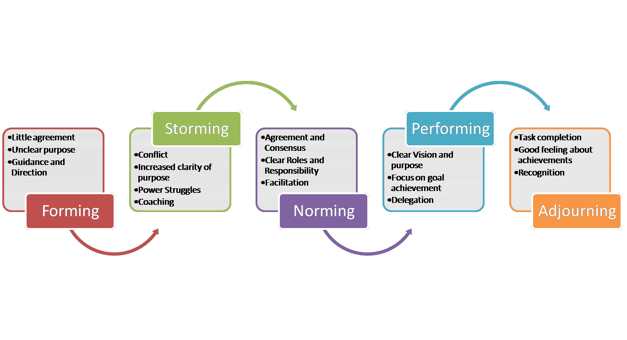
Norm – behavior , rule , or standard expected to be followed by team members (cover : Performance , appearance , social arrangement , allocation of resources)
Cohesiveness- degree to which members are attracted to and motivated to remain part of a team

Task & maintenance roles

- Task activities – an action taken by a team member that directly contributes to the groups performance purpose
- Maintenance activity – action taken by a team member that supports the emotional life of the group
- Distributed leadership – When all members of a team contribute helpful task and maintenance behaviors
- Distruptive activities – self serving behaviors that interfere with team effectiveness

Communication Networks

- Decentralized communication network – Allows all members to communicate directly with one another
- Centralized communication network – communication flows only between individual members and a hub or centre point
- Restricted communication network – subgroups have limited communication with one another

Problem-Solving (Process-Improvement) Teams

  - –Groups of employees from the same department who meet for a few hours each week to discuss ways of improving quality, efficiency, and the work environment.
- •Quality Circles
  - –A work group of employees and managers who meet regularly to discuss their quality problems, investigate causes, recommend solutions, and take corrective actions.
- •Self-Managed (Self-Directed) Teams
  - –Groups of people who take on responsibilities of managers on a rotating basis.

Role Conflict

  - –A situation in which an individual is confronted by divergent role expectations.
Role Ambiguity
  - –A person is unclear about his or her role.
Role Overload
  - –Too much is expected of someone.
Role Underload
  - –Too little is expected of someone.

The Punctuated-Equilibrium Model
- •Phase 1

  - –The first meeting sets the group’s direction.
  - –The first phase of group activity is one of inertia.
- •Transition
  - –A transition takes place at the end of the first phase, which occurs exactly when the group has used up half its allotted time.
  - –The transition initiates major changes.
- •Phase 2
  - –A second phase of inertia follows the transition.
- •Last meeting is characterized by markedly accelerated activity.

Task-orientated roles – Roles performed by group members to ensure that the task of the group are accomplished

Maintenance roles – Roles performed by group members to maintain good relations within the group

Individual roles – Roles performed by group members that are or are not productive for keeping the group on task.

Conflict

- Disagreement over issues of a substance and/or an emotional antagonism
- Substantive conflict – Involves disagreements over goals, resources , rewards , policies , procedures and job assignment
- Emotional Conflict – results from feelings of anger, distrust , dislike ,fear and resentment as well as from personal clashes
- Function conflict – construction and helps task performance

- Dysfunctional conflict – destructive and hurts task performance

Conflict Management styles

- Avoidance – withdrawal pretends that a conflict doesn’t exist
- Accommodation - plays down differences and highlights similarities to reduce conflict
- Competition – authorities command uses force ,superior skill or domination to win conflict

- Compromise – occurs when each party to the conflict gives up something of value to the other

- Collaboration – problem solving involves working through conflict differences and solving problems so everyone wins

- Lose-lose conflict – no one achieves his or her true desires , and the underlying reasons for conflict remain unaffected

- Win-lose conflict- one parts achieves its desires and the other party does not

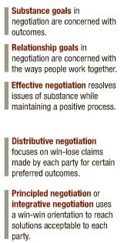

4 Negotiation rules

  - Separate the people from the problem
  - Focus on interests not on positions
  - Generate many alternatives before deciding what to do
  - Insist that results be base on some objective standard .

Bargaining zone – space between ones party’s minimum reservation point and the other partys maximum reservation point .

Mediation – a neutral part tries to help conflicting parties improve communication to resolve their dispute
Arbitration – a neutral thirst party issues a binding decision to resolve dispute .

12/02/18
Week 5

Chapter 02 – lec 05 - Management Theories

Classical School of Thought – Classical : assumption that people are raitonal

● Approaches include:

○ Scientific management (Frederick Taylor)

○ Administrative principles (Henri Fayol and Mary Parker Follett)

○ Bureaucratic organization (Max Weber)

Scientific Management (Frederick Taylor) – emphasizes careful selection and training

    - Develop rules of motion, standardized work implements, and proper working conditions for every job.
    - Carefully select workers with the right abilities for the job.

    - Carefully train workers and provide proper incentives.

    - Support workers by carefully planning their work and removing obstacles.

Scientific Management (the Gilbreths)

● Motion study – science of reducing task to basic physical motions

Administrative Principles (Henri Fayol) – Behavior management

- Division of labor
- Authority
- Discipline
- Unity of command – 1 person in charge
- Unity of direction – you know your goals
- Subordination of individual interests – something we want to do but we give away to follow the rule sof the organization
- Remuneration – how much money to make
- Centralization – one central office where the boss takes charge
- Scalar chain – similar to heirchy
- Equity – treating everyone with respect

Administrative Principles (Mary Parker Follett)

● Groups are mechanisms through which individuals combine their talents for greater good

Bureaucratic Organization (Max Weber)

● Bureaucracy

○ An ideal, intentionally rational, and very efficient form of organization.

○ Based on principles of logic, order, and legitimate authority.
- System of government where most important decisions are made
- Clear division of labor , clear hierachy of authority , formal rules and procedures, impersonality , careers based on merit

● Characteristics of bureaucratic organizations

○ Clear division of labour

○ Clear hierarchy of authority

○ Formal rules and procedures

○ Impersonality

○ Careers based on merit

● Possible disadvantages of bureaucracy

○ Excessive paperwork or “red tape”

○ Slowness in handling problems

○ Rigidity in the face of shifting needs

○ Resistance to change

○ Employee apathy

Behavioral or Human Resource Approach

● Human resource approaches include:

○ Hawthorne studies

○ Maslow’s theory of human needs

○ McGregor’s Theory X and Theory Y

○ Argyris’s theory of adult personality

Hawthorne Studies – physiological factors ; study with light

● Hawthorne studies – psychological factors ; study with light. Elton Mayo – made workers feel important . social settings help productivity
- Hawthorne effect – tendency of persons singled out for special attention to perform as expected
- Human relations movement – managers using good human relations will achieve productivity
- Organizational behavior – study of individuals & groups in organizations
Maslows Theory of Human Needs – physiological > safety > social > esteem > self-actualization
- Needs - physiological/psychological deficiency that person wants to satisfy
- Based on 2 principles ;
  - Deficit principle – satisfied need is not a motivator of behavior
  - Progression principle – a need becomes a motivator once the preceding lower-level need is satisfied.

McGregors Theory X and Y

- Theory X - assumes people dislike work, lack ambition, irresponsible, prefer to be led (command & control managers)
- Theory Y - assumes people willing to work, accept responsibility, self-directed & creative (participative managers)
- Self-fulfilling prophecy – occurs when person acts in way that confirms another’s expectations

Argyri’s Theory Of adult personality
- Classical management principles prevent employees from achieving their potential.
- People will act how you treat them. E.g treat them like babies they will act like it
- Adult personality workers regarding their age will act as adults when they are given responsibility.

Modern Management foundations

- Management science and operations research – use quantitive analysis and applied mathematics to solve problems
- Operations management – the study of how organizations produce goods and services

Organizations as systems

- System – collection of interrelated parts working together to achieve common purpose
- Subsystem - A smaller component of a larger system
- Open systems – organizations that interact with their environment in the continual process transforming resource inputs into outputs

Contingency Thinking
- Tries to match managerial responses with the problems and opportunities specific to different situations. Appropriate way to manage depends on situation
- Contingency perspective tries to help managers understand situational differences and respond to them in a appropriate ways.
Total quality management (TQM) – process that makes quality principles part of the organization’s objectives, applying them to all aspects of operations and striving to meet customers needs by doing right the first time.
- Continuous improvement – always looking for new ways to improve on current performance
Knowledge management – process through which organizations use information technology to develop , organize and share knowledge to achieve success.
- Process of using intellectual capital to competitive advantage – patents , intellectual property rights, trade secrets, special processes and methods , understanding of workplace

Organizational learning ; Peter Senge -
¬ Mental models- everyone sets aside old ways of thinking
¬ Personal mastery- everyone becomes self- aware and open to others
¬ Systems thinking- everyone learns how the whole organization works
¬ Shared vision- everyone understands and agrees to a plan of action
¬ Team learning- everyone works together to accomplish the plan

Evidence based Management – The process of making management decisions based on hard facts about what really works
High performance organizations – organizations that want Hight- performance results while also creating high quality-of-work-life environments for their employees
- People oriented
- Team oriented
- Information oriented
- Achievement oriented
- Learning oriented

Evidence based positive human resource Management Practices - Employment security, pay based on merit , training and development

Chapter 14 – lecture 6 – Motivation

Motivation - Accounts for the level of direction and persistence of effort expended at work
Need – Is an unfulfilled physiological and psychological desire

Hierarchy of needs
Lower-order needs – physiological , safety , social needs in maslows hierchy
Higher-order needs – esteem and self actualization in maslows hierchy

ERG Theory – Clayton Alderfer
Existence needs – desires for physical well being
Relatedness needs – desires for good interpersonal relationships
Growth needs – desires for personal growth and development
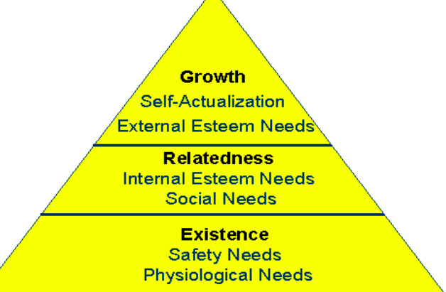

Two-factor Theory – Frederick Herzberg

- Satisfier/motivating factor – found in job content (what people do in terms of job tasks) just as sense of achievement , recognition , responsibility ,advancement or personal growth
- Hygiene factor – found in job context (the work setting in which they do it) , such as working conditions , interpersonal relations , organizational policies , salary , personal life.

Acquired Needs Theory- David McClelland
- People acquire needs through life experiences
  - Need for achievement – desire to do something better, solve problems or to master complex tasks
  - Need for power – desire to control m influence or be responsible for other people
  - Need for affiliation – desire to establish and maintain good relations with people

Process theory’s of Motivation

- Equity theory – J Stacy Adams
  - inequity is a motivating state.
  - E.g if employee is being treated unfairly compared to others they might put in less work , asking for better treatment., changing comparison points to make things better, leaving the job
  - Equity sensitivity – reflect that people have different preferences for equity and react differently to perceptions of inequity
- Expectancy theory – Victor Vroom
  - Persons motivation to work depends on the relationship among 3 expectancy factors depicted.
    - Expectancy – persons belief that working hard will result in a desired level of task performance being achieved (effort performance expectancy )
    - Instrumentality – persons belief that successful performance will be rewarded ( performance-outcome expectancy )
    - Valence – the value a person assigns to the possible rewards and other work related outcomes
  - Process theories of motivation - Motivation = expectancy x instrumentality x valence
  - If either E , I , or V are low motivation will be low
- Goal setting theory – Edwin Locke

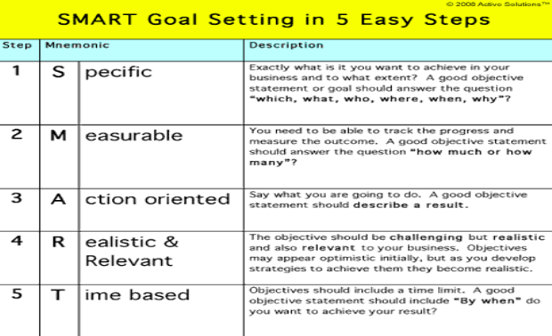

- Self – efficacy - Albert Bandura
  - Refers to a persons belief that she or he is capable of performing a task.
  - Enactive mastery – when a person gains confidence through positive experience
  - Vicarious modelling – learning by observing others
  - Verbal persuasion – when someone tells us that we can perform a task.

Reinforcement theory of motivation
- Law of effect – states that behavior followed by a pleasant consequences is likely to be repeated.
- Operant conditioning – control of behavior by manipulating its consequences
- Positive reinforcement – strengthens behavior by making a desirable consequence contingent on its occurrence
  - Shaping – creation of a new behavior by the positive reinforcement
  - Continuous reinforcement – rewards each time a desired behavior occurs
  - Intermittent reinforcement - rewards behavior periodically
- Negative reinforcement – strengthens behavior by making the avoidance of an undesirable consequence contingent on its occurrence
- Punishment – discourages behavior by making and unpleasant consequence occur
- Extinction – discourages behavior by making the removal of a desirable consequence

Motivation and Job Design

- Job design – Arranging work tasks for individuals and groups
  - Job rotation – increases task variety by periodically shifting workers between different jobs
  - Job enlargement – increases task variety by combining into one job two or more tasks done by separate workers.
  - Job Enrichment – increases job depth by adding work planning and evaluation duties normally performed by the supervisor
- Job simplification – employs people in clearly defined and specialized tasks with narrow job scope
- Automation - the total mechanization of a job

Hackman and Oldham job Characteristics model
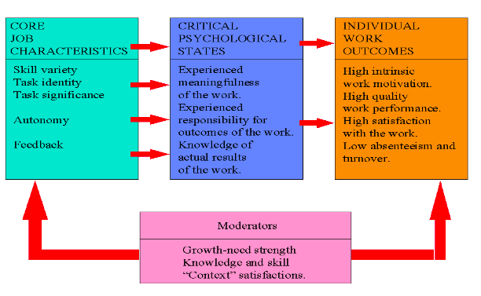

Flexible working hours – give employees some choice in dailty work hours
Compressed workweek - Allows a full-time job to be completed in less than five days
Job sharing - splits one job between two or more people
Telecommuting- work arrangement that allows a portion of the scheduled work to be completed outside of the office
Contingency workers- employed on a part time and temporary basis to supplement a permanent workforce

Chapter 6: Planning Processes and Techniques

Planning

● Planning → setting objectives and determining how to best accomplish them.

● Objectives → identify the specific results/desired outcomes that one intends to achieve.

● Plan → a statement of action steps to be taken in order to accomplish the objective.

● Steps in the planning process:

1. Define your objectives.

2. Determine where you stand vis-a-vis objectives.

3. Develop premises regarding future conditions.

4. Analyze and choose among action alternatives.

5. Implement the plan and evaluate results.

● Benefits of planning:

○ Improves focus and flexibility

○ Improves action orientation – avoid complacency trap – being carried along by the flow of events

○ Improves coordination

○ Improves time management

○ Improves control

Roles of planning
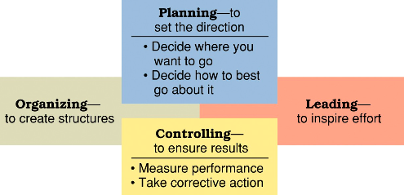

Types of Plans

1. Short Range and Long Range Plans

○ Short range plans = 1 year or less ( western0

○ Intermediate range plans = 1 - 2 years

○ Long range plans = 3+ years (easter society )

● People vary in their capability to deal effectively with different time horizons.

● Higher management levels focus on longer time horizons.

2. Strategic and Operational Plans

- Strategic plans – set broad, comprehensive , and loger term action directions for the entire organization
- tactical plans → define what needs to be done in specific areas to implement strategic plans. . ( form of functional plans which indicate how different component of the enterprise will contribute to the overall strategy.
○ Production plans

○ Financial plans

○ Facilities plans

○ Marketing plans

○ HR plans
- Vision – clarifies the purpose of the organization and future asipiration/hopes
- Operational plans – describes what needs to be done in the short term in response to different stuation

3. Policies and Procedures

● Standing plans → policies and procedures that are designed for repeated use.

● Policy → broad guidelines for making decision and taking action in specific circumstances.
● Rules/Procedures → plans that describe exactly what actions are to be taken in specific situations.
4. Budget and Project Schedules

● Single use plans → only used once to meet the needs and objectives of a well-defined situation in a timely manner.
● Budgets → single use plans that commit resources to activities, projects, or programs.

→ fixed, flexible, and zero-based budgets. ( no guarantee funding will be renewed)

● Projects → one-time activities that have clear beginning and end points.

→ project management and project schedules.

Planning Tools and Techniques

● Forecasting

○ Making assumptions about what will happen in the future.

○ Qualitative forecasting uses expert opinions.

○ Quantitative forecasting uses mathematical and statistical analysis.

○ All forecasts rely on human judgement.

○ Planning involves deciding on how to deal with the implications of a forecast.

● Contingency Planning

○ Identifying alternative courses of action that can be implemented to meet the needs of changing circumstances.
○ Contingency plans anticipate changing conditions.

○ Contingency plans contain trigger points.

● Scenario Planning

○ A long term version of contingency planning.

○ Identifying alternative future scenarios.

○ Plans made for each future scenario.

○ Increases organization’s flexibility and preparation for future shocks.

- Benchmarking
- Use of external and internal comparisons to better evaluate current performance and identify possible actions for the future
- Adopting best practices of other organizations that achieve superior performance

- Best Practices – things that lead to superior performance
- Participatory planning – includes persons who will be affected by plans & ones who will implement them
Implementing plans to achieve results
- Goal Setting - can make a big difference in how well management does in pointing people in the right directions and inspiring them to work hard
- Great goals are SMART
- Specific, measurable attainable, regularity, timely
- Management by objectives (MBO)
- a structured process of regular communication
- supervisor/team leader and workers jointly set performance objectives ,

Chapter 12- Lec 07 – Individual Behaviour
Perception:
● The process through which people receive, organize and interpret information from the environment
● People can perceive the same things or situations differently
- Psychological contract- set of individual expectations about the employment relationship (e.g put in time , effort and get pay , training in return )

Attribution:
● It is a process of explaining events
● If someone cuts in line, internal attribution: Person is selfish
● External attribution: Person is unaware (situational)
● If I cut in line, I would most likely believe that I was unaware.

Fundamental attribution error:
● Blame others performance problems on internal rather than external factors, a man is walking down a crowded sidewalk, carrying loaded bags from shops. If someone bumps into him, he is probably inclined to think “what an idiot!”

Self­serving bias:
● Blame personal performance problems on external factors and attribute successes to internal factors.
● Ex: I earned an A on my POM exam because I studied hard. I received a C on my Accounting exam because the prof deliberately set a difficult exam.

- Stereotype – occurs when attributes commonly associated with a group are assigned to an individual
Perceptual tendencies and distortions: Stereotype:
● Occurs when someone is identified with a group or category, and then
oversimplified attributes associated with the group or category are used to describe the individual

Hallo effects:
● Occurs when one attribute is used to develop an overall impression of a person or situation

Selective perception:
● The tendency to focus on parts of the situation or person that reinforces one’s existing beliefs, values, or needs.

Projection:
● The assignment of personal attributes to other individuals.
● (Self: Polite, so you expect everyone else to be.)
Impression Management – a systematic attempt to influence how others perceive us
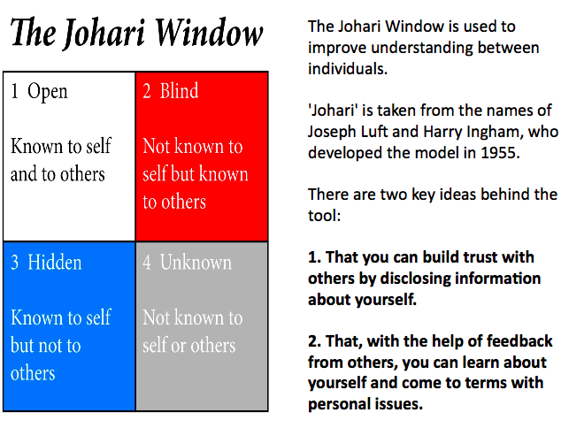

Big Five personality Dimensions
- Extraversion – being outgoing, sociable and assertive
- Agreeableness – being good natured , cooperative and trusting
- Conscientiousness – being responsible , dependable and careful
- Emotional stability- being relaxed, secure and unworried
- Openness to experience – being curious , receptive to new ideas and imaginative
Myers Briggs Type inventory
- Purpose of the myers-briggs type indicator (MBTI) personality inventory is to make the theory of psychological types described by carl Jung understandable and useful in people’s lives
- The essence of the theory is that much seemingly random variation in the behavior is actually quite orderly and consistent , being due to basic difference in the ways individuals prefer to use their perfection and judgment 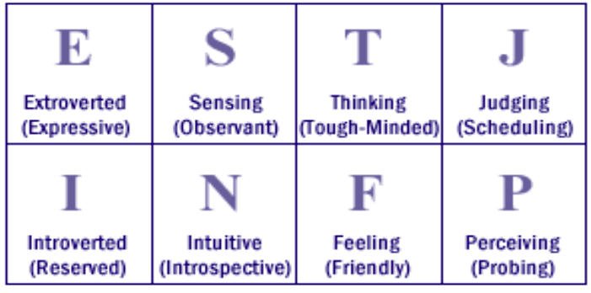
Other personality traits that affect work behavior:
Locus of control:
● The extent to which people believe they are in control of their destinies versus believing that what happens to them is beyond their control.

Authoritarianism:
● The degree to which a person defers to authority and accepts status differences.

Machiavellianism:
● The extent to which someone is emotionally detached and manipulative in using power.
- The “high mach “ personality is exploitative and unconcerned about others
- The “low-match “ personality is deferential in allowing power to be exerted over him/her

Other personality traits that affect work behavior:

Self –monitoring:
The degree to which someone is able to adjust and modify behavior in response to the situation and external factors. (How fast do you speak?)

Type A:
● Competitive
● Time urgent
● Hostile and aggressive

Type B:
● Relaxed
● One thing at a time
● Express feelings

Attitudes:

Cognitive dissonance. (Leon Festinger)
● The discomfort a person feels when attitudes and behavior are inconsistent.
● Usually try to rationalize it

Constructive stress: (Eustress or “Euphoric stress”)
● acts in a positive way to increase effort, stimulate creativity, and courage diligence in one’s work

Destructive stress: (Distress)
● impairs the performance of an individua

Withdrawal behaviors – occur as a temporary absenteeism and actual job turnover
Employee engagement - Strong positive feeling about one’s job and the organization
Organizational citizenship – is a willingness to go beyond the call of duty in ones work
Emotional intelligence (Danial Goleman)– ability to understand emotions and manage relationships effectively
- Self awareness, social awareness, self management, relationship management
Mood contagion – the spillover of ones positive or negative moods onto others
Stressor – anything that causes stress
Constructive stress- acts in a positive way to increase effort, stimulate creativity and encourage diligence in ones work
Destructive stress – impairs the performance of an individual
Job burnout – physical and mental exhaustion from work stress
Workplace rage – aggressive behavior toward co-workers or the work setting
Personal wellness – the pursuit of ones’ full potential through a personal health promotion program

Chapter 7: Strategy and Strategic Management

Foundations of Strategic Competitiveness

● Basic concepts of strategy:

○ Competitive advantage (outperforms competitors)

■ Cost and quality (emphasis on operating efficiency and product quality)

■ Knowledge and speed (emphasis on innovation and speed to market)

■ Barriers to entry (protection from barriers)

■ Financial resources (emphasis on investments)

■ Technology (to gain operating efficiencies, market exposure, loyalty)

○ Sustainable competitive advantage (outperform rivals in ways that are costly or difficult to imitate)
○ Strategy (comprehensive plan guiding resource allocation to achieve long-term organizational goals)
○ Strategic intent (focuses organizational energy on a unifying goal)

○ Strategic management (process of formulating and implementing strategies)

Environments and Competitive Advantage

● Monopoly

○ One player, no competition

○ Creates absolute competitive advantage

● Oligopoly

○ Few players not directly competing against each other

○ Long-term competitive advantage in defined market segment

● Hypercompetition

○ Several players directly competing against each other

○ Any competitive advantage is only temporary

Strategic Management Process
- Strategic analysis – the process of analyzing the organization , the environment and the organizations competitive position and currenty strategies.

● Strategy Formulation → the process of creating strategies.

○ Involves assessing existing strategies, organization, and environment to develop new strategies and strategic plans capable of delivering future competitive advantage.
● Strategic questions for strategy formulation:

○ What is our business mission?

○ Who is our customer and what do they consider value?

○ What have been our results and what is our plan?

● Strategy Implementation

○ Process of allocating resources and putting strategies into action.

○ All organizations and management systems must be mobilized to support and reinforce the accomplishment of strategies.

Strategic Management Process Steps

1. Identify and Analyze

● Mission and stakeholders, core values, and objectives

2. Analyze Organization and Environment (vis-a-vis mission and objectives)

● SWOT analysis, rivalry and industry attractiveness

3. Revise Objectives and Select New Strategies

● corporate/business/functional strategies

4. Implement strategies

5. Evaluate results

● Change strategic plans and/or implementation process as necessary

Three Levels of Planning

● Strategic
● Tactical
● Operational

Strategic Planning

● Envisioning goals for the future
● Creating goals from above
● Creating a sequence of steps to achieve them

Tactical Planning

● The steps or tactics needed to achieve the goals defined in a strategic plan
● For example, if a company’s strategic plan is to become a market leader, its tactical plan might be to spend more on advertising and marketing

Operational Planning

● The process of planning strategic goals and objectives to tactical goals and objectives o Specific goals
o Actions and time required to achieve goals
o Human Resources required
- Physical Resources required
- Budget required

Analysis of Missions

● Mission → the reason for an organization’s existence (purpose).

● Good mission statements identify: customers, products/services, location, and

underlying philosophy.

● An important test of the mission is how well it serves the organization’s stakeholders.
- Strategic constituencies analysis – asses interests of stakeholder and how well the organization is responding to them

Analysis of Values

● Organizational culture → the predominant value system for the organization as a whole.
- Core value – are broad beliefs about what is or is not appropriate behaviour

Analysis of Objectives

● Operating objectives → specific results that organizations try to accomplish (direct).

● Typical operating objectives:

○ Profitability → operating a net profit

○ Financial health → earning positive returns

○ Customer service → meeting customer needs and gaining loyalty

○ Cost efficiency → using resources well to operate at low cost

○ Innovation → developing new products and processes

○ Human talent → recruiting and maintaining a HQ workforce.

SWOT Analysis

● Examines organizational strengths and weaknesses.

○ Core competency → special strength that gives an organization a competitive advantage.
● Assess environmental opportunities and threats.

Strategies Used by Organizations

Porter’s Five Forces Model

● Forces affecting industry competition

1. Industry Competition

● The intensity of rivalry among firms in the industry & the way they behave competitively.

2. New Entrants

● The threat of new competitors entering the market.

3. Substitute Products

● The threat of substitute products.

4. Bargaining Power of Suppliers

● The ability of resource suppliers to influence the price one has to pay for products.

5. Bargaining Power of Customers

● The ability of customers to influence the price that they will pay for the products.

Three Levels of Strategy

1. Corporate Level Strategy

● Sets long term direction and guide resource allocation for the total enterprise.

● Identifies how the company intends to compete across multiple industries/markets.

● “In what industries and markets are we going to compete?”

2. Business Level Strategy

● Identifies how a division or strategic business unit will compete in its product domain.

● Includes choices about product mix, facilities locations, new technologies, etc.

● “How are we going to compete for customers in this industry and market?”

3. Functional Strategy

● Guides activities within one specific area of operations.

● “How can we best utilize resources in a function to implement our business strategy?”

● Improving operating efficiency, product quality, customer service, innovativeness.

Corporate Level Strategy Formulation

1. Growth Strategy

● Involves expansion of the organization’s current operations.

● Seeks to expands the size and scope of operations in respect to such things as total
sales, market shares, and operating locations.

● “Acquisition”, “merger”, “global expansion”

2. Stability Strategy

● Maintains current operations without substantial changes.

● Pursued when an organization is performing well, already operating at capacity, or when the environment appears stable or exceptionally risky.
3. Renewal Strategy

● Also called retrenchment or defensive strategy.

● Tries to solve problems and overcome weaknesses that are hurting performance.

● Often cut size and rearrange operations to improve performance.

● Liquidation: business operations cease and assets are sold to pay creditors.

4. Combination Strategy

Growth and Diversification Strategies

● Growth → seek an increase in size and the expansion of current operations.

● Types of growth strategies:

○ Concentration Strategies → growth within the same business area.

○ Diversification Strategies → growth in new business areas.

■ Related diversification

■ Unrelated diversification

■ Vertical Integration → growth by acquiring suppliers or distributors.

Restructuring and Divestiture Strategies

● Readjusting operations when an organization is in trouble.

● Retrenchment → correcting weaknesses by making changes to current operations.

○ Liquidation → business operations cease and assets are sold to pay creditor.

○ Restructuring → changes the mix or reduces the scale of operations

○ Downsizing → decrease the size of operations.

○ Divestiture → sells of parts of the organization to refocus attention on core business areas.
Global Strategies

● Globalization strategy → world is one large market; standardized products and advertising for use worldwide. (ethnocentric view - everyone wants the same thing)
● Multidomestic Strategy → customized products and advertising to local markets.

(polycentric view)

● Transactional Strategy → seeks efficiencies in global operations with attention to global markets. (geocentric view)
Cooperative Strategies

● Strategic alliances → 2+ organizations partner to pursue an area of mutual interest.

○ Outsourcing alliances → contracting to purchase important services from another organization.
○ Supplier alliances

○ Distribution alliances

● Co-opetition → working with rivals on projects of mutual benefit.

E-Business Strategies

● The strategic use of the internet to gain competitive advantage.

● Popular e-business strategies:

○ B2B: uses IT and web portals to link organizations vertically in supply chains.

○ B2C: uses IT and web portals to link businesses with customers.

Strategic Portfolio Planning

● Seeks the best mix of investments among alternative business opportunities.

Bcg Matrix: analyzes business opportunities according to market growth rate and market share. Stars: high market share, high market growth rate.
● Stars

○ High market share, high-growth markets (dominant position, growing industry)

○ Preferred strategy: growth (further resource investment recommended)

● Question Marks

○ Low market share, high-growth markets (poor position, growing industry)

○ Preferred strategy: growth (risk) or retrenchment

● Cash Cows

○ High market share, low-growth markets (dominant position, low growth industry)

○ Preferred strategy: stability or modest growth.

● Dogs

○ Low market share, low-growth markets (poor position, low growth industry)

○ Preferred strategy: retrenchment (low profits and little potential for future)

Business Level Strategy Formulation

Competitive Strategies

● 2 considerations: market scope and source of competitive advantage.

1. Differentiation Strategy

● Seek competitive advantage through uniqueness.

● Offers products that are different from the competition.

● Must have strengths in research and development, marketing, and advertising.

● Broad market scope and unique product.

● Coke and pepsi

2. Cost Leadership Strategy

● Seek to operate with low costs so that products can be sold at low prices.

● Needs operating efficiencies throughout purchasing, production, distribution, etc.

● Broad market scope and low price.

● Walmart

3. Focus Strategy

● Concentrates on serving a unique market segment (niche customer group, geographical region, or product line) better than anyone else.
● Competitive advantage achieved by combining focus with differentiation or low cost.

● Focused differentiation: offers unique product to a special market segment.

● Focused cost leadership: lowest cost of operations within a special market segment.

● Strategic Incrementalism: makes modest changes in strategy as experience builds.

● Emergent strategy: unfolds overtime as managers learn from & respond to experience.

Strategy Implementation

● Lack of participation error: a failure to include key persons in strategic planning.

● Corporate governance: the system of control and performance monitoring of top management.
● Strategic control: makes sure strategies are well implemented and that poor strategies are scrapped or modified.
● Strategic leadership: inspires people to continuously change, refine, and improve strategies and their implementation.

Chapter 11: Leadership and Communication

Nature of Leadership

● Leadership → the process of inspiring others to work hard and accomplish tasks.

● Contemporary leadership challenges

● Power → the ability to get someone else to do something you want done or to make things happen the way you want.
● 2 Sources of managerial power

○ Position power (based on things managers can offer to others)

■ Reward power → the capacity to offer something of value as a means of influencing other people (positive outcome). “I’ll reward you”
■ Coercive power → the capacity to punish or withhold positive outcomes as a means of influencing others. “I’ll punish you”
■ Legitimate power → the capacity to influence others by virtue of formal authority, or the rights of office. “You must do what I ask”
○ Personal power (based on how managers are viewed by others)

■ Expert power → the capacity to influence others because of specialized knowledge. “I’m a source of special knowledge”
■ Referent power → the capacity to influence others because of their desire to identify personally with you. “People like to identify with me”

Leadership and Vision

● Visionary Leadership → brings to the situation a clear sense of the future an an understanding of how to get there.
● Meeting the challenges of visionary leadership

○ Clear vision, communicating the vision, and getting people motivated and inspired to pursue the vision in their daily work.

Leadership as a Service

● Servant leadership: leadership based on a commitment to serving others - to helping people use their talents to full potential... “other centred”.
● Focus shifted towards others generates empowerment.

○ Servant leaders provide people with the information, responsibility, authority, and trust to make decisions and act independently.

● Leadership styles: the recurring pattern of behaviors exhibited by a leader.

○ A leader high in concern for the task: plans and defines the work to be done, assigns task responsibilities, sets clear work standards, urges task completion, and monitors performance results.
○ A leader in high concern for people: acts warm and supportive towards followers, maintains good social relations with them, respects their feelings, is sensitive to their needs, and shows trust in them.

Classic Leadership Styles

● Autocratic Style: retains authority and information, command-and-control fashion.

● Human Relations Style: emphasizes people over tasks.

● Laissez-faire Style: “do the best you can and don’t bother me”

● Democratic Style: emphasizes both task and people.

Blake and Mouton’s Leadership Grid
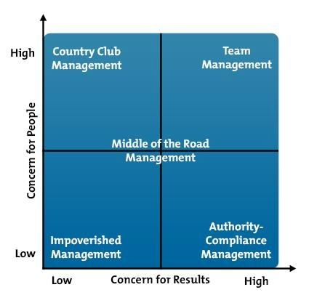
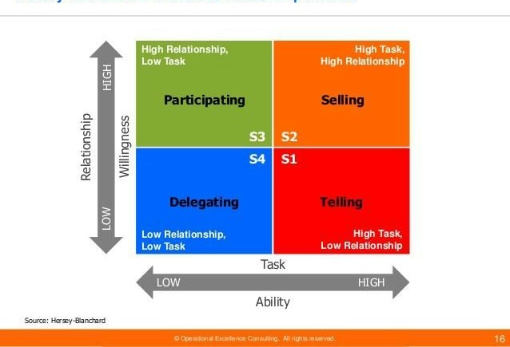

Fiedler’s contingency model

Question – which leadership styles work best in different type of ituatons that leaders face.
- Least-preferred co worker scale – contingency model to measure a person’s leadership style
- Believes that leadership style is part of ones personality , it is relatively enduring and difficult to change
- 3 contingency variable used to diagnose situational control

- Quality of leader relations – good or poor. Measures the degree to which the group supports the leader
- Task structure – high or low. Measures the extent to which task goals , procedures and guidelines are clarly spelled out
- Position power – strong or weak – measures the degree to which the position gives the leader power to reward or punish subordinates.

Hersey - Blanchard situational leadership model
- Question – how should leaders adjust their leadership styles according to the task readiness of followers?

- Believes leadership styles can be changed
- 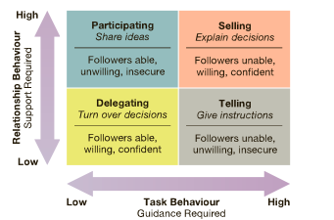

House path-goal leadership theory
- Effective leader is the one who clarifies paths by which followers can achieve both task-related and personal goals
- Use leadership styles that fit situations
- Directive leadership – letting subordinates know what is expected ; giving directions on what to do and how ,; scheduling work to be done
- Supportive leadership – doing things to make work more peasant ; treating group members as equals
- Achievement oriented leadership – setting challenging goals, expecting th highest levels of perfromane, emphasizing continuous improvement in performance
- Participative leadership – involves subordinates in decision making; consulting with subordinates; asking for sugestions from subordinates ; using these to make decisions 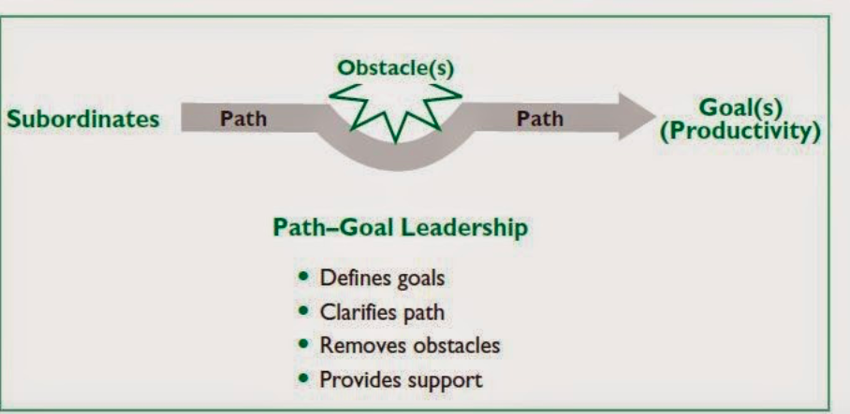
- Substitutes for leadership – are factors in the world setting that direct work efforts without the involvement of a leader

Leader member exchange theory -
- Not everyone will be treated the same by the leader
- Those in “in-group “ considered better performers , those in “out group” are often excluded from certain attributions and benefits
Leader Participation model – Vroom-jago
- Vroom Jago leader participation model indicates that leadership success results when the decion making method used by a leader best fits the problem being faced
- Authority decision – made by the leader and then communicated to the group
- Consultative decision – made by a leader after receiving information , advice or opinions from group members
- Group decision- made by group members themselves.

Transactional Leadership

● Someone who directs the efforts of others through tasks, rewards, and structures

Transformational Leadership

● Someone who is truly inspirational as a leader and who arouses others to seek extraordinary performance accomplishments

Emotional Intelligence

The ability of people to manage themselves and their relationships effectively

● Components of emotional intelligence:
o Self­awareness
o Self­regulation
o Motivation
o Empathy
o Social skills

Interactive leadership – leaders are strong communicators and act in democratic and participative manner with followers
Moral leadership – is always good and right by ethical standards
Integrity – leadership is honesty , credibility and consistency in putting values into action
Authentic Leadership – activates positive psychological states to achieve self awareness and positive self-regulation
Effective communication – intended meaning is full understood by the receiever
Efficient communication – occurs at minimum cost
Persuasive communication – presents a message in a manner that causes the other person to support it
Credible communication – earns trust, respect and integrity in the eyes of the other
Communication channel – pathway through which a message moves from a sender to receiver
Filtering – the intentional distortion of information to make it appear most favorable to the recipient
Active listening – helps the source of a message say she or he really means
Freedback- process of telling someone else how you feel about something that person did or said
Proxemics – involves the use of space in communication
Channel richness – capacity of a communication channel to effectively carry information
Electronic grapevines – use of electronic media to pass messages and information among members of social networks
Management by wandering around – Interactive management – managers spend time outside their offices to meet and talk with workers at all levels
Ethnocentrism – the tendency to consider ones culture superior to any and all others

Chapter 5: Entrepreneurship and Small Business Management

● Entrepreneurship → strategic thinking and risk-taking behavior that results in the creation of new opportunities for individuals and or organizations
● Entrepreneur → risk taking individuals who take actions to pursue opportunities and situations others may fail to recognize or may view as problems or threats.

Typical Characteristics of Entrepreneurs

● Internal locus on control

○ Entrepreneurs believe that they are in control of their destiny.

● High energy level

● High need for achievement

● Tolerance for ambiguity

○ Entrepreneurs are risk takers; they tolerate uncertainty.

● Self-confidence

● Passion and action-orientation

○ Act head of problems.

● Self-reliance and desire for independence

● Flexibility

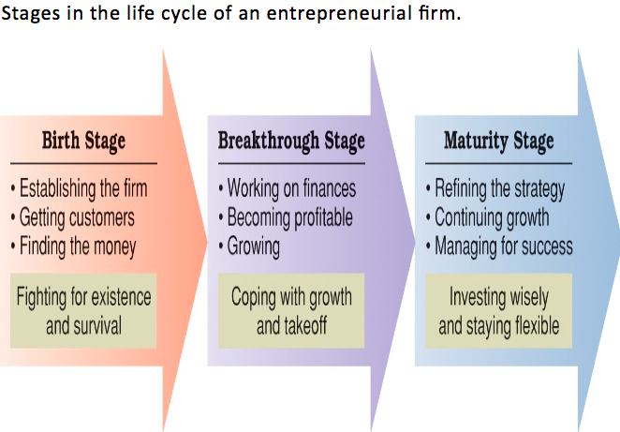

Necessity-based entrepreneurship → when other employment options don’t exist.

Social entrepreneurship → form of ethical entrepreneurship that seeks novel ways to solve pressing social problems.

Harper (2013)

● Entrepreneurship can be a function of self-efficacy and locus on control.

● Self-efficacy → competence (the ability to do something successfully)

● Personal agency belief (entrepreneurship) is multiplicative function

= self-efficacy * locus of control

Typical Entrepreneurial Background and Experiences

● Parents were entrepreneurs or self employed.

● Families encourages responsibility, initiative, and impedance.

● Have tried more than one business venture.

● Have relevant personal or career experiences.

● Became entrepreneurs between 22 and 45 years of age.

● Have strong interests in creative production and enterprise control.

● Seek independence and sense of mastery.

Common Myths About Entrepreneurs

● Entrepreneurs are born, not made.

● Entrepreneurs are gamblers.

● Money is the key to entrepreneurial success.

● You have to be young to be an entrepreneur.

● You must have a degree in business to be an entrepreneur.

Small Businesses

● Ones with 100 or less employees.

● Independently owned and operated.

● 50% of the private labour force works in small businesses.

● Micro business → fewer than 5 employees.

● Are established by:

○ Starting a new business

○ Buying an existing business

○ Buying and running a franchise

Characteristics of Small Businesses

● Entrepreneurship and the internet.

● International business entrepreneurship

● Family business

● Reasons for small business failures

8 reasons why many small businesses fail:

● Lack of experience

● Insufficient commitment (not devoting enough time to the requirements)

● Bad or no strategy (not taking the time to craft a vision / formulate a strategy)

● Ethical failure (fraud, deception, embezzlement)

● Lack of expertise

● Growing too fast (not taking the time to consolidate a position)

● Poor leadership

● Poor financial control (not keeping track of numbers, etc

Starting a New Venture

Important issues in new venture creation:

● Does the entrepreneur have good ideas and the courage to give them a chance?

● Are they prepared to meet and master the best of strategy and competitive advantage?

● Can they identify a market niche that is being missed by other established firms?

● Can they identify a new market that has not yet been discovered by existing firms?

● Can the entrepreneur generate first-mover advantage by exploiting a niche or entering a market before competitors?

Questions that Keep a New Venture Focused on its Customers

● Who is your customer?

● How will you reach key customer market segments?

● What determines customer choices to buy or not buy your product?

● Why is your product a compelling choice for the customer?

● How much does it cost to make and deliver your product?

● How much does it cost to attract a customer?

● How much does it cost to support and retain a customer?

Basic Items that should be Included in a Business Plan

● Executive summary (overview of business purpose, highlight key elements of the plan)

● Industrial analysis (nature of the industry; including economic trends, important legal or regulatory issues, potential risks)
● Company descriptions (missions, owners, and legal form)

● Products/Services descriptions (competitive uniqueness)

● Market description (size of market, competitor strengths/weaknesses, sales goals)

● Marketing strategy (product characteristics, distribution, pricing, market research)

● Operations description (manufacturing methods, supplies/suppliers, procedures)

● Staffing description (management/staff skills needed, compensation, HR systems)

● Financial projection (cash flows, break even points, phased investment capital)

● Capital needs (amount of funds needed, available, and requested)

● Milestones (timetable of dates showing when key stages will be completed)

Forms of Legal Ownership

● Sole proprietorship: owned by one person.

● Partnership: two or more people

○ General Partnership: everyone is involved and everything is shared with the people involved.
○ Limited Partnership: you contribute money, but you’re not going to be a part of the business itself (you have limited contribution).
○ Limited Liability Partnership: you don’t want to be liable for the mistakes of your partner, so your liability is limited to your own actions.
● Corporation: separate entity (you can use the business, not the individuals).

● Limited liability corporation (LLC)

○ A hybrid business form combining advantages of the sole proprietorship, partnership, and corporation.

Financing a New Venture

● Sources of outside financing:

○ Debt financing: borrowing money that must be repaid over time, with interest.

○ Equity financing: exchanging ownership shares for outside investment monies.

● Equity financing alternatives:

○ Venture capitalists: make large investments in new ventures in return for an equity stake in the business.
○ Initial public offerings: an initial selling of shares of stock to the public at large.

○ Angel investors: a wealthy individual willing to invest in a new venture in return for equity in a new venture.

Resources that Support Entrepreneurship and Business Development

● Promoting entrepreneurship in large enterprises

○ Intrapreneurship

○ Skunkworks

● Business incubators

● Small business development centers

Chapter 8: Organization Structures and Design

Organizing as a Management Function

● Organizing: the process of arranging people and resources to work toward a goal.

● Organization structure: a system of tasks, reporting relationships, and communication linkages.

Formal Structures

● The official structure of the organization

● Organization chart: describes the arrangement of work positions within an organization

(job titles, line of authority, and communication between them).

● Basics of an organization's formal structure:

○ Division of Work (positions and titles show work responsibilities)

○ Supervisory Relationships (lines show who reports to whom)

○ Communication Channels (lines show formal communication flow)

○ Major Subunits (positions reporting to a common manager are shown)

○ Levels of Management (vertical layers of management are shown)

Informal Structures

● The set of unofficial relationships among an organization's members.

● Social network analysis: identifies the informal structures and their embedded social relationships that are active in an organization.
○ Asks people to identify others whom they communicate regularly, whom they turn to for help most often, and who energizes or de-energizes them.
○ Used to redesign the formal structure for better performance, and it legitimizes the informal networks people use in their daily work.

Functional Structures

● Groups together people with similar skills who perform similar in formal work units.

● Departmentalization: the process of grouping people and jobs into work units.

Advantages:

● Economies of scale with efficient use of resources.

● Task assignments consistent with expertise and training.

● High-quality technical problem solving.

● In-depth training and skill development within functions.

● Clear career paths within functions.

Disadvantages:

● Difficulties in pinpointing responsibilities (cost containment, product quality, etc).

● Functional Chimneys Problem: a lack of communication, coordination, and problem solving across functions.
● Because functions become more formalized (organization chart and in mindsets), peoples cooperation can break down.
● The sense of common purpose gets lost to self-centred and narrow-minded viewpoints.

Divisional Structures

● Groups together people working on the same product or process, serve similar customers, or are located in the same area or geographical region.
● Product Structures

○ Groups together people and jobs focused on a single product or service.

○ Clearly identify costs, profits, problems, and successes in a market area with a central point of accountability.
● Geographical Structures

○ Groups together people and jobs performed in the same location.

○ Typically used when there is a need to differentiate products/services in various locations, such as different parts of a country.
○ Common in international operations - help to focus attention on the unique cultures and requirements of particular regions.
● Customer Structures

○ Groups together people and jobs that serve the same customers/clients.

○ Goal: best serve the special needs of different customer groups.

● Process Structures

○ Groups jobs and activities that are part of the same process.

○ Work process: a group of related tasks that collectively creates something of value to customers.

Advantages:

● More flexibility in responding to environmental changes.

● Improved coordination across functional departments.

● Clear points of responsibility for product or service delivery.

● Expertise focused on specific customers, products, regions.

● Greater ease in changing size by adding or closing down divisions.

Disadvantages:

● Can reduce economies of scale.

● May increase costs through duplication of resources and efforts across divisions.

● Potentially can create unhealthy rivalries as divisions compete for resources and top management attention, and emphasize divisions needs to the detriment of the goals of the organization as a whole.

Matrix Structures

● Combines functional and divisional approaches to emphasize project or program teams.

● Workers in a matrix organization belong to at least 2 formal groups at the same time (a functional group and a product program or project team).
● Manufacturing (aerospace, pharmaceuticals, electronics), service industries (banking, brokerage, retailing), professional fields (accounting, advertising, law), non profit sector (hospitals, universities, federal agencies), MNC (offers flexibility).
Advantages:

● Better cooperation across functions.

● Improved decision making; team level information available

● Increased flexibility in adding, removing, or changing operations to meet changing demands.
● Better customer service

● Better performance accountability

● Improved strategic management; top managers are freed from lower-level problem solving to focus more time on strategic issues
Disadvantages:

● The 2 boss system is susceptible to power struggles.

● Can also be frustrating if it creates task confusion and conflicting work priorities.

Horizontal Organizational Structures

● Harness the powers of teams and information technology to improve communication,

collaboration, and flexibility.

● Teams and technology are used to decrease hierarchy, increase empowerment, and better mobilize human talents.

Team Structures

● Uses permanent and temporary cross-functional teams to improve lateral relations

(solve problems, complete special projects, and accomplish day-to-day tasks).

● Cross-functional teams: brings together members from different functional departments.
● Project teams: convened for a particular task or project and disband once completed.

Advantages:

● Help eliminate difficulties with communication and decision making that result from the functional chimney problem.
● Team assignments break down barriers between departments.

● People working in teams experience a greater sense of involvement and identification.

● Improves speed and quality of decisions (information sharing).

Disadvantages:

● Conflicting loyalties.

● Issues of time management and group process.

● Time spent in meetings may not always be productive.

● Depends on interpersonal relationships, group dynamic, and team management.

Network Structures

● Uses information technologies to link with networks of outside suppliers and contractors.

● Own core business and use strategic alliances and outsourcing to provide the rest.

Advantages:

● Fewer full-time employees and less complex internal systems.

● Lean and streamlined; helps organizations stay cost-competitive through reduced overhead and increased operating efficiency.
● Allow organizations to employ outsourcing strategies and contract out specialized business functions.
Disadvantages:

● New management responsibilities.

● The more complex the business, the more complicated it is to control and coordinate the

network of contacts and alliances.

● If one part of the network fails to deliver, the entire system suffers.

● Potential to lose control over activities contracted out.

● Potential to experience a lack of loyalty among contractors.

● Outsourcing can be dangerous (critical activities such as finance, logistics, HR, etc)

Boundaryless Structures

● Eliminates internal boundaries among subsystems and external boundaries with the external environment.
● Combination of team and network structures with the addition of temporariness.

● Internal context - teamwork and communication replace formal lines of authority.

● External context - organizational needs are met by a shifting mix of outsourcing contracts an operating alliances that change with circumstances.
● Key requirements: absence of hierarchy, empowerment of team members, technology utilization, knowledge sharing, and acceptance of impermanence.
● Virtual organization: uses IT and the internet to engage a shifting network of strategic alliances.

Organizational Designs

● The process of creating and implementing structures that accomplish the organization’s missions and objectives.

Mechanistic and Organic Designs

● Bureaucracy

○ Form of organization based on logic, order, and legitimate use of formal authority.
○ Clear division of labour, strict hierarchy of authority, formal rules/procedures.

○ Supposed to be fair and highly efficient (now often associated with “red tape”)

Mechanistic Designs

● Highly bureaucratic: centralized, with many rules and procedures, clear division of labour, narrow spans of control, formal coordination.
● Work best for organizations doing routine tasks in stable environments (fast food chains)

● Vertical structures.

Organic Designs

● Not bureaucratic: decentralized, fewer rules and procedures, open division of labour, wide spans of control, and more personal coordination.
● Adaptive organization: operates with minimum of bureaucratic features and encourages worker empowerment and teamwork.
● Horizontal structure, done through informal structures and networking.

● Work well for organizations facing dynamic environments that demand flexibility in dealing with changing conditions.

Subsystems Design and Integration

● Subsystem: a work unit or smaller component within a larger organization.

● Differentiation: the degree of difference between subsystems in an organization.

● Integration: the level of coordination achieved between subsystems in an organization.

● The greater the differentiation among subsystems, the greater the need for integration, yet also the harder it is to achieve integration.
● Low differentiation

○ Integrating mechanisms that rely on vertical coordination and the use of authority relationships work best.
○ Includes use of rules and procedures, hierarchical referral, and planning.

● High differentiation

○ Integrating mechanisms that emphasize horizontal coordination and improved lateral relations work better.
○ Include the use of direct contact between managers, liaison roles, task forces, teams, and matrix structures.

Trends in Organizational Design

Flat Structures

● Trend: organizations are cutting unnecessary levels of management and shifting to wider spans of control. Managers are taking responsibility for larger numbers of subordinates who operate with less direct supervision.

● A typical organization shows the chain of command and has narrow span of control.

● Chain of command: links all persons with successively higher levels of authority.

● Span of control: the number of subordinates directly reporting to management.

● Wider spans of control and fewer levels of management prove to be more efficient, more flexible, less costly (reduces overhead), and more customer sensitive.
● Allows workers more empowerment and independence.

More Delegation and Empowerment

● Trend: managers are delegating more. They are finding ways to empower people at all levels to make more decisions that affect themselves and their work.
● Delegation: the process of entrusting work to others by giving them the right to make decisions and take action.
● Three action steps:

1. Manager assigns responsibility - explain tasks and expectations.

2. Manager grants authority - allow others to make decisions and act.

3. Manager creates accountability - obligation to finish work and require to report results.

● Authority-and-responsibility principle: authority should equal responsibility when work is delegated from a supervisor to a subordinate.
● Delegation leads to empowerment and builds performance potential.

Decentralization with Centralization

● Trend: delegation, empowerment, and horizontal structures are contributing to more decentralization in organizations; at the same time, advances in technology are allowing for adequate centralized control.
● Centralization: the concentration of authority for most decisions at the top level of an organization.
● Decentralization: the dispersion of authority to make decisions throughout all organization levels.
● Technology allows upper levels to stay informed about day-to-day performance.

Reduced Use of Staff

● Trend: organizations are reducing the size of staff. They are lowering costs and increasing efficiency by employing fewer staff personnel using smaller staff units.
● Staff positions: provide technical expertise for other parts of the organization.

● Problem: sometimes it can cost more than it’s worth.

