REVIEW:

WEEK 1:
- Research: a systematic enquiry that aims to generate new scientific knowledge
  - Generates new ideas
  - Advances knowledge, leads to new insights
  - Builds on work of others
  - Systematic
  - Repeatable
- Health research: one that is relevant to health
  - 4 pillars of health research:
    - Biomedical research
    - Clinical research
    - Health services research
    - Social, cultural, environmental and population health research
- 4 purposes of health research:
  - 1. To describe
    - Document patterns and make comparisons
  - 2. To explain
    - Understand why a health problem occurs and the differences among sub-populations
    - Aim to improve our understanding of etiology of different diseases
      - Common research design used for this is cohort study
  - 3. To predict
    - Draws from findings in 1 and 2 to develop and evaluate strategies to mitigate the health problem of interest
  - 4. To control
    - Draws from findings in 1 and 2 to develop and evaluate strategies to mitigate the health problem of interest
- The role of the researcher:
  - Study specific responsibilities
    - Develop the research question
    - Select study design
    - Ensure that the study is ethically sound
    - Conduct data collection
    - Conduct data analysis
    - Prepare the study findings
    - (Repeat)
  - Administrative responsibilities
    - Establish a budget
    - Develop a timeline or schedule for the study
    - Record-keeping
    - Supervise research team
- 12 steps to the research process:
  - 1. Identify the research problem you’re interested in
  - 2. The literature search:What do we already know?
  - 3. Define the problem
  - 4. Develop the research question
    - 3 types of research questions:
      - Descriptive questions: Identifies key features and characteristics of a population of interest
      - Difference questions: How are some sub-groups different from others?
      - Relationship questions: Are 2 or more variables associated?
    - Use PICOT to develop a research question:
      - Patient, population, or problem
      - Intervention
      - Comparison
      - Outcomes
      - Timeframe
  - 5. Generate a hypothesis
  - 6. Choose the appropriate design study
    - Experimental designs: Considered the gold standard to establish cause-effect
    - Exploratory designs: Seek to examine relationships between variables
    - Descriptive designs: Aim to identify key features of participants
  - 7. Define the variables and other key terms
  - 8. Identify the study population of interest
  - 9. Conduct the study
  - 10. Data analysis
  - 11. Inform others, get the word out!
  - 12. Start again, generate a new research question
- The quantitative/qualitative debate: a debate about the suitability of different methods that address health-related problems
- Quantitative argument: Research should utilize methods based in observation and measurement because valid knowledge comes from objective measurement, not subjective interpretation
  - Guided by concerns to measure,test hypotheses, assess relationships, and generalize from samples to populations
  - Quantitative research aims at (causal) explanation
  - Strengths of Quantitative Research:
    - Objective
    - Can be generalizable
    - Emphasis on measurement and explanation
    - Focused on describing health problems
    - Emphasis on the sample or population experience
  - Weaknesses of Quantitative Research:
    - Does not address lived experience
    - Cannot account for complexity and contradiction
    - Rigidly bound by categorizations
- Qualitative argument: Research should utilize methods based in subjective understanding of meaning because valid knowledge comes from understanding how people subjectively interpret social phenomena, not objective measurement
  - Emphasis on meanings, context, experiences, viewpoints
  - Qualitative research aims at understanding
  - Strengths of Qualitative Research:
    - Well-suited to address complex issues
    - Stresses holistic understanding and context
    - Emphasis on deep meaning and discovery
    - Emphasis on individual experience
    - High validity
  - Weaknesses of Qualitative Research:
    - Subjective
    - Replication is rare
    - Results are not generalizable
    - Convenience samples may be biased
- Quantitative and qualitative approaches are complementary not contradictory
- Deductive (quantitative) approach: Involves the researcher testing an existing theory or hypothesis
- Inductive (qualitative) approach: The researcher gathers data and then develops a theory drawn from the data

WEEK 2:
- Nuremberg Code(1947)
  - Specific to medical experiments
  - Emerged from Nazi war crimes trial
  - 10 codes:
    - 1. Voluntary consent
    - 2. For good of society
    - 3. Animal experiments 1st; human experiments 2nd
    - 4. Avoid unnecessary suffering
    - 5. Do not conduct if death & debility likely
    - 6. Risk commensurate with benefits
    - 7. Protect subjects against even remote possibility of harm
    - 8. Conducted only by qualified persons
    - 9. Subjects should be at liberty to discontinue experiment
    - 10. Terminate if becomes apparent that death or debility will occur
- Belmont Report(1978)
  - Emerged after Tuskegee Syphilis study (1932-1972)
  - Principles:
    - 1. Respect for persons
    - 2. Beneficence
    - 3. Justice
  - Applications:
    - 1. Informed consent
    - 2. Assessment of risks/benefits
    - 3. Fair selection of subjects
- TCPS2 key principles:
  - Respect for persons
  - Welfare
  - Justice
- Primary role of SFU REB and ORE:
  - To protect human participants
  - To preserve rights of human participants involved in research
- Principles of consent:
  - Free
  - Informed
  - Ongoing
- Components to the consent process:
  - Recruitment
  - Information
  - Documenting Consent
  - Debriefing (when required)
- Elements of informed consent:
  - Consent form should be written in plain and simple language and provide an accurate description of:
    - The research purpose and proposed use of data collected
    - Foreseeable risks and potential benefits
    - Extent of confidentiality promised
    - Requirements of the study(e.g. duration, frequency, nature of tasks and/or measures)
    - Withdrawal procedure
    - Extent of incentives
    - Data management (access and safeguards)
    - Plans for provision of new information
    - Plans for dissemination of results
    - Contact information of the researcher in charge of the study
    - Contact information of the REB
- What scenarios/participant populations can you think of where capacity to consent may be an issue?
  - children whose capacity is still developing
  - Adults whose capacity is diminishing or fluctuating due to illness or injury
  - Those whose capacity remains only partially developed
  - Participants who are under the influence of drugs and alcohol
- TCPS2 Chapter 9
  - This chapter is designed to serve as a framework for the ethical conduct of research involving Aboriginal peoples.
  - It is offered in a spirit of respect.
  - Its purpose is to ensure, to the extent possible, that research involving Aboriginal peoples is premised on respectful relationships.
  - It also encourages collaboration and engagement between researchers and participants.
- Requirement of Community Engagement in Aboriginal Research:
  - research conducted on First Nations,Inuit or Métis lands;
  - recruitment criteria that include Aboriginal identity as a factor for the entire study or for a subgroup in the study;
  - research that seeks input from participants regarding a community’s cultural heritage, artefacts, traditional knowledge or unique characteristics;
  - research in which Aboriginal identity or membership in an Aboriginal community is used as a variable for the purpose of analysis of the research data;and
  - interpretation of research results that will refer to Aboriginal communities, peoples, language, history or culture.
- Community engagement: interaction between researchers and community
- 5 types of risk:
  - Physical
  - Psychological
  - Economic
  - Social
  - Legal
- Probability: How likely is it that any participant will suffer any harm as a result of the study?
- Magnitude: How severe could the harm be?
- Confidentiality: is the obligation of an individual or organization to safeguard information and protect information from unauthorized access,use, disclosure, modification, loss or theft
- Major Concepts: Confidentiality and Anonymity
  - Directly Identifying Information
  - Indirectly Identifying Information
  - Coded Information
  - Anonymized Information
  - Anonymous Information

WEEK 3:
- Concepts that REBs examine when reviewing studies
  - 1. Minimizing potential risks to participants
  - 2. Ensuring that consent is free and informed
  - 3. Ensuring the scientific merit of the research
  - 4. Ensuring that any conflicts of interest have been properly managed
- Consent & Assent
  - We must always obtain informed consent
  - When a participant is not able to provide consent, their next of kin can provide consent
  - the participant is conscious, they must provide assent
- Confidentiality:
  - Directly identifying information
    - You know who the person is (e.g. SIN)
  - Indirectly identifying information
    - When info is grouped together, you know who the person is (e.g.DOB)
  - Coded information
    - You replaced the identifying info with a study ID in the data set but you have a separate list of the study IDs and who they correspond to
  - Anonymized information
    - Same as coded except you throw away the master list and therefore can never link the study IDs back to the individuals
  - Anonymous information
    - You never collected any identifying information (e.g.survey)
- 3 Forms of Misconduct in Research:
  - 1. Fabrication: making up data, methods, or findings
  - 2. Falsification: manipulation or omission of data, methods, or findings without appropriate disclosure
  - 3. Plagiarism: referring to another researcher’s work without appropriate attribution, referencing, or permission
- Conceptualization of health:
  - Personal trouble
  - Public issue
    - Local level
    - National level
    - International level
- Paradigm: refers to the assumptive base underlying a particular investigation or enquiry that has been undertaken
  - Within the context of health-related research, a research paradigm reflects beliefs about what constitutes knowledge and how that knowledge is generated
  - 3 dimensions to define the paradigm:
    - Epistemology: the branch of philosophy concerned with the nature and definition of knowledge and truth
      - Defines the types of data that would be considered valid and useful
    - Ontology: the branch of philosophy concerned with the nature of reality
    - Methodology: approach to data collection and analysis
      - Clear pragmatic difference between quantitative and qualitative
- 3 important epistemologies:
  - Positivism: Argues that valid knowledge and truth is generated through a scientific process based on observation/measurement and generalization
    - View scientifically produced data as neutral and unbiased
    - Positivist methods include:
      - Epidemiological study designs
      - Survey research
      - Secondary document analysis
      - Structured interviewing
      - Systematic reviews
    - Feature of positivist research:
      - Determinism
      - Objectivity
      - Quantification
      - Reliability
      - Generalizability
    - Advantages of Positivism:
      - Use consistent and relatively concrete outcome measures
      - Techniques of randomization and blinding are effective at reducing bias
    - Critique of Positivism:
      - Many questions (i.e. ‘why’) can’t be answered
      - Give insufficient attention to a person’s lived experience
      - Difficulty in remaining objective
      - Complete objectivity is a fallacy
  - Interpretivism: Describes a position developed in critique of positivism
    - Within this tradition, the purpose of research is to understand how people make sense of their situation/circumstance
    - Features of interpretivism:
      - Objectivity and scientific practice are not neutral– but rather,gendered and partial
      - Less formalized methods are used
      - Value neutrality is not possible: research is not independent of social relations
      - Not concerned with inference
      - Research is not necessarily replicable
      - Aims to achieve an ‘understanding’ of subjective meanings through interpretation
      - High on validity, not necessarily on reliability
    - Advantages of Interpretivism:
      - Researchers may be less likely to ‘get stuck’ in convention always of thinking
      - Observations demand the creation of new ideas and categories rather than testing pre-existing ideas
      - A qualitative, interpretive approach allows acknowledgement of conflict, ongoing struggle, tension and subjectivity, as well as the situated and co-produced nature of the accounts
      - Interpretive research is about subjectivity and complexity– it seeks to represent rich, subjective experience, show differences, retain nuanced data and not to count or reduce
    - Critique of Interpretivism:
      - There is little consensus on appropriate methods of data collection and analysis
      - Qualitative researchers must not attempt to make unjustified generalizations from a small number of accounts
      - Qualitative researchers may adopt convenience sampling strategies that are biased
      - Informants’ accounts are not so much uncovered as created by the researcher
  - Critical realism: Argues that valid knowledge and truth is often generated by theorizing rather than measuring or observing
    - Posits that reality exists independently of individuals’ experiences
    - A critique of both interpretivism and positivism:
      - Argues that interpretivism in not capable of going beyond the stated narratives of individuals
      - Goes beyond reality of measurement of positivism and calls for theoretical analysis of “generative mechanisms” big structural forces e.g. alienation,exploitation
      - Accepts that which is unseen is of equal importance to that which can be.
- 2 critical ontologies:
  - Objectivism: Researchers study phenomena that exist as external objects
  - Constructionism: Researchers study socially constructed objects (i.e., beliefs, ideologies,behaviours)
- Deductive (quantitative) approach: Involves the researcher testing an existing theory or hypothesis
- Inductive (qualitative) approach: The researcher gathers data and then develops a theory drawn from the data

WEEK 4:
- If the study is purely qualitative, positivism can’t be found in the study
- Muddy points: research paradigms
  - Positivist = objectivist = uses quantitative methods
  - Interpretivist = constructionist = uses qualitative methods
- Descriptive study: to describe
- Analytic study: to quantify the relationship between factors
  - Randomized/experimental study: intervention is randomly allocated
  - Observational study: intervention isn’t randomly allocated
- Cross-sectional study: observe a collection of people at one time
  - Sample population → exposed/ non-exposed → cases/ non-cases
  - Best way to determine prevalence
    - Prevalence: proportion of population who have a disease at a specific time -ONGOING CASES
  - Can study multiple outcomes and exposures
  - Frequently conducted with questionnaires
  - Advantages of Cross-sectional Study:
    - Could find more than one association
    - Faster, cheaper, no follow-up required
    - If based on a representative sample of the general population:
      - Highly generalizable
      - Provides estimates of population prevalence of disease and exposures or risk markers that can be used for program planning and resource planning
  - Limitations of Cross-sectional Study:
    - Only assesses prevalence
      - Will see more cases of a disease that has a long duration
      - Don’t know if the association between exposure and disease is really an association of:
        - Exposure with duration of disease (survival) OR
        - Exposure with risk of disease (incidence i.e. new onset of disease)
    - Rare conditions can’t be efficiently be studied
    - Usually can’t establish temporal relationship between exposure and outcome
      - Difficult to separate cause from effect
      - Exposure status at time of study may not be related to exposure at time disease began
- Cohort study: looking at people over a period of time from exposure to outcome
  - Observing a category of people over time that share a similar experience at one period
  - Defined population → Not randomly assigned → exposed/ not exposed → disease/ no disease
  - Potential biases:
    - Biases from non-response and loss to follow-up
    - Bias in assessment of the outcome
      - Can be addressed by masking the person making the disease outcome
    - Information bias
  - Cohort studies are warranted when:
    - We have an idea of which exposures are suspected as possible causes of disease
    - When we can minimize attrition (loss of follow-up) of the study population
    - Relatively short interval between exposure and outcome
  - Cohort studies aren’t warranted when:
    - Lack of evidence to justify mounting of large and expensive study
    - It can be difficult to ascertain who is exposed and not exposed
    - Many diseases occur at low rates
  - Retrospective cohort studies:
    - When studying documented info on past exposures
      - Especially when studying workplace exposures
    - When studying diseases with long latency periods
  - Advantages of Cohort Studies:
    - Temporal relationship is important
      - Can be inferred (prospective design)
    - Can look at rare exposures
    - Can determine incidence
    - Time-to-event analysis is possible
    - Multiple outcomes can be studied
  - Limitations of Cohort Studies:
    - Long and expensive
    - May require large samples
    - Not suitable for rare diseases or diseases with long latency
    - Unexpected environmental changes may influence the association
    - Loss-to-follow-up biases
    - Sub-clinical disease may go undetected at baseline
- Case-control study:
- Incidence: the number of new cases of disease among those at risk during a specific time period -NEW CASES
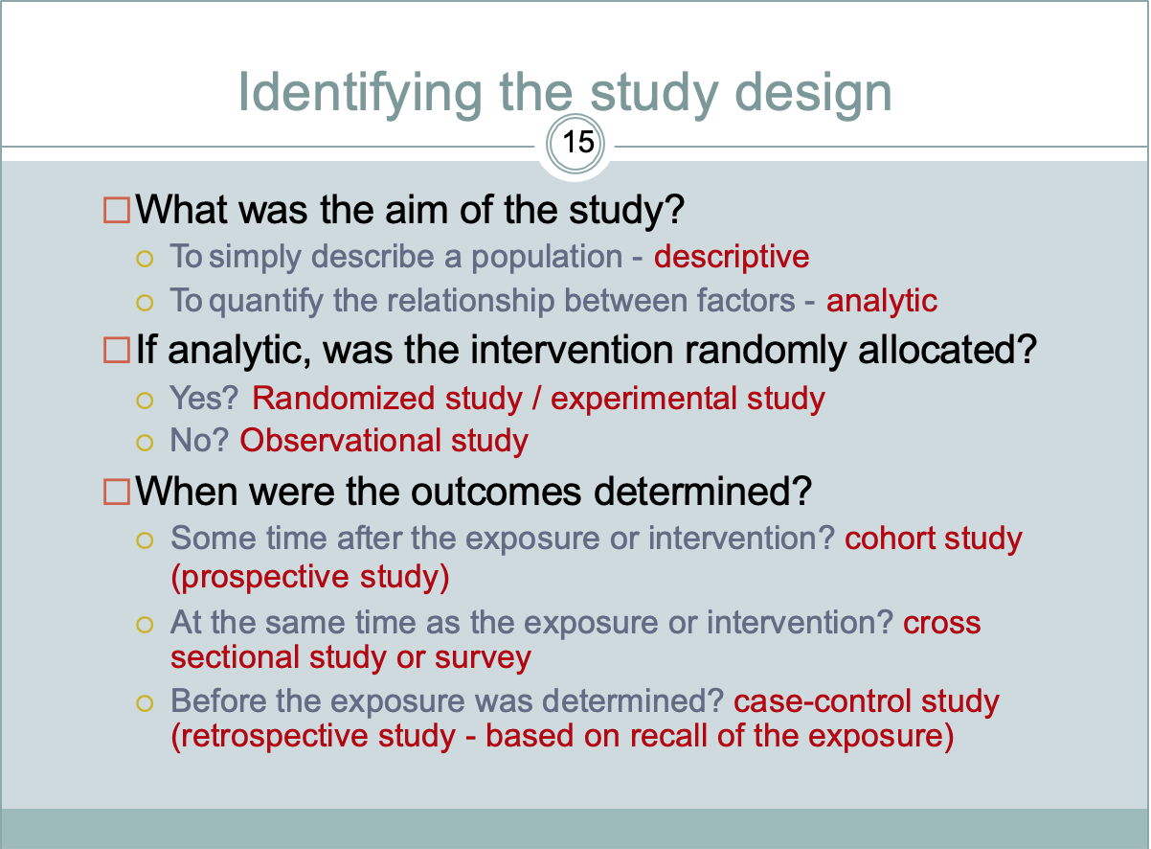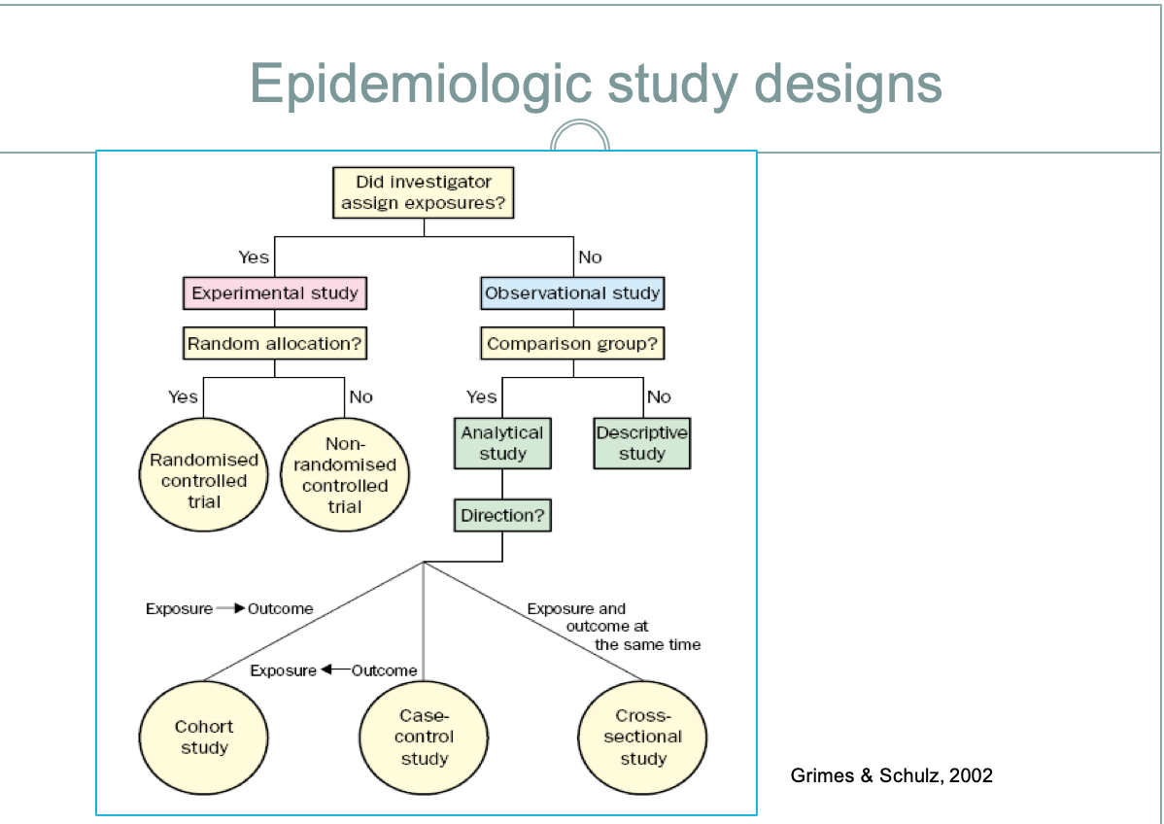

WEEK 5:
- Case-control studies: when to do them?
  - Rare diseases
  - New diseases/syndromes
    - Often performed as follow-up to outbreak investigations
  - Diseases of little-known etiology
  - Diseases for which medical care is usually sought
- Case-control studies: case selection
  - Case definition: Need clear diagnostic criteria with high sensitivity and specificity
  - Ideal: ALL cases in a defined population over a specified period of time (or a representative sample of ALL)
    - Population can be defined geographically or by membership (e.g., occupational group)
    - Selection process can be facilitated by surveillance registry
    - But, can be very expensive and thus unfeasible
  - Most common:
    - All (or representative sample of) cases diagnosed (or receiving care) in certain facilities within a specified time period
      - So, selected from among persons seeking medical care for disease
        - Note: not everyone seeks medical care
      - Preferably newly diagnosed cases (i.e., incident cases)
        - If prevalent cases and find association with exposure, may be due to association with duration of illness or survival rather than disease risk
        - May not know true date of disease onset (late diagnosis) and if the disease is rare it could take a while to get enough incident cases
      - Selection must not be biased with respect to exposure status
    - Death certificates also possible case source
- Case-control studies: control selection
  - Controls are “intended to provide an estimate of the exposure rate that would be expected to occur in the cases if there were no association between the study disease and exposure” (Schlesselman, 1982)
    - Based on the counterfactual ideal, controls estimate the frequency of exposure that would have occurred among cases ‘in the absence of an exposure-disease association’ (Koepsell and Weiss, 2003)
  - Counterfactual ideal = impossible for the same person to be diseased and non-diseased at the same time
  - Controls should be selected in an unbiased manner from those individuals who would have been included in the case series, had they developed the disease under study
  - IDEAL control group:
    - Selected from a population with exposure distribution identical to the population from which the cases arose
      - Does not mean that controls have the same exposure distribution as cases
      - Controls should be representative of all persons w/o the disease in the population from which the cases are selected
    - Exposure measurement of controls must be
      - Accurate
      - Obtained in a manner identical to that used for cases
  - Most common:
    - Non-hospitalized persons living in the community
      - Ideally, a representative sample of the total population
        - Random-digit dialing
      - Practically, instead use
        - School rosters
        - Drivers license database
        - Birth logs or live birth registries
        - Neighbours of cases
        - Friends or siblings of cases
    - Hospital or clinic patients
      - Persons seeking medical care at same institutions as cases for conditions believed to be unrelated to the cases’ diagnosis
      - Other ‘diseased’ controls from birth defect, cancer, or other registries
- Case Control Studies: Limitations
  - Not well suited to study weak associations
    - Hard to distinguish between a true weak association and one due to bias
  - You need a fair sample size
    - Often potentially differential response rates by exposure status for cases and controls, leading to selection bias
  - Misclassification of exposure
    - Recall bias- diseased folks remember more exposure than controls
    - Poor recall
  - Prevalent cases, may be especially hard to establish temporality
- Case Control Studies: Advantages
  - Relatively inexpensive
    - Compared with prospective cohort studies
  - Can study multiple exposures at once
  - Can be conducted in relatively short time period
  - Generally require relatively small numbers of cases and controls for study

WEEK 6:
- Randomized Trials
  - Randomized trials or experimental studies are considered true experiments
  - Observational studies are considered “natural” experiments
  - Study population → randomly assigned → current treatment/ new treatment → improve/ did not improve
- Randomization
  - aims to ensure that the groups are similar and therefore we can compare the intervention more fairly between the groups
  - No systematic differences between groups in factors that are known and unknown
    - the only expected difference between groups is the intervention
- Masking or Blinding
  - Blinding = one or more parties in a trial are kept unaware of which treatment arms participants have been assigned to
  - We would like the subjects not to know which group they are assigned to
  - Placebos are frequently used to mask the intervention
- 4 types of blinding:
  - Unblinded: all parties are aware of what treatment a participant receives
  - Single blind: only one party is blinded (usually the participants)
  - Double blind: participants and study staff are blinded
  - Triple blind: participants, study staff, and data analysts are blinded
- Placebo: An inert substance that looks, tastes, and smells like the intervention agent
  - Placebos play a major role in identifying both the real benefits of an agent and its side effects
    - Placebos are used to make the groups as comparable as possible
    - Use of a placebo is also important for studying the rates of side effects and reactions.
- Problems with randomized studies
  - Random allocation is difficult to achieve in practice
  - The control must be the best available current standard of care
    - If there’s a commonly used treatment, you can’t use a placebo
  - There are ethical issues in withholding educational interventions
  - It is virtually impossible to avoid contamination of a control or comparison area in a health promotion intervention
- Randomization is not predictable based on a pattern!

WEEK 8:
- Measurement: links data and concepts
  - Why are we studying measurement?
    - To explain, describe, predict, and control health problems/issues
  - Measurement process:
    - Conceptualization: refinement of abstract concepts
      - Conceptual definition: a definition in abstract, theoretical terms
      - Process of thinking through various meanings of the concept
    - Operalization: development of specific research procedures that will result in empirical observations
      - Operational definition
        - Important because it allows for replication and force us to think critically
- Categorical variables: take average of categorical variables it has no meaning
- Continuous variables: take average of continuous variables it has meaning
- Discrete variables: a variable that can only take on a certain number of values
- 4 levels of measurement:
  - Nominal
    - Allows a researcher to classify characteristics of study population into categories
    - Least precise level of measurement
    - Mutually exclusive
    - No mathematical interpretation
  - Ordinal
    - Characteristics can be put into categories and ranked
      - Rank ordered according to amount of characteristics the object possesses
    - Mutually exclusive
    - Distances between variables not necessarily equal across the range
  - Interval
    - Can be rank ordered and actual value between values has some meaning
    - Numbers have meaning but no true absolute zero point
  - Ratio
    - All the characteristics plus absolute zero which represents the absence of the attribute
    - Fixed measuring units
- Reliability: the ability of a measuring instrument to give consistent results on repeated trials
  - 4 Measurements of reliability:
    - Test-retest reliability: reliability across time
    - Inter-rater reliability: independent evaluations conducted by different individuals
    - Parallel forms reliability: reliability across indicators
    - Internal consistency: whether different items on the same test correlate
  - How to improve reliability:
    - Conceptualization
    - Increase level of measurement
    - Multiple indicators
- Validity: the degree of confidence we can place on the inferences we make about people based on their scores from that scale
  - 5 Types of validity:
    - Construct validity: uses multiple indicators and has 2 subtypes: how well indicators of one construct converge or how well indicators of different constructs diverge
    - Convergent validity: used for multiple indicators based on the idea that indicators of one construct act alike or converge
    - Discriminant validity: used for multiple indicators based on the idea that indicators of different constructs diverge
    - Face validity: in which an indicator makes sense as a measure of a construct in the judgement of others
    - Content validity: requires that a measure represent all the aspects of the conceptual definition of a construct
- A test cannot be truly valid if its not reliable
- Sampling: a process that selects part of the population for observation
  - Qualitative perspective:
    - Less focus on representatives
    - Greater focus on the relevance of the sample to the research topic
    - Interest in cases that will enhance what the researchers learn about the processes of social life in a specific context
    - Non-probability samples
  - Quantitative perspective:
    - Representativeness
    - Produce accurate generalizations about larger group
    - Probability samples
- Non-probability sampling: Non random sampling
  - Based on their relevance to the research topic rather than representativeness (unclear whether it is generalizable)
  - Less costly, not methodologically viable (hard to reach population, participant cooperation difficult with stigmatized behaviours, hard to get a large sample)
  - 6 types of non-probability sampling:

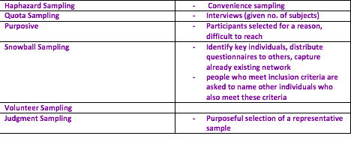

Probability Sampling
Terms:
- Target Population: The concretely specified large group of many cases from which a researcher draws a sample and to which results from a sample are generalized
  - Those you are interested in studying
- Sample: a select subset of the target population ÷ e.g. the target population for a study of infant health may be all children born in British Columbia in the 1990s and the sample is the 500 children born in BC in the 90s that you recruited (subset of those in the sampling frame)
- Sampling unit/element: A member of the target population (e.g. a person, a health facility)
- Sampling Frame: A list of all available sampling units in the target population (e.g. telephone list, electoral list, list of schools, driver’s license records)
- Sampling ratio: The ratio of the size of the sample to the size of the target population

NB: Probability sampling that is most likely to produce a sample that truly represents the population (generalizable).

- Probability Sampling: method of sampling that allows inferences to be made about the population based on observations from a sample
  - 2 primary criteria of probability sampling:
    - Individuals must be randomly selected
    - Individuals must have non-zero chance of being selected
  - 1) Parameter = true characteristics of the population
  - 2) Statistic = information from the sample to estimate a population parameter
  - Avoids selection bias (with random sampling) – allows the researcher to estimate mathematically the degree of match between the sample and the population
    - Sampling error = the degree to which a sample deviates from a population
  - Random = selection process that gives each element/unit in a population an equal probability of being selected (use random selection process without subjective human decisions form a sampling frame/list of units in the population).
  - Common features of random sampling:
    - Must begin with an accurate sampling frame or list of units in population
    - Must use a random selection process without subjective human decisions
  - 4 Types of probability sampling:

Simple random sampling (SRS) | Names drawn out of a hat (e.g.)  - Sampling distribution: many random samples, horizontal/vertical, shows frequency of different sample outcomes for many separate random samples  - Advantage = simple to conduct  - Disadvantage = can be expensive and requires list prior to sampling
Systematic Sampling | Gap, interval, between each selection  - Tells researcher how many elements to skip in the sampling frame before you pick one of your sample
Stratified Sampling | Pop divided into groups (strata) that differ in important ways  Must be mutually exclusive and exhaustive  Select random sample from within each group
Cluster Sampling | Entire pop divided into clusters/groups and random sample of these clusters is selected  Used when researcher can’t get a complete list of the members of the pop they would like to study (but can get a list of groups)  - Probability portion size = adjustment made in cluster sampling when clusters are different sizes

- Probability sampling: the larger the sample, the more precise the estimates are likely to be but the cost will also be higher. Size depends on: degree of accuracy required, degree of variability in the population, the number of different variables examined simultaneously in data analysis (large sample does not guarantee a representative sample.
- Pragmatic Trials: Many trials aren’t adequately informing practice because they were designed to assess efficacy: relatively small, experienced study sites and experienced investigators, highly selected participants.
o Pragmatic trial should be done after a phase 3 clinical trial (known if intervention is beneficial, who benefits the most and potential adverse effects)
o Implementation stage (from get go).
- Explanatory trials = trials that aim to confirm a physiological or clinical hypothesis
- Pragmatic trials = trials that aim to inform a clinical or policy decision by providing more ‘real-world’ evidence for the adoption of an intervention
  - Pragmatism:
    - Extent participants in trial are similar to patients who receive intervention if part of usual care
    - Extra effort made to recruit participants over and above what would be used in the usual care setting to engage with participants
    - Difference in settings (trial vs. real life)
    - Differences in resources, provider expertise, organization of care delivery in the intervention group of the trial from those available in usual care
    - Difference in flexibility of deliverance in trial vs. real life
    - Difference in flexibility in how participants are monitored and encouraged to adhere to the intervention from the flexibility anticipated in usual care.
    - How different is the intensity of measurement and the follow-up of the participants in the trial from the atypical follow-up in usual care
    - Extent of primary outcome of the trial directly relevant to participants
    - Extent are all data included in the analysis of the primary outcome
  - When to do a pragmatic trial?
    - Perhaps after phase 3 of a clinical trial

MI FREEE (The Post Myocardial Infarction Free Rx Event and Economic Evaluation) – cluster based trial in US

WEEK 9:
- 3 measures of frequency:
  - Prevalence: refers to proportion of people at risk who have a specific condition at a given time
    - Number of people with disorder / number of people at risk during interval
    - Consists of a mix of cases (new and existing)
    - 3 types of prevalence:
      - Point prevalence
      - Period prevalence
      - Lifetime prevalence
    - The size of the window matters
  - Incidence: only looks at new cases
    - Number of new cases with disorder/ number of people at risk during interval
    - Denominator only includes people at risk
    - All incident cases are prevalent ones, but not all prevalent ones are incident cases
  - Incidence density: number of new cases in a given period/ total person time of follow up
    - Appropriate for longitudinal cohort study
- 5 measures of mortality:
  - Mortality rate: how many people die from a disease in a given time
    - Number of deaths due to disease/ number of people at risk
  - Case fatality rate: proportion of people with the disease who die within a given time
    - Number of deaths due to disease/ number of people with disease
  - Proportional mortality rate: number of deaths due to disorder in a given time/ number of deaths from all disorders
  - Standardized mortality rate: ratio of the number of observed deaths from a given cause in a given period to the expected number of deaths
    - Number of deaths due to a disorder in a given time/ number of expected deaths
  - Age-standardized mortality rate: to adjust age distributions of the two countries so that they are the same
    - Only way to fairly compare mortality rates
- 6 measures of impact:
  - Relative risk: [A*(C+D)]/[C*(A+B)]
  - Relative risk reduction
  - Absolute risk reduction
  - Population attributable risk
  - Odds ratio: AD/BC
  - Hazard ratio: the ratio of the hazard rates for different groups
    - HR = 1, no difference in hazards between the groups
    - HR = 2, one group has twice the rate of hazard
    - HR is instantaneous risk
    - Tells you about rate of outcome in two groups
    - Most used for patient survival time analyses

WEEK 10:
- Statistics: way to measure and describe aspects of biology from samples
  - Allows us to estimate and test hypotheses
  - 2 types of statistics:
    - Descriptive statistics: summarize and describe data; describes basic patterns;
      - Uses tables, graphs, estimates
      - Usually first step before inference
      - Categorical vs continuous data
    - Inferential statistics: draws conclusion from data
- Nominal data displayed using:
  - Frequency table
  - Bar graph
  - Pie chart: a digression
    - Difficult to see differences between groups
    - Therefore not the best
- Continuous data displayed/described using:
  - Frequency table: create artificial groups and report frequency
    - Not very informative and throws out info
  - Histogram: reveals shape of data
    - Shapes of data: uniform; bell/normal; skewed; bimodal
  - Parameters (mean, median, ect..):
    - Central tendency: summarize data using a single data
      - Measures of central tendency:
        - Mean: average of a set of measurements
          - Distorted by unusual values called outliers
          - Use if sample is bell-shaped
        - Median: number that splits the data into equal halves
          - Use if sample is skewed
        - Mode: the number that occurs the most often in the data
          - Not affected by outliers
          - Most used
    - Measures of variability or spread:
      - Range: smallest and largest values
      - Percentiles: a measure of dispersion for one variable that indicates the % of cases at or below a score or point
        - Often report in quartiles
      - Variance/ standard deviation: a measure of dispersion for one variable that indicates an average distance between the values and the mean
        - Used for comparison purposes and for hypothesis testing
- Box plots: shows median, IQR, and range or outliers
  - Can be used to compare groups

WEEK 11:
- Qualitative Research Methods: Concerned with meaning and generates descriptive narratives (i.e. concerned with developing explanations of social phenomena and the process of construction, exchange, interpretation and use of meaning)
  - they are more flexible and allow for greater spontaneity and adaptation:
    - Why people behave the way they do
    - How opinions and attitudes are formed
    - How people are affected by an event
    - How and cultures have developed in the way they have
    - The difference among social group
    - Emphasis on meaning, experiences, and views of participants
    - Identify intangible factors: social norms, socioeconomic factors, gender roles, ethnicity and religion etc
- Creswell suggests qualitative research is preferred when health science researchers seek to:
  - (a) share individual stories
  - (b) write in a literary, flexible style
  - (c) understand the context or setting of issues
  - (d) explain mechanisms or linkages in causal theories
  - (e) develop theories
  - (f) when traditional quantitative statistical analyses do not fit the problem at hand
- Focus Groups : A group of individuals selected and assembled by researchers to discuss and comment on, from personal experience, the topic that is the subject of the researcher
  - Rely on interaction within the group based on topics provided by the researcher
  - 6-12 people; 1-2 hours; neutral location; within groups participants should be homogeneous
  - Was adopted for application in qualitative research in social sciences
  - When to use focus groups:
    - Exploratory/preliminary studies
    - To uncover factors relating to complex behaviour/motivation
    - When you want ideas to emerge from the group
  - When not to use focus groups:
    - Detailed probing of behaviour, attitudes/needs is required
    - Subject matter under discussion is confidential/emotionally charged
    - Socially acceptable norms exist and the need to conform in a group discussion may influence response
  - Advantages:
    - Enable a larger sample size
    - Time and cost efficient
    - Large amounts of rich can be obtained
    - Participants may feel secure in a group environment
  - Disadvantages
    - Group think
    - Summarization and interpretation are challenging
    - Subjective responses
    - Time consuming analysis
    - Groups can vary considerably
    - Groups can be difficult to assemble
  - Focus Group Moderator:
    - One moderator facilitates and other takes notes, checks equipment and gives feedback
    - Clear explanation of purpose
    - Guide the discussion: steer back on course when needed, probe for details
    - Ensure good time-keeping
    - Ensure people are relaxed and comfortable
    - Tease out diverse range of meanings
    - Avoid showing personal opinion
  - Recruitment:
    - Invitation issued by a hierarchically person can be most effective, ethical aspects should be considered
    - Face to face contact (can promote participation)
    - Interest in the topic/at least in research in general can increase participation
    - Poor physical fitness can also prevent some from participating
    - Patients liking for/dislike of, talking can influence their tendency to join groups; ‘talkative’
  - Communication:
    - Uses open questions, directly addressing quiet participants and handling the discussion guide in a flexible way
    - Moderators should show an interest and generate a feeling of security
    - Groups moderated by the researchers themselves can be helpful because they can answer questions relating to the research topic
    - Status differences between moderators and participants can impact communication
      - Example: to describe the community understanding of pre-eclampsia
- Interviews = Researchers pose questions in a neutral manner, listen attentively to responses, and ask follow-up questions and probes
  - Unstructured
  - Semi-structured
  - Structured
  - Organization: duration (1-2hr, comfortable, familiar location. Convenient and private)
  - Interviewer skills (Attentive, Good communication skills, familiar with subject matter)
  - Advantages:
    - Flexible/responsive method
    - Ability to explore additional research questions and issues if they arise
    - Ability to gain rich and descriptive data
    - Most people accept interviews readily
    - Ability to follow-up research participants for clarification/further exploration if needed
      - Example: usually of new technology or to explore the potential for task sharing to community health workers
- Surveys = systematic method for gathering information for the purpose of constructing
descriptions of the attributes of the larger population
- Tips for tool development
  - Keep only the need to know questions
  - Review/revise the questionnaire
  - Give clear directions
  - Avoid ‘and’ & ‘if’ questions
  - Example: identify information needed of women with hypertensive disorders of pregnancy
- Content Analysis = A method for studying the content of communication
  - Types of documents:
    - Photos
    - videos/film footage
    - Emails
    - policy documents etc.
  - Cost-effective
  - Secondary data
  - Documents may be out of date
  - Authenticity and credibility
  - Incomplete sources
  - Example: identify and characterize health policies related to the role community health workers in the management of pre-eclampsia and eclampsia in Mozambique
- Observation = The observer participates in the daily life of the people under study, either openly in the role of researcher/covertly, observing things to happen, listening to what is said, and questioning people
  - Data collected in a natural environment
  - Content specific
  - Use multiple observers/teams
  - Repeat observations under varying conditions
- Sampling
  - Sampling Approaches
    - Convenience – most accessible subjects
    - Purposive – select most productive sample to answer the research questions
    - Quota, snowball
    - Probability - truly random and statistically representative sample, facilitates generalizability
    - Non-probability - selecting cases rich in information that will permit an in-depth understanding of the research question
  - Sample size
    - Not a single planning decision, but an iterative series of decisions throughout the process
    - Mean qualitative sample size was 87 participants, range of 1-700
    - Literature shows sample sizes have increased over time
    - Literature consistently shows sample sizes tend to exceed what is needed
    - This risks the data becoming repetitive, qualitative analysis that loses depth, increases required resources, and could cause ethical issues around overburdening participants
- Ethical Considerations
  - Access to community groups
  - Conflict in the role of researcher
  - Researcher/participants relationship
  - Researcher’s subjective interpretations of data
  - Study design
- The mental health of people doing qualitative research
  - Data collection requires high levels of human contact and interaction
  - Data collection, transcription and analysis require extensive time and effort
  - Researchers are prone to having fixed mind-sets: to attribute their successes to their own inherent skills and abilities
  - This is associated with higher insecurity, lower productivity, and a tendency to misrepresent data and results to appear more successful
- Qualitative methods before RCTs
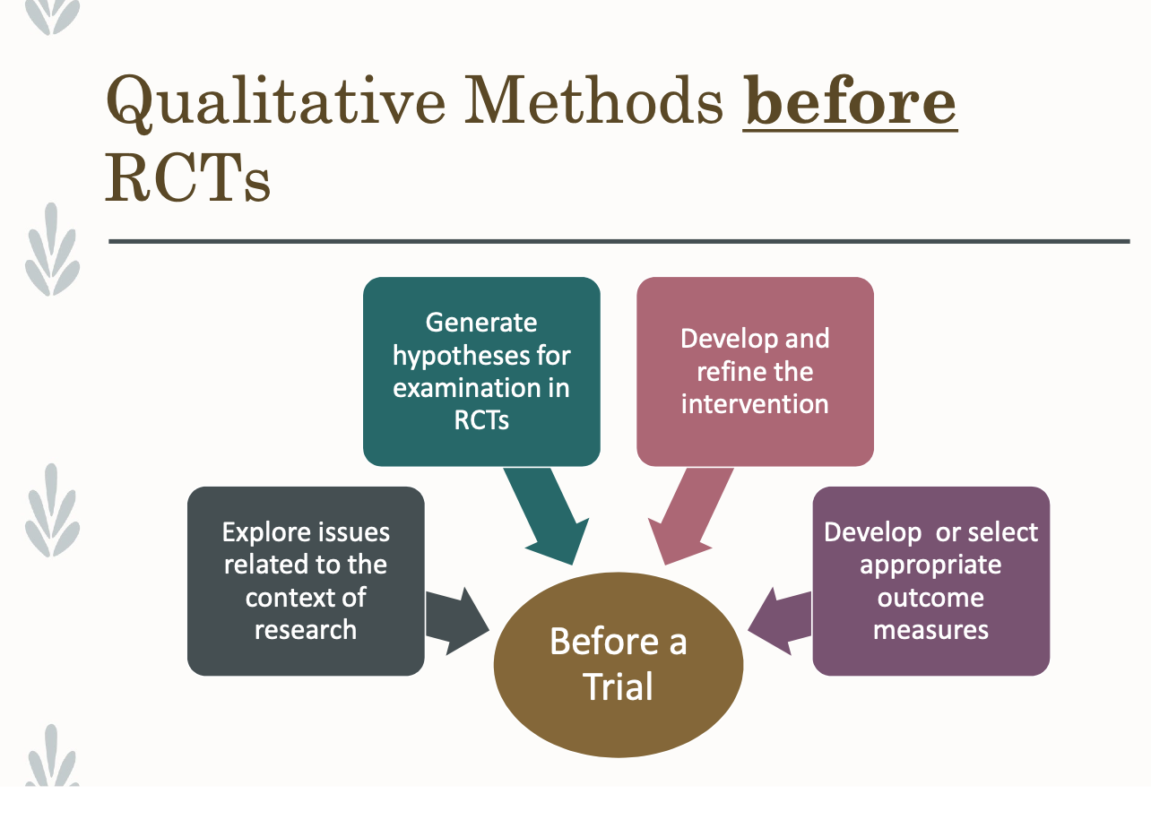
- Qualitative methods during RCTs
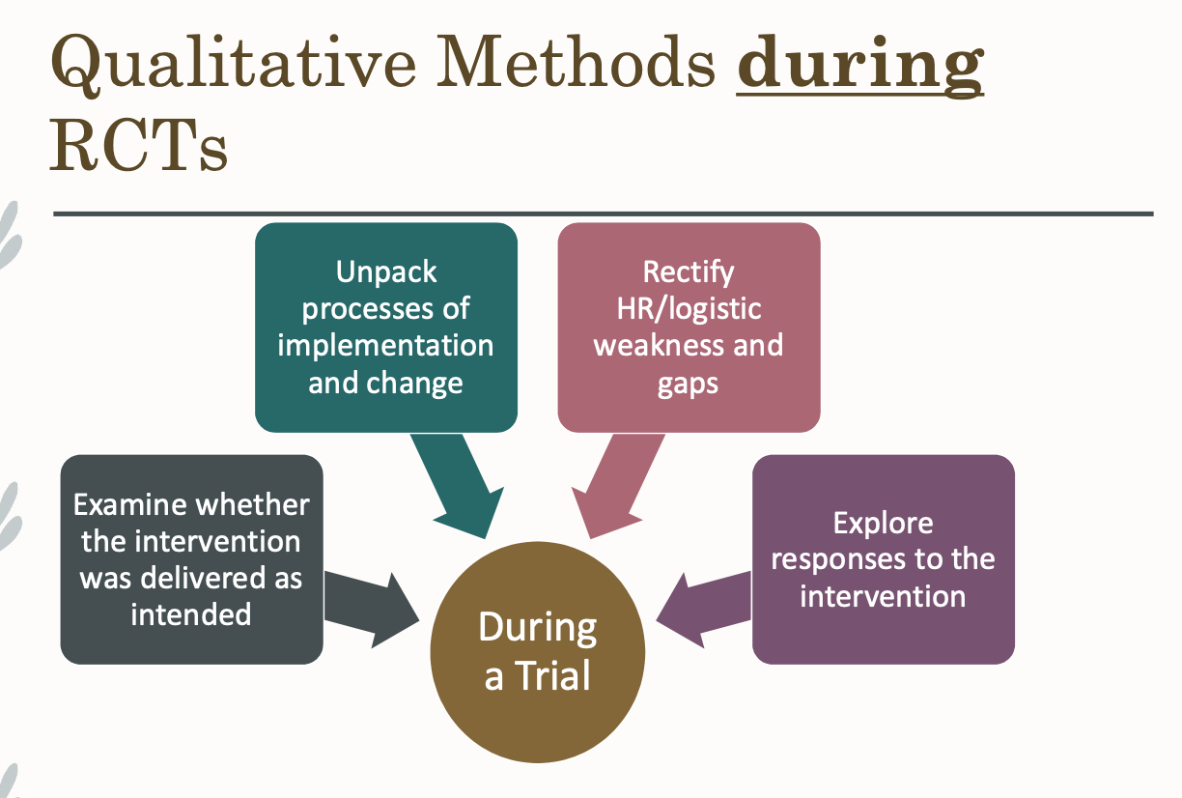
- Qualitative methods after RCTs
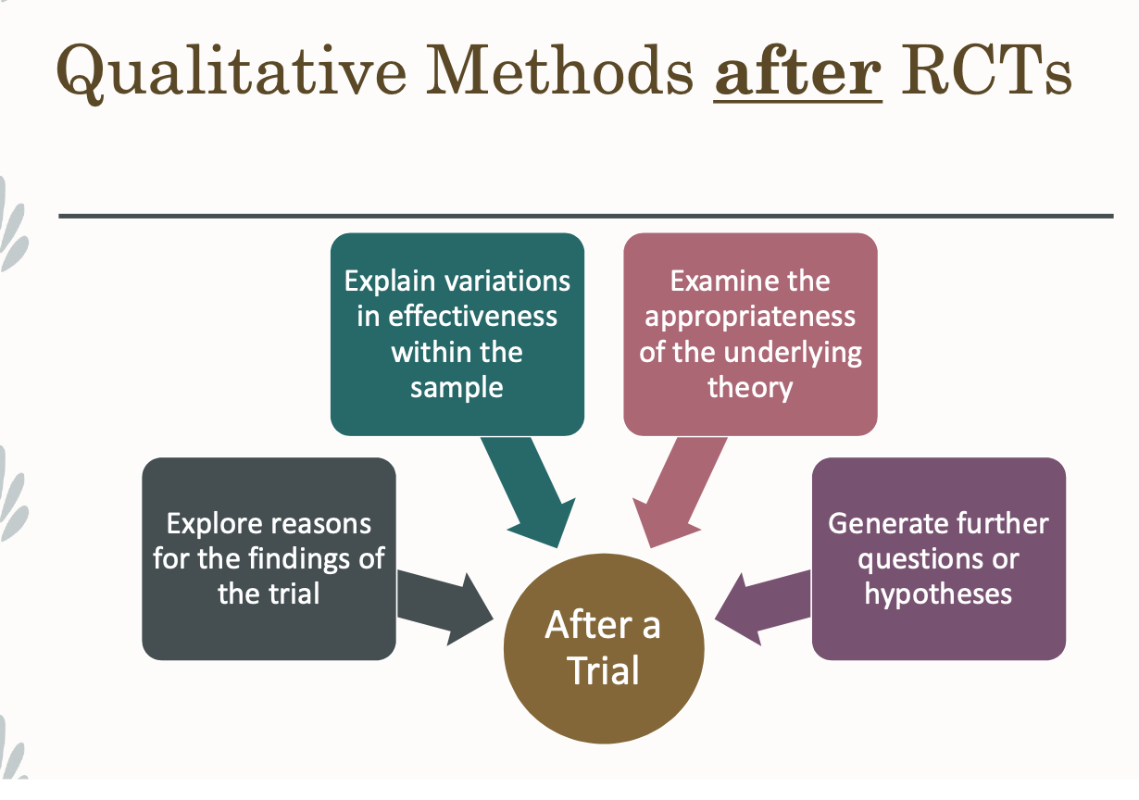

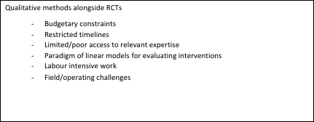

WEEK 12:
- Strategy for Patient-Oriented Research (SPOR): Canada’s strategy to ensure that the right patient receives the right intervention at the right time
  - Increases amount of research being conducted with and by research knowledge users
- SUPPORT UNITS (Support for people and patient research trials Units): are provincial elements of Canada’s national SPOR
  - BC Support Unit is 1 of 11 SPOR-funded support units across Canada
  - Fraser Health
- Fraser Centre goals:
  - Building capacity to conduct and implement high quality patient-oriented research
  - Increasing the quality and impact of patient-oriented research
  - Ensuring ongoing support for patient-oriented research
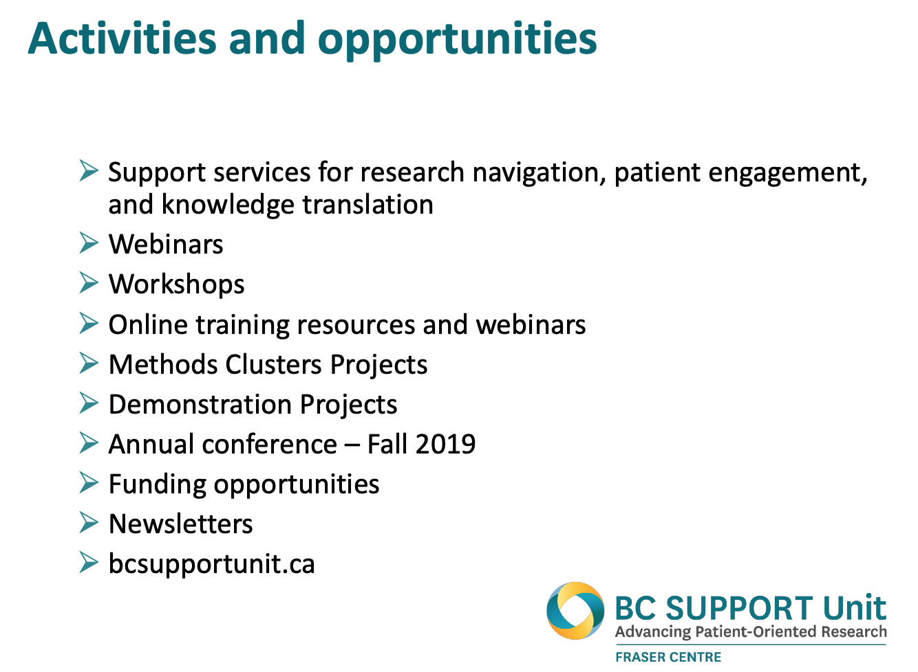
- Individuals with personal experience of health issue:
  - Patients
  - Caregivers
  - Family and friends

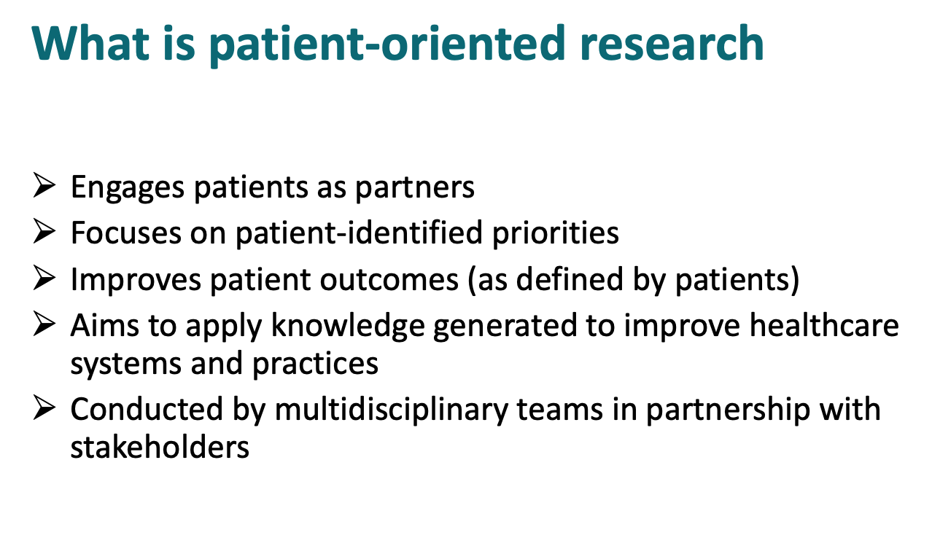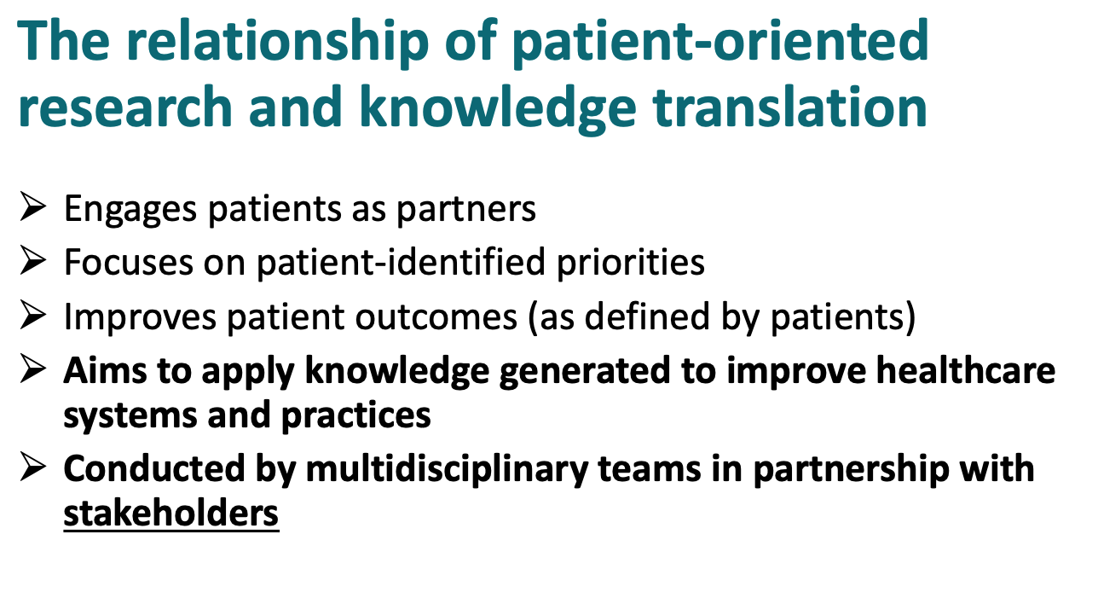
- What is knowledge translation?
  - Aims to improve health, health services, and products and the health care system through moving knowledge into action
    - Involves knowledge users
- Knowledge translation vs Implementation Science
  - Knowledge translation is applicable to all research
  - Implementation science studies only the implementation of evidence based practices/ policies
- Dissemination: spread of information about a finding

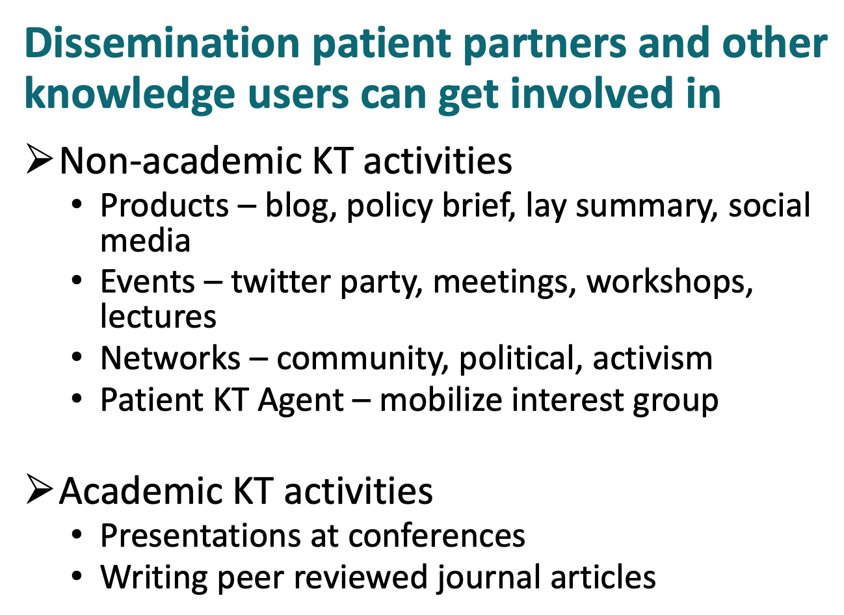
- Implementation: use of strategies to adopt and integrate evidence based interventions and change practice patterns within a setting



