GEOG 1020-B02 Assignment #2: Population Dynamics
March 9th 2019
Table 1: Demographic and Other Data for Selected Countries (2012)

Country | Total Population  (millions)* | Gross National Income PPPº per capita (US$)† | Crude Birth Rate  (/1000)* | Crude Death Rate  (/1000)* | Rate of Natural Increase  (%) | Doubling Time, years | Total Fertility Rate* | Total Area (km²) † | Population  Density  (people /  km2) | Percent urban *
Afghanistan | 33.4 | 860 | 43 | 16 | 2.7 | 26 | 6.3 | 652,230 | 51.2 | 22
Thailand | 69.9 | 7, 640 | 12 | 7 | 0.5 | 140 | 1.6 | 513,120 | 136.2 | 31
South Korea | 48.9 | 27,240 | 10 | 5 | 0.5 | 140 | 1.2 | 99,720 | 490.4 | 78
Canada | 34.9 | 37,280 | 11 | 7 | 0.4 | 175 | 1.7 | 9,984,670 | 3.5 | 80
Latvia | 2 | 16,800 | 9 | 14 | -0.5 | -140 | 1.1 | 62,249 | 32.1 | 50
Kenya | 43 | 1,570 | 35 | 8 | 2.7 | 26 | 4.7 | 580,367 | 74.1 | 18
Chile | 17.4 | 13,420 | 15 | 5 | 1.0 | 70 | 1.9 | 756,102 | 23.0 | 87
Singapore | 5.3 | 59,700 | 10 | 4 | 0.6 | 117 | 1.4 | 687 | 7714.7 | 73
Mexico | 116.1 | 14,700 | 20 | 5 | 1.5 | 47 | 2.3 | 1,943,945 | 59.7 | 15
º PPP: Purchasing Power Parity;
Sources: * World Population Data Sheet 2012, Population Reference Bureau, and † CIA World Factbook 2012

2
- The doubling rate for Canada is misleading due to the nature of Canada’s population growth. The growth rate has less to do with the natural increase in Canada in the modern age as it only accounts for one third of the population increase in the country as found by a study by statistics Canada. Therefore, the immigration accounts for a large percentage of the population increase which shortens the doubling rate considerably.

- Future population totals are also affected by the introduction of immigrants as well as the flow of citizens leaving for other countries. This statistic in particular will affect Canada due to the large number of immigrants that Canada introduces and fact that that only one third of new citizens are through natural increase in Canada.
3
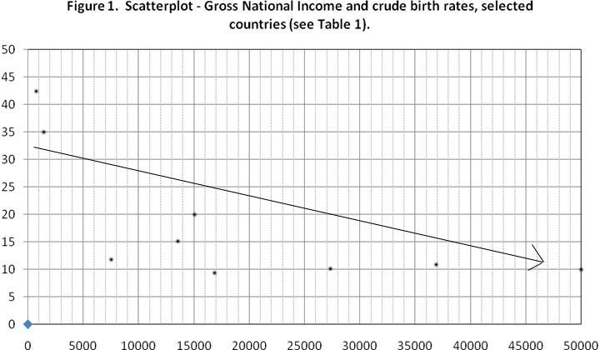

4
Figure one does show a strong correlation between the incomes and crude birth rates. Through inspecting the chart, one can see a clear negative correlation. This is due to how under developed countries have higher death and infant mortality rates compared to more developed countries. When a country has more income per person, or wealth in the country; the amounts of deaths in the country tend to lower significantly due to having more readily available health care/education. This creates a population model called “demographic transition” in which the mortality rates lower causing the birth rates to lower as well to stabilize the population. Countries (like Afghanistan) also have a lower percentage of urbanized area or gross national income due to them being agricultural or developing nations. Due to this, the citizens of these countries tend to benefit from having more offspring since it provides a good source of manual labor required to effectively run the agricultural or developing industries. As a result of these factors, the countries that have a lower GNI tend to have a strong link to having a high natural birth rate. On the opposite end of the spectrum, the countries that are more developed such as Canada tend to have higher GNIs due to the wealth involved with being more developed. They also tend to have a lower natural birth rate due the value of manual labor being significantly lowered. These developing nations also tend to have higher living costs per person and as a result, more children are more an economic hindrance rather than a gain.
5
There is not a very strong correlation between the population density and the gross national income. Looking at two similar countries in terms of population density; Afghanistan (51.2 people/km2) and Mexico (59.7 people/km2) one can see that their gross national incomes are vastly different with Afghanistan having a GNI of 860 and Mexico having 14700.
6
- Overpopulation is when the density of a population is too high as to cause environmental damage, lower quality of life or inability to maintain said population.

- From the data on the chart, the threat of overpopulation can be seen in South Korea, Thailand and Singapore due to their population densities. Another factor to the issue of overpopulation comes in the form of the % of urban land. The countries that have a high percentage of urbanized land can leverage their land more effectively through the use of high rises and apartment buildings. Countries that do not have the same urban space (namely Thailand, Afghanistan and Kenya) would require citizens to live more horizontally and have issues spacing individuals in small areas. As to the future countries that could be affected this issue, I would have to choose Afghanistan and Kenya due to their population’s doubling time only being a short 26 years as well as having low urban area percentages. With that doubling time, it would only take 26 years for their population densities to rival that of Thailand and with their low urban area percentages, they would have the same problematic citizen distribution as Thailand.

REFERENCES

Knox, Paul L., and Sallie A. Marston. Human Geography: Places and Regions in Global Context. Pearson, 2016.
Statistics Canada. “Population Growth: Migratory Increase Overtakes Natural Increase.” Women and Paid Work, Government of Canada, Statistics Canada, 17 May 2018, www150.statcan.gc.ca/n1/pub/11-630-x/11-630-x2014001-eng.htm.

