GMS – Ch.1 Management today
- working today – diversity issue relate to educational opportunity, access to tech, housing and jobs
- high performing company get results from employees, their knowledge and talents crucial to workplace
- intellectual capital; combined brainpower and shared knowledge of organization employees
- knowledge worker; add to intellectual capital of organization by insight and creativity tht is always developing, use and apply knowledge
- commitment x competency = intellectual capital
- competency personal capabilities
- commitment how you apply capabilities
- technology; tech IQ ability to use current technology in personal life while keeping updated to latest versions
ex. check inventory, make sales transaction, telecommunicating
- globalization; worldwide independence of resource flows, product markets, and business competition tht characterize economy, touches almost every dimension
ex. financing from dimension of natural environment are bing globalized or health issues such as pandemic tht move across continents or terrorism or technology like planes and internet
- controversial consequence is job migration; shift jobs from diff countries
- opposite is reshoring; shift jobs back home from overseas
- ethics; code of moral principles, standard set of conduct wht is good/right vs bad/wrong
- transparent allows stronger and successful organization individual behaviour and business practices
ex. Enron took electricity out the state to make profit, the leadership economists and traders being a source of the problem
- corporate governance; board of director hold top management responsible for organizational performance
- financial performance → ethical performance → sustainability
- sustainability is important in terms of social and environmental concepts for future generations so we are not stealing from the future gens
- diversity; composition of worker in workplace
- diversity bias set by prejudice; display of negative opinion of group of ppl
ex. prejudice against working mothers
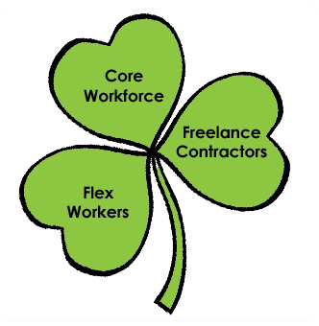
- becomes active discrimination; unfair treatment
ex. manager deny interview w/ visible minority
- glass ceiling effect; invisible barrier prevent minorities to jobs
- developing skills is difficult and can be divided into three type of workers, shamrock organization …
- core – fulltime follow standard career path
- freelance – specialized skill tht work contract based
- partime (flex worker) – simple work with no benefit
- have to get used to free agent economy; work on flexible contracts with shifting employees
- stress self management; ability asses yourself, manage personal development, make constructive changes
- important bc change is always happening and need to start learning on your own to be able to evolve and follow the world
- master a talent, network, entrepreneurship, technology, marketing, renewal
- organizations – collection of ppl working together achieve common purpose, provide goods etc …
- all are open systems; interact w/ outside environment by obtain resource and transform into output for customers use
- value created when resources used to produce new good and care for customer through …
- productivity; measure quantity/quality of output relative to cost of input
- performance measure; output measure of goal accomplishment help meet customer demand
- performance efficiency; input measure of resource associated w/ goal accomplishment
- managers; ppl in organization tht directly support, supervise, help activate work enthusiasm, socially responsible
- diff lvl of manager include …
- board of director (trustee) – elected by shareholder make sure organization run lawful and ethical manner
- top manager (C-suite) - manage team tht report to board, responsible for organization w/ purpose and mission
ex. CEO, CFO, CDO
* accountability
- middle manager - oversee large department coordinate action plans for organization strategies to accomplish key objectives
ex. clinic director, deans
- team leader – small work group of non-managerial workers
ex. audit team leader
- types of mangers include …
- line managers – direct work contribute to output
- staff manager – technical expertise advise front of line worker
- functional manager – responsible over single area (ex. finance, marketing, production, human resources, accounting, sales)
- general manager (administrator) – oversee everything like purchasing, manufacturing, finance etc ..
- managers hold accountability; responsibility to answer to higher authority for the results achieved
- they are considered effective when there is high quality of work life (QWL); fair pay, safe conditions, room to grow, respectful
- the upside down pyramid explains managers mobilize and deliver support to workers while serving customer needs
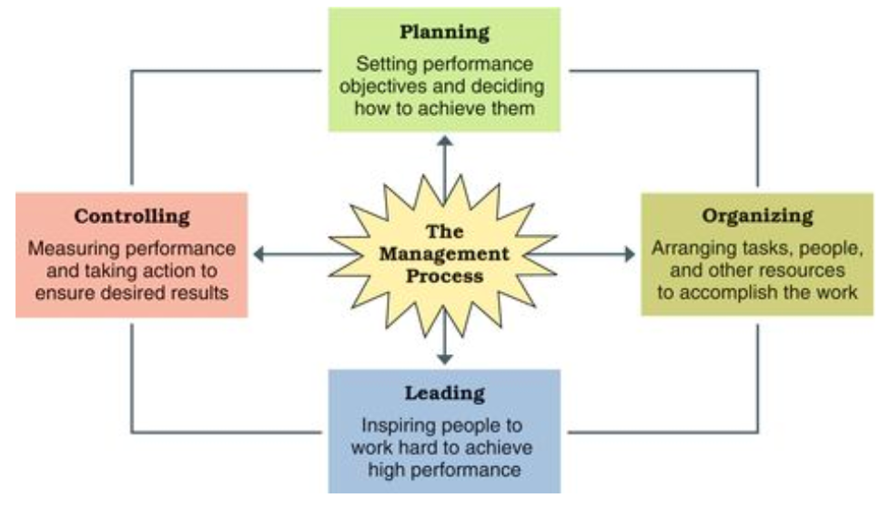
- management process; planning of manager to achieve high performance
- planning creating action plans and steps need to accomplish
- organize assign task, coordinate plans to employees
- leading inspiring ppl work efforts
- controlling measure work taking corrective action where needed
- Mintzbergs manager roles include …
- interpersonal where interact with ppl inside/outside work
- informational involve give, receive, analyze information
- decisional use info address problems or opportunities
- making sure team working together is KEY role of manager
- can accomplish through agenda setting; make action priorities w/ goals and plans for both long and short time frames made through networking and creating social capital
GMS Ch.7 – Information, Technology, and Management
- career and personal success need three must have competency …
- technological – ability understand new tech
- information – ability locate, gather, organize, display info
- analytical – ability evaluate info and make decision
- data; raw facts that when made useful is information
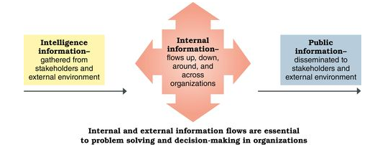
- Timely— available when needed
- High quality— accurate, and it is reliable
- Complete—complete, current
- Relevant— appropriate for the task at hand, free from irrelevant material.
- Understandable
- information systems (IS) provide internal information for organizational decision making, intelligence information to deal w/ customers, public information in the form of social media posts and advertisements
- data mining; analyse data produce useful info for decision maker, big data
ex. UPS spend over one billion per year on technology
- data isn’t always used well all depending on business or management analytics; systematic evaluation of data to make informed decisions
- business intelligence (BI); mining info system to extract data for decision making
ex. to keep Amazon at the top the team buys products from other retailers to see wht they can do better
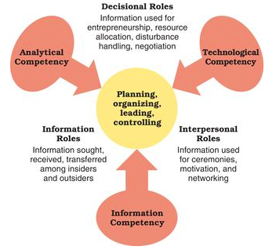
- problem solving; process identify discrepancy btwn actual and desired affair taking action to solve it
- performance threat; smtg is already wrong, situation moving in unfavourable direction
- performance opportunity; chance for better future performance
ex. Problem: Airline aisles are clogged during boarding with frustrated passengers. Airline executives know that minutes saved in boarding can mean money saved.
Analysis: A study by astrophysicist Jason Steffen shows that boarding alternating rows back to front and boarding window–middle–aisle for each row beats other methods.
Result: Airline executives may be as stuck in their thinking as their passengers are in the aisles. Most have no plans to change current boarding systems.
- three types of problem solvers …
- problem avoider; ignore useful info not want make decision
- problem solvers; willing make decision when forced into the situation
- problem seekers; constantly process info looking for problems to solve
- manager use systematic thinking; step by step approach, slow, make plan before execute wile other intuitive thinking; spontaneous on the spot thinking
- manager deal w/ portfolio of problem require mulit-dimensional thinking; ability view problem in relation to each other over long and short horizon
- ability map out priority, avoid side-track, strategic opportunism
- four types of cognitive styles; way ppl deal w/ information
- sensation thinker – hard facts, clear goals
- intuitive thinker – idealist, theoretical, avoid details
- sensation feeler – global issue, insightful human rltnship
- intuitive feeler – realistic approach, sensitive to feelings/values
- diff problems need diff kind of problems solving skill …
- structured; familiar, straightforward, delt through programmed decisions using solutions readily available and unstructured; new unusual situations needed nonprogrammed decisions solution are made at hand
- crisis decision; unexpected problem tht can quickly lead to disaster in which good IS help managers make good solutions
- Figure out what is going on—Take time to understand what's happening
- Remember that speed matters—Attack crisis as quickly as possible when its small
- Remember that slow counts, too—Know when to back off and wait for a better opportunity
- Respect the danger of the unfamiliar—Understand danger of all-new territory
- Value the sceptic—Don't look for and get too comfortable with agreement
- Be ready to “fight fire with fire”—When things going wrong and no one seems to care, you may have to start a crisis to get their attention
- three types of decision making environments …
- certain – best condition bc factual info available, simple decisions, uncommon
- risk – incomplete consequences, probabilities, most common
- uncertain– few facts, intuition based on informed guessing
ex. Hurricane Sandy
- decision making process; process begin w/ identify and end w/ evaluation
Step 1: identify problem – specific goals clarify solution
- mistakes such as can be defined too broadly or narrow, focusing on symptoms, indicating urgency of the problem
Step 2: generate and evaluate alternative solution – clarify wht is/needs to be known
- stakeholders, effects of action
- unintended consequences can be avoided by considering many alternatives which can be done by cost-benefit analysis
Step 3: choose preferred course of action
- classical decision model; decision making w/ complete info ∴ make optimized decision provide best solution, rational choice
- behavioural decision model; act w/ partial info ∴ make satisficing decision, bounded rationality
Step 4: implement decision
- can encounter lack of participation error; lack support needed in the process
Step 5: evaluate results – gather data measure performance and compare to desired goals
- simplifying when there is limited time, little info, and no energy can lead to errors …
- framing error – resolving problem based on perceived data
ex. 40% market share can be seen negatively
- availability bias – asses situation based on memory
ex. not invest in new product bc u remember it “failed”
- representativeness bias – basing on stereotyped occurrence
ex. hire someone bc went to same skl
- anchoring and adjustment bias – influence of inappropriate differences
- confirmation error – try to justify actions
- escalating commitment – trying to force a solution tht wont work, don’t want admit they are wrong
- key in problem solving is creativity bc Big-C creativity; extraordinary things done by big ppl and Little-C creativity; average ppl find unique ways to event

CH. 5 – Global Management and Cultural Diversity
- live in the age of global economy; resources, supplies, product market, business compete worldwide
- influenced by globalization; economic, political, social, cultural relations come create borderless world
- World 3.0; form of globalization where try to balance economic gains and local needs
- global management; manage business in more than one country
- success depend on global managers who are culturally aware and informed ppl abt international issues
- international business; conduct for profit transaction of good and service across national boundaries have many benefits …
- profit gains
- new customers
- suppliers - access to materials/product/service
- labour – access to lower cost talented workers
- capital – tap into larger financial resources
- risk - spreading assets amongst diff country
- economic development - global firm does business in foreign country to help local economy
ex. Starbucks, Green Mountain Coffee send advisor teach coffee grower how meet international standard to be able sell worldwide, firm get good quality coffee at good price and farmer get skills
- companies go global through market entry strategies; sale of goods or service to foreign market tht aren’t expensive
- global sourcing – process purchase, manufacture, locate parts and business around world for low cost
ex. china
- have to work hard maintain brand reputation while deal with hard auditing
- outsourcing cause higher labour rate and costs ∴ reshore; move back to home land for cheaper energy, stable wages, better quality control and public relations
- export/importing – sell local good in foreign market vs buy foreign made product and sell domestically
ex. Canada find new natural recourse to export
- licensing – foreign firm pay fee for right sell company product grant access to mechanics and trademarks
- risk loss control when contract die
ex. New Balance revoke license but china keep producing
- franchising – form licensing firm buy right to use name and operating method
- challenge is creating locally popular menu while retaining coherence with main branding goals
- Foreign Direct investment (FDI); investment in form of control ownership of business in one country by entity based in another country
- insourcing; assign job to someone in the organization
- commonly start with joint venture; co-ownership foreign and local partner agree to share risk, buy part or create whole new
- type of global strategic alliance; foreign and domestic firm work together for mutual benefit hope create more profit
- risks include unmatched goals, loss business secret, line btwn acceptable practice and infringement
- one way around is foreign subsidiaries; partially or whole owned company under larger corporation , highest lvl involvement and very profitable
- factors tht influence business are wht make up the global business environment (ex. USMCA) there also being many challenges they need to face
- difference legal and political system since international business expected abide by local laws
- incorporation practice and business ownership
- negotiation and implementation of contract w/ foreign parties
- foreign exchange, system deal with currency of other countries
- intellectual property rights, patents, trademarks, copyrights
- political risk; loss of value in investment bc instability of host country
- use political risk analysis to forecast probability of disruptive events
- trade agreements and trade barriers are another challenge
- when international business think they are being mistreated go to World Trade Organization (WTO); global organization made promote free trade and open markets
- give most favoured nation status; favourable treatment for import/export
- include tariffs; tax put on imports to promote local buying of goods and non-tariff barriers; discourage import in non tax method rather in forms of protectionism
- characteristics of globalization is growth regional economic alliance; free trade agreement btwn ten member states, for economic gains
- NAFTA; Canada, Mexico, US creating trilateral trade bloc for free trade
- EU; regional economic and political alliance of global importance, 28 member remove barriers
- APEC; promote free trade and investment in pacific region, 21 member with fastest growing economies (ex. Korea, Russia, Australia, Indonesia)
- SADC; economic and development effort, 15 member
- TPP; largest trade free zone no longer in use
- ASEAN; regional grouping promote economic, political, security coop. 10 member
- types of global business include …
- global corporation (MNE-Multinational Enterprise/MNC-Multinational Corporations) – extensive operation in more than one foreign country being recognized by tht foreign country
ex. Walmart, Nestle, RBC

- transportation corporation – business around world not identified with one national home, view world as domain for brand
ex. Apple, Coke
- pros include …
- mutual benefits for host country and global corporation
- shared growth, income, learning, development opportunity
- larger tax base, increase employment, tech transfer, new industries
- cons include …
- extraction of excessive profits, dominate local economy, interfere local government, fail to respect customs, fail transfer tech to host country
- home country government tend identify with local and national interest giving priority to domestic social responsibilities
- concerned abt tax inversion; domestic based MNC buy firm in low tax country to shield foreign earnings
- ethical issues for global business …
- corruption; illegal practice tht further one personal business
- corruption of foreign public officials acts; make it illegal for Canadian firm and their representative to engage in corrupt practise, believe to put Canadian company at disadvantage bc cant offer deals
- bribe to foreign official
- excessive commotion
- non monetary gift
- child labour and sweat shops
- conflict minerals; sale of scarce minerals
- culture; set shared belief, value, patterns of common group of ppl
- culture shock; confusion due to unfamiliar culture experienced in diff stages …
Stage 1: confusion – anxious and uncomfortable with first contacts of the culture
Stage 2: small victories – interaction bring up confidence
Stage 3: honeymoon – cultural immersion and infatuation with local ways
Stage 4: irritation and anger – overwhelmed that culture becomes target of criticism
Stage 5: reality – rebalance, accommodate less desirable aspects
- need to have cultural intelligence; ability to adapt to new cultures
- avoid ethnocentrism; consider one culture superior to others
- dimensions of culture include …
- context
- low - whts is said is said and written (ex. Canada)
- high - rely on nonverbal and situation cues as well as spoken and written words (ex. Thailand)
- space
- proxemics - how ppl use space to communicate (ex. personal space)
- time
- monochromic - one thing at a time (ex. Canadian wedding)
- polychromic - many diff things at once (ex. Egypt)
- the strength of norms and tolerance for deviations depend on the culture
- tight culture; social norms are clear, expected to fit in and self govern
ex. Korea, Japan
- loose culture; less concerned with conformity, acceptable to be more loose
ex. Australia, Brazil
- values and national cultures ways of considering how cultural differences can influence management and organizational practices
- power distance; degree society accept or reject unequal distribution of power among ppl in organizations
- individualism-collectivism; degree society emphasize individual accomplishment, not group efforts
- uncertainty avoidance; degree society comfortable with risk and change, low display openness to change vs high display more structure and order
- masculinity-femininity; degree society value assertiveness and materials feeling, relationship and quality of life
- time orientation; degree society emphasize short term or long term goals

Ch. 2 – Management Learning Past and Present
- classical approaches to management include …
- scientific (Fredrick Taylor)
- improve worker productivity by training and supporting them in best way possible through supervisors
- make science w/ rules of motion (jobs with efficient methods), standardized work implement, working conditions
- make results based on compensation
- carefully select workers with abilities to do jobs
- train with incentives
- plan out workers path
- motion study; reduce job task to basic physical aspects
ex. Taco Bell worker action designed in assembly line to have efficient fast service, rewards given to employees
- administrative (Henri Fayoi)
- five rules of management …
      - foresight – plan of action
      - organization – resources
      - command – lead, select, evaluate worker
      - coordination – work as group
      - control – carried out according to plan
- scalar chain principle; clear unbroken line of communication from top to bottom
- unity of command principle; everyone get order from one boss
- unity of direction principle; group with same performance objective had one person in charge
- bureaucratic (Max Weber)
- clear division of labour – well defined job w/ highly skilled worker to preform
- clear hierarchy of authority
- formal rules and procedures
- impersonality – all rules applied uniformly
- careers based on merit – worker selected and promoted on ability, competency and performance
- management approaches became behavioural based on the fact tht ppl like social rltnships, respond to group pressures, search for personal fulfillment

- organizations as communities (Follet)
- respect workers and avoid too much hierarchy so tht manager and worker work together combining talents, sharing feelings
- employee ownership, profit sharing, gain-sharing plans all make employee an owner of business work
- vis-a-vis
- Hawthorn Studies
- psychological factors tht affect workers output found through study
- result new social setting motivated worker as interactions and feeling of importance made them feel good
- flawed yet concluded rltnship w/ co-worker important
- Hawthorne effect; change in behaviour bc awareness of being observed
- Maslow’s Theory of Human Needs
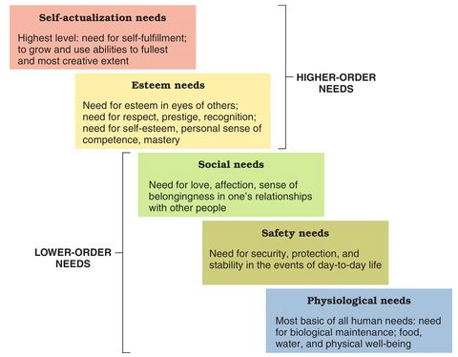
- need; psychological deficiency person feels compelled to satisfy creating tension influence worker behaviour
- based on deficit principle; need tht doesn't motivate behaviour and progression principle; need tht become active when lower need is satisfied (ex. I am thirsty and lonely but I won’t be motivated to talk to ppl unless I had smtg to drink)
- manager who understand worker needs will get most out of employees
- Theory X and Theory Y (McGregor)
- theory X; employee don't like work, no ambition, prefer to be led
- theory Y; employee work hard, self control, creative
- self fulfilling prophecies so tht when manager behave just like they are assumed to be employees will act to confirm such expectations
- Argyis’s Theory of Adult Personality
- manager treat employee as adult will get best results
- more modern management approaches include the use of …
- quantitate analysis and tools; systematic mathematical techniques used to solve problems
ex. big box retailer try to decrease profit margin while avoid being out of stock ∴ use inventory analysis to find how much inventory there should be
- analytics; big data of organization tht solve problems and make informed decisions
ex. Foood Company have flat sales and lots inventory so after implement analytics program situation was improved
- system view of organization; interrelated part with subsystems that work together to achieve common goal
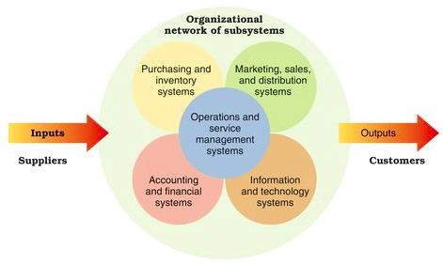
- open systems; interaction with environment tht support larger system to make things happen
- contingency thinking; management behaviour depend on the circumstance
ex. tight bureaucracy best when environment stable and operation predictable
- commitment to quality management
- (TQM) Total Quality management; system based on workers committed to maintain high standard of work in all operations
- emphasize continuous improvement; look for new way improve current practice, nevr be satisfied
- ISO certification; stamp of approval for quality management
- evidence based management; decision based on hard facts rather than “dangerous half truths”
- ask questions, create multiple hypothesis, research design to test hypothesis, gather data, and analyze hypothesis based on evidence

Ch. 8 – Planning Processes and Techniques
- the management process is divided into different categories …
- Planning – provide sense of direction, set objectives for other steps and how to accomplish them
- organizing – arrange resources for finishing
task
- leading – guide and inspire other achieve high lvl of accomplishment
- controlling – monitor task and correct
- planning is key factor …
step 1: define objectives – identify desired results specifically
step 2: determine where you stand vis-à-vis objectives – review current accomplishments
ex. strengths and weaknesses
step 3: develop premises regarding future conditions – anticipate future events
ex. scenarios
step 4: analyze alternatives and make a plan – list possible outcomes and choose best alternative
step 5: implement the plans and evaluate results – take action and measure progress and revise anywhere needed
- focus on objectives and goals tht used to achieve most accomplishment, stretch goals; performance target tht you have to work extra hard to reach
- create realistic plan; steps taken to accomplish objectives and goals
- ongoing process
- benefit to planning include …
- flexibility and focus increased, willing and able to change to fit new opportunity
ex. understand customer, how to go about a situation

- keep goal visible avoid complacency trap; carried away by events
- result (sense of direction), priority, advantage (resource used to best ability), change (anticipate problem) oriented
- coordination improvement, link btwn planning and control so tht actions don't lack objectives
ex. McDonalds system update couldn't keep up with promises ∴ focus on more customer oriented plans
- types of plans used by managers range depending on challenges faced …
- long term plans; 3+ years, senior management, act as mission effecting how the short term plans will be carried out
- short term plans; less than 1 year, middle and organizational management, move faster and make timely decisions
- strategic plans; focus on whole organization, long term plans setting broad direction for vision/purpose of the future
- tactical plans; implement strategic plans how resources can be used and put to action take form of functional plans; indicate how different component of enterprise contribute to overall strategy
- production – work method and tech
- financial – money and capital investment
- facilities – physical space and work layout
- logistics – suppliers and resource inputs
- marketing – selling and distribute good/service
- human resources – build talented workforce
- operational plans; guide behaviour, describe wht need to be done in short term strategic and tactical plans
- include standing (policies; guideline make decisions) and (procedures; rules wht actions taken in diff situations, ex. SOP)
- single use (budgets; commit resources for specific time period for acidities, projects, programs, ex. zero based budget)
- planning with strong foundations are useful including …
- forecasting; predict future based on qualitative expert opinions or quantitative mathematical models, treat as aids bc can be wrong info
- contingency planning; identify alternative actions for change of situation with trigger points to activate the alternatives, better than not having anything prepped
- scenario planning; identify several possible future scenarios, long term
ex. Shell use to plan for climate change, sustainable development, human rights etc …
- benchmarking; use of external and internal comparisons for better evaluation to determine wht other groups are doing well
- best practices; things ppl and organization do help achieve superior performance
- staff planning; expert in all planning process steps
- how goals are set have big impact on functions and motivation to accomplish set goals …
- SMART goals
- specific, measurable (most difficult), attainable, relevant, timely
- when goals set unrealistically high put plan at risk ∴ set learning goals; create knowledge and skills required for performance and outcome goals; set target for actual performance results
- last step of planning is goal alignment where hierarchy of goal/objectives; organize task based on importance
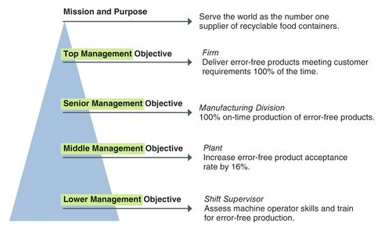
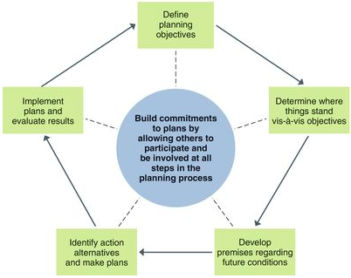
- planning is a process where the more ppl involved the more motivated you are to accomplish them, participatory planning; including those who will affected by the plans

Ch. 6 – Entrepreneurship and New Ventures
- entrepreneurship; strategic thinking and behaviour result new opportunity
- classic entrepreneur; risk taker action pursue opportunity others cant see vs serial entrepreneur; move from one venture to the next (ex. own Football league team and open software company at same time)
- successful entrepreneur have first mover advantage; quickly exploit and deliver product to new/unrecognized niche in exist market
ex. Brad Templeton – electronic publishing, ClairNet Communications Corp. wrote abt political computing and network issues
Vinay Chopra – mobile app solution, create difficult to copy product that make him middle man btwn android apps and developers
Anita Roddick – natural base and health care products niche, The Body Shop known for human rights, environment, economic development
Shannon Rogers – president of Global Relay growing company in cloudbase msg, archive, and compliance service
- characteristic of entrepreneurs include …
- talent is gained, risk taker, start w/ little, no “right” age, don't need a degree
- self confident/directing, determined, resilient, adaptable, driven by excellence/need to achievement, passion and action oriented by getting ahead of problems
- family and childhood uniqueness where raised in responsible, initiative, impendent environment
- necessity based entrepreneurs; stat new venture bc no other career options, usually women and minorities
ex. Anita Roddick, The Body Shop needed to create a living for her family
- play role in society by help address social issues, social entrepreneurship; ethical entrepreneurship seek way solve social problem
ex. tech for poor family, literacy for young, housing
- make social enterprise; mission make life better for under deserved population, make change to world in ways the government doesn't
ex. George Cape – Evergreen Brickworks, from abandoned brickyard to urban eco friendly market
Mike Labbe – build home for low income families
- small business/start up; independent owned business, temporary organization try discover profitable, scalable business model, hoping it will take shape and be successful
- 5 to 100 employee usually wholesale, retail, food service
- start buy purchase existing or run franchise; owner sell right to operate name under smaller business in another location
- need business model; plan to make profit
- minimum viable product to attract customer which will later develop more advanced
ex. Facebook
- lean start up; max advantage of resources (opens oftware and free web) while stay small and simple operations
- start ups fail bc ..
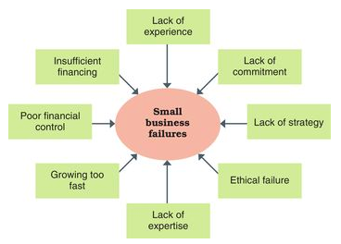
- inexperience, bad partners, copycat, economy, not publish product
- no value proposition (inflated sense of product worth)
- no x10 (need to be 10 times better), rely on investor
- premature scaling (expansion isn’t always good)
- ARUP and COGS ( average revenge per user and cost of good sold, high price with little purchases)
- when develop small business join a business incubator/accelerator; facility offer pace, admin service, equipment, management advice, for healthy survival and expand their opportunities
ex. Startup Canada
- Business Development Program (BDP); how set up manage operations, expand, modernize
- family business; owned by family members, 85% private firms make $150 billion annually
ex. James Richardson & Sons ltd. grain handling and trading company balance commerce and family dynamics
- family business feud; disagreement abt work responsibility, business strategy, operating approaches, finances etc … cause difficulty survive
- succession plan; formal statement describe leadership transition, fianancial matter during changeover
- stages of entrepreneurial firms …
Stage 1: Birth – struggle w/ new venture
- control and management problems
Stage 2: Breakthrough – start pursue business model
Stage 3: Maturity – market success and stability
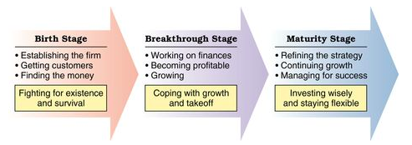

- when making business plan; detail for operating new start up, think through issues, give all info needed
- clear model, identify strength/weakness, market potential for service, competitor analysis, mission and key direction, money, credibility
- sample business plan outline ….
- exec summary - purpose
industry analysis – nature of industry
description of company – mission, owner
product and service description – major service/good
marketing strategy – product characteristics
operation description – manufacturing service method
staffing description - staffing
financial projection - break even point, cash flow
capital needs – funds needed
milestones – key stags of new venture
- diff forms of ownership …
- sole proprietorship – individual, most common, personal liable all debits and claims
- partnership – two or more ppl, share profit and loss,
- general; share management responsibility
- limited; losses limited to amnt of investment, don't involve n day to day business
- corporation – chartered by provincial/federal govern exist separate from owner, profit
- grant certain legal right and responsible for own liabilities
- costly and hard to control
- benefit corporation – benefit society
- “B Corps” state goals and fill out benefit report so can be properly assessed
ex. Ben and Jerry
- limited liability corporation (LLC) – combination of all
- gaining finances for ventures can be done two ways …
- debt financing; borrow money from others, paid overtime w/ interest, collateral against business assets
- equity financing; give ownership share to investor w/ some control
- usually from venture capitalist; make investment in new venture in return for equity stake in business in hope gain popularity
- of $1 mill or more
- management role
- initial public offering; shares in business become public first and if successful og investment rise in value
- angel investor; wealthy investor in return for equity
- crowd funding; go online to get group of ppl
- donation model
- reward model
- pre-purchase model
- peer to peer lending (unsecured loans)
- equity security model (exchange for securities)

Ch. 10 – Strategy and Strategic Management
- competitive advantage; use resources to preform better than competition
- technology, cost and quality, knowledge and speed, barriers to entry, financial resources
- sustainable competitive advantage; advantage tht difficult for others to copy
ex. Apple
- need strategy; action plan identify long term direction, risk taking
ex. Facebook went from computer to mobile app based
- corporate lvl strategy; highest lvl, direct whole organization
“wht industry and market should we compete in?”
- business lvl strategy; single business or product line, facility locations, new technology etc …
“how are we going to compete for customers?”
- functional strategy; organizational resources to implement business strategy, customer service, improve products etc …
“how can we use resources towards our business strategy?”
- in order to have good strategy need a process to follow through with strategic management; process make strategies to accomplish long term goals …
Step 1: strategy analysis – asses organization, surroundings
Step 2: strategy formulation – develop
Step 3: strategy implementation – use resources and evaluate result for improvement
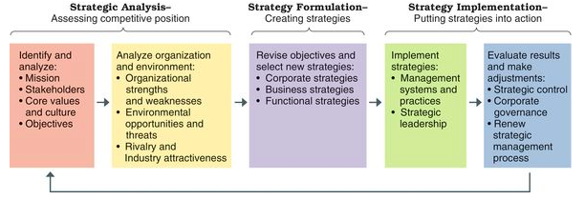

- to e
- ensure organization doesn't waste anything apply strategic intent; all energy direct towards accomplishing the strategic goal formed
- essentials to strategic analysis …
- wht is our business mission?
- mission; reason for existence help inspire stakeholder and those directly affected by organization and its movements
- how values align with mission is key, need core values; belief abt wht is or isn’t appropriate
- gives organization culture; an identity, as sense of character, help guide behaviour of member
- need operating objectives; direct activity toward key performance area
- profit, sustainability, social respons, finances, cost efficiency, customer service, product quality, market share, human capacity, innovation
- who are our customers? wht do our customers value? wht have been our results? wht is our plan?
- to answer these question use SWOT analysis; look at organization strength, weakness, environmental opportunities and threats
- major goal identify core competencies; things they do really well
- can relate to personal discoveries such as …
- build on and use strengths to create core competencies
- avoid rely on weakness tht cant turn into strength
- move toward opportunity to capture advantage
- avoid threat or action tht minimize impact
- Michael porter five forces …
- industry competition – way act with each other
- new entrants – threat of new competitor based on presence or absence of barriers
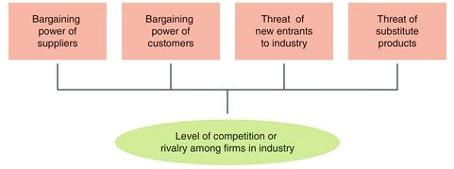
- substitute product or service – threat of customer able to get product from other customer
- bargain power suppliers – resource supplier influence on price organization have to pay fro their product
- bargain power of customers – customer influence on price they will pay for firm product
- unattractive industry have intense rivalry, threats of new entrants, bargain power over price over quality
- attractive industry have less competition, fewer threat, new entrant, low supplier buyer bargain power

- (Corporate lvl strategy) CEO and top management responsible for strategic direction of organization and to help with process use BCG Matrix; focus on market growth rate for industry and market share held by firm
- divided into four strategic types …
- Grow the stars (stars); business with high market share in high growth market, make lots profit through penetration of expanding market
ex. Apple
- Milk the cash cows (cash cows); business with high market share in low growth market, good profit but little upside potential ∴ all about stability
- Grow or retrench the question marks (question marks); business low market shares in high growth market, don't make much profit but have potential to grow
- Retrench the dogs (dogs); business low market share in low growth market
- growth strategies; seek expand size and scope operations, acquisition, merger, global expansion
- can get caught in expansion trap where growth is too much for organization to handle
- concentration; expand within same business area
ex. McDonald add more location but still concentrate on primary business
- diversification; expand into diff business area
ex. Starbucks bought Tazo Tea
- related diversification pursue growth from new business with similar area
- unrelated diversification diff areas of business
- vertical interrogation; business move upstream further from customer
- backward vertical interrogation; move downstream closer to customer to acquire distributors
- experience problem w/ economy, rapid growth, and too much diversification force shift towards retrenchment, restructuring, and turnaround strategies
- retrenchment:
- Bankruptcy and Insolvency Act; Canadian firm protection while recognize restore solvency
- liquidation; assets sold off to creditors
- reconstruction :
- downsize; decrease operation size usually by reduce workforce
- divestiture; sell parts of organization to focus on core competencies, cutting costs, and improve operating efficiency
- turnaround strategy; fix specific performance problems, change in top management
- embrace global economy is most difficult, firms use globalization strategy; view world as one integrated market, make most decisions from corporate headquarters to standardize products and advertising used around the world
- alternatives include multidomestic strategy; customize product to region
ex. McDonalds have McLobster in Atlantic Canada
- transitional strategy; operate without national identity
ex. Ford
- cooperative strategies include strategic alliance; partnership to pursue in same area of interest
- outsourcing; alliance; purchase service from the other organization
- supplier alliance; flow of supplies btwn partners
- distribution alliance; join together sell and distribute products or service
- co-competition; alliance btwn competitor
ex. airline share codes for frequent fliers
- (Business lvl strategy) use Porters model for choosing competitive strategy based on product and service
- differentiation; make product unique
ex. Polo or Ralph Lauren
- cost leadership; make at lower cost, improve operating efficiencies
ex. Walmart Strategy
- focused differentiation; use differentiation, unique product to special niche market
ex. NetJet offer luxury air travel
- focused cost leadership; use cost leadership, special prices to particular market
ex. Easy Jet “no-frills” flying at lower cost
- strategic implementation needs goo management to motivate employees, failure of substance and process commonly show up in the form of lack of participation error; lack commitment
- need strategic control; ensure strategies are implanted well to meet demand of changing condition
- if fail at top management take over corporate governance; system control exercise by board of director
- strategic leadership; capability inspire ppl successfully engage in process of continuous change, performance enhancement, implementation or organization strategies
- guardian of trade offs, ensure resources consistent with strategy
- sense of urgency, good pace of work
- ensure everyone understand strategy
- be a teacher, communicator

Ch. 14 – Leading and Leadership Development
- leadership; process inspire other work hard to accomplish tasks, influence behaviour of others
- need power; ability get others do smtg u want done the way you want
- position power + personal power = managerial power
- position power
- reward power; influence through rewards, offer smtg of value such as bonus, promotion
- coercive power; influence through punishment, unlikely to continue once threat gone
- legitimate power; authority
- personal power
- expertise; influence through skills and reputation, “you should do what I want bc wht I have accomplished”
- human capital; getting things done based on wht we know to do
- information and networking; influence through info and contact with others, “I have contacts so I can get things done”
- social capital; ability get things done based on who you know
- referent; admiration and desire for positive indentification with you
- have vision and have visionary leadership; understanding of action need to successfully go through with vision
- personal integrity is key, especially servant leadership; serving others and help them use their talent to benefit society
- other-centered, empowerment to get other exercise power and achieve organizational influence
- followership; join with leader to accomplish task, co-produced
- “what personal traits and characteristics are associated with leadership success?
- great person theory states drive, self confidence, creativity, cognitive ability, motivation, job relevant knowledge, motivation, flexibility
- “How is leadership success affected the ways leaders behave when engaging with followers?”
- concerned for task at hand – plan for work to be done
- concerned for people – support, good social relations
- high-high focussed on accomplishments while empowering workers
- “How do diff leadership styles combine concerns for task and concerns for people?”
- autocratic style; task over ppl, authority, command-control fashion
- human relations style; ppl over task
- lassiez-fire style; lets other do the task, you do the best you can attitude
- democratic style; high-high committed to both ppl and task
- Fidler contingency model says leadership tight with personality ∴ put specific styles in works areas tht it best fits
- use least preferred co-worker scale; assess according to amnt of control offered to leader
- either task motivated (high control situation) ex. lead of team market researchers or rltnship motivated leader (moderate control) ex. faculty chairperson asked to improve student-faculty rltns
- leader member relation, task structure, position power
- Hersey Blanchard Situational Leadership Model; successful leader adjust leadership styles based on readiness; how able and willing followers perform required task
- delegating; group take responsibility, low task low rltnship (high readiness)
- selling; task directions in supportive/persuasive way, high task high rlsnthip (moderate to high readiness)
- participating; emphasize shared ideas, low task high rltnship (low to moderate readiness)
- telling; give specific task, high task low rltnhsip (extreme low readiness)
- House’s Path-Goals leadership theory; how can leader use alternative style to add value in diff type situations? right fit btwn leadership style and situation
- directive; let them know wht is expected, give direction
ex. when direction are unclear
- supportive; make work pleasant, treat as equals etc
ex. when self-confidence is low
- achievement oriented; set challenged goals, expect the best of the best
ex. when task challenge insufficient in job raise aspirations
- participative leadership; involve team in decision making
ex. poor incentives, needs individual clarification
- substitutes for leadership; factors at work tht direct work without involvement of leader
- leader-member exchange theory; how do group dynamics influence leader follower rltnships? ppl fall into “in group” and “out group” treated diff by leaders
- leader-participation model; how should leader make decision in diff type of problem situations?
- authority decision; made by leader and communicated to team
- consultative decision; made by leader after gather info from team
- team decision; made by tem member with leader participation
- decision quality based on who has the info
- decision acceptance based on decision eventual implementation
- decision time based on availability to make the decision
- personal leadership development is a goal likely to be reached if you the concepts and models
- charismatic leaders; ability to inspire, have strong vision
ex. Martin Luther King
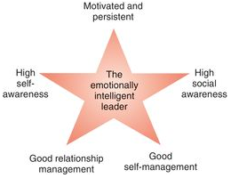
- transformational leadership; inspirational and arouse efforts in other performance
- emotional intelligence; ability understand emotion in self and other to handle rltnship, senior management
- gender similarity hypothesis; males and female similar psychologically
- both equal effective as leader
- perceived as having different styles creating leadership double bind; women get criticized for show stereotype male and female leadership characteristics
- interactive leadership; woman said to have democratic, participative, connecting style
- moral leadership; ethical standard tht meet test of being “good”, begin with integrity (honesty)
- risk of moral overconfidence; overly positive view of strength of character
- authentic leadership; high lvl self awareness and clear understanding of personal values
- Drucker “Good Old-Fashioned” Leadership
- define and communicate a clear vision
- accept leadership as a responsibility, not a rank
- surround yourself with talented people
- don't blame others when things go wrong
- keep your integrity; earn the trust of others
- don't be clever, be consistent

Ch. 11 – Organization Structures and Design
- organizing; process arrange, connect, integrate ppl to accomplish goal
- organization structure; how parts of firm arranged, connect work of ppl within firm
- organization chart; diagram report rltnship and arrangement of work position within organization
- identify job titles, communication lines, formal structure (how supposed to be run), supervisory rltnship, major subunits
- informal structure (shadow organization made up of social networks)
- social networking analysis/sociometrics identify patterns and rltnship through survey and data mining
- use info to update organization chart
- essential bc make connection with other ppl,, source of emotional support
- have potential to carry rumour, inaccurate info, divert from work
- functional structures; put ppl similar work skills together
- advantages include efficient use of resources, consistent tasks, high quality problem solving, in-depth training and skill development, clear career path
- disadvantage include functional chimney; department lack communication with others, neglect “big picture”
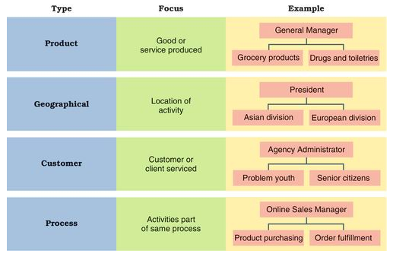
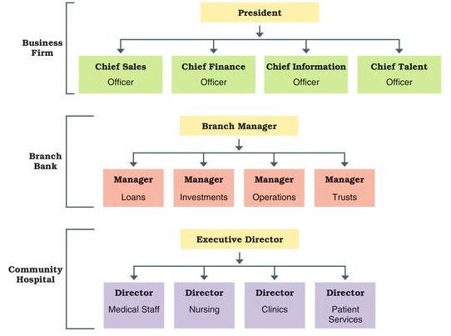
- divisional structure; put together ppl work on same product, process or are located in dame area, common in complex firms
ex. Toyota bring together engineering, manufacturing and sales under leadership rather than have each own top executive
- advantages include …
- flexibility to environmental changes
- better coordination across department
- clear point of responsibility
- expertise focused on specific customer, product, region
- greater ease in size change
- disadvantages include …
- reduce economy scale
- increase costs
- unhealthy rivalries to compete for top management attention
- product structure; group ppl with jobs focused on singe product or service, link cost, profit, problems, and success in market
- geographical structure; group jobs preformed in same location, focus on unique culture
- customer structure; group job serving same customers, common in consumer product industry, diverse need for diff customer groups
- process structure; group job part of same process meaning tasks tht collectively create smtg of value for customers (work process)
- matrix structure; functional and divisional structure combined, create team in matrix tht cut across diff functions
- advantages include …
- better communication
- improved decision making
- increase flexibility
- better customer service
- better performance
- improve strategic management
- disadvantages include …
- expensive
- power struggles
- groupitsis, loyalty cause loss of focus on larger organization goals
- horizontal organizational structure include team structure; use of permanent and temporary cross-functional teams improve lateral relations
- usually cross functional teams; group of ppl from diff area of work with intention of break down functional silos, make horizontal connections and faster decision making
- also use project teams; group made for specific project
- advantages include …
- break interpersonal barriers, mobilize talents
- shared knowledge increase problem solving and decision making
- sense of involvement
- disadvantages include …
- conflict loyalty
- time management
- network structure; have central core full time employee surrounded by network who give essential service
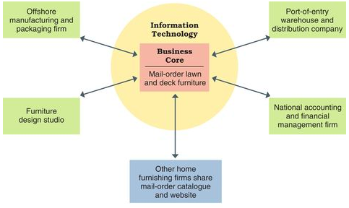
- strategic alliances; cooperative agreement with partner firm to get minimal staff
- outsourcing strategic alliance – purchase service from another organization
- supplier strategic alliance – link for smooth supplies
ex. unis reduce campus housing by enter public private partnership tht turn dorm over to private firms
- advantages include …
- lean and streamlined
- reduce cost
- create jobs
- disadvantages include …
- complicated to control, one part break down whole system at risk
- experience lack of loyalty
- aggressive and dangerous outsourcing such as finance, logistic and human resources
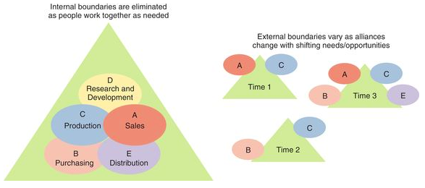
- boundaryless organization; combined team and network structure, eliminate internal boundaries among subsystems and external boundaries with external environment
- no lines of authority, continuously share info, form and disband teams as needed
- virtual organization; shifting network of alliance create when needed using mobile IT solutions
ex. Twitter and LinkedIn
- organizational design; process choosing structure accomplish mission for tht organization
- bureaucracy; organization based on logic, order, legit use of authority, vertical structure, clear cut
- should be fair but usually associate with “red tape”, cumbersome and impersonal to customers
- mechanistic designs; centralized authority with lots rules and procedures
- best for routine tasked organization, to the point where appearance is regulated
ex. local fast food
- adaptability require more organic design; decentralised authority, less rules, less clear cut
- create adaptive organization; loose system where work get done through informal structure, built on trust foundations, freedom of ideas
- trends include fewer lvls of management
- typical chart show chain of command; line of authority link position to successively higher lvl
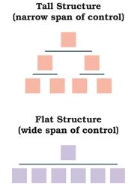
- lvls get influenced by span of control; number of ppl reporting to manager
- tall structure; narrow span, lots lvl management, expensive, less efficient
- flat structure; fewer lvl management, reduced cost and supervision, overworked manager

- trends include more delegation and empowerment
- delegation; process entrust work to other by giving them rights to take action
- many manager don't delegate enough bc self enhancement bias; view self more capable than others
- make sure person being delegated has sufficient authority, authority and responsibility principle; state authority equal responsibility
Step 1: manager assign carefully with expected responsibility
Step 2: grant authority to act
Step 3: manager create accountability
- done well lead to empowerment; allow other make decision
- trends include centralization and decentralization
- centralization; concentrate authority at top lvl
- decentralization; spread authority make decision throughout all organization lvl
- trends include reduced staff so tht costs don't outweigh its benefits

