CLA230 STUDY PACKAGE

READINGS:

CHAPTER 1: INTRO
LORD BYRON: “Fair Greece! Sad relic of departed worth! Immortal, though no more! Though fallen, great!” –Childe Harold’s Pilgramage (written when Byron was 25)
- Lord Byron was a handsome wealthy lord, one of England’s most famous poets
- Had it all but left it behind to sail for Greece in it’s uprising against the Ottoman Empire
- Died in 1824 thousands of miles from home in a terrible siege located in Missolonghi (central Greece)
- Example of how fascinated people around the world became with Greece
HISTORICAL SKETCH:
- Between 700-200 BC the Greeks did a number of remarkable things
  - society composed of equal citizens, masterpieces of literature and art,
  - invention of democracy, philosophy, history writing, drama
  - development of science, mathematics, and representational art
- Byron and his contemparies saw timeless truths in Greek art and literature
  - I.e. fellow poet John Keats thought he grasped the world’s truths simply by gazing at a painted Greek vase, wrote a poem entitled “Ode on a Grecian Urn”, was not interested in just one urn but rather hundreds of pots
- Achievements of Greek great, but modern analysis reveal that their advancements were built on the labor of others (often slaves from overseas)
  - Furthermore their democracies excluded women
  - Fought endless wars, commited atrocious acts of violence
- Great bronze civilizations had arisen in Mesopotamia AKA “the land between the rivers” (Iraq) and Egypt
- BRONZE AGE TIMELINE: begins with introduction of bronze metallurgy
  - 3,000 BC-2000BC
  - Sumerian cities flourish in Mesopotamia c. 2800-2340
  - Minoan civilization flourishes in Crete c. 2500-1200
  - Akkadian Empire in Mesopotamia c. 2334-2220
  - Summerian revival c. 2200-2000
- Mesopotamian kings claimed they had special relationship with the gods, and unless the kings acted as middle men the gods would not smile on humans
- Kings of Egypt went even further claiming they WERE gods
- By 2000BC somewhat similar societies formed in Greece
  - Their palaces flourished until 1200BC but were burned along with cities all over the east Mediterranean
- The purpose of this destruction is unknown but its consequences are momentous
- In Mesopotamia and Egypt the idea of godlike kings was revived but in Greece this was of thinking was over (if it even existed)
- Between 1200 and 800BC writing disappeared from Greece and the country’s population shrank and was isolated from the wider world
- Our textbook focuses on the Greek societies that emerged from this “Dark Age” in the 8th century
- A new world much different from the “bronze age” emerged as a result
- This new world had several radical features:
  - Most greeks organized themselves into small city states called poleis (plural form, Polis=singular) rather than kingdoms
  - As the population grew in the 8th century some Greeks sailed and established new communities along the Mediterranean shores
  - Greeks came to see their poleis as communities of equal free males, the basis of the idea of citizenship
  - Refused to believe the gods gave any elite the divine right to rule
- These developments caused both problems and opportunities not found in other civilizations
- One problem was that if the gods did not put sacred kings on earth to rule, what then was the relationship between gods and mortals?
  - The greeks believed that the gods were powerful and wise, that the world was full of spirits and ghosts, and that only a few oracles and priests would have access to the supernatural (although some challenged this “access” and priests were not allowed to use their abilities to dominate others
- This way of thinking caused a problem: how could mortals REALLY know what was true?
- From this “not knowing” came the fundamental conflict called the greek problem: a set of conditions with which Greek thinkers struggled with
  - without gods that revealed the truth many greeks concluded that human reason was the only guide to truth
  - if no king had special access to truth, then all males must be equally qualified to discuss the truth, therefore the only source of good decision came from the whole male community (only freeborn males were considered citizens)
- By 500BC the idea of “equal qualification” led to worlds first democracy where all male citizens debated and voted on major issues (democracy comes from the Greek word dêmokratia meaning “power of the people”)
- Other Greeks drew different conclusions from the greek problem
  - Some thought that elites should rule: the richest men with the most respected family connections would be trained in the skill of reason on behalf of a whole community
- The conflict between mass and elite was a driving force in greek history, and one that remains familiar today
  - What is the place of intellectuals in a democracy?
  - How should wealth be distributed?
  - What do equality and freedom mean?
- While these philosophical debates raged on, the Greeks still had to live in the real world
  - Like us they had a growing population and conflicting demands on their resources
- Leading men in ever polis competed for power and wealth and the rich as a group were often at odds with the poor
- Neighbouring poleis fought for land and other resources, sometimes dividing into great power blocs
- The greeks as a whole fought with empires such as Persia (a mighty power in asia) and Carthage (a powerful trading city in what is now Tunisia)
- Different poleis worked out different ways to work out a civil society independent of the rule by gods and their agents
  - Sparta developed a militaristic society suppressing debate in the interest of security
  - Athens turned toward democracy, pluralism and open expression
  - Syracuse in Sicily alternated between Athenian style creativity and rule by brutal tyrants
- These diverse responses to the greek problem resulted in two things:
  - Constant intercity warfare because different poleis promoted their own interests and their own visions of the “good” society
    - i.e. in the 5th century BC it looked like Athens might defeat all comers, unite Greece, unite a nation state and then become said state’s capital, but after Sparta defeated Athens in 404BC the wars only intensified becoming more destructive and expensive
  - 2nd consequence of living with the greek problem was more positive. Thinkers not only had to explain how the universe worked independent of divine whim, but also why there was such variety in it
    - as early as the 6th century BC greek intellectuals in Ionia on the western coast of Asia Minor (modern day turkey) developed rationales models of how the cosmos worked, they understood that the gods created the universe but assumed that the physical world continued to work because of natural forces
    - The questions of these thinkers initiated Greek science and philosophy
    - In the 4th century BC they led to the epoch-making works of Plato and Aristotle, and in the 3rd century BC to the mathematical discoveries of Sicilian engineer Archimedes
    - Other thinkers extended logical, rational analysis, asking why greek poleis were so different from each other and why Greece as a whole was so different from foreign peoples like the Persians
    - This questioning lead to the writings of Herodotus and Thucydides, and the origin of histoy, anthropology, and poltical science
    - At the same time poets and artists struggled to define man’s relationship to the gods
      - At the end of the “dark age” (8th century BC) Homer sang the Iliad and Odyssey set in ancient times when men and gods walked together
      - In the 5th century BC the tragedians Aeschylus, Sophocles and Euripides retold the greek legends to explain profound moral problems
      - The sculptor Phidias gave visual expression to new ideas of man’s place in the cosmos, and Athens built the Parthenon
- The triumphs, and tragedies of the greeks in the archaic period (7th and 6th century BC) and classical period (5th and 4th centuries BC) were driven by the greek problem
- Sudden and unexpected changes in the late 4th century began to make the question irrelevant
  - At this time a new king, Philip, modernized and centralized Macedon (large, loosely organized kingdom on the edge of the world of the poleis)
  - He used its wealth and manpower to defeat the greek cities, a mere sideshow to Philip who planned to overthrow Persia
  - After his murder in 336 BC his son Alexander did just this
- Philip and Alexander’s conquests seemed superhuman, both kings saw their own triumphs as god-like and in 324BC Alexander ordered the poleis to worship him as a god
- The great greek experiment that founded society on reason was evolving into new forms
- In many way the 3rd century BC was the Greeks’ golden age (a description usually used for 5th century Athens)
  - Greeks were more numerous and richer than ever and their cities spread as far as Afghanistan
- Their culture triumphed from the borders of India to the Atlantic, and their intelectuals made great break throughs
- In the Hellenistic period (from Alexander’s death in 323BC to Cleopatra’s death in 30BC) the greeks had to wonder how to live with peoples they conquered, and as the Romans grew into a dominant power, how they were to live in a world with just one superpower
WHY STUDY THE GREEKS?
- These problems interest people today because we share many of them with the ancient greeks
  - Around 1500AD the kings in Europe claimed to rule through divine right as the Mesopotamians had
  - During the 18th century AD (European Enlightenment) philosophers and scientist challenged these beliefs like the archaic and classical greeks. They too asked how humans could know the truth and govern themselves well if they could not rely on divine kings and their priests to tell them what to do. They eventually came to the same conclusion as the Greeks: only through reason, unbiased reason, could one find their way forward
  - During the French and American revolutions constitutions written by Man were elevated above divine scriptures. Similar to the greeks, the revolutionaries thought that state was a community of equal (male) citizens founded on reasons aiming at the pursuit of happiness
  - In the 19th century democracy became an important social question all over Europe and like the greeks debates sprung up that innovated philosophy, science, history writing, and art
  - People again asked how they could make sense of the world through reason, and found that the Greeks had already asked these questions
  - We learned as much from the Greeks’ failures as their triumphs however
    - i.e. the greeks recognized that the freedom and equality of male citizens clashes with the oppression of slaves and women but did not change anything. In contrast between 1861 and 1865 almost 700,000 americans died over the right to hold slaves
  - Thus the greeks were good to think with, but not a blueprint on how to live
WHO WERE THE GREEKS?
- For about 200 years the world has divided itself into nation states (the idea that everyone belongs in an ethnic group, defined by shared language, culture and descent)
- The notion behind nation states is that each group should govern its own destiny by forming a territorial state. The boundaries of the ethnic states and political states should coincide so that the americans stay in America, the germans stay in Germany and the French stay in france.
- In reality though things are not so simple: for ex. The largest concentration of greek speakers is in Athens BUT the second largest is in Melbourne, Australia. You can find a greek meal in Chicago as authentic as that found in Greece.
- For this reason defining a people is never easy
- In modern history we find a heavy presence of one-people-one-state ideal
  - The holocaust
  - Kurds destabilizing the middle east for a “nation state”
  - Iraq and Afghanistan turning into slaughterhouses over ethnicity
- In ancient history the idea of nation state however did not exist
- Greek speakers called themselves “hellenes” (the word “greek” actually comes from the name romans gave them, ironic) lived in cities scattered from Spain to Ukraine
- Although hellas was considered the greeks’ ancestral home (Hellas laid around the Aegean sea in what is today considered Greece and the west coast of turkey) even those Greeks from Sicily felt as greek as someone from Athens
- The idea that all ethnic greeks should be unified as one political entity was not a popular one, for greekness had nothing to do with belonging to a particular political unit
- Most modern nations define ethnic identity in terms of common ancestry, language, and culture. These beliefs are sometimes patently false and within any nation people often choose among competing and contradictory stories to suit the needs of the moment. The Athenian Thucydides wrote around 400BC described similar behavior in Greece:
  - Before the Trojan war Hellas never did anything in unison, nor was it even known as Hellas
  - People went by their tribal names, particularly “Pelasgian”
  - Then when the sons of Hellên gained power in Phthiotis (an area in central Greece) and aligned with other poleis, they began to be known as “hellenes” (it took a while before this name caught on though)
  - Homer is the best evidence of this, although he lived a long time after the Trojan war he never gives them a single name and reserves “hellenes” for the follower of Achilles who came from Phthiotis and were the original hellenes
- Thucydides applied his reason to homers text to draw conclusions about the past: in homers day the greeks were not a single people
- He explained that Athenians claimed a different ancestry from greeks
  - They believed they alone were autochthonous (born from the soil)
  - On the other hand there were greeks who believed their ancestors had at some time invaded their territory, lived with and then later expelled the pelasgians (people of the sea)
    - Thus there were competing stories and limited sense of greekness
    - Most of the time ancient greeks identified with the polis that they lived in (but in times of serious wars, groups of poleis would forge together under one cause)
  - Occasionally people would put their differences aside to unite as hellenes, whether or not hellên really existed he was a symbol for the people, in 480BC when Persia invaded Greece and carthage invaded sicily the people united under a common heritage as the sons of hellênes
- Greeks felt distinct from those around them who spoke another language or lived differently
- They never translated their sense of greekness into political unity, so in other words although they felt greek in general that did not mean they would unite with those around them
- After 300BC the distinction between greeks and foreigners broke down
- Thousands emigrated from Greece to the near east (now known as the middle east)
- These emigrated greeks did not learn the languages of those they settled amongst, and instead native born Egyptians, Syrians and others learned greek, wore their clothes, and acted in greek ways (so after a few generations, how could you know who was “really” greek and who wasn’t
- By the time rome conquered the eastern Mediterranean, greek was widely diffused and taking on new meaning
CHAPTER 2: COUNTRY AND PEOPLE
GREEK GEOGRAPHY, CLIMATE AND AGRICULTURE
- 90% of greeks lived within a day’s walk of the Mediterranean sea hence why plato referred to greeks as “frogs around a pond”
  - this was where the best farmland was and people inland were essentially cut off from the world outside
  - a roman inscription had said that it cost less to move a load of grain 1000 miles by sea, then it was to move it 75 miles inland
  - therefore the sea was the lifeblood of the Greek civilization
- Almost all greeks across the land experienced generally the same climate and geography
- The greek homeland around the Aegean sea was made up of coastal plains, cut up by hills and often backed by forbidding mountains
- The plains were heavily cultivated, while scrub and brush covered the hills
- Some mountains were occupied by pine forests and others were bare and hostile
- In the 320’s BC (after Alexander’s conquest) Greeks also settled in Egypt and Mesopotamia where they came across the Nile, Tigris, and Euphrates rivers
  - Here, farming depended on irrigation, but around the Aegean, farmers relied on rainfall to water their crops
- To greeks, nothing mattered more than rain
- Greek writers’ comments about the weather, and evidence like tree rings from fragments of ancient wood suggest the weather then was similar to weather today
- The greek summers on beaches, that attract tourists today, were lazy days for farmers
- In july and august it hardly ever rained, and temperatures reached 90 degrees Fahrenheit, the cool wet winters were the bust season
  - Although it could snow in December and January in the greek plains, it hardly ever did
  - The mountains often saw blizzards
- On average Athens got just 8-24 inches of rain a year, while the mountains of arcadia (less then 100 miles to the southwest) got five times as much
- The weather in the plain was not just low, but also unpredictable
  - Farmers who sowed their field with wheat saw their crops fail 1 in four years, they would recover less then they had used in seed
  - Barley was hardier, and failed one year in twenty, so although the athenians preferred wheat bread to barley bread they often ate the latter
- The small plains were the prime grain growing area, but the thinner soil on the hills supported olives and vines
- On the whole the mountains supported little crops and were mainly used by herdsmen leading sheep and goats
- Goats provided:
  - Milk, cheese, meat, and cloth
- Sheep provided:
  - Meat and wool
- The few cattle (expensive) were used to pull plows and sometimes for meat
- The Mediterranean environment made life possible, but set limits on what could be done
  - Greeks often liked to talk about how poor they were
  - It was often thought that only backbreaking labor could yield a living
DEMOGRAPHY
- Educated greeks were not much concerned with ordinary matters of population, health etc. thus the only records we have are from brief literary references but nonetheless we can sketch a credible picture of ancient greek demography (the study of the biological aspects of human societies i.e. their size, distribution, growth, rates of birth and death, marriage and disease)
- Mortality and fertility rates were high and life expectancy at birth was low
- In premodern societies about one third of all babied born alive died before their first birthday, barely half survived to 5
- Those who made it through early childhood expected to live into thirties, but fewer than one in six made it to 60
- Aristotle said: “most deaths occur before the child is a week old”
- Cemeteries included depressing numbers of infants and children stored in pots that were makeshift coffins
- People dealt with death on this scale by trivializing it to reduce the emotional toll as every family experienced it over and over again
- This type of high mortality demanded high fertility
- To keep the population stable women had to average four or five live births, but this number was likely to be closer to 7 or more live births
- Because most greek women died in their mid to late thirties, most of their lives were dominated by child rearing
- Child deaths were normal, but the death of adolescents and young adults (from natural causes) was not natural, and the greeks mourned these deaths
  - Greeks referred to those who died at this time as aôroi (the untimely ones)
  - The death of a young man in battle was noble and glorious, but the death of a teen due to disease or accident was simply unfair
- Greeks skeletons show that most adults died in their 30’s or 40’s
- Few adults reached their 60’s but those who did were not considered lucky because severe arthritis and other ailments tormented many
  - Some even prayed to die before they got old
- The weird thing is that the most famous greeks generally reached the age of 70
  - Philosophers: Socrates, Aristotle and Plato
  - Dramatists: Sophocles and Euripides
  - Historians: Herodotus, Thucydides
- These demographic stats were not constant however
  - Upward trend in adult life expectancy across bronze and stone ages
  - Downward trend during the dark ages
  - Peak in classical and hellenestic periods
- By 300BC adults generally lived an extra four or five years, as women lived longer through their fertile periods the population increased
- Evidence shows that between 900BC and 300BC the population grew about a tenfold
  - 900BC: approx. 0.5 million greeks
  - 300BC: approx. 6 million greeks
- there are three possible explanations for this change
  - migration
    - main source of migration was forced (slaves)
    - Greece was a big purchaser of slaves from overseas at it’s height greek states (not including Athens) has 2,500-3000 slaves. Athens at its height dominated with 50,000-80,000 slaves
    - Some were born in greek captivity but most were purchased
    - The number of slaves made up about 2.5% of the population, not enough to significantly affect the population- in fact the majority of migration occurring in Greece was emigration
  - Disease
    - Ancient texts tell us that Greece experienced terrible epidemics
    - Thucydides described a plague that broke out in Athens in 430BC- it killed the greek leader pericles and even Thucydides himself caught it (but survived)
    - This plague was severe because Athens was under a siege by the Spartans, people were crammed in small spaces and diseases went unchecked, and people were buried in mass graves
    - Modern study of their DNA shows that they died of Typhoid fever, spread by fecal contamination
    - Many epidemics that limit life expectancy are due to everyday sicknesses found and easily avoided in the developed world
    - Compared to our sanitation system, Greece’s disposal of waste was primitive and unsanitary (people did not have toilets, they would empty their waste in pits that would be resold as fertilizer
    - There was virtually to public health system (no control of water quality)
    - Wealth did not affect these conditions where people would die from easily avoidable ailments (i.e. The Egyptian king Tutankhamen died from an injury to the leg)
    - Young children were particularly at risk which explains that high mortality rate
    - Women often died in childbirth from infection
    - Greek skeletons show that the greeks were infested with parasite, had worn joints from manual labor and worn down teeth from coarse foods (remember the barley they had to eat instead of wheat)
    - These factors explain why the greeks numbers had dwindled, but not why their population grew after 800BC
    - Although by OUR standards the greeks lived in poor health, by ancient measures they had relatively good health which could be attributed to their advance medical skills
    - Hippocrates was the greatest greek physician, and the creator of the Hippocratic Oath
    - The doctors were so renown that Persian kings would only hire greeks and give them extravagant gifts, the doctors were among the richest men in Greece
    - The doctors were skilled at prognosis and diagnosis, but not so much at figuring out the cause of the illness or the treatment
    - Their knowledge of the body was crude, and they did not favor dissection
    - If you survived your childhood, your chances of living were generally good unless you were injured or infected, after your fourties your mortality would drastically decline
  - Nutrition
    - Resistance to disease depended on health and health depended on diet
    - The greek diet was simple
    - Most greeks ate barley and meat was a luxury
    - Most animals in Greece were used more for their muscle power than for their meat except at religious sacrifices were animals were slaughtered
    - Homeric heroes disdained fish, and in one part of the odyssey the men would rather starve then eat fish- contrary to this, fish were a delicacy in the classical era (in comedies someone would be represented as wealthy if they were eating fish) tuna and mackerel were the most decadent
    - Olives and wine were often used as replacements for grain
    - Wine, bread, and olives made up what is called the Mediterranean triad
    - Although their diet was monotonous and protein poor, it was still healthy and sometimes tasty
    - Honey was used as sweetener and salt was hard to come by (salt often used as currency in the post-classical world and is the basis for the world salary)
    - Garlic, onions, grapes, goat cheese and some kinds of sausage were common
    - Rich greeks would flavor their foods with sauces, spices and dips
    - Historians often find a correlation between diet in childhood and diet, skeletons show that the greeks were short: in the classical period the average man stood at about 5 foot six inches, in the dark ages they were even shorter still
    - Nutrition obviously improved between 900BC and 300BC and sources of food became more stable
    - In comparison to populations around the Mediterranean today, the classical greeks were taller (hence more well nourished)
    - Thus the increase in population could partially be attributed to the improvement of nutrition
STANDARD OF LIVING
- A major component of quality of life also related to shelter
- In the dark ages, houses were simple one roomed structures with a curved back end in a shaped called apsidal (saved the builders from have to make corners) with walls to thin to support a second story
- Made from mud-brick walls on stone foundation
- Cooking, eating, sleeping and other activities were done in the main room or in the open air
- Six hundred years later the basic components were the same but now had tile roofs and courtyards that would provide shade in the summer and sheltered from rain in the winter
- They also now had distinct rooms, for cooking, eating, sleeping
- The roofed part of the home was about 2500 square feet and much larger than those found in the dark ages
- Compared to the dark ages, the greeks now had better health, shelter and more varied domestic goods
- Greece had also significantly increased its wealth, with houses costing much more than before
- Public amenities also improved drastically, by 6th century BC major centers like Athens and Syracuse has underground pipes that brought water to downtown areas, temples were built, in addition to statues
ECONOMIC GROWTH IN ANCIENT TIMES
- innovative developments have a major impact on economies
- Up until the 3rd century BC there were no major improvements to existing technologies
- The economic growth between the dark age and the classical period depend on changes in the organization of society not technologies
- Economic planning was not done intentionally, even the greatest of philosophers didn’t understand economics, therefore the greeks had accidentally set changes that lead to growth
- One of these changes was increased personal freedom for the Greek citizen
- In the classical period the citizen was legally protected better than most ancients, shielded from having their things taken by force greeks had more incentive to profit from their trade (hence an accidental stimulant to growth)
- These types of unintentional development is an important theme in history
  - I.e. alphabetic writing used to record poetry but helped merchants keep records of their trade, coinage used for political propaganda and simplified exchange- little by little the greeks became more and more economically integrated
- As wealth increases people spent more on food and housing and health improved while mortality declined, and population increased
- Regions began specializing and exploiting the unequal distribution of personal skills and natural endowments
- the division of labor improved efficiency and created even more wealth which lead to a cycle of better health, increased population and so on
- without this economic growth, many of the greeks’ developments would not have been possible
- before this chapter ends two factors must be stressed
  - 1: although conditions were better for the average greek in the 4th century than the 10th century, life was still hard by our own standards. Economic growth reached a ceiling without technological growth, and the greeks never went further
  - 2: greek economic growth was attributed to slavery, although only a minority of the population were slaves they were essential to the addition of labor enterprises. When workers were no longer profitable they would be disposed of. Some wealthy people bought gangs of slaves and would rent them for difficult and dangerous jobs like mining. Classical Greece could not have existed without slaves. In today’s time we use machines as “labor saving slaves” if the greeks didn’t have access to the technology we do, how can we judge them for their practices?

CHAPTER 3: THE GREEKS AT HOME
GENDER RELATIONSHIPS: IDEALS AND REALITIES
- Throughout greek history, men virtually agreed on a few points about marriage
  - Women marry around 30, women as teenagers
  - Brides should be virgins (but widows and divorcees could remarry)
  - No man would marry a young woman who was not a virgin aka a “broken vessel”
  - Marriages were contracted between grooms and the parents of the bride-to-be who would give their girls a dowry to set up their household
  - a woman was to obey her husband and not act independently except within he oikos (where they would prepare food, birth children, and prepare cloths
  - generally women did not own any real estate
  - women, by law, would only be able to partake in trivial financial transactions, and were denied rights to the legal system
  - often disobedient wives would be beat, although this was not stated directly it was hinted
  - one must consider that all texts were written by men for men, so there may have been women who found their way around the laws on property and used men as access to court
  - SAPHO: unique female poet who lived around 600BC, is studied furiously for hints on the female perspective on gender but she wrote in a tone similar to her male counterparts. She celebrated love and marriage as a woman’s primary concern, she also wrote poems addressed to females and since the romans people thought this suggested homoerotic love (hence the term lesbian, as she lived on the island of lesbos) but the greeks did not believe this as her voice was never personal but rather written to be performed by others at weddings: the only place where female sexuality was celebrated without shame
  - The men may have made the rules, but the respectable female (mother, grandmothers, aunts) enforced them
  - Male sources often represent women as evil forces, and essentially a different species
  - This misogyny (hate for women) is an important theme in greek culture
  - Hesiod justified this hate with a story of how Zeus created the dreaded female as a way to punish men for accepting the theft of fire from the heavens
  - The first female was Pandora (meaning all gifted, for the gods had given her many gifts)
  - Xenophon wrote an alternate tale, between aristotle and Ischomachus in which women were not a punishment but still inferior to men who were tougher and more suited for the outdoors. He described marriage as a partnership where the husband was in control but he and his wife must work together. A virtuous husband would educate his wife so that her contributions to the home would be equal to his own. In Xenophon’s version Ischomachus’ wife happily stays at home trying to live up to her husbands expectations. In the Athenian writer Andocides’ version the wife, named Chrysilla, begins an affair with a man named Callias who marries Ischomachus’ daughter while sleeping with his mother in law. Chrysilla then moves in with the man and her daughter (who becomes so distraught she attempts suicide before leaving Callias) in response Callias throws out Chrysilla who is now pregnant with his child. Later Callias takes Chrysilla back and adopts their son and live together (but maybe no happily). Perhaps Xenophon had idealized his wife into what he and many other Athenian men thought marriage ought to be like
SEXUALITY
- Ischomachus said that he chose his wife bec she was the best person to share his home and children with
- A wife’s worth was judged by her ability to produce sons
- Marriage was swiftly followed by pregnancy, and many women spent the majority of their married lives pregnant or nursing
- Male writers often refered to sexual activity in marriage as work, or, the production of male heirs
- Sex outside of marriage was available to men in various ways, but forbidden for women
- Many men owned slaves, and sexual relations between master and slave was common, but adultery with a free woman was dangerous as the brother, father or son would sometimes kill the adulterer (though the adulteress was often spared)
- Many poleis tried to prevent retaliations that turned into blood-feuds by imposing heavy fines for adulterers (which was twice the fine for rape, bec rape was a one time occurrence but adultery was a consistent seduction away from the oikos-or worst pass on an adulterer’s heir as a legitimate son thereby stealing from her husband)
- Prostitutes were an easy source of pleasure and many were found in major poleis like Athens and Corinth
- Prostitutes were divided into two categories:
  - Hetairai: courtesians, some of which who made fortunes from their trade
  - Pornai: whores or sex workers who were often slaves who lived unglamorous lives
- The famos pericles kept a courtesan names Aspasia who bore him a son, and whom he had kissed in full view of his citizens, and who would lead discussions with the leading minds. Plato even joked that she had wrote some of percles’ speeches
- Comic writers in 5th century Athens made prostitution sound fun-filled, but sometimes they would let on to the other side. 4th century athenian speechwriter Andocides told of a slave girl who slept with her master. He got tired of her and decided to sell her to a brothel. The slave was so terrified she poisoned him and a visiting friend too and was tortured and executed for her crime
- Greek men also had sexual relations with boys and occasionally men of their age
- In its respectable form, a mature male was the sexually active partney (the erastês, or lover) and a prepubescent boy (eromenos, or beloved) would be the passive partner receiving the erect penis of the erastês
- This pederasty (boy-love) grew out of the social envionement of the greek symposium (a greek drinking party) where prepubescent boys served wine and learned about adult male behavior
- After sexual maturity it was shameful to remain an eromenos
- In many poleis adult erastês introduced his younger eromenos to polite society, and established social connections for help later in life
- If the eromenos was wealthy, from a good family, takented or handsome he would reflect honor onto his erestês
- Some greek writers, notably plato, thought that the relationship should remain chaste (hence the term platonic love) focusing on intellectual development, in contrast other though that it should be explicitely sexual but should come to an end at the beginning of puberty
- Spartan pederasty was a part of moral and militaristic training and not overtly sexual as plato had suggested
- Though we know a lot about male sexuality, little is known about female sexuality
- Women that were convicted of adultery was by law to be divorced, banned from religious festivities and sent back to their parents in shame whether the husband wanted it or not
- With little chance of finding a new husband, female adulterers could not be saved from disgrace
- Occasionally comic writers joked about free women having relations with male slaves and comedies and vases would depict women having sexual pleasure from dildos indicating that the greek were not prudish about sexuality, but they were meant for male eyes only
- Although men were portrayed naked in art, it was for their athletic excellence- women on the other hand were portrayed in clothes until the 4th century for it was not proper for a woman to be seen naked
ADULTS AND CHILDREN
- According to euripides children were the center of life, typically married couples were surrounded by small children for most of their lives
- Different poleis imposed different education systems for their children and Sparta was particularly distinct
- Birth and the first few days of life were hazardous for mothers and children, there were no hospitals let alone epidurals but there were midwives who were well experienced in child-rearing
- In theory fathers had the right to decide whether to keep their new borns or expose them to die, more often girls were exposed than boys
- Unwanted babies were left in well known spots that slave traders would check and the babies would either die or be sold into a life time of slavery
- Boys and girls were brought up together until they were roughly between 5 and 7, spending most of their time with their mothers
- They helped around the house and played ball games and board games
- Death or divorce often ended marriages where children were still young
- Men typically died in their 40’s 10-14 years after marriage, their wives either moving back with their families or remarrying leading to complications
- Far more children were orphaned then, than today: wealthy orphans would have a guardian until maturity and poor orphans would turn to relative to support. Life was generally hard for the orphan who would turn to the underworld like thievery or prostitution
- Once children who had parents reached 5-7, they were segregated
  - Boys spent most time in fields and girls learned weaving and housekeeping skills they would need for marriage
- In wealthy familes boys (and a few girls) received a formal education (learning the alphabet, memorizing poems, accompanying the lyre)
- Educate man was expected to have some skill in these areas but not much
- Even in athens where literacy was widespread only 1 in 10 males could read
- Most professionals in primary education were slaves, and no one wanted to be so skilled as to be mistaken for a slave
- These educated slaves would accompany wealthy school children at all times and spent most of their time trying to control the students
- Punishment was common but aristocratic boys were not too happy about being slapped around by slaves, leading to stories were students attacked their teachers
- Once puberty set in, this type of education was concluded, there was no higher education but wealthy younf men could attach themselves to intellectuals
- In many poleis many boys spent a couple of years between the ages of 14 and 18 engaging in militaristic training
  - This training involved garrison duty, and sleeping in rough (such behavior was highly developed in Sparta)
- Greek literature is full of stories of men having rebellious sons who would act out, like many pre-modern societies there were no police in the poleis so fathers were expected to control their sons: in contrast girls were usually married by this age
- Technically boys became adults and were admitted to the ranks of citizenship warriors at age 18, many having already lost their fathers to death

Chapter Four ‘The Greeks Before History’ 12000-1200 B.C
- For Chapter 4-5 I tried to focus on the movement of people as well as political and economic changes. In terms of in-depth knowledge for these chapters such as terminology and specific dates refer to the text book and lectures. Although I don’t think the emphasis of the exam will ask anything specific for these two chapters.

- Summary for The End of the Last Ice Age 1300- 9500 B.C and The Origins of Agriculture 9500-5000B.C
- The way of living for the Greeks very much depended on the climate. Warmer weather allowed Greeks to harvest there own grain, settle in one permanent settlement and sustain for a larger community. The Neolithic Revolution (7000 B.C) marked a growing civilization, domestication of crops and animals and a shift towards sedentary civilization.

- Greek and Indo-Europeans

Greek langrage is influenced by Indo-Europeans. These langrage consists of over 400 langrage. However some of these langrage spoken in Europe did not have the same ancestry. Therefore it is believed that these langrage came from a group of called the Proto-Indo-Europeans – a single langrage that was somehow ancestor to all the other indo-European langrage.

Neolithic Society and Economy 5000-3000 B.C

As settlements got bigger important the need for resources increased. New improvements towards technology such as the development of the plow allowed greater harvest. However with the development of the plow required energy to operate the plow with oxs and as a result more resources were needed to sustain the ox. The secondary product revolution is the shift towards rising animal longer for traction, milk and wool.

Society at this point had to change because with permanent settlement ownership became important. The idea of owning something such as private property resulted in gender role, class, and the development of institution. The development of the plow made land important, people wanted heirs to pass the land of too and people with good land married into other people with good land. As a result good land were controlled by few, organization was required to watch over harvest and those who weren’t so lucky had to work for those who were more privileged. Before the Neolithic period groups were small and travelled often for food. As the climates changed permeniate settlements were made possible and people had to work harder to sustain the larger settlements as well as the land.

The Early Bronze Age 3000-2700 B.C

During the early bronze age period (3000 B.C) the elites separated themselves from the masses and obtained power and wealth. Areas with more resources tend to have more military tensions. As populations within settlements grew, the need to appoint sheriffs and ‘rulers’ were required. ‘rulers’ at the time must be able to persuade the masses to support there control. Again, the elites were usually those who had the control over the most fertile land. Therefore control over the whole of the settlement also rested on those who had control over the most resources. Advances in architecture showed a shift in bigger and better monuments (often shown to be influenced by the Mesopotamia and Egypt), for example House of Tiles in Lerna (2500 B.C) was an administrative centre. Tension of wealth within these elites caused inequalities and inequalities within the community.

The Middle Bronze Age, 2300-1800 B.C

Between 2300-2000 B.C a numbers of things happened. 1) house of tiles burnt down (2300 B.C) 2) Figurines disappeared from the Cyclades graves (2200 B.C) 3) trading halted in the mainland of Greece. The Middle Bronze Age marked the disappearing of complexity and people lived in smaller villages. Archeologist can not explain the sudden change in life-style however some believe it may have been due to an invasion of new colonies in 2300 B.C or a change in climate.

Crete, however did not suffer the same recession as the mainland did. Neolithic times continued to flourish on the island of Crete. In 2000 B.C,

The Rise of Minoan Palaces 2000-1600 B.C

Cnossus started building structures similar to those in mainland. These structures were larger and they called it palaces. Evidence show that these places were constantly remodeled and replaced. Religion and ceremony added to the concentration of power. It is believed, that Crete was ruled by a king named Minos and the people of Crete were often called Minions for this reason. It is also believed that, one of the reasons Crete continued to flourish during the middle bronze age, was because they had good trading relationships with the east. Crete was able to provide them with materials that allowed them to make bronze. In 1750 B.C an earth quake destroyed the palace in Cnossus which resulted in a reorganization to a single Minioan state.

The Second Palace Period were considered the best known phase for the Minoans. The palaces that were rebuilt after the first one was destroyed was bigger and ‘closer to god’. These Minoan palaces were distribution centers which held onto Grain, oil and wine. The Minoans ran a very tight system. This system tells people within the different regions to harvest specific foods depending on the fertility of there land. If the land was more suitable for grain then will only grow grain. Grain will be delivered to the palace and the palace decides where the grain will go (probably to an area where grain is not easily harvested). This allowed them to run a centralized command economy – and it was categorized in linage A (first evidence of langrage). The Cretans used the same system between 2000 B.C – 1400 B.C.

The Rise of Mycenaean Greece, 1750-1500 B.C

Between 1750-1700 a place called Mycenae (in the mainland) flourished. A grave excavated there revealed artifacts similar to the those found on the island of Crete. Archeologists also found 19 people in those grave sides, suggested these people were quite important further examination showed that these people ate fish and meat (wealthy people diet). This grave was called grave circle A

- Late Bronze Age 1600-1200 B.C

During the late Bronze age a place named plyos(1600 B.C) flourished as well. In 1500 B.C evidence of a new langrage called linear B was developed. Linear B was later on deciphered by Michael Ventris in 1952 B.C. These tablets were extremely important to keep track of economics. Greeks used these tablets to record the amount of inventory they had in palaces and trades. Linear B were also found in Cnossos in 1400 B.C

The End of Minoan Civilization 1600-1400 B.C

In 1628 B.C a large volcano erupted and destroyed Akrotrini. The palaces survived the eruption but they were weakened. the winds carried the ashes of the volcano south (near the palace). In 1450 B.C the palaces were burnt down allowing the Mycenaean Greeks to take over. In 1400 B.C the palace in Cnossus burnt down.

Mycenaean Greece: Archaeology, Linear B and Homer

The Mycenaean palaces were much more fortified compared to the palaces of the Minioans. Suggesting military tensions perhaps? He Mycenaeans used Linear B as a form of langrage often written on papyrus, suggesting trading with Egypt. Linear B langrage was often used to record the number of different resources that were in stock.

Although there were evidence of Minoan influence within Mycene, the distribution of power were not equal like the Minoans. It is important to note the importance of Mycenaeans on an international stage. 1) they were active in trade with many parts of Greece. 2)Mycenean kings were great rulers. 3) successful trading continue to move north towards Mt Olympus.

The End of the Bronze Age, Circa 1200 B.C

Myceneans and Hittites were more powerful than ever in the 1300 B.C however records show that they were beginning to use there resources more sparely why?. 122501195 B.C the period of Trojan war, according to Thucydides Hellas was at a state of turmoil, there were constant population turn over and poleis were widely disrupted and redistributed. Records in Plyos show sacrifices of animals and humans to god suggesting an effort to balance out the hard times. Others the fall of the Myceneans was due to an earth quake between 1225-1175 B.C. Others blamed it on invaders, Sea People or the philistines. These people settled on the Gaza strip and southern Isreal. Regardless of the reason this period, 2000 B.C, was a time of great distruction and population change.

Chapter 4 (diff, author)
35000
-first modern humans in Greece, move in bands of 15-25 people following food source
4500
- temperature is close to that of today - Fertile Crescent develops (north Iraq/ East Turkey) with low but reliable rain fall, grains evolve - gatherers can support bigger population - eventually, the first genetically modified grain by crossing strains to improve them and start animal husbandry - permanent villages - agriculture= more work but more reliable food source, stability - difficult for hunter gatherers to continue to exist once there was a shift to farming 7000 -Neolithic Revolution: domestication of crop and animals and shift to sedentary life (barley, wheat, sheep and goats in Greece) Indo Europeans -William Jones travels to India and in learning Sanskrit recognizes similarities between these and Classical languages he already knows (ex, Irish, Persian, Latin, Greek) to become known as Indo European language family -every country has non Indo European place name, the theory is that there is one proto- IndoEuro language which was dispersed through migration to Europe/ Asia displacing the natives of this places -some argue it proto-IndoEuro language was spoken in Eastern Turkey and then spread out with conquest of other lands, a lot of evidence to suggest this happened in 7000 though some suggest not until 2000
Neolithic Society Economy 5000-3000 3000-ploughs common in Greece (require oxen and more food to feed them) people start killing cows later and keep them longer for work -secondary products revolution: shift toward raising animals as much for traction, milk and wool as for food -farmer society marks start of hierarchy, gender class distinction, private property, family as core institution -having good land to give as inheritance becomes more important with plow technology -marriage of kids in wealthy families perpetuates wealth inequality, some forced to work for others 4500- chiefs appear in Greece Early Bronze Age 3000-2300 -craftsmen learn to make bronze by mixing copper with tin or arsenic -architecture develops monumental buildings -elites separated by wealth and power -House of Tiles (Lerna) large building 80x40 with clay roof tiles might have been a distributive/administrative centre, fortified against attack -did not have the wealth or social structure that helped Egypt build pyramids (claim to divinity in kings) but Lerna was more sophisticated than villages with art music pomp and pageant -Cycladic Figurines: mostly female (maybe fertility symbol) clean simple line of human figure, most found in a few graves suggesting they are luxury of the elite Middle Bronze Age 2300-1800 -social regression, little known of this time 2300 House of Tiles burns 2200 Cycladic Figurines disappear from graves 2000 settlements reduced to a few sites -only Crete maintain social complexity -some believe Greece was attacked in 2300 and in 2000 explaining the destruction of the House of Tiles and the change in pottery at the time, some think this is when Indo European came to greece Minoan Palaces Age 2000-1600 -power art ceremony continue on Crete
-Cnossus has palace at 2000 -oldest writing of 135 symbols found here, un deciphered, contain recognizable objects -same time as palaces, people start to commune with gods on mountain tops, develop elaborate architecture for altars (religion and ceremony are linked to concentration of power) -classical period has tales of this era, particularly Mino great king for whom this era is named. He failed to sacrifice special bull to Poseidon so his wife fall in love with bull and bears its child, Minotaur which is kept in a Labrynth -show Classic era attempts to understand strange maze like ruins at Cnossus -Arthur Evans dug Cnossus in 1899: revealed glamorous lives of Cnossus rulers delicate gold jewellery, even commoners had bronze 1800- direct communication with the east through Ugarit, Cretans are minor players on international scale but communication is important to them for trade (need tin and goods) 1750-either war or earthquake destroy Minoan palace, in the reconstruction there is social reorganization as one single state Second Palace Period -elaborate palace with drainage, elaborate art, vast quantities of wine, oil, grain -”Linear A” used to keep track of products (economic accounts) not decoded -palaces are redistributive centers for command economy (each region ordered to grow one thing it can do best and send harvest to palace where rulers skim what they need and send an assortment of needs and good to each region) -local trade and markets still exist -no fortifications or fear of attack “thalassocracy” kingdom of the sea -many contacts with the east (there are egyptian paintings of “Keftiu” probably Cretan) -Akrotiri: Minoan trading post or colony on Santorini preserved by Volcano, a lot of Crete things were found here including Linear A tablets Mycenaean Greece 1750-1500 -wealthy war like rulers are in control of Mycenaea (perhaps gained wealth trading with Minoans) -Grave Circle B still in use in 1650 when Grave Circle A was built -Scliemenn discovered B in 1876 Late Bronze Age 1600- graves with great wealth similar in design to the tholos beehive tomb -Linear B found here derived from Linear A, still being used for running redistributive economy -Ventris decoded it as a form of Greek, syllabary meaning that each sign stands for a syllable -wanakes: kings in Mycenaean (close to gods) End of the Minoan 1600-1400 1628: island Santorini suffers Volcano 1450: enemies burn Minoan only Cnossus survives Mycenaean use this opportunity to occupy Cnossus 1400: Cnossus burns Mycenaean Greece -megaron: rectangular building with porch and circular hearth in centre -war and pastoral images on the walls How we know things about this period: Linear B and Homer Linear B: temporary moulds in clay which are used to transfer symbols on to papyrus and then moistened, wiped clean and reused, however with the fire at the palace, these were preserved almost as if in a kiln. we only have information from the transactions happening around the time of the fire shows distinguished professions within a hierarchy where everyone collected from those beneath them and owed to those above them Homer: secondary source separated from this period by several centuries
tells us more about what poets in 8 century bc believed about Mycenaea then it does about Mycenae; these people try to make sense of the physical ruins and in doing so project their own society onto this historical one) Homer mentions the Achaea (Greeks) helps us interpret the Egyptian complaints of the Ahhiyawa as complaints about Greeks, also shows that Greeks were playing larger role in international stage
End of the Bronze Age 1200
13 century: shortfalls in tax, movement of population to defendable regions, sparing use of metal 1225-1175: fires rage throughout Greece might be the Trojan War if it happened; perhaps an earthquake storm (would explain the way that the buildings were destroyed) might be Sea Peoples: Ramses writes about triumph over Sea People around 1176; Philistine appear to be Mycenae refugees (migration plays a part in this destruction) 1200- wave of violence, art disappeared, population plummets, dark age wanakes are nothing without their palaces and the social order

Chapter Five: The Dark Age, 1200 B.C – 800 B.C

Summary of The Collapse of the Old Cities, Like Among the Ruins and Dark Age ‘Heros’

Between 1200-1100 B.C there were great movement of population, falling of state, distribution of colonies and burning of cities. An account of a strong man from Assyria, who killed off all his rivals attempting to reunite his territory failed after his death. The colony disappeared until the 900 B.C. Egypt resisted the invasion of the sea people up until the 1100 B.C before it’s kingdoms got destroyed. Many places fell including Syria, but the Greeks would take the longest to recover. The Greeks had the least to start with and came out with even less. There was constant migration in and out of Greece, trading stopped as a result, places that had the potential to flourish had no means of trading goods, economy flanked.

Bronze production required tin from Anatolia but after 1100 B.C it’s resources dried up. And iron became the main source of materials the Greeks used. The Greeks had also known how to make iron however, it was much more difficult to make iron than bronze because it can only be produced under very hot temperatures, however by the 1050, bronze production was no more.

The Greeks suffered the most between 1025-925 B.C. Communication between colonies and states were limited. Crete, Minioans and Myceneans style of homes were now much smaller then the ones build in the middle bronze age. Places further away from the coast like Athens, Arogos and Thebes occupied very little civilization (2000-1000 people). Life style of the Greeks were similar to the lifestyle before the Neolithic period.

Despite the dark times, there are still evidence of leaders called basileus and local officials called qasireus which later on became king when times got better.

During the Dark Age buildings were small and life was kept simple. Honoring the Gods was uncommon. And Although Greeks visited popular sites of the Bronze age, no one rebuilt any of them.

Art and Trade in the Dark Age

In 1025 B.C a new type of art style emerged called the proteogeometric, it’s defined by concentric circles and semi-circles drawn by a compass. In addition, art in the dark ages were kept simple and plain compared to there bronze age counter parts.

In 1200 B.C a major trading centre in the Phoenicia was being revived the port expanded from Levant (near the red sea) to the southern part of Spain. With the revivial of Phoenicia Greece was beginning to flourish once more. Between 900-800 B.C life quicken, and trading also between states began to pick up, bringing the dark ages to an end.

The Eight Century renaissance Economy

In 800 B.C weather increase in temperature as well as rain fall made agriculture much more suitable for farming, especially in the Mediterranean areas. By the 700 B.C population in Greece flourished and just like the beginning of the bronze age. A system was need to organize all the resources that was coming in and out. People worked harder and harder. Tradining also expanded to Italy in the 800 B.C as well as Silicy, Tunisia and Spain. Between 775-750 B.C Greeks settled at Pithekoussai (monkey island) becoming the first western Greece settlement. In 734 B.C other Greeks settled to the east coast of Sicily, taking up unoccupied land or taking already occupied land. 750-650 B.C 30 000 began settlement in silicy and southern Italy under the guidance of wise men at the shrine in Delphi. These new settlements became the new polies, eventually these new settlements did so well they sent out sub-settlements. The Peloponnesian war in 431-404 B.C was a result of tension between the mother colonies. Invasion into other land was common, the most famous was Sparta invasion in Messenia.

As a result of a growing population a more efficient organization of resource was required. Unlike the Minioans and the Mycenaean, people were not told what to grow and what not to grow. Greeks were free to govern there own property. This was a more efficient way of economy and population grew.

The 800 B.C renaissance: Society

Most colonies were organized so that the rich people tend to have bigger and better land. And the poor people were usually employed by the rich. However in 750 Sicily things were a bit different, men were equal. And land was distributed equally. As the population grew there was an emphasis on territory. Tension increased and by the 700 B.C body armors were seen. Dark age chefs were now kings and commanders of war. During this time, not only resources and land was important. The ability to have armor means you were able to protect you land. And Army became a factor of power.

Dark Age Chefs were described as ‘Basilers’ by Homer and Hesiod. They were given this role because they were believed to have specific relationships with the god. They jobs were to set things right and they enjoyed there roles as leaders because they would be given gifts by the followers. These leaders were usually strong enough to deligate in political and family affairs but not strong enough to take as they please.

The 800 Century B.C Renaissance: Culture

Social conflicts were tied to social development. By the 750s Greeks began to build stone alters. These temples were modest, but there were considered to be big and required the greatest capital, labor and ambition. Sacrifice for Gods Became Huge, winners the Greek games would offer one-tenth of there winnings to these temples. Instead of putting there money in there homes and there land, wealthy Greeks used there money and gave it to the Gods.

The late Geometric Style age illustrated war battles as well as honor to long lost heros.

Chapter 5 (diff author) Dark Age 1100-
powerful new kingdoms emerge (phrygia in the west, urartu in east) both wealthy and literate -neohittite form in syria -asssyria royal family breaks up in violent factions until 900 -Aramaeans settle in Damascus -Egypt loses power and breaks up into smaller kingdoms 1000- Greece population is 1/3 of what it was in 1300 -no long distance trade, little writing -dark Age= Iron Age, time of retrogression and progress -after 1100 start working with iron because no bronze 1025-925: cut off form outside world -little communication within greece -smaller more local cultures develop -biggest towns: Thebes, Argo, Athens, Lefkandi -social and wealth distinctions still exist, Athens might have aristocracy -qasireu become basileus (headsmen) Dark Age Heroes -Lefkandi house dated back to 1000-950 is 5x the size of the house of the time, under the floor is a magnificent burial, cremated man and inhumation of woman in valuable heirloom breastplate, knife and gold object, four horses are also found. House was then filled with earth and convered -later texts of heroes might explain (beings born of sexual union between gods and humans) -generally great fighters, men who died glorious deaths, or people oracle deemed worthy of title -graves of important people are marked with mounds and weapons/ offerings Art and Trade Protogeometric (precedes geometric that will appear around 900): concentric circles and semicircles drawn by means of several compasses producing several parallel lines at once (no more figures of humans or animals) -Phoenicia reviving in trade before 900 (Eastern objects appear in Greece, Greek thinks found in Tyre) -Greeks start to make valuable gifts to the gods again, esp Olympia (shows piety and affluence) 8 century Renaissance -population double, temperature drops -land hungry leads to more intense use of the land and resources, better to find new land (emigrate) -740: Phoenicians develop trade posts in Sicily, Tunisia, Spain -Pithekoussai: Naples island, first western greek settlement probably home to traders -750-650: head west and seize unoccupied land or steal from natives -ask Delphi oracle for advice= Apollo becomes the god of colonization -colonization spreads greek all over the mediterranean -called colonies but actually separate poleis not satellites, do not owe loyalty to mother city -8c sees many wars for land, most famous is Sparta’s invasion and enslavement of Messenia (to the west) -organization is through free market not command economy like in Minoan Palace Age 8 century society -egalitarian grave practices -tension rise between people who want aristocracy/ free men to have a say in community doings -political boundaries become more defined, people become more aware of group membership/loyalty -warfare favors centralized power, Dark Age chiefs sometimes become kings who make major decisions -agriculture society needs basileis strong enough to protect property rights (so people feel comfortable investing in land) but not so strong that they can help themselves to others earnings -general opinion is that community should have basileis but that they should be just and act in best interest of society -weak institutions, men of community expected to correct injustice -Hesiod denounces basileis in Works and Days 8 Century Culture -Greeks start to separate religion and social power -building temples and offerings
-Eretria and other towns have hekatompeda (“hundred feet”) massive undertakings -victors of battle offer 1/10 of plunder to sanctuaries -most poleis have 2 sanctuaries, one in towns heart another one at the frontier to mark it distinct from neighbours -no longer great graves to show personal wealth, instead donations to public shrines to benefit the entire community -revival of art in late geometric style of vase painting (humans return for the first time since late bronze -myths seem to be created now, perhaps due to influence of of near east images -greatest invention is greek alphabet - Linear B disappears in 1200
- - 800 Phoenician script sometimes called “consonantal” part of the “west semitic writing” family that was used all over Levant perhaps derived from Hebrew writing
- - required just 22 signs
- - unique method of learning by memorizing (like ABC song)
- - West semitic cannot be pronounced unless you speak the language but greek alphabet is the first technology to preserve the approximate sound of speech
- - probably used for politics, religion and laws

Chapter 6
- Homeric question
  - Homer: first known European poet
  - Homer became the basis for Greek education
  - The Iliad and The Odyssey

- Friedrich August Wolf
  - German scholar who wrote “prolegomena ad Homerum” (introduction to Homer)

- The pisistratean recension (writers – authors related to peisistratus)
  - Plato speaks of a kind of performer called a rhapsode
  - Rhapsode – staff-singer
  - These were professional reciters who memorized the Homeric texts and presented them at the Athenian festival (Great Panathenaia)
  - Wolf concluded that the Homeric poems were the product of editorial activity in Pisistratus time (if Homer’s world was illiterary)
  - Unknown editors for Homeric poems
  - Analysts divided the poems into “early” and “late” portions
- Milman Parry and Oral poetry
  - Dactylic hexameter
    - Each line contains 6 units, each of which contains the 3 beats “long-short-short” or the 2 beats “long-long”
  - E.G., “swift – footed – Achilles”, “Hector of the shining helm”
  - Homer’s style
  - These are epithets which were not used to clarify the dramatic situation, but vary simply according to where in the poetic line the phrase appears.
  - Albert Lord travelled to Serbia and found oral singers who are called guslari (because they were using “gusle”)
  - Guslari can’t read, so they didn’t think of separate words.
  - Parry found that there’s no such “fixed text”. Nothing has been memorized.
- The oral poet in Homer
  - “Aoidoi”; GRK. Oral poets, singers. (aoidos) is the sg.
- Heinrich Schliemann and the Trojan War.
  - At troy, Heinrich Schliemann found great walls surrounding a citadel on a promontory overlooking the Scamander plain of the Hellespont.
- Tragic Iliad
  - The Iliad: takes place over a period of 53 days in the tenth year of the Trojan War. (5 days from book 2~22)
  - Achilles’s anger (rage) at beginning.
    - Homer indication that angel can be a life-preserving force on the field of battle, enhancing courage in combat, but within a group and to the individual, anger bring destruction.
  - Time and Geras
    - Shame cultures to guilt cultures
    - Shame is external issue and guilt is internal issue
    - In the Iliad
      - Time: honor, respect
      - Geras: prize
    - A man couldn’t have time without geras
    - E.g., Cryseis, using time an dtkaing other’s geras
    - Achilles should have more time because of his achievements in battle
      - Homeric Ithaca was a stateless society
      - Achaean army has little military discipline
  - Achilles anger
    - Athena stops Achilles by promising 3 times of geras later
    - God’s intervention
    - Achilles prays to his mother, Thetis – Zeus turns the battle against the Greeks
  - Embassy and Achilles crisis
    - Fast talking Odysseus, hard fighting Ajax, elderly phoenix (Achilles’ boyhood tutor)
    - They form an embassy to beg Achilles to return
    - Achilles’ rejection
  - The deaths of Patroclus and Hector
    - Patroclus begging to borrow armor
    - Hector kills patroclus and strips his armor
    - Achilles is back and kills hector and drags his body by his chariot
  - Ransom of Hector & the end of Achilles anger
    - Old king Priam loads a cart with ransom and protected by Hermes (Guide of the souls to the other world), travels at night across the plain into Achilles’ camp
    - Achilles accepts ransom and gives Hector’s body back to Priam
      - Common humanity in both king Priam and his own father
  - Homer and the invention of plot
    - Aristotle notices that a plot (muthoi) has 3 parts: beginning, middle and end
    - Plot-print: when sth happens and the direction of story changes

- The comic odessey
  - Also 3 parts in a plot (in spirals… than in a straight line)
  - Describes a man who journeys far, suffers much, then returns to his proper place in society

Chapter 7 Overview:
Definitions of Religion and Myth:
Starting off there are the two major types, Religion, and Myth. Myths in general are defined by the constant question as to what is and isn’t true in them such as the Trojan War. Religion compared to myth is defined by the strict practices used to appease or worship nonhuman deities while myths are simply stories. Focusing on Greek Myth in particular, there are three subcategories in the general idea of Mythos they are Divine Myths, Legends, and Saga’s. Divine myths are the godly stories, legends are the heroic epics, and sagas are the simple parables told to pass on a moral.

Hesiod’s Myth of the Origin of the Gods:
Given the gift of song by the Muses, Hesiod writes down how the gods came to be. A brief summary is that everything started from Chaos, afterwards the three entities of Gaea (Earth), Ouranos (Sky), and Eros (Sexual Desire) came into existence. Ouranos and Gaea had the children called the titans but in his fear of being overthrown, Ouranos forced them to remain inside Gaea until she along with one son, Kronos, planned and dismembered Ouranos with a scythe. After this, the titans had children of their own, the Olympians, and just like his father Kronos feared being overthrown and as each of his children were born he ate them save the baby Zeus who was hidden by his mother Rhea. Once he was old enough he faced his father, saved his siblings and overthrew Kronos and established himself and the Olympians as the main rulers.

Greek Religion in History:
A general description of Greek religion is that it was polytheistic, anthropomorphic, and evolutionary which meant that most of what occurred in the Greek’s everyday lives was influenced in some way by divine powers. The way that the Greeks believed in these gods were that they were in fact not all-powerful and just like them were influenced by the ultimate power of fate. This meant that the Greeks openly embraced both the powers and fears brought about by their stories.

Forms of Greek Religious Practice:
Magic: Used as a way to influence the powers around us for our benefit, magic was commonly used in Greek religion. Primarily it was used in the form of curses or blessings as can be seen in many works from antiquity such as the Iliad and Odyssey.
Persuasion: Persuasion for the Greeks was the use of the god’s names among other things to convince or even bully others into things. An example can be seen at the beginning of the Iliad where Chryses persuades Apollo to punish the Achaeans.
Sacrifice: This form was mainly used in the submitting of animals, fruits, or plants to the gods in order to appease them for past transgressions or to attempt to gain favor before asking them for one in turn.

Gods and Other Mysterious Beings:
This section deals with the various gods of the Greek Pantheon and other parts of its myths. The major deities to note from this section are the ones previously stated in Hesiod’s origin story along with the Olympians: Zeus, Hera, Poseidon, Athena, Ares, Dionysus, Hephaestus, Demeter, Apollo, Artemis, Aphrodite, and Hermes. (Hestia originally was an Olympian but gave up her seat for Dionysus.)

Chthonic Religion:
This style of religion is defined by its cults and it’s affinity towards the spirits of the world. Some important aspects from this style are the belief in the psyche, translated as soul or breath, psychai, the faint remnants of humans. Afterwards the chapter goes into detail about various stories from antiquity:
The Ungrateful Dead and the Laying of the Ghost: In the Iliad, the ghost of Patroclus appears to Achilles begging to be released from the mortal world.
Miasma: From Sophocles the Miasma is used to explain to Oedipus about the beginning of a plague in Thebes caused by the unavenged murder of King Laius.

Ecstatic and Mystical Religion:
The Eleusinian Mysteries: These “mysteries” come from the various processions and ceremonies held in honor of Demeter and Persephone in Eleusis. These would go from Athens to the countryside outside the temple and would start with hymns, and other forms of praise. The basis of this comes from the story of Persephone and the Garden of Hades in which Persephone, Demeter’s daughter is forced to live in the underworld during the winter months and on the Earth in the Spring, Summer, and Fall thus creating the changes in weather between seasons.
The Orphics: The Orphics were followers of Orpheus who was considered a mastersinger. His story was that after his wife died he went to the underworld and used his singing ability to convince the dead to let him bring his wife back to the world of the living so long as he didn’t look back at her on the way out of Hades. He held of for a while but eventually looked back and lost his wife forever. Plato and his ideas on the body, soma, and soul also heavily influenced the Orphics.
Cult of Dionysus: The people who followed Dionysus were mainly known to enjoy in the type of revelry and partying that was accustomed to their patron god Dionysus or Bacchus as he is known in Rome.

Chapter 8
Archaic Greece, 800-480 BCE: economy, society, politic

- Government by oligarchy
  - The bronze age Greeks had great kings, the Wanakes
  - Weaker kings, “Basileis”, replaced wanakes in the Dark Age
  - Basileus often seems to be the leading man among a group of feuding chiefs
  - In the polis of the 7th century BCE, basileis lost their power to “oligarchies”
  - Oligarchies: rule of the few
  - Western Asia – monarchies (rule be one man)
  - Rich men were called agathoi meaning the good people
  - Poor people were called kakoi meaning the bad people
  - By the 525 BCE, demos (the people) as a whole making important decisions in poleis
  - 3 main reasons why the archaic Greek agathoi had little power in economic, military and ideological

- Wealth
  - Land and labor were the bases of wealth within Greece
  - By 600 BCE, large pots called amphoras (two-handled vassels) used to ship wine and olive oil turn up from their centers of manufacture
  - Most poleis had iron ore in their territory, but lacked of good timber and building stone
  - Athens and Thasos had silver
  - Klenias (the Athenian) equipped a warship at his own expense at the end of the archaic period
  - The ruling class of Akragas in Sicily… grew rich from selling olive oil and wine to Carthage, the Phoenician trading colony
  - Not many tombs
  - Most wealth have been found from sanctuaries

- War
  - Hoplite and phalanx system
  - Egalitarian society among aristocrats and common people
  - Hoplite soldier brought the hoplon which is the round shield
  - To maintain the phalanx formation, they should stick together
  - Discipline was very important

- Ideology
  - This is the most important reason why archaic Greek aristocrats were relatively weak
  - Though the rich dominated the politics, their grip was weak
  - Agathoi claimed merely to have superior moral qualities, moderation, and wisdom

- Elite culture
  - Drinking – public bars existed
  - Agathoi preferred private parties called symposia – singular: symposium
  - Usually 9 men
  - Partygoers gathered in a room called an andron (men’s room)
  - They drank mixed wine
  - There were some entertains like musicians, dancers, acrobats, and clowns
  - Sexual activities like pederasty

- Athletics
  - Olympia – panHellenic athletic festival
  - Boxing, wrestling, archery, javelin-throwing, foot, horse, chariot races etc.
  - Pankration was all in wrestling
  - Pindar tells the origin of the Olympian games

- Intermarriage
  - Opened gaps between classes
  - But not as much as in Near East

- Tyrants
  - Meaning of tyrant is different with “tyrant” in modern
  - Drenos and other officials (called demioi) agree to restrict everyone to a single term as kosmos each decade
  - Cylon, Peisistratus, peisistatids etc.
  - They existed all over ancient Greece
  - Sparta opposed tyrants on principle
  - They have 2 king systems
  - But in Athens, there’s ostracism and people could kick out tyrants

- The structure of archaic states – different political system like democracy, oligarchy, tyrants etc.

Chapter 9 notes/Key Terms

Ionia
- The area settled by the Greeks leaving the mainland/dark age behind
- Believed they were descendants of Ion, hence Ionia
Miletus
- A city along the Ionian coast
- The focal point of Greek and Mesopotamian learning fusing together
Ionian Enlightenment
- 6th CE. during which Greek and Mesopotamian learning fused
  - Most notably in Miletus
Thales
- One of the first natural philosophers, from Miletus
- Didn’t write anything
- Held that the primordial element of the world was water
  - Suggested all matter is water in one of its three states
- Predicted a solar eclipse in 585 BCE and measured the height of the pyramids using their shadows
Anaximander
- Natural philosopher from Miletus
  - Developed his theories through criticisms of Thales
  - Thought the true element was the Infinite (apeiron)
- His explanations have many parallels to modern thinking
- Offered the first mechanical theory of the cosmos, as well as produced the first map of the known world
  - Spatial relationships were especially important to him
Anaximenes
- Natural philosopher from Miletus
- Took over much of Anaximanders’ theories and thought
  - Thought of the primary substance as air, instead of water
  - Had found other explanations for how substances turned into new substances
Pythagoras
- Another thinker from the Ionian enlightenment
  - From the island Samos, which he fled to escape its tyrant, settling in Croton, a Greek city in southern Italy
- Pushed thinking in three main areas
  - Mathematics, mysticism, and politics
- First to call the universe the kosmos, meaning ordered whole
  - Also saw the individual as an ordered whole
  - Used mathematics to prove the world was an ordered kosmos
  - Mathematics show how reality works, Pythagoreans believed they were unlocking the universe’s secrets
- Him (or his followers) seized several Greek cities, turning them into utopias through adherence to mathematical theories
  - These eventually failed, but for a time Pythagorean aristocrats were the most powerful men in western Greece
- This application of scientific abstractions to society and nature became central to the Greek way of thinking
Herodotus
- Historian and thinker from Halicarnassus
  - The first to attempt to explain human events in human terms
  - More of a writer akin to Homer than a historian
- Traveled extensively, acted much like an investigative reporter
  - Explained events as her truly understood them
Historie
- Greek for inquiry
- Now the word history means a rational, orderly investigation into human events
Archilochus
- The earliest and most celebrated lyric poet
- A fighter, proud of it, as referenced in some of his writings
Daedalic style
- Borrowed from the near eastern countries, a Greek style of art with very primitive features
- Named after legendary craftsman Daedalus
- Characteristics include Near Eastern features, stiff posture, and Egyptian-like wig representing hair
Naucratis
- Around 670 BCE the ruler of Egypt ordered all Greek merchants to operate out of a single port, Naucratis
  - Became the major conduit for the transfer of artistic styles and techniques from Egypt to Greece
Kouros
- Means young male
- Greek statues heavily influenced by Egyptian style
  - Straight arms with clenched fists, left leg advanced slightly
- Unlike Egyptians, the Greek kouros were always naked
Kore
- Same art style as kouros, but statues of young females
  - Always clothed
- Corresponds to the kouros
Cella
- Long main room of Greek temples
  - In which the cult statue stood
Doric order
- One of the distinct types of temple building
- Simpler than other styles
  - Less ornamentation

Ionic order
- One of the distinct types of temple building
- Named after the ethnic division of Greeks along the Ionian coast
- Fancier, more ornamented building style
Pediments
- Triangular areas under the roof at the front and back of the temple
  - Often had small sculptures
Orientalizing phase
- A period of time during which near eastern influence became extremely strong in Greek art
  - 750 BCE for the rest of the century
  - Led to a painting style known as Protocorinthian
Ripe Corinthian
- A style of painting done by the Greeks that was heavily influenced by the near east
  - Favored a dense texture of detail
    - Eastern inspiration
  - Every square inch of the art was stuffed with detail, including the backgrounds
- Designs were applied with a thin film of wet clay that, when fired, becomes a part of the pot
Protoattic
- Wild seventh century style developed by Athenians
- Best work was put/done on large vessels
  - Undisciplined, many random filler items floating in the background
Black-figure
- The combination of ripe corinthian and protoattic styles
- Athenians continued painting mythical figures, but absorbed the neatness and tight composition of the Corinthian style, eventually surpassing them
  - The famous Francois vase had 200 figures painted on it
- Figures were painted in slip, then firing it so the background remained the reddish colour of clay while the figures turned black
Red-figure
- Invented around 530 BCE
- Done by using the exact opposite of black-figure
  - Painting in the negative space, leaving the figures red
  - This allowed for much more complexity in the scenes

Chapter 10 notes/Key Terms
Helots
- State owned serfs (slaves)
Spartan mirage
- An idealized version of Sparta
  - Greeks and Romans loved writing about Sparta, leading to this mirage
  - A vision of stability, hierarchy and order
    - All knew their place
- Contrasted against Athens, the home of indiscipline, freedom and disorder
- Began with the story of Lycurgus
Lycurgus
- The legendary law-giver of Sparta
- It is said he created perfect laws for Sparta
  - Made all men equal, regulated their lives, forged the ultimate fighting machine that was the Spartan army
Laconia
- The region around Sparta
  - Declined quickly after it burned to the ground around 1200 BCE
- Conquered by the Spartans
Dorian
- A dialect of the Greek language, spoken by the Spartans
  - Would have sounded weird to an Athenian but roughly intelligible
- Named from the Dorian invasion
  - Spartans believed they were direct descendants of these conquerors, and therefore had a right to dominate the indigenous peoples
Perioikoi
- Lucky Laconians were renamed perioikoi, ‘dwellers around’
  - Lived in dozens of villages around Sparta, paid tribute and served in the army
Spartiates
- True Spartan citizens, 5,000 in number
  - Owned land, contributed to important decisions regarding Sparta
Messenia
- A large, fertile territory to the west of the Spartan valley Lacedaemon
- When pressed for food and resources due to expanding population, the Spartans overran Messenia, reducing its population to Helot status
  - This almost doubled the land and labour force under their control
Council of Elders
- One of the political offices in Sparta
- Composed of 28 members, including the two kings
- Settled all serious lawsuits and determined what questions to pose to the assembly
- It was the greatest honour in Sparta to be made an Elder, elected by the assembly
- Controlled the law

Ephors
- Five ephors were elected every year by the assembly, serving for one year
- Supervised the kings, Elders and the Assembly
- Held formidable but negative power
  - authority to impeach or depose either king if they broke any unwritten laws
  - Could arrest the king if he fell short of his military obligations
- At the end of their term, they were subject to judicial review by the new Ephors, hence they had to be very careful about who the offend in office
- Ensured fair play
Assembly
- Includes all Spartiate men aged over 30, and met outdoors every month
- The Elders made proposals and the Spartiates yelled their approval or disapproval with little discussion
Peloponnesian League
- A Spartan alliance, in which they would aid oligarchies, offering military assistance
  - Were sworn to have the same friends and enemies, and to follow the Spartans wherever they lead
- Did not pay tribute, and couldn’t be forced into joining a war
  - Even if the allied group agreed with Sparta to fight, individual allies could still decline
Alcmaeonid
- An important Athenian family
  - The Athenian assembly laid a curse on them for their part in the slaughtering of the suppliants
    - Cylon attempted to stage a coup, failed, and his followers who were promised safe passage, were massacred
Solon
- Chosen by the Eupatridai to work out a compromise with the rebellious poor and the Athenian aristocracy of which he was a member
- Solon produced a new code of law
  - All freeborn Athenians were released of their debts, and from then on none could be owned
  - Redistributed property
  - Banned the export of grain from Attica
  - Overhauled the political system
Archons
- Nine archons were elected each year from the top two classes
- One was chief Archon and had access to extensive powers
- Could only serve as Archon for one year term
Areopagus
- A council composed of men who had previously served as Archons
- This upper-class body tried major lawsuits, murder especially, and had general judicial oversight
Council of 400
- Designed to give the poor more power
- Composed of 100 men from the four traditional tribes of Athens
  - They drew up the agenda for assembly meetings, giving even citizens of modest means a voice in politics
Pisistratus
- A powerful Athenian aristocrat that launched a bloodless coup and established a tyranny in Athens
- Administered affairs more like a citizen than a tyrant, governing through political alliances more than the muscle he used to take power
Hippias
- The oldest son of Pisistratus, wielded the real power
- Continued to promote Athens as a cultural center
- Escaped the assassination planned for him by Harmodius and Aristogeiton
Hipparchus
- Younger brother of Hippias
- Fell in love with a boy named Harmodius
- Killed by Harmodius and Aristogeiton
Harmodius
- Beloved of Aristogeiton, Hipparchus fell in love with him
- He rebuffed his advances, and plotted with Aristogeiton to kill the two tyrants
- Killed immediately after by the guards
Aristogeiton
- Lover of Harmodius, plotted with him to have Hippias and Hipparchus killed
- Captured after killing Hipparchus and was tortured to death
Cleisthenes
- An Alcmaeonid who emerged as a strongman in the state during the resurgence of chaos as aristocrats vied for power
- In return for their help, he said he would give power, finally, to the demos
  - Broke up the traditional tribes system, that had been the basis of the aristocrats power

Council of 500
- An improved council instated by Cleisthenes
- Composed of 50 men from each of the 10 new tribes
- Councilors could only serve for one year, for a total of two
  - This ensured almost every Athenian citizen would have to serve at some point in his life
Demokratia
- The radically egalitarian political system of Athens
- Means power of the people
  - Everyone had political say, excluding men who were not Athenian citizens, women and children
Ostracism
- Annual unpopularity contest held by the Council of 500
- One citizen was chosen, by vote, to be ostracized from the community
- Many could not read or write, so shards of pottery with the most popular choices were distributed

Key Terms from the Chapter 11
Important Dates
Important People
Important Locations

EMPIRES OF THE ANCIENT NEAR EAST
ASSYRIA
- located in upper bank of River Tigers
- agricultural people who started expanding their territories as bandits, requiring all the defeated people to revere their god Ashur and installed local client-kings to rule the submissive regions
- rebellious people against the Assyrians: Babylonians, Israelis → Assyrians depopulated Israel and sacked Babylon (rage against disobedience of these people towards their god Ashur)
- Phoenicians intensified their trade with the west in order to buy protection from the Assyrians and keep peace with them. They founded many colonies overseas: in western Sicily, Sardinia, Carthage. Through this trading, Carthage became rich and powerful.
- Rebellious Babylonians and the Medes people burned down Assyria’s capital → flight of Mesopotamian thinkers to Ionia
LYDIA
- Phrygia (another region near Lydia) and its famous ruler King Midas
- Lydia was famous for its wealth, possibly because of their resources of gold
Gyges (supposedly seized throne in 680sBC): legend about one of the Lydian rulers says that he was a usurper who was ordered by his king to spy on the queen while she was naked to admire her beauty. Upon discovery by the queen, he was told by the queen that his option was either killing the king or to be killed himself. Gyges conquered the Ionian Greeks and made them pay tribute, when one city refused, he ordered that a mound to be build around the city wall to send in soldiers.

Croesus (new Lydian king taking the throne in 560 BC) took the coastal Greeks into his empires, taxed them and installed client-tyrants to rule over them. He also planned further conquests according to Herodotus.

PERSIA
Astyages→ Cyrus (grandson) → Cambyses (son)--> Darius (nobleman) → Xerxes (son)
- used to be a minor client-state of the Median Empire
- Cyrus aka. Cyrus the Great, member of the Achaemenids family
  - LEGEND (acc. Herodotus): his grandfather Astyages dreamed that his grandson would be a threat to his power so he ordered his relative Harpagus to expose (Cyrus). Harpagus gave Cyrus to a shepherd and he grew up. when Astyages learned that Cyrus was alive, in order to punish Harpagus, he invited H. to dinner and cooked H.’s own children for him to eat. Harpagus feigned forgiveness and loyalty to the king while urging Cyrus to revolt when he became the chief of the Persians. When Harpagus was then sent by the king to put down the revolt, he joined the revels and helped Cyrus to overthrow Astyages in 550 BC.
  - here Herodotus uses the story (whether true or not) to illustrate the big difference b/w the empires of the near east and Greece: in Greek polis, no one should be allowed to rule so above others that he’s allowed to act so cruelly.
- After he had defeated the Medians, in 546 BC, Cyrus went on with his conquest to threaten Croesus of Lydia: the famous(and funny) story of the ambiguous Delphic oracle which said “if you fight with the Persians, a great empire will fall” Acc. to Herodotus, Croesus was first ordered to be burnt but was later forgiven by Cyrus and became his advisor instead.
- Cyrus went on to conquer the Babylonians, and according to the Cyrus Cylinder, he claims that he was asked by the Babylonian god to punish those people who had inappropriate conduct with their religion.
- Cyrus’ religion: Zoroastrianism claims that the universe is a battleground b/w the wise God Ahuramazda and the liar Ahriman, and that Ahuramazda has chosen Cyrus’ family to help Ahuramazda’s victory. Thus Cyrus has always said that he was fighting for the god’s wishes.
- Cambyses (Cyrus’ son) conquered Egypt, but kept the local traditions and didn’t change much as a ruler. One Egyptian general switched sides to the Persians hoping that they would protect the temple of Neith.--> many noblemen of the conquered territories did the same, in exchange for support and protection from the Persians.
- Acc. to Herodotus, a guy who had the same look and name as Cambyses’ murdered brother raised a revolt and claimed the throne by impersonating Smerdis. When he was discovered, he was killed and now the noblemen needed to decide who would take the throne. They decided to let the divine omen to decide: the person whose horse neighed first after dawn would be the new king. Darius cheated and became the new ruler.

PERSIAN EXPANSION AND THE IONIAN REVOLT
- Darius wanted more internal organization of the empire so he set up satraps(local governors) who were loyal to the empire. They acted like local kings of the province to keep taxes in check, provide troops etc.
- Darius seized Samos around 521BC
- Darius started pursuing the Scythian nomad → Scythians tried to pursued the Ionian Greeks guarding for the Persians to abandon their post → Histiaeus, a pro-Persian tyrant of Miletus opposed the idea for he liked to be a ruler of Miletus even though he had to give up freedom as an Ionian Greek under the Persian empire → the Ionians tricked the Scythians and helped Darius win → Darius rewarded Histiaeus with a piece of land he asked in the north Aegean.
- Later on, Darius started to suspect that Histiaeus wanted to use that land as natural fortress to revolt against him, so he took Histiaeus with him back to the Persian court, leaving Histiaeus’ nephew Aristagoras as ruler of Miletus.
- In 499 BC, the former oligarch of Greek island Naxos was taken down by the democratic faction. He fled to Miletus asking help from Aristagoras to restore Naxos for him. But the siege failed and Aristagoras was afraid that he would be executed for wasting the Empire’s resources, so he chose to raise a revolt. He gave up his power to the citizens of Miletus and asked help from Greece against Persia. Sparta declined, but Athens and Eretria sent ships as aids. Initially the Ionians caught the Persian satraps by surprise, but they were quickly put down: massacre, castration, slavery, burning of temples and cities → Aristagoras was killed for treachery.

THE BATTLE OF MARATHON, 490 BC
- Darius wanted to punish Athens and Eretria for supporting the Ionians. He sent a fleet with his son-in-law Mardonius in 492 BC, but a storm came and took down 300 ships and around 20,000 men.
- Undeterred by this loss, Darius sent heralds to all sorts of Greek cities and towns to ask for submission. Most of the towns submitted but not Athens.
- Darius went on to sack Naxos and Eretria, enslaving the entire population.
- arriving at Marathon:
  - Athens: led by the general Miltiades (but decisions were made by a committee of ten generals)
  - Athens send a messenger to Sparta asking for help but Sparta declined and said they were occupied by their religious festival. Only the city of Platea helped Athens.
  - Athens won the battle even when they were outnumbered, abandoned by Sparta and surrounded by traitors → it was a glorious victory for the Athenians!
Chapter 12 Notes
STORM IN THE WEST
- after Darius died, his son Xerxes went on to suppress two revolts from Egypt and Babylon. This gave the Athenians time to prepare themselves for war against the Persians once again
- people lived in Sicily were very rich from intensive trading and had large class divide b/w the rich and the more
- while in the west, in 498, tyrant of Gela - Hippocrates created his empire in eastern Sicily, attacking other Greeks around the area. His successor Gelon restored the nobles and seized Syracuse for himself. He made marriage alliance with Theron, tyrant of the second greatest city of Sicily to dominate east and central Sicily.
- In 483, Theron ousted the tyrant of Greek Himera, but his tyrant had good relations with Carthage, and by ousting him, Theron shutted out the Carthaginian traders from central Sicily.
STORM IN THE EAST
- the Greek population in the east needed to unite as one in order to fight the Persians. An Athenian named Themistocles persuaded the city to use a newly discovered silver mind to fund the construction of 200 ships.
- Sparta took leadership and asked for help from Gelon. Gelon agreed to send 200 ships, 20,000 hoplites and more, but later withdrew because the Aegean Greeks would not agree letting him be their leader.
BATTLE OF HIMERA 480 BC
- Carthaginians, led by their general Hamilcar, went to siege the Sicilian Greeks. Theron sent a messenger to Gelon asking for help and Gelon helped them won the battle.
BATTLE OF THERMOPYLAE 480 BC
- 300 Spartans were led by their king: Leonidas. They were winning at the beginning, but a Greek traitor Ephialtes led the Persians through a secret path to attack the Spartans. They fought to the last man
THE FALL OF ATHENS
- the Persians withdrew to the island of Salamis while the Athens back to the Isthmus.
- Later, when the Persians invade Athens, they burnt the temples and killed whoever was left in the city (the rest were evacuated)
BATTLE OF SALAMIS
- the only hope for the Athenians was a naval battle so Themistocles tricked Xerxes into thinking that he was switching sides and told him that the Athenians were terrified. He lured the Persians into the narrow area around Salmis. (meanwhile Artemisia, the woman commander in the war, advised Xerxes to fight in Isthmus instead)
- the Persian ships went near Salamis and discovered that they were outnumbered but unable to escape due to the narrow space. The Greeks won a decisive battle, leaving the Persians scattered trying to flee.
- Xerxes left Mardonius with 300,000 men while he retreated, without any supplies. The campaign was a disaster and Xerxes ended up with the loss of many men, his fleet, and his reputation.

BATTLES OF PLATAEA AND MYCALE 479 BC
- after the battle of Salamis, the Spartans were once again led by a guy named Pausanias, regend for Leonida’s infant son, to seek out and destroy the Persian army. The Greeks took up position near Plataea. Both sides consulted the omens and and a stand off for 7 days.
- The Persians blocked the Greeks from their water supply, and the Greeks had to move in order to find a new one. The Persians were not as skilled and had the same resources as their opponents so they were forced to fly to their camps.
- on the Asian side of the Aegean, the Persians at Samos retreated to Mycales to escape from the pursuing Greeks. They sent most of the Ionians away and engaged the Greeks themselves.
- The Milesians were ordered by the Persians to guard the passes, but in the end they led the fleeing Persians back to the fight where they killed all the soldiers -- the 2nd Ionian revolt

Key Terms

Chapter 1
Attic – dialect of Ancient Greek that was spoken in Attica, including Athens.
Bronze Age –complex societies involving Cycladic, Helladic and Minoan
Mesopotamia–area near the Tigris-Euphrates river. Land between two rivers
Dark Age–end of the Myycenaen palatil civilization, reverted back to village life
Polis –small Greek city states
The Greek Problem–how could mortals really know what is true…stopped believing in gods/divine right
Demokratia–direct democracy as opposed to representative democracy
Archaic Period–7th and 6th century driven by greek problem (triumphs etc…)
Classical period – 5th and 4th century driven by greek problem (triumphs etc..)
Hellenistic Period- from alexander to Cleopatra, question of how to live with conquered
Hellenes –What greek speakers called themselves
Hellas ancestral home of greek speakers around Aegean sea
Autochthonous –born from the soil…was claimed by Athenians
Pelasgians –peoples of the sea…lived habited territory of Athens b4 athenians
Ionians –descendants of Ion legendary ancestor sided with Athens during Peloponnesian war
Dorians –descendants from Heracules supported Sparta during the peloponnesian war

Chapter 2
Hesiod –poet lived around 700BC wrote Works and Days
Works and Days –poem by Hesiod about agriculture and moral advice
Demography –study of biological aspects of a people. Fact that death of newborns was very common. Upward trend in adult life…decline during the Dark Age
Thucydides –Athenian historian of the Pelopponesian war
Hippocrates –famous great doctor wrote an oath still said to this day by doctors
Mediterranean Triad –diet which consisted mostly of Bread, Olives, Wine

Chapter 3
Oikos –social foundation of Greece meaning house/family. Included slaves, close relations and house and its contents
Sappho –unique female poet 600BC celebrates love and marriage in poems
Misogyny –hatred of women in greek culture…gods sent them to punish men
Xenophon athenian aristocrat and soldier
Aspasia –courtesan of pericles
Pederasty boy love the ancient greeks practiced
Amphidromia –ritual wanted / alive babies went through involving father walking around the hearth presenting baby to Hestia. Known as running around
Hestia –godess of the hearth
Quiz Information

Next class (Sept. 23), you will write your first quiz for the course, worth 5%. You will write the quiz in the first half of the classtime (prior to the mid-class break).
The quiz will cover material from the first two lectures and from the textbook up to the end of the section 'Life among the Ruins' on page 75.
The quiz should not take more than 20 minutes to write. It consists of 1 page of questions, where you are given a term, name or date and need to identify it, or you will be given a definition and you need to supply the term. The second page will be a map quiz, on Bronze age cities, similar in format to the one we did together in class. To get full marks you need to spell the ancient words correctly.
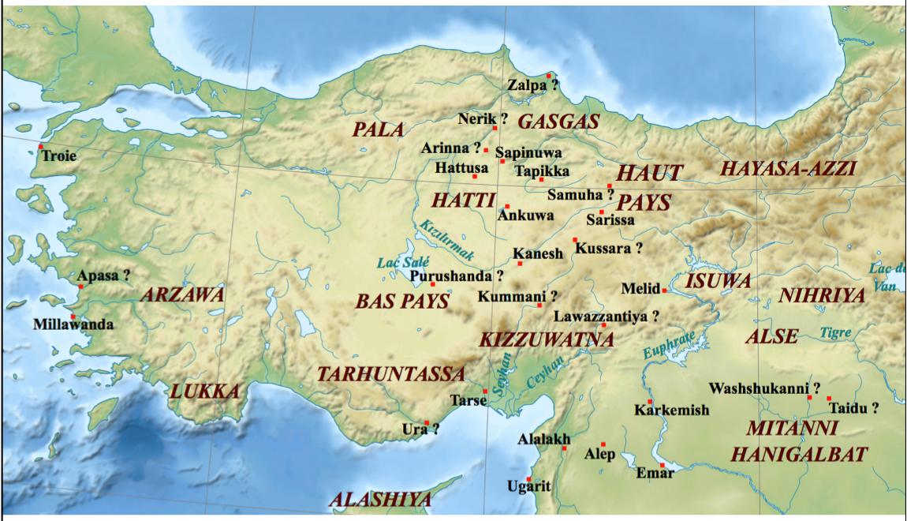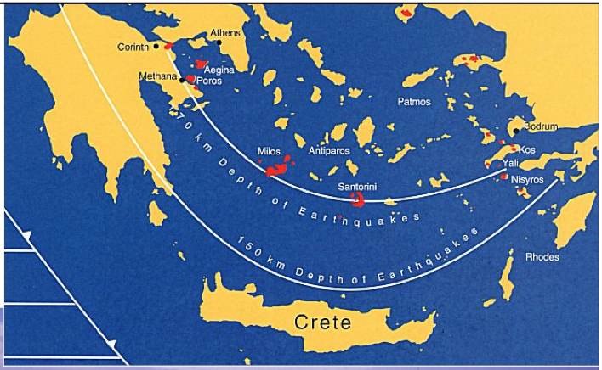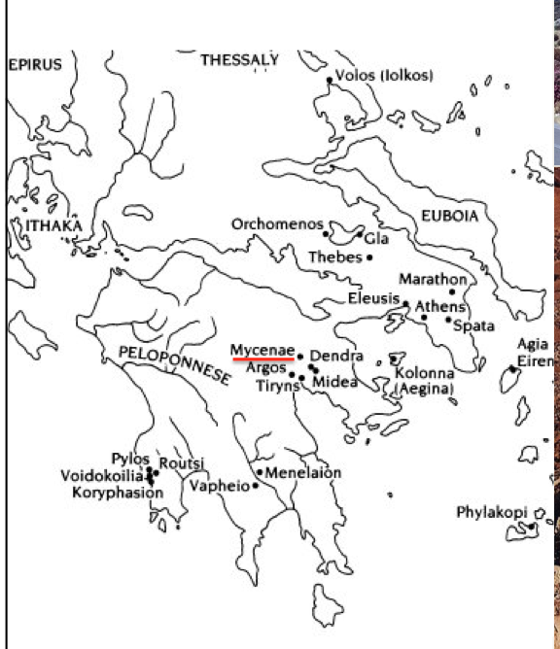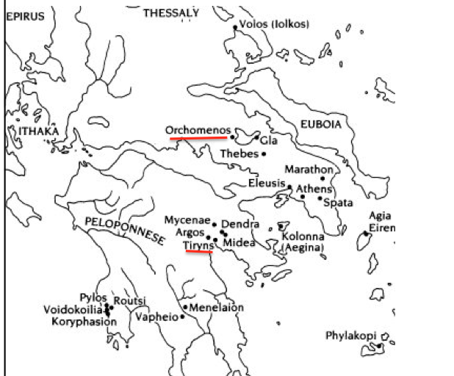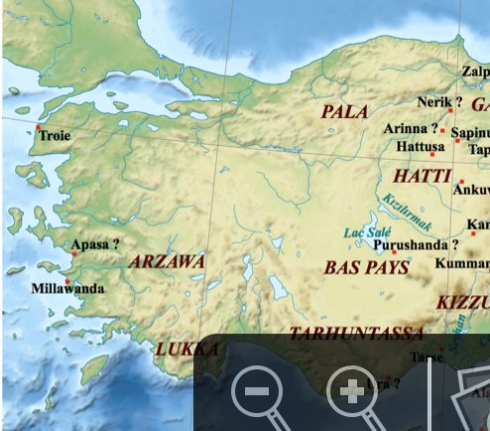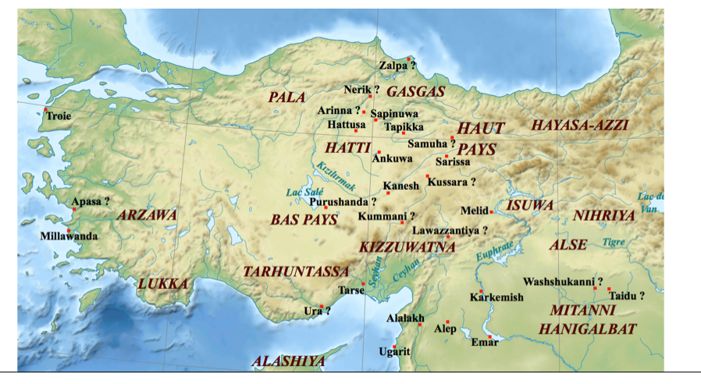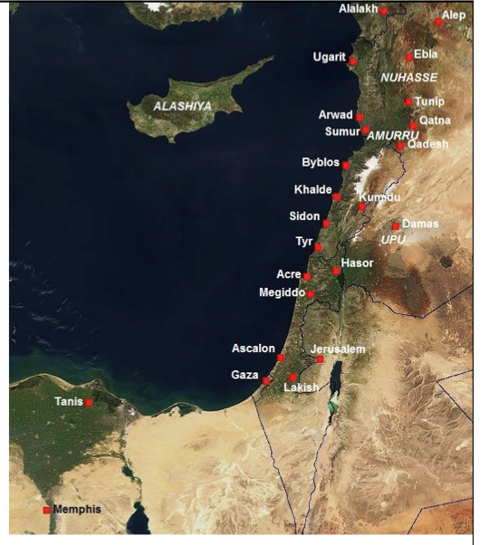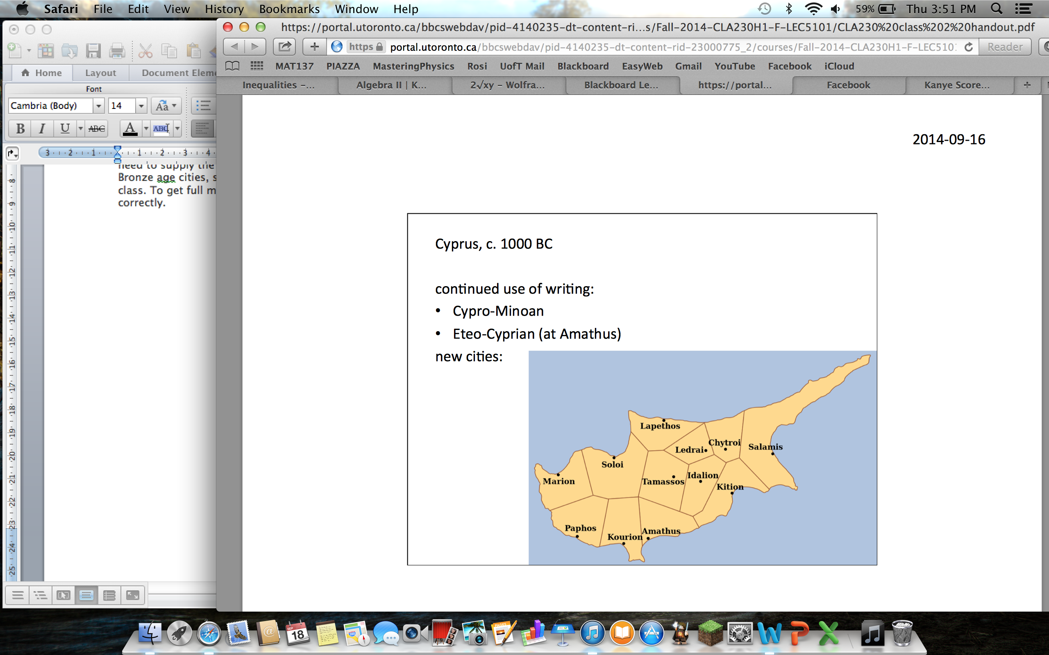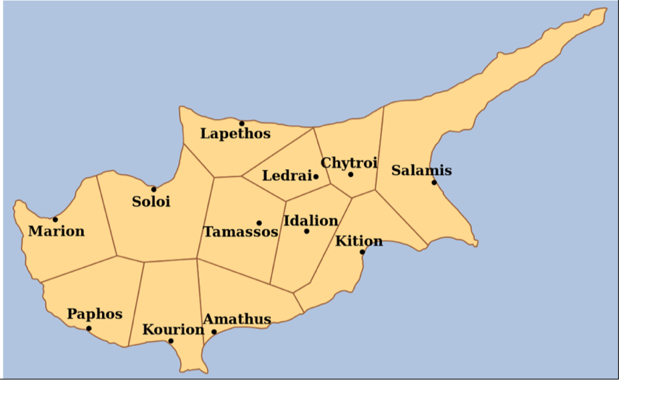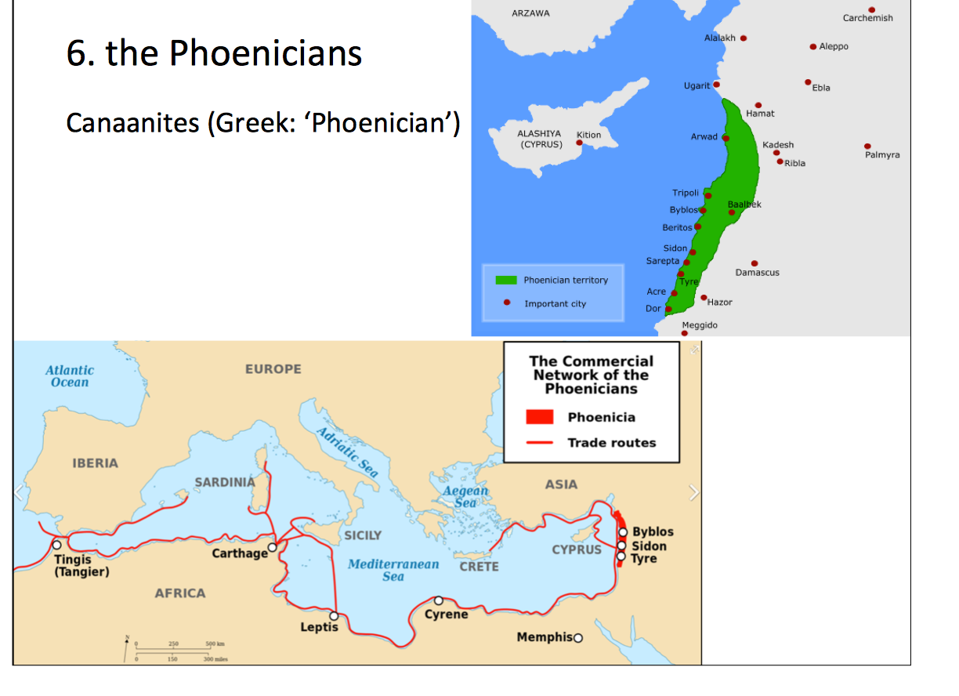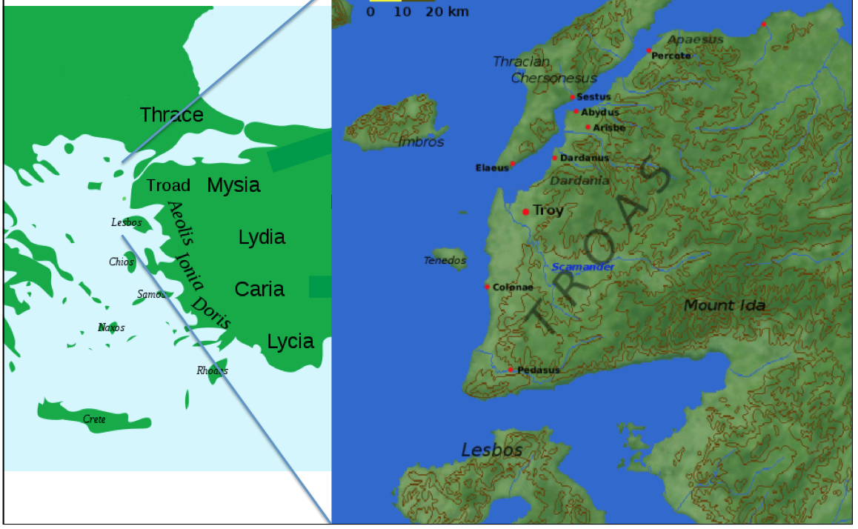
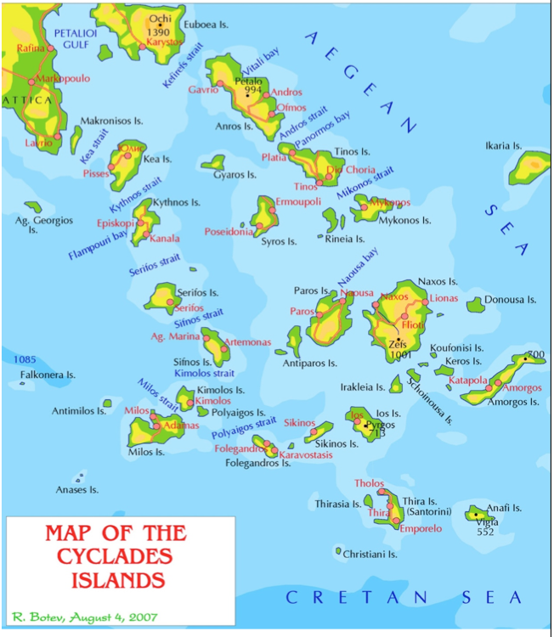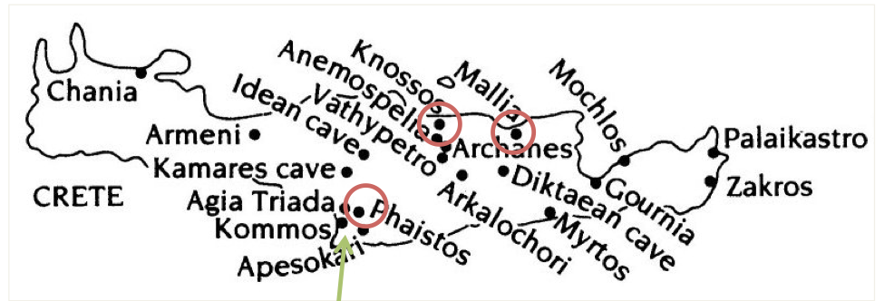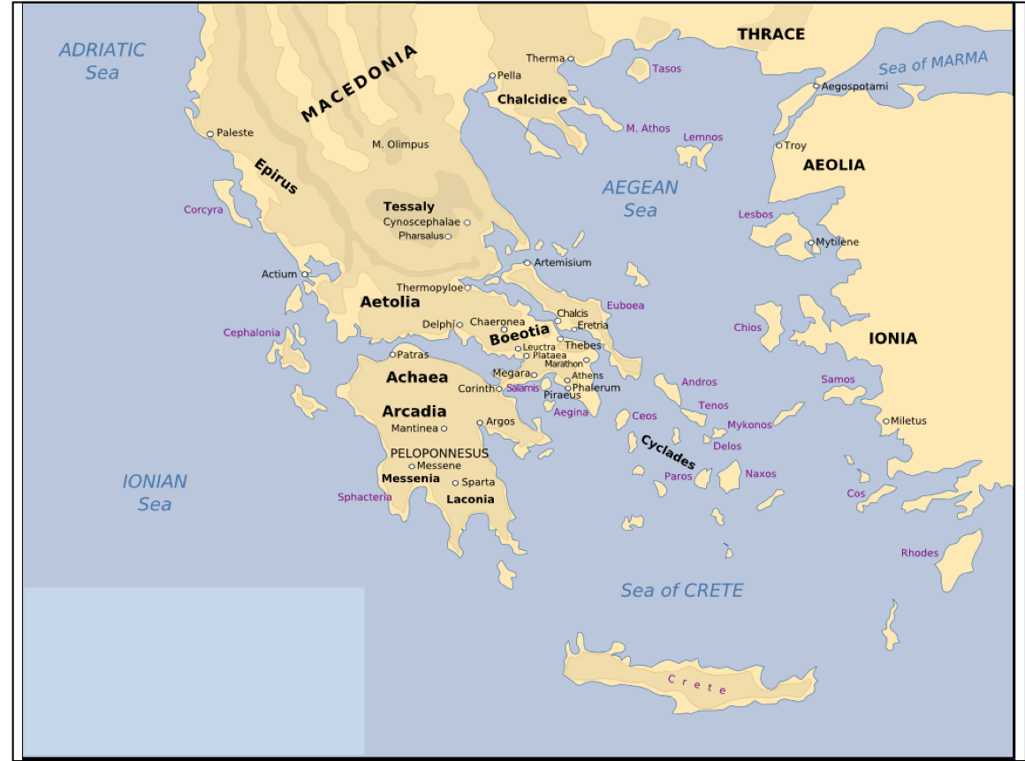
Key Terms 2

Chapter 5
Assyria – a major bronze age state on the upper tigris river
Lefkandi – Big town on the island of Euboae
Euboea – Island where Lefkandi is located
Basileus – Name of the leading man in each community aka King
Protogeometric – 900BC pottery characterized by concentric circles and semicircles
Olympia – Where Greeks would leave valuable gifts for gods (1st time since LBA)
Pithekoussai – First Western Greek settlement, came from Euboea
Messenia – Territory that Sparta invaded, they enslaved the population
Dike – means injustice
Hekatompeda – Hundred foot towers built on Eretria on Euboea
Late Geometric Style – 750-700BC shows humans in battles and at funerals
Greek Alphabet – Huge cultural innovation…based on earlier Semitic script, sometimes called Phoenician alphabet
West Semitic Writing – Family of closely related writings that Phoenician syllabary belonged to and was used all over the Levant.
Chapter 6 (two authors)
Chapter 6: Homer
Terms:
-Homeric Question: How could Homer have written in such detail about events that happened hundreds of years before him?
-Friedrich August Wolf: The first to ask how Homer could have written his poems.
-Rhapsode: “Staff-Singer.” Called as such since he sang and normally held a staff.
-Milman Parry: The one who first proposed that Homer was utilization a style of oral poetry in his epics.
-Dactylic Hexameter: A style of poetry used to keep a rhythm. In this case the rhythm is three beats of long-short-short or two beats of long-long.
-Guslari: The Serbian oral poets met by Milman Parry. Called as such due to their instrument of choice, the gusle.
-Aoidoi: Oral poets or “singers.”
-Shame Culture: External shows of ridicule and distaste when one has “lost face.”
-Guilt Culture: Internal feelings of remorse when one has done wrong.
-Time: The intangible representation of honor, respect or prize.
-Geras: A physical representation of honor or “prize.”
-Calypso: A female character from Homer’s Odyssey who Odysseus meets on the island of Ogygia.
-Phaeacia: A female character from Homer’s Odyssey who Odysseus meets on Corcyra after leaving Ogygia.
-Lotus Eaters: A group of people from mythology encountered by Homer in the Odyssey who through the use of the Lotus drug, try to make him forget his quest to return home.
-Cyclops: A giant one-eyed monster from the Odyssey, the most notable being Polyphemus.
-Circe: A powerful sorceress who Odysseus encounters on his way back to Ithaca who attempts to turn Odysseus and his crew to pigs.
-Sirens: Mythological creatures from the Odyssey who’s songs would drive sailors to their deaths. Odysseus took his passing through there waters as an opportunity to learn more and had himself tied to the mast while his crew sailed through with ear plugs.
-Xenia: “Treatment of a Stranger”
___________
Homeric Question – central issue of humanistic study…who was homer, where did he come from
Friedrich August Wolf – German scholar wrote Introduction to Homer
Rhapsode – performer. Likely a staff-singer because he held a staff as he declaimed
Milman Parry – Californian scholar who noticed things about Homeric Question
Dactylic Hexameter – meter used in Homeric verses
Guslari – Oral illiterate singers found in Serbia who used gusle instruments
Aoidoi – What the Greeks called oral poets
Heinrich Schliemann – Archaeologist who proved Trojan war was real
Shame culture – To become angry about what is wrong you need strong convictions about what is right, moral systems are ranged along a spectrum from this to Guilt Culture
Guilt Culture – On the range of moral systems, see above
Time – A man’s standing before others. His honor, respect or value, price. Every warrior strove for time
Geras – External, tangible sign of time…meaning prize.
Plot-point – Plot point two is when he returns to ithaca
Calypso – the name of a Sea Nymph who’s island Odysseus was imprisoned on
Phaecia – Island Odysseus comes ashore after his raft breaks… King Alcinous rules here
Lotus Eaters – people who eat The Lotus which is a drug that makes you forget your purpose to go home again
Cyclops – Odey ends up on his island and ends up killing him..has juan eye
Circe – A witch whos island odey ends up on…she makes his men pigs
Sirens – Sing songs to sailors making them crash
Xenia – Means treatment of a stranger. One was obliged to receive a wandering stranger with courtesy and food
Chapter 7 (two authors)
Chapter 7: Mythology and Religion
Terms:
-Mythos: Stories passed down from generations to explain or convey ideals.
-Divine Myths: Stories about important events such as the creation of the universe, always including gods, titans, etc.
-Legends: Stories about human past featuring heroes such as Achilles, Odysseus, and Heracles.
-Folktale: Stories considered fictional that still hold moral advice.
-Chaos: The entity in which everything comes from.
-Tartarus: The darkness under the Earth, and later the jail of the enemies of the Olympians.
-Gaia: Mother Earth, Mother of the Titans, Cyclopes, Hundred Handed Ones, and Giants.
-Ouranos: Father Sky, forced his children, the titans, into Gaia’s womb until Kronos used a scythe to cut him up.
-Eros: Force of sexual desire.
-Titans: Children of Gaia and Ouranos and parents of the Olympians. Notable titans include, Kronos, Rhea, Hyperion, Iapetus, and Prometheus.
-Kronos: Titan of Time, main father of Olympians such as Zeus, Posiedon, and Hades, killed his father Ouranos and was dethroned by his son Zeus.
-Furies: Angry persecuting spirits created from the blood of Kronos.
-Polytheistic: Religions that worship many gods.
-Anthropomorphic: Imagining gods in human or human-lite forms.
-Evolutionary Religion: A religion that embraces the totality of things feared by a social group at one time with no specific origin. (Always Polytheistic)
-Revealed Religion: Religions with founders and are have man have special relationships with deities.
-Magic: Forcing the powers of life to do as we wish and is used very often in Mythology.
-Sacrifice: Killing of an animal or offering of fruits and plants to express thanks to the gods.
-Etiological Myth: Myths that explain the causes of why things happen, i.e. the Persephone myth.
-Olympians: The group of 12 gods we are familiar who reign on top of Mount Olympus.
-Chthonic Cult: A cult of the earth directed towards spirits of the underworld.
-Muses: The goddesses that enabled singers to tell stories in great detail.
-Zeus: King of the Olympians; Dominion over Sky, Thunder, Hospitality, etc.
-Hera: Queen of the Olympians; Dominion over marriage, family ties, etc.
-Athena: Daughter of Zeus; sprung from his head in full armor; Dominion over war and battle-strategy and was the patron goddess of Athens.
-Apollo: Son of Zeus and Leto, twin of Artemis; Dominion over prophecy, music, and arguably Archery.
-Artemis: Daughter of Zeus and Leto, twin of Apollo; Goddess of the Hunt, maidens, and fertility.
-Ares: God of War and Bloodshed.
-Aphrodite: Goddess of Love, born from Ouranos’ dismembered genitals.
-Hephaestus: God of the Forge, Fire, Volcano’s, etc.
-Hestia: Goddess of the Hearth, home; gave her spot of the 12 up to Dionysus to prevent fighting.
-Poseidon: God of the Sea, earthquakes, horses, etc; brother of Zeus.
-Dionysus: God of revelry, insanity, and wine; originally a mortal who became a god.
-Demeter: Goddess of agriculture, Mother of Persephone.
-Hermes: Messenger of the Gods.
-Persephone: Daughter of Demeter who was forced into marrying Hades. Eventually had to stay in the underworld for the winter months and could come back to the world in spring. Used her story as an explanation of the seasons.
-Hades: God of the Underworld, Death, etc. Note: Not an Olympian, his court is in Hades.
-Psyche: The soul of a person. Literal translation as “breath.”
-Miasma: Translated as “stench” or “blood-pollution.” Used in the Odyssey to explain an outbreak of plague.
-Eleusinian Mysteries: Initiation ceremonies held every year for the cult of Demeter and Persephone based at Eleusis in ancient Greece. They are considered the most famous of the secret religious rites of ancient Greece.
-Orphics: Followers of Orpheus, a famous singer who supposedly went to the underworld to retrieve his dead wife. Only able to do so as long as he didn’t look at her, eventually he did and she was lost to him forever.
-Bacchae: Female followers of the god Bacchus, i.e. Dionysus.

______________
Mythos – root of Myth..but Greek shave it translated as thoughts
Divine myths – stories in which gods are important..creating the universe, etc..
Legends – stories about heroes and the human past
Folktale – recognized as fiction and contain moral advice
Chaos – IN the beginning first there was chaos meaning gap or chasm
Gaea – Then came gaea, something to stand on
Eros – the force of sexual desire
Uranus – consort of gaea, meaning Sky
Titans – Children of Gaea and Uranus / Earth and Sky
Cronus – A titan
Furies – Grew from cronus’ scattered blood on earth…the angry persecuting spirits
Polytheistic – Means having many gods ‘poly’
Anthropomorphic – means imagining Gods in human form
Evolutionary religion – These embrace the totality of things..are always polytheistic. Greek religion falls under here
Revealed religion – these have founders who are men with special relation to the divine ..tied to written documents
Magic – allows the powerful forces of life to do what we wish (we use magic to control these forces)
Sacrifice – the most visible form of religion in the ancient world
Etiological myth – this myth describes the cause of something (hesiods story describes the division of the animal in sacrifice)
Olympians – The Gods who lived on lofty Mount Olympus
Chthonic cult – Division of religion concerned with ghosts, spirits and hallway supernatural beings
Muses – Personified the mysterious force that enabled singer to strum a lyre..aka gods of music
Zeus –Head of the Olympians bearing an aegis symbol = bull…power of the sky felt in storms rain etc..
Hera – symbol was cow she protected marriage
Athena – protected Athens and encouraged arts
Apollo – god of prophecy
Artemis – arrow shooting goddess of fertility..liked sacrifices
Poseidon – earthquake god and lord of the Aegean sea
Aphrodite –Godess of sex and war
Psyche –literally means breath
Miasma – meaning stench or blood pollution Ghosts bring this upon people
Eleusinian Mysteries – Unknown events that occurred in a temple in Eleusis..initiation into mysteries brought about happy life in afterworld
Demeter – Mother of Persephone goddess of wheat growing
Persephone – Was forced to marry Hades…god of underworld
Orphics – followers of Orpheus, a legendary singer. Orphics were a small self contained group
Dionysus – life force god. Resides in sap, wine, semen, milk
Bacchus – followers in cult of Dionysus who tore apart aniamls..alternate name for the cult
Bacchae – female followers of Bacchus or cult of D
Chapter 8
Oligarchy – meaning rule of the few…an oligarchy could be a handful of men or a council of hundreds
Agathoi – What rich men in greek polis liked to call themselves, means ‘the good people’
Kakoi – What these rich men call the poor ‘the bad people’
Demos – Means people as a whole…525BC heard about demos as a whole making important decisions in several poleis
Talents – a very large sum of money
Hoplite – the heavy infantryman…mainstay of the Archaic greek armies
Phalanx – formation the hoplites formed in order to protect their exposed right sides (shoulder to shoulder formations)
Symposium – Drinking parties the agathoi would host
Andron – The room partygoers would gather in during a symposia
Theognis – A poet from Megara who wrote about symposium etiquette
Olympia –Every 4 years great athletic competition held here
Panhellenic games – meaning “all greek” games
Gymnasia – ‘naked places’ where Greek men exercised naked
Pankration – “all-in wrestling” only rules = no biting or gouging
Pindar – 5th century poet who wrote about athletes, specifically Telesicrates
Tyrant – Ruthless aristocrats who scorned agreements and set themselves up as sole rulers
Ostracism – Athenian institution where citizens exiled people they thought would become a tyrant (basically unpopularity contest)
Chapter 9
Ionia – Place (area) where descendants of Ion settled
Miletus – A place in Ionia..Ionian Enlightenment thought to be here
Ionian Enlightenment – enourmous advances in scientific thought, especially in miletus
Thales – Philosopher thought primary element was water
Anaximander – Thought the primary element must be the infinte
Anaximenes –Defined the infinite more precisely and thought primary element was air
Pythagoras – Thinker from the Ionian Enlightenment….right triangle stuff
Herodotus – Famous historian wrote about the Persian invasions of Greece
Historie – Word meaning ‘inquiry’ … root of history
Archilochus – Earliest and most celebrated lyric poet
Daedalic style – named after Daedalus. Stiff posture, Egyptian like wig, near eastern features
Naucratis – Single port all greek merchants were ordered to operate out of (in Nile Delta)
Kouros – Statues of young men (style borrowed from Egyptian techniques)
Kore – Statues of young women (style borrowed from Egyptian techniques)
Cella – Long main rooms of early 7th century houses
Doric Order – Distinction of temple canon divided after two principal greek ethnic divisions (columns)
Ionic Order – Distinction of temple canon divided after two principal greek ethnic divisions (columns)
Pediments – Areas at the front and back of a temple. Often had sculptures
Orientalizing phase – Named due to the stron near eastern influence on painting
Ripe Corinthian – 625BC, style favoring dense texture of detail of eastern inspiration…developed by corinthians
Protoattic – Style developed in Athens…painter put their best work on large vessels
Black figure – A merging of Protoattic and Corinthian producing this...black figures
Red figure – Reversed process of black figure pottery where…figures where red
Chapter 10
Helots –State owened serfs who worked the land in Sparta..state owned slaves
Spartan mirage – Flase vision of stability, hierarchy and order in which all knew their place
Lycurgus – Said to have created perfect laws for Sparta (Made all Spartan men equal, etc…)
Laconia – The region around Sparta
Dorian – Language that the Spartans spoke…was a dialect of Greek
Perioikoi – Lucky conquered laconians who only had to pay tribute to sparta
Spartiates – Full citizens of Sparta
Messenia –Terriotory Sparta overran due to population growth issues
Council of elders – One of the four main political institutions. Kings, Ephors, This, Assembly
Ephors – the ‘overseers’Supervised kings and elders with authority to impeach or depose if they broke any laws
Assembly – Included all Spartiate men aged over thirty and met outdoors each full moon
Pelopennesian league – a bicameral leagure / Spartan alliance with conquered places
Alcmaeonid – a powerful and noble family in Athens who were cursed for commit murder
Solon – chosen by the Eupatridai to work out a compromise with the rebellious poor
Archons – Nine were elected each year..they were leaders.
Areopagus – After serving as an archon, you were on a council called this “stake of Ares”
Council of 400 – created by Solon to give the poor more power. They drew up the agenda for assembly meetings
Pisistratus – Powerful aristocrat who launched a coup and established a tyranny in Athens
Hippias – Eldest son of Pisistratus, held most of the power in the junta that ruled Athens.
Hipparchus – Younger son of Pisistratus…ruled with bro and promoted Athens as a cultural center
Harmodius – Boy who Hipparchus fell in love with
Aristogeiton – Harmodius’ erastes….old man lover o_O
Cleisthenes – AN Alcmaeonid who emerged as a leader after Athenian tyranny fell
Council of 500 – Replacement of Council of 400, composed of 50 men from each tribe
Demokratia – power of the people
Key Terms 3
Chapter 11
Assyrians – an agricultural people who lived along the upper banks of the Tigris River
Carthage – a colony the Phoenicians founded near Tunis
Medes – a warrior people from the mountains of western Iran who burned Assyria’s capital Nineveh
King Midas – King of Phrygia rumored to turn everything he touched in gold
Lydia - place close to Aegean Sea and was very wealthy
Gyges – a usurper who seized Lydias throne in 680BC
Croesus – assumed Lydia’s throne, was blamed for east-west clash
Cyrus – grandson of Astyages and became chief of the Persians
Zoroastrianism – dualistic religion based on prophet Zoroaster, clamming universe was a battleground between..(below)
Ahuramazda – The uncreated creator, wise god
Achaemenids – Family name of cyrus, was chosen to lead the struggle in this world.
Darius – Became king of Persia after Cambyses died
Cambyses – Cyrus’ son, he continued the Achaemenid expansion, attacking egypt
Hybris – violence, a punishable act
Satraps – Local govenors, were virtually kings….set up by Darius
Histiaeus – pro-persian tyrant of Miletus. Ruled with Darius then fled becoming a pirate
Eretria – island on Euboea
Triremes – ships with three banks of oars down each side
Marathon – famous battle. Persians landed here before marching to Athens..sprinter guy
Miltiades – Athenian general who took charge for battle of Marathon
Chapter 12
Xerxes – Darius’ son
Mardonius – Persian commander of naval expidition
Syracuse – In modern day Italy, had amazing temples and has incredible ruins
Gela – small city south coast of Sicily
Gelon – former cavalry commander of Gelon (the tyrant of Gela)
Himera – greek city in sicily, had tyrant terillus ousted by theron
Themistocles – An athenian who began preparing for imminant war with persia
Hamilcar – Carthaginian general…simply wanted to reopen the island for trade
Thermopylae – the hot gates. Impassable mountains, logical place to make a stand
Leonidas – King of the 300 spartans
Salamis – Island off the harbor of Athens, battle against Xerxes took place here
Plataea – Where greeks took position against Mardonius’ cavalry, place of battle
Mycale – Island where a battle took place at the same time as Plataea
Chapter 13
Hiero – brother of Gelon, left in charge of Gela
Common Resolution – resolution signed by all sicilian cities to stop the blood shed, old citizens allowed right to return home
Demagogues – leaders of the people in Syracuse
Segesta – a city which Elymians were concentrated in, major role in meditteranean politics
Cimon – leading atheninan politician took part in a bloodless coup
Ephialtes – Rival of cimon who turned The Assembly against him
Pericles – Rival of cimon who turned The Assembly against him
Long Walls – athenian fortifications linking Athens and its harbor piraeus
Old Oligarch – an anonymous writer, hostlie towards democracy but enjoyed material benefits from naval power
Metics – greek traders from verb to live with
Liturgies – public services…paying for festivals, sacrifices, etc…
Corcyra – Corinthian colony besieged by Corinth for not aiding Epidamnus
Epidamnus – Corinthian colony who asked Corcyra for aid during its internal conflicts
Chapter 14
Heraclitus – from Ephesus..profound thinker…everything flows and our senses mislead us
Logos –order, word, reason..sometimes equated with God
Anaxagoras – thinker from Ionias, asked about origin of things, invented nous
Nous – meaning pure mind…the only pure force
Parmenides – philosopher from Elea…thought things either exist or they do not
Zeno – follower of Parmenides, had some crazy theories
Paradoxes of Zeno – that Achilles could never overtake a tortoise…half distances running etc…
Pluralists – succesors of Parmenides, thought the world must be made up of many things in the first place
Empedocles – athlete and philosopher, four original substances/roots, earth, air, fire, water
Democritus – devised atomic theory…from Thrace
Atomic Theory – postulation that world is made of plethora of uncuttable things, atomos
Sophists – intellectuals who flocked to Athens
Arete – virtue or excellence
Moral relativism – Thoughts morals were relative and not absolute
Protagoras – famous sophist, coined the phrase “man is the measure of all things”
Socrates – opposed moral relativism. Wrote nothing. Featured in Plato’s works
Inductive Method – encouraged by Socrates for discovering general definitions
Lost-wax technique – technique used for casting bronze sculptures
Severe style – sculptures with serenely calm facial expressions
Phidias – the most famous Athenian sculptor
High classical – refining style of sculpture, more so than severe style
Parthenon – temple to Athena
Elgin Marbles – marble stolen by Lord Elgin from Britain and kept in the British Museum
Propylaea – great gate or the fore-gates
Erechtheum – strange temple in elaborate Ionic Style
Athena Nike – temple built meaning victory, had figure of Nike
Caryatids – statues in the Erechtheum that replace normal columns
White-Ground Style – style of painting used by vase painters to imitate vases made of ivory

