Chapter 1 Notes- MKT
- Consumer behavior: set of value-seeking activities that take place as people go about addressing needs
- Want: way a consumer goes about addressing a recognized need
- Exchange: acting out of the decision to give something up in return for something of greater value
- Costs: negative results of consumption
- Benefits: positive results of consumption

Why it’s important to understand consumers
For Marketers
- Be able to design products that provide more value
- Enhance the well-being of the company and its customers
For Policy Makers
- Make more effective public policy decisions
For Consumers
- Understanding consumer behavior can make better decisions concerning how they allocate scarce resources

Marketing Ethics and Consumer Misbehaviour
Definition: Manipulative marketing practices, deceptive advertising, and corporate scandals upset the value equation associated with a given exchange.
- Unfair exchange: when a company misrepresents a product, consumers are left to expect more than is actually delivered
- Fair value exchange: exists when markets and consumers act with good faith, complete disclosure, and trust.
- Ethics: standards or moral codes of conduct to which a person, group, or organization adheres.
- Marketing ethics: consists of societal and professional standards of right and faith practices that are expected of managers as they develop and implement marketing strategies.

Effect of Corporate Misbehaviour
Definition: Ultimately, consumers “vote with their wallets” when companies engage in unethical behavior

Consumption and Consumer Behaviour
Consumer behavior can be defined from 2 different perspectives:
- Human thought and action
- A field of study (human inquiry) that is developing an accumulated body of knowledge

Consumer Behaviour as Human Behavior- The basic CB Process
Definition: CB is the set of value-seeking activities that take place as people go about addressing their needs
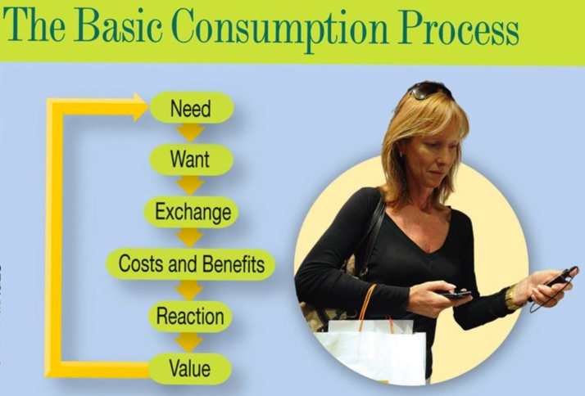
Consumption
Consumption: the process by which goods, services, or ideas are used and transformed into value
- If the product preforms well, value may result
- If the customer is unhappy with the product, very little value or a negative amount of value may result.

Consumer Behavior as a Field of Study
Consumer behavior as a field of study: represents the study of consumers as they go about the consumption process

Why study Consumer Behaviour?
- Input to business/marketing strategy
- Force that shapes society
- Input to making responsible decisions as a consumer

Resource-Advantage Theory
Definition: Explains why companies succeed or fail; the company goes about obtaining resources from consumers in return for the value the company’s resources create.

CB and Personal Growth
Studying CB helps consumers make better decisions by understanding:
- Consequences of poor budgeting
- Role of Emotions
- Avenues for redress (Remedy)
- Social influences
- Environmental effects

Trends
- Internationalization: consumers are different in every part of the work, thus companies must deal with geographical distances and cultural distances. Every culture’s people interpret products and behaviors differently
- Technological Changes: Internet, mobile communication have simplified things for consumers
- Pure play= internet only
- Changing Communications: Technological changes=communication changes. Some people prefer communication over the phone, email, voice, SMS. Depending on the consumers age depends on the communication they prefer.
- Changing Demographics: Changing demographic trends have shaped CB patterns. Ex; two primary income providers, decreasing family sizes in North America and Europe.
- Changing Economy: The economy has been going down in the recent years resulting in higher unemployment rates. As a result, consumers are more cautious about spending money and react more favorable to price-cutting policies. There has also been a decrease in charitable giving because consumer perceive themselves as having less discretionary income.

Economics and Consumer Behaviour
Economics: the study of production and consumption
- The economist’s focus on consumer behavior is generally a broad, or macro, perspective.
- Macro- are more interested in emerging markets. Economists study CB from a macro perspective
- Micro-When they study micro they focus on individual consumer behaviour. CB researchers study CB on a micro/individual level
- Higher price elasticity= changes in price affects consumers buying decisions

Psychology and Social Psychology
Psychology: the study of human reactions to their environment, including behaviour and mental processes.
Social Psychology: focuses on the thoughts, feelings, and behaviors that people have as they interact with other people (group behaviour)
Cognitive Psychology: deals with the intricacies of mental reactions involved in information processing

Marketing
Marketing: involves the multitude of value- producing seller activities that facilitate exchanges between buyers and sellers. These activities include the production, promotion, pricing, distribution, and retailing of goods, services, ideas, and experiences that provide value for consumers and other stakeholders.
- Marketing actions are targeted at and affect consumers while consumer actions affect marketers
Consumer Behavior and Other Disciplines
Other disciplines that share things in common with consumer behavior:
- Sociology focuses on the study of groups of people within a society.
- This has relevance for consumer behavior because consumption often takes place within group settings or is in one way or another affected by group behavior.
- Anthropology: study in which researchers interpret relationships between consumers and the things they purchase, the products they own, and the activities in which they participate.

Competition and Consumer Orientation
- Industry Canada and the Competition Bureau regulate practices such as price fixing, secret rebates, and customer coercion in accordance with federal laws
- Consumer (customer) orientation: way of doing business in which the actions and decision making of the institution prioritize customer value and satisfaction above all other concerns
- A consumer orientation is a key component of a firm with a market-orientated culture
- Market Orientation: organizational culture that embodies the importance of creating value for customers among employees
- A market orientation stresses the need to monitor and understand competitor actions in the marketplace and the need to communicate information about customers and competitors throughout the organization.
- Profitable firms are usually market oriented

Relationship Marketing and Consumer Behaviour
- Relationship marketing: activities based on the belief that the firm’s performance is enhanced through repeat business.
- Touchpoints: direct contacts between the firm and a customer

Chapter 2: Value & the CB Value Frame Work

The Consumer Value Framework (CVF)
Represents consumer behavior theory illustrating factors that shape consumption-related behaviours and ultimately determine the value associated with consumption.
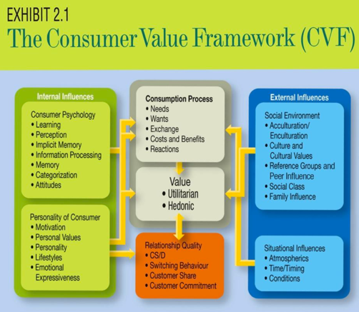

Types of Value
- Utilitarian: Value derived from a product that helps the consumer with some task
- Hedonic: value derived from the immediate gratification that comes from some activity

