Flow Through a Venturi Meter

Station Performed at: #3
Date Performed: February 11th, 2019
Date Submitted: February 25th, 2019
Performed By:
Jacob Pacheco-Phillips – 101076882 (Jacobpachecophillips@cmail.carleton.ca)
Joseph Caidor (Josephcaidor@cmail.carleton.ca)
Instructor: Prof. Hanachi
Course: MAAE 2300-D L01
Summary
The lab preformed was an analysis and introduction to venturi meters and apply Bernoulli’s equation under specific conditions. The venturi meter used was at station 3 with a fixed inlet diameter of 0.02654 meters and a fixed throat diameter of 0.01796 meters. Two tests were run with a motor operating at 40 RPM for the first test and 30 RPM for the second. Using both tests and averaging the calculated venturi coefficients (C_{v}) of 0.9829 outlining a smooth, non-viscous, steady flow with no work or heat transfer being done. This makes sense being so high as it must adhere to all those factors to be able to apple Bernoulli’s equation properly.
Nomenclature
Variable | Symbol | Units
Mass | m | $$[kg]$$
Newtons | N | $$[\frac{kg*m}{s^{2}}]$$
Pressure | P | $$[\frac{N}{m^{2}}]$$
Density | ρ | $$[\frac{kg}{m^{3}}]$$
Velocity | V | $$[\frac{m}{s}]$$
Gravity’s Acceleration (Constant) | g = 9.81 | $$[\frac{m}{s^{2}}]$$
Height | h | $$[m]$$
Table 1: Common Variables and their Respective Units.

Procedure
- Set up at station 3, with a throat diameter of 0.707 inches (17.9578 mm) and intake diameter of 1.045 inches (26.543 mm)
- All taps were measured as a power of 40 RPM and 30 RPM.
- All data was recorded and put into table 2.

Collected Data
Tube | Distance from Mouth of Venturi (mm) | Test #1, P_{in} = 40 RPM  Head | Test #2, P_{in} = 30 RPM  Head
1 | 50.8 | 158 | 126
2 | 76.2 | 156 | 126
3 | 104.2 | 158 | 126
4 | 116.9 | 176 | 135
5 | 129.6 | 194 | 144
6 | 139.8 | 230 | 162
7 | 152.5 | 270 | 181
8 | 165.2 | 334 | 212
9 | 188.1 | 464 | 280
10 | 211 | 448 | 272
11 | 221.2 | 332 | 215
12 | 233.9 | 297 | 196
13 | 246.6 | 250 | 174
14 | 256.8 | 228 | 164
15 | 269.5 | 210 | 156
16 | 294.9 | 194 | 148
ATM | 0 | 82 | 86
Table 2: Data Acquired from the Venturi Meter

Results and Discussion
- Test #1
$$P1+\frac{1}{2}ρ{V1}^{2}+ρgh1=P2+\frac{1}{2}ρV2^{2}+ρgh2$$
$$V1=\sqrt{-2*\frac{P2-P1}{ρ}}=\sqrt{-2*\frac{82-158}{1000}}=0.38987\frac{m}{s}$$
$$Q actual=A inlet*V1=\frac{π}{4}*{0.026543}^{2}*0.38987=0.00021573 \frac{m^{3}}{s}$$
- Test #1
$$P1+\frac{1}{2}ρ{V1}^{2}+ρgh1=P3+\frac{1}{2}ρV3^{2}+ρgh3$$
$$V3=\sqrt{2*\frac{P3-P1+\frac{1}{2}ρ(V1^{2})}{ρ}}=\sqrt{2*\frac{464-158+\frac{1}{2}*1000*({0.38987}^{2})}{1000}}=0.874070144\frac{m}{s}$$
$$Q Ideal=A throat*V3=\frac{π}{4}*{0.01796}^{2}*0.874070144=0.000221436\frac{m^{3}}{s}$$

- Test #1
$$Cv=\frac{Q actual}{Q ideal}=\frac{0.00021573 }{0.000221436}=0.9742$$
- Test #1
Stagnation Pressure = Static Pressure + Dynamic Pressure
$$P Stag=P+\frac{1}{2}ρV^{2}$$
$$P Stag=464+\frac{1}{2}*1000*{\left(0.874070144\right)}^{2}$$
$$P Stag=464+382=846 Pa$$

- Test #2
$$P1+\frac{1}{2}ρ{V1}^{2}+ρgh1=P2+\frac{1}{2}ρV2^{2}+ρgh2$$
$$V1=\sqrt{-2*\frac{P2-P1}{ρ}}=\sqrt{-2*\frac{86-126}{1000}}=0.282842712\frac{m}{s}$$
$$Q actual=A inlet*V1=\frac{π}{4}*{0.02654}^{2}*0.282842712=0.000156472\frac{m^{3}}{s}$$
- Test #2
$$P1+\frac{1}{2}ρ{V1}^{2}+ρgh1=P3+\frac{1}{2}ρV3^{2}+ρgh3$$
$$V3=\sqrt{2*\frac{P3-P1+\frac{1}{2}ρ(V1^{2})}{ρ}}=\sqrt{2*\frac{280-126+\frac{1}{2}*1000*({0.282842712}^{2})}{1000}}=0.622896459\frac{m}{s}$$
$$Q Ideal=A throat*V3=\frac{π}{4}*{0.01796}^{2}*0.622896459=0.000157804\frac{m^{3}}{s}$$
- Test #2
$$Cv=\frac{Q actual}{Q ideal}=\frac{0.000156472}{0.000157804}=0.9916$$
- Test #2
Stagnation Pressure = Static Pressure + Dynamic Pressure
$$P Stag=P+\frac{1}{2}ρV^{2}$$
$$P Stag=280+\frac{1}{2}*1000*{\left(0.622896459\right)}^{2}$$
$$P Stag=280+194=474 Pa$$

Figure 1: Velocities compared to head pressures.

For the actual flow rate compared to the ideal were extremely close together for both tests ran, but higher when less power was applied, and can be most likely explained as there is less power and therefore slower meaning there are less collisions between the walls of the venturi most likely allowing for a venturi coefficient closer to 1 than not (see 3.2 & 3.1). As the static pressure increased when power in was increased leading to both a faster flow rate (see 1.1 & 1.2) and outlined when calculating stagnation pressure (see 4.1 & 4.2) and the dynamic pressure would increase a fair amount by the fluid moving faster as the venturi would approach the throat (see 4.1 & 4.2) as outlined in figure 1.
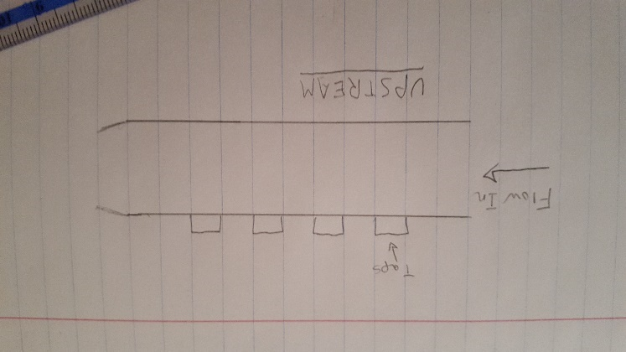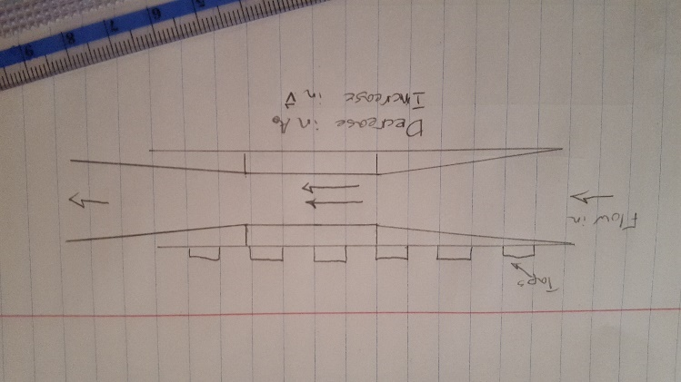
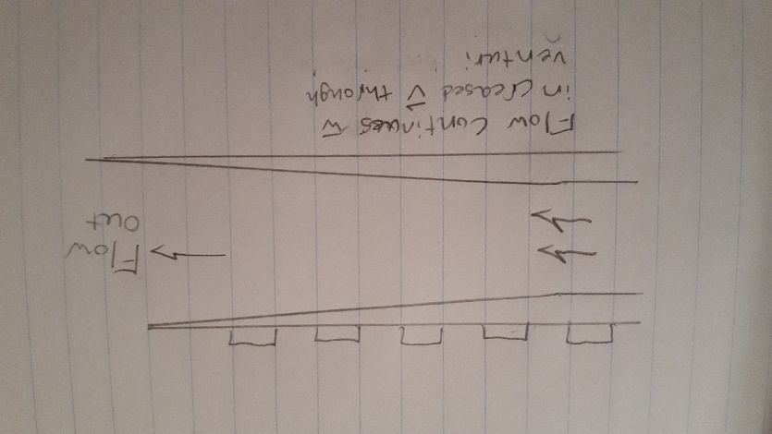

Conclusion
To conclude, as the power supplied to the venturi meter increased so did both the static pressure and the dynamic pressure via the velocity being faster given the static pressure was found to be 464 Pa and the dynamic being 383 Pa when it was operating at 40 RPM versus when the second test was performed and static pressure was found to be 280 Pa and a dynamic pressure of 194 Pa. With both tests yielding quite high venturi coefficients averaging to 0.9829. The coefficient being this close to 1 means that it is calibrated quite well, being less than 0.05 for perfection. As Bernoulli’s equation to be applied in this situation must adhere to having a constant density, steady flow, non-viscous, and no work or heat transfer. Following those principles, it can be logically deduced that it is the most likely reason that the coefficient is as high as it is. The sources of error for this lab would be most likely mechanical, it was stated in the instructions to let the venturi meter run for a while prior to taking the readings to let it stabilize yet some of the taps never stopped moving, therefore making it difficult to get proper reading from the venturi. The observations were averaged from the lowest value the meniscus read and the max that the meniscus was at typically varying in two to six millimeters.

