Education

Education in Historical-Global Perspective
- Cultural transmissions: process by which children and recent immigrants become acquainted with the dominant culture believes, values, norms, and knowledge of society.
- Informal education, learning that occurs in a spontaneous, unplanned way.
- Formal education is learning that takes place with in academic setting. Where teachers convey specific knowledge, skills, and thinking process to students
-Mass education refers to providing free, pubic schooling for wide segments of a nations population.
- By 1900’s, mass education had taken hold in Canada.
- Japan did not make public education mandatory, right away. Once the country underwent industrializing, education was viewed as a crucial link to economic success in japan, at this point. Pg. 444

Sociological Perspectives on Education

Functionalist view education as one of the most important components of society
- Emile Durkheim says education is crucial for promoting social solidarity and sustainability
- The 1994 world commission of learning outlined three purposes of schooling, first, to ensure all students high levels of literacy by building on basic reading, writing, and problem-solving skills.
- Second to develop an appreciation of learning the wish to continue learning, and the ability and commitment to do so and 3rd to prepare students for responsible citizenship .Pg 444
Manifest Functions of Education, defined as open, stated, and intended goals or consequence of activities within an organization or institution. In education, these are…
-Socialization
-Transmission of culture
-Social control
-Social placement
-Change and innovation
Pg. 446
Latent Functions of Education. Hidden, unstated, and sometimes unintended consequences of activities within an organization.
-Restricting some activities
-Matchmaking and production of some social networks
-Creation of the generation gap
Pg. 447

Conflicts View. Conflict theorists do not believe that public schools reduce social inequality in society, they believe that schools often perpetuate class, racial ethnic and gender inequalities as some groups seek to maintain their privileged position at the expense of others.
-Bourdieu asserts that students from diverse class backgrounds come to school with differing amounts of cultural capital- social assets that include values, beliefs, attitudes, and competencies in language and culture.

The Hidden Curriculum
- Is the transmission of cultural values and attitudes, such as conformity and obedience to authority, through implied demands found in rules, routines, and regulations of schools.
- Educational credentials are extremely important in societies that have emphasize credentialism- a process of social selection in which class advantage and social status are linked to the possession of academic qualifications (Collins,1979: Marshall, 1998) Pg. 449

Feminist perspectives
-Teachers pay more attention the boys
- Boys and girls were split up on the playgrounds
-Teachers displayed stereotypical expectations of male and female students aptitudes and interests
-Ministries of education an eliminated gender bias and stereotyping in schools curriculum and classroom practices
-In 2006 60% of university graduates were female

Symbolic interactionism perspectives
- Focus on classroom communication partners and education practices that effect students self-concept and aspirations.

Labeling it and the self-fulfilling prophecy
-Labeling is the process whereby a person is identified by others eyes possessing a specific characteristic or exhibiting a certain pattern of behavior
- Self-fulfilling prophecy Defined as an unsubstantiated belief or prediction resulting in behavior that makes the originally false belief come true.

Postmodern perspectives
Postmodern theories often highlight differences and irregularity in society

Table on Pg 454 has all the key elements of the different Sociological perspectives on education. LOOK BELOW

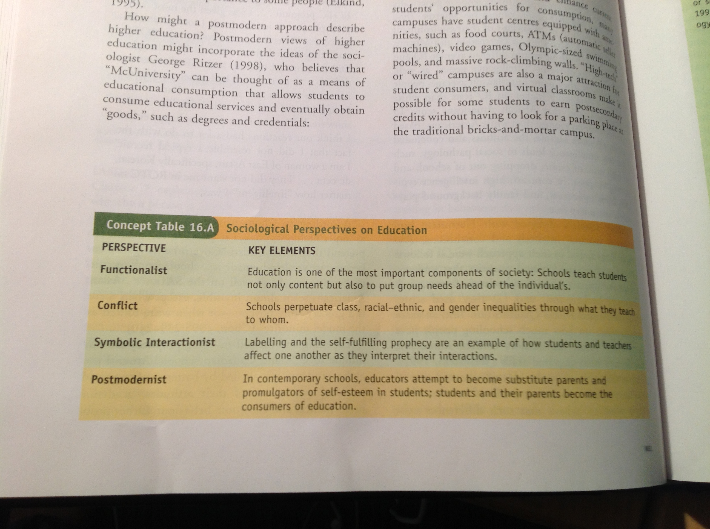
Education in the future
Education in the future will remain an institution in this century
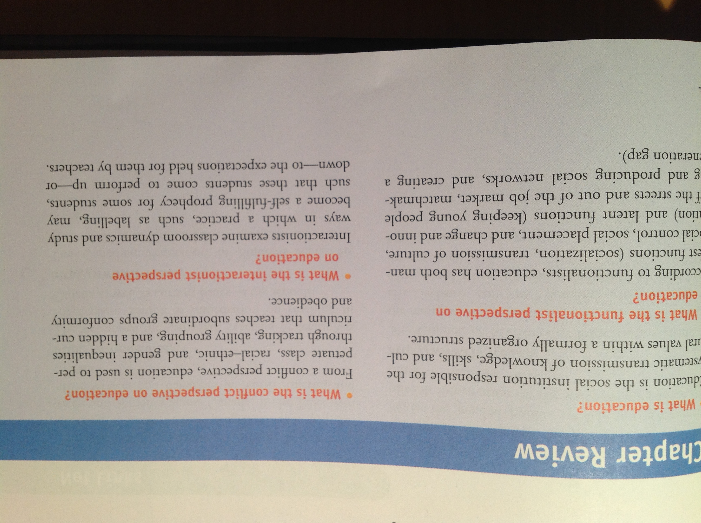
REVIEW pg 463

Ethnic relations and race
-Canada is diverse and complex society composed of racial and ethnic different groups
- Our country has a reputation as a tolerant and compassionate country
-Racism is something that not only is part of Canada’s history but also it is and main aspect of current circumstances

Pg266
- Racism will be the central to the discussion of race and ethnicity and will explore the subjective impact of race and ethnicity on people’s lives and whether those of effects are changing.

Race - is a social constructed reality not a biological one
- Not biological because there has been a lot of interbreeding

Ethnic groups
- Unique culture traits English-language
- A sense of community
- A feeling of ethnocentrism
- I scribed membership from birth
- Territoriality

Visible minority – nonwhite, nor Caucasian. Today one in six people identified themselves as members of the visible minority between 2001 – 2006

Minority group/one that is disadvantaged.

Majority group/ one that is advantaged.

Pre-justice – negative attitude about members of selected groups, can mean a group is better off than you, but usually refers to negative attitudes, racial pre-justice

- Pre-justice is rooted in stereotypes and ethnocentrism. To regard own culture as superior.

Pg.271
Scapegoat – person or group that is incapable of offering resistance to the hostility or aggression of others

Measuring pre-justice/example, social distance, the extent to which people are willing to interact with members of racial and ethnic groups or other than their own.

Pre-justice is an attitude
Discrimination is an action or practice not because of ability or permit

Pg. 271 Dejure discrimination = legal discrimination not really exist anymore.
- The Canadian charter of rights and freedom prohibits discrimination of the bias of race, ethnic or religion.
Pg. 272 De Facto discrimination is more subtle and less visible and therefore more difficult to eradicate (get rid of )

Pg.273 Racism involves pre-justice, ethnocentrism, stereotyping and decimators

Overt racism in Canada
- White supreme racist groups, Heritage Front, White Aryan Nation, Western Guaro.

Polite racism is an attempt to alilute or disguise behavior.

Subliminal racism is not directly expressed but is demonstrated in opposition to progressive minority policies.

Institutionalized racism is made up on the rules, procedures, and practices, which may directly or indirectly promote, sustain, or entrench differential advantage or privilege for dominant group members.

Sociological perspectives on Race and Ethnic relations

Symbolic integrationist perspectives
-Have equal status
- Pursue the same goals
-Cooperate with one other to achieve their goals and receive positive feedback when they interact with one another

Pg. 276 Functionalist perspectives
Assimilation is a process by which members of subordinate racial and ethic groups become absorbed into dominant culture.
Ethnic pluralism is the coexistence of a variety of distinct racial and ethnic groups within one society.
Segregation is the spatial and social separation of categories of people by race, ethnicity, class, gender, and/or religion.

Conflict Perspectives
Internal Colonialism to refer to a situation in which members of a racial or ethnic group are conquered or colonized and forcibly placed under the economic and political control of the dominant group.

The split labor market Refers to the division of the call me into two areas of employment, a primary sector or upper tier, composed of higher paid workers in more secure jobs, and a secondary sector or lower tier, made up of lower paid workers in jobs with little security and hazardous working conditions.

LOOK ON Pg. 282 For Feminist, Postmodern and Critical Race Theory’s

