- Intro
  - Sketch, list and explain the functionality of the components of the Von Neumann model.
    - 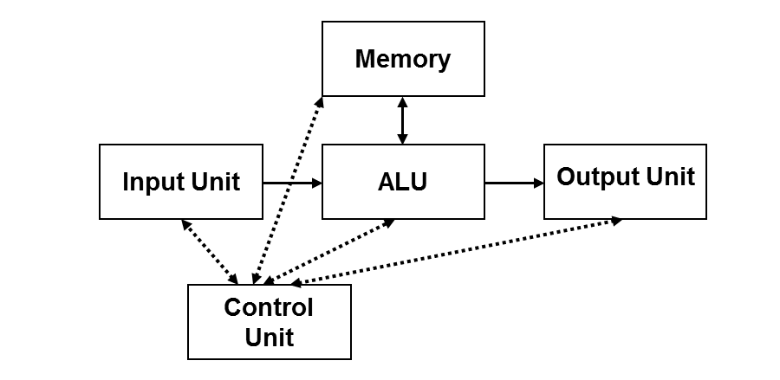
    - Memory: stores data and program
    - Input: obtains data
    - Output: produced data
    - Control: orchestrate program flow and control signals
    - ALU: responsible for arithmetic operation and logic
  - To which component in the Von Neumann model do the following entities belong
    - Flash memory: memory
    - DVD-RW: I/O
    - ROM: memory
    - Hard disk: I/O
    - Microprocessor: control and ALU
  - How many bytes are there in a 4G × 8 memory section? How many bits are needed to address each location in this section?
    - 4G = 2^2 x 2^30 = 2^32 bytes in the memory section
    - 2^32, therefore, 32 address bits are needed to address each location
  - The double-word AC43BCBCH is stored in the memory location starting at A0000H of an 8088- based microprocessor system. Draw a memory map indicating the exact location of each byte of this double-word.

AC | A0003
43 | A0002
BC | A0001
BC | A0000
- Programming Model
  - Give an example of three instructions, each one automatically affects one of the following: CX, SP and the Z flag.
    - CX: MOV CX, 12H
    - SP PUSH AX
    - Z MOV AX, 1 DEC AX
    - C: MOV AL,0Fh ADD AL, 0F1h
    - P (even parity to set): MOV AL, 00h ADD AL, 03h
    - S (having msb as 1 to set): MOV AL, 10 ADD AL, 00
    - OF: MOV AL, FFh ADD AL, FFh
  - Suppose that DS=1000H, SS= 2000H, CS=3000H, ES=4000H, BP=FFH, BX=FFFFH and DI=5H.
    - RECALL: 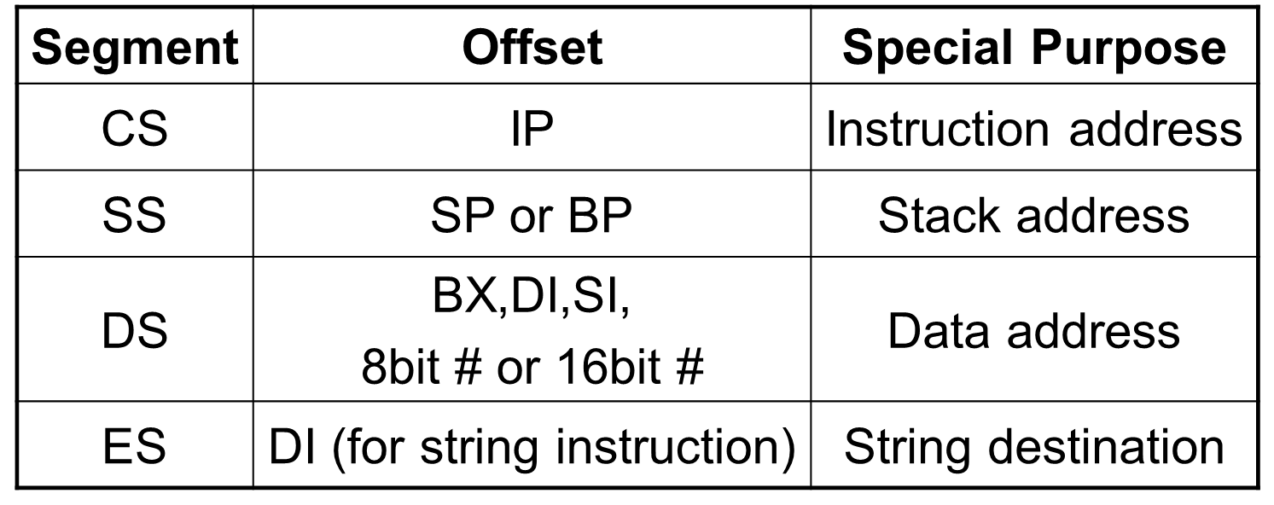
    - Which memory locations are addressed by: MOV DL, [BP]?
      - Since BP, we use segment SS 20000 + FF = 200FF
1 memory location only since you are moving to DL (1 byte) | 200FFh
    - Which memory locations are addressed by: MOV EAX, [BX+DI]?
      - First we add BX+DI FFFF + 5 = 1 0004 (drop the 1 cuz its an OF)
      - Then we add that to DS 1000 + 0004 = 1004
      - 4 memory locations since you are moving to EAX (4 bytes = 32 bits). Therefore memory locations 10004, 10005, 10006, 10007
  - Explain why the max size of a memory segment in the real addressing mode is 64K.
    - Since each segment is 16 bits, 2^16 = 2^6 x 2^10 = 64K
  - Code a descriptor that describes a data memory segment that grows upward and begins at location 03000000H and ends at location 05FFFFFFH and can be written. The memory has not been accessed, and can be accessed with the lowest privilege level. Assume that the segment is available (i.e., AV=1) and that the instructions are 32 bits (i.e., D=1).
    - Start=base=03000000 = 0000 0011 0000 0000 0000 0000 0000 0000
    - Size=end-start=05FFFFFF – 03000000 = 02FFFFFF. With G=FFF=1 and limit = 02FFF → 0000 0010 1111 1111 1111
    - Access Rights:
      - A=0 cuz memory has not been accessed
      - W=1 since data may be written
      - ED=0 since segment grows upwards
      - E=0 since descriptor describes a memory segment
      - S=1 since it’s a data descriptor
      - DPL=11 since it’s the lowest privilege level
      - P=1 since segment contains valid base and limit
Base (B31-B24) 0000 0011 | G=1 | D=1 | 0 | AV=1 | Limit (L19-L16) 0000
Access Rights 11110010 | Base (B23-B16) 0000 0000
Base (B15-B0) 0000 0000 0000 0000
Limit (L15-L0) 0010 1111 1111 1111
- Addressing modes and machine coding:
  - Machine encode the instruction MOV AX, [BX+DI+2H]
    - MOV acc, mem → 1010 00dw disp
W=1 since we moving to AX d=1 since moving to reg AX
Disp= 02 = 0000 0010
Therefore, final instruction is A302
  - What is the instruction corresponding to the following machine code: 8CC8H?
    - 8CC8 = 1000 1100 1100 1000
which matches to 1000 11d0 ooss smmm disp
d=0=out of reg oo=11 sss=001=CS mmm=000=AX no disp
therefore, final instruction is MOV CS, AX
  - Let IP=0100H and CS=1000H before executing the previous instruction. What are the contents of the memory location CS:IP and CS:IP+1?
    - IP=0100 CS=1000 CS+IP= 10000 + 0100 = 10100
    - Therefore, AH in 10101 and AL in 10100
  - Estimate the execution time of the following code:
MOV DI, FH (reg, imm) 4 cycles 1 time 4
Again: ADD [1234H+DI],AL (mem, reg) 16+ea=25 15 375
DEC DI 3 15 45
JNZ Again T 16 14 224
F 4 1 4
=652
- The 8086 and 8088 hardware and bus structure
  - Suppose that a microprocessor operates at 5MHz. How long does the bus cycle occupy, assuming no wait states are inserted?
    - Period of each t state = 1/5Mhz = 200 ns. In 1 bus cycle, there are 4 t states, so 4 x 200 ns = 800 ns.
  - What happens during T1, T2, T3 and T4 of a standard write bus cycle? Show a timing diagram.
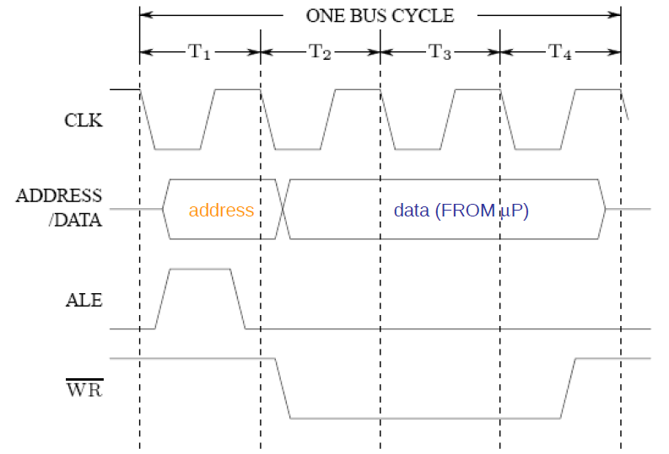
    - T1: address latch enable goes high, address is shown on bus, nothing is being written
    - T2: Address latch enable is now low, data starts to be written since WR is now low
    - T3: data still being written
    - T4: signals are being finalized and deactivated
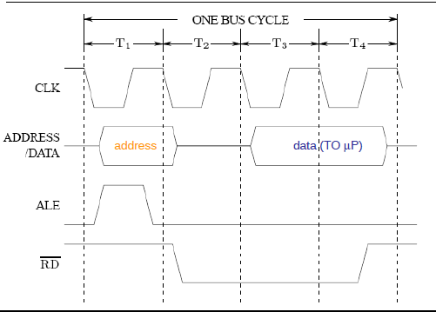
  - Design a circuit that uses the 8284A clock generator and an 8-bit shift register to insert two wait state in the bus cycle of the 8086 microprocessor. Don’t forget to show the signal coming from the external device that needs the wait states.
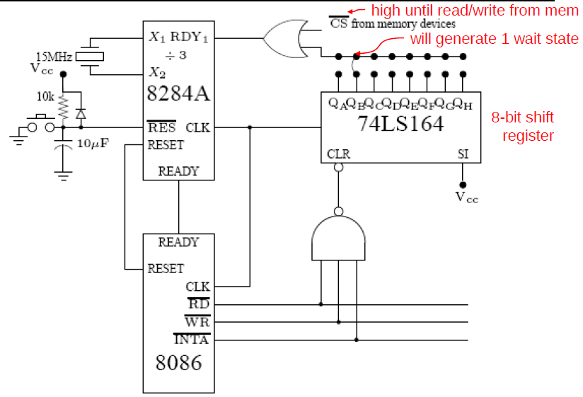

- Memory interfacing: Design a memory interface for the 8086 which will provide 128K bytes of SRAM, organized as 64K×16 bits, starting at address 50000H and using 62256 SRAM 32K×8 chips. Follow the following steps to arrive at the required design.
  - How many chips are required?
    - 128 / 32 = 4 chips
  - How many address lines go to each chip?
    - 32K = 2^5 x 2^10 = 2^15, therefore 15 address lines
  - How will the chips be organized in banks? Which parts of the address bus will be used?
    - 2 in low bank and 2 in high bank. And since 32K=2^15 → 15 bits address are used (B15-B1)
  - Determine the address range?
    - Start = 50000 = 0101 0000 0000 0000 0000
    - Size = 128K=2^7 x 2^10 = 2^17, so 17 bits of 1, now add these 2 together, we get
    - 0110 1111 1111 1111 1111
    - Where constant = 01 select = 10 memory= 111 1111 1111 1111 BLE=1
  - Generate the overall chip select signal (MSEL)
    - Use the constant bits
  - Generate the bank specific write signals
    - 

