Week 3 – Maintenance and Reliability

Defining Reliable
- Authentic, consistent, infallible
- Trustworthy apply to persons, objects, ideas, or information that can be depended upon with confident certainty
- Reliable suggests
- Consistent dependability of judgement, character, performance
- Such as a reliable formula, judge, car, meteorologist
Being reliable
- In this course, consider that the objective of maintenance and reliability is to maintain the capability of systems. Systems make products, products make money.
The Strategic Importance of Maintenance of Reliability
At the Pickering nuclear generating station, a generator failure is very expensive for both the company and its customers. Power outages are instantaneous, with potentially devastating consequences. Similarly, managers at frito-lay, walt Disney, and UPS are intolerant of failures or breakdown.
- Maintenance is critical at Frito-Lay to achieve high plant utilization and excellent sanitation
- At Disney, sparkling clean facilities and safe rides are necessary to retain its standing as one of the most popular vacation destinations in the world
- UPS’s famed maintenance strategy keeps its delivery vehicles operating and looking as good as new for nearly 20+ years
Summary of Strategic Importance of Reliability
- Failure has far-reaching effects on a firm’s:
  - Operation
  - Reputation
  - Profitability
  - Dissatisfied customers
  - Idle employees
  - Profits becoming losses
  - Reduced value of investment in plant and equipment
The objective of maintenance and reliability is to maintain the capability of the system. Good maintenance removes variability. Systems must be designed and maintained to reach expected performance and quality standards.
- Maintenance includes all activities involved in keeping a system’s equipment in working order
- Reliability is the probability that a machine part or product will function properly for a specific time under stated conditions

Variability corrupts processes and creates waste. Designing for reliability and managing for maintenance are crucial ingredients for doing so. The four tactics organized around reliability and maintenance are:
- Reliability tactics
  - Improving individual components
  - Providing redundancy
- Maintenance tactics
- Implementing or improving preventative maintenance
- Increasing repair capabilities or speed
Reliability
Systems are composed of a series of individual interrelated components, each performing a specific job. If any one component fails to perform, for whatever reason, the overall system (ex. airplane) can fail.
Reliability can be improved by considering any and all of the following:
- Component design
- Production/assembly techniques
- Testing
- Redundancy/backup
- Preventative maintenance procedures
- User education
- System design

Improving individual components
Because failures do occur in the real world, understanding their occurrence is an important reliability concept. We now examine the impact of a failure in series. The figure below shows that as the number of components in a series increases, the reliability of the whole system declines very quickly.
- A system of n=58 interacting parts, each of which has a 99.5% reliability, has an overall reliability of 78%.
- If the system or machine has 100 interacting parts, each with an individual reliability of 99.5%, the overall reliability will only be about 60%.
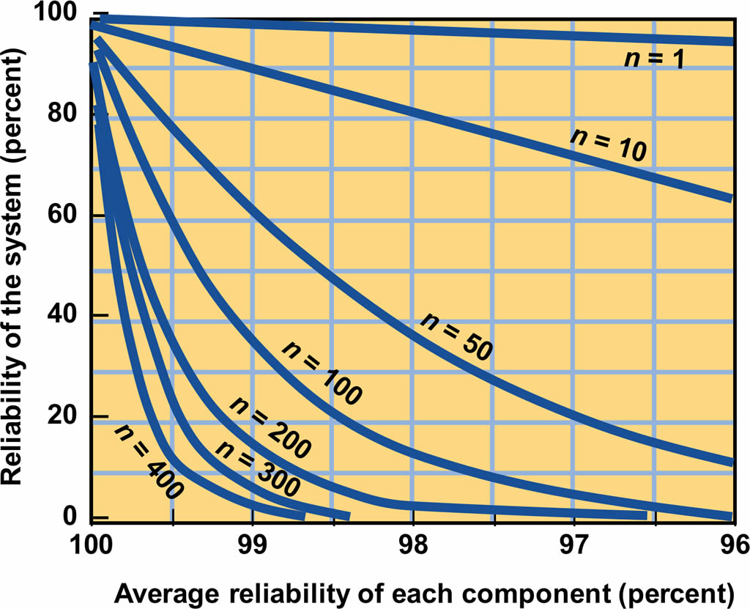

To measure reliability of a system in which each individual parts of components may have their own unique rates of reliability, we cannot use the reliability curve in the figure. However, the method of computing system reliability (Rs) is simple. It consists of finding the product of individual reliabilities as follows.
RS=R1×R2×R3×...×RnRS=R1×R2×R3×...×Rn
Where
R1=R1= reliability of component 1
R2=R2= reliability of component 2

EXAMPLE 1.
The Bank of Montreal’s loan-processing centre processes loan applications through three clerks set up in a series, with reliabilities of 0.90, 0.80. and 0.99, find the system reliability.
Answer:
Rs = R1 x R2 x R3
=0.90 x 0.80 x 0.99
= 0.713 or 71.3 %
Because each clerk in the series is less than perfect, the air probabilities are cumulative and the resulting reliability for this series is 0.713, which is less than any single clerk.
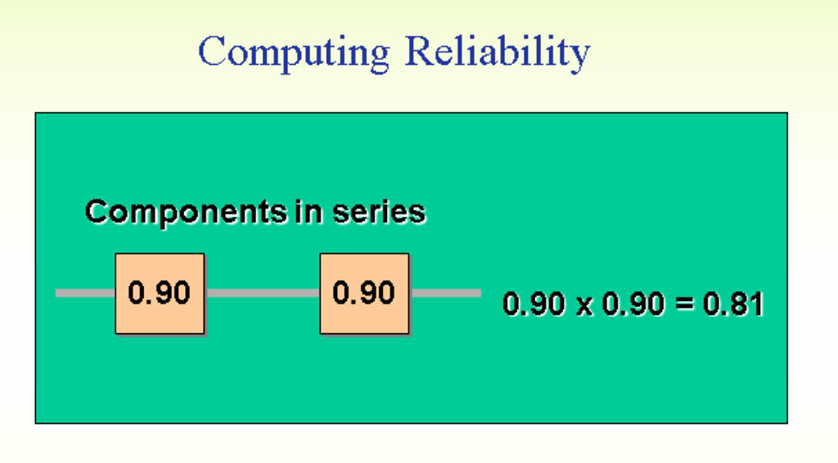

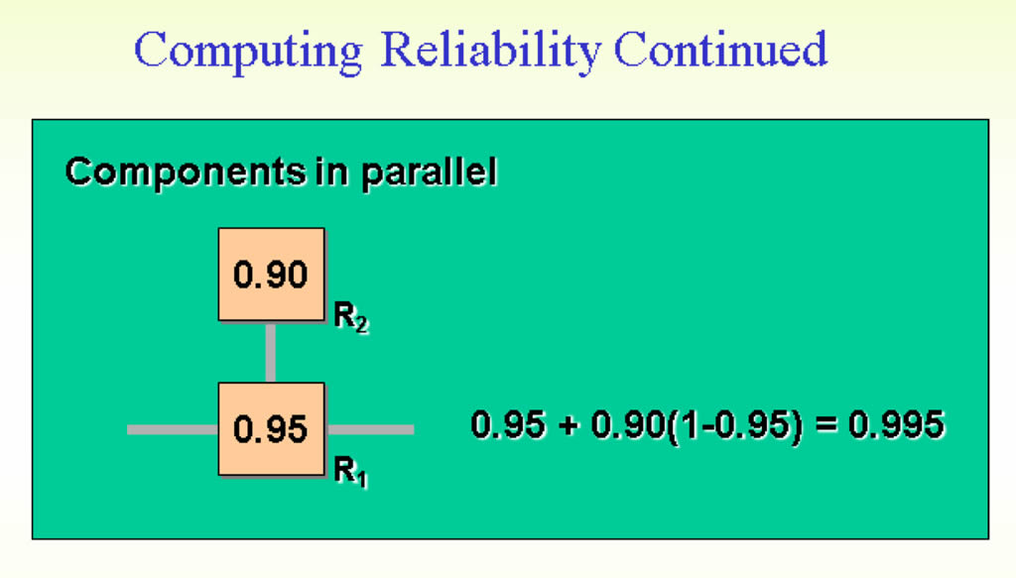
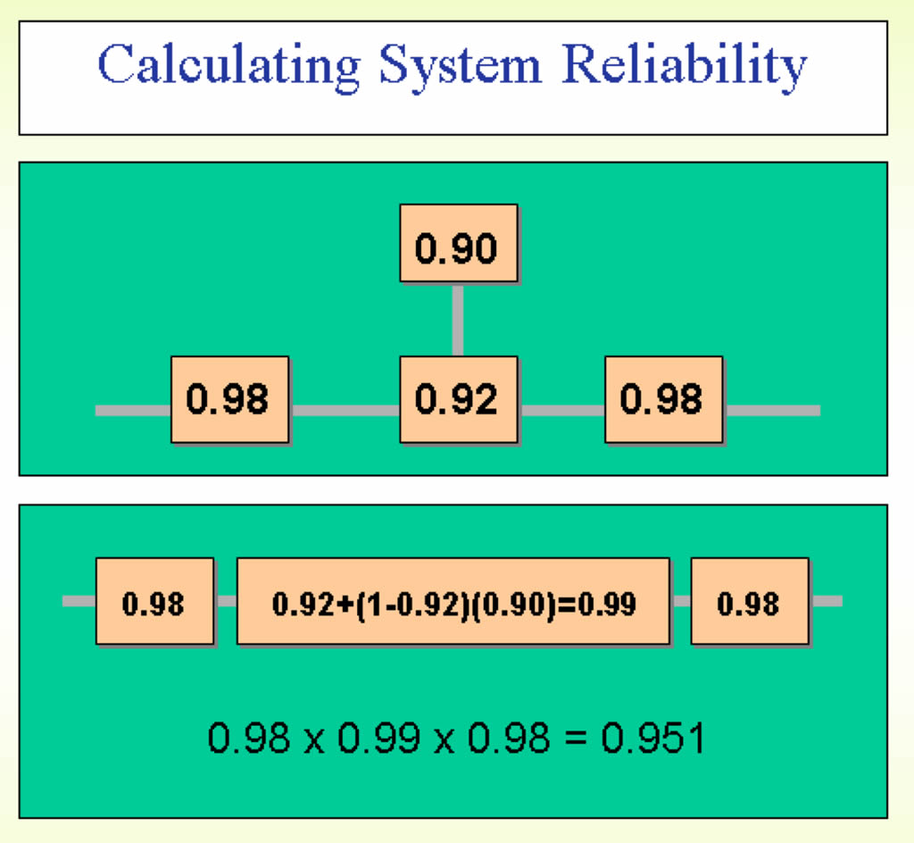

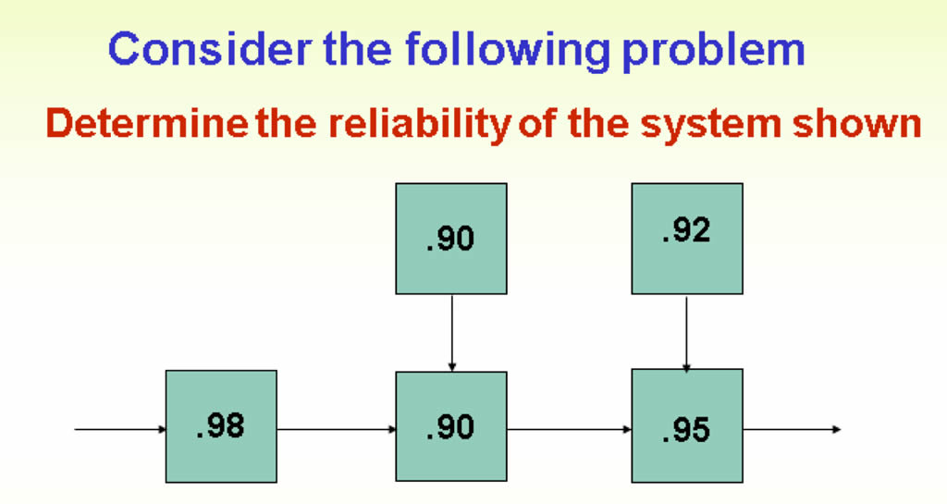
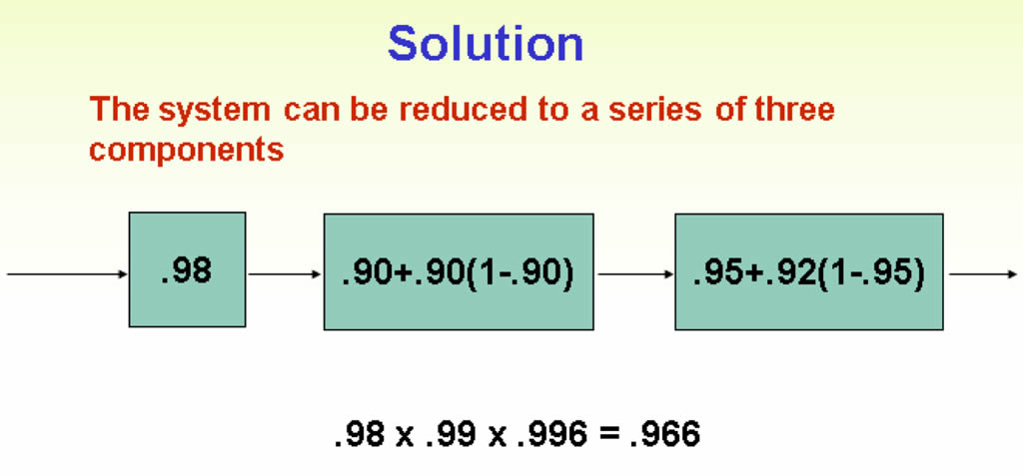

Product Failure Rate
Component reliability is often a design or specification issue for which engineering-design personnel may be responsible, however, supply-chain personnel may be able to improve components of systems by staying abreast of supplier’s products and research efforts. Supply-chain personnel can also contribute directly to evaluation of supplier performance. The basic unit of measure for reliability is the product failure rate.
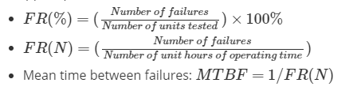
Providing Redundancy
To increase the reliability of systems, redundancy is added. The technique is to “back up” components with additional components. This is known as putting units in parallel and is a standard operations management tactic. Redundancy is provided to ensure that if one component fails, the system has recourse to another. This can be expressed as:
Probability of first component working + [(probability of second component working) X (probability of needing second component)]

EXAMPLE
Say that reliability of a component is 0.80 and we back it up with another component with reliability of 0.80. The resulting reliability is the probability of the first component working plus the probability of the backup or parallel component working multiplied are the probability of needing the back of component:
0.80 + [(0.80 x (1.0 - 0.80)]
0.80 + (0.80 x 0.2) = 0.80 + 0.16 = 0.96, or 96% reliability

- What is the objective of maintenance and reliability?
- How does one identify a candidate for preventive maintenance?
- Why is simulation often an appropriate technique for maintenance problems?
- What is the trade-off between having an operator perform maintenance versus having a supplier perform maintenance?
- How can a manager evaluate the effectiveness of the maintenance function?
- How does machine design contribute to either increasing or alleviating the maintenance problem?
- What roles can information technology play in the maintenance function?
- During an argument as to the merits of preventive maintenance the company owner asked, “Why fix it before it breaks?” How would you, as the Director of Maintenance, respond?
- Will preventative maintenance eliminate all breakdowns?

