Test One Review

Review: Lecture 1

Globalization:
- National boundaries of world business have largely disappeared

Technology:
- Increasing demand for workers with technological skills

Workforce Diversity:
- Gender, race, age, religion, sexual orientation offers challenges and opportunities to employees
Talent:
- Intellectual capital is the collective brainpower of a workforce that can be used to create value

Ethics:
- Code of moral principles of conduct about what is good and right

Organizations:
- People working together to achieve a common purpose

Organizational Environment:
- Competitive Advantage
  - A core competency that clearly sets an organization apart from competitors and gives it an advantage over them in the marketplace
  - Achieved through
    - Cost efficiency, Higher quality, Better delivery, Greater flexibility

Managers in the New Workplace:
- Line Managers:
  - Responsible for work activities that directly affect organizations outputs
- Staff Managers:
  - Use technical expertise to advise and support efforts of line workers
- Functional Managers:
  - Responsible for more complex units that include many functional areas
- Administrators:
  - Work in public and non-profit organizations

Managerial Performance and accountability:
- Accountability:
  - The requirement of one person to answer to a higher authority for relevant performance results
- Effective Managers fulfill performance accountability by helping others to achieve high performance
- Quality of work life
  - An indicator of the overall quality of human experiences in the workplace
  - Fair play, safe working conditions, opportunities to learn, room to grow, pride in work, protection of individual rights

4 Functions of management:
- Planning, Organizing, Leading, Controlling

Managerial Skills:
- Technical skill:
  - The ability to apply a special proficiency or expertise to perform tasks
- Human/interpersonal:
  - Ability to work well with others
    - Emotional Intelligence
      - Ability to manage ourselves and relationships effectively
  - Conceptual Skill
    - Ability to think critically and analytically to solve complex problems

Review: Lecture 2

Information and knowledge – Basic Linkages:
- Knowledge Worker:
  - Someone whose value to the organization rests with intellect, not physical capabilities
- Intellectual Capital
  - Shared knowledge of a workforce that can be used to create wealth
- Data: Raw facts and observations
- Information: Data made useful for decision making
- Characteristics of Useful Information
  - Timely, High quality, Complete, Relevant, Understandable

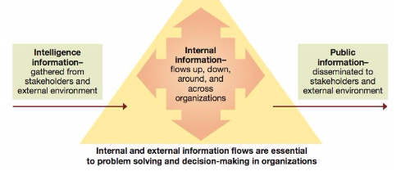

Implications of IT:
- Facilitation of communication and information sharing
- Operating with fewer middle managers
- Flattening of organizational structures
- Faster decision making
- Increased coordination and control

Organizations Need Information:
- Information exchanges with external environment
  - Gather intelligence information
  - Provide public information
- Information exchanges within the organization
  - Facilitate decision making and problem solving
- Basic information system concepts:
  - Information system
    - Use of IT to collect, organize, and distribute data for decision making
  - Management Information System (MIS)
    - Specifically designed to meet the information needs to managers in daily decision making
- Managerial Advantages of IT utilization:
  - Planning
    - Timely access to useful information
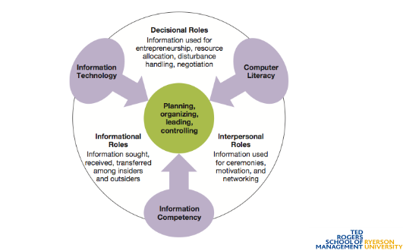
  - Organizing
    - Improved communication, coordination and integration
  - Leading
    - Improved communication and clear objectives
  - Controlling
    - Most accurate performance measuring, real-time
solutions

Informational and Managerial Decisions:
Problem Deficiency:
- Actual performance being less than desired performance
Performance Opportunity:
- Actual performance being better than desired performance
Problem Solving:
- The process of identifying a discrepancy between actual and desired performance and acting to resolve it
Decision:
- A choice among possible alternative course of action

Problem Solving Approaches:
- Avoiders
  - Inactive in information gathering and solving problems
- Solvers
  - Reactive in gathering information and solving problems
- Seekers
  - Proactive in anticipation problems and opportunities and taking appropriate action to gain an advantage

Systematic VS. Intuitive Thinking:
- Systematic Thinking
  - Approaches problems in a rational, step-by-step, and analytical fashion
- Intuitive Thinking
  - Approaches problems in a flexible and spontaneous fashion
- Multidimensional Thinking
  - Applies both intuitive and systematic
- Effective Multidimensional Thinking
  - Requires skill at effective opportunism

Cognitive Styles
- Sensation Thinkers
  - Emphasize the impersonal rather than the personal and take a realistic approach to problem solving
- Intuitive Thinkers
  - Are comfortable with abstraction and ted to be idealistic. Spontaneous fashion
- Sensation Feelers:
  - Emphasize analysis and human relations and tend to be realistic and prefer facts
- Intuitive Feelers
  - Prefer broad and global issues and are comfortable with intangibles

Programmed Decisions:
- Apply solutions that are readily available from past experiences to solve structured problems
- Structured Problems:
  - Ones that are familiar, straightforward, and clear with respect to information needs
- Best applied to routine problems that can be anticipated

Non-Programmed Decisions:
- Develop novel solutions to meet the demands of unique situation that present unstructured problems
- Unstructured problems
  - Ones that are full of ambiguities and information deficiencies
- Commonly faced by higher-level management

Crisis Decision Making:
- A crisis involves an unexpected problem that can lead to disaster if not resolved quickly and appropriately
- Rules
  - What is going on, Speed matters, Slow counts too, respect the danger, value the skeptic, fight fire with fire

Decision Environments:
- Certain
  - Offer complete information about possible action alternatives and their outcomes
- Risk
  - Lack complete information about action alternatives and their consequences, but offer some estimates of probabilities of outcomes for possible action alternatives
- Uncertain
  - Information is so poor that probabilities cannot be assigned to likely outcomes of know action alternatives

The Decision-Making Process:
- Step 1: Identify and define the problem
- Step 2: Generate and evaluate possible outcomes
  - Benefits, Costs, Timeliness, Acceptability, Ethical Soundness
- Step 3: Decide on a preferred course of action
  - Classical decision model
    - Managers act rationally in a certain world
    - Face defined problems and have knowledge of all alternatives and consequences
    - Results in an optimizing decision
  - Behavioural decision model
    - Managers act in terms of what they perceive about a given situation
    - Recognize limits to human information-processing capabilities
      - Cognitive limitations, Bounded rationality, Results in a satisfying decision

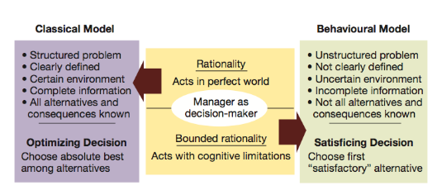

- Step 4: Implement the decision solution
  - Involves acting to make sure the solution decided upon becomes a reality
  - Managers need to have willingness and ability to implement action plans
  - Lack-of-participation error should be avoided
- Step 5: Evaluate results
  - Involves comparing actual and desired results
  - Positive and negative consequences of chosen course of action should be examined
  - If actual results fall short of desires, return to earlier steps

Types of heuristics of simplifying decision making:
- Availability heuristic
  - People use information “readily available” from memory as a basis for assessing a current event or situation
- Representativeness heuristic
  - People assess the likelihood of something happening based upon its similarity to a stereotyped set of occurrences
- Anchoring and adjustment heuristic
  - People make decisions based on adjustments to a previously existing value or starting point

Creative Decision Making should be encouraged in organizations and are highly task motivated
Group Decision: Advantage
- Greater availability of information and knowledge; more alternatives
- Commitment, understanding and acceptance of outcomes
Group Decision: Disadvantage
- Pressure to conform; minority may dominate
- Decision making takes longer
Works Best When:
- Problem is unclear
- Time is sufficient
Ethical Decision Making:
- Leads to better decisions and presentation of costly litigation
- Decisions satisfy the criteria of Unity, Rights, Justice, Caring

Review: Lecture 3

Management and Globalization:
Global Economy:
- Resource supplies, product markets, and business competition are worldwide, rather than local
Globalization:
- The process of growing interdependence of these components in the global economy
Global Management:
- Management in organizations with business interests in more than one country
Global Manager:
- Informed about international developments
- Transnational in outlook
- Competent in working with multicultural people
- Aware of regional developments in a changing world
Global Businesses:
- Conduct for-profit transactions of goods and services across national boundaries
Reasons Why Businesses Go Global:
- Profits, Customers, Supplies, Capital, Labor

Market Entry Strategies:
- Involve the sale of goods or services to foreign markets but do not require expensive investments
- Types
  - Global sourcing
    - The process of purchasing materials or services around the world for local use
  - Exporting
    - Selling locally made products in foreign markets
  - Importing
    - Buying foreign-made products and selling them domestically
  - Licensing agreement
    - One firm pays fee for a right to make or sell another company’s products
  - Franchising
    - A fee is paid for rights to use another firm’s name and operating methods

Foreign Direct Investment:
- Building, buying all, or buying part ownership of a business in another country
  - Insourcing
    - Job creation through foreign direct investment
Types of Direct Investment Strategies:
- Joint ventures
  - Operated in a foreign country through co-ownership by foreign and local partners
  - Criteria
    - Familiarity with your firm’s major business
    - Strong local workforce
    - Future expansion possibilities
    - Values its customers
    - Strong local market for partner’s own products
    - Good profit potential
    - Sound financial standing
- Global strategic alliances
  - A partnership in which foreign and domestic firms share resources and knowledge for mutual gains
- Foreign subsidiaries
  - Local operation completely owned by a foreign firm
Complications in the Global Business Environment:
- Political risk
  - The potential loss in value of a foreign investment due to inability and changes in host country
- Local legal systems
  - Complex and unfamiliar laws can create problems
- World Trade Organizations
  - Resolves trade and tariff disputes among countries
- Protectionism
  - Can complicate global trading relationships

Regional Economic Alliances:
- NAFTA
  - North American Free Trade Agreement
- TPP
  - Trans-pacific partnership
- EU
  - European Union
- SADC
  - Southern Africa Development Community

Types of Global Businesses:
- Global corporation
  - MNC (multinational corporation) with extensive business operations in more than one foreign country
- Transnational corporation
  - MNC operates worldwide on a borderless basis

Host-country Benefits of Multinational Corporations:
- Larger tax bases, Increased employment opportunities, Technology transfers, Introduction of new industries, Development of local resources

Host-country Complaints of Multinational Corporations:
- Excessive profits, Domination of local economy, Interference with local government, Hiring the best local talent, Limited technology transfer, Disrespect for local customs
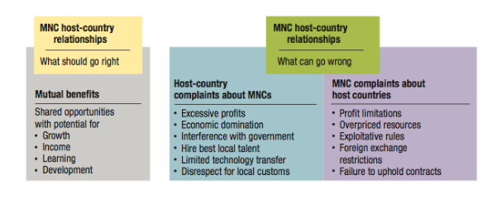

Ethical Issues for Multinational Corporations:
- Corruption
  - Illegal practices that further one’s business interest
- Sweatshops
  - Employing workers at low wages for long hours and in poor working conditions
- Child labor
  - Full-time employment of children for work otherwise done by adults
- Sustainable development
  - Meeting current needs without compromising future needs

Review: Lecture 4

Culture and global Diversity:

Culture
- The shared set of beliefs, values and patterns of behaviour common to a group of people
Cultural shock
- Confusion and discomfort a person experiences in an unfamiliar culture
Ethnocentrism
- Tendency to consider one’s own culture as a superior to others
Cultural intelligence
- The ability to adapt and adjust to new cultures

Stages of adjustment
- Confusion, Small victories, Honeymoon, Irritation and anger, Reality

Silent Language of culture
- Context
  - Low-context cultures
    - Emphasize communication via spoken or written words
  - High-context cultures
    - Rely on nonverbal and situational cues as well as on spoken or written words in communication
- Time
  - Monochronic
    - People tend to do one thing at a time
  - Polychromic
    - Time is used to accomplish many different things at once
- Space
  - Proxemics
    - Is how people use space to communicate

Values and National Cultures (Hofstede)
- Power Distance
  - How power is distributed within an organization
- Uncertainty Avoidance
- Individualism VS. Collectivism
- Masculinity VS. Femininity
- Time Orientation
- Indulgence

Project GLOBE (Global Leadership and Organizational Behavior Effectiveness)
- Power distance, Uncertainty avoidance, Gender egalitarianism, Future orientation, Institutional collectivism, In-group collectivism, Assertiveness, Performance orientation, Humane orientation

Review: Lecture 5

Classical Management Approaches:

Scientific Management (Frederick Taylor)
- Develop rules of motion, standardized work implements, and proper working conditions for every job
- Carefully select workers with the right abilities for the job
- Carefully train works and provide proper incentives
- Support by planning and removing obstacles for workers
- Scientific Management (the Gilbreths)
  - Motion Study
    - Science of reducing a job to its basic physical motions
    - Eliminating wasted movements improves performance

Administrative Principles (Henri Fayol)
- Division of labor, Authority, Discipline, Unity of command, Unity of direction, Subordination of individual interests, Remuneration, Centralization, Scala chain, Order, Equity, Personnel tenure, Initiative, Esprit de corps
- Scalar Chain
  - There should be a clear and unbroken line of communication from the top to the bottom of the organization
- Unity of Command
  - Each person should receive orders from only one boss
- Unity of Direction
  - One person should oversee all activities with the same performance objectives

Bureaucratic Organization (Max Weber)
- An ideal, intentionally rational, and very effective form of organization
- Based on principles of logic order and legitimate authority
- Characteristics
  - Clear division of labor, Clear hierarchy of authority, Formal rules and procedures, Impersonality, Careers based on merit
- Disadvantages
  - Excessive paperwork, Slowness in handling problems, Rigidity in the face of shifting needs, Resistance to change, Employee apathy
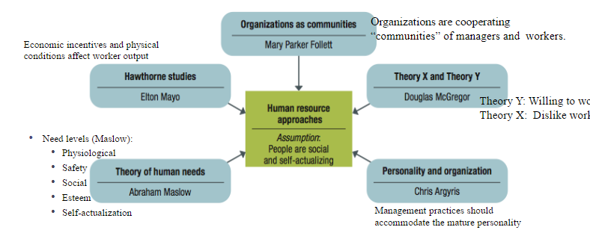

Higher Order Needs:
- Self-actualization and Esteem needs

Lowe Order Needs:
- Social, Safety, Physiological
Contingency Thinking
- Each Managerial is unique to each situation
Total Quality Management (TQM)
- Continuous quality improvement for a total organization: ISO certification
Knowledge Management
- Process of using information technology to achieve performance success; intellectual assets include patents, intellectual property rights, trade secrets
Organizational Learning VS. Learning Organization
- A Learning Organization continuously improves, using the lessons of experience

Attributes of a 21st Century Manager:
- Global strategist
  - Understanding the interconnections among nations, cultures and economies
- Master of technology
- Inspiring leader
- Model of ethical behavior

Types of Plans Used by Managers:
- Strategic
  - Set broad, comprehensive and longer-term action directions for the entire organization
- Tactical
  - Define what needs to be done in a specific function to implement strategic plans
    - Production, Financial, Facilities, Marketing and Human resource plans
- Operational
  - Policies
    - Broad guidelines for making decision and acting in specific circumstances
  - Rules/procedures
    - Plans that describe exactly what actions are to be taken in specific situations
  - Budgets
    - Single-use plans that commit resources to activities, projects, or programs
    - Fixed, flexible, and zero-based budget

Planning Tools and Techniques:
- Forecasting
- Contingency
  - Identifying alternative courses of action that can be implemented if circumstances change
- Scenario
- Benchmarking
- Use of staff planners

Achieving Goals:
- Goal setting
- Specific, Measurable, Attainable, Regularly referred to, Timely (SMART)

Review: Lecture 6

The Nature of Entrepreneurship:
Entrepreneurship:
- Strategic thinking and risk-taking behavior that results in the creation of new opportunities for individuals and or organizations
Entrepreneurs:
- Risk-taking individuals who take actions to pursue opportunities and situations others may fail to recognize or may view as problems or threats
- Are….
  - Founders or a business that become large-scale enterprises
  - People who:
    - Buy a local franchise outlet
    - Open a small retail shop
    - Operate a self-employed service business
  - People who introduce a new product or operational change in an existing organization (also known as INTRAPRENEURS)

Factors for Small Businesses Success:
- Focus, Motivation, Commitment, Resourcefulness, Government support, Networking, Niche opportunism
Small Business failures:
- Poor financial control, Lack of experience, Lack of commitment, Lack of strategy, Ethical failure, Growing too fast, Lack of strategic leadership

New Venture Creation:
- Birth stage
  - Establishes the firm
  - Getting customers
  - Finding the money
  - “FIGHTING FOR EXISTENCE AND SURVIVAL”
- Breakthrough stage
  - Working on finances
  - Becoming profitable
  - Growing
  - “COPING WITH GROWTH AND TAKE OFF”
- Maturity stage
  - Refining the strategy
  - Continuing growth
  - Managing for success
  - “INVESTING WISELY AND STAYING FLEXIBLE”

Items that must be included in a business plan:
- Executive summary, Industry analysis, Company description, Product description, Market description, Marketing strategy, Operations, Staffing, Financial position, Capital needs, Milestones

Forms of Legal Ownership:
- Sole Proprietorship
- Partnership
- Corporation
- Limited liability corporation (LLC)

Financing the New Venture:
- Outside financing
  - Debt
  - Equity
- Equity financing alternatives
  - Venture capitalist
  - Initial public offerings
  - Angel investors

Test Possibilities

Q1: Who us know as the father of scientific method?
A: Frederick Taylor

Q2: In a management by objectives approach, the supervisor/team leader and subordinates/team members______
A2: Jointly plan, individually act, and jointly control

Q3: The stage in the life cycle of entrepreneurial companies in which the business is fighting for existence and survival is called the renewal stage.
A3: False

Q4: Exploiting a niche or entering a market before competitors is called a ________
A4: Entrepreneurial mistake

Q5: Hofstede would describe a culture whose members respect age and authority and whose workers defer to the preferences of their supervisors as….
A5: High Power Distance

