Assignment #1

Course Name: From Our Star to the Cosmos
Course Code: Phys 1902

Q. No. 1.
- In the article, Bohannon, a science columnist who has a Ph.D., describes how he carried out an elaborate hoax to expose how easily bad nutrition science gets disseminated in the mainstream media. Bohannon's full story is long yet justified regardless of the read as it brings out the shortcomings in science communication, particularly nutrition data in the present media. The study showed accelerated weight loss in the chocolate-eating group. Bohannon and his partners chose to make a wrong to demonstrate that wrongs exist. They deceived general society to make their point. He and his colleagues set out to demonstrate how easy it is to turn bad science into the big headlines and get attention from public. They recruited people and did small clinical tests on them to see whether eating dark chocolate helped people lose weight. The team used real data from their real trial and published their results in a real journal, the International Archives of Medicine. The study did find an effect, but that was likely due to a statistical sleight-of-hand; it was impossible to say whether chocolate really helped people lose weight. The study design itself was flawed as it had only few subjects, and the research measured too many factors, making it likelier that some random factor would appear to have statistical significance. He himself explains the specifics himself. He wanted show that there are journalists reporting on a study that was never done. We have news releases from medical journals, academic institutions and industry that mislead journalists, who then mislead the public.

Through his article Bohannon was able to deceive the public. In journalism deception is used to uncover serious wrongs or as a last tactic when there are no other ways to expose fraud. Even though his thought behind this idea was the welfare of the people I feel like he should have used some other methods to convey his points. That's an undoubted benefit, but one does not experiment on humans without informed consent. At least, participants should have been debriefed at the end of the study period about what Bohannon intended to do with the data. Not only was Bohannon's con morally inexcusable he deceived general society, undermining their trust in both news coverage and science Also he is liable of the very practices he asserts he uncovered. It's deliberate deception in a way that could harm people. There's so much bad information out there, especially around diet and science, that when you make it worse you become part of the problem.

But I guess it did have some benefits too. Health journalists now know that they might be outed as fools if they don't do due diligence. Now most of them are aware about the consequences and backlashes they are going to face making false and fake reports.

- Journalists’ awareness of scientific methods can improve the quality of scientific reporting. Scientists have an important responsibility not only to make and communicate new discoveries, but also to help educate journalists and the public about basic scientific principles. Many cases of poor science reporting arise not because of deliberate fabrication, but because a journalist has inadequate knowledge about the philosophy of science. Since journalists are the primary conduits for public dissemination of science, this ignorance then feeds directly to the media consumer. Scientists should also be careful to help journalists avoid logical fallacies. Increased engagement between scientists and journalists will result in increased public education. Also, to encourage more accuracy in reporting incentives can be provided to the journalists. This will help them to provide public with more accurate and engaging reports.

Q
.

No.

2

a.
Equ
i
nox = 90
–

45

=
45

degre
es

North P
olaris

South

P
olaris

Horizon

Ecliptic

E
quino
x

Sun

Celestial Equator

b. Solstice 68.5 degrees
Sun
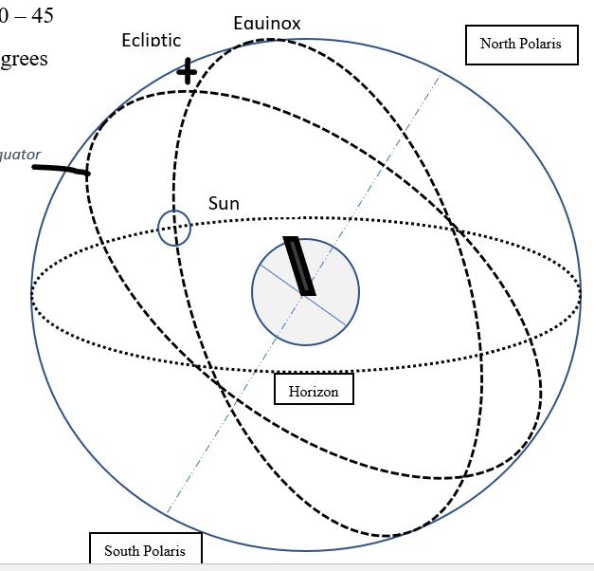
Celestial Equator
Solstice

