Unit 3
Species: A group of organisms that can reproduce viable offspring’s
Biological evolution: New species arise
Natural selection: Acts on natural genetic variation (or diversity) between individuals
- Certain traits more likely to survive and reproduce under certain environmental conditions

Environments are always changing (Slide 25)
Change in Environment: Droughts, flooding, hurricanes, etc.…
- When environments change, some individuals in a population may breed and survive more successfully than others
Natural Selection (Slide 27)
- There is a variation in traits: (e.g., some beetles are GREEN some a BROWN)
- Differential reproduction:
- Environment can’t always support unlimited population growth, not all individuals get to reproduce to their full potential (e.g., GREEN beetles eaten by birds and survive to produce less often than BROWN beetles do)
3. Heredity: (surviving BROWN beetles have brown baby beetles as their traits get passed on; genetic basis)
4. End result: More advantageous trait, brown coloration, allowing the beetle to have more offspring, becomes more common in the population
- If continued all individuals in the population will be brown

Evolution by natural selection (Slide 28)
Genetic variation: Populations evolve through the action of natural selection
Where variation come from?
- Some natural/random when traits are product of many genes
- Arises through mutation
Mutations: Random changes in DNA molecules
- Most mutations are mildly DETERIOUS (harmful)
- Occurs at random

Who is Charles Darwin?
- Wrote Origin on Species: Natural selection
- Explored the world on the “HMS beagle” where he explored evolution
- Went to South America in the Galapagos
Rosemary and Pater Grant (Slide 33)
- Discovered that finches had different beaks (at the Galapagos)
- Different environmental conditions caused some to die and some to survive due their beak sizes to find food (Those that survived passed their genetic information)
- ONLY ONE mainland bird came to the Galapagos and created 13 different species of finches (ONLY ONE COMMON ANCESTOR)
- Natural selection changed the average beak size

New species (Slide 35)
Speciation (new species arising): When populations of the same species become reproductively isolated (no longer interbreed)
- Geographic isolation
- Temporal/habitat isolation
- Behavioural isolation

Evolution, Speciation, and Extinction (Slide 36)
Phyletic evolution: Process in which population has undergone so much change that it is no longer able to interbreed with the original population and new species is formed (speciation)
Speciation: Occur due to geographic isolation of populations or adaptations of a part of a population to a new food source
Genetic diversity: Helps to protect a species from extinction

Adaptation through Natural Selection Has Limits (Slide 37)
- Adaptive genetic traits MUST EXIST in the population BEFORE change in the environmental conditions
- When environmental change is extremely rapid, species may not be able to adapt in time
- Reproductive capacity
- Species that reproduce rapidly and in large numbers are better able to adapt QUICKLY
- K-Strategists and r-Strategists

Characteristics of K-Strategists and r-Strategists (Slide 38)
K-Strategies (vulnerable for species) e.g., most mammals
r-Strategies (fittest species - reproduce quickly) e.g., mushrooms, insects, rabbits

Correcting Common Misunderstandings of Evolution through Natural Selection (Slide 38)
- Selection acts at the level of the individual/genes, not species
- “survival of the fittest” is not “survival of the strongest” or “best” better to think of “Fit” to environment
- Organisms do not develop traits out of need or desire (mutation is random)
- No grand plan of nature for perfect adaptation, adaptation is both inevitable when environments change and no guarantee of survival when changes occur rapidly
- Complex organisms are not “more evolved” or “more adapted”, although there are trends of increasing complexity over evolutionary time
- Naturalistic fallacy/ is-ought problem

Human influences on species evolution (Slide 39)
- Directly introduce selection pressure
- Indirectly introduce selection pressure through environmental change
- Introduce alien species and genes
- Eliminate species through extinction and extirpation
“Unnatural selection?” Human introduced selection pressure (Slide 41)
- Humans introduce a factor or agent that applies selection pressure and may favour mutations that could otherwise be deleterious
- Strong section pressure → rapid evolution if all wild type individuals can’t survive selection pressure (e.g., Antibiotics)
Indirect selection pressure from human-cause environmental changes (Slide 46)
- Human caused climate change
- Flower blooming earlier, Phenology: the study of seasonal phenomena
- Migration timing changing (later departure, earlier return)
Industrial Melanism (Slide 47)
- Peppered moth (grey and dark version)
- When industrialization was not booming, grey moths would blend into wood causing dark moths to be spotted and eaten as the prey
- “Survival of the fittest” occurred for grey moths that could blend in so dark moths decreased in population
- When industrialization was booming, pollution occurred changing the environment and less trees up due to them being cut down
- Change in the environment caused the dark moths to blend and increase its population and the grey moths decreased

Introduction of species and genes (Slide 56)
- Humans introduce alien (or invasive) species throughout the world
- Humans introduce new genes to species via Genetically Modified Organisms (GMOs)
Invasive species (Slide 57) – NOT originally from here; was brought over from another area
- The UN Convention on Biological Diversity defines “alien species” as a species introduced outside its normal past or present habitat.
- Introduced into new habitats and regions (often by human activity).
- Often compete for similar niches to native species but may lack natural predators or limiting factors (reproductive advantage).
- May proliferate rapidly (e.g. placental mammals in Australia/New Zealand)
- Can be difficult to eradicate once in place.
- Some may act as keystone species, altering the native ecosystems. (e.g. earthworms)
- In Canada, some 12 per cent of the 11,950 species assessed are not native.

(Slide 57) Occupational health and safety link to invasive species
The species is a plant- hog wood (very toxic once exposed to the sun)
Invasive species examples (Slide 58)
- purple flower
- 2. zebra muscles
- 3. Asian carp
- 4.earth worm
- 5. giant hogweed

What are GMOs? (Slide 66)
- Genetically modified organisms
- Refers to direct manipulation of DNA (new), rather than selection or breeding processes (used for century)
- Used in crop plants (e.g. Round Up Ready crops, BT corn, golden rice)
- Try to rely on peer-reviewed evidence
- No evidence of negative health effects due to consumption.
- Potential ecological effects? Biodiversity?
Extinction and Extirpation (Slide 69)
- Extirpation – complete loss of a species within a given area, region or location
- Extinction – complete loss of a species from Earth
Hunting and Harvesting (Slide 72)
- Humans harvest organisms from wild environments (vs. cultivated)
- Often, larger individuals are favoured for harvesting
- Can reduce fertility of the population (e.g. BOFFF hypothesis)
- Harvesting
Habitat loss (Slide 73)
- By far, the biggest cause of human caused extinction is habitat loss
- Main threat to 85% of currently identified “endangered” and “threatened” species
- An estimated 9-52% of terrestrial species on path to extinction by 2050

Unit 4
Matter Matters (Slide 10)
- “Matter” is anything that has mass and takes up space
- Matter is made up of atoms
- Atoms are the smallest unit of a substance that retains its properties
- All atoms are comprised of subatomic particles: protons, electrons, neutrons
- Individual combinations of protons, neutrons and electrons define individual elements
- Molecules form when two or more atoms bond together (of the same or different elements)
- Compounds are chemical combinations of two or more elements, bonded in specific proportions
*Key Notes:
- Carbon is required by any organic molecule
- Carbon based life form; carbon is important
- Water is super important; plays a role in respiration

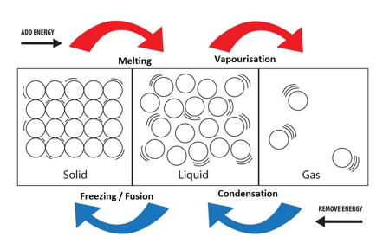
Is it Matter? (Slide 11) * Key note: Law holds true if you use this system
The air in this room & Radioactive uranium (both are)
Matter changes state (Slide 12)
- Matter can exist in solid, liquid or gaseous states
- Matter can be transformed from one state to another via input or release of energy
- Law of Conservation of Matter – matter can’t be created or destroyed, only changed from one state to another
- Mostly still holds true, though we now say “Conservation of mass in thermodynamically isolated systems”
More Matter (Slide 13)
- Ions
- Gain or lose electrons, meaning they carry a charge
- Can be positive (+) or negative (-)
- Form ionic compounds (e.g. salts)

- pH
- Low pH indicates an acid, high pH indicates an alkaline substance (alkaline substance can also be called a “base”)
- Mid pH (7) indicates neutrality
Biogeochemical cycles (Slide 15): Bio: LIVING - GEO: LIFE - CHEMICAL
- A series of processes and interacting steps by which matter cycles through ecosystems
- Generalized nutrient cycle models help represent the complexity of Earth’s processes
- Ecosystems vary substantially in terms of the speed of cycling and the relative proportion of nutrients in each compartment
- Speed of cycling may also change within a cycle, depending on season and type of nutrient
- Residence time: the typical length of time something stays in one Earth system component

Human influences on biogeochemical cycles (Slide 16)
- Under natural conditions, recycling rates often reach a relatively stable input and output pattern.
- Human activities often speed up transference between cycles components.
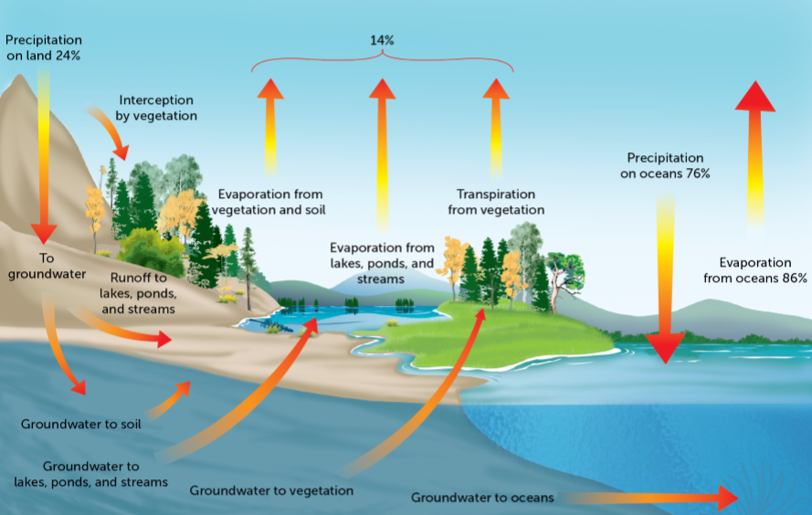
- Pollution problems result from human-induced accumulation in one or more components of a cycle.

Key note:
- Transportation that occurs through a plant; another form of evaporation
- Energy coming from the sun to cause the cycle to go
- Fresh water cannot always be accessed; in the deep ocean, in the ground or trapped in ice
- Only some fresh water can be obtained through streams/mountains

The Hydrological Cycle (Slide 18)
- Water occurs in a fixed supply that cycles between various reservoirs driven by energy from the sun.
- The ocean is the largest reservoir (contains 97 per cent of the water on Earth)
- Most of the rest is tied up in polar ice caps and a small amount occurs in fresh water.
- Water travels ceaselessly between these reservoirs through the main processes of evaporation and precipitation known as the hydrological cycle.

Time scale of hydrological cycle (Slide 22)
- In the deep ocean, it may take 37,000 years before water is recycled through evaporation into the atmosphere.
- Once in the atmosphere, average residence time is in the order of 9 to 12 days.
- The hydrological cycle involves the transport of water from the oceans to the atmosphere, through terrestrial and subterranean systems, and then back to the oceans—all fuelled by energy from the sun.
Canada’s water (Slide 23)
- Canada may have up to one-third of the world’s fresh water, but most of it is held in a solid state.
- Canada’s ~100,000 glaciers contain more than 1.5 times the volume of liquid fresh water.
- Most of this is in the Arctic, where summer air temperatures have risen markedly due to global climate change.
- Melting is a large contributor to global sea level rise.
Human effects on hydrologic cycle
- Depletion of groundwater (agriculture, industry)
- Increased evaporation (climate change)
- Increased run-off inputs in some systems (because we change surfaces to those water can’t permeate or pass through)
- Reduced water retention in some systems due to deforestation
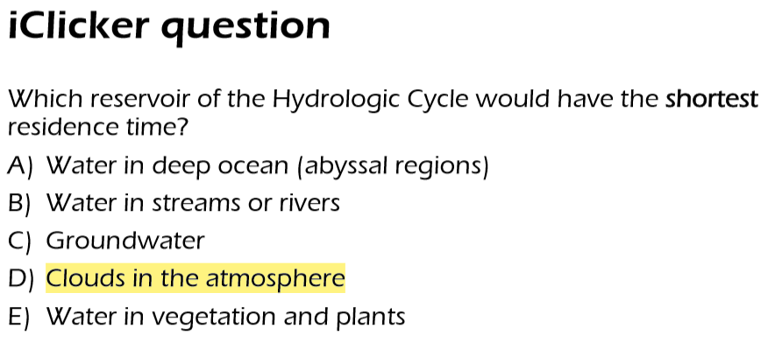

The Carbon Cycle (Slide 28-29)
- Carbon dioxide is the main reservoir for the carbon that is the building block for all necessary fats, proteins, and carbohydrates that constitute life.
- Plants take up carbon dioxide directly from the atmosphere through the process of photosynthesis.
- Carbon is incorporated in biomass and passed via the food chain

Carbon Cycle continued
- Carbon can be stored in the lithosphere for extended periods of time as organisms become buried before they decompose
- This is particularly true under relatively inefficient anaerobic decay conditions such as in peat bogs
- Over millions of years, past forest, marine, and freshwater ecosystems have been transformed into fossil fuels through heat and compression
- Respiration by organism transforms some carbon in biomass back into CO2 which enters atmosphere
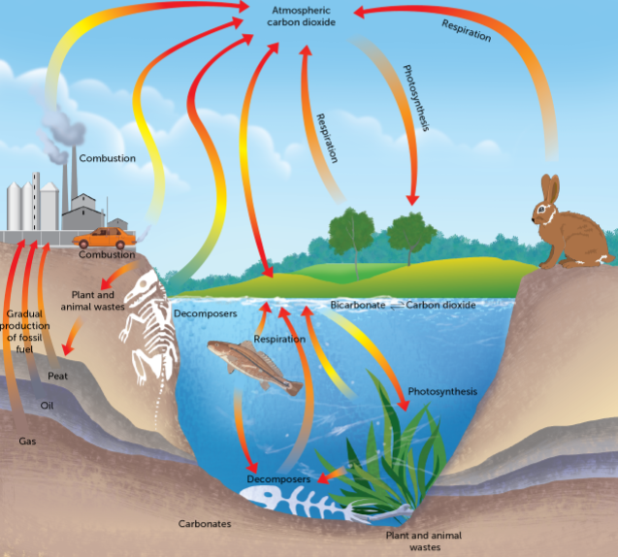
- Cellular respiration by decomposers helps to return carbon from dead organisms into the atmosphere as CO2 (methane-CH4 in anaerobic conditions)
Key note: Bio mass; incorporated into living organisms
Carbon dioxide; humans exhale CO₂
Through the use of fossil fuels; fossilized organic things

Human effects on the carbon cycle (Slide 30)
- Burning of fossil fuels – drastic increases in CO2 concentration in atmosphere
- CO₂ currently increasing at rate of 2ppm /year
- Current ~400 ppm
- Has never really gone above 300 ppm in the past

Less familiar cycles
The nitrogen, phosphorus and sulphur cycles entail cycling through the lithosphere, and atmosphere

Nitrogen cycle (Slide 34)
- Mostly in a gaseous state (N₂) in the atmosphere
- Approximately 78% of Earth’s atmosphere
- N₂ usually called “inert” because it is not very reactive
- All organisms require N as a building block, especially found in proteins and nucleic acids (e.g. RNA, DNA)
- Atmospheric N too unreactive to use in biological reactions
Nitrogen made usable to living things via microbial nitrogen fixation and nitrification

Nitrogen fixation (Slide 36)
- Nitrogen fixation occurs as bacteria transform atmospheric nitrogen into various forms that are available to plants
- The most important nitrogen fixers are bacteria of the Rhizobium family that grow on root nodules of plants. (In agriculture, especially plants of the legume family: alfalfa, clover, beans, peas, etc.)
- Nitrogen is also made available through atmospheric fixation
- Lightning causes extremely high temperatures that unite oxygen and nitrogen to form nitric acid (HNO3), which is subsequently carried to earth as precipitation and converted into nitrates (NO3–)
Key note: Plants are symbiosis or mutualism

The Phosphorus Cycle (Slide 39)
- Macronutrient incorporated into many organic molecules
- Essential for metabolic energy storage and transport
- Relatively rare in relation to biological demand; essential that it cycles efficiently between components
- Heavily concentrated in the lithosphere
- No (or extremely limited) gaseous component
- It is not well-replenished via weathering or soil availability; the amount retained by biomass is critical
- Often a limiting factor to growth/productivity in ecosystem

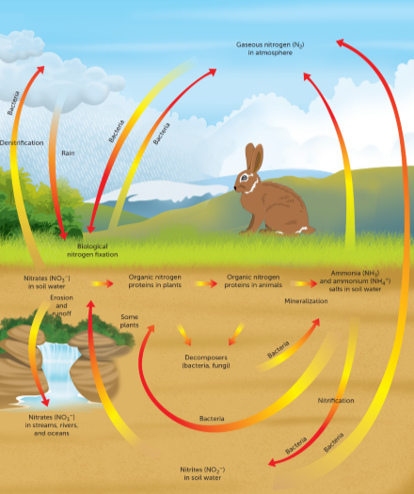

The process is slow as human processing will happen quick as access to resources are quick ↓ cycle
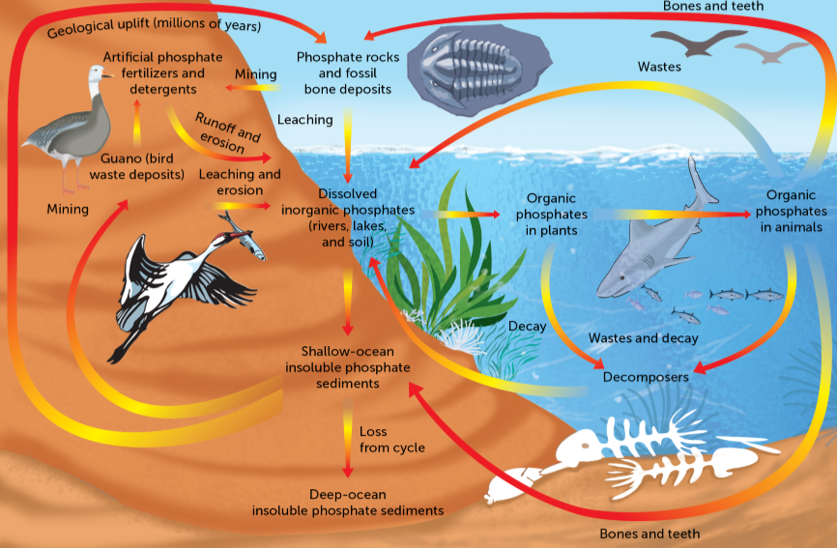

More on Phosphorus Cycle (Slide 45)
- Rocks in the Earth’s crust are the main reservoir of phosphorus.
- Bacteria mineralize organic phosphorus into inorganic forms for plant uptake.
- Most of the water transport occurs in particulate form by streams—concern about excessive sedimentation occurring through land-use activities such as logging and agriculture.
- Guano: marine bird droppings return P from marine food chain back to land—fertilizer source.
- The availability of phosphorus in the soil is influenced by soil acidity: it gets bound into insoluble compounds under very acidic, and very basic conditions—acid precipitation limits P availability.
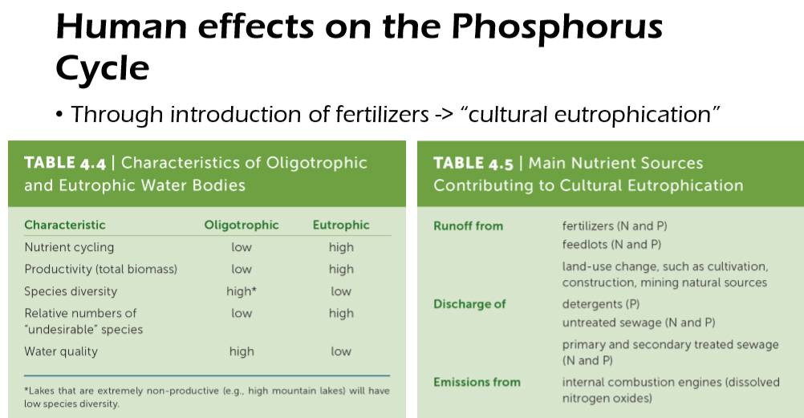

Remediating Cultural Eutrophication (Slide 49)
- The main way to control eutrophication is to limit the input of nutrients into the water body.
- It can be difficult to deal with diffuse, non-point sources, such as runoff from urban areas and agricultural land
- Point sources of pollution, or single discharge points, include effluent discharges from sewage plants or industrial processes
Sulphur / Sulfur Cycle (slide 51)
- Sulphur is a necessary component for all life and a building component of proteins
- It has an atmospheric component and thus better recycling potential (it is rarely limiting)
- It has strong dependencies on microbial activity (changing sulphur into various forms)
- The form of S in soils depends on the presence (aerobic) or absence (anaerobic) of oxygen (a reflection of the relationship of the site of transformation to the water table) and the presence of other elements such as iron.
- Interactions occur between cycles
- Iron sulphides in sediments benefits the phosphorus cycle by converting P to a soluble form

ICLICKER Q: BURN LESS GAS IN HOMES FOR EUTROPHICATION
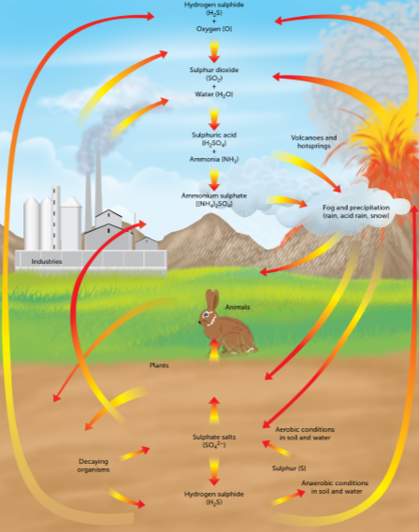
Human effects on the sulphur cycle (slide 52)
- Through the burning of fossil fuels and smelting
of metals → acidification and acid deposition
(sulphur oxides)
- Has local and longer-range effects
- In 1980s, not uncommon to record pH of 4.0
in Ontario rain
Causes of Acid Deposition (Slide 53)
- Increases in acidity to due human interferences in the S and N cycles
- Largest sources: smelting of sulphur-rich ores (for copper, nickel production) and fossil fuel burning
- Point sources (industrial plants) much easier to control than non-point (e.g., nitrogen emissions from combustion --transportation)

Effects od Acid Deposition (Slide 54)
- Disfigurement, death and extirpation of insects and fish, food chain effects through depletion of food sources
- Acid shock: pulse of acidity in spring with snow melt
- Destruction of vegetation, inhibition of microbial activity
- Animal can survive; but the eggs will be affected (e.g., the health of the babies)
- Population can drop
Ecosystem sensitivity (Slide 55)
- Critical load: the maximum level of acid deposition that can be sustained in an area without compromising ecological integrity
- Areas with deep soils and carbonate rock have a high buffering capacity (e.g., Southern Ontario, Prairies) and are not as sensitive to acid deposition, while areas with thin soils and noncarbonate rock are more susceptible (e.g. Canadian Shield, Atlantic Canada

