Carleton University
Laboratory Report

Course: PHYS1007 Experiment #: 1

Measure of Density Experiment

Ricky LaFleur
101406569

Date Performed: Dec 7, 2018
Date Submitted: Dec 7, 2018
Lab Period: L4
Partner: Neil DeGrasse Tyson
Station #:
TA: Tyrone
Abstract
The goal of this experiment is to verify the conservation of energy of the pendulum while examining the relationship between period of a pendulum and other variables. The values tested were determined to be very consistent.

Theory
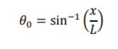
We find amplitude of oscillation, 𝜃, using the trigonometric relationship between the length of pendulum, L, and the horizontal displacement, x
(1)

The oscillations in all trials of this experiment were less than 60°, therefore the period of the pendulum was approximated using
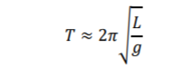
(2)
The horizontal displacement, x, required to achieve each angle of the pendulum was found using
$x=L sinθ$ (3)
The vertical displacement h, can be resolved as
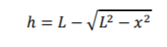
(4)

To determine the consistency of the overall experiment, the t-test is used
$t= \frac{x_{1}-x_{2}}{\sqrt{σ^{2}+σ^{2}}}$ (5)
Lastly, the uncertainty on 𝜃 is determined using the following equation
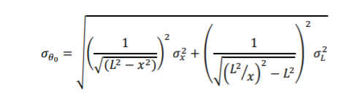
(6)

All units are in metres or m/s and the total mechanical energy of the pendulum is conserved.

Apparatus
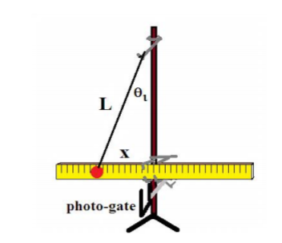
- Metre stick accurate to 1mm
- Photogate accurate to 0.01s
- Masses accurate to 0.01g
- Caliper measurements accurate to 0.001cm
- Timer accurate to 1ms
- 2 bobs
- String

Figure 1 Pendulum setup for experiment
The period of oscillation is recorded using a photogate, as the bob swings from a fixed pivot point. Measurements of the bobs are known and thus allow for velocity to be determined.

Observations
Table 1: Length Effect (using aluminum bob)
 |  |  |  |  | Period |  | Velocity
 | L (m) | x (m) | T  (s) | 𝜃  (°) | x̄ (s) | stdev | x̄ (m/s) | stdev
Readings | 0.404 | 0.105 | 1.28 | 15 | 1.262 | 0.0003950 | 0.5199 | 0.0206
Readings | 0.612 | 0.158 | 1.56 | 15 | 1.567 | 0.0005650 | 0.6483 | 0.0301
Readings | 0.643 | 0.170 | 1.61 | 15 | 1.611 | 0.0006186 | 0.7042 | 0.03123
 | 0.671 | 0.174 | 1.64 | 15 | 1.641 | 0.0006186 | 0.7197 | 0.02385
 | 0.375 | 0.097 | 1.23 | 15 | 1.223 | 0.0005425 | 0.5461 | 0.02385

Table 2: Mass Effect (brass bob)
 |  |  |  |  | Period |  | Velocity
 | L (m) | x (m) | T  (s) | 𝜃  (°) | x̄ (s) | stdev | x̄ (m/s) | stdev
Readings | 0.403 | 0.104 | 1.27 | 15 | 1.304 | 0.0003256 | 0.6418 | 0.01281

Table 3: Amplitude Effect
 |  |  |  | Period |  | Velocity
 | L (mm) | x (cm) | 𝜃  (°) | x̄ (s) | Stdev  (x10-6) | x̄ (m/s) | stdev
Readings | 506 | 29.0 | 35 | 1.450 | 8308 | 1.333 | 0.01585
Readings | 506 | 30.4 | 37 | 1.448 | 5802 | 1.299 | 0.01304
Readings | 506 | 32.5 | 40 | 1.461 | 1147 | 1.497 | 0.02735
 | 506 | 34.5 | 43 | 1.460 | 9335 | 1.497 | 0.01637
 | 506 | 38.8 | 50 | 1.476 | 1476 | 1.752 | 0.02973

Graphs
Results of graphs generated in Logger Pro Software

Discussion
Overview
The goal of this experiment was to learn the physics of a simple pendulum. The physics principle that makes this system work is conservation of energy; a balance of kinetic and potential energy that sustains each swing of the mass. In this experiment, the effect of mass, pendulum length, and amplitude on period duration were tested. The mass of the bob appeared to have very little effect on the period of the pendulum, while pendulum length showed to be linearly related to length of period. Also, increasing the amplitude angle also showed a linear relationship to the length of the period. In processing, logger pro was able to find a linear correlation in the data using a gravitational acceleration value of 9.83m/s². We can examine this value and compare it to the known value for gravitational acceleration of 9.81m/s² and see that they are very close. In addition, all three of the t-tested values showed values far under 2, suggesting that the results of this experiment were highly consistent.
Analysis
To increase accuracy of this experiment I would suggest a more accurate method to measuring the horizontal displacement of the mass or the amplitude angle, as this proved to be the largest source of uncertainty in the data for this experiment. In the laboratory, calculations were made using desired angles to find the horizontal displacement required to achieve that angle of amplitude for the corresponding trial, however, a student would have to hold a metre stick (accurate to 0.1cm) outwards from the centre of the mass with one hand while aligning the dangling mass with the other hand and eyeing it to correspond to the metre stick measurement. This was a very difficult and inaccurate method to use to set specific amplitude angles. Going forward, I would implement an adjustable arm to hold the mass at a specific horizontal displacement, to allow the student to more carefully check his/her measurement. If a tool other than a wooden metre stick was used to make the majority of the measurements in this lab the uncertainty would be reduced by a factor of 2.
Applications
The methods and principles of physics used in this laboratory are comparable to some interesting applications in the industry. One example is in amusement parks, a large number of rides rely on the physics of swinging masses, where the chair is hoisted up along a circular path and dropped, swinging the riders back and forth until they reach a stop. These rides are designed with similar attention to kinetic and potential energy and the law of conservation of energy.

*Please note: Raw data is included in observations and graphs

