
Globalization
Global economy is not fully integrated
September 7, 2018
8:30 AM

What is Globalization?
  - Globalization refers to the shift towards a more integrated and independent world economy
  - As globalization unfolds, its transforming industries and creating anxiety among those who believed their jobs were protected from foreign competition.

The interdependent Global Economy
  - Globalization denotes increasing interdependency as: In todays world, national economies are merging into an interdependent economic system.
  - Two countries that are equally dependant on each-other are interdependent.
  - Temporal dimension --> Time/Context Matters
Qualities of an Interdependent Global Economy
  - Barriers to cross-border trade and investment are tumbling
  - Perceived distance is shrinking due to advances in transportation and telecommunications technology
  - Material culture is starting to look similar the world over,
  - Na national economies are merging into an interdependent global economic system

Challenges of going global
  - The hard reality is that for all the superficial similarities in material and popular culture and in business systems, doing business in foreign nations still has unique challenges.
  - Because of different tastes and preferences, what sells in Brittan may not sell in Thailand
  - Business processes that give their retailer a competitive advantage in the united states may be difficult to implement in Mexico
  - A brand that means something in Kansas may mean little in Indonesia

Facets of Globalization
  - Globalization of Markets
  - Globalization of production
  - Globalization of Consumers

Globalization of Markets
  - Refers to the merging of separate national markets into one huge global marketplace
  - Low-cost transportation has made it more economical to ship products around the world there by helping create global markets
  - Low cost communications networks such as the World Wide Web are helping to create electronic global markets
  - A logical result of this evolution is the emergence of global markets for consumer products
  - Very significant differences in culture, consumer preference and business practices still exist in even in the "global village"

Globalization of Production
  - Globalization of production " refers to the sourcing of goods and services from locations around the world to take advantage of national differences, costs, and quality of factors of production."
  - As transportation costs associated with the globalization of production declined dispersal of production to geographically widespread locations became more economical.

Globalization of customers
  - Globalization of consumers "refers to the merging of separate national markets into one global marketplace"

Global Institutions
  - Institutions are needed to help manage and regulate the global marketplace as we continue to globalize
  - Prominent institutions include
    - United Nations (1945)
    - World Trade Organization or WTO
      - Preceded by GATT
    - International Monetary Fund or IMF
    - World Bank

Drivers of Globalization
  - Decline in barriers to the free flow of goods, services, and capital since the end of WWII
  - Technological Change in communication, information processing and transportation

Decline In Barriers
  - Lowering of barriers to international trade enables firms to view the world rather than a single country, as their market
  - The lowering of trade and investment barriers also allows firms to base production at the optimal location for that activity, serving the world market place from that location
  - A firm might design a product in one country
    - Produce components in two other countries
      - Assemble in yet another country
        - An then export the finished product around the world

Technological Change
  - The lowering of trade barriers and globalization of markets and production a theoretical possibility.
  - Technological change has made it a tangible reality
    - Since the end of World War II, the world has seen major advances in
    - Communication
    - Information Processing
    - Transportation technology
    - The emergence of the internet
  - Changes the Internet Made
    - The Internet has changed the way people communicate.
    - The Web makes it much easier for buyers and sellers to find each other, wherever they may be located and whatever their size.
    - It allows businesses, both small and large, to expand their global presence at a lower cost than ever before

The Changing of Demographics of the global economy
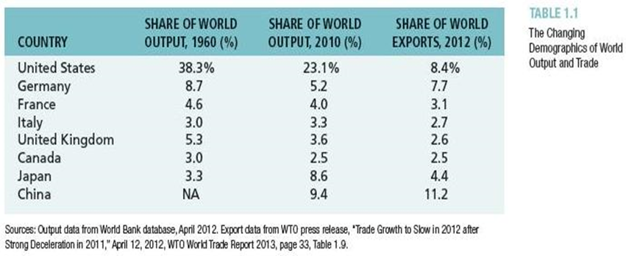

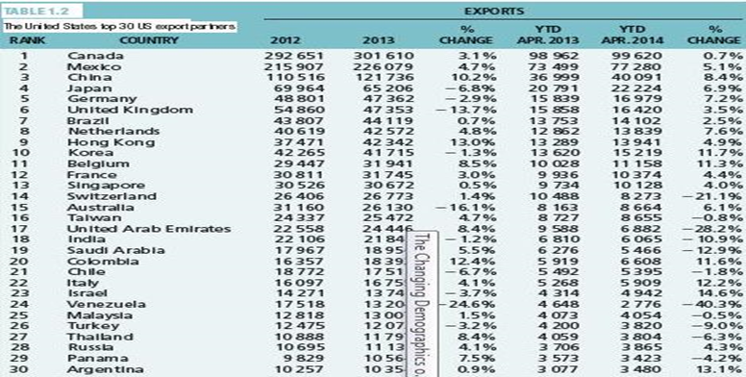

Changes in Foreign Direct Investment
  - Among developing nations, the largest recipient of foreign direct investment has been china, which in 2004 - 10 received 60 billion to 100 billion a year in inflows

Globalization and National Sovereignty
  - Another concern voiced by critics of globalization by critics of globalization is that today's increasingly interdependent global economy shifts economic power away from national governments. And toward supranational governments such as the World Trade Organization, the EU, and UN
  - The WTO is a favourite target of those who attack the headlong rush towards a global economy

Managing in the Global Market Place
  - The nature, dynamics and impacts of globalization highlighted above offer opportunities and challenges for t business organization and their managers
  - The task of managing an international business
    - Differences between countries require that an international business vary its practices country by country
    - Cross-border transactions require that money be converted from the firms home currency into a foreign currency and vice versa
IB = trade + Investment

Export Import Inward Outward

Foreign Investment
- FDI (Long-term)
- Portfolio Investment (Short Term)

