Lecture 12: Exploratory Statistics
Central Tendency & Dispersion
Mean and standard deviation can be used to characterize the location and spread of a distribution
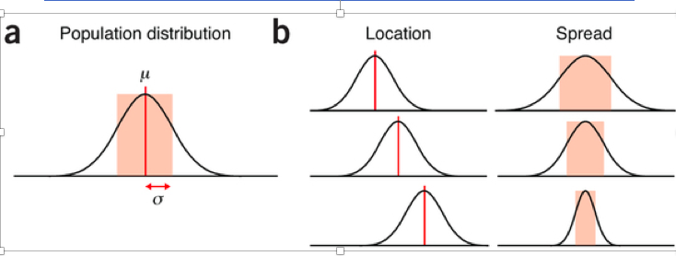
Mean= u or x | Standard deviation = o(sigma)
Rank-ordered data
- Rank from least to most.
Data Analysis
Descriptive Stats: summarize data from sample using indexes such as the mean or standard deviation.  Central tendency (or location) seeks to characterize the distribution’s central or tropical value  Dispersion (or variability) characterizes the extent to which members of the distribution depart from its center and each other | Inferential Statistics: draw conclusions from data that are subject to random variation (ex. observational errors)  Form of exploratory data analysis with a dual purpose:  - Can help formulate questions and hypotheses (ex. during pilot study or observations)  - Helps organize and clean data that we will be using to answer questions and hypotheses (ex. after data collection)  cleaning= looking for mistakes in data entry

Frequency Distribution
A mathematical function showing the number of instances in which a variable takes each of its possible values
USE: create table where each possible score is listed in column on the left side and the frequency with which it occurred listed on the right.
CON: does not provide much information
Histogram
Accurate graphical representation of the distribution of numerical data. Diagram consisting of rectangles whose area is proportional to the frequency of a variable and whose width is equal to the class interval.
USE: provides a graphical way of exploring a frequency distribution. Provides an estimate of the probability distribution of a continuous variable
MAKE: create class intervals (bins) of equal size and then calculate the number of occurrences with each bin.

Central Tendency
- Calculate WHERE the center of a frequency distribution (histogram) lies -
Central tendency: MEAN, MEDIAN, MODE.
MEAN, MEDIAN, & MODE - give NO INFORMATION about how frequently numbers close to the mean are going to be encountered. NEED VARIATION.

Mean: sum of all scores divided by the total # of scores  •Need to know information about the VARIATION in the sample to make sense of the mean value | Mode: the most commonly occurring value in the frequency distribution
Median: middle value that separates the higher half from the lower half of the data set

Quantifying Dispersion
Variability is the dispersion of scores within a distribution.
Common measures include:
Range, Interquartile range, standard deviation, coefficient of variation, standard error of mean, confidence interval of mean.
Range:  Difference between the greatest and least data values. | Interquartile Range  Measure of dispersion. It is the midspread of middle 50%. Difference between the 75th & 25th percentiles (upper&lower quartiles)
Standard Deviation  Measures amount of variability or dispersion from the mean for a sample set of data  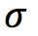= standard dev  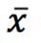=mean  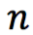= sample size  = observation | Coefficient of Variation  Measure of variability; standardized measure of dispersion  Standard deviation & mean are expressed in the same units, whereas coefficient of variation is a fraction with NO UNITS.  Can multiply CV by 100 to express in %  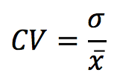
Standard Error of the Mean  - Measures how far the sample mean of the data is likely to be from the true pop  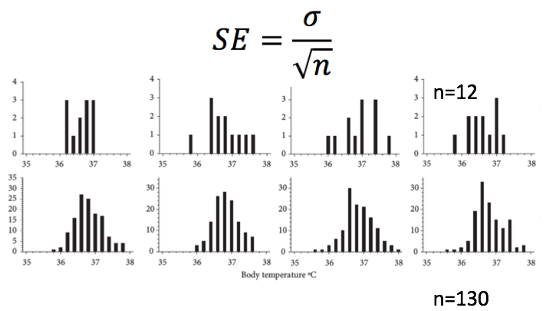 | Confidence Intervals of the Mean  Range of values defined with a specified probability that the value of the mean lies within it  95% confidence intervals mean: there is a 95% chance that the mean lies between the minimum and maximum confidence interval  Compute: sample mean, SD, sample size, degree of confidence  n=130  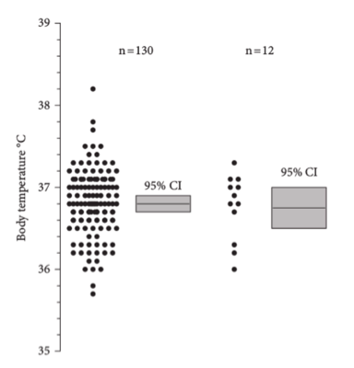
Homogenous vs Heterogeneous
A lower value of the standard deviation indicates a narrower distribution (more similar or homogeneous) of the raw scores around the mean. | The higher the standard deviation, the wider the distribution of the scores is around the mean. This indicates a more heterogeneous or dissimilar spread of raw scores on a scale.

Dispersion: Standard Error of the Mean
- Standard Deviation tells us how well the mean represents the sample data (bc usually collect samples bc we don’t have access to entire population)
- IMP: taking several samples from pop will make samples diff slightly

Lecture 13- Exploratory Statistics 2
Error bars
- <100 data points- use scatter plot to show variation in all values
- >100 data points - box-and whiskers plot or frequency distribution (histogram)
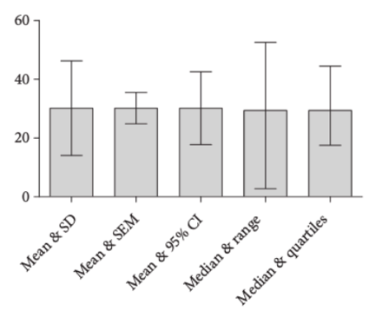
Deviations from Normal Distribution
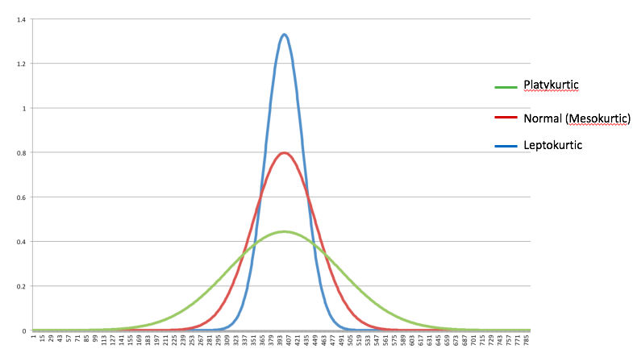
Pointyness = Kurtosis
Lack of symmetry = skewed
Positive Skew Histogram Negative Skew Histogram
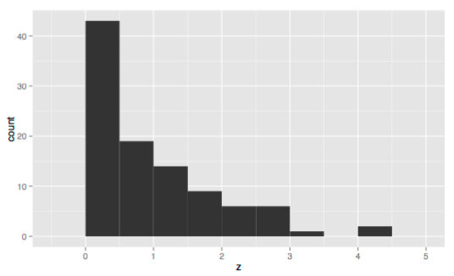 | 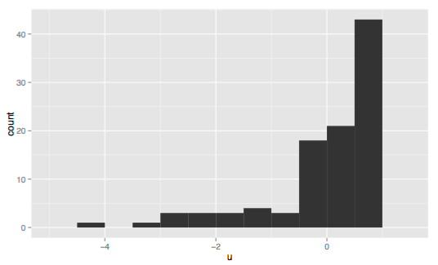

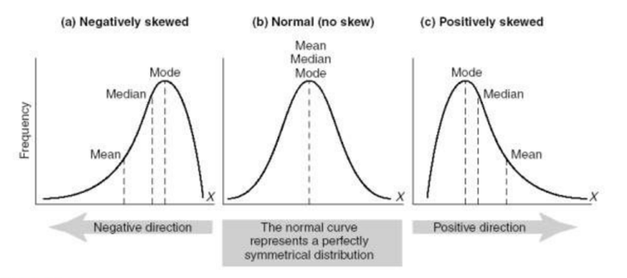
Most frequent scores (the mode) and median are BELOW the mean

Box and Whiskers Plot
- Whiskers as confidence intervals
- Dots represent less than 5% or above 5% 95 percentiles
- If both boxes are pretty equal
- If dots equal than distribution looks pretty normal
Good sense of distribution of data without showing every value (unlike scatter/dot plot)
Great when there’s too many data points to show clearly on scatterplot but don’t want to take the space to show full frequency distribution
MUST USE when the distribution is not Gaussian

Detecting Outliers and Mistakes
Outlier: observation that lies an abnormal distance from other values in a random sample from a population
Scatter Plots and boxplots most useful to identify outliers
- Boxplot uses median and the lower and upper quartile ranges to define what an outlier will be
Mistakes:
- Assuming all distribution are normal/Gaussian
- Number so far outside the norm? You need to see if there’s a problem

Lecture 14: Inferential Statistics I: Probability & P Values

Descriptive vs Inferential Statistics
Describe our data  Ex. central tendency, variance, box plot | Provide inferences about population from a sample  Ex. Theory, methods, and practices of forming judgements about the parameters of a population and the relatability of statistical relationships

Statistical Significance
Null hypothesis: no relationship, no effect
USED FOR: accepting or rejecting null hypothesis and if predictions are supported.
Statistical inference testing: Assume null hypothesis is true
Alpha below 0.05 (5%) than we REJECT the null hypothesis & accept alternative hypothesis
Above 0.05 THAN RESULTS ARE NONSIGNIFICANT, we DO NOT reject null hypothesis
Null hypothesis not rejected: assume that our apparent relationship was due to chance sampling effect

Null Hypothesis

NULL HYPOTHESIS VS RESEARCH HYPOTHESIS
The ratio of males to females is equal to a theoretical expectation of 1:1 | The sex ratio of males to females is different from theoretical expectation of 1:1
P= 0.030 WHAT DOES P MEAN? 3% probability chance of your sample

Lecture 15: Inferential Statistics II: Probability and P Values
P Value and Significance
P Value: calculated probability of finding the observed, or more extreme, results when the null hypothesis of a study question is true. HELPS DETERMINE THE STATISTICAL SIGNIFICANCE OF A TEST
Significant NOT Significant
P=0.0425  Reject null hypothesis bc less than alpha=0.05 | P=0.1024  Accept null hypothesis bc greater than a=0.05

Accept or Reject Null Hypothesis: False Positive or Type 1 Error
ALWAYS Reject Null hypothesis: CHANCE U MADE A MISTAKE
Your experimental results may deviate from the hypothesis due to chance
We never “prove” something in science; there’s always a chance our data are fooling us/deviate from null hypothesis due to chance.
False positive/ Type I Error: Data fool you into rejecting the null hypothesis even though it’s true. | False negative/Type II Error: You don’t reject null hypothesis, even though it’s not true.
Significance: we never say that our data shows the null hypothesis to be true: all we say is that we haven’t rejected the null hypotheses.

Significance level (alpha) influences False positives & Negatives
With a significance level of a=0.05, you stand a 5% chance of rejecting the null hypothesis, even if it is true. (5% of your experiments will give you a false positive/Type I Error).

If you use a higher significance level than a conventional a=0.05 like a=0.10 then you will INCREASE your chance of a false positive or Type I error to 0.10 (increase your chance of embarrassing wrong conclusion) or DECREASE your chance of a false negative/Type II error (increasing your chance of detecting subtle effect).

If you use a lower significance level than the conventional a=0.05, like a=0.01 then you will decrease your chance of an embarrassing false positive & decrease chance of detecting a real deviation from the null hypothesis

Null hypothesis will always be false, if you have a big enough sample size.

P Value: Common Mistakes
- Interpreting P value as the chance that there is a real difference between populations
Example: Researchers compared a mean in groups of patients given two different treatments and found P values equals 0.03
Interpretation (CORRECT) (INCORRECT)
If the two population means are identical (Null hypothesis is true), there is a 3% chance of observing a difference as large or larger than observed.  Random sampling from an identical population will lead to a difference smaller than observed in 97% of experiments and larger than observed in 3% of experiments. | there is a 97% chance that there is a real difference between populations and 3% chance that the difference is random

- Thinking that the P value is the probability that the result was due to sampling error
P value computed assuming that null hypothesis is true (assumption that the difference is due to random chance) P value CANNOT tell you probability that the result is due to sampling error

- Assuming a large P value PROVES that the null hypothesis is true
A high P value (P>0.05) does NOT prove that the null hypothesis is true- just means we cannot reject the null hypothesis.

- Focusing only on P values when interpreting data
Need to also look at effect size and confidence intervals

Significance Levels and Effect Size
A high level of significance is not the same as a large effect in the sense of a large difference or a steep trend
Difference of trend/magnitude of effect: is the effect size

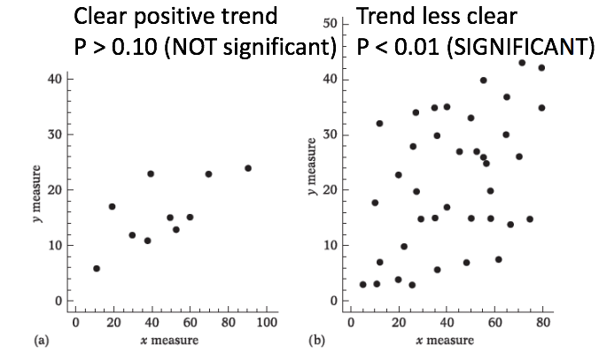
P value (level of significance) gives little indication of difference or effect size.
Important to provide an indication of the magnitude of the differences or the trend, usually in the form of summary statistics & their associated sample sizes.

Effect Size: independent of sample size

Lecture 16: Test for Difference I: Exact & Chi Square Tests
E-test of Goodness
Example: Yukilevich and True (2008) asked whether fruit flies prefer to mate with conspecifics from their own area, versus conspecifics from further away?
Null hypothesis: Flies mate at random, so there should be no effect of distance
Hypothesis: flies do not mate at random, so there should be on effect of distance.
Experiment: Mixed 30 male and 30 female from Alabama with 30 male and 30 females from Grand Bahama Island and observe who mates who. 
Results: 246 matings
140 were homotypic (male and female from same location)
106 were heterotopic (male and female from different locations)
Statistical Results: Significantly more homotypic than heterotopic matings (P=0.035).
Process
Collect the data
Directly calculate the probability (P value) of obtaining the observed data under the null hypothesis
Determine whether the P value is less than alpha, and if it is, reject the null hypothesis
Chi-Square Goodness of Fit
Null Hypothesis: The observed data does not differ from theoretical expectations
Research Hypothesis: The observed data differs from theoretical expectations
Assume: The individual observations are independent, meaning that the value of one observation does not influence the value of other observations

Chi-Square Test of Independence
Null hypothesis: The relative proportions of one variable are independent of the second variable
Research Hypothesis: The relative proportions of one variable are dependent on the second variable.
Testing if the proportions are the same in different groups
Example: wanted to know: is better give the diphtheria, tetanus and pertussis vaccine in the thigh or in the arm?
Goodness of Fit - You use theoretical relationship to calculate the expected frequencies
Chi-Square Test of Independence- You used observed frequencies to calculate the expected.

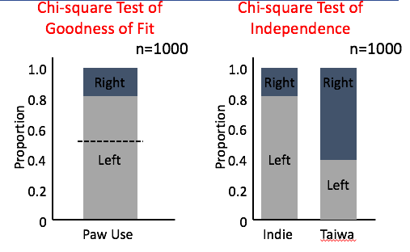
T-Test 1 Sample
Data Type: Continuous
Goal: Tests whether the mean of the measurement variable is the same as the null expectation.
For Use: ONE SAMPLE- when you have one measurement variable and a theoretical expectation of what the mean should be under the null hypothesis.
Null Hypothesis: The mean of the measurement variable does not differ from theoretical expectations (equal to number you decided before experiment)
Research Hypothesis: the mean of the measurement variable differs from theoretical expectation.
Assume: observations within each group are normally distributed

T-Test 2 Sample
Data Type: One continuous variable and one categorical variable with only two values.
Goal: test whether the means of the measurement variable are the same for two groups.
Null hypothesis: the means of the measurement variable are equal for two categories. The means of the measurement variable differ for the two categories.
Assume: 1. observations within each group are normally distributed.
2. HOMOSCEDASTICITY - (equal variances within the two groups).

ANOVA
Goal: test whether the means of the measurement variable are the same for different groups (2 or more) one categorical variable and one measurement variable; the categorical variable divides the measurements in to tow or more groups
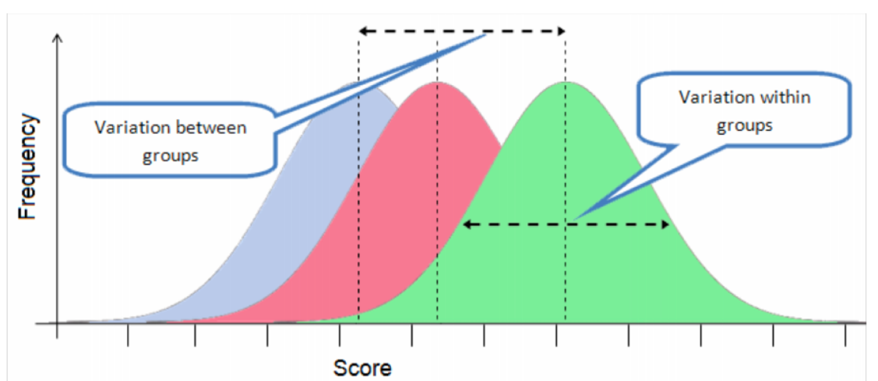
For use:
p= 0.0125
p<0.0001
Might be significant but where do the differences lie?
At least two are significantly different from each other

ANOVA – from Variance to F Value
Larger variance between groups means + smaller variance within groups + larger sample sizes per group = larger F value = less plausible that population means are equal
Assume: The ANOVA assumes that the observations with each group are normally distributed
The ANOVA assumes homoscedasticity (equal Variances in the two groups)

Lecture 18: Test for Trend: Correlation & Regression
Correlation & Regression
Data Type: Continuous
Goal: USe regression or correlation when you want:
- To know whether one measurement variable is associated with another measurement variable
- To measure the strength of the association (r2)
- An equation that describes the relationship and can be used to predict unknown values
For USE: 2 continuous variables
Testing: Is there an association between the two variables? [as the X variable goes up, does the Y variable tend to change (up or down)]
Hypothesis Testing: Does pulse rate change with higher speeds? YES: P=1.3x10-8  Strength of Association: Tight relationship (r2=0.098). If you knew speed of elliptical machine, you’d be able to predict the pulse rate with high accuracy.  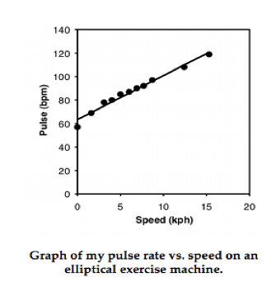 | Hypothesis Testing: Do females have more eggs or fewer eggs than smaller amphipods? YES: P=0.015. STRENGTH OF ASSOCIATION (how tight): Loose: (R2=0.21). Even if its statistically significant, knowing the female’s weight would only let you predict the number of eggs she carries with 21% accuracy.  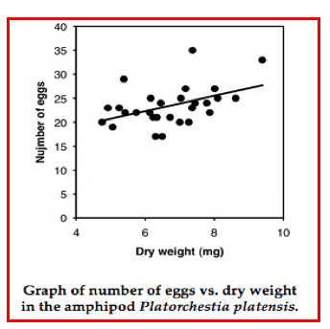
Regression (MANIPULATIVE)
Cause and Effect: Researcher determines the values of the independent variable (X)
Ex. researcher determined the speed of the elliptical machine was set at and then measured the effect on the study subject’s pulse rate
Independent variable: speed of elliptical machine (Plotted on X axis)
Dependent variable: Pulse rate (plotted on the Y axis)
Association: The least-squares regression line DOES depend on which variable is the X and which is the Y.
Correlation (OBSERVATION)
Association: are the two variables associated? We cannot infer a cause-and-effect relationship.
Researcher does not determine either variable ahead of time: both natural (OBSERVATIONAL)
If you find an association, you infer that variation in X may cause variation in Y, or variation in Y may cause variation in X, or variation in some other factor may affect both Y and X.
Ex. Being bigger may cause amphipods to have more eggs
EX. Having more eggs may cause the mothers to grow bigger
Not clear which is the independent variable and which is the dependent, even f you think there may be a cause-and-effect relationship.
Association: P value and r2 are not affected by which variabel you call X and which you call Y; you;ll get identical values either way.

Linear Regression line: minimizes the sum of the squared vertical distances between the points
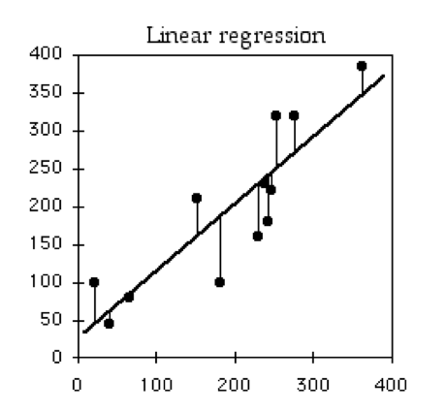

Coefficient of determination (r2) expresses the strength of the relationship between the X and Y variables.
R2 is the proportion of the variation in the Y variable that is “explained” by the variation in the X variable.

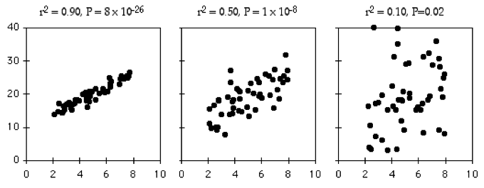

Correlation & Regression ASSUMPTIONS
- Observations within each group are normally distributed
- Homoscedasticity (equal variances)
- Linearity (that the data fit a straight line)
- Independence (that the data points are collected independent of each other)
ANCOVA
Goal: want to compare two or more regression lines to each other. Tells you whether the regression lines are different from each other in either their slope or their intercept.
For Use: two continuous variables (or more) and one categorical variable. The categorical variable divides the regression line into two or more sets.
SIG: evaluates whether the means of the dependent variable are equal across levels of a categorical independent variable, while statistically controlling for the effects of a continuous variable that is not of primary interest (covariate).
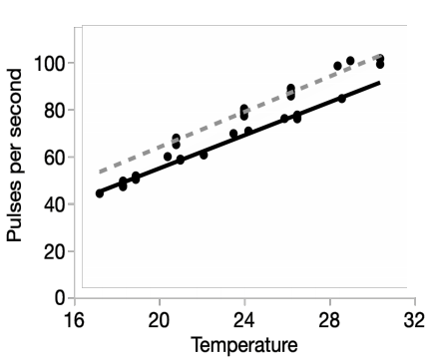
Remember, the equation of a regression line:
Ŷ=a+bX a is the Y intercept; b is the slope
Null Hypothesis (2)
- The slopes of the regression lines (b) are all equal (the regression lines are parallel to each other).
- If you accept null hypothesis #1, you test whether the Y intercepts of the regression lines (a) are the same.

Graph: evaluates whether the pulses per second means are equal across the two species, while controlling for the effects of temperature (covariate)
Steps:
- Compute each species regression line
- Determine if slopes are significantly different (CAN’T do STEP 3: comparing the Y intercepts) if the slopes are significantly diff from each other). If the slopes are significantly different, the lines will cross each other somewhere, so one group will have higher Y values in one part of the graph and lower Y values in another part of the graph.
- If the slopes do not differ, draw a regression line through each species of points, all with the same slope. The common slope is weighted average of the slopes of the different species.
- Test the null hypothesis that all of the Y intercepts of the regression lines with a common slope are the same. BECAUSE THE LINES are parallel, saying they are significantly different at one point (the Y intercept) means that the lines are different at any point.

Lecture 19: Midterm Review
Independent variable – manipulated to observe influence on dependent variable
How does X affect Y?
How do changes in X affect Y? X=INDEPENDENT
How does X Influence Y? Y=DEPENDENT

Continuous Variables: uncountable values (eg. Weight, length, height, width, longevity, ph).
Categorical: expressed as a word (eg. Sex, species, genotype, blood type, normally described as proportions or percentages).

Assumptions
- Variables are normally distributed
- Variables are homoscedastic (equal variances)
- Each independent Variable is linearly dependent variable
- Data are collected independently from each other
Lecture 20: Test For Trend II: Multiple Regression
Multiple Regression
Goal: Explain the variation in a dependent variable with two or more independent variables. You can use multiple regression for
- Prediction: predict values of the dependent variable. Prediction estimation of an unknown Y values corresponds to set of X values.
- Causes: suggest which independent variables have a major effect on the dependent variable.
USE: when you have 3+ Continuous variables
Example: Endangered Tiger Beetle
Goal: interested in finding suitable habitat to reintroduce beached tiger beetles, which lives on sandy beach of Atlantic coast.
Measured
Density of Tiger Beetles (dependent variable)
Biotic and Abiotic factors (independent variables)
- wave exposure
Sand particle size
Beach steepness
Density of amphipods
Multiple regression Uses: Predictions

If you went to beaches that currently have no tiger beetles and measured all the independent variables (wave exposure, sand particles, etc.) than you could use your multiple regression model to predict the density of tiger beetles THAT COULD live there.
SIG: guide your conservation efforts, so you don’t waste resources introducing tiger beetles to beach that may not support them/many of them.
To make predictions we use partial regression coefficients
The magnitude of the partial regression coefficients depends on the unit used for each variable, so it does not tell you anything about the relative importance of each variable.

The intercept, a, and the slopes, b (the partial regression coefficients)), are determined from the minimization of the squared deviations between the observed and expected values of Y.
P-values can be obtained by A
The t and F statistics are related in part to the number of observations and the number of X variables.

Multiple regression Uses: Causes
Understand functional relationships between the independent and independent variable, to see what might be causes the variation in the dependent variable.

The magnitude of the standard partial regression coefficients tells you something about the relative importance of different variables.
X variables with bigger standard partial regression coefficients have a stronger relationship with the Y variable.

Linear Regression vs Multiple regression
Only concerned about the relationship of the independent variable with the dependent variable | Consider relationship of each independent with the dependent variable, BUT ALSO their relationship to each other.  Has R2 value but called The coefficient of multiple determination; a measure of how well the multiple regression model explains the variance in Y.  R2 range 0-1  0= is indicative of no relationship, 1 is indicative of perfect relationship,

Assumptions
Variables are normally distributed
Variables are homoscedastic (equal variances)
Each independent variable would be linearly related to the dependent variable, if all the other independent variables were held constant.
Independence (the data points are collected independently of each other).
The X variables are not multicollinear, which occurs when two (or more) independent variables are highly correlated.

Lecture 21: Statistical Assumptions & Presenting Results
Assumptions #1
Normality
Most statistical tests (t-test, ANOVA, correlation, regression, known as parametric tests) assume that the continuous data fit the normal distribution).
If your continuous variable is NOT normally distributed, your chance of a false positive increases if you analyze the data using statistical tests that assumes normality.
Are frequency approximates a normal (Gaussian) distribution

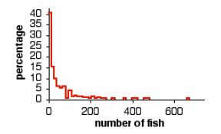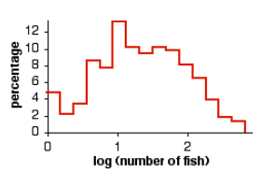

If the data appear extremely skewed, consider TRANSFORMING your continuous variable.
To transform your data, you perform a mathematical operation on each observation, then use these transformed numbers in your statistical test.
Example: abundance of fish species is non-normally distributed
Applying the log transformation makes the data approximate a normal distribution

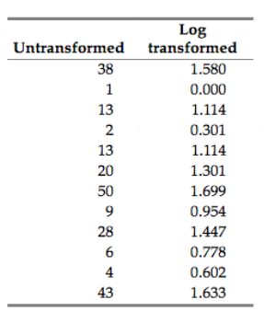Your
log transforms each observation, plot the log transformed data in a histogram, and then see if the histogram looks normally distributed.

Transformations
Log  Many biological variables have log-normal distributions because the product of several independent factors multiplied together is log-normal. | Square-root:  Often used when the variable is a count of something, such as bacterial colonies per petri dish, blood cells going through a capillary per minute, mutations per generation.
Arcsine
Used for proportions, which range from 0 to 1

Assumptions #2
Variables are normally distributed
Variables are homoscedastic (equal variances)
Each independent variable is linearly related to the dependent variable
Independence: the data points are collected independent of each other.

Homoscedasity
When the three populations were homo (had the same standard deviation) the ANOVAs on the data sets were signifigant (P,0.05) about 5% of the time. BUT when the standard deviations were different, P value was less than 0.05 in about 18% of simulations.
Assumption of Regression & correlation.

Heteroscedasticity
Compare the standard deviations of different groups, to see if they are extreamly different.
If you see a >2 fold different in standard deviations between groups, try transforming your data
REMEMBER: groups with larger means often have larger SDs; a log or a square-root transformation will often fix this problem.

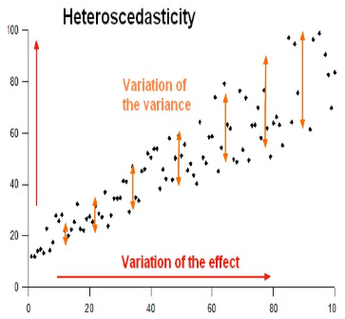

Assumptions #3
Each Independent variable is linearly related to the dependent variable
Linearity
Create a scatterplot where you plot the dependent variable against your independent variable and then visually inspect the scatterplot to check for linearity
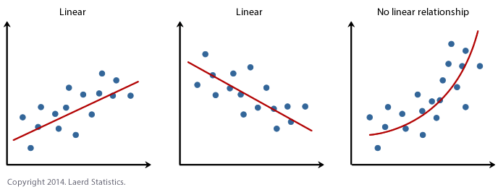
Non-linear
-transform your data

Independence
The value of one observation does not affect the value of other observations
Violated when the value of one observation is too similar to the values of other observations
Can make your statistical test give too many false positive
Ex. If you weigh five black/white cats from same litter, chance of getting a P,0.05 could be much greater.
THERE ARE NO TRANSFORMATIONS THAT CAN FIX LACK OF INDEPENDENCE

Communicating Results
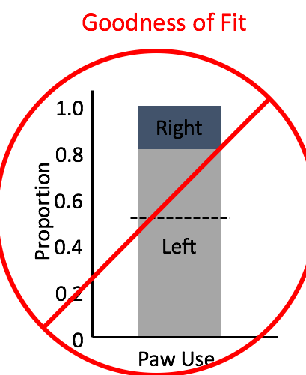If there are only two values of the nominal variable, DO NOT display the result in a graph as that would be a bar graph with one bar. REPORT PROPORTION.
EX. While blank used left paw, these results are not significantly different from the null expectation (p=0.109, df=1).

If there are three or more values of the nominal variable, present the results in a table or graph of observed/expected proportions. If findings are significant USE A GRAPH. Use a bar graph for the observed proportions; the expected proportions are shown with a horizontal dashed line, or with bars of a different pattern.
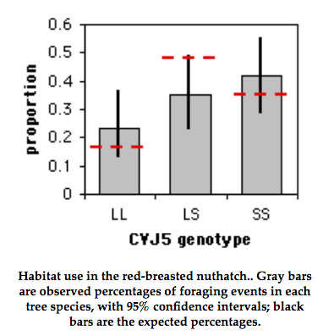
One sample t-test wouldn’t be in a graph
ONLY COMPARING ONE OBSERVED MEAN TO one expected value.
Report means and statistical results: mean height of one group does not differ from mean height of other (165.1cn, t=-18, df=1, P=0.8576).

T-test (2) or ANOVA
When significant, present a figure of the t-test or ANOVA using a bar graph or box plots. The heights of the bars indicate the means,
Report the F or t statistic, df, and P value for the tests. ex. The sexes of students in BIOL1105 differ in height (ANOVA: F2,133=43.`5, P<0.0001). You can also just present summarized tables
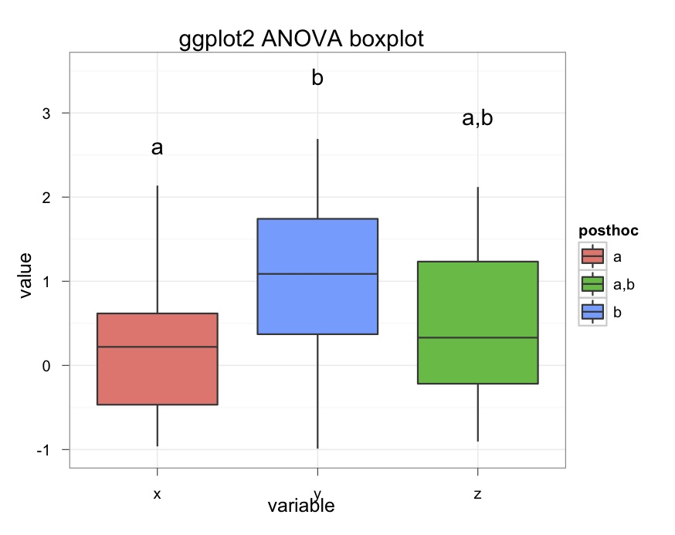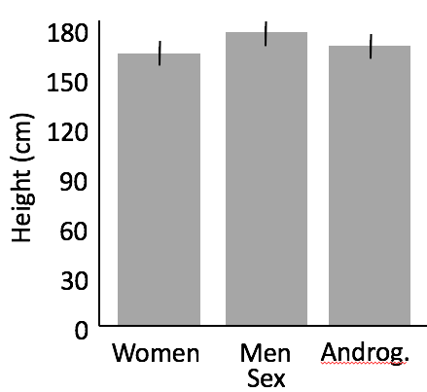

Correlation & Regression
NOT SIGNIFICANT? – report it in one sentence in results
SIG- Use a scatterplot, with the independent variable on the x-axis, the dependent variable on the y-axis. Include a regression line if you manipulated the independent variable or if it is obvious.
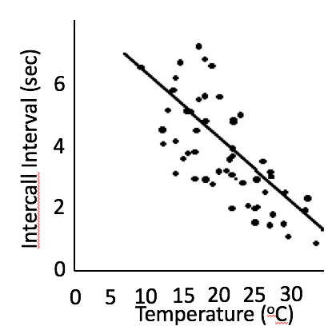ex. Inter-call interval calls declines linearly with increasing temperature. Temperature MUST influence calls, bc calls can’t influence temperature.

ANCOVA
Significant?
- use a scatterplot, with independent variable on the X axis and the dependent variable on the Y axis
- use a different symbol for each value of the nominal variable, as in the figure, where filled circles are used for females and triangles are used for males.
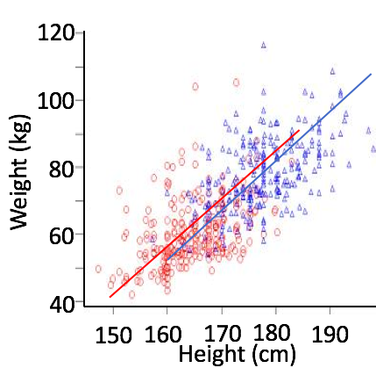Plot the individual regression lines for each set of points, even if the slopes are not significantly different, as this lets people see how similar or different the slopes look. Report the results for whether the slopes of the two regression lines and the intercepts are significantly different.
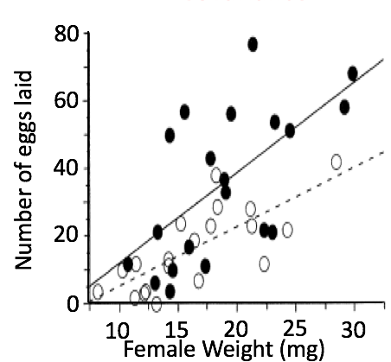Ex. The slopes of the regression line are not significantly different (ANCOVA: F1,36=1.1, P=0.30), however the Y intercepts are significantly different (ANCOVA: f1, 36=8.8, P=0.005)

Multiple Regression
If equation includes two independent variables, you can draw a three-dimensional graph of the relationship.
More than 2 - Use a table


